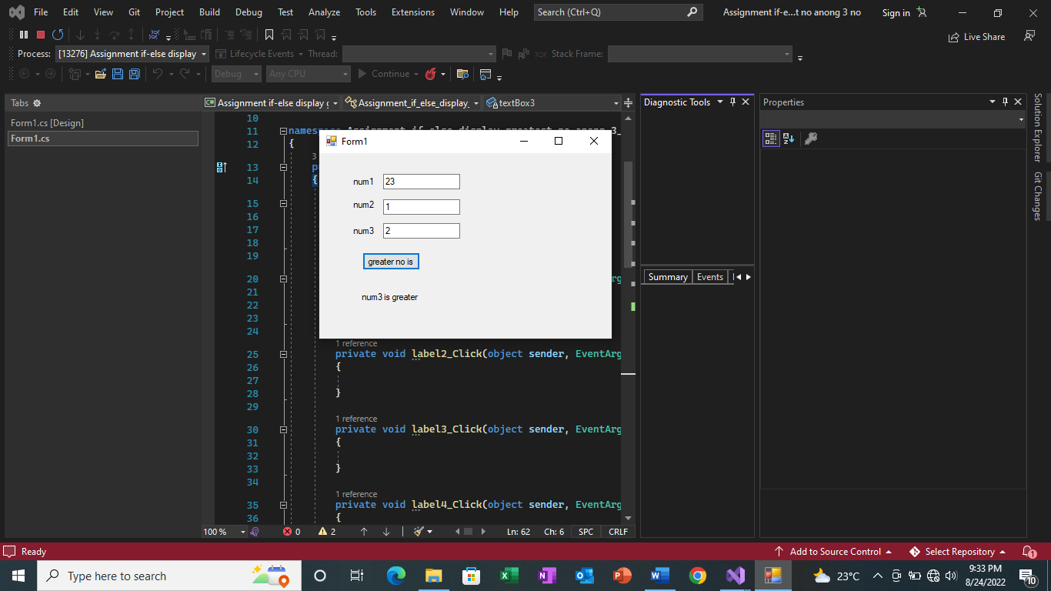

using System;

using System.Collections.Generic;

using System.ComponentModel;

using System.Data;

using System.Drawing;

using System.Linq;

using System.Text;

using System.Threading.Tasks;

using System.Windows.Forms;

namespace Assignment_if_else_display_greatest_no_anong_3_no

{

public partial class Form1 : Form

{

public Form1()

{

InitializeComponent();

}

private void label1_Click(object sender, EventArgs e)

{

}

private void label2_Click(object sender, EventArgs e)

{

}

private void label3_Click(object sender, EventArgs e)

{

}

private void label4_Click(object sender, EventArgs e)

{

}

private void button1_Click(object sender, EventArgs e)

{

int num1 = Convert.ToInt32(textBox1.Text);

int num2 = Convert.ToInt32(textBox2.Text);

int num3 = Convert.ToInt32(textBox3.Text);

int res;

if(num1>num2 && num1>num1 )

{

label4.Text = "num1 is greater";

}

else

if (num2 > num1 && num2 > num3)

{

label4.Text = "num2 is greater";

}

else

{

label4.Text = "num3 is greater";

}

}

}

}