Lab Assignment 2 - Backend

Kaelyn James
Centennial College
Web Application Development (COMP229)
Professor Blessing Ajiboye
2 November 2026
Lab Assignment 2 - Backend
GitHub repository link: https://github.com/Kae-James/COMP229_Assignment2
Part 1
- Configure the Backend of your portfolio Application.
  - Configuring the backend and frontend of your application or week6 final zip folder in your course shell, make a copy of the folder.
  - Copy the client folder and replace it with the client folder in the new MyPortfolio folder in Assignment2.
NOTE1: You will have to delete the client folder in the MyPortfolio folder before pasting to avoid duplication.
NOTE2: At the terminal change the directory to client folder run the application by running the command yarn dev or npm run dev.
NOTE3: I used npm instead of yarn throughout the assignment.
You will notice only the Frontend is running on port 5173. http://localhost:5173/

Frontend:
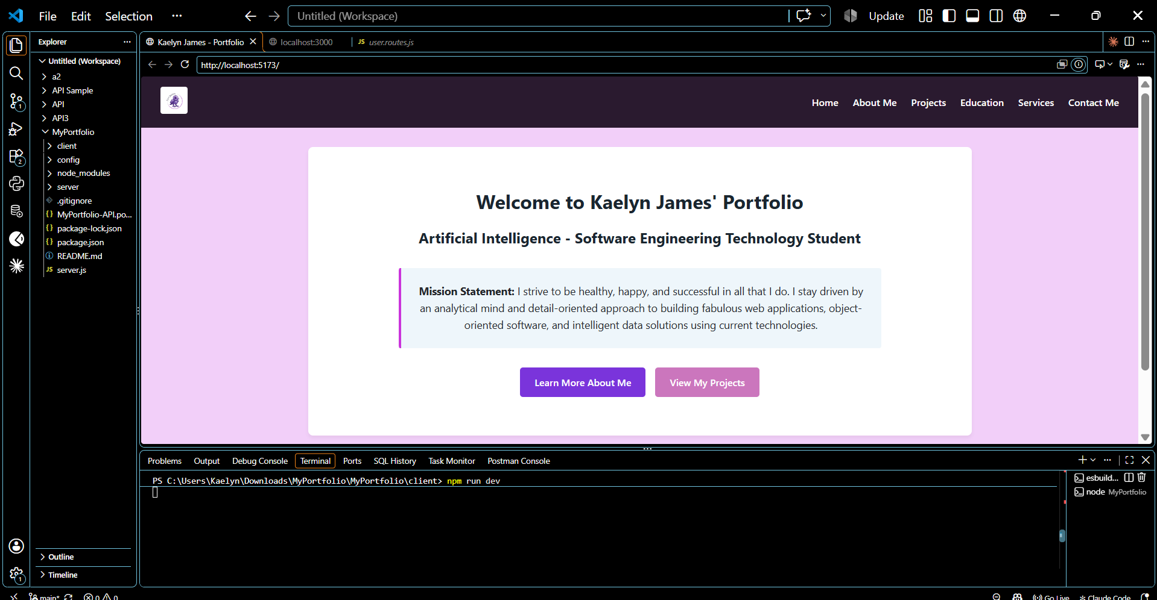
Backend:
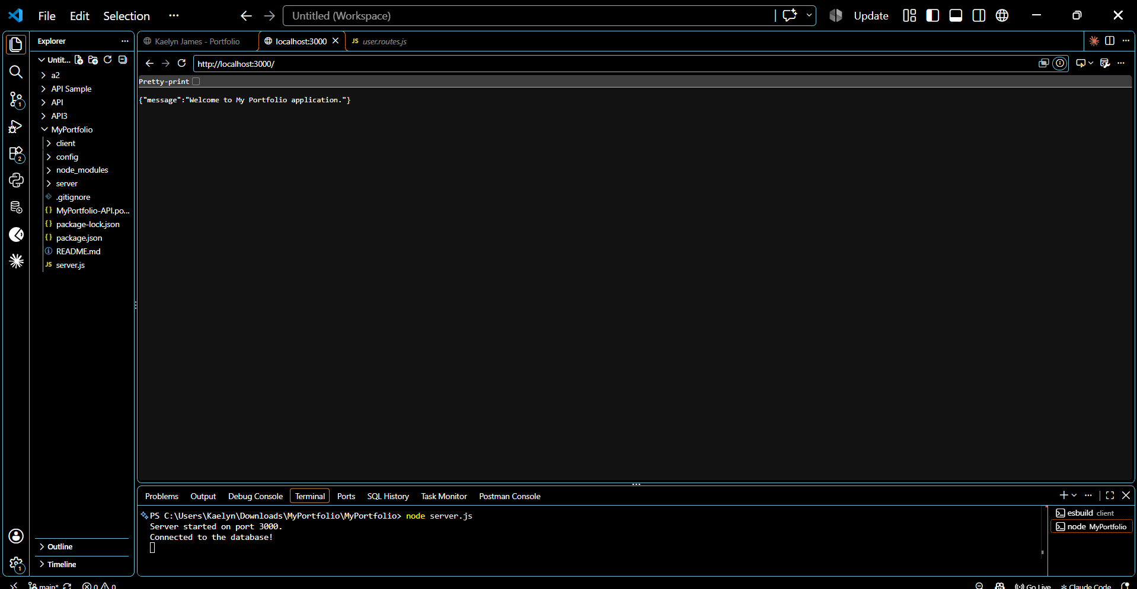
  - Stop the server from running and also stop the frontend from running.
  - To ensure the frontend and Backend run concurrently open a new terminal.
  - At the terminal change the directory to client folder and install nodemon and concurrently to be able to run it concurrently at the same time.
npm install --save-dev nodemon concurrently
Frontend and backend running concurrently:
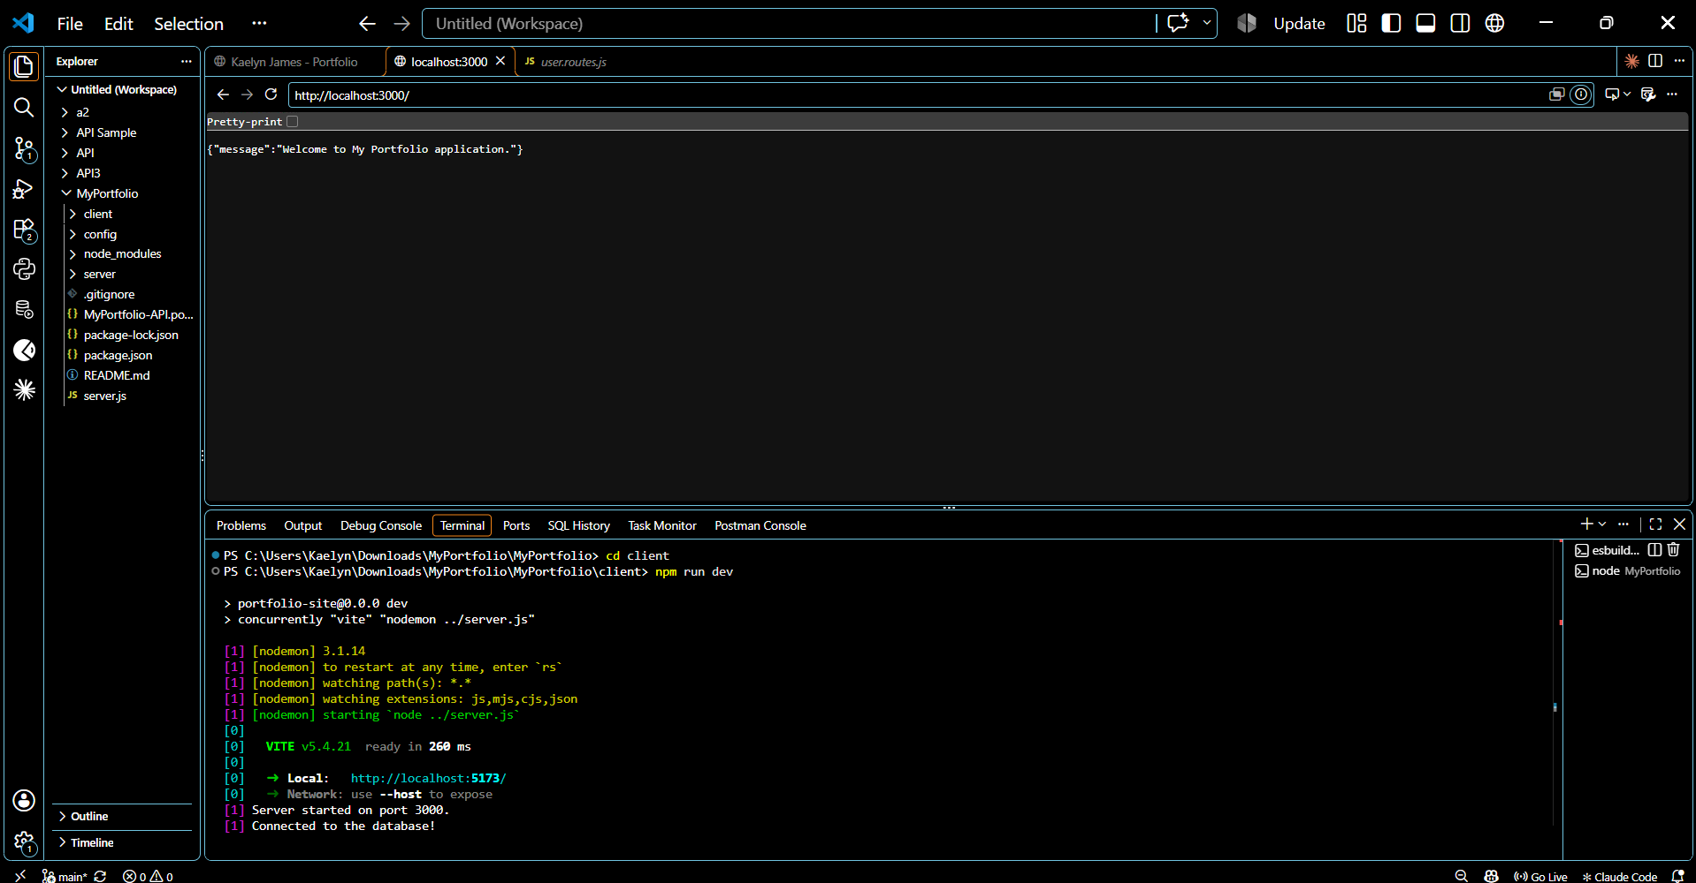
  - Open the package.json in the client in the scripts section update "dev": "vite" with "dev": "concurrently \"vite\" \"nodemon ../server.js\""
  - Open a new terminal, cd client, then run npm run dev
Part II
- Using MongoDB database, create:(25 Marks):
  - A database by name Portfolio.
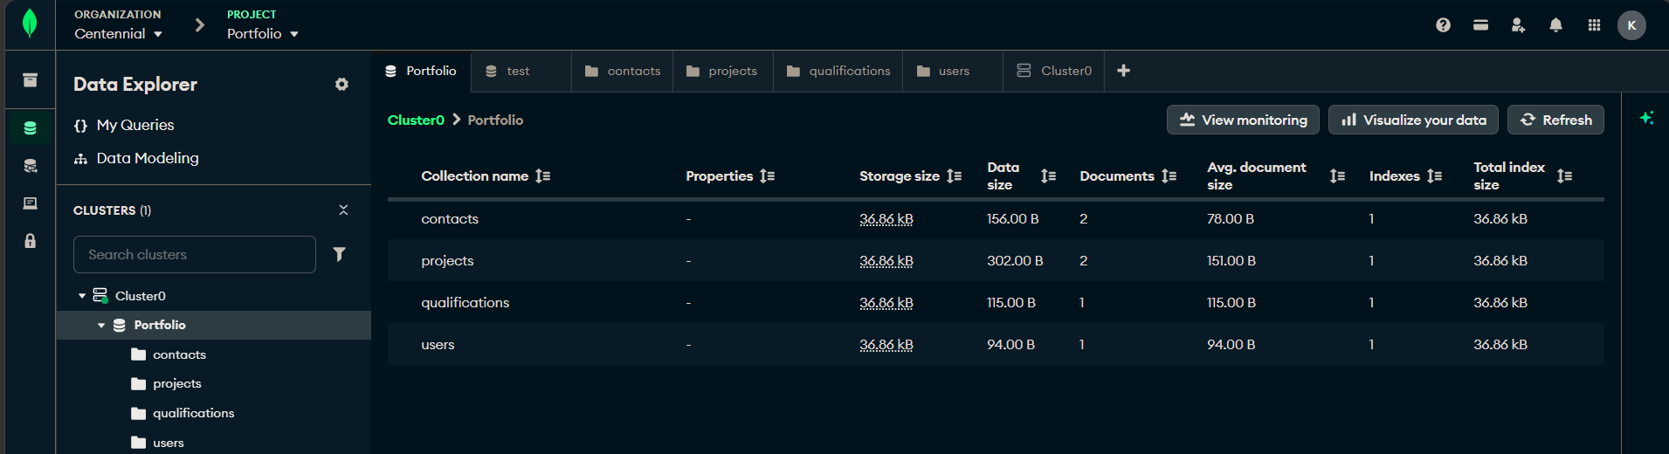
  - Create the following collections with their respective property. (5 Marks: Functionality).
- contacts
firstname: string
lastname: string
email: string
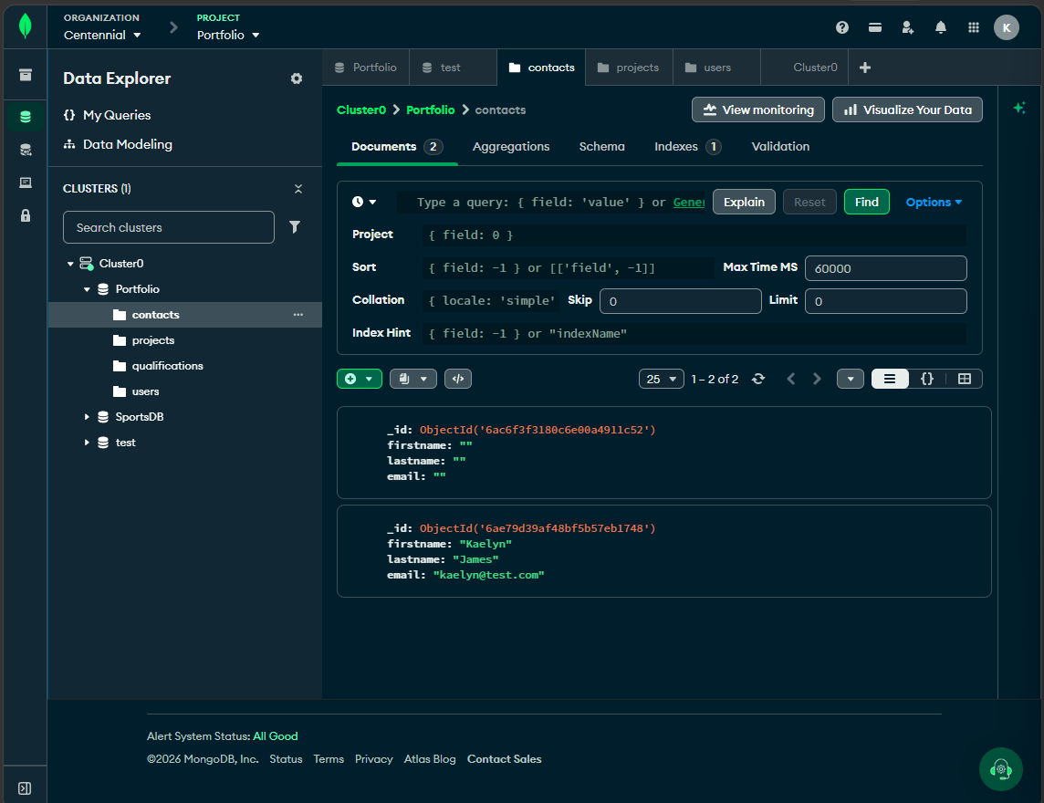
- projects
title: string
firstname: string
lastname: string
email: string
completion: Date
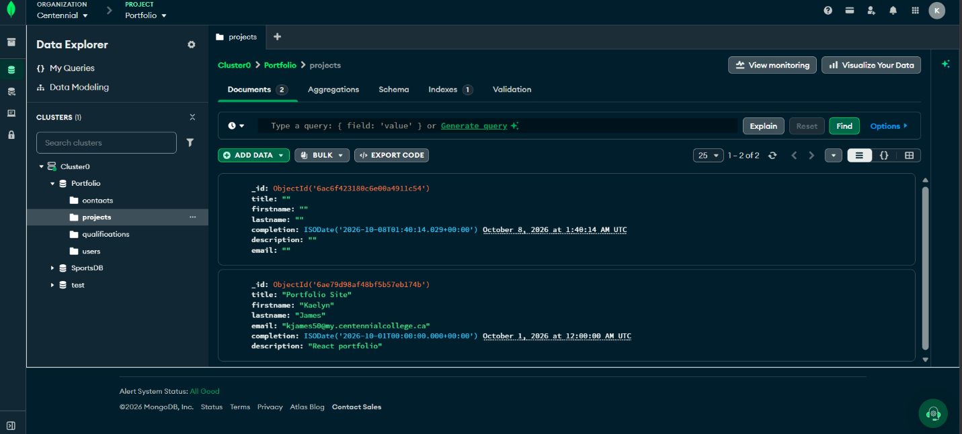
description: string

- qualifications
title: string
firstname: string
lastname: string
email: string
completion: Date
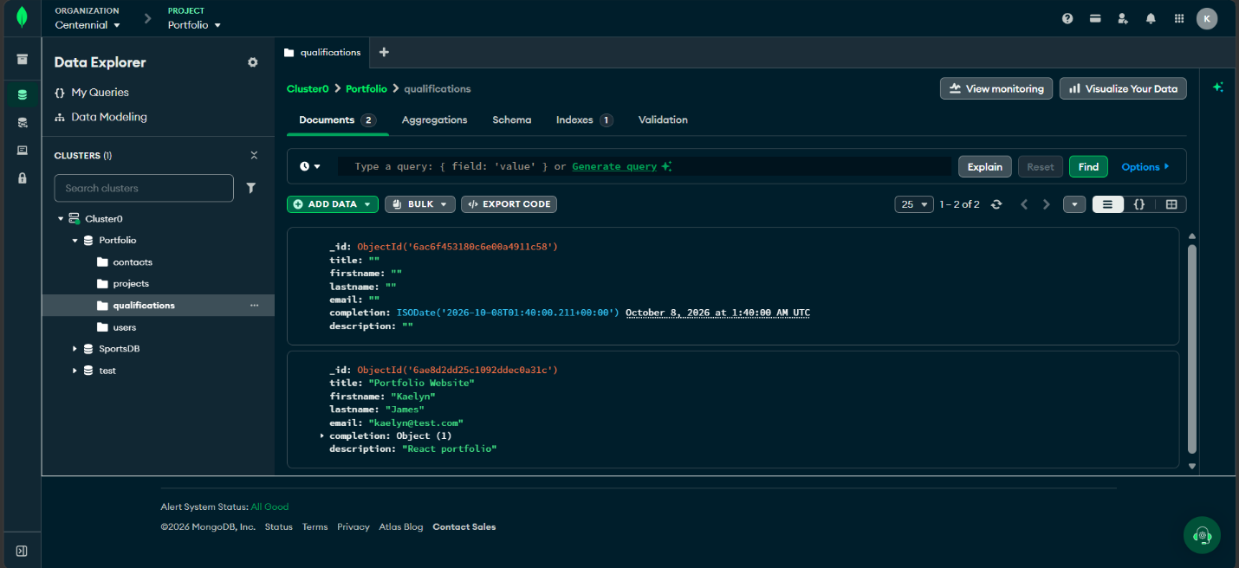
description: string

- users
name: string
email: string
password: string
created: Date
updated: Date
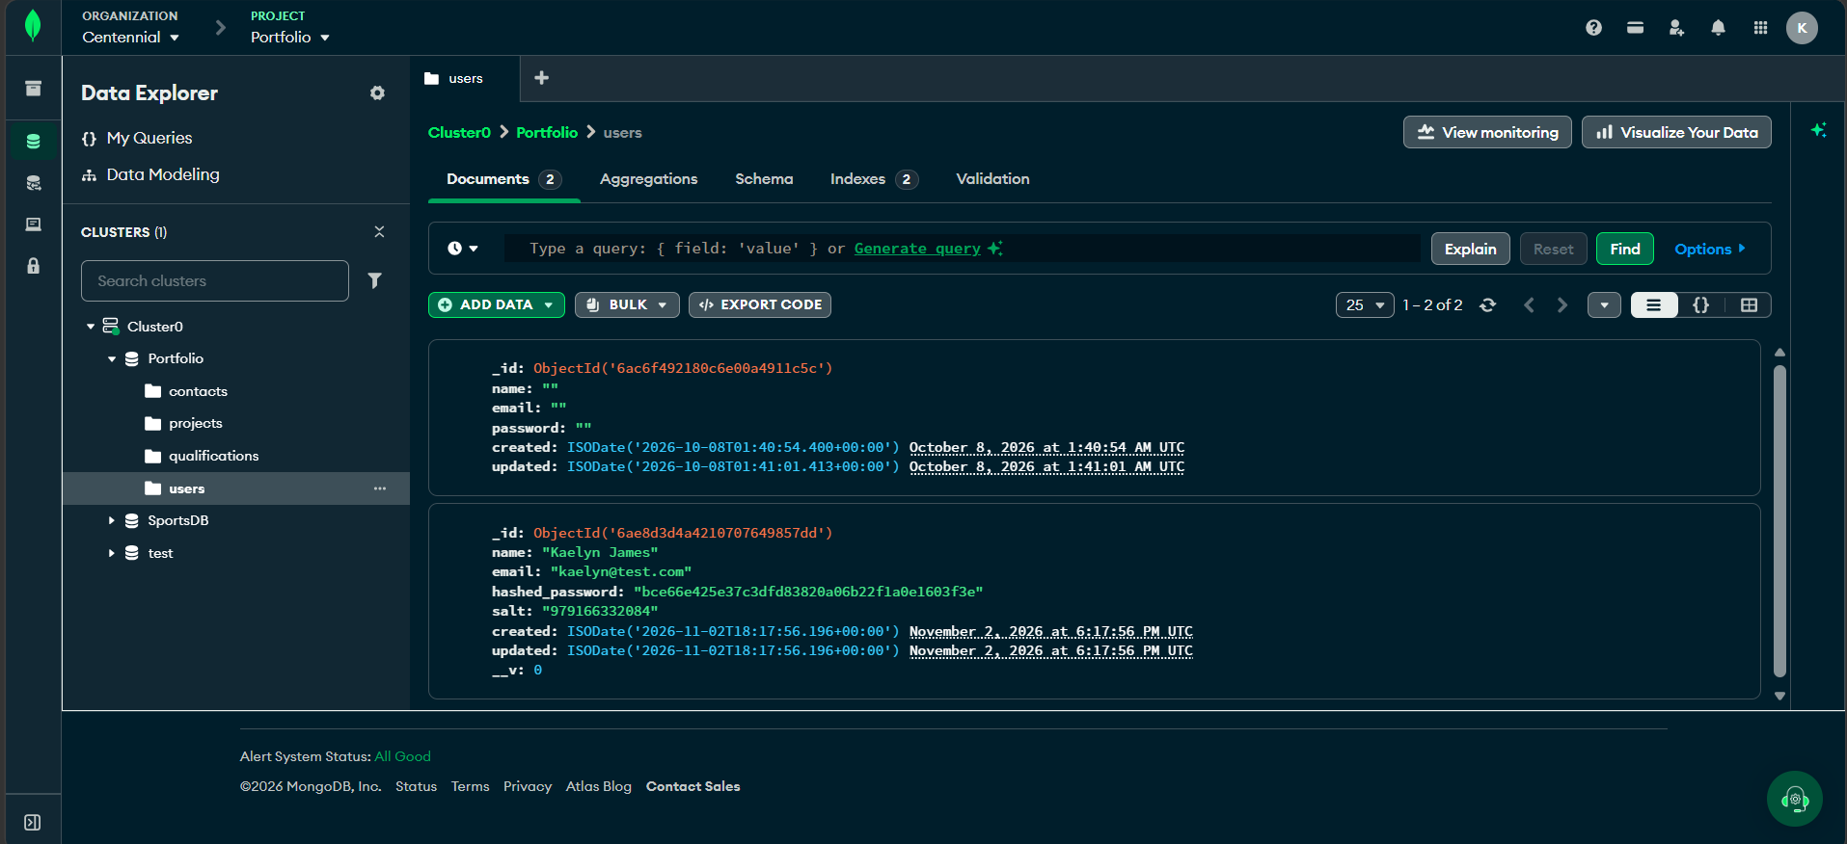
Any password is saved as hashed_password and salt.
  - Obtain your connection string ( url or uri)
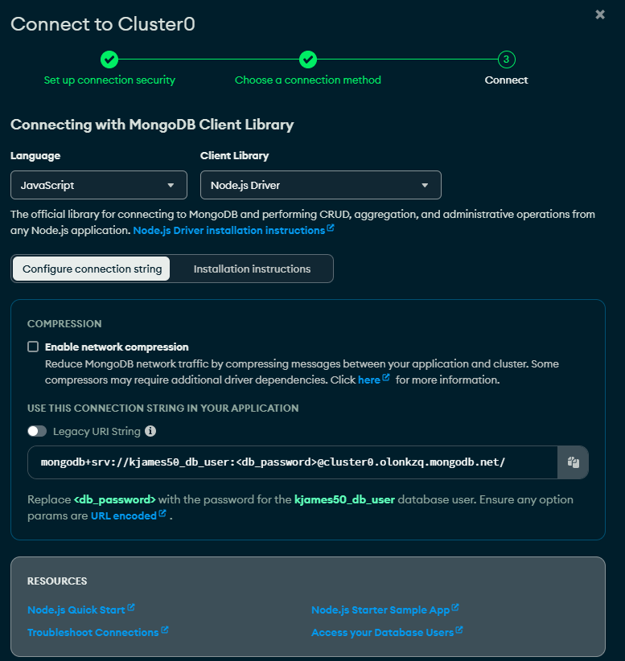
  - Provide the screen snapshot of your MongoDB database showing the above steps from 1a – c.
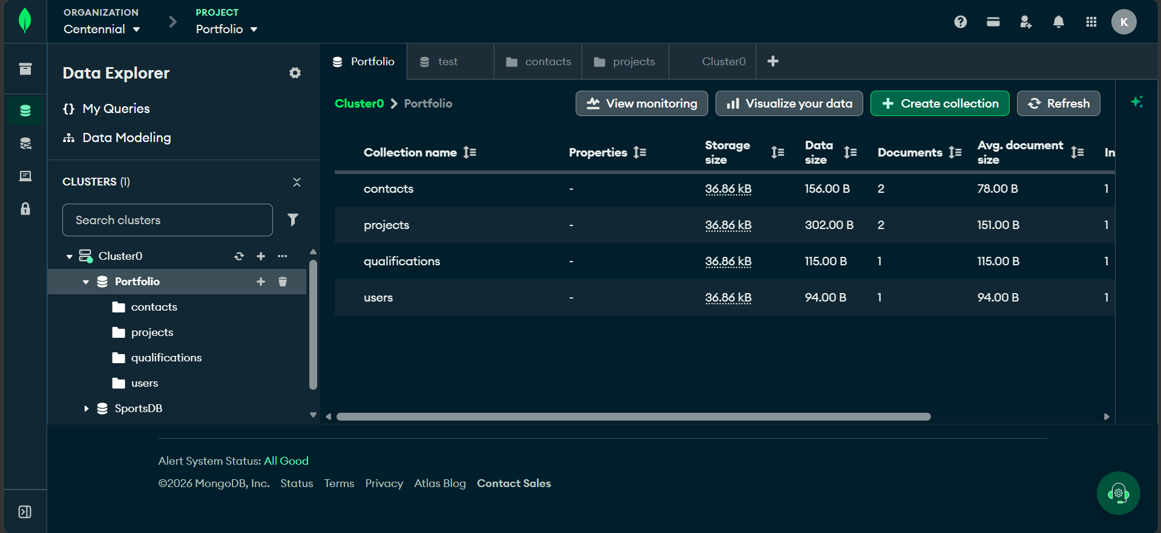
- Configure the Backend of your portfolio Application by creating the server.js file in the root folder for your server and a server folder or backend folder in the root folder for all your backend code.
  - Update the server.js file i.e the server with code to display the message shown in the snapshot below when you run the app and provide a screen snapshot of it running in the browser.
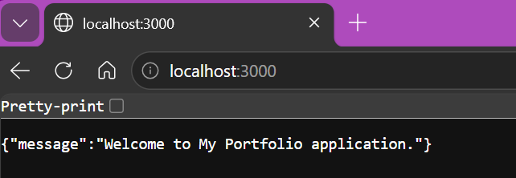
- Create the web server after creating the Express web server next: (30 Marks)
  - Add the configuration for the MongoDB database, ensure your application is connected to the database and give the screen snapshot of the connection from your console.
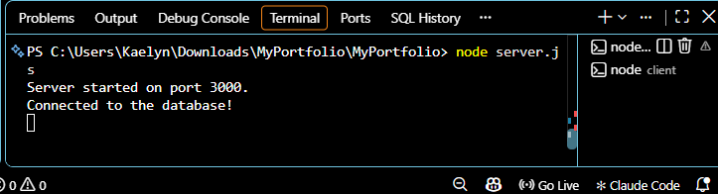
  - Create contact, education, project and user model with Mongoose.
Models are in the folder server/models (contact, project, qualification, and user).
Example - project.model.js:
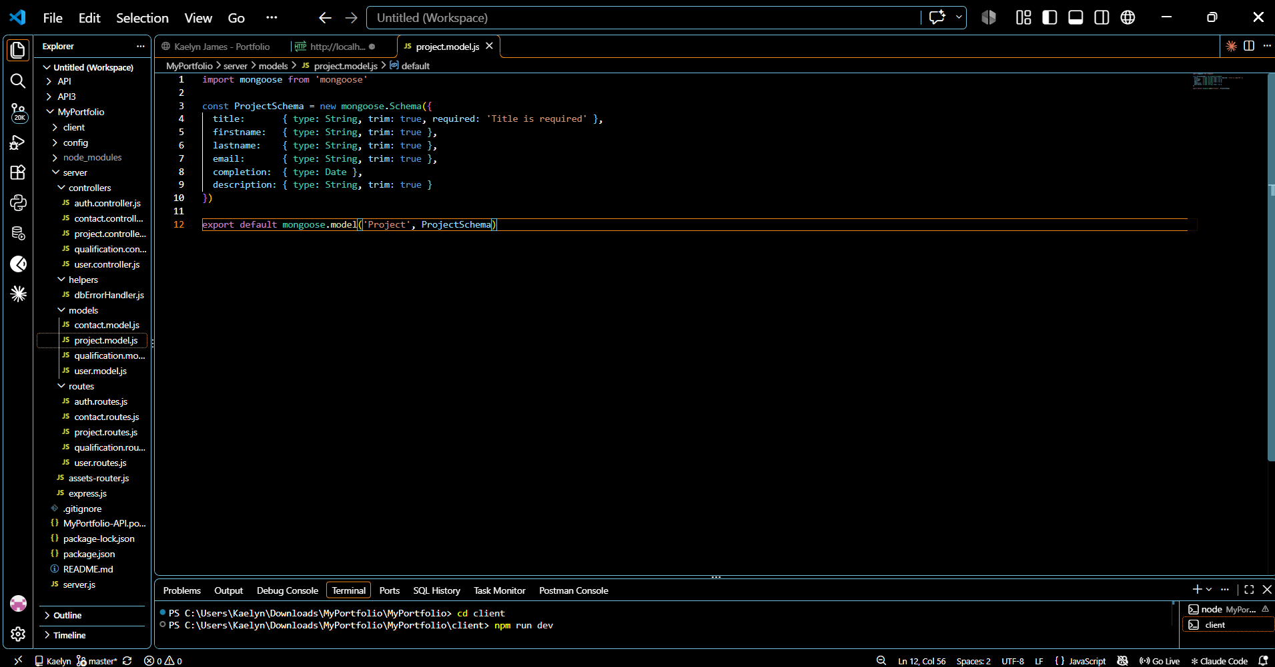

Part III
  - Write the controller for contact, education, project and user.
Controllers are in the folder server/controllers (contact, project, qualification, user, and auth).
Example - qualification.controller.js:
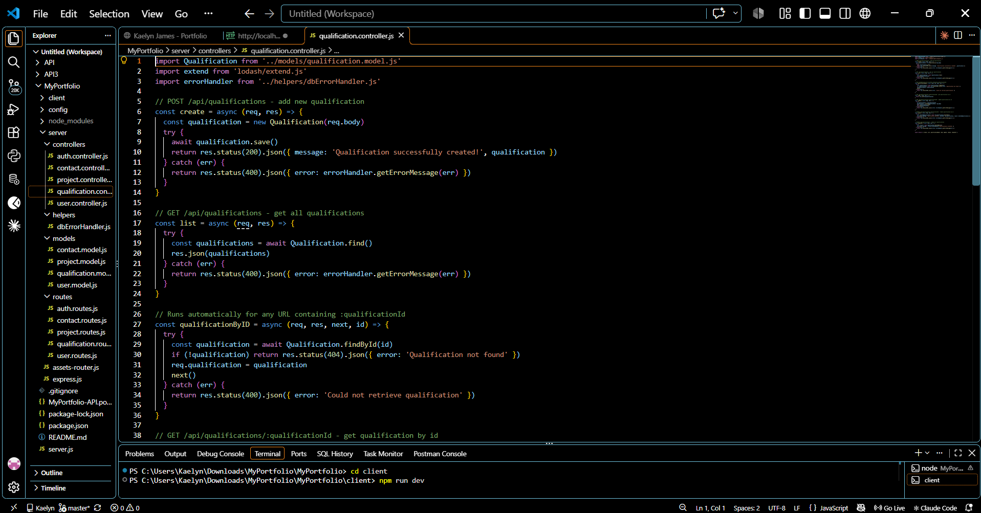
  - Define the routes for handling all CRUD operations for the contact, education, project and users api.
Routes are in the folder server/routes (contact, project, qualification, user, and auth).
Example - contact.routes.js:
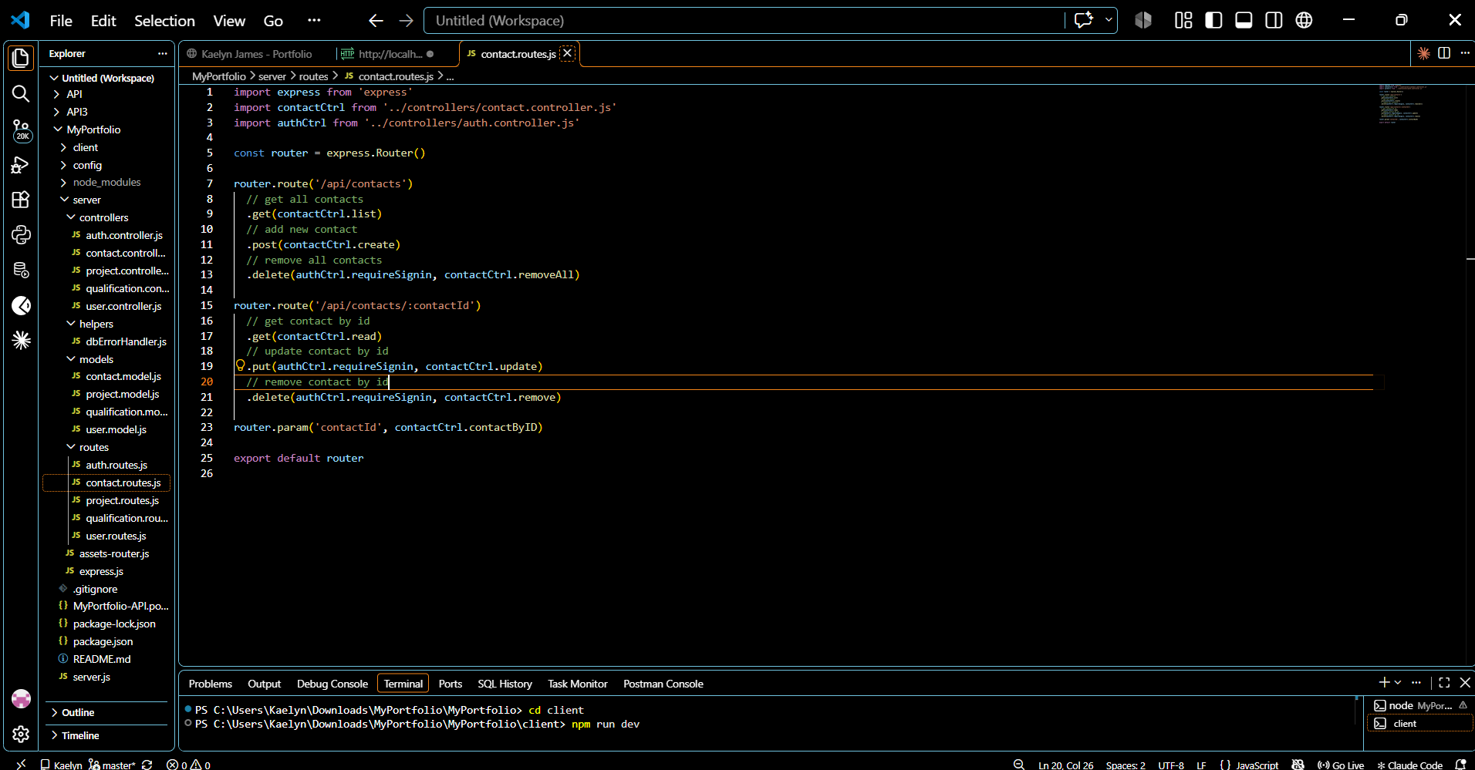

Below is an overview of the REST APIs that will be exported:
contacts
The fields are as follows:

Field Data type
firstname string
lastname string
email string

Methods | Urls | Actions
GET | api/contacts | get all contacts
GET | api/contacts/:id | get contacts by id
POST | api/contacts | add new contact
PUT | api/contacts/:id | update contact by id
DELETE | api/contacts/:id | remove contact by id
DELETE | api/contacts | remove all contacts

projects
The fields are as follows:
Field Data type
title string
firstname string
lastname string
email string
completion Date
description string

Methods | Urls | Actions
GET | api/projects | get all projects
GET | api/projects/:id | get projects by id
POST | api/projects | add new project
PUT | api/projects/:id | update project by id
DELETE | api/projects/:id | remove project by id
DELETE | api/projects | remove all projects

qualifications
The fields are as follows:
Field Data type
title string
firstname string
lastname string
email string
completion Date
description string
Methods | Urls | Actions
GET | api/qualifications | get all qualifications
GET | api/qualifications/:id | get qualifications by id
POST | api/qualifications | add new qualification
PUT | api/qualifications/:id | update qualification by id
DELETE | api/qualifications/:id | remove qualification by id
DELETE | api/qualifications | remove all qualifications

users
The fields are as follows:
Field Data type
name string
email string
password string
created Date
updated Date

Methods | Urls | Actions
GET | api/users | get all users
GET | api/users/:id | get users by id
POST | api/users | add new user
PUT | api/users/:id | update user by id
DELETE | api/users/:id | remove user by id
DELETE | api/users | remove all users

- a) Test the REST APIs above using Postman, Thunder client or any tool you are familiar with. e.t.c.
b) Provide the screen snapshot of the test. (20 Marks)
Users and sign-in:
- POST http://localhost:3000/api/users
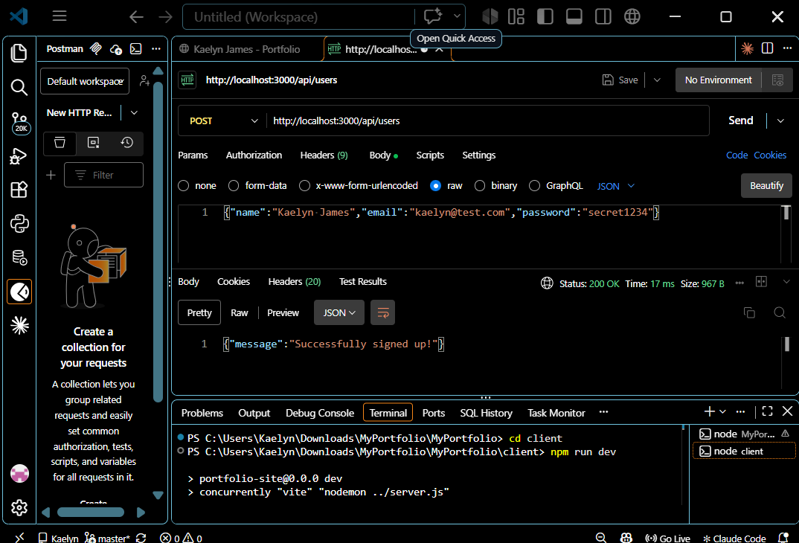
- POST http://localhost:3000/api/users
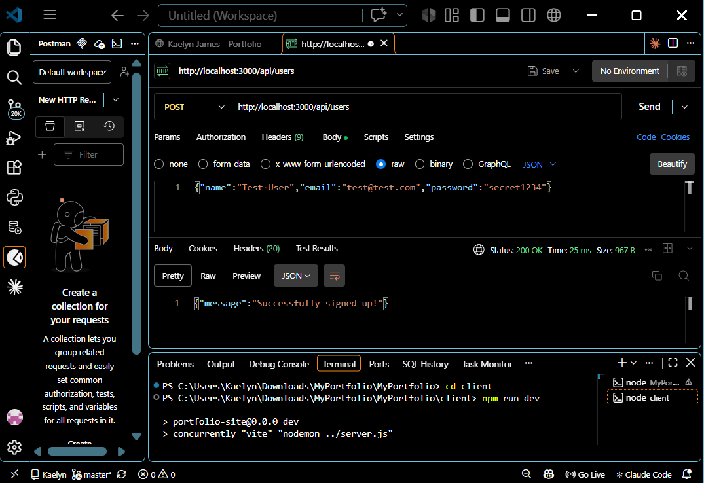
- GET http://localhost:3000/api/users
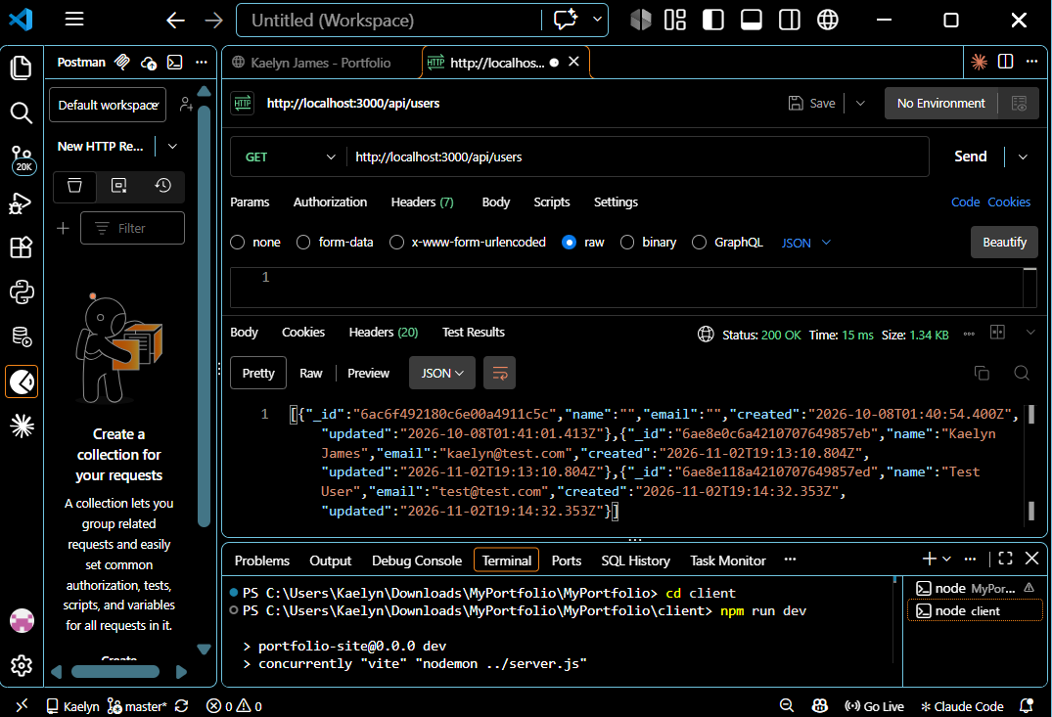
- GET http://localhost:3000/api/users/:id
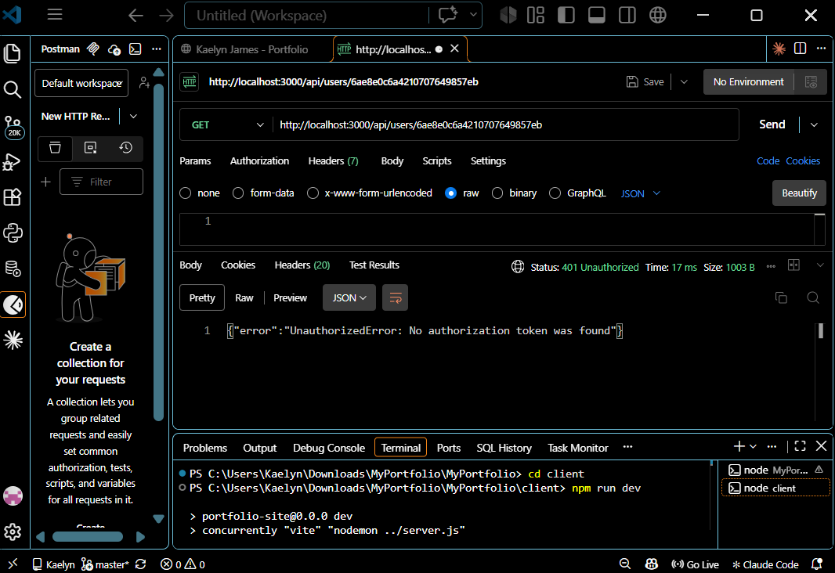
- POST http://localhost:3000/auth/signin
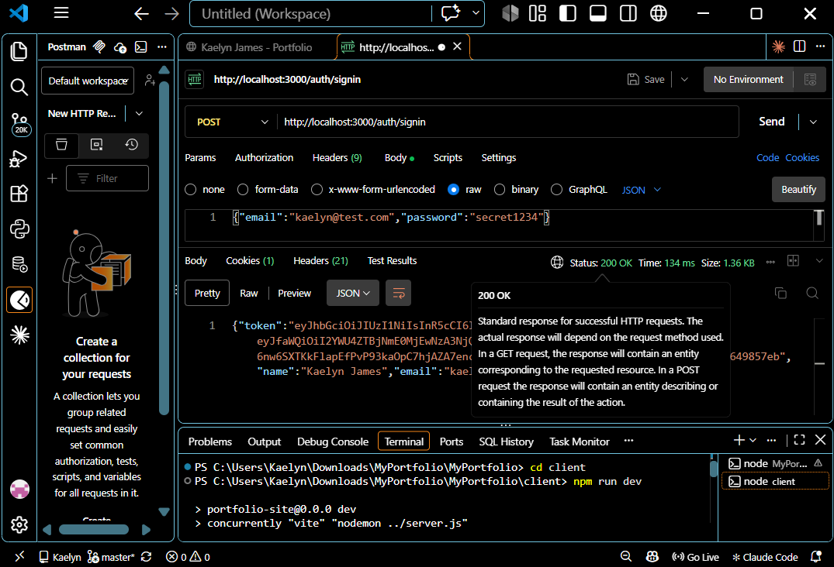
- GET http://localhost:3000/api/users/:id
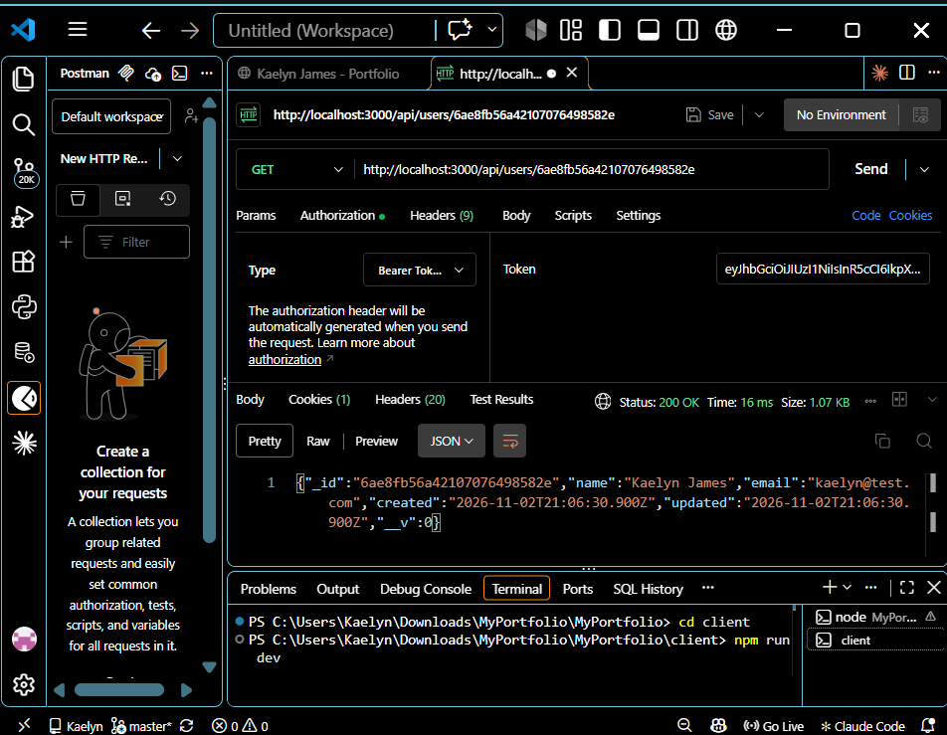
- PUT http://localhost:3000/api/users/:id
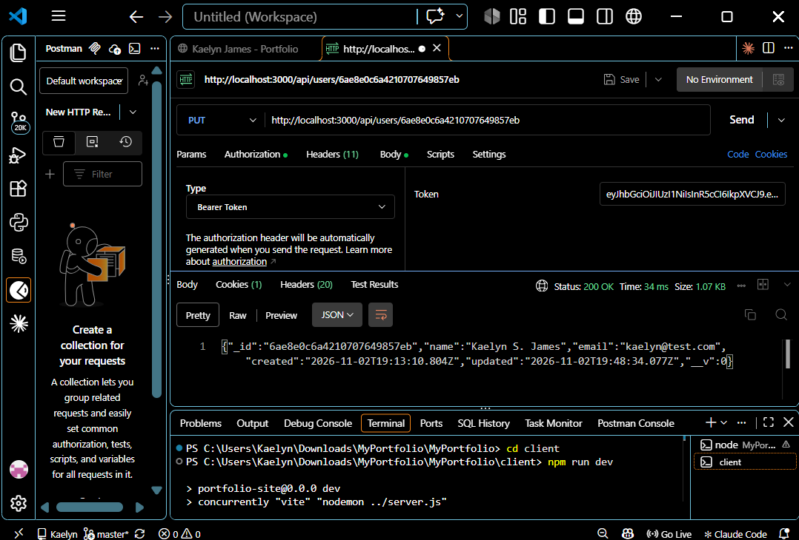
- PUT http://localhost:3000/api/users/:id
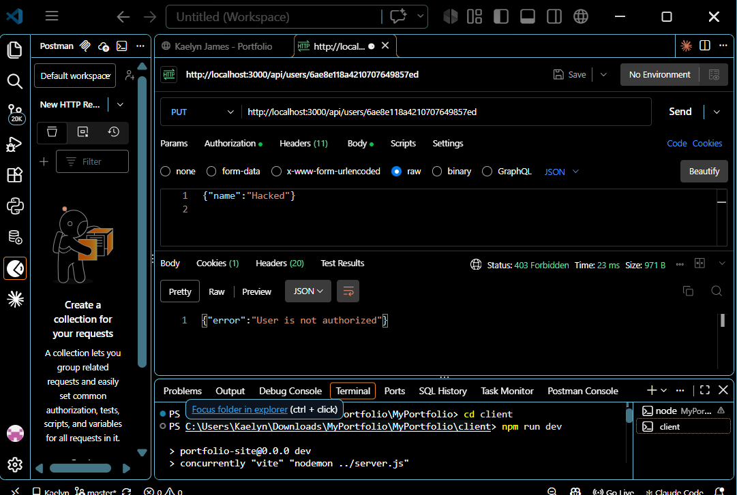

Contacts:
- POST http://localhost:3000/api/contacts
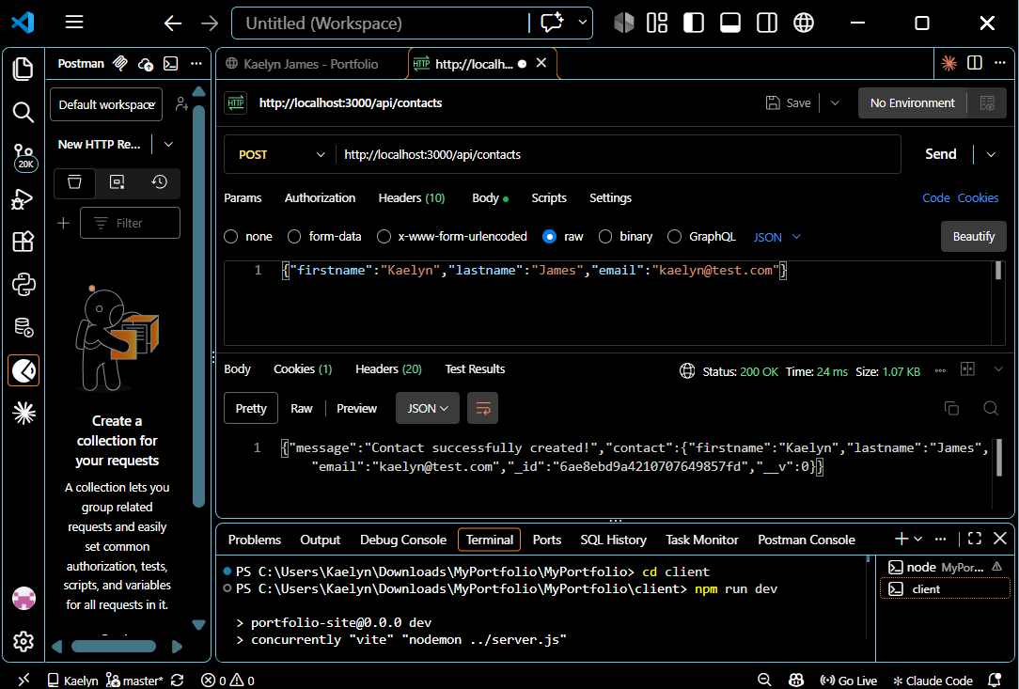
- GET http://localhost:3000/api/contacts
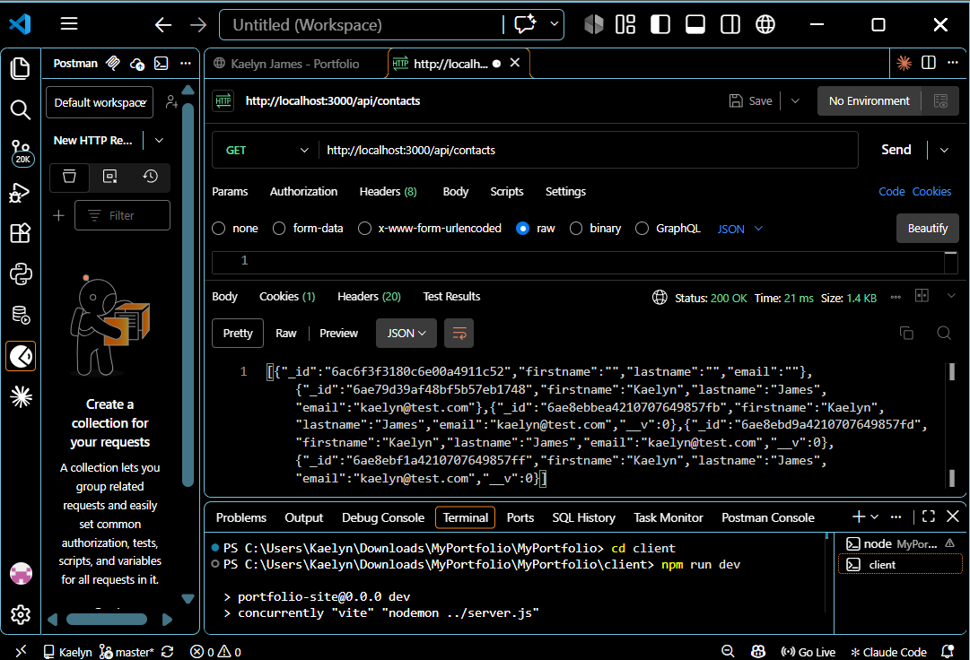
- GET http://localhost:3000/api/contacts/:id
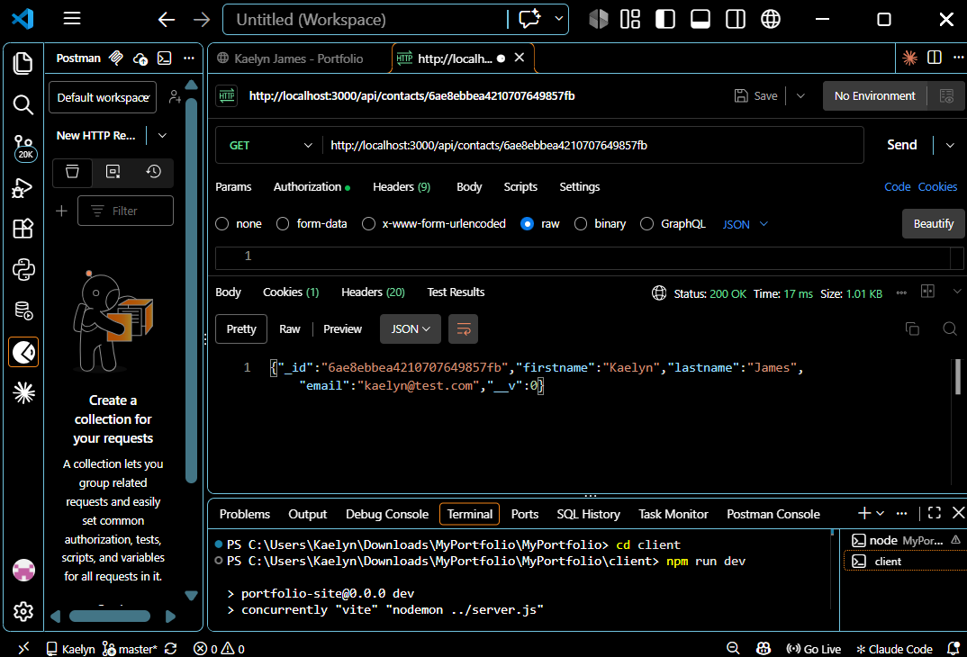
- PUT http://localhost:3000/api/contacts/:id
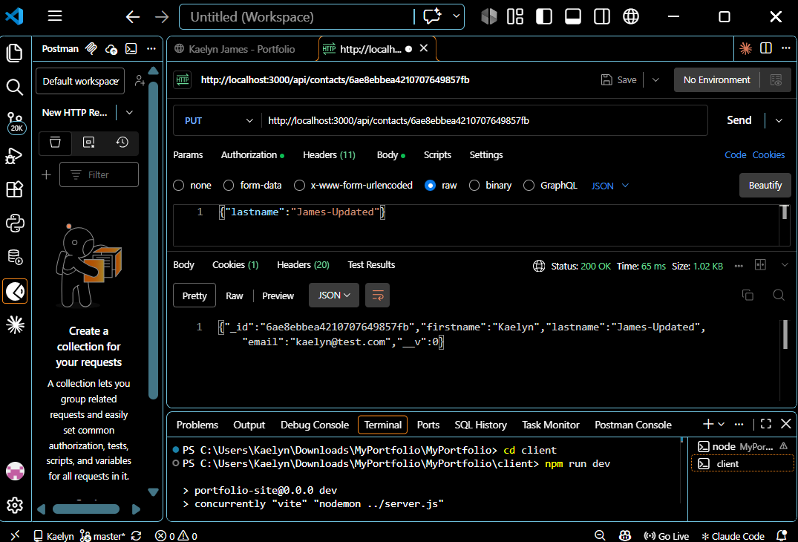
- DELETE http://localhost:3000/api/contacts/:id
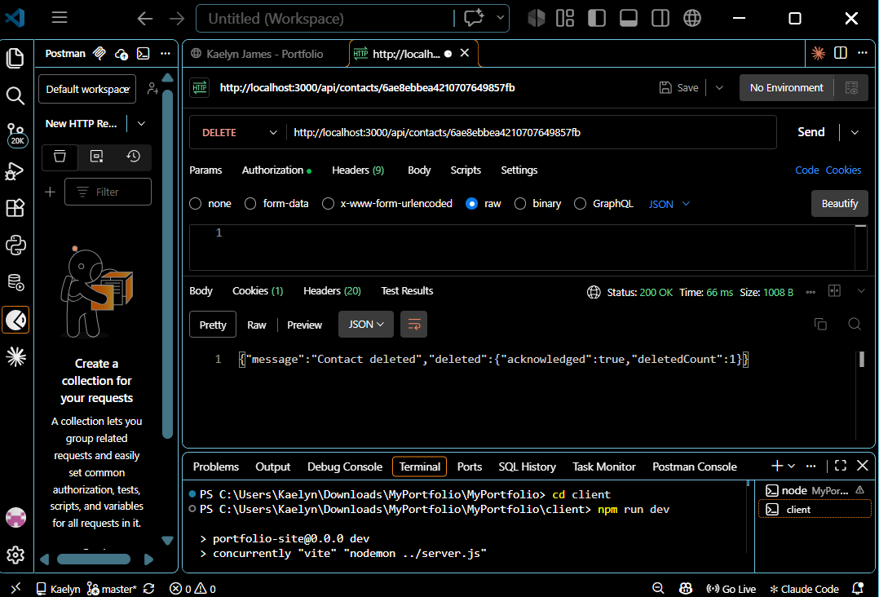
- DELETE http://localhost:3000/api/contacts
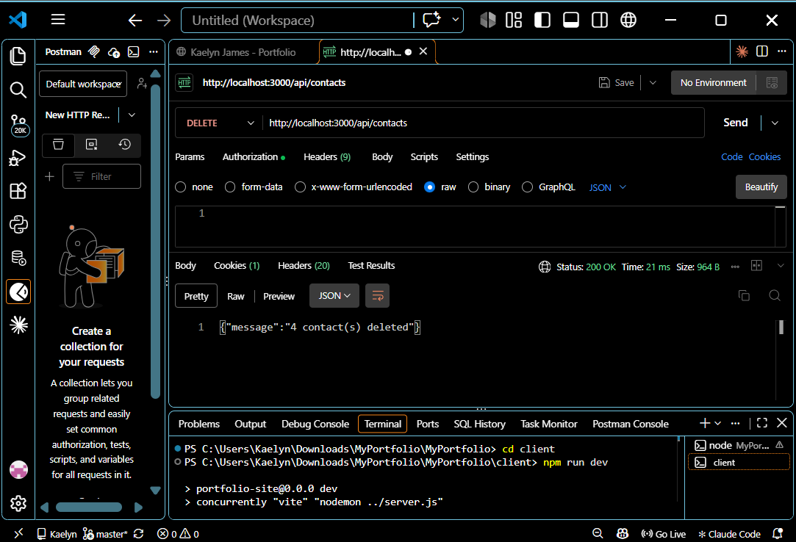
Projects:
- POST http://localhost:3000/api/projects
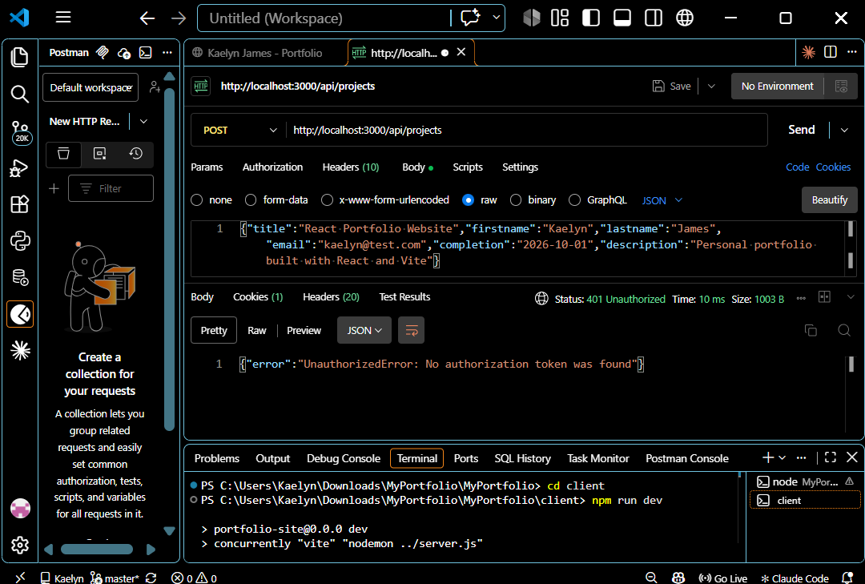
- POST http://localhost:3000/api/projects
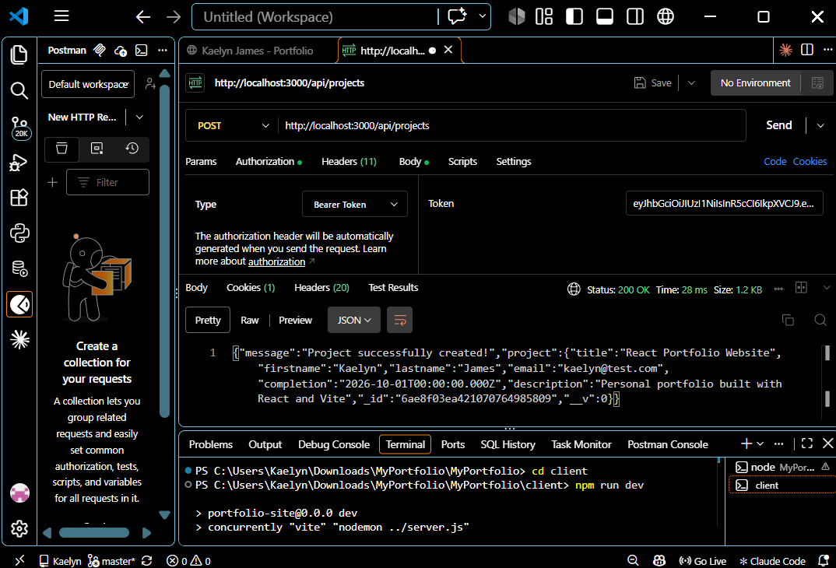
- GET http://localhost:3000/api/projects
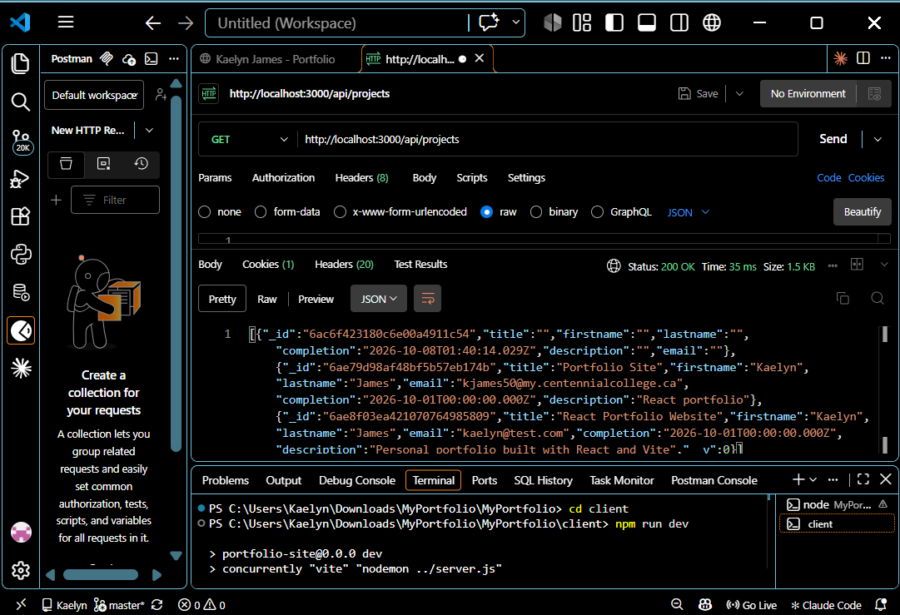
- GET http://localhost:3000/api/projects/:id
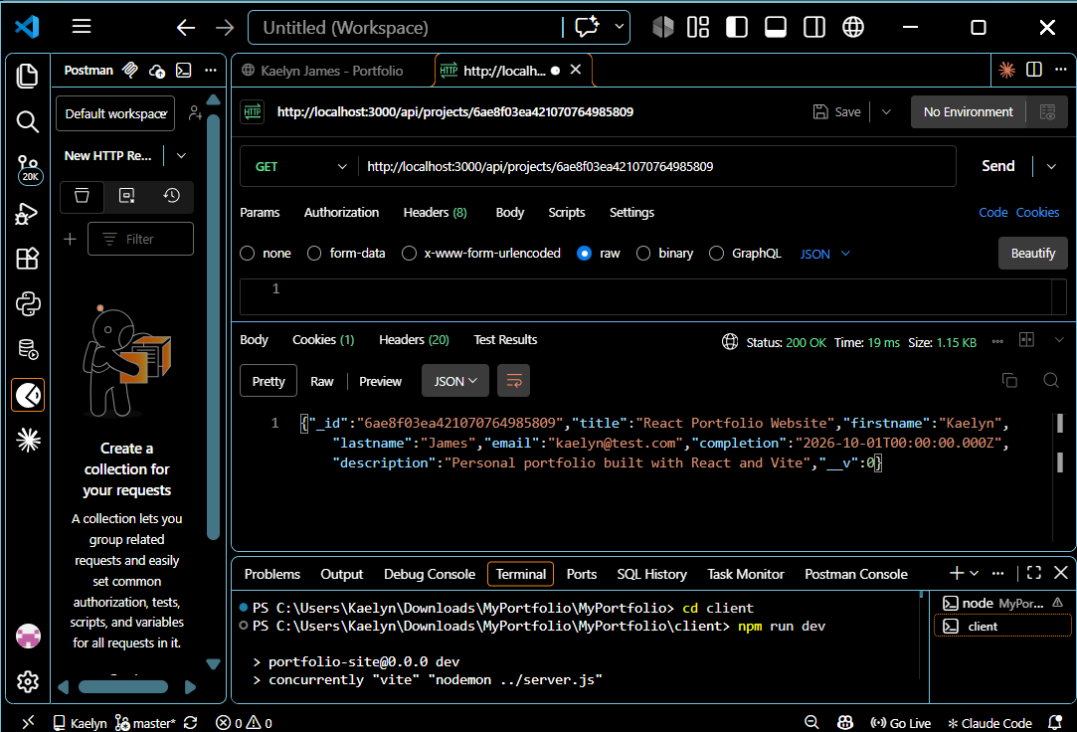
- PUT http://localhost:3000/api/projects/:id
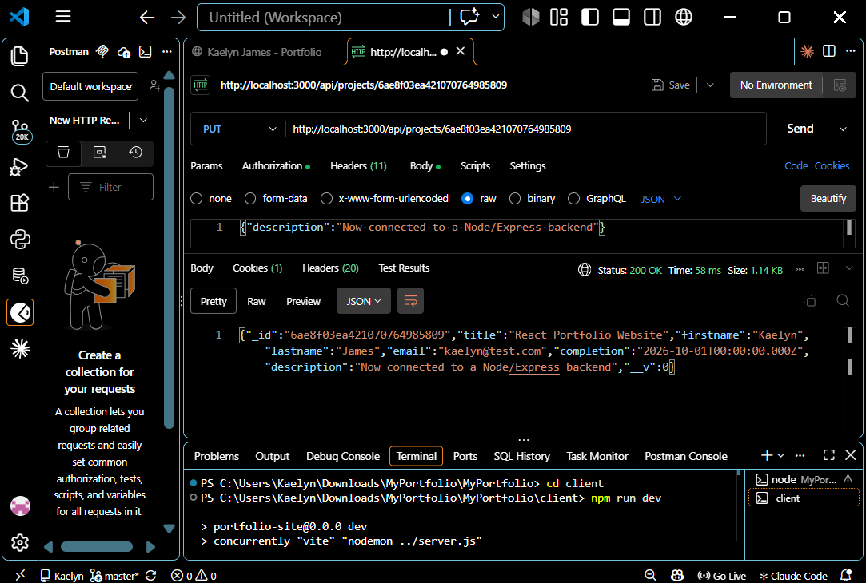
- DELETE http://localhost:3000/api/projects/:id
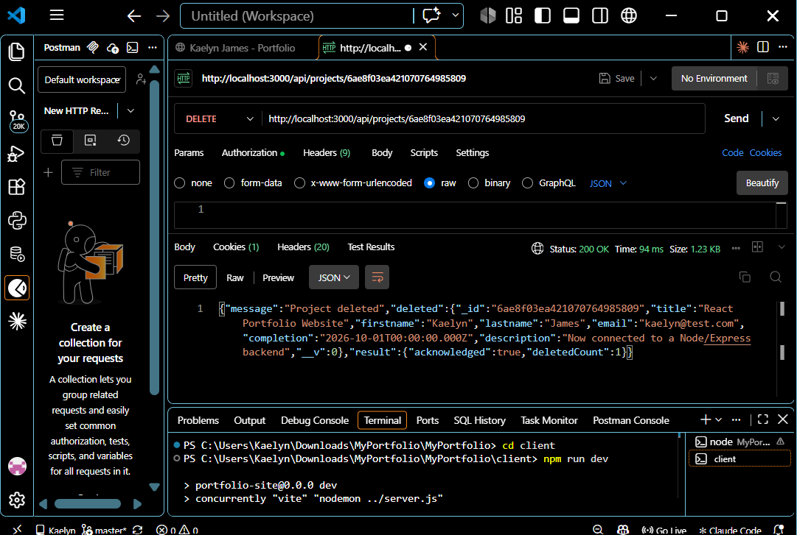
- DELETE http://localhost:3000/api/projects
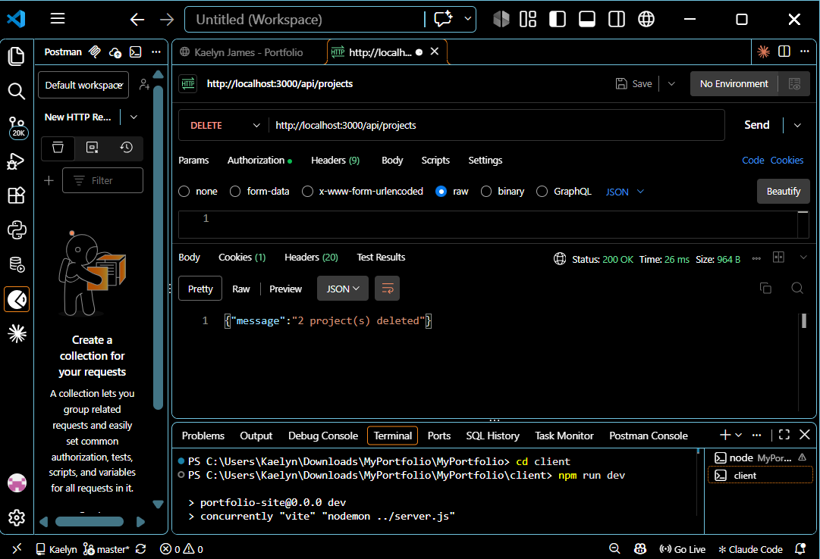

Qualifications:
- POST http://localhost:3000/api/qualifications
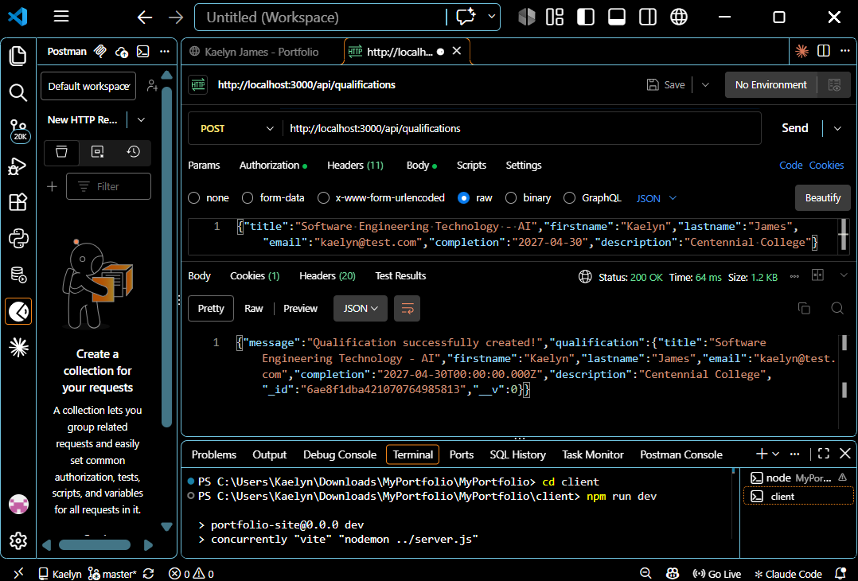
- GET http://localhost:3000/api/qualifications
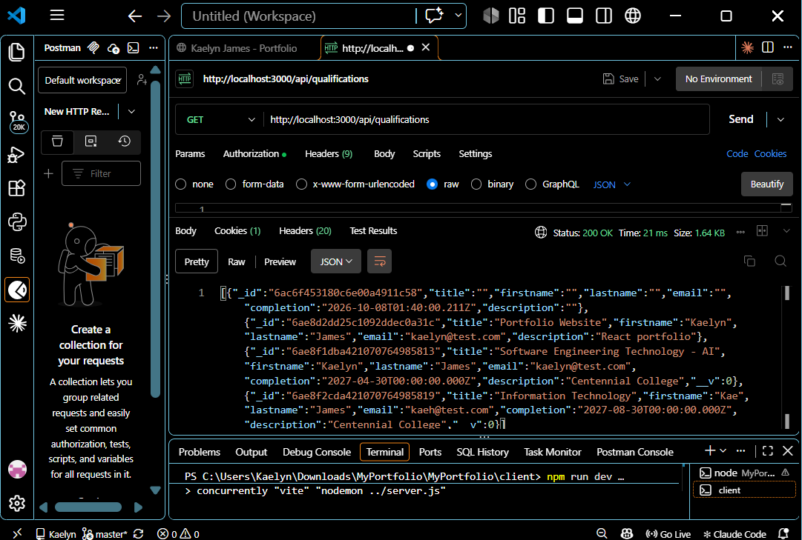
- GET http://localhost:3000/api/qualifications/:id
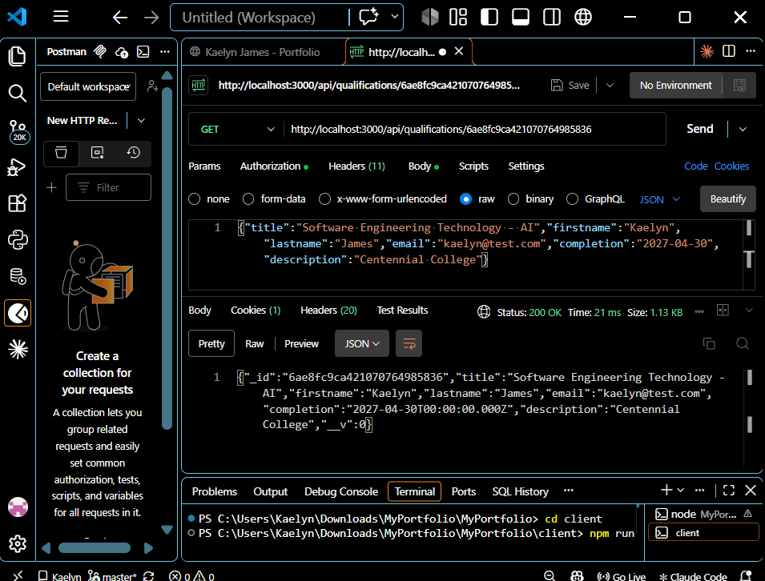
- PUT http://localhost:3000/api/qualifications/:id
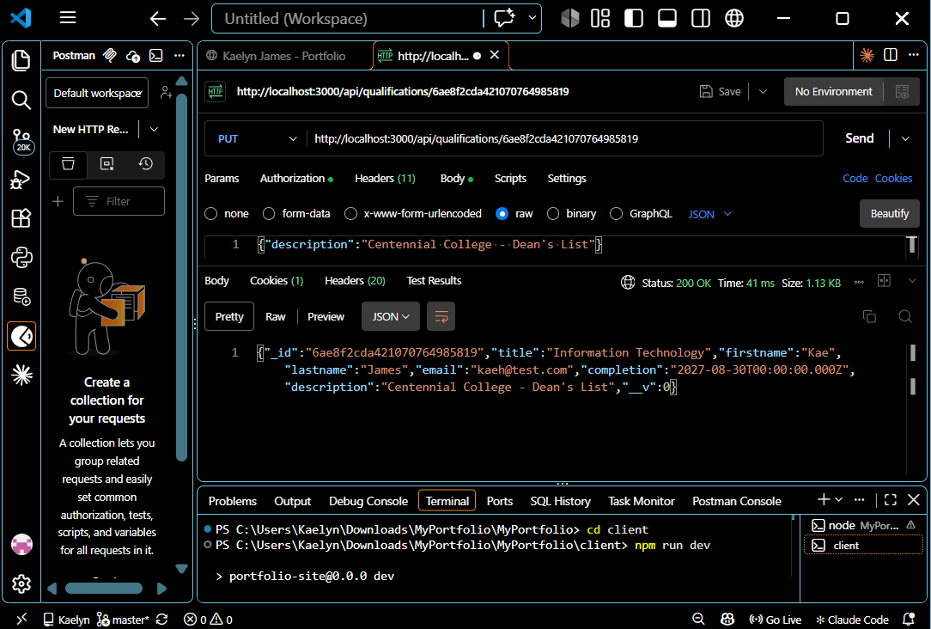
- DELETE http://localhost:3000/api/qualifications/:id
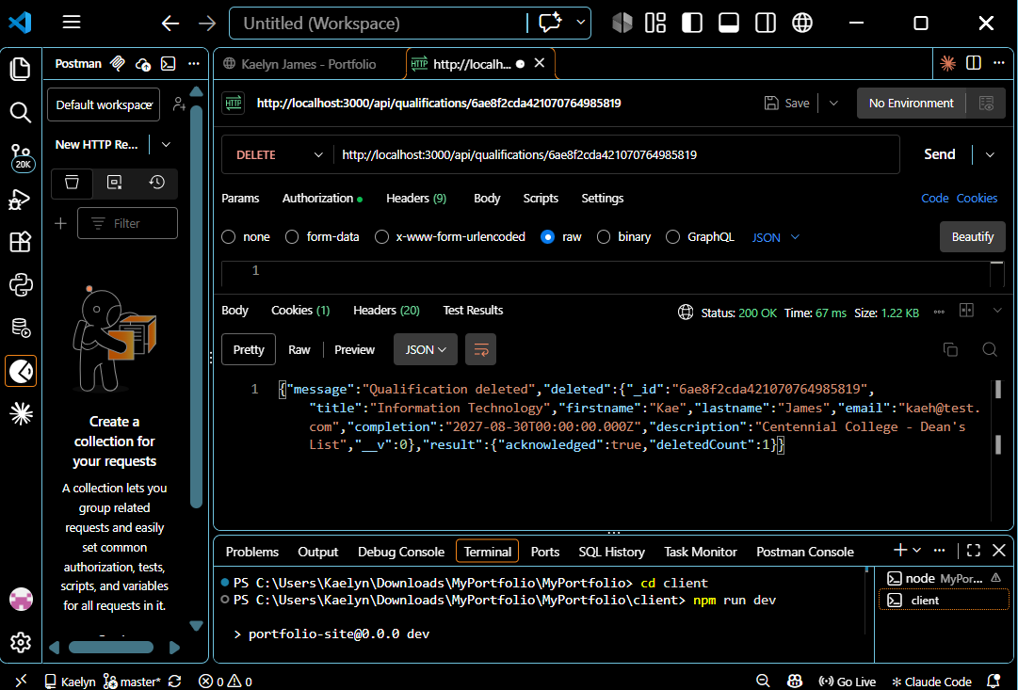

- DELETE http://localhost:3000/api/qualifications
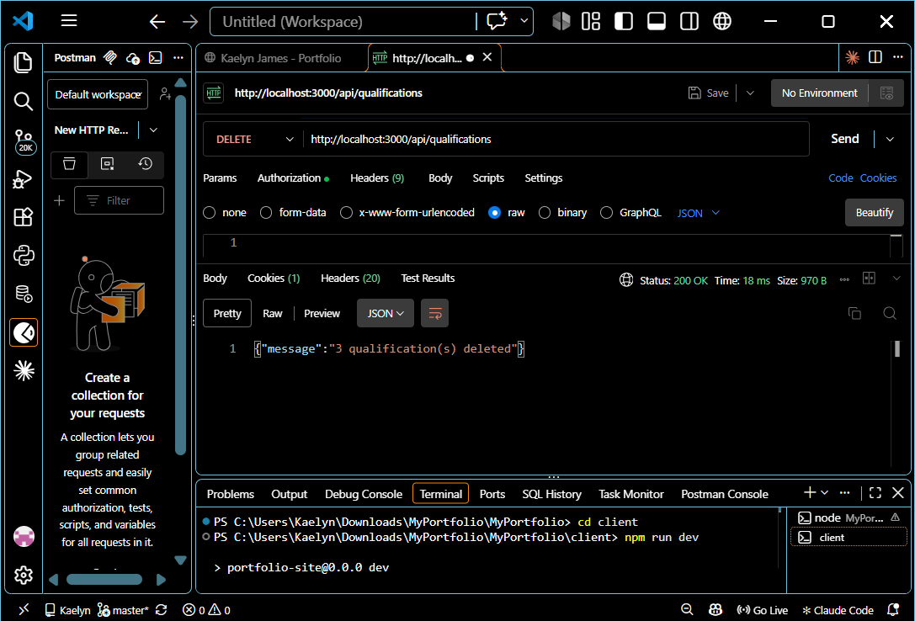

User deletes/sign-out:
- DELETE http://localhost:3000/api/users/:id
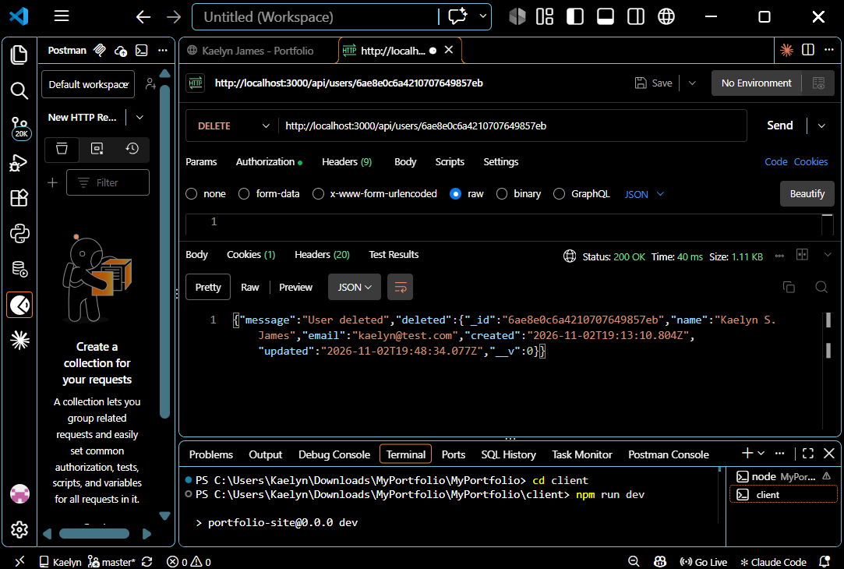
- DELETE http://localhost:3000/api/users
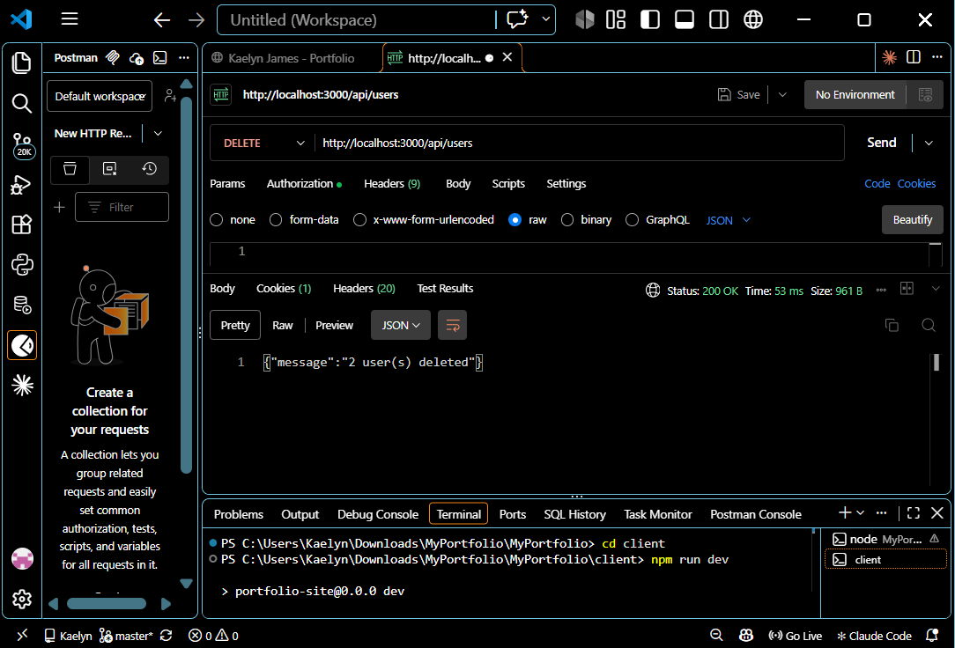
- GET http://localhost:3000/auth/signout
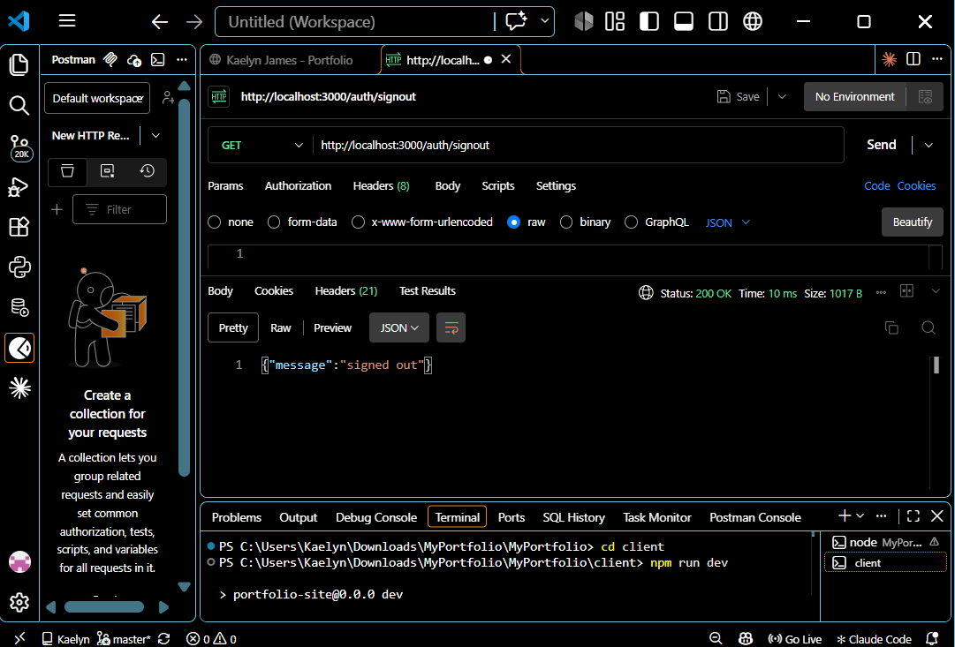

Part IV – Authentication Backend code
- a) use week6 slide – Authentication.ppt to complete the backend authentication code
- b) Create the route, corresponding controller function and authentication backend code for user to sign in and sign out using JWT token.
Example - auth.controller.js:
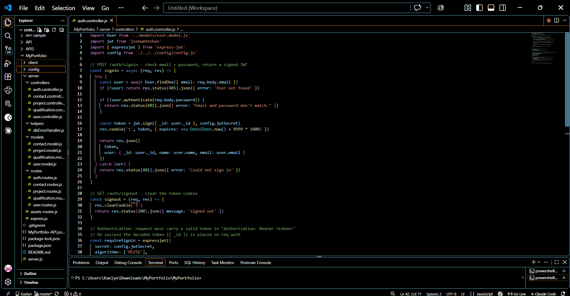
c) create protected routes. etc. (10 Marks)
See tests above:
#4 - 401 without token
#5 - sign-in returning a JWT
#6 - access with Bearer token
#8 - 403 when editing another user
#15 – 401 when creating a project without a token
#30 - sign-out

