Mikaela Snell
Assignment 10.2: GUI ToDo Screenshots
August 2nd, 2025

Pre-modifications: Post Modifications:
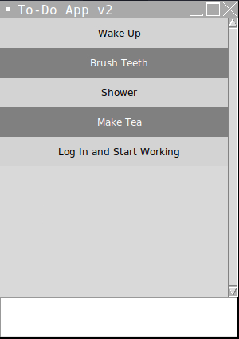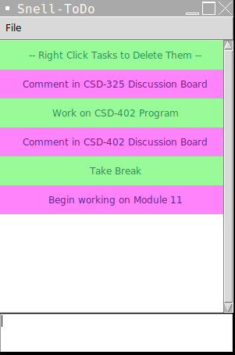
Deleting a task: After deletion:
