HW4-1

HW4-1

HW4-2

HW4-1 Pycarat to compare ML agorithms on classification problem 16 Model (multi-features titanic is ok , )

| # 安裝必要的套件  !pip install pycaret  !pip install pandas  # 載入必要的庫  import pandas as pd  from pycaret.classification import *  # 下載 Titanic 資料集  url = 'https://raw.githubusercontent.com/datasciencedojo/datasets/master/titanic.csv'  titanic_data = pd.read_csv(url)  # 顯示資料集的前幾行  print(titanic_data.head())  # 使用 PyCaret 來設置環境  # 設定目標變數 'Survived'，session_id 用於確保可重現性  clf1 = setup(data=titanic_data, target='Survived', session_id=123)  # 比較多個模型，並選擇最佳的模型  best_model = compare_models(fold=5)  # 建立一個邏輯回歸模型  lr_model = create_model('lr')  # 進行模型預測  predictions = predict_model(lr_model)  # 顯示預測結果  print(predictions.head())  # 評估模型效能  evaluate_model(lr_model)  # 儲存訓練好的邏輯回歸模型  save_model(lr_model, 'titanic_lr_model')  # 從檔案加載已儲存的模型  loaded_model = load_model('titanic_lr_model')  # 使用已訓練的模型進行預測  loaded_predictions = predict_model(loaded_model)  print(loaded_predictions.head())  # 建立一個 Stack 模型，將多個基礎模型進行集成  # 注意：meta_model 應該傳入訓練好的模型物件，而不是字串  stacked_model = stack_models([lr_model, best_model], meta_model=lr_model)  # 評估堆疊模型效能  evaluate_model(stacked_model)  # 儲存預測結果為 CSV 檔案  stacked_predictions = predict_model(stacked_model)  stacked_predictions.to_csv('titanic_stacked_predictions.csv', index=False)  # 顯示堆疊模型的預測結果  print(stacked_predictions.head()) |
| --- |

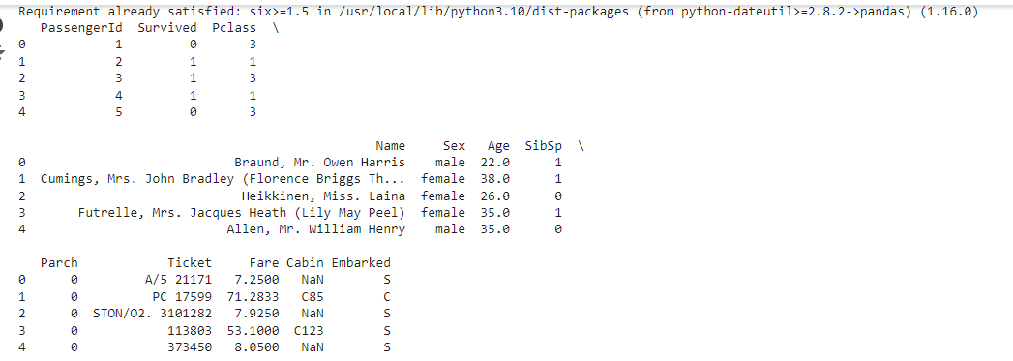

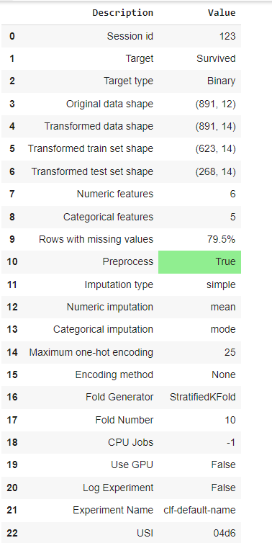

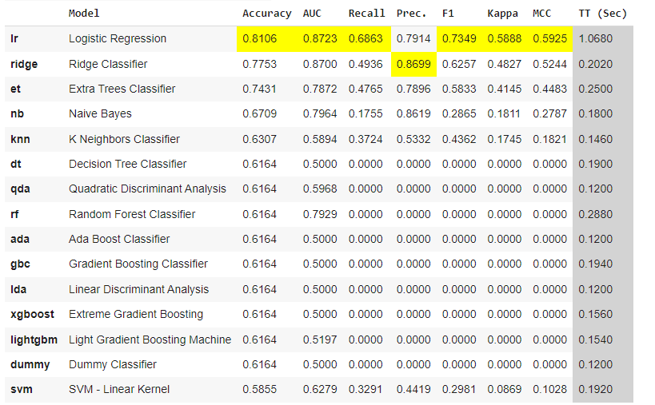

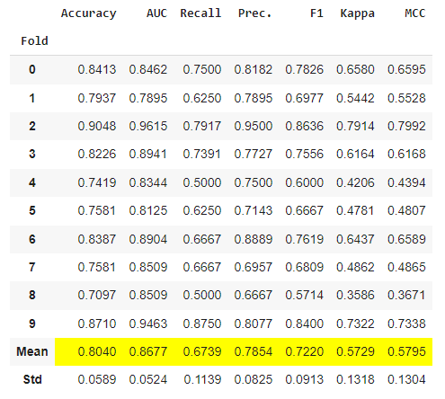

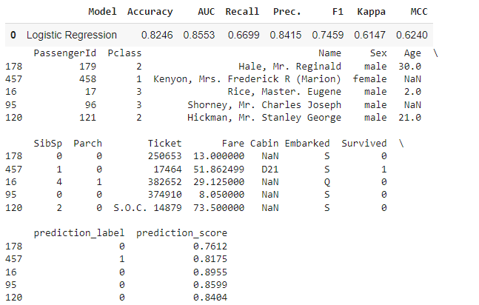

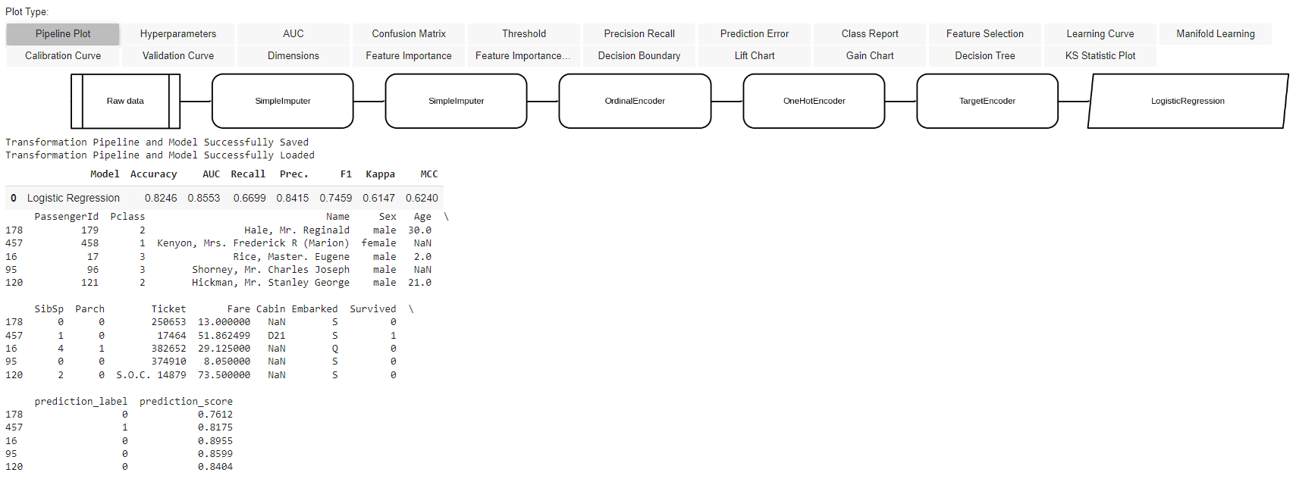

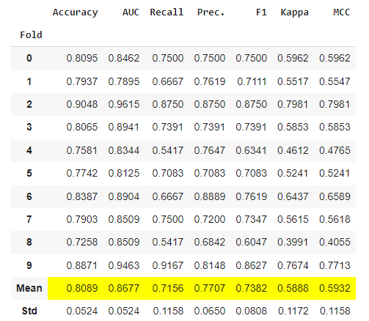

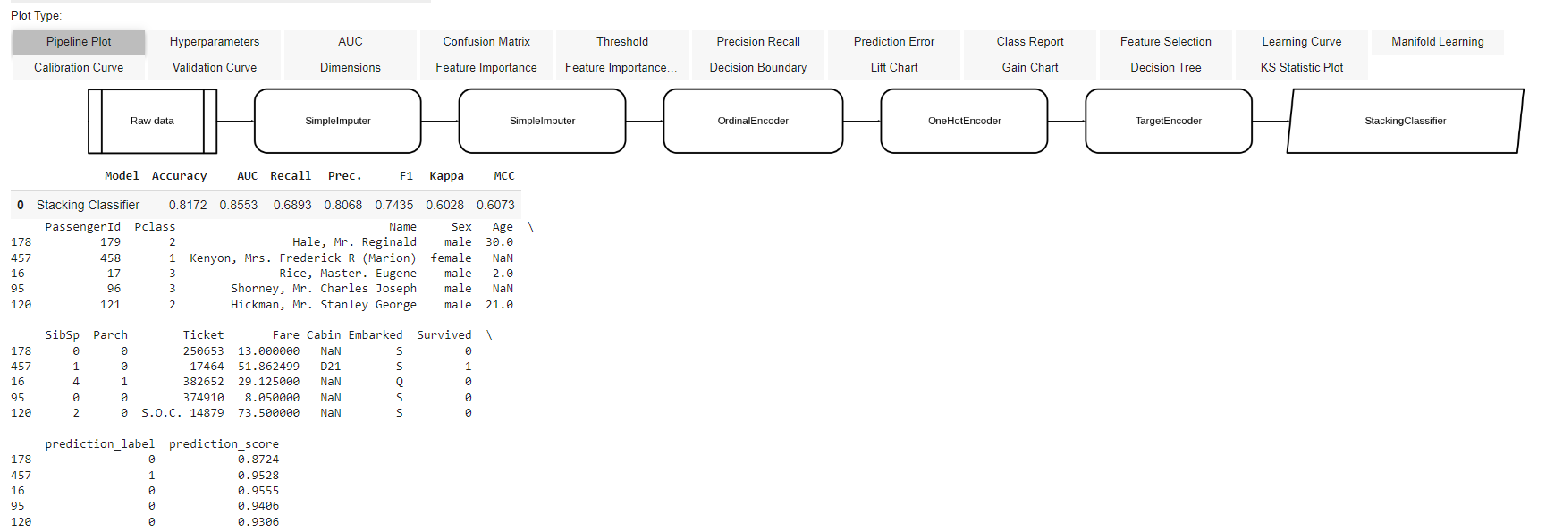

HW4-2

HW4-1

HW4-2

HW4-2 對 model optimization using pycarat or optuna or other AutoML,meta-heuristic

1. Feature engineering, 2. model selection , 3 . training 超參數優化

| !pip install optuna scikit-learn  import pandas as pd  import optuna  from sklearn.datasets import load_breast_cancer  from sklearn.model_selection import train_test_split  from sklearn.ensemble import RandomForestClassifier  from sklearn.svm import SVC  from sklearn.linear_model import LogisticRegression  from sklearn.metrics import accuracy_score  # 讀取資料集  data = load_breast_cancer()  df = pd.DataFrame(data.data, columns=data.feature_names)  df['target'] = data.target  # 特徵工程  X = df.drop('target', axis=1)  y = df['target']  X_train, X_test, y_train, y_test = train_test_split(X, y, test_size=0.2, random_state=42)  # 模型選擇：訓練並比較不同模型  rf_model = RandomForestClassifier(random_state=42)  svm_model = SVC(random_state=42)  lr_model = LogisticRegression(random_state=42)  models = [rf_model, svm_model, lr_model]  model_names = ["Random Forest", "SVM", "Logistic Regression"]  for model, name in zip(models, model_names):  model.fit(X_train, y_train)  predictions = model.predict(X_test)  accuracy = accuracy_score(y_test, predictions)  print(f"Model: {name}, Accuracy: {accuracy:.4f}")  # Optuna 超參數優化  def objective(trial):  n_estimators = trial.suggest_int('n_estimators', 50, 200)  max_depth = trial.suggest_int('max_depth', 3, 10)  min_samples_split = trial.suggest_int('min_samples_split', 2, 10)  model = RandomForestClassifier(  n_estimators=n_estimators,  max_depth=max_depth,  min_samples_split=min_samples_split,  random_state=42  )  model.fit(X_train, y_train)  predictions = model.predict(X_test)  accuracy = accuracy_score(y_test, predictions)  return accuracy  study = optuna.create_study(direction='maximize')  study.optimize(objective, n_trials=100)  print("Best parameters: ", study.best_params)  print("Best accuracy: ", study.best_value) |
| --- |

Best parameters: {'n_estimators': 130, 'max_depth': 10, 'min_samples_split': 10}

Best accuracy: 0.9649122807017544