PROG7313 – PART 1
Group 1
Kyra Naidoo ST104484114
Diya Lakha ST10439176
Kaehil Indurjeeth ST10438880
Zario Di Paolo ST10441349
Gregory Luyckfasseel ST10441344

Introduction
Making a budget can be hard and take a lot of time. With smartphone apps, managing money has become easier and more fun. This study looks at the features of three budgeting apps: YNAB, Goodbudget and Simplifi by Quicken. We want to create a budgeting app that helps people manage their money better. To create a new user-friendly budgeting software that promotes proactive financial management, goal-setting, and regular tracking of spending patterns, this research will analyse existing applications to find best practices and practical features.

Application 1: YNAB (You Need A Budget)
Overview of the App
YNAB is a tool for personal budgeting. You can use it on your Android phone or other devices. The app has a way of budgeting called zero-based budgeting. This means you have to assign each unit of money to a category or goal. It helps you plan how you will spend your money before you spend it. (YNAB, 2026).

The app operates on four main principles (Moneytoolhub, 2025):
- Give every rand a job.
- Embrace true expenses.
- Roll with the punches.
- Age your money.
With YNAB you can set goals for paying off debt and saving money. You can also make your budget categories and track your spending in real time. The app shows you how you are spending your money and helps you make financial decisions. YNAB has a free trial period. Then you have to pay for a monthly or annual membership plan.
Main Dashboard
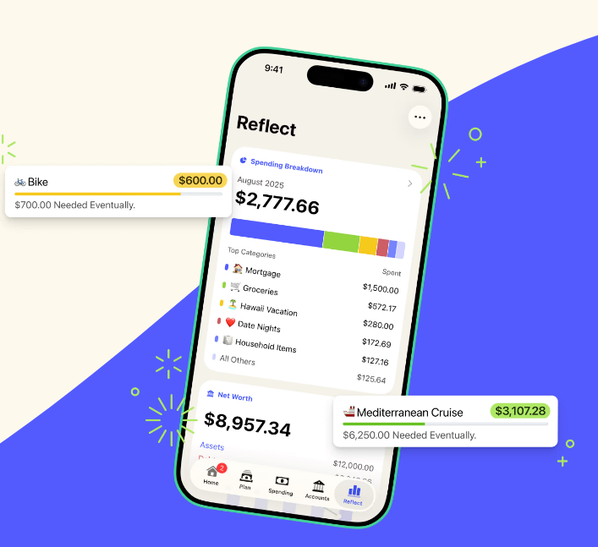
Figure 1: YNAB Budgeting Dashboard (YNAB, 2026).
The core user interface where finances are allocated is seen in this image. To guarantee zero-based budgeting compliance, it exhibits a simple, straightforward design with a distinct hierarchy that draws the user's attention to the "Ready to Assign" balance at the top.

Reporting/Analytics
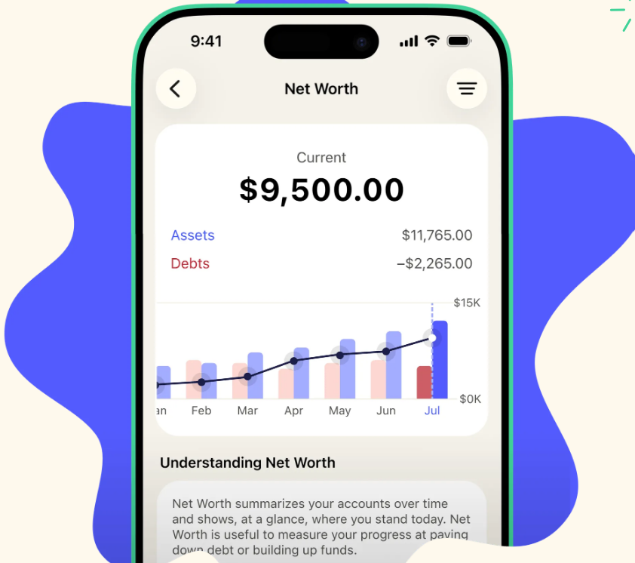
Figure 2: YNAB Spending Report (YNAB, 2026).
The app's data visualization features are demonstrated in this display. The interface enables users to do a "mid-month checkup" and modify their behaviour based on visual spending patterns by utilizing color-coded pie charts and spending trends.

Loan Planner
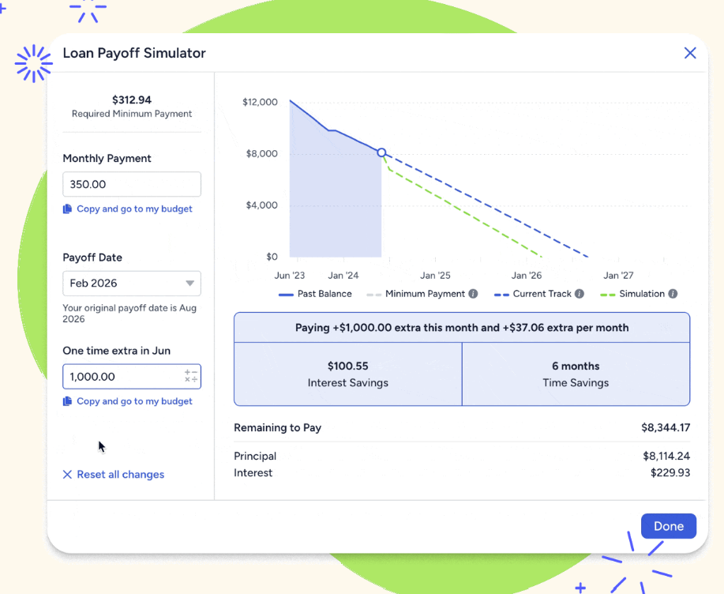
Figure 3: YNAB Loan Planner Tool (YNAB, 2026).
This part of the dashboard helps you visualize your path to being debt-free. The loan planner helps you see how you can pay off your debt. You can use it to try out scenarios and see how they work.

Strengths of YNAB
- Provides instructional materials such as publications, workshops, and classes to assist users in developing effective financial practices (YNAB, 2026).

- Encourages financial discipline by using a zero-based budgeting approach that requires users to set aside each unit of income (YNAB, 2026).

- Enables goal-oriented planning by establishing monthly spending caps, debt repayment targets, and savings objectives (YNAB, 2026).

- Allows customers to access and modify their budgets on many devices by providing real-time cloud synchronization (YNAB, 2026).

Weaknesses of YNAB

- Budget-conscious consumers may find YNAB, a premium budgeting app, to be expensive (Moneytoolhub, 2025).

- restricted options for users that prefer different approaches, such as the 50/30/20 rule (Moneytoolhub, 2025).

- There aren't many tools for tracking investments, which might not be ideal for people who want to increase their net worth (Moneytoolhub, 2025).

- Even with automatic imports, manual transaction approval and classification are necessary, which can take time (Moneytoolhub, 2025).

Innovative Features of YNAB

- By allocating money to categories prior to spending, "Give Every Rand a Job" promotes proactive budgeting (YNAB, 2026).

- Money aging supports long-term financial stability by tracking how long funds remain in the budget (YNAB, 2026).

- If overspending happens, customers can swiftly reallocate funds and modify plans thanks to dynamic budget changes (YNAB, 2026).

- These characteristics distinguish YNAB by actively influencing financial behaviour rather than only monitoring expenditures (YNAB, 2026).

Application 2: Goodbudget
Overview of the App
Goodbudget is a budgeting app designed to help people and families take control of their finances using the envelope system, where money is divided into categories like groceries, rent, transport, and savings. The app is available on Android, iOS, and web, and focuses on manual expense tracking, which lets users actively record their spending and better understand their habits. By requiring users to wait until the next budgeting period once an envelope runs out, Goodbudget promotes thoughtful spending and financial discipline. It also offers the option to share budgets, making it easier for families or couples to stay on the same page with their money (Goodbudget, n.d.).
Dashboard
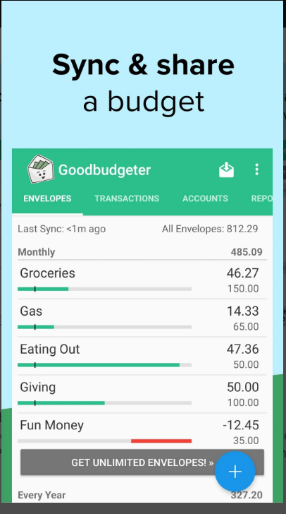
Figure 4: Goodbudget mobile dashboard (Dayspring Partners, 2026).
The mobile dashboard in this screenshot depicts budget categories as actual "envelopes." The app's fundamental envelope-budgeting concept is supported by the progress bars, which offer instant visual feedback on remaining cash (Dayspring Partners, 2026).

Debt Account View
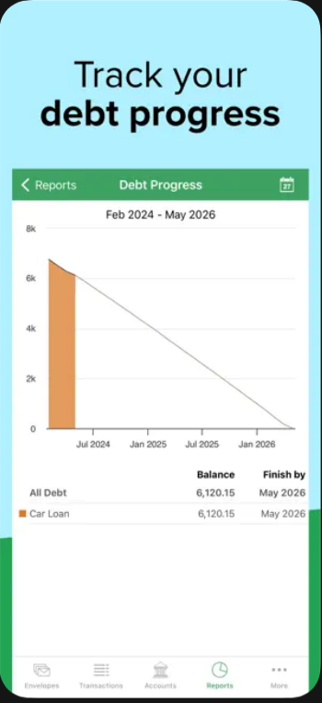
Figure 5: Goodbudget Debt Progress Interface (Dayspring Technologies, 2026).

This dashboard offers a graphic representation of a user's debt reduction process. The remaining balance, and the anticipated debt-free date based on current monthly contributions are all highlighted (Dayspring Technologies, 2026).

Transaction Entry Screen
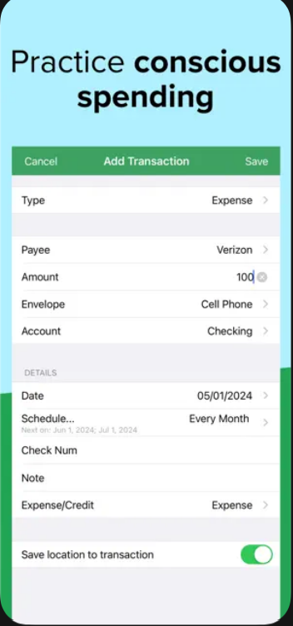
Figure 6: Goodbudget Transaction Entry (Dayspring Technologies, 2026).

The manual entering procedure is displayed in this screenshot. It emphasizes how easy it is to link a purchase to a particular envelope, which is crucial given the app's emphasis on proactive, purposeful spending (Dayspring Technologies, 2026).

Strengths of Goodbudget
Goodbudget runs on the envelope budgeting method, making it easy for users to organize expenses into different categories such as groceries, rent, and dining out. Instead of just tracking what’s already spent, the app pushes you to plan for future purchases. The layout’s straightforward visual makes it a lot less intimidating for anyone who’s had trouble sticking to a budget before. You can see how much you’ve got left in each envelope, so progress feels real. One standout feature is “Sync & Share.” This lets everyone in the household stay on the same page, whether they use iPhones, Android devices, or the web. Changes update instantly, so no matter who buys what, everyone knows where the money’s going. Goodbudget offers a free version for basic needs, and for those who want more, there’s a premium “Plus” edition with extra tools.

Weaknesses of Goodbudget
There are several restrictions with Goodbudget, especially for users of the unpaid tier. With just twenty envelopes and one bank account, the free edition is noticeably limited and might not be enough for families or people handling complicated budgets (Experian, 2024). Additionally, since automated bank synchronization is only available to premium members, users on the free plan must manually enter each transaction (Experian, 2024). The platform lacks broader financial utility beyond these tier-specific limitations; it only concentrates on envelope budgeting and does not offer integrated features for bill paying, investment tracking, or all-encompassing financial management (Experian, 2024).

Innovative Features of Goodbudget
- Goal Envelopes: An automated savings tool that figures out how much you need to set aside each month to hit your financial goals (Goodbudget, n.d.).

- Debt Accounts: Tracks your daily spending along with how much you’ve paid off, so you can actually see how your day-to-day choices affect your debt payoff in real time (Experian, 2024).

- Budget Checkup: A flexible feature that lets you tweak your “fill” amounts mid-month as your priorities shift, with clear visuals that show how your spending stacks up against what’s left (Goodbudget, n.d.).

Application 3: Simplifi by Quicken

Overview
The final budgeting app that was researched is Simplifi. Simplifi is a finance application that has been developed by Quicken. Quicken is a US based financial software company that develops SaaS products. The Simplifi mobile application is designed to offer users an intuitive way to manage personal finances from their mobile devices. Simplifi is available on iOS, Android and web browser platforms. The application operates on a subscription-based model. Does not offer a free version. Users are required to pay an annual fee to access its features. There are two pricing plans, the first one is $5.99 a month and the second is $9.98 a month. The Simplifi mobile application is designed to offer users a consolidated and intuitive way to manage personal finances from their mobile devices.

Dashboard
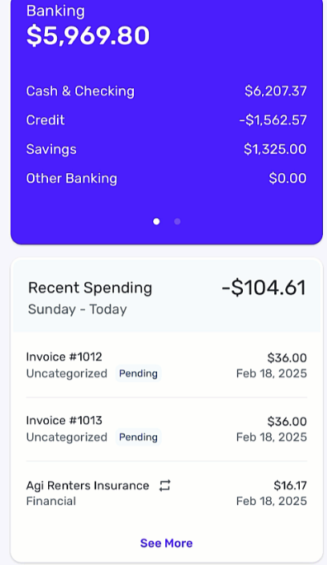

Figure 7: Simplifi Dashboard (Simplifi, 2026).
This Dashboard shows the current account balance, spending, cash and checking amounts, savings and other banking expenses. The dashboard gives a general overview of the users’ accounts.

Spending plan
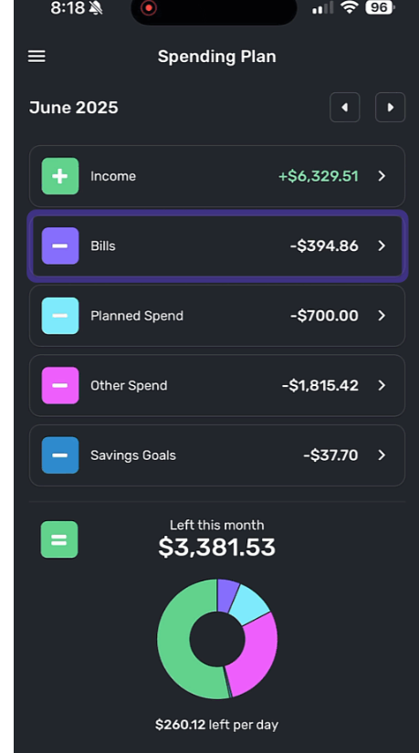
Figure 8: Simplifi spending plan (Simplifi, 2026).

The spending plan gives the user a general overview of their expenses such as bills, income, saving goals, and other expenses.

Goal Saving
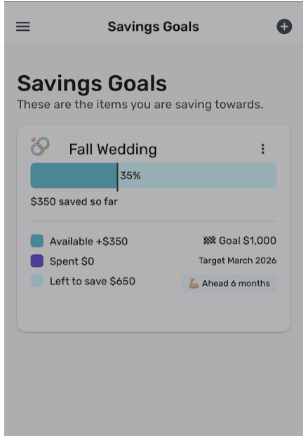
Figure 9: Simplifi goal saving (Simplifi, 2026).

The savings goal view allows for the user to enter in an amount they would like to save and creates a mini budget for the goal.

Bills and income
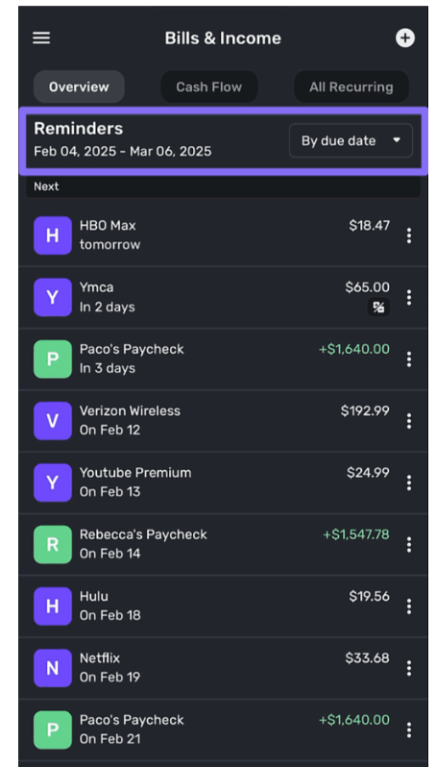

Figure 10: Simplifi Bills and Income (Simplifi, 2026).

This view shows the users bills and income.

Adding Accounts
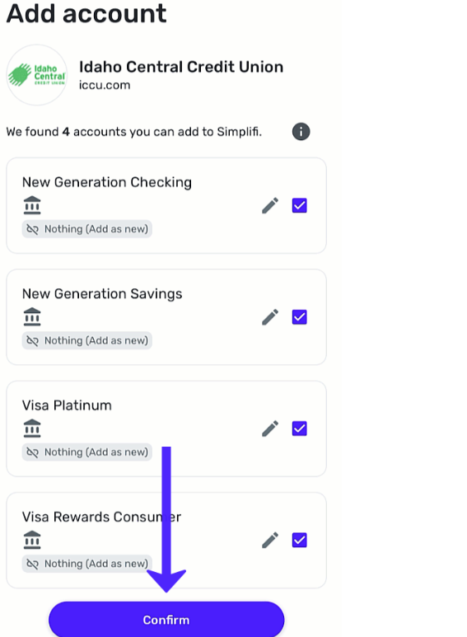
Figure 11: Simplifi adding accounts (Simplifi, 2026).
This view shows the process that allows the user to add their bank accounts to the application.

Strengths of Simplifi
- User Interface: Simplifi's simple, user-friendly design makes it perfect for beginners who don't know anything about finance (Bankerology, 2023).

- Effective budgeting tools: Effective tracking of income and expenses is made possible by features like the Spending Plan and transaction categorizing.These apps help users identify their spending habits and manage their finances more effectively (Quicken, 2026).

- Ability to connect multiple financial accounts: Simplifi allows users to connect different financial accounts such as bank accounts, credit cards and loans. This enables users to view all financial information in one place, which provides a more comprehensive overview of their financial situation (Family Money Adventure, 2023).

Weaknesses of Simplifi
- No free version: One of the main limitations of Simplifi is that it does not offer a free version of the application. Users must pay a subscription fee to access the platform and its features (Bankerology, 2023).

- Limited investment tracking features: Although Simplifi allows users to monitor investment accounts, the investment analysis and reporting tools are limited compared to some competing personal finance applications (MoneyCrashers, 2024).

- No credit score monitoring: Simplifi does not provide built-in credit score tracking, which is a feature that some other financial management applications include (MoneyCrashers, 2024).

- Limited advanced financial tools: The application focuses primarily on budgeting and personal finance tracking and therefore lacks more advanced financial tools such as integrated banking services or complex financial analysis capabilities (Modest Money, 2023).

Innovative features
- Adding Financial Accounts (Quicken, 2026): The first substantive step in the setup process is the addition of financial accounts. Simplifi supports the integration of bank accounts, credit cards, loans, and similar instruments, which may be linked automatically to financial institutions (connected accounts) or entered manually. The app consolidates these accounts to present an aggregated view of a user’s finances

- The Spending Plan in Simplifi helps users to manage money by showing exactly how much they can safely spend after accounting for income, bills, as well as savings goals. It works alongside the Projected Cash Flow feature, which estimates future income and expenses to help users plan and avoid overspending, providing a clear snapshot of available funds (Quicken, 2026).

- Goal Saving: Simplifi takes your goal amount, and it’ll suggest a target date and a monthly contribution amount. The app can also deduct saving goals from your spending plan (Quicken, 2026).

A visual (infographic) comparison of all three apps.
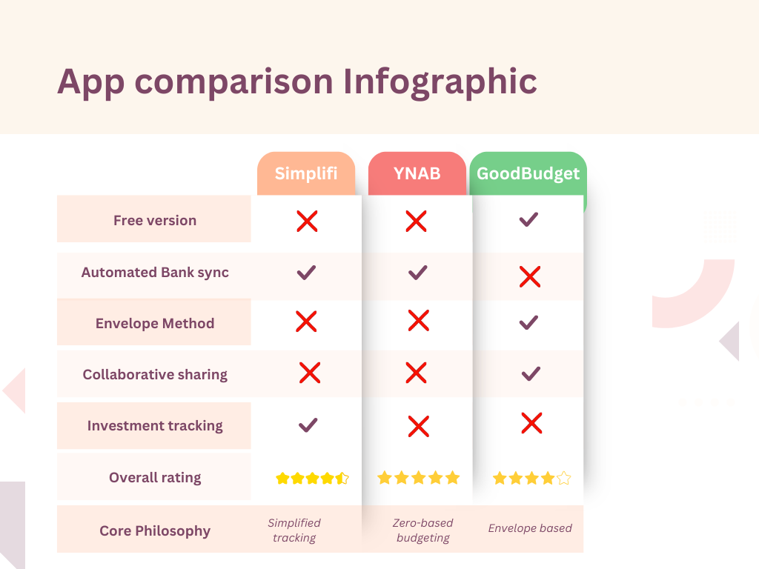
Figure 12: Infographic.2026 (canva, 2026)

List of the best features from all apps

- Zero-Based Allocation ("Give Every Rand a Job"): Adopt the YNAB principle, which assigns a category to each unit of money before it is spent. This guarantees that customers prepare their spending plans prior to the transaction (YNAB, 2026).

- Color-Coded Analytics: Utilize pie charts and visual expenditure patterns to facilitate "mid-month checkups," assisting users in changing their behaviour in response to spending trends (YNAB, 2026).

- Sync & Share for Households: Establish a shared budgeting environment so that when money is taken out of a category, everyone in the household is immediately informed (Goodbudget, n.d.).

- Financial Literacy Resources: To assist users in developing solid financial habits and strengthening their financial discipline, incorporate instructional materials, such as articles and workshops, right into the app (YNAB, 2026).

- The "Smart" Spending Plan: Instead of a static budget, this feature calculates exactly how much "fun money" is left over after accounting for income, fixed bills, and pre-determined financial commitments (Quicken, 2026)

- Subscription & Bill Reminders: A dedicated tracker for recurring payments and subscriptions that sends reminders for upcoming bills, helping users avoid late fees and surprise charges (Quicken, 2026).

- Visual Spending Milestones: A tool that promotes long-term planning and motivation by allowing users to define and track goals, such as an emergency fund or a major purchase (CNBC Select, 2024).

Conclusion
According to the research, modern budgeting applications provide a variety of features that promote goal-oriented planning, financial discipline, and user engagement. Goodbudget offers a clear visual envelope system and household synchronization, Simplifi offers an easy-to-use interface with integrated account tracking, and YNAB excels in proactive budgeting and behavioural modification. These apps' insights, such as zero-based allocation, visual spending analytics, goal setting, and account integration provide a basis for creating an engaging and successful budgeting app that empowers users to take charge of their money and makes budgeting enjoyable and accessible.

Reference List (Harvard Anglia)
Aenten, 2024. Quicken Simplifi overview and features. [online] Available at: <https://www.aenten.com/for-quicken/articles/quicken-simplifi> [Accessed 6 March 2026].

Bankerology, 2023. Simplifi by Quicken: A streamlined solution for budgeting. [online] Available at: <https://www.bankerology.com/article/simplifi-by-quicken-a-streamlined-solution-for-budgeting> [Accessed 5 March 2026].

CNBC Select, 2024. Quicken Simplifi review. [online] Available at: <https://www.cnbc.com/select/quicken-simplifi-review> [Accessed 6 March 2026].

EXPERIAN, 2024. Goodbudget App Review. [online] Available at: <https://www.experian.com/blogs/ask-experian/goodbudget-budgeting-app-review/> [Accessed 5 March 2026].

Dayspring Partners, 2026. Goodbudget mobile dashboard [online image] Available at: <https://play.google.com/store/apps/details?id=com.dayspringtech.envelopes> [Accessed 5 March 2026].

Dayspring Technologies, 2026. Goodbudget Debt Progress Interface. [online image] Available at: <https://apps.apple.com/us/app/goodbudget-budget-planner/id471112395> [Accessed 5 March 2026].

Dayspring Technologies, 2026. Goodbudget Transaction Entry. [online image] Available at: <https://apps.apple.com/us/app/goodbudget-budget-planner/id471112395> [Accessed 5 March 2026].

Family Money Adventure, 2023. Simplifi by Quicken review. [online] Available at: <https://familymoneyadventure.com/simplifi-by-quicken-review> [Accessed 6 March 2026].

Goodbudget, n.d. Digital Envelope Interface. [online image] Available at: <https://goodbudget.com/what-you-get/> [Accessed 5 March 2026].

Goodbudget, n.d. What You Get. [online] Available at: <https://goodbudget.com/what-you-get/> [Accessed 5 March 2026].

Goodbudget, n.d. How It Works. [online] Available at: <https://goodbudget.com/how-it-works/> [Accessed 5 March 2026].

Moneytoolhub, 2025. You need a budget review: Pros and Cons – is YNAB Worth it in 2025, 5 September 2025. [online] Available at: <https://moneytoolhub.com/> [Accessed 5 March 2026].

Modest Money, 2023. Simplifi by Quicken review. [online] Available at: <https://www.modestmoney.com/simplifi-by-quicken-review> [Accessed 6 March 2026].

MoneyCrashers, 2023. Quicken Simplifi review. [online] Available at: <https://www.moneycrashers.com/simplifi-quicken-review> [Accessed 6 March 2026].

Quicken.com, 2026. Plans & Pricing | Quicken. [online] Available at: <https://www.quicken.com/products/pricing-comparison-products/> [Accessed 5 March 2026].
Quicken, 2020. Getting Started on the Mobile App | Quicken Simplifi Help Center. [online] Available at: <https://support.simplifi.quicken.com/en/articles/6098227-getting-started-on-the-mobile-app> [Accessed 5 March 2026].

Quicken, 2020. Getting Started on the Mobile App | Quicken Simplifi Help Center. [online image] Available at: <https://support.simplifi.quicken.com/en/articles/6098227-getting-started-on-the-mobile-app> [Accessed 5 March 2026].

Quicken, 2020. Simplifi Dashboard | Quicken Simplifi Help Center. [online image] Available at: <https://support.simplifi.quicken.com/en/articles/6098227-getting-started-on-the-mobile-app> [Accessed 5 March 2026].

Quicken, 2020. Spending plan | Quicken Simplifi Help Center. [online image] Available at: <https://support.simplifi.quicken.com/en/articles/6098227-getting-started-on-the-mobile-app> [Accessed 5 March 2026].

Quicken, 2020. Saving Goals | Quicken Simplifi Help Center. [online image] Available at: <https://support.simplifi.quicken.com/en/articles/6098227-getting-started-on-the-mobile-app> [Accessed 5 March 2026].

Quicken, 2020. Bills and Income | Quicken Simplifi Help Center. [online image] Available at: <https://support.simplifi.quicken.com/en/articles/6098227-getting-started-on-the-mobile-app> [Accessed 5 March 2026].

Quicken, 2020. Adding accounts | Quicken Simplifi Help Center. [online image] Available at: <https://support.simplifi.quicken.com/en/articles/6098227-getting-started-on-the-mobile-app> [Accessed 5 March 2026].
YNAB, 2026. Why YNAB is different. [online] Available at: <https://www.ynab.com/why-ynab-is-different> [Accessed 5 March 2026].

YNAB, 2026. YNAB Budgeting Dashboard. [online image] Available at: <https://www.ynab.com/features> [Accessed 5 March 2026].

YNAB, 2026. YNAB Spending Report. [online image] Available at: <https://www.ynab.com/features> [Accessed 5 March 2026].

YNAB, 2026. YNAB Loan Planner Tool. [online image] Available at: <https://www.ynab.com/features> [Accessed 5 March 2026].

In the List of Figures:

Figure 1: YNAB Budgeting Dashboard.
Figure 2: YNAB Spending Report.
Figure 3: YNAB Loan Planner Tool.
Figure 4: Goodbudget Mobile Dashboard.
Figure 5: Goodbudget Debt Progress Interface.
Figure 6: Goodbudget Transaction Entry.
Figure 7: Simplifi Dashboard.
Figure 8: Simplifi spending plan.
Figure 9: Simplifi goal saving.
Figure 10: Simplifi Bills and Income.
Figure 11: Simplifi adding accounts.
Figure 12: Infographic.2026 (See disclosure under references)
Disclosure

Annexure A
Title: Disclosure of AI that is used in my assignment.
Name: OpenAI
Section: Research
Purpose: Used for help with research and understanding
Date: 5 March 2026
Link: https://chatgpt.com/share/69b7a845-f7e4-8009-bd3f-8b15f04046bd

Annexure B
Title: Disclosure of Canva that is used in my assignment.
Name: Canva
Section: Infographic
Purpose: Used to create the infographic
Date: 5 March 2026
Link: https://www.canva.com/design/DAHDJrSOMPQ/Y5MVgwdNKIqytLcJIhgF7Q/edit

