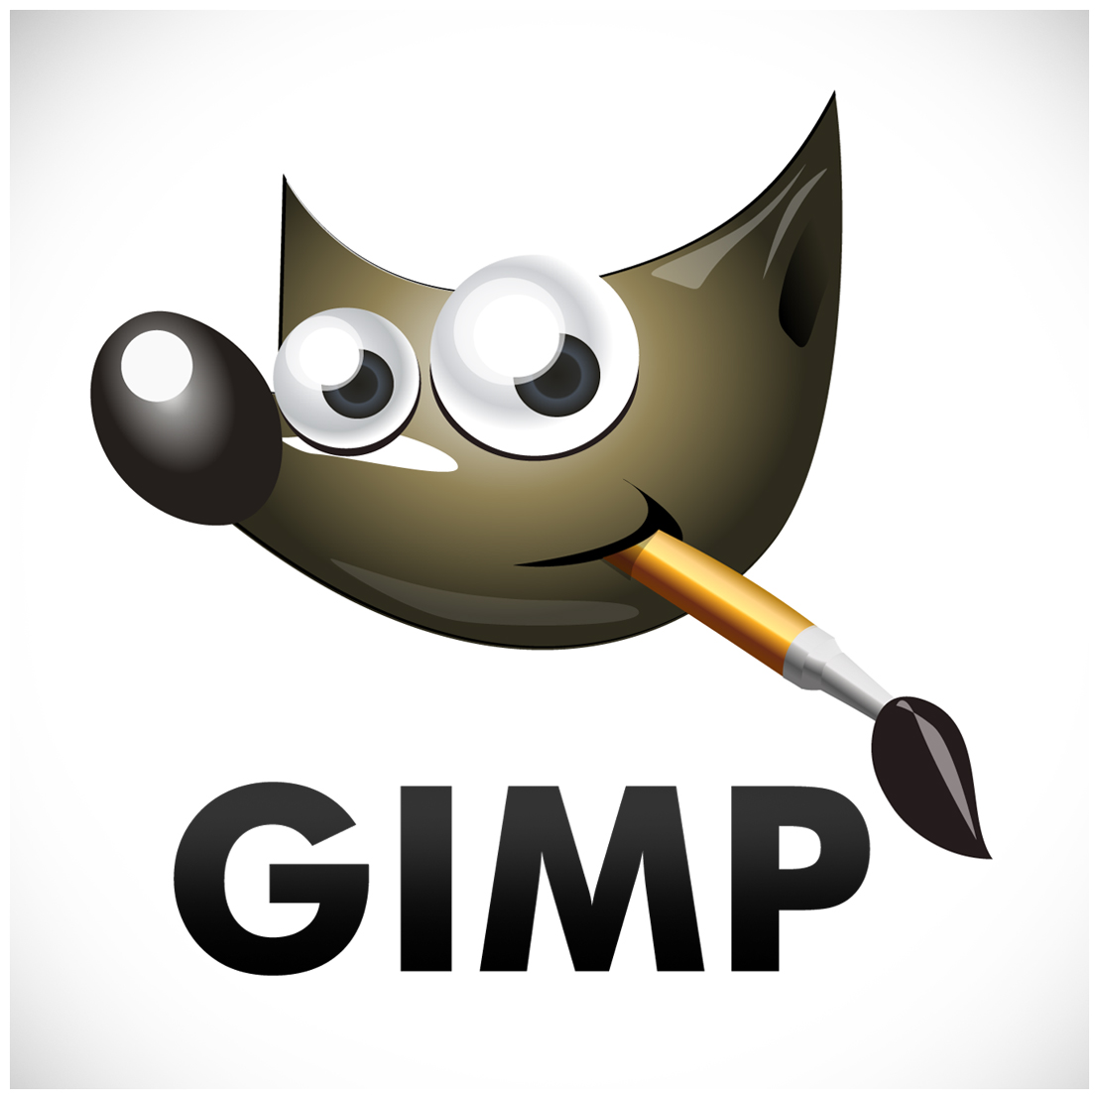

By:

Tanvi Bhambri

Katelin Keong

INSTRUCTION MANUAL

# Table of contents

#### Introduction………………………………………………………………………..2

What is Image Manipulation?…………………………………………………………………………………2

Welcome to GIMP…………………………………………………………………………………………………..2

What You Need………………………………………………………………………………………………………2

*Working With GIMP……………………………………………………………….3*

Merging Two Images Together in GIMP……………………………………………………………………3

Optional: Adding Text to the Image………………………………………………………………………......5

*Designing With GIMP……………………………………………………………...6*

Creating a Simple Logo…………………………………………………………………………………………….6

*Working With Photographs………………………………………………………..8*

Adding Depth of Field to a Photograph……………………………………………………………………...8

*Creating Enhanced Images……………………………………………………...10*

Enhancing a Pre-rendered Image……………………………………………………………………………10

*Appendix…………………………………………………………………………...12*

Glossary of Terms…………………………………………………………………………………………………..12

Frequently Asked Questions…………………………………………………………………………………...13

# Introduction

This manual is a beginner’s guide to setting up GIMP (GNU Image Manipulation Program) on a personal computer/laptop. It is mainly intended for graphic designers and developers learning graphical design, but unable to afford Photoshop. You will learn the basics of GIMP and how to utilize the tools provided in the software, allowing for simple but expressive images, regardless of the operating system the software is installed onto.

*What is Image Manipulation?*

Image manipulation, is exactly what it says on the box. It involves using a program to transform or alter images using a variety of methods and techniques to achieve desired results. With image manipulation, anything from simple banners to images created by taking parts from various other sources of pictures can be created, the only limit being your imagination. The major benefits of image manipulation are that you can use it for a variety of tasks, and regardless of skill level, just about anyone can take an image and manipulate it, the level of complexity varying.

Image manipulation has become widespread throughout the world. Before image manipulation software, inks, airbrushes and darkroom techniques were the main way to manipulate images. Graphic designers and developers will use image manipulation programs the most, as part of projects assigned, to enhance the overall visual appeal of their work.

*Welcome to GIMP*

GIMP, or GNU Image Manipulation Program, is a multi-platform photo manipulation tool. GIMP is suitable for a variety of image manipulation tasks, including photo retouching, image composition, and image construction. GIMP has many capabilities, and can be used as a simple paint program, an expert quality photo retouching program, an online batch processing system, a mass production image renderer, an image format converter, etc. In order to use GIMP, you need either a working laptop or desktop.

*What You Need*

This manual expects you to have one of the three most common operating systems on your desktop or laptop: Windows, Apple Mac OS X, or Linux, as well as rudimentary computer skills, such as saving images, copying and pasting, and resizing and cropping images.

# WorkinG With gimp

After GIMP has been installed and set up, you are ready to dive into the world of image manipulation. Once GIMP has been launched, you are ready to get started. Aside from the basics of cropping and re-sizing an image, GIMP can also be used for more complex tasks. GIMP is simple enough to pick up, while still producing quality images equal to that of Photoshop. The following instructions show you how to merge two images together to form a single image.

*Merging Two Images Together in GIMP*

One way to combine images together with a fade effect is to use a layer mask.

Save the two images you wish to merge, then open them on GIMP.

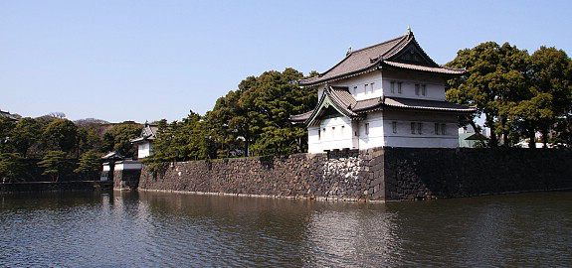

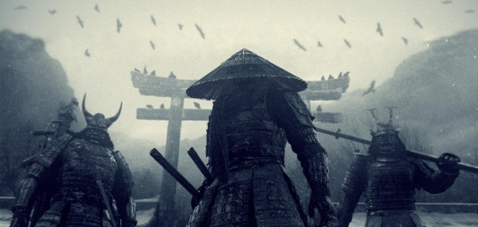

Click on the layer of the image on the left. Using the right mouse button, click “Add layer mask” and a dialog box below will appear. Choose white to initialize the mask, as white corresponds to opaque. Choose from the tool box a black foreground color and a white background color.

­­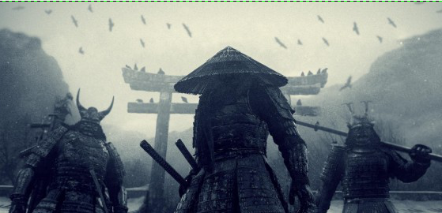

Click on the Blend tool, which is the gray square button, and make a gradient, moving from right to left, starting from the edge of the image and stopping in the middle of it, the other half maintaining visibility. In the layers window, click on “Merge Layers.” This results in only one layer visible in the window. Click on the image of the samurai, and “Select All”, then “Copy.” Go to the forest image, in selection mode, and click “Paste.” Move the image as you wish, then save.

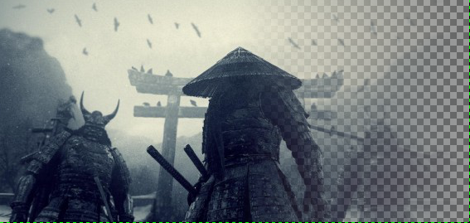

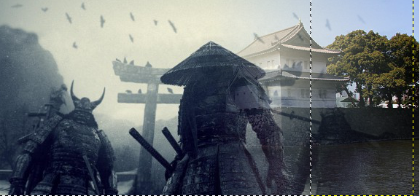

*Optional: Adding Text to the Image*

Click on the Text tool, which is the “A” button in the Toolbox window. Choose the font, size and colour that you wish the text to be from the options that appear at the bottom of the Toolbox window.

Click on the spot you want the text to appear on the image window, then type the text in the text area of the GIMP Text Editor dialog window. The text will appear on the image as you type.

Click on the “Close” button at the bottom of the text editor window when you have finished adding the text, then save.

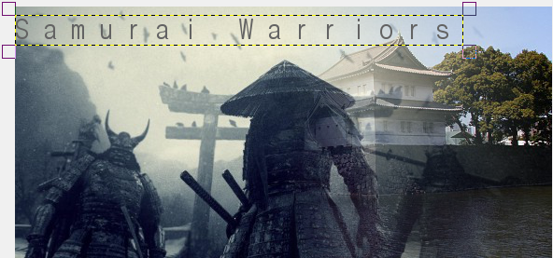

# Designing with gimp

GIMP is not limited to just manipulating pre-rendered images. It can also be used to create images from scratch, which include, but are not limited to, watermarks, 3D text, even company logos. The following instructions show you how to create a simple logo.

*Creating a simple Logo*

Logos can range in complexity, but this particular logo will be neutral and can be used for many different things.

Create a new file with the size you want. Once it has been created, write two text pieces on the layer, with the font size you want. Deactivate the “hinting”-option, since it is only useful for small fonts. Click on the Move Tool, which is the four-way arrow button, and position one text above the other.

Take the Paths Tool, which is the ink pen button, and start clicking until you have the same points in the picture below. When you reach the first point, hold ctrl to unify the last point with the first point, resulting in a fully closed path. After completion, click and move the bottom edge downwards, forming a curve.

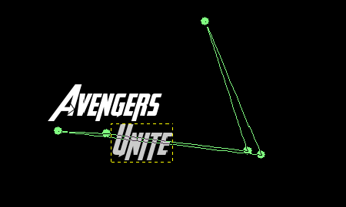

With two dashed lines appearing, you are able to adjust the curve. Click on the left dashed line and move it slightly towards the middle, making the curve a little more even, and move the right dashed line a bit to the right. Try to get as close to the picture below as possible. Press the ENTER button and you should get a selection of the path.

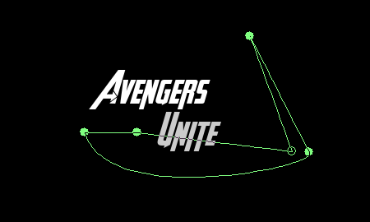

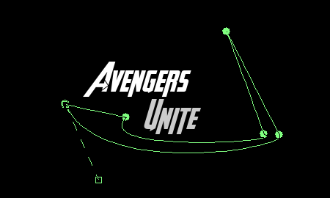

Create a new, empty layer, and set #dcf6ff and #00b8e0 as the background color. Click on the gradient tool and draw the gradient anywhere on the layer. The selection is then filled with the gradient. Adjust the Brightness-Contrast levels to -25/+35, then save.

# Working with photographs

GIMP can also be used to manipulate photographs, from sharpening the quality of a photo, to creating effects on the photo that were not present in the original. In the following set of instructions, you will learn how to add visual effects to photographs.

*Adding Depth of Field to a Photograph*

Depth of field is an important aspect of photography, as the focus is centered on the subject, as opposed to the background.

Open the photograph you want to use. Make a copy of the original file, by pressing the copy layer icon in the layers window. Click the Free Select Tool, and outline the subject in the photograph. Once the subject has been selected, go to the paths tab in the layer window and select the selection to path tool. On the top layer, right click and select “Add Alpha Channel.” This will allow you to delete the background.

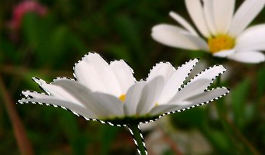

Invert the selection so that everything but the subject will be deleted. With the background deleted, press the eye icon on that layer so that it is no longer visible, then select the layer with nothing deleted, and invert the selection again so that the flower is selected. Grow the selection by about 15 pixels by going to the Select tab, and clicking on Grow. Use Heal Selection to get rid of the subject.

*If you do not have Heal Selection, you can download the plugin here:* [*http://registry.gimp.org/node/27986*](http://registry.gimp.org/node/27986)

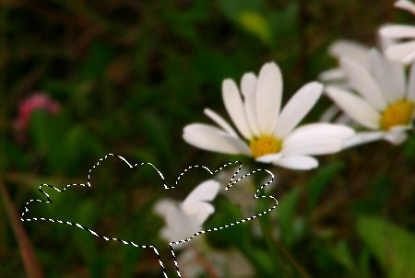

Once Heal Selection has removed the subject, go to Filters, select Blur, then Gaussian Blur, and blur the background. Play around with the blur until you are satisfied with it. Now press the eye on the top layer to get the subject to appear visible again.

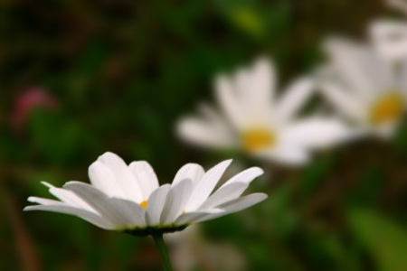

# Creating enhanced images

GIMP can also be used to enhance images, allowing for other images to be transposed on top of an existing image, and seamlessly blend it in. The following set of instructions will show you how to enhance a picture by adding a transparent image to the original image.

*Enhancing a Pre-rendered Image*

By using GIMP to enhance an image, you can create non-ordinary images involving ordinary places, people, and things.

Open the images you want to use. The two images will open up in two separate windows, indicating they have their own individual layer.

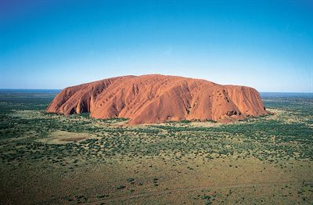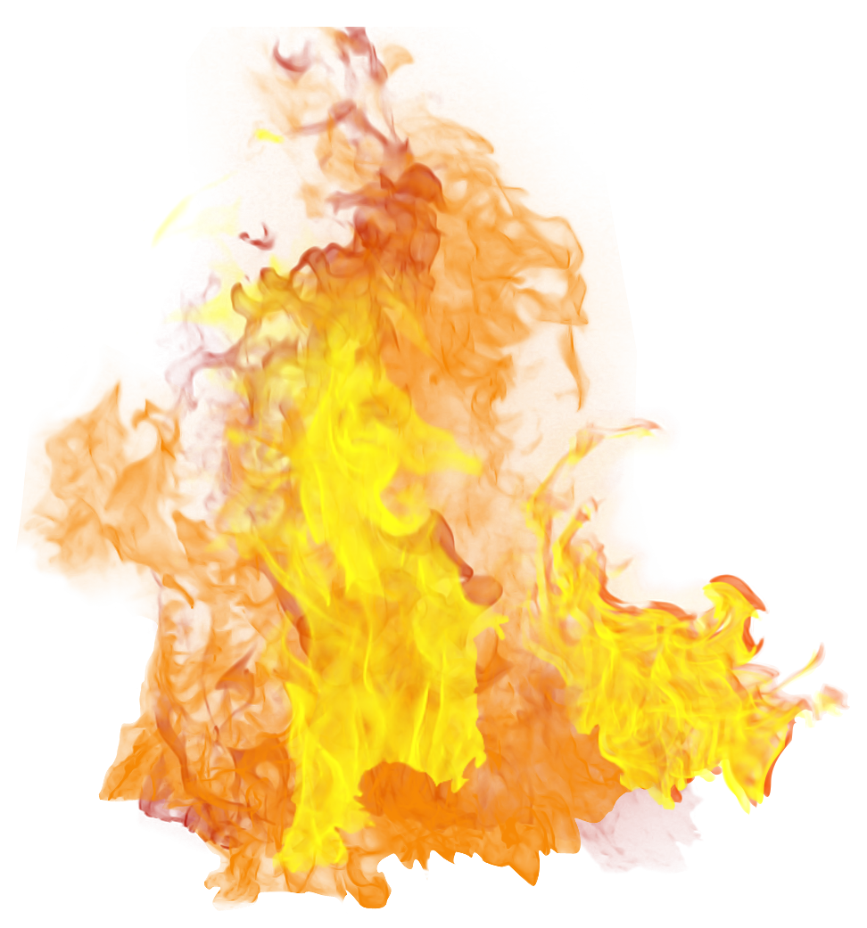

Click on the window of the secondary image that will enhance the primary image, and double-click to full screen the window. If the image you chose has larger dimensions than the primary image, you will have to resize or crop the image, to make it smaller and able to fit in the primary image, by selecting either the Scale tool, or the Crop tool.

After the image is small enough, right-click on the picture and select “Copy.” Paste the image into the primary image. Since the secondary image is in a different layer, you can move it around to a different place on the picture using the Move tool in the toolbox.

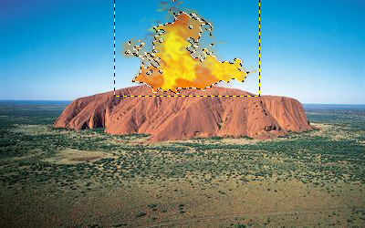

Once the secondary image has been positioned where you want it, save the new enhanced image under a new name, using the formats GIF, JPEG, BMP, PNG, TIFF, PSD (Photoshop format) or XCF (GIMP format).

# Appendix

*Glossary*

Alpha Channel: An alpha channel of a layer is a grayscale image of the same size as the layer representing its transparency. For each pixel the gray level (a value between 0 and 255) represents the pixels’s Alpha value. An alpha value can make areas of the layer to appear partially transparent.

Feathering: The process of Feathering makes a smooth transition between a region and the background by softly blending the edges of the region.

File Format: A file format or file type is the form in which computer data is stored. Since a file is stored by an operating system as a linear series of bytes, which cannot describe many kinds of real data in an obvious way, conventions have been developed for interpreting the information as representations of complex data. All of the conventions for a particular “kind” of file constitute a file format. Some typical file formats for saving images are JPEG, TIFF, PNG and GIF. The best file format for saving an image depends upon how the image is intended to be used.

Layers: You can think of layers as being a stack of slides which are more or less transparent. Each layer represents an aspect of the image and the image is the sum of all of these aspects. The layer at the bottom of the stack is the background layer. The layers above it are the components of the foreground. You can view and manage the layers of the image through the Layers dialog.

Path: A Path is a contour composed of straight lines, curves, or both. In GIMP, it is used to form the boundary of a selection, or to be stroked to create visible marks on an image. Unless a path is stroked, it is not visible when the image is printed and it is not saved when the image is written to a file (unless you use XCF format).

*Frequently Asked Questions*

Why doesn’t my image look the same as the screenshot?

If your image does not look the same, that’s perfectly fine. It won’t appear exactly identical; it just needs to look close enough to what is presented. If you want it to look exactly like the screenshot, Ctrl+Z is your best friend, as it will allow you to undo your actions without completely erasing your progress.

Is GIMP the better alternative to Photoshop?

That all depends on your preference, while Photoshop is more commonly employed by professional graphic designers, the cost is not so friendly to students. GIMP is free to use, so it will never break your wallet, but there are features in Photoshop that are not present in GIMP. If you need an image manipulation program just to get through school, then go with GIMP.

I am not a graphic designer or developer, can I still use GIMP?

Absolutely. GIMP is a complex program that is suitable for professional artwork, but it is also a lot of fun – a place to play with pretty pictures and let your imagination run wild. With GIMP, you can use it to make some amazing pictures, signatures, banners, literally anything involving an image, can be made in it.