## British Columbia Institute of Technology

## Proposal for Integrating the Spark wave Chat Application into BCIT



**Table of Contents**

Table of Contents ………………………………………………………………………………… 1

Summary …………………………………………………………………………………………….. 2

Introduction ………………………………………………………………………………………… 2

Details …………………………………………………………………………………………………. 3

Stage 1 – Preparation ………………………………………………………………… 3

Stage 2 – Introduction ……………………………………………………………….. 4

Stage 3 – Integration …………………………………………………………………. 6

Stage 4 – Evaluation ………………………………………………………………….. 6

Schedule …………………………………………………………………………………………….. 7

Budget ……………………………………………………………………………………………….. 8

Conclusions ………………………………………………………………………………………… 9

Recommendations …………………………………………………………………………….. 9

References ………………………………………………………………………………………… 10

Appendices ……………………………………………………………………………………….. 10

**Summary**

The British Columbia Institute of Technology is a rapidly expanding institute with a large multitude of students enrolled on its main campus, and professors specializing in a variety of subjects. As a result, communication is highly crucial to keep both the students and instructors connected and informed on any unexpected instances. Using the Spark wave Chat Application, a cloud-based chat platform, would benefit both the staff and students without placing a huge dent in the institute’s budget. Some of the benefits included are:

* Money from the institute’s budget would not be required, as all the fees would be paid by the students monthly subscription
* Allow instructors and students to remain in constant communication

Integrating the chat platform into the school system would be broken up into 4 stages. This is to allow students and faculty plenty of time to learn the platform and transition easily into it. During the three weeks, the semester would still run as normal, but with the added benefit of giving students an easier way to get in touch with their instructors.

Stage I should begin at the end of the month (March, 2016), to ensure that all students and faculty are present just before finals exam week begins and students are more concerned with studying.

**Introduction/Background**

As an institute of higher learning with over 100 instructors teaching a multitude of courses, communication has always been important between the students and professors, if anything unexpected happens with the professor. With this in mind, if a professor ends up extremely ill or incapacitated enough that they require another staff member to send a mass e-mail out to the students, informing them that a class is cancelled, there is an off-chance the staff member forgets to send the e-mail to the students. Should this happen, and the students end up attending the class, resulting in wasted effort and time for all, a more efficient and reliable way of informing students of sudden events regarding a professor and how it affects them is needed. E-mailing students is the most common used method, but is not completely reliable, as it relies on not only the professor being physically able-bodied to access their computer and send an e-mail out, but also relying on another staff member to actually remember to send the e-mail out, if the professor delegates the task off.

The institute needs a way for professors to easily inform their students of any unforeseen circumstances, in a cost-effective and simple manner. Implementing the Spark wave Chat Application would provide a large amount of benefits that would make it easier for professors to communicate with their students in each course they teach, and make it quicker for them to inform the students of any unplanned cancellations in a lab or lecture. Through introducing and implementing the chat application, the institute can:

* Swiftly notify students of cancellations of labs and lectures
* Allows instructors to keep in contact with students
* Instructors can create chat rooms for each course they teach
* Students can easily ask instructors any questions they have on a particular topic

Although the chat platform is relatively new, it is constantly being updated to improve chat performance and reliability, which benefits more than hinders the overall quality of the chat platform and its usage.

**Details**

The Spark wave Application is a chat messaging platform. It is similar to online chat rooms, as it allows individuals to communicate instantly with others in the chat, keeping everyone informed and up to date. However, unlike online chat rooms, the BCIT Chat Application is specifically tailored for and used by BCIT instructors and students, designed to keep instructors in touch with their students, if any unforeseen events come up and the instructor is unable to teach a lab or lecture. It does this by setting each instructor up with a private chat room based on the courses they teach, and the students enrolled in each course can be added. This gives students easier communication with their instructors and they can contact he or she almost immediately, should they have any questions about material presented in lecture. The main idea behind this chat application is about keeping the channel of communications between the instructor and students open and fast.

Instructors can not only inform their students of any illness or situation preventing them from teaching a lab or lecture, they can also answer any questions students who are struggling may have, and provide help almost instantly. The implementation of the chat application would be relatively easy and take almost little to no time for both the students and instructors. It is similar to the WhatsApp application mobile users have on their phones, but is flexible as it is not difficult to learn how to use, with the chat application integrated into the system within a three week time period. Both students and instructors should have little trouble adapting to the chat application, as it is no different from a regular online chat room. To smoothly integrate the application into BCIT, the plan is to separate the process into four stages: preparation, introduction, integration, and finally evaluation.

Stage I – Purchasing & Informing the Students and Faculty

Before starting, it should be confirmed that all students and instructors have a valid BCIT ID, as it will be required to login to the chat platform. As the platform can be accessed through a computer or cell phone, through a free downloadable application, the students and instructors do not need to spend additional money in order to obtain basic access to the chat room. Also, as the platform is web-based, it works with any modern web browser, regardless of what operating system is used. Though the chat application itself is free, a private server for the institute’s sole use will have to be purchased, requiring students to pay a fee each month to keep the server maintained. The Student Association will collect the fee from each student, and send the money to Spark wave, the company that developed the chat platform, before the end of each month.

As this chat application impacts both the faculty and the students, informing them immediately of the implementation of the platform is advisable. A mass e-mail should be sent out to all myBCIT accounts providing details of the chat application, how the application works, and how it will be integrated into the institute’s IT system. This e-mail will function more for informative purposes, so students and faculty can become familiar with the chat application and how it works and the varies functions, before the platform itself is physically implemented into the school, allowing for easier and gradual integration into the school system.

Stage II – Introducing to Students and Staff

The next part would be introducing the chat platform to staff and students. Another e-mail would be sent out to all myBCIT accounts, detailing instructions on how to sign up for an account, if the chat application is used on a desktop or laptop, or how to find the mobile application and download it onto their cell phone. Both methods are simple to figure out, as the chat application for a personal computer requires the student or instructor to only go onto the website and login using their BCIT ID and password they set for their account, which would function universally alongside their myBCIT account and D2L account. As long as each individual BCIT ID is valid, students and teachers should have little trouble logging in.

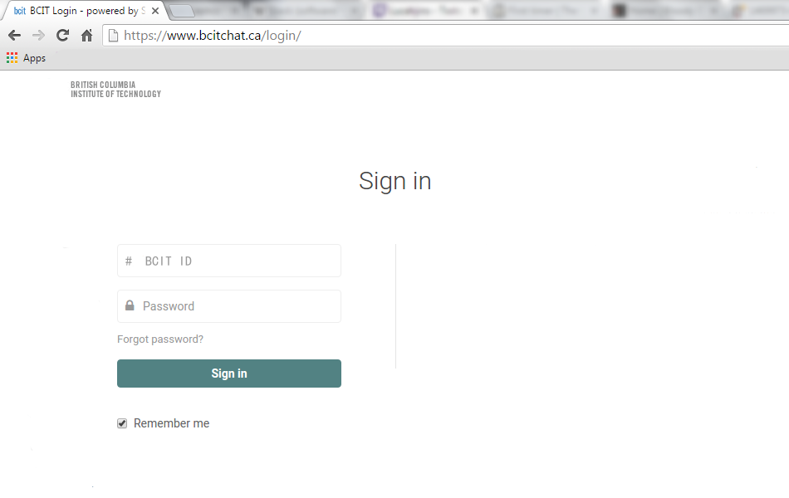

**BCIT Chat Application Login Page.** ID and Password are required.

Once a student or instructor is logged in, setting up their account profile is simple to figure out. The privacy settings for the account are important to configure, as it affects who they can directly message, as well as who can directly message them. All students and instructors would be competent with chat rooms and adjusting settings, especially if they have used Skype before.

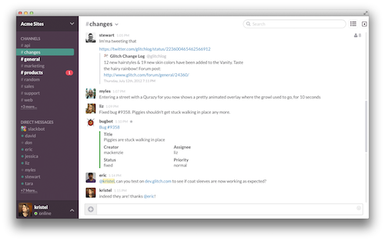

**User Dashboard.** Provides an overview of the profile and recent messages.

All of BCIT’s instructors are highly skilled in the use of technology, and the students, regardless of age, are a generation constantly exposed to the latest technology and can easily adapt to new technologic-based applications. Usage is simple enough to learn and figure out with little trouble, but if the faculty or students have any questions on how to use the chat platform, they will have access to phone or e-mail support connected directly to Spark wave, saving students and faculty time and effort to contact the school tech support for any issues that may come up.

**Stage III – Integration into the School System**

At this point in time, all students and instructors should have their chat account set up and personalized their profile, so that the chat application can be integrated into the school system. Though time is important, it is important that both students and faculty receive a decent amount of time to grow accustomed to the platform and get a feel for how it works. Most important of all though, both the students and instructors need to get used to using the chat system regularly, instead of returning to regularly using e-mail to communicate. Students can start using the chat system to direct message their instructors and ask any questions they may have on material presented in lecture, giving them a chance to learn how it functions. This also allows instructors to learn how the chat application works, as they will be answering back questions, allowing them to figure out how the chat application works through hands-on interaction with it.

Once a basic knowledge of the platform has been established, it should noted to both instructors and students that the chat platform will serve as the main method of communication between instructors and students, with myBCIT used for sending out e-mails pertaining to BCIT as a whole, or to inform students of important information for their programs or courses. As the server for the chat platform is private, all messages between instructors and students will remain confidential, especially 1 on 1 direct messages.

**Stage IV – Evaluations and Fine-tuning**

Some instructors may be reluctant to use chat platforms to reply back to students questions that require detailed explanations, which is inevitable, especially for the older instructors who are not as technology-inclined as others. Although ideally, all instructors would be willing to switch to the chat platform while the e-mail platform is slowly pulled back and used for administrative purposes only, to expect that of all instructors would be highly inflexible. However, Spark wave took this into account and came up with an alternative. For instructors that do not wish to constantly log in and log out, any direct messages students send to the instructors can be forwarded to their main e-mail, so they can still receive questions and answer students back.

Once two weeks have passed and both students and instructors are comfortable with using the chat platform, reviewing can begin. It is recommended that feedback be collected from students and instructors, grouped by program type and would consist of questions that pertain to the usage of the chat application. In particular, it would aim to determine:

* Ease of usage of the chat platform
* How frequently the platform is used
* Attitude towards chat performance

With this information, the institute will be able to see and determine how adequate and useful the chat platform is. Any instructors or students with low results would be instructed to spend time working on any areas of the chat platform they are having trouble with, as the ultimate purpose of the questionnaire is to ensure that all faculty members and students are comfortable with using the chat platform.

**Schedule**

Overall, the entire implementation of the BCIT Chat Application will run for a total of 3 weeks, which is a relatively short time period considering the number of instructors employed and students enrolled in the institute. The stages of implementation have been planned according, to give a sufficient amount of time for each stage, should any delays arise, allowing for some leeway.

|  |  |  |
| --- | --- | --- |
| **Week** | Day | Stage |
| **Week 1** | Monday | **Stage I** |
| Tuesday |
| Wednesday |
| Thursday | **Stage II** |
| Friday |
| **Week 2** | Monday |
| Tuesday | **Stage III** |
| Wednesday |
| Thursday |
| Friday |
| **Week 3** | Monday |
| Tuesday |
| Wednesday | **Stage IV** |
| Thursday |
| Friday |

Stage I Schedule (3 days):

* Registration and Administration confirm all current instructors and students have a valid BCIT ID
* Ensure all instructors and students have downloaded the chat platform on either their laptops or cell phones.
* Contact Spark wave to purchase and set up a private server
* Send out informative e-mail detailing the transition to the chat platform

Stage II Schedule (3 days):

* E-mail students and faculty members with instructions on how to log in and set up chat account
* Provide students and instructors time to view the videos and guides to learn the different features of the platform.

Stage III Schedule (6 days):

* Students begin using chat platform to send any questions to their instructors on material covered in lectures.
* Instructors use platform to reply to students questions
* Chat platform should be also utilized by instructors to inform students of any unexpected circumstances that occur.
* Faculty and students learn to log in regularly to check for new messages or updates.
* Chat platform is fully integrated into the school system.

Stage IV Schedule (3 days):

* Determine how many students and faculty members are actively utilizing the chat platform.
* Distribute the questionnaire through myBCIT e-mail to collect information of the usage of Spark wave’s chat application.
* Use the data collected to improve communication between students and instructors.

**Budget**

Switching from using myBCIT e-mail to the chat platform is relatively inexpensive. The application itself is free to download, but the private server for BCIT’s own use will cost each student $10.00 a month, totally to roughly $10,000 annually. In addition to the fees there are the hours instructors will spend learning how to use the chat platform, and also time spent with troubleshooting in the event technical issues come up.

|  |  |
| --- | --- |
| Stages I-IV | Cost |
| **Variable Wage Expenses**  Instructor Training  Technical issues | **$ 2,800.00**  **$ 600.00** |
| Total  **Fixed Monthly Expenses**  Account Subscription x 1000 | **$ 3,400.00**  **$10,000.00** |
| Annual Subscription total | **$120,000.00** |

**First Year Annual Total $123,400.00**

**Conclusions**

With many instances of instructors falling ill or becoming physically incapacitated, preventing them from teaching lectures or labs, e-mailing students has been the most often used method to inform them of changes to their schedules. However, this is not the most reliable, as the professor may be unable to send the e-mail out themselves, instead delegating it to another staff member, who in turn may forget to send the e-mail out or send it out but students receive it after already arriving for class. A more reliable and concrete way of keeping the line of communication between students and instructors open is needed. This is where Spark wave’s chat application comes in. By setting up a private server with all students and instructors placed in chat groups based on the program they teach in or are enrolled in, lines of communication are made easier. Implementing the chat application will ensure both the students and instructors will remain up to date and easy to get a hold of.

The relatively low cost of the platform and private server and the overall integration of Spark wave into the school system makes the platform not only flexible, but also easy to adapt to. With the work placed into implementing it, the financial return from the fees alone is significant. As more and more students enroll into BCIT, adding accounts to the server and having the students make use of it takes little to no trouble at all.

**Recommendations**

If this proposal is approved, it is recommended Stage I begin at the end of this month (March, 2016). As a majority of students are either on break or taking summer classes, this is good chance for both students and faculty to spend the time learning the platform and features. It is best to begin when all students and faculty are still present, just before finals week begin for all.

**References**

Slack Product Tour. (n.d.). Retrieved March 8, 2016, from Slack product website: <https://slack.com/is>

Slack Pricing. (n.d). Retrieved March 10, 2016 from Slack Pricing website: <https://slack.com/pricing>

**Appendices**

Explanation video of the various products and features of Slack.com, a chat application similar to the one in the proposal: <https://www.youtube.com/watch?v=Ivn5jfKE_5M>

Slack.com Blog, which provides articles relating to the platform and its features:

<https://slackhq.com/>