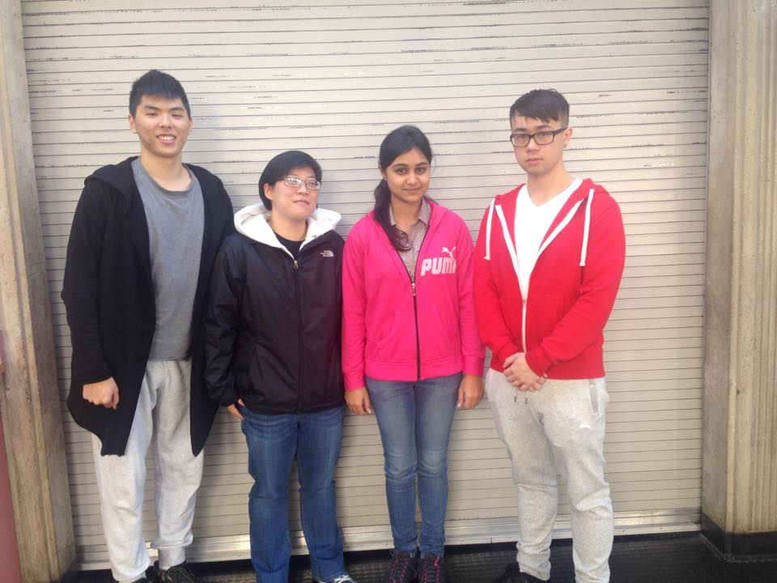

**“**We’re not really loud, but we’re certainly proud, and we’re smarter than you think. We are United Asians.”

Tanvi Bhambri

Katelin Keong

Kelvin Trieu

Lin Yang

**Mission Statement:** Guided by unceasing focus, we will discover and develop the skills required in IT field. We will strive to excel in every course while at BCIT. Our vision is to become the recognized students in terms of academics. All our strategies and actions will be planned and executed while keeping in mind a set of core values that are shared by all the team members.

**Core Values:**

3 core values shared by all members:

1. Conformity (**CONFORMITY:** Restraint of actions, inclinations, and impulses likely to upset or harm others and violate social expectations or norms)
2. Universalism (**UNIVERSALISM:** Understanding, appreciation, tolerance, and protection for the welfare of all people and for)
3. Self Direction (**SELF-DIRECTION:** Independent thought and action — choosing, creating, exploring)

**General Goals:** United Asians’ primary focus is to graduate from BCIT with a CIT diploma. It is done by self-motivation and hard work. Another goal we share is to attain both knowledge and skills that will aid us in the workforce in the future. Teamwork is essential because it is one of the core attributes in a successful organization. The ability of being able to work interdependently with each other is a highly sought out trait. Abilities brought in by individuals play a key role in this.

**Individual Goals:**

**Katelin:** Katelin wants to obtain a career in Gaming Development. This goal can be achieved by acquiring skills and knowledge from enrolling in and entering into two full-time programs offered at BCIT, the CIT program and the BTech program, going into Gaming Development. Both programs are two years long. By the time 2017 comes around, Katelin should have enough credits to enter into the BTech program and complete the program by 2019.

**Kelvin:** Kelvin wishes to pursue a career as a Network System Administrator. He can achieve this goal by attaining new skills and knowledge from enrolling in two programs at BCIT, the CIT program and the BTECH program. Both the programs are two years long. By 2017, Kelvin should have enough credentials to attempt the BTECH program and completing his education by 2019. He may prolong his journey by another two years if he decides to enroll into the part-time studies of BTECH.

**Lin:** Lin wants to start a studio of video games in the future. First, he will upgrade his management skills, communication skills, decision-making skills, and the most important skill of all, computer programming. That is his stage goal. He will finish his diploma in computer and then successfully enter the game development degree program.

**Tanvi:** Tanvi wishes to explore a career in Cyber Crime Investigation and Forensics. After graduating from the CIT program, whose duration is two years, she will aim to get a good job. She will save money for the next two years and then enrol into the Cybercrime and Forensics program at BCIT. As it is a part-time course she will be able to study while working full time.

**Specific Goals:**

As of September 26, 2015, United Asians’ projects:

|  |  |  |  |
| --- | --- | --- | --- |
| PROJECT | DEADLINE | WEIGHT | DESIRED GRADE |
| ORGB1100 Team Charter | 2/10/2015 | 10% of final grade | 85% |
| Peer Assessment | 16/10/2015 | 10% of final grade |  |

Currently, United Asians are not collaborating in any other projects together. The projects or assignments deadlines outside of this course as of September 26, 2015:

|  |  |  |
| --- | --- | --- |
| Project/Assignment | Deadline | Comments |
| ACIT1630 Database Project | Week 5 of term | Awaiting proposal approval |
| ACIT1620 Chinese Zodiac | 2/10/2015, 18:30 |  |
| ACIT1515 Logistics Sim | 9/10/2015, 23:59 |  |
| ACIT 1630 Database Milestone 2 | 9/10/2015 23:59 |  |
| ACIT 1620 Mobile Zodiac | 18/10/2015 23:59 |  |
| ACIT 1630 Database Milestone 3 | 23/10/2015 23:59 |  |

1. **Jobs (Tasks): Chair Person:** He/she will plan and conduct meetings with effective outcomes. He/she will develop the agenda in company with the Project Manager. He/she will provide leadership. His/her job includes providing support and supervision to the members of the team. He/she will represent the team and will be its spokesperson. He/she does not dominate meetings; has good listening skills and is impartial in letting all views be heard.
2. **Project Manager:** Project Manager has the overall responsibility for the successful initiation, planning, design, execution, monitoring, controlling and closure of a project. His/her role also includes presiding over meetings when the chairperson is absent. His/her duty is to recognize any risk that directly impacts the project his/her team is working on.
3. **Time Keeper:** His/her role is to ensure that everyone arrives at the meeting room 10 minutes before the scheduled meeting time. He/she decides the time and duration of the meeting.
4. **Designer/Formatter**: Presentation of your report plays an essential role. Other organizations or teams will judge your team on the basis of the report presented to them. Designer/formatter is responsible for collecting, analyzing, organizing and editing data. He/she is responsible for designing the format of the assignments and project reports.
5. **Note Taker/ Scriber**: He/she is responsible for taking notes and writing down all important information discussed about during the meeting.

|  |  |  |  |  |
| --- | --- | --- | --- | --- |
| Jobs/Tasks | Katelin | Kelvin | Lin | Tanvi |
| Chairperson |  | ☺ |  |  |
| Project Manager |  |  |  | ☺ |
| Time Keeper |  |  | ☺ |  |
| Lead Developer | ☺ |  |  |  |
| Designer/Formatting | ☺ |  |  |  |
| Task Master |  |  |  | ☺ |
| Note taker/Recorder |  |  | ☺ |  |
| Supervisor | ☺ |  |  |  |

United Asian’s ruling is based on each member. The group standards and rules include:

* Members must be ready to start the meeting five minutes before actual meeting start time.
* Outside meeting and school time, most of the team communicating and file sharing is done via Facebook, for simplicity. If contact is urgent, face to face communication will be the preferred method. However, if distance is an issue, contacting members by phone is the next choice.
* Tasks are divided equally throughout the team. All assigned tasks and designated deadlines are to be delegated by the team project manager, Tanvi Bhambri. The team may negotiate with Tanvi about the tasks and deadlines.
* Disagreements and conflicts are to be dealt with as a group
* Any late assignments are to be made up by buying lunch for the whole team
* If assistance is required, please request ASAP; don’t be afraid
* Treat each other with respect as a family.
* Any misconduct that is out of the group’s control will be dealt with using the progressive discipline process, starting at step 2.

Progressive discipline process:

1. A verbal reminder is given to the misbehaving member. If the problem persists, the other members will vote to move on to step 2.
2. A written notice is given to the member with inappropriate conduct. The notice will specific what problems the member in question is creating or what part of the team charter the member has broken. A copy of this notice will be given to the instructor.
3. There will be a meeting with the instructor to address the problem and to prepare a written last chance agreement. The agreement will state the specific requirements that must be met by the team member. Copies of the last chance agreement will be provided to the instructors.
4. A written recommendation for dismissal of the team member in question will be written up if the last chance agreement has not been adhered to.

|  |  |  |  |  |
| --- | --- | --- | --- | --- |
| Performance Criteria #1: Working Skills | | | | |
| Description: A team member produces amount of work in a period of time. Ability to work independently completed tasks and assignment efficiently. | | | | |
| **RATINGS** | | | | |
| **Exceeds**  **Expectations**  **5** | **Meets**  **Expectations**  **3** | | **Below**  **Expectations**  **1** | |
| **Behavioral Anchors(Descriptors)** | | | | |
| Work assigned is always finished on time. | Work assigned is sometimes finished on time. | | Work assigned is never finished on time. | |
| Works very hard and with full dedication to achieve the stated objectives. | Tries to achieve the stated objectives. | | Does not put in much effort or shows dedication towards the stated objectives. | |
| Follows all the rules and instructions carefully. | Follows most of the instructions. | | Does not follow instructions at all. | |
| Willingly helps others in completing their task. | Occasionally helps others in completing their tasks. | | Never helps team mates with their tasks. | |
| Performance Criteria #2: Knowledge | | | | |
| Description: A team member processes and demonstrates an understanding of the work instructions, equipment and materials required to perform the job. | | | | |
| **RATINGS** | | | | |
| **Exceeds**  **Expectations**  **5** | | **Meets**  **Expectations**  **3** | | **Below**  **Expectations**  **1** |
| **Behavioral Anchors(Descriptors)** | | | | |
| Full knowledge of work. | | Average knowledge of work. | | Lacks knowledge of work. |
| Can finish task independently. | | Works independently with some help from the others. | | Lacks ability to work independently (Gives up on work without even trying). |
| Perfectly combines personal knowledge with work experiences. | | Average connection between knowledge and work experiences. | | Does not have any work experiences which can connect to own knowledge. |
| Great quality of work produced with minimum to no mistakes. | | Average quality of work produced which required some changes to be done. | | Irrelevant work produced having no connection with the task assigned. |

|  |  |  |
| --- | --- | --- |
| Performance Criteria #3: Interpersonal Relationship | | |
| Description: A team member demonstrates the ability to communicate with other team members. | | |
| **RATINGS** | | |
| **Exceeds**  **Expectations**  **5** | **Meets**  **Expectations**  **3** | **Below**  **Expectations**  **1** |
| **Behavioral Anchors(Descriptors)** | | |
| Always communicates with each and every team mate which helps to build strong relationships. | Tries to communicate with other team mates. | Never shows interest in communicating with other team members. |
| Respects other cultures and opinions never have conflict with others. | Respect other cultures but sometimes have little conflict with others opinions. | Does not respect others and create conflicts or struggles. |
| Trusts the other team mates and their decisions. | Sometimes trusts other team mates. | Does not trust team mates and often disagrees with their ideas or work. |
| Never have conflicts with other team mates, as he/ she willingly listen to others’ opinions. | Sometimes have conflicts with other team mates. | Always opposes other team mates’ decisions thereby landing into conflicts. |
| Performance Criteria #4: Meeting Skills | | |
| Description: A team member demonstrates the ability to state the opinion clearly and create professional environment during the group meeting. Be on time for the meetings. | | |
| **RATINGS** | | |
| **Exceeds**  **Expectations**  **5** | **Meets**  **Expectations**  **3** | **Below**  **Expectations**  **1** |
| **Behavioral Anchors(Descriptors)** | | |
| Very well prepared for the meeting. Strategy related to the meeting agenda, clearly describes his/her ideas to team members. | Sometimes come prepared for the meetings. Planned strategies sometimes related to the meeting topic. | Does not have strategy or any ideas during the meeting. |
| Never distracts during meetings or goes off topic. | Sometimes acts as a distraction during meetings. | Always distracts others and talk about irrelevant material during meetings |
| Always arrives 10 minutes before the schedules meeting time. | Sometimes arrives before the meeting time. | Is always late more than 10 minutes of the scheduled meeting time. |
| Actively participates and takes interests in all group meetings. | Sometimes shows interest in group meetings. | Never participates or take interest in any of the group meetings. |