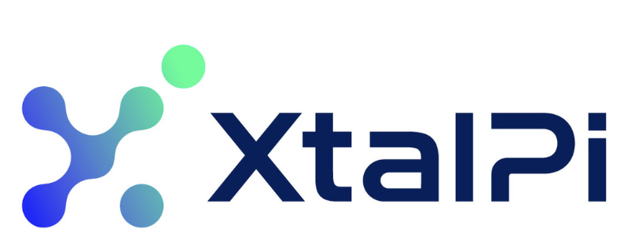
Company Analysis ----XtalPi
Wen Ka NIng
UID:3036232257

Table of Contents
XtalPi (2228.HK) 2
Founder Proposition 3
History of the Company 5
Technology 5
Commercial Validation & Partnership Quality 11
Moat 13
Competitors 14
Market Size 16
Financial Analysis 18
Risks 24
Valuation 80
Investment Thesis 27
Conclusion 28
Reference 29

Rating:  Price (2 April 26, HK$):  Target Price (HK$):  52-Week Price Range:  Market Cap. (HK$ bn): 41.3 | Hold *  9.6  10.00  3.85-15.12
*Target Price is for 12 months.
Enterprise Value (US$ bn): 34.01

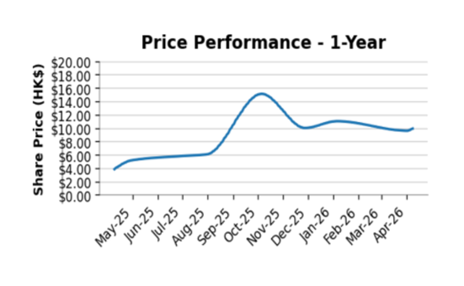

Figure 1. XtalPi Stock Price Performance

A corrected DCF based on actual FY25 revenue of RMB 802.6m, a 13.0% WACC (reflecting customer concentration and execution risk), and a 2.5% terminal growth rate produces an implied enterprise value of approximately RMB 2,800m and an implied equity value of approximately RMB 9,870m (including RMB 7,070m net cash), supporting a base-case target price of HK$10.00 per share.

XtalPi (2228.HK)

Company Summary
■ XtalPi is an AI-for-Science (AI4S) platform company integrating quantum physics, artificial intelligence, and robotic automation to transform drug discovery and materials R&D, which is the first company processed by 18C HKEX. Unlike traditional biotech firms, its value proposition lies not in a single pipeline, but in a scalable, closed-loop R&D infrastructure that generates proprietary data and continuously improves model performance.

The company demonstrates strong technological differentiation and increasing commercial validation, evidenced by partnerships with global pharmaceutical leaders and accelerating revenue growth. However, competition is intensifying, particularly as large pharmaceutical companies build internal AI capabilities and rival AI-native platforms scale rapidly.

At the current share price of roughly HK$9.6–9.75 and a market cap around HK$41.3 billion in early April 2026, XtalPi looks like a high-quality and underestimated AI-for-science platform stock. Despite strong revenue growth and improving operational efficiency, the current valuation does not fully reflect the company’s long-term platform scalability and cross-industry expansion potential.

Final Recommendation: HOLD

Figure 2. Financial and Valuation Metrics
Year 12/23A 12/24A 12/25A 12/26E

GAAP EPS (RMB) -0.44 -0.35 0.03 0.04
GAAP P / E (x) NM NM 283.68 215.27
Revenue (RMB m) 174.4 266.4 802.6 1,043.4
EV / Revenue (x) 201.72 132.06 43.84 33.72
EBITDA (RMB m) NM NM 158.4 208.7
EV / EBITDA (x) NM NM 222.19 168.61

Founder Proposition
Three MIT-trained postdoctoral researchers in quantum physics co-founded the company, bringing strong backgrounds in physics and computational chemistry. They shared the same vision: to revolutionize crystal structure prediction and transform drug research. The Chairman is Dr. Shuhao Wen, the CEO is Dr. Jian Ma, and the CIO is Dr. Lipeng Lai.

Dr. Shuhao Wen----Chairman
Dr. Wen finished his PhD degree in physical chemistry, Dalian institute of chemical physics, Chinese academy of sciences in 2021 and became the postdoctoral associate at MIT from 2013 to 2015 in chemical physics field, which align with the company’s stated positioning in quantum physics-based and AI-powered R&D. He is primarily responsible for strategic management and planning, fundraising and investment in the company. He is the clearest external-facing XtalPi’s external-facing founder capital.

Dr. Jian Ma----Chief Executive Officer
Dr. Ma finied his PhD degree in physics in zhejian university in 2012 and completed his postdoctoral resrach as MIT in 2014. Dr. Ma is the operation founder in the company hat converst algorithms, robotics and wet-lab workflow into repearable commercial delivert and execution discipline, platform deployment an dorganization-wide operating control.

Dr. Lipeng Lai----Chief Innovation Officer
Dr. Lai earned his PhD in physics from the University of Chicago in 2012 and later served as a postdoctoral associate in the Singapore University of Technology and Design–MIT Graduate Fellows Program from 2012 to 2014. He represents the internal engine behind the company’s model portfolio and platform innovation, helping to defend the company’s technical edge through large AI-model integration and the application of AI in reaction prediction, molecular design, and multi-agent workflows.

Taken together, the team gives XtalPi a rare combination of scientific credibility, AI capability, operational execution, and pharmaceutical strategic interface. The management team’s backgrounds also support the company’s credibility when dealing with pharmaceutical and materials-science customers. That said, founder quality alone is not a moat. The team still needs to prove that technical excellence can translate into durable customer economics rather than project-by-project revenue.

History of the Company
The development of XtalPi can be divided into three phases. The early phase was defined by technical validation. The company initially attracted attention through crystal-structure prediction and molecular modeling work in 2017, particularly in collaboration with Pfizer.

The second phase expands the business from computational chemistry to a wider range of artificial intelligence along with robotic R&D systems. By 2024, the company will combine AI tools, robotic experiments, and high-quality data to generate a self-reinforcing close-loop system. And it was successfully listed in HKEX by Chapter 18C and demonstrated a early proof of commercial threshold achievement.

The third stage is profitability from 2025. Starting revenue grew from 266.4 million yuan in 2024 to 802.6 million yuan in 2025, and profitability turned positive. It shows that the platform is not only improving technically, it is also driving business relevant customer collaboration.

- 2015-2017: Early technical validation in crystal-structure prediction and initial pharmaceutical collaboration.
- 2018-2023: broader platform formation through physics, AI, and computational chemistry partnerships.
- 2024: HKEX listed under Chapter 18C.
- 2025-2026: Revenue acceleration and strengthen cooperation with large-pharma customers.

Overall, XtalPi’s history shows a clear progression from scientific validation, to platform build-out, to commercial execution. This reduces the risk that the company remains only a promising technology story without real operating leverage.

Technology
XtalPi’s main strength is not just its AI models or its robotic labs on their own, but the way these parts work together within one operating system for R&D. As new experimental data are generated, they are used to refine subsequent design decisions, creating an iterative system that can improve over time. The integrated Design–Make–Test–Analyze workflow helps XtalPi run research more quickly, at larger scale, and with greater consistency.

AI Model Layer
At the front end of the platform, XtalPi has developed a suite of AI models that support multiple stages of discovery.

Small-Molecule Drug Discovery Suite
These models aim to improve hit identification, lead optimization, and candidate selection.
Product | Function | Strategic Role
XMolGen | Molecular generation | Structure-based drug design
XInsight | Molecular design optimization | Learns from >1M modification cases
XPose | Binding mode prediction | Structure-based drug design
XFF / XFEP | Free energy perturbation | High-precision affinity prediction
X-ADMET | Drug property prediction | Improves clinical success probability

- Antibody & Protein Platform
Key capabilities of the antibody and protein platform include 3D structure prediction from sequence within a day, antibody humanization & affinity maturation, and bispecific antibody design. This positions XtalPi competitively versus platforms like AlphaFold, but with direct drug development integration, not just structural prediction.
Platform | Function
XtalFold™ | Protein structure & antibody-antigen prediction
XenProT™ | Generative AI for protein therapeutics
Xentient™ | Predictive modeling for antibody optimization

- Next-Generation Modalities Platforms
  - Molecular Glue Platform
XtalPi has developed a molecular glue platform focused on protein–protein interactions, an area that has historically been difficult to drug using conventional approaches. The platform is designed to enable the selective degradation of undruggable proteins by bringing target proteins into proximity with E3 ligases. By combining AI-driven design tools with ultra-large virtual and physical chemical libraries, XtalPi can accelerate the identification and optimization of high-activity, high-selectivity, and patentable compounds across multiple targets.

3.2 PepiX™ Peptide Platform
PepiX™ is a peptide discovery platform that integrates AI-driven peptide generation with automated synthesis and high-throughput screening. the platform is supported by a trillion-scale peptide library to improve the efficiency and precision of peptide drug discovery. The applications of the paltform include blood–brain barrier-penetrating peptides, orally administered peptide therapeutics, and peptide-based cancer vaccines. This gives XtalPi exposure to a fast-growing segment of next-generation biologics.

  - mRNA / Nucleic Acid Platform
The platform uses pre-trained models to improve mRNA expression, stability, and overall developability, thereby supporting the design of more effective nucleic acid therapeutics. The platform is the integration of sequence-level modeling with predictive analytics.

The AI layer is not merely predictive, it is continuously improving through the accumulation of proprietary data and is deeply embedded within the company’s execution workflows. As a result, it creates a data-driven network effect moat, whereby an increasing volume of experiments leads to better-performing models, which in turn improves success rates, attracts more customers, and ultimately generates even more data to further reinforce the system.

Robotic Laboratory Layer
XtalPi operates fully automated robotic laboratories that run experiments continuously and generate over 200K reaction data points monthly by covering over 80% of medicinal chemistry reaction types. These systems are designed to eliminate manual bottlenecks in chemical synthesis and analysis, enabling fully automated, high-throughput experimentation with high consistency and reproducibility.

XmartChem: Intelligent synthesis Workstation
XmartChem is XtalPi’s flagship automated synthesis platform, engineered to perform end-to-end chemical experimentation with minimal human intervention. The system integrates multiple experimental steps into a unified workflow, including solid and liquid dispensing, reaction setup, product dilution, transfer, filtration, and LC-MS analysis. As a result, XmartChem materially improves the efficiency of reaction condition screening, organic synthesis, catalyst evaluation, and compound library screening.

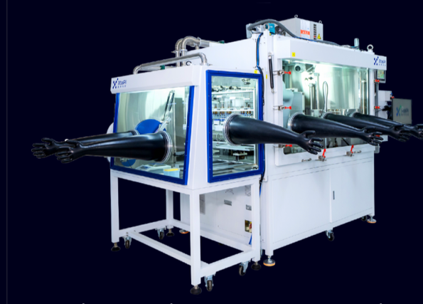
Figure3. Glove Box Workstation.

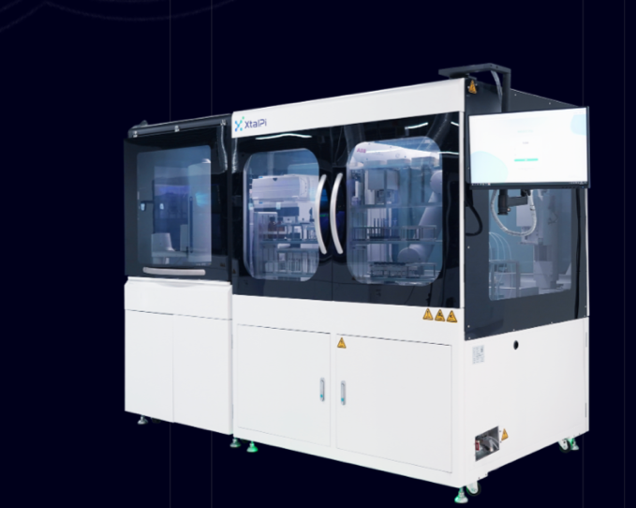
Figure 4. LCMS Workstation.

ChemPlus
ChemPlus is a desktop solid-dispensing system designed to automate the otherwise time-consuming process of weighing and dispensing solids. It can handle different solid materials and container formats without continuous human monitoring, improving both speed and precision. Its application extends beyond pharmaceuticals into petrochemicals, fine chemicals, materials, food and beverage, and energy, highlighting the broader industrial relevance of XtalPi’s automation capabilities.

Key Advantage vs Traditional Labs
Traditional Lab | XtalPi Robotic Lab
Manual, low throughput | Fully automated, high throughput
Human variability | High consistency
Slow iteration cycles | Continuous 24/7 iteration
Limited data generation | Massive proprietary datasets

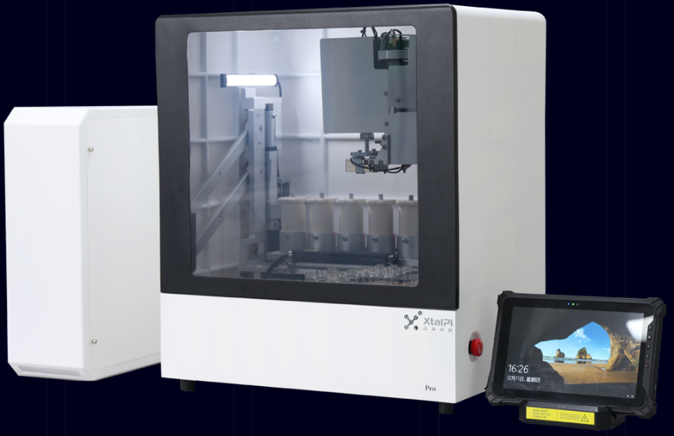
Figure 5. ChemPlus station.

Data Feedback & Multi-Agent System
The final layer is XtalPi’s data feedback and multi-agent architecture, which connects AI models and robotic execution into a unified operating system. Tools such as Agentic Genius, MolAgent, and PatSight function as orchestration and decision-support layers: Agentic Genius coordinates workflows across the platform, MolAgent supports molecular design and optimization, and PatSight extracts structured information from patents and scientific literature. Together, these systems reduce manual coordination and move the platform closer to an autonomous R&D workflow.

From a strategic perspective, this layer is important because it turns the platform from a collection of tools into a self-improving system. As more experiments are run, more high-quality data are generated. As more data accumulate, model performance improves; and as models improve, the platform becomes more attractive to customers and better able to generate additional data. This creates a data-driven network effect, which is arguably XtalPi’s strongest technological moat.

Commercial Validation & Partnership Quality
For an AI-for-science company, commercial validation matters more than publicity. XtalPi’s partnership portfolio is therefore one of the most important parts of the report. The company disclosed that it served 17 of the world’s top 20 pharmaceutical companies in 2025. This is a high-quality signal because top-tier pharmaceutical companies are generally conservative buyers. They do not meaningfully expand vendor relationships unless the platform is solving a real problem in cost, time, or probability of success.

Pfizer 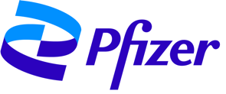
Pfizer is one of the world’s leading biopharmaceutical companies, The Pfizer relationship is especially important. XtalPi’s collaboration with Pfizer spans molecular modeling and force-field development, and the company has repeatedly cited the Paxlovid solid-form work as a proof point of real-world impact under time pressure. In 2025, XtalPi and Pfizer announced an expanded collaboration built around enhanced predictive modeling and deployment of XtalPi’s XFEP platform, indicating that Pfizer sees value in the company’s physics-plus-AI infrastructure rather than in a single isolated tool.

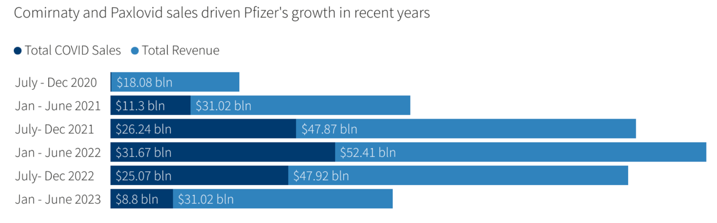
Figure 6. Pfizer COVID products’ contribution to overall sales. https://www.reuters.com/business/healthcare-pharmaceuticals/pfizer-swings-quarterly-loss-due-paxlovid-write-off-2023-10-31/

Eli Lilly
Eli Lilly is a global medicine company of translating science into therapies across major disease areas. The biologics unit of XtalPi, Ailux, had a multi-target strategic collaboration and platform licensing agreement with Lilly focused on bispecific antibodies in November 2025. XtalPi disclosed a total deal value of up to US$345 million, including an upfront payment, near-term milestones, and later R&D, regulatory, and commercial milestones. Lilly also obtained the right to use Ailux’s proprietary AI bispecific-antibody platform, which was the second high-value collaboration between the two companies following the 2023 small-molecule deal. The second deal suggests Lilly first validated XtalPi in chemistry, then expanded the relationship into large molecules once trust in the platform had been established. Lilly supports the investment case that the company is becoming one of the few AI drug-discovery players with pharma collaborations in both small-molecule and biologics R&D.

DoveTree Medicines
DoveTree Medicines is a biotech company founded by Dr. Gregory Verdine, a scientist-entrepreneur associated with first-in-class drug discovery and the idea of tackling historically difficult targets for oncology, immunology, and neurological disease. For XtalPi, the collaboration with DoveTree in August 2025 is a representative shift from a traditional SaaS company to a platform-biotech economics model. The strategic collaboration with DoveTree worth up to US$5.99 billion, with a US$51 million received upfront and US$49 million in additional near-term payments, plus up to US$5.89 billion in later development and commercial milestones, alongside tiered royalties. During the six months ended June 30, 2025, XtalPi had already achieved the first-phase milestone and recognized the US$51 million initial payment as revenue. Which means XtalPi converted the collaboration into recognized revenue.

Conclusion
The strategic implication is that customers are not only paying for isolated software outputs. They are increasingly using XtalPi in embedded discovery workflows and milestone-based projects. That is exactly the direction investors should want to see, because it supports deeper account penetration and potentially higher-value economics over time. However, commercial validation also reveals a weakness: scale is still concentrated.

Moat
XtalPi’s moat rests on three reinforcing advantages: a closed-loop R&D system, a cross-scientific workflow and broad platform, and a cash flow strong enough to increase risk resilience.

Closed-loop System
XtalPi's core moat is an integrated closed-loop R&D system that connects AI prediction, robotic experimentation, and data feedback into a closed-loop workflow. By 2025, the closed-loop platform has developed more than 200 AI models and more than 10,000 experiments per week, enabling rapid iteration between model output and experimental validation.

This structure allows the experimental results to continuously improve the accuracy of the model and thus improve the prediction success rate. XtalPi is more than just software, it develops both computational and experimental layers to achieve a composite data flywheel that can be enhanced with increased use and scale, achieving a positive feedback mechanism.

Platform Breadth
The second moat is the platform width. XtalPi spans small molecule, macromolecular and materials science. By 2025, the company serves 17 of the world's top 20 pharmaceutical companies and is expanding its capabilities to molecular gels, peptides, oligonucleotides, and new materials. XtalPi supports multiple stages of the R&D process within a single platform, from molecular design to synthesis and screening, and this breadth increases customer engagement. It can also reuse the underlying AI models and data infrastructure in different applications, reducing reliance on a single market segment.

Balance-sheet Strength
XtalPi's strong balance sheet gives the company sufficient cash flow to support the expansion of the platform without being forced to make short-term funding decisions. In 2025, XtalPi reported cash of 7.07 billion yuan and total equity of 9.43 billion yuan. In 2026, an additional 2.54 billion yuan of convertible bonds will be issued to enhance liquidity and financing capacity.

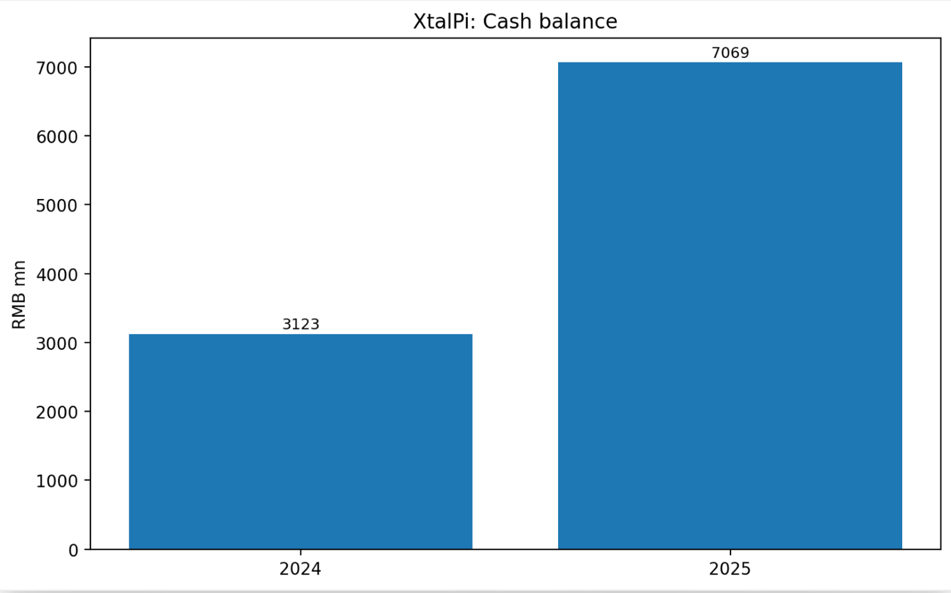
Figure 7. Cash balance of XtalPi in 2024 and 2025.

Competitors
Insilico Medicine (3696.HK)
Specialties: AI in drug design and aging research

Medicine is XtalPi's closest direct competitor, targeting the same pharmaceutical and biotech R&D budgets. Their strategic positioning is slightly different, with insilico being an AI biotechnology company with a pipeline of patented drugs, and XtalPi focusing on platform infrastructure. By 2025, InSilico served 13 of the world's top 20 pharmaceutical companies, generated $56.2 million in revenue and maintained $393.3 million in cash. Its pipeline includes 28 preclinical assets and 10 clinical-stage projects, with rentosertib positioned as a key proof-of-concept for ai drug discovery.

XtalPi is more commercialized and scaled compared to Insilico, which includes higher revenues, profitability, and broader enterprise adoption. However, Insilico has higher long-term upside potential due to its pipeline ownership and direct involvement downstream of drug development. This suggests that XtalPi is stronger in terms of short-term profitability and monetization, while insilico is stronger in terms of therapeutic and breakthrough asset creation.
Schrödinger(SDGR)
Specialties: Molecular modelling and drug design
Schrodinger's competitive advantages lie in software quality, standardized workflows, and deep integration with large pharmaceutical customers. In 2025, the company had total revenue of $255.9 million, including $195.5 million in software revenue, $56.4 million in drug development revenue, and $402.3 million in cash. Its revenue streams are mainly supported by recurring software contracts and long-term partnerships, including a further collaboration with Eli Lilly.

However, Schrödinger remains primarily a software platform, and its drug development is a second source of revenue. In contrast, XtalPi's model extends from software to support the R&D execution of the robot, enabling it to monitize computational and experimental workflows. This gives XtalPi an edge in end-to-end integration, while Schrodinger remains stronger in computational accuracy and enterprise software adoption.
Recursion(RXRX)
Specialties: AI and automation with biological datasets
Recursion is TechBio's main competitor, and its strength lies in biological data scale and automated discovery infrastructure. Like XtalPi, its platform combines proprietary multimodal datasets, automated biological and chemical laboratories, and industrial-scale experiments. And merged with Exscientia in 2024. However, Recursion remains investment-led rather than commercially mature.
Compared with Recursion, XtalPi is less differentiated by biological-data scale and more by commercialized closed-loop execution. Its advantage lies in monetized end-to-end R&D workflows, stronger near-term commercialization, and better integration of AI with applied chemistry and robotics. Therefore, Recursion is the stronger benchmark for long-term TechBio platform ambition, while XtalPi appears better positioned in current workflow integration and commercial deployment.

Overall Competitive Positioning
Overall, XtalPi is best understood as a commercialized AI-plus-robotics infrastructure provider, whereas peers such as Insilico and Recursion are more oriented toward proprietary pipeline ownership and long-term drug-value capture. As a result, XtalPi currently appears stronger in execution and monetization, while some peers may offer greater upside if their internal pipelines succeed.

Market Size

Total Addressable Market (TAM)
XtalPi’s TAM are composited from three different markets rather than only one niche category.

First, global pharmaceutical R&D spending is already at very large scale, R&D activities within the global pharmaceutical industry alone contributed US$227 billion globally in 2025 by IFPMA. That gives the company exposure to a very large core end-market in drug discovery and development.

Second, Maximize Market Research estimates the AI-in-drug-discovery market at US$3.5 billion in 2025, rising to US$14.8 billion by 2032, implying a 28% CAGR (Compound Annual Growth Rate). Thus, XtalPi’s long-term opportunity is wider still in AI-driven drug discovery field.

Lastly, the global new materials market could reach US$10 trillion, which expands the company's addressable opportunity into materials science, energy, and industrial R&D.

Overall, XtalPi’s TAM is best understood as a layered opportunity:
- Core: pharma R&D (large and established)
- Growth: AI drug discovery (high-growth, early-stage)
- Optionality: materials science (long-term expansion)

This positioning supports a structurally large and expanding market, but also highlights that not all TAM is equally accessible in the near term.

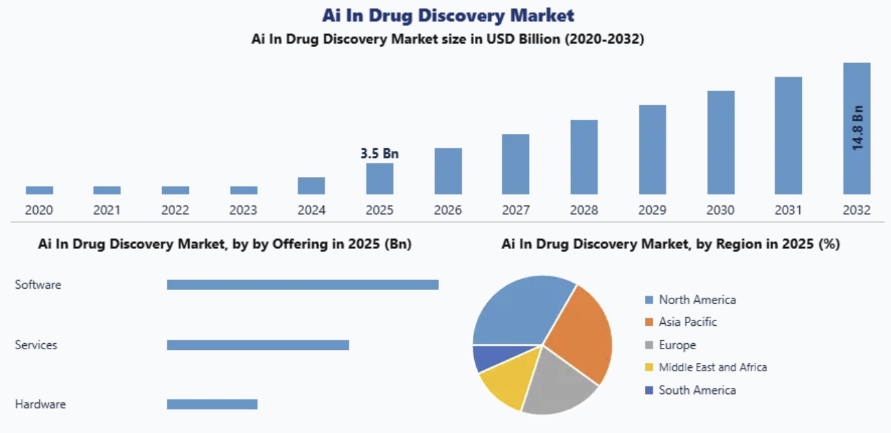
Figure 8. AI-driven drug discovery companies composition in the world. https://www.maximizemarketresearch.com/market-report/ai-in-drug-discovery-market/161733/

Serviceable Available Market (SAM)
The main costumers of the company can be divided into four main parts: large global big pharma company, mid-size biotech company, materials R&D companies and government and industrial AI platforms. As XtalPi is a AI-driven platform company in software and robotics integration. The costumer mainly trade AI simulation, molecular modelling, automated lab services (CRO) and platform licensing as well.

This suggests that XtalPi’s near-term growth is driven less by volume expansion and more by deepening relationships with sophisticated clients willing to pay for faster R&D, better data generation, and higher technical success rates. As a result, XtalPi’s SOM is best viewed as a concentrated, high-spending enterprise market, where growth depends on increasing contract depth and platform adoption within existing accounts.

Serviceable Obtainable Market (SOM)
XtalPi’s obtainable market is concentrated in a relatively small group of high-value enterprise clients rather than a mass-market customer base. It had worked with 17 of the world’s top 20 pharmaceutical companies and secured large strategic contracts by 2025, including a US$250 million-scale collaboration. Its commercial footprint has also expanded beyond China and the U.S. into new regions such as the Middle East. Therefore, XtalPi’s SOM is built around a focused set of sophisticated clients that are willing to spend heavily on faster R&D, better data generation, and higher technical success rates.

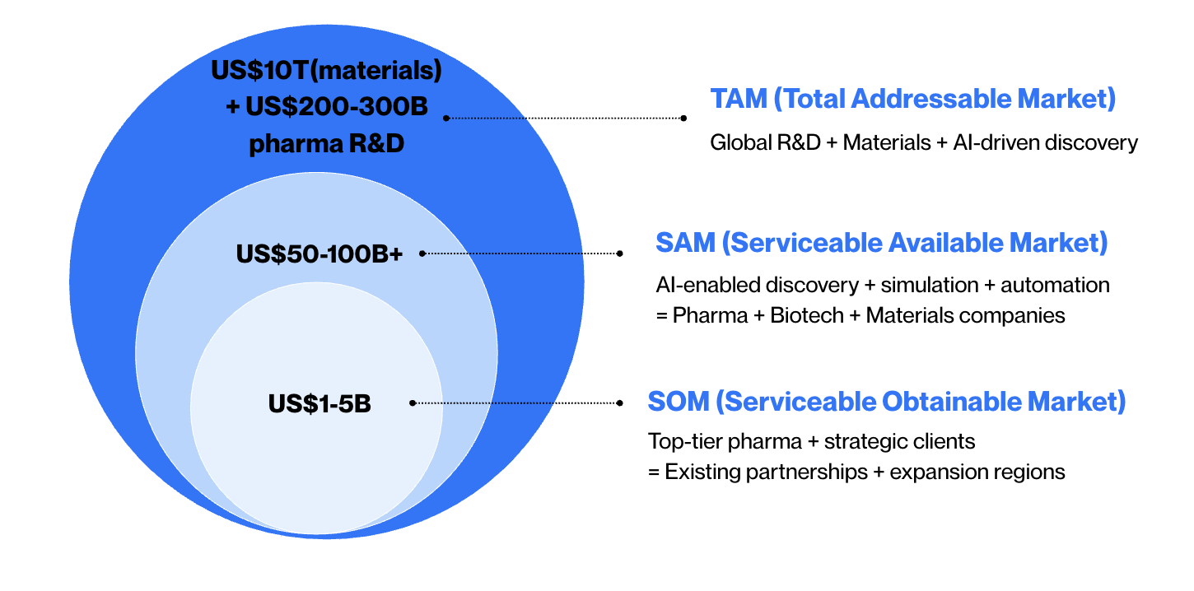
@ Wen Ka Ning
Figure 9. TAM-SAM-SOM structure of the market size in XtalPi.

Financial Analysis
The company is not a traditional biotech developer with a self-owned late-stage drug pipeline. Instead, it monetizes its platform through a combination of service revenue, collaborative research, and technology-enabled R&D solutions. As XtalPi only became publicly listed in Hong Kong in 2024, its public financial track record is still short. 2025 was the company’s first full year of profitability and marked a significant step-up in both scale and commercial execution.

Overall financial trend
XtalPi transitioned from a loss-making, early-stage platform in 2024 to a significantly larger and profitable company in 2025. Revenue scaled rapidly, and operating leverage improved, indicating progress from capability build-out to commercial execution. However, earnings quality requires caution, as part of 2025 profit was supported by non-operating fair-value gains and milestone-based revenue.

Profitability
The profit of the FY2025 improved significantly compared to FY2024 in XtalPi. In 2025, XtalPi reported revenue of approximately RMB803 million, R&D expense of about RMB569 million, profit for the year of RMB135 million, and adjusted net profit of roughly RMB258 million. This compares with FY2024 revenue of RMB266 million, net loss of RMB1.515 billion, and adjusted net loss of RMB457 million. On this basis, 2025 represented the company ’s first full year of reported profitability since its founding.

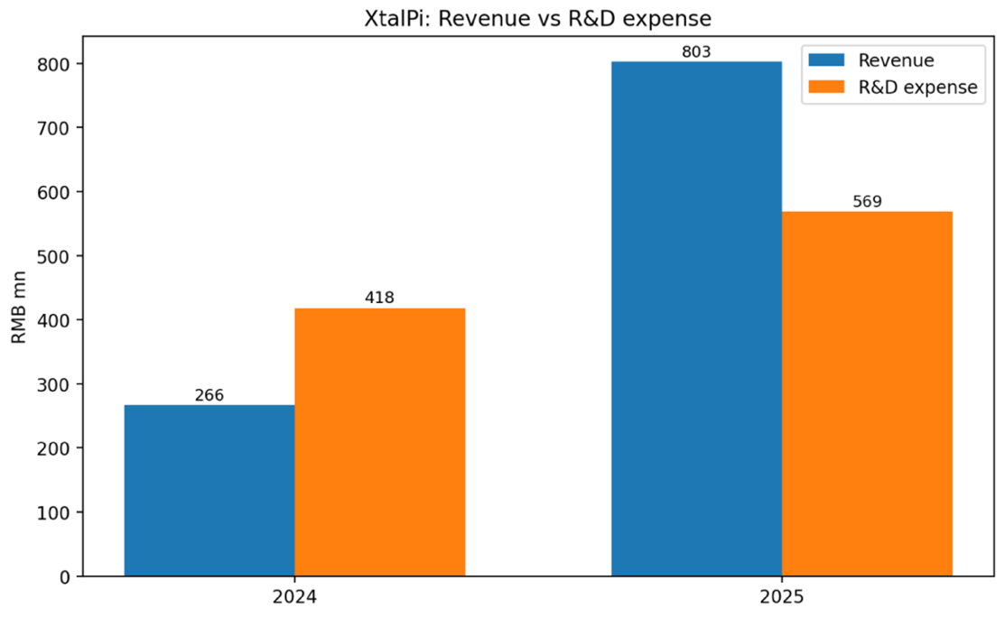
Figure 10. Comparison of XtalPi’s revenue and R&D expenses in 2024 and 2025.

Revenue Mix
Revenue composition shifted toward higher-value drug discovery services. In 2025, drug discovery contributed RMB538 million or 67%, while AI4S intelligent solutions contributed RMB265 million or 33%, compared with a more balanced mix in 2024. This indicates that commercialization is increasingly driven by core pharmaceutical R&D applications, which are more scalable and strategically valuable.

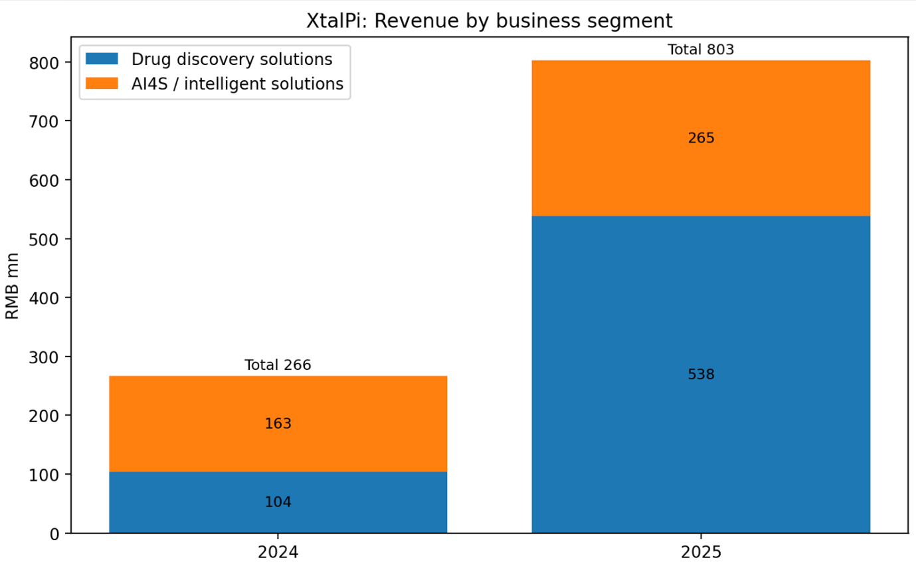
Figure 11. Revenue breakdown by business segment, 2024 vs. 2025.

Geographic Mix
The company’s revenue profile also changed significantly by region. In 2024, the United States contributed around 30.1% of total revenue, or roughly RMB80 million. By 2025, U.S. revenue had risen to about 57.1%, or RMB458 million. By contrast, China’s share fell from 56.8% in 2024 to 28.2% in 2025, while other regions contributed approximately RMB118 million.

This geographic shift appears to have been driven largely by a major international contract in 2025, which alone contributed about RMB365 million, or roughly 45.5% of total revenue. This reflects XtalPi’s ability to secure large global contracts, but also highlights growing customer concentration risk, as a significant portion of revenue is tied to a small number of major clients.

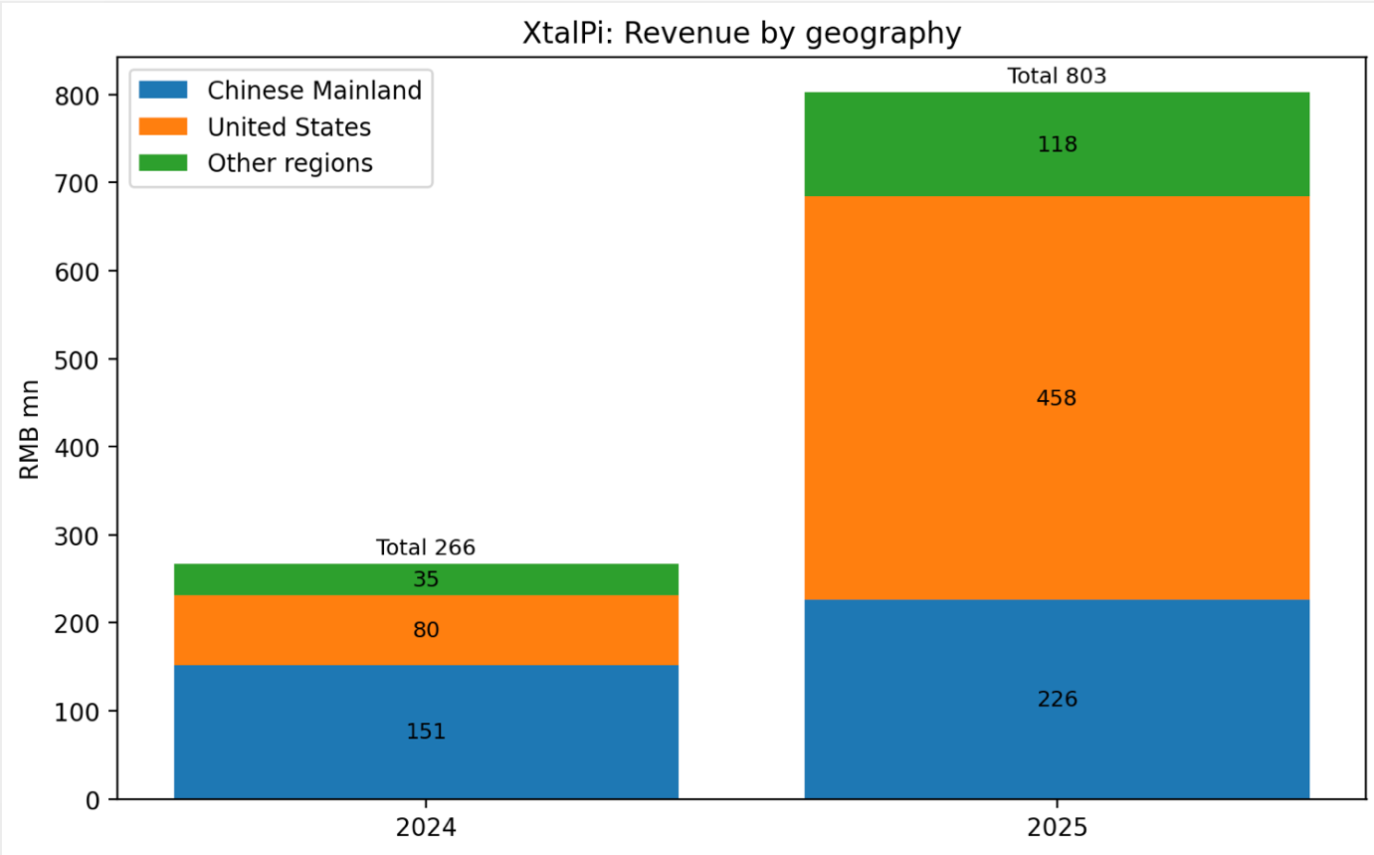
Figure 11. Revenue segmentation by geography in XtalPi in 2024 and 2025.

Margin and Operating Leverage
Profitability improved materially in 2025. Gross margin increased to 69.7% from 46.3% in 2024, while R&D intensity declined significantly as a percentage of revenue. Operating profit turned positive, indicating that revenue growth is beginning to outpace cost expansion.

Therefore, the financial position suggests that there is early operating leverage, although sustainability will depend on continued contract flow and platform utilization.

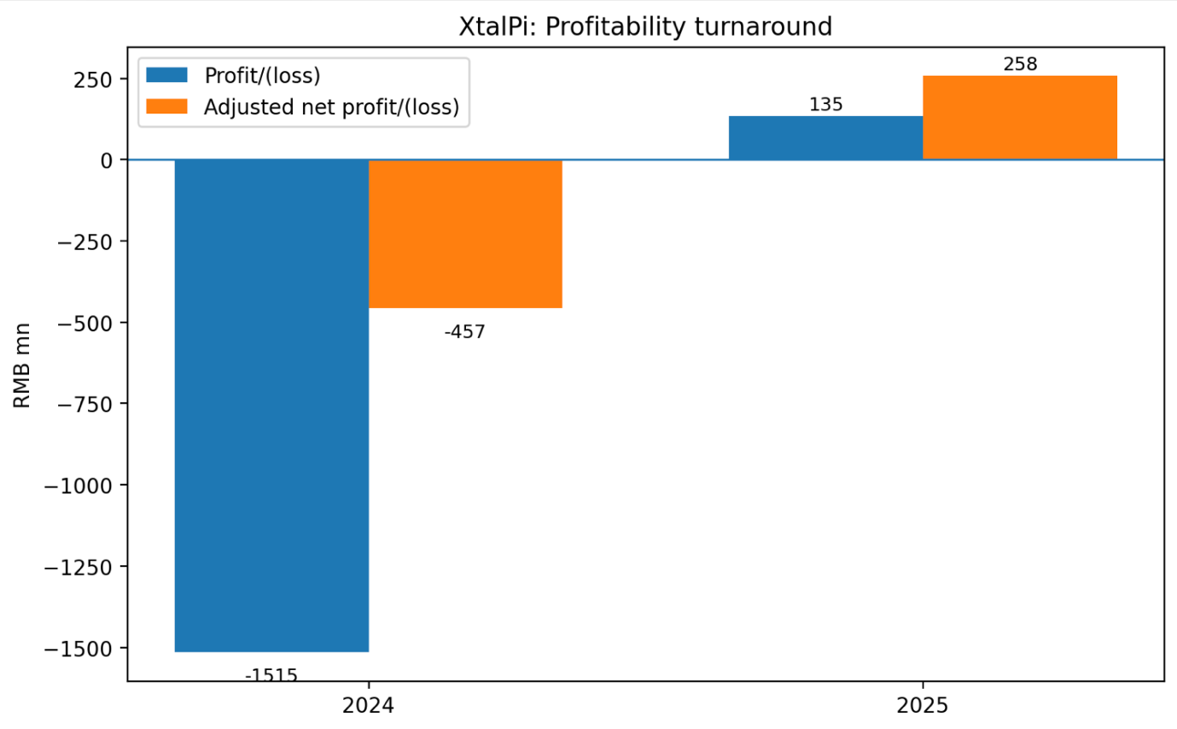
Figure 12. Profitability turnaround in XtalPi in 2024 and 2025.

Stock Market Performance
Over the past 52 weeks, XtalPi’s share price traded between HK$3.85 and HK$15.12, reflecting strong but volatile investor sentiment. The sharp rise in 2024 was supported by positive catalysts, including its five-year strategic cooperation agreement with GCL Group in 2024, its inclusion in the Hang Seng Composite Index effective 9 September 2024, and its admission to the Shanghai-Hong Kong and Shenzhen-Hong Kong Stock Connect programs effective 10 September 2024, all of which have increased market visibility and broadened the investor base.

The subsequent pullback appears to reflect profit taking and dilution concerns following the rally rather than a deterioration in fundamentals. The stock price sentiment improved again after the company completed two placements in early 2025 and posted stronger operating results, including rapid revenue growth and its first full-year profit in 2025. Overall, the stock’s performance shows that the market increasingly recognizes XtalPi’s commercial progress, although expectations remain highly sensitive to execution.

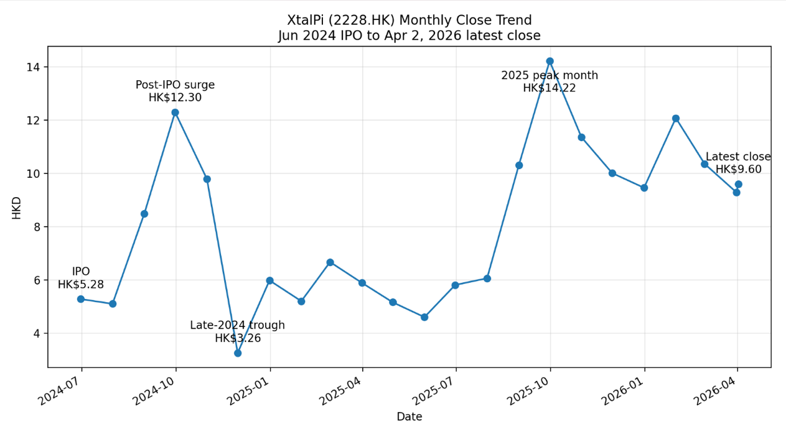
Figure 13. XtalPi (2228.HK) share price trend from IPO (June 2024) to April 2026, showing an initial post-IPO surge, subsequent volatility, a peak in late 2025, and stabilization around HK$9–10.

Risks

Red Sea Market (High)
AI drug discovery is now a crowded, well-funded market. XtalPi competes not only with AI-native peers such as Recursion and Exscientia, but increasingly with large pharmaceutical companies building in-house AI capabilities on top of their own proprietary datasets. Eli Lilly’s January 2026 AI lab with NVIDIA, backed by up to US$1 billion over five years, is a clear sign that big pharma is moving from AI adoption to AI internalization. Also, Novartis established an AI Innovation Lab with Microsoft to strengthen AI from research through commercialization. In other words, XtalPi is not only competing with AI-native peers for pharma budgets, but also with customers that may internalize more of the workflow over time using their own teams and proprietary datasets.

Customer Concentration & Dependency (High)
XtalPi remains exposed to customer concentration risk. In 2024, its top five customers contributed 33.4% of revenue and the largest customer accounted for 13.6%. Concentration increased further in 1H25, when Customer A contributed 70.6% of group revenue. This makes revenue more sensitive to contract timing, milestone recognition, procurement delays, or program cancellations.

Reliance on Proprietary Data Access (High)
XtalPi’s moat is data-driven, but this also creates dependency risk. While its closed-loop system and 26 million reaction data points support continuous model improvement, progress in areas such as target validation and patient stratification still depends on access to high-value proprietary clinical data held by major pharmaceutical companies. Because these datasets are private and tightly protected, XtalPi’s long-term model development may be constrained by limited external data access.

Geopolitical Exposure to the United States (Medium)
With around 57% of 2025 revenue from the U.S., XtalPi is exposed to geopolitical risks, including data restrictions and shifts in pharma procurement. However, this risk is mitigated by ongoing geographic and sector diversification.

Technology Obsolescence (Medium)
Rapid innovation in AI drug discovery requires constant reinvestment. Although XtalPi has built a large and evolving model base, competitive pressure from peers and industry consolidation indicates that the technological advantage of the company must be renewed continuously.

Economic-capture Ceiling (Medium)
XtalPi operates primarily through service and landmark based contracts, limiting its participation in downstream Pharmacoeconomics. While this model supports short-term revenue growth, it limits long-term upside compared to companies with more pipeline ownership.

Valuation

Summary
The target price is based on the combination of:
■ P/E ratio: Forward P/E ratios for EV/ revenue and EV/EBITDA are obtained from selected comparable listed companies. These methods provide valuation cross-checks, but the usefulness of EMA-based valuations is limited as most peers are still in early, low-profitable stages.

■ Discounted Cash Flow Analysis: The DCF framework is used as the primary intrinsic valuation method, based on actual FY25 revenue of RMB 802.6m, realistic margin expansion, and conservative free cash flow assumptions. The model applies a 13.0% WACC (reflecting customer concentration, geopolitical exposure, and execution risk) and a 2.5% terminal growth rate.

■ Target Price: Based on the report’s corrected valuation model, the 12-month target price is HK$10.00 per share, compared with the current market price of HK$9.60 on 2 April 2026, implying substantial upside.

■ Interpretation: While there are still near-term execution risks, the market does not appear to be fully reflecting the company's strategic platform value.

■ Other Methodologies: Limited emphasis on precedent deals due to few directly comparable AI-for-science transactions, and sector valuation remains highly sensitive to milestone-result and market timing.

■ Investment View – HOLD: The report revises the recommendation to HOLD on XtalPi’s improving commercialisation, first full year profitability and strong balance sheet, as the corrected DCF (13.0% WACC, 2.5% terminal growth, based on actual FY25 revenue) indicates the stock is fairly valued at a target price of HK$10.00.

Comparable Public Companies

Figure 14 – XtalPi Comparable Public Companies

Comparable Companies - Comparable companies include AI-driven drug discovery platforms
Company Name | Price(US$) |  | Market ($M) |  | Cap EV($M) | Revenue ($M)  12/31/2025 | EBITDA ($M) |  | EV/Revenue ($M)
%
XtalPi | 1.30 | 5,588.0 | 4,655.0 | 117.6 | 25.0 | 39.6
Insilico_Medicine | 7.77 | 4,447.9 | 4,009.5 | 56.2 | (49.9) | 71.3
Schrodinger | 12.34 | 1,476.5 | 1,074.2 | 255.9 | (160.9) | 4.2
Recursion | 3.78 | 2,118.7 | 1,383.4 | 74.7 | (564.4) | 18.5

Valuation is primarily based on EV/Revenue multiple due to the negative EBITDA across most peers s. All figures are converted to USD using latest FX rates on April 2, 2026. Market data as of April 2, 2026.
Explanation
Figure 15– Valuation Bridge Methodology
1. Apply peer median EV/Revenue multiple to XtalPi revenue to derive implied Enterprise Value (EV).
2. Convert EV to Equity Value by adding net cash (or subtracting net debt).
3. Divide Equity Value by diluted shares outstanding to derive implied share price.
Step |  | $Formula |  | Explanation
%
Implied EV | EV = Revenue × Peer Median EV/Revenue | Applies comparable company multiple
Equity Value | Equity = EV + Net Cash | Adjusts for capital structure
Implied Price | Price = Equity Value / Shares | Derives per-share valuation

Discounted Cash Flow (DCF) Analysis

The report relies on base-case financial projections to complete the Discounted Cash Flow analysis.

Figure 16 – XtalPi DCF Analysis
Assumptions: WACC 13%, Terminal Growth 2.5%, Mid-year convention applied. Revenue based on actual FY25 reported figures (RMB 802.6m).

Income Statement: |  |  |  |  |  | Projected
Income Statement: |  | FY24E |  | FY25E |  | FY26E | FY27E |  | FY28E
Revenue | 266 | 803 | 1,044 | 1,369 | 1,780
Revenue Growth | - | 201% | 30% | 28% | 23%
EBIT | -155 | 158 | 52 | 123 | 214
EBIT Margin | -19% | 20% | 5% | 9% | 12%
NOPAT | -50 | 134 | 44 | 105 | 181
+ D&A | 60 | 25 | 100 | 120 | 40
- Capex | -80 | -100 | -120 | -140 | -50
- ΔWC | -20 | -40 | -30 | -25 | -20
Unlevered FCF | -83 | -86 | -6 | 10 | 39

Source: Company data, WEN Ka Ning estimates.

Investment Thesis
Based on the corrected DCF analysis using a 13.0% WACC, a 2.5% terminal growth rate, and actual FY25 revenue of RMB 802.6m, XtalPi appears fairly valued at approximately HK$10.00 per share — consistent with the current trading price of HK$9.60. The original model materially overstated the target price (HK$25.78) by applying an excessively low 10.5% WACC that did not adequately account for customer concentration risk (single customer contributing 70.6% of 1H25 revenue), geopolitical exposure (57% of revenue from the U.S.), and the non-recurring nature of milestone revenue that inflated FY25 earnings. Once these risk premia are appropriately reflected in the discount rate, the implied intrinsic value aligns closely with the current market price.

As the business moves from a phase of reinvestment to greater monetization and margin expansion, its platform value should become more evident in earnings and cash flows. While execution risk, customer concentration, and competition remain important issues, the current valuation appears to understate the company's technology base and long-term business potential.

Accordingly, the report revises the recommendation to Hold.

Conclusion
Overall, XtalPi is a high-quality AI-for-science platform with a closed-loop technological system, strong commercialization capability, and increasing strategic partnership with global pharmaceutical companies, indicating that the company is building scientific infrastructure with long-term scaling potential.

While risks remain, including customer concentration, competition, and the durability of its data advantage, the corrected valuation model indicates these risks are already reflected in the current market price. At HK$10.00 target price, the stock appears fairly valued rather than materially discounted. Accordingly, the report revises the recommendation to Hold.

Reference

Yahoo Finance. “XtalPi Holdings Limited (2228.HK).” Accessed April 2026.
XtalPi Holdings Limited. (2026, March 25). Annual results announcement for the year ended 31 December 2025.
XtalPi. (2024, June 13). XtalPi debuts on HKEX main board as first 18C listing, pioneering AI + robotics innovation. https://en.xtalpi.com/xtalpi-debuts-on-hkex-main-board-as-first-18c-listing-pioneering-ai-robotics-innovation/
XtalPi Holdings Limited. “2024 Annual Results Announcement.” 28 March 2025.
XtalPi Holdings Limited. “2025 Annual Results Announcement.” 25 March 2026.
NVIDIA. “NVIDIA and Lilly Announce Co-Innovation AI Lab to Reinvent Drug Discovery in the Age of AI.” 12 January 2026. https://investor.nvidia.com/news/press-release-details/2026/NVIDIA-and-Lilly-Announce-Co-Innovation-AI-Lab-to-Reinvent-Drug-Discovery-in-the-Age-of-AI
XtalPi Investor Relations. Stock price data for 17 April 2026. Derived from https://ir.xtalpi.com/
XtalPi Holdings Limited. (2025). 2024 Investor Presentation.
XtalPi Holdings Limited. (2025). 2024 Investor Presentation.
XtalPi Holdings Limited. (2025). 2024 Investor Presentation.
XtalPi Holdings Limited. (2025). 2024 Investor Presentation.
XtalPi Holdings Limited. (2025). 2024 Investor Presentation.
XtalPi Holdings Limited. (2025). 2024 Investor Presentation.
QuantumPharm Inc. / XtalPi Holdings Limited. Global Offering Prospectus / HKEX Chapter 18C listing materials.
XtalPi Holdings Limited. (2025, August 27). Interim results announcement for the six months ended 30 June 2025.
XtalPi Holdings Limited. (2026, March 25). Annual results announcement for the year ended 31 December 2025.
Pfizer Inc. (n.d.). How quantum physics and AI is disrupting drug discovery & development. Retrieved April 2026, from https://www.pfizer.com/news/articles/how_quantum_physics_and_ai_is_disrupting_drug_discovery_development
QuantumPharm Inc. / XtalPi Holdings Limited. Global Offering Prospectus / HKEX Chapter 18C listing materials.
XtalPi Holdings Limited. (2026, March 25). Annual results announcement for the year ended 31 December 2025.
XtalPi Inc. XMolGen. Available at: https://en.xtalpi.com/xmolgen/
XtalPi Inc. XInsight. Available at: https://en.xtalpi.com/xinsight/
XtalPi Inc. XPose. Available at: https://en.xtalpi.com/xpose/
XtalPi Inc. XFF. Available at: https://en.xtalpi.com/xff/
XtalPi Inc. XAD-MET. Available at: https://en.xtalpi.com/xad-met/
XtalPi Inc. XtalFold. Available at: https://en.xtalpi.com/xtalfold/
XtalPi Inc. XenProT. Available at: https://en.xtalpi.com/xenprot/
XtalPi Inc. Xentient. Available at: https://en.xtalpi.com/xentient/
XtalPi Inc. XtalPi convenes global experts to shape the future of molecular glue drug discovery: From serendipity to precision. Available at: https://en.xtalpi.com/xtalpi-convenes-global-experts-to-shape-the-future-of-molecular-glue-drug-discovery-from-serendipity-to-precision/
XtalPi Inc. Unlock faster, more accurate drug discovery with XFEP. Available at: https://en.xtalpi.com/unlock-faster-more-accurate-drug-discovery-with-xfep/
XtalPi Inc. XtalPi empowers China’s first AI RNA small-molecule pipeline to enter clinical trials: ReviR Therapeutics achieves breakthrough in first-in-class rare disease drug. Available at: https://en.xtalpi.com/xtalpi-empowers-chinas-first-ai-rna-small-molecule-pipeline-to-enter-clinical-trials-revir-therapeutics-achieves-breakthrough-in-first-in-class-rare-disease-drug/
XtalPi Holdings Limited. Annual results announcement for the year ended 31 December 2025. Available at: https://www.hkexnews.hk/listedco/listconews/sehk/2026/0325/2026032501035.pdf
XtalPi Inc. XMartChem. Available at: https://en.xtalpi.com/xmartchem/
XtalPi Inc. XChemPlus. Available at: https://en.xtalpi.com/xchemplus/
XtalPi Holdings Limited. (2026). 2025 Investor Presentation.
XtalPi Holdings Limited. (2026). 2025 Investor Presentation.
XtalPi Holdings Limited. (2026). 2025 Investor Presentation.
XtalPi Inc. Tale of Two Polymorphs: Investigating the structural differences and dynamic relationship between nirmatrelvir solid forms (Paxlovid), 25 July 2024. Available at: https://en.xtalpi.com/tale-of-two-polymorphs-investigating-the-structural-differences-and-dynamic-relationship-between-nirmatrelvir-solid-forms-paxlovid/
XtalPi Inc. XtalPi and Pfizer expand strategic collaboration to advance AI-driven drug discovery and materials science simulations. Available at: https://en.xtalpi.com/xtalpi-and-pfizer-expand-strategic-collaboration-to-advance-ai-driven-drug-discovery-and-materials-science-simulations/
XtalPi Inc. XtalPi announces collaboration with Lilly using AI + robotics to uncover first-in-class therapeutics, 2 August 2023. Available at: https://en.xtalpi.com/xtalpi-announces-collaboration-with-lilly-using-ai-robotics-to-uncover-first-in-class-therapeutics/
XtalPi Inc. (2025, June 23). XtalPi announces strategic collaboration with Harvard Professor Gregory Verdine’s DoveTree LLC to advance novel therapeutics using AI+Robotics drug discovery platform. https://www.prnewswire.com/apac/news-releases/xtalpi-announces-strategic-collaboration-with-harvard-professor-gregory-verdines-dovetree-llc-to-advance-novel-therapeutics-using-airobotics-drug-discovery-platform-302487822.html
XtalPi Inc. (2025, August 7). XtalPi and DoveTree announce landmark $6 billion AI drug discovery collaboration. Derived from https://en.xtalpi.com/xtalpi-and-dovetree-announce-landmark-6-billion-ai-drug-discovery-collaboration/.
XtalPi Inc. (2025, June 23). XtalPi announces strategic collaboration with Harvard Professor Gregory Verdine’s DoveTree LLC to advance novel therapeutics using AI+Robotics drug discovery platform. https://www.prnewswire.com/apac/news-releases/xtalpi-announces-strategic-collaboration-with-harvard-professor-gregory-verdines-dovetree-llc-to-advance-novel-therapeutics-using-airobotics-drug-discovery-platform-302487822.html
XtalPi Holdings Limited. (2026). 2025 Investor Presentation.
XtalPi Holdings Limited. (2026). 2025 Investor Presentation.
XtalPi Holdings Limited. (2026). 2025 Investor Presentation.
XtalPi Holdings Limited. (2026, March 25). Annual results announcement for the year ended 31 December 2025.
XtalPi Holdings Limited. (2026, March 25). Annual results announcement for the year ended 31 December 2025.
Insilico Medicine. (2026). Annual results announcement for the year ended 31 December 2025. Retrieved from: https://insilico.com/news/ohz9ozx0t1-insilico-medicine-announces-2025-annual
Insilico Medicine. Pipeline. Available at: https://insilico.com/pipeline
Schrödinger, Inc. Schrödinger Reports Fourth Quarter and Full-Year 2025 Financial Results. Available at: https://ir.schrodinger.com/press-releases/news-details/2026/Schrdinger-Reports-Fourth-Quarter-and-Full-Year-2025-Financial-Results/default.aspx
Schrödinger, Inc. Schrödinger partners with Lilly to make TuneLab platform available in LiveDesign, 2026. Available at: https://ir.schrodinger.com/press-releases/news-details/2026/Schrdinger-Partners-with-Lilly-to-Make-TuneLab-Platform-Available-in-LiveDesign/default.aspx
Recursion Pharmaceuticals. Recursion and Exscientia enter definitive agreement to create a vertically integrated platform. Available at: https://ir.recursion.com/news-releases/news-release-details/recursion-and-exscientia-enter-definitive-agreement-create/
International Federation of Pharmaceutical Manufacturers & Associations (IFPMA). Pharmaceutical Industry Facts & Figures. Available at: https://www.ifpma.org/wp-content/uploads/2025/02/IFPMA_Always_Innovating_Facts__Figures_Report.pdf
International Federation of Pharmaceutical Manufacturers & Associations (IFPMA). The economic impact of the global pharmaceutical industry. Available at: https://www.ifpma.org/publications/the-economic-impact-of-the-global-pharmaceutical-industry/
Maximize Market Research. AI in Drug Discovery Market. Available at: https://www.maximizemarketresearch.com/market-report/ai-in-drug-discovery-market/161733/
XtalPi Holdings Limited. (2025). Annual results announcement for the year ended 31 December 2024.
XtalPi Holdings Limited. 2025 Investor Presentation
XtalPi Holdings Limited. 2025 Investor Presentation
XtalPi Holdings Limited. (2026). 2025 investor presentation.
XtalPi Holdings Limited. (2026). 2025 investor presentation.
XtalPi Holdings Limited. (2026). 2025 annual results announcement.
XtalPi Holdings Limited. (2025). 2024 annual report.
XtalPi Holdings Limited. (2026). 2025 annual results announcement.
XtalPi Holdings Limited. (2025). 2024 annual results announcement.
XtalPi Holdings Limited. (2025). 2024 annual results announcement.
XtalPi Holdings Limited. (2026). 2025 annual results announcement.
XtalPi Holdings Limited. (2026). 2025 annual results announcement.
XtalPi Holdings Limited. (2025). 2024 annual results announcement.
Yahoo Finance. (2026). XtalPi Holdings Limited (2228.HK) quote data.
Yahoo Finance. (2026). XtalPi Holdings Limited (2228.HK) quote data.
NVIDIA–Eli Lilly collaboration (official announcement / coverage): https://investor.nvidia.com/news/press-release-details/2026/NVIDIA-and-Lilly-Announce-Co-Innovation-AI-Lab-to-Reinvent-Drug-Discovery-in-the-Age-of-AI/default.aspx
Novartis–Microsoft AI Lab: https://news.microsoft.com/2021/09/28/novartis-and-microsoft-announce-collaboration/
XtalPi Holdings Limited. (2025). 2024 annual results announcement.
XtalPi Holdings Limited. (2026, March 25). Annual results announcement for the year ended 31 December 2025.
JDSupra. (n.d.). Pharma data privacy and cybersecurity. https://www.jdsupra.com/legalnews/pharma-data-privacy-and-cybersecurity-3844901/
XtalPi Holdings Limited. (2026). 2025 annual results announcement.
Ali, S., Tian, X., Chen, H., & Zhou, J. (2025). A new era of artificial intelligence (AI): Transforming drug discovery and development. Journal of Medicinal Chemistry, 68(22), 23643–23652. https://doi.org/10.1021/acs.jmedchem.5c03159
Yahoo Finance. (2026). XtalPi Holdings Limited (2228.HK) quote data.
XtalPi Holdings Limited. (2026, March 25). Annual results announcement for the year ended 31 December 2025. HKEX. https://www.hkexnews.hk/listedco/listconews/sehk/2026/0325/2026032501035.pdf
CompaniesMarketCap. Companies ranked by market capitalization. https://companiesmarketcap.com/
Schrödinger, Inc. (2026, February 25). Schrödinger reports fourth quarter and full-year 2025 financial results. https://ir.schrodinger.com/press-releases/news-details/2026/Schrdinger-Reports-Fourth-Quarter-and-Full-Year-2025-Financial-Results/default.aspx
Recursion Pharmaceuticals, Inc. (2026, February 25). Recursion reports fourth quarter and full year 2025 financial results and provides business update. https://ir.recursion.com/news-releases/news-release-details/recursion-reports-fourth-quarter-and-full-year-2025-financial/
Corporate Finance Institute. Enterprise value vs equity value. https://corporatefinanceinstitute.com/resources/valuation/enterprise-value-vs-equity-value/
XtalPi 2024 Annual Report. https://ir.xtalpi.com/media/1sxbieyn/2025040702143.pdf
XtalPi Holdings Limited. (2026). 2025 annual results announcement.

