(NASDAQ: ABNB) Airbnb: SHORT
Current S/P (9/24/2026): $151.39 | Mkt Cap: $89.3B | Target Price: $120 | 12M Return: −20.7% | SI: 3.59%
Investment Thesis: We recommend a SHORT on ABNB with a $120 target, −20.7% over 12 months. The market has missed one fact: Airbnb's growth has slowed every year since 2022, and its 2026 re-acceleration was bought, not earned. A one-time bundle of booking features, plus FX, dressed up underlying nights growth of ~7% that is heading to ~6% by 2H27, and the bundle now laps. The 5 Nov 3Q26 print starts the reveal: we expect nights of +9.2% against the Street's +11.5% and a 4Q26 guide below consensus. The February 4Q26 print, when management frames 2027, completes it. FY27 consensus then converges to our numbers: revenue +7.5% (Street +11.7%) and adjusted EBITDA of $4.89bn, 16% below the Street's $5.83bn. About half the downside is lower estimates, half the lower multiple that slower growth earns. A liquid $89B large cap with low short interest, and a thesis that plays out through estimate cuts over several prints, lets the position be sized.
The setup, and why the Street is wrong. Nights growth fell from +31% in 2022 to +13.8%, +9.7% and +8.4% in 2023–25, bottoming at +7.4% in 2Q25. Management answered with a bundle of conversion features: Reserve Now, Pay Later (RNPL: $0 at booking, Aug 2025), 14-day free cancellation and a host-only fee. Nights re-accelerated to +10.3% in 2Q26 and the stock rose 17% on the print. Management credited the bundle with "over 200 basis points" of nights in 4Q25 and "approximately three points" in 1Q26, then stopped sizing it; without it, nights grew ~7% (Graph 1). After 19 straight beats of Airbnb's own revenue guide, analysts took the re-acceleration as the new trend: every 3Q26 estimate is at +10% or higher, and FY27 consensus has nights at +8.9% against our +6.4%. The 23 Sep sell-off (−7.6%, on Expedia's integration with Meta's AI agent) cut the multiple, not the estimates.
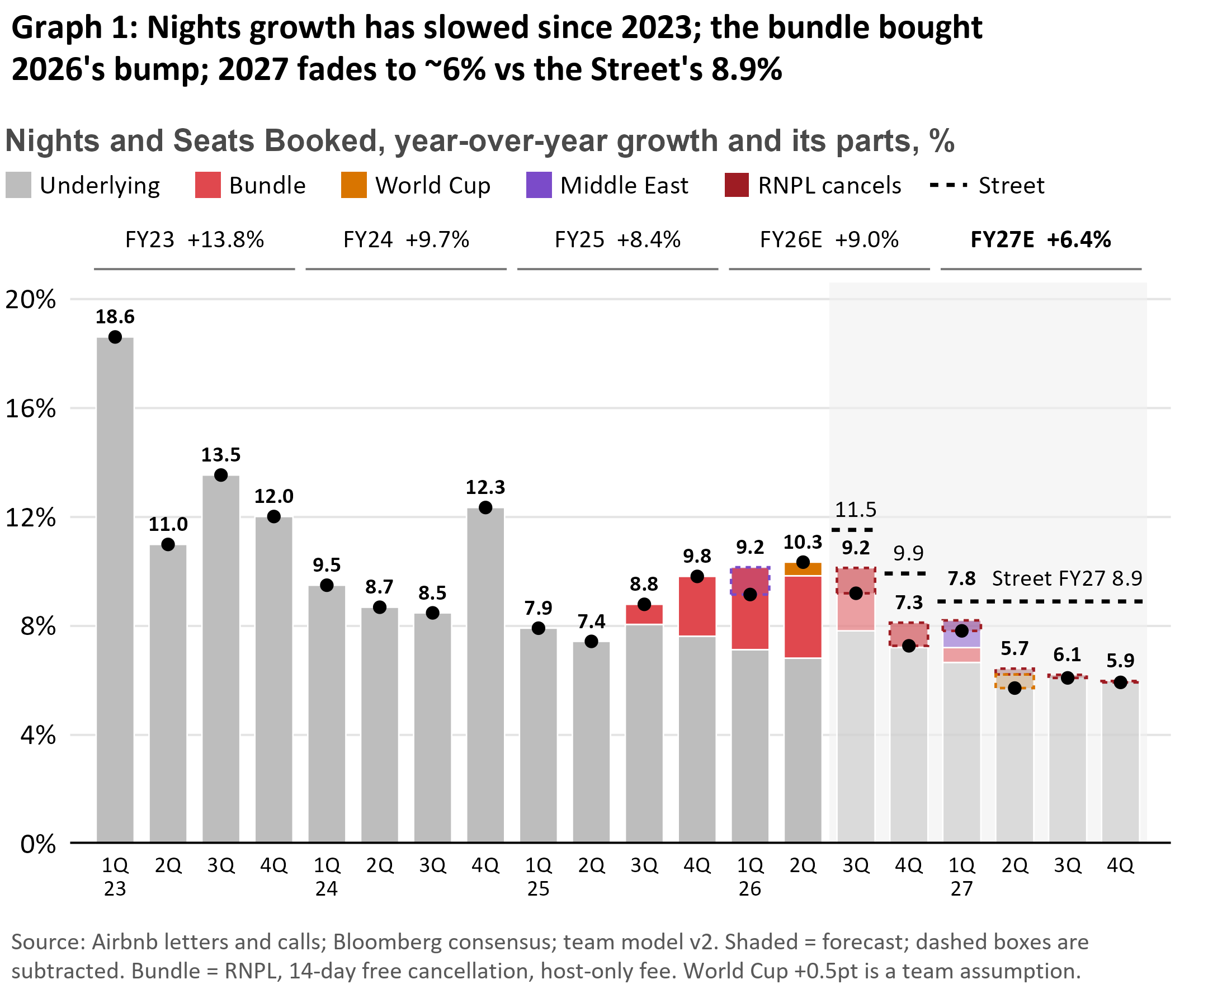 | 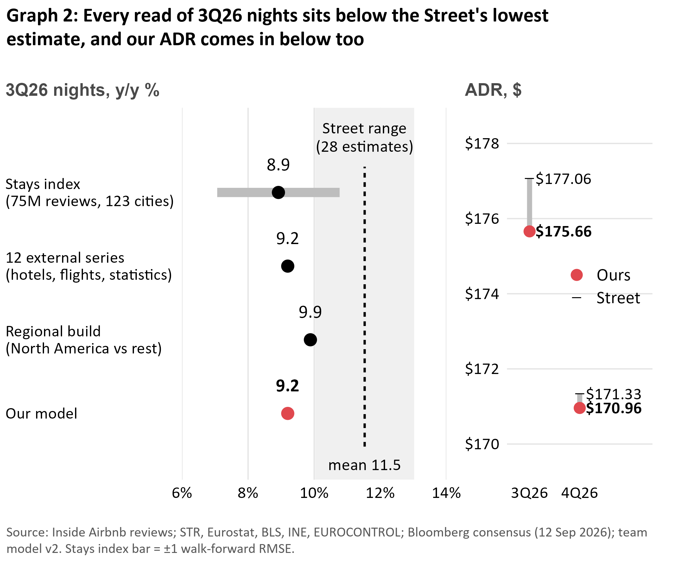

Why the bundle creates the illusion of growth. A conversion feature raises the level of bookings once, so it lifts the growth rate only until it laps: US RNPL in 3Q26, the cancellation and fee legs in 4Q26, RNPL outside the US in 1Q–2Q27. RNPL has stopped spreading ("roughly 20%" of GBV in 1Q26, "over 20%" in its first full global quarter), and its cost arrives later: RNPL bookings "have experienced higher cancellation rates" (2Q26 10-Q), and the CFO's platform rate of "maybe 16%… going to 17%" implies ~22% on RNPL bookings. Guests pay just before check-in, so the booking counts at once and the cancellation lands a quarter later. Net of cancellations, the bundle adds ~1.4pt in 3Q26 and ~0.1pt in 4Q26, while FX, a tailwind all of 2026, fades from 4Q26.
Our nowcast: we count the stays that actually happen. Bookings include reservations that later cancel; a guest review exists only after a completed stay. We built a stays index from 75 million Inside Airbnb reviews across 123 cities. Reviews disappear as listings delist (15–16% a year), so we compare each month at the same age in two annual snapshots, which cancels the deletion, then roll cities up to Airbnb's four regions, weighted by each region's share of stays that quarter. Covered cities show 3Q26 stays growth of 5.99% through August. A two-parameter model, frozen on pre-RNPL history (1Q23–2Q25), maps covered-city stays to global nights: +8.9% (±1.9pp). Refit each quarter, the index has predicted reported nights with about 0.7x the error of a naive forecast in both backtest windows. Two independent routes agree: twelve external series (hotel RevPAR, air traffic, national tourism statistics) read +9.2%, and a regional build (North America vs the rest) +9.9%. We take +9.2%; every route lands below the lowest Street estimate (Graph 2), and our model puts the chance of a print at the Street under 10%.
Price does not rescue it. The Street's 3Q26 ADR ($177.06) is what a straight currency translation gives. Our FX estimate, which has the better point-in-time record, makes FX a −0.4pt drag, for $175.66. Ex-FX ADR growth then slows from +4.0% in 2Q26 to about +1% by 1Q27: the bundle's ~1pt price lift laps, like-for-like pricing reverts to its 2023–26 average, and growth shifting to Latin America and Asia-Pacific (FY25 ADRs $95 and $118 vs North America's $255) pulls mix down 1.6pt. 4Q26 is roughly in line ($170.96 vs $171.33); the price gap widens in 2027, where the Street has no quarterly ADR.
Why Airbnb is no longer a growth company. The organic engine is running down. Nights per active listing have held at ~62.6 since 2022, so growth comes only from new homes, while stays at existing listings shrink (−3% to −7% y/y in 2026). North America, the most profitable market, fell from 39.8% of nights (1Q22) to ~29%. Regulators cap supply where Airbnb is densest (New York; 65,122 listings removed in Spain), and the new businesses are small: hotels are a single-digit share of nights and ad revenue is zero. Macro does not help: the Fed resumed hiking on 16 Sep and airfares were +25.5% y/y in July.
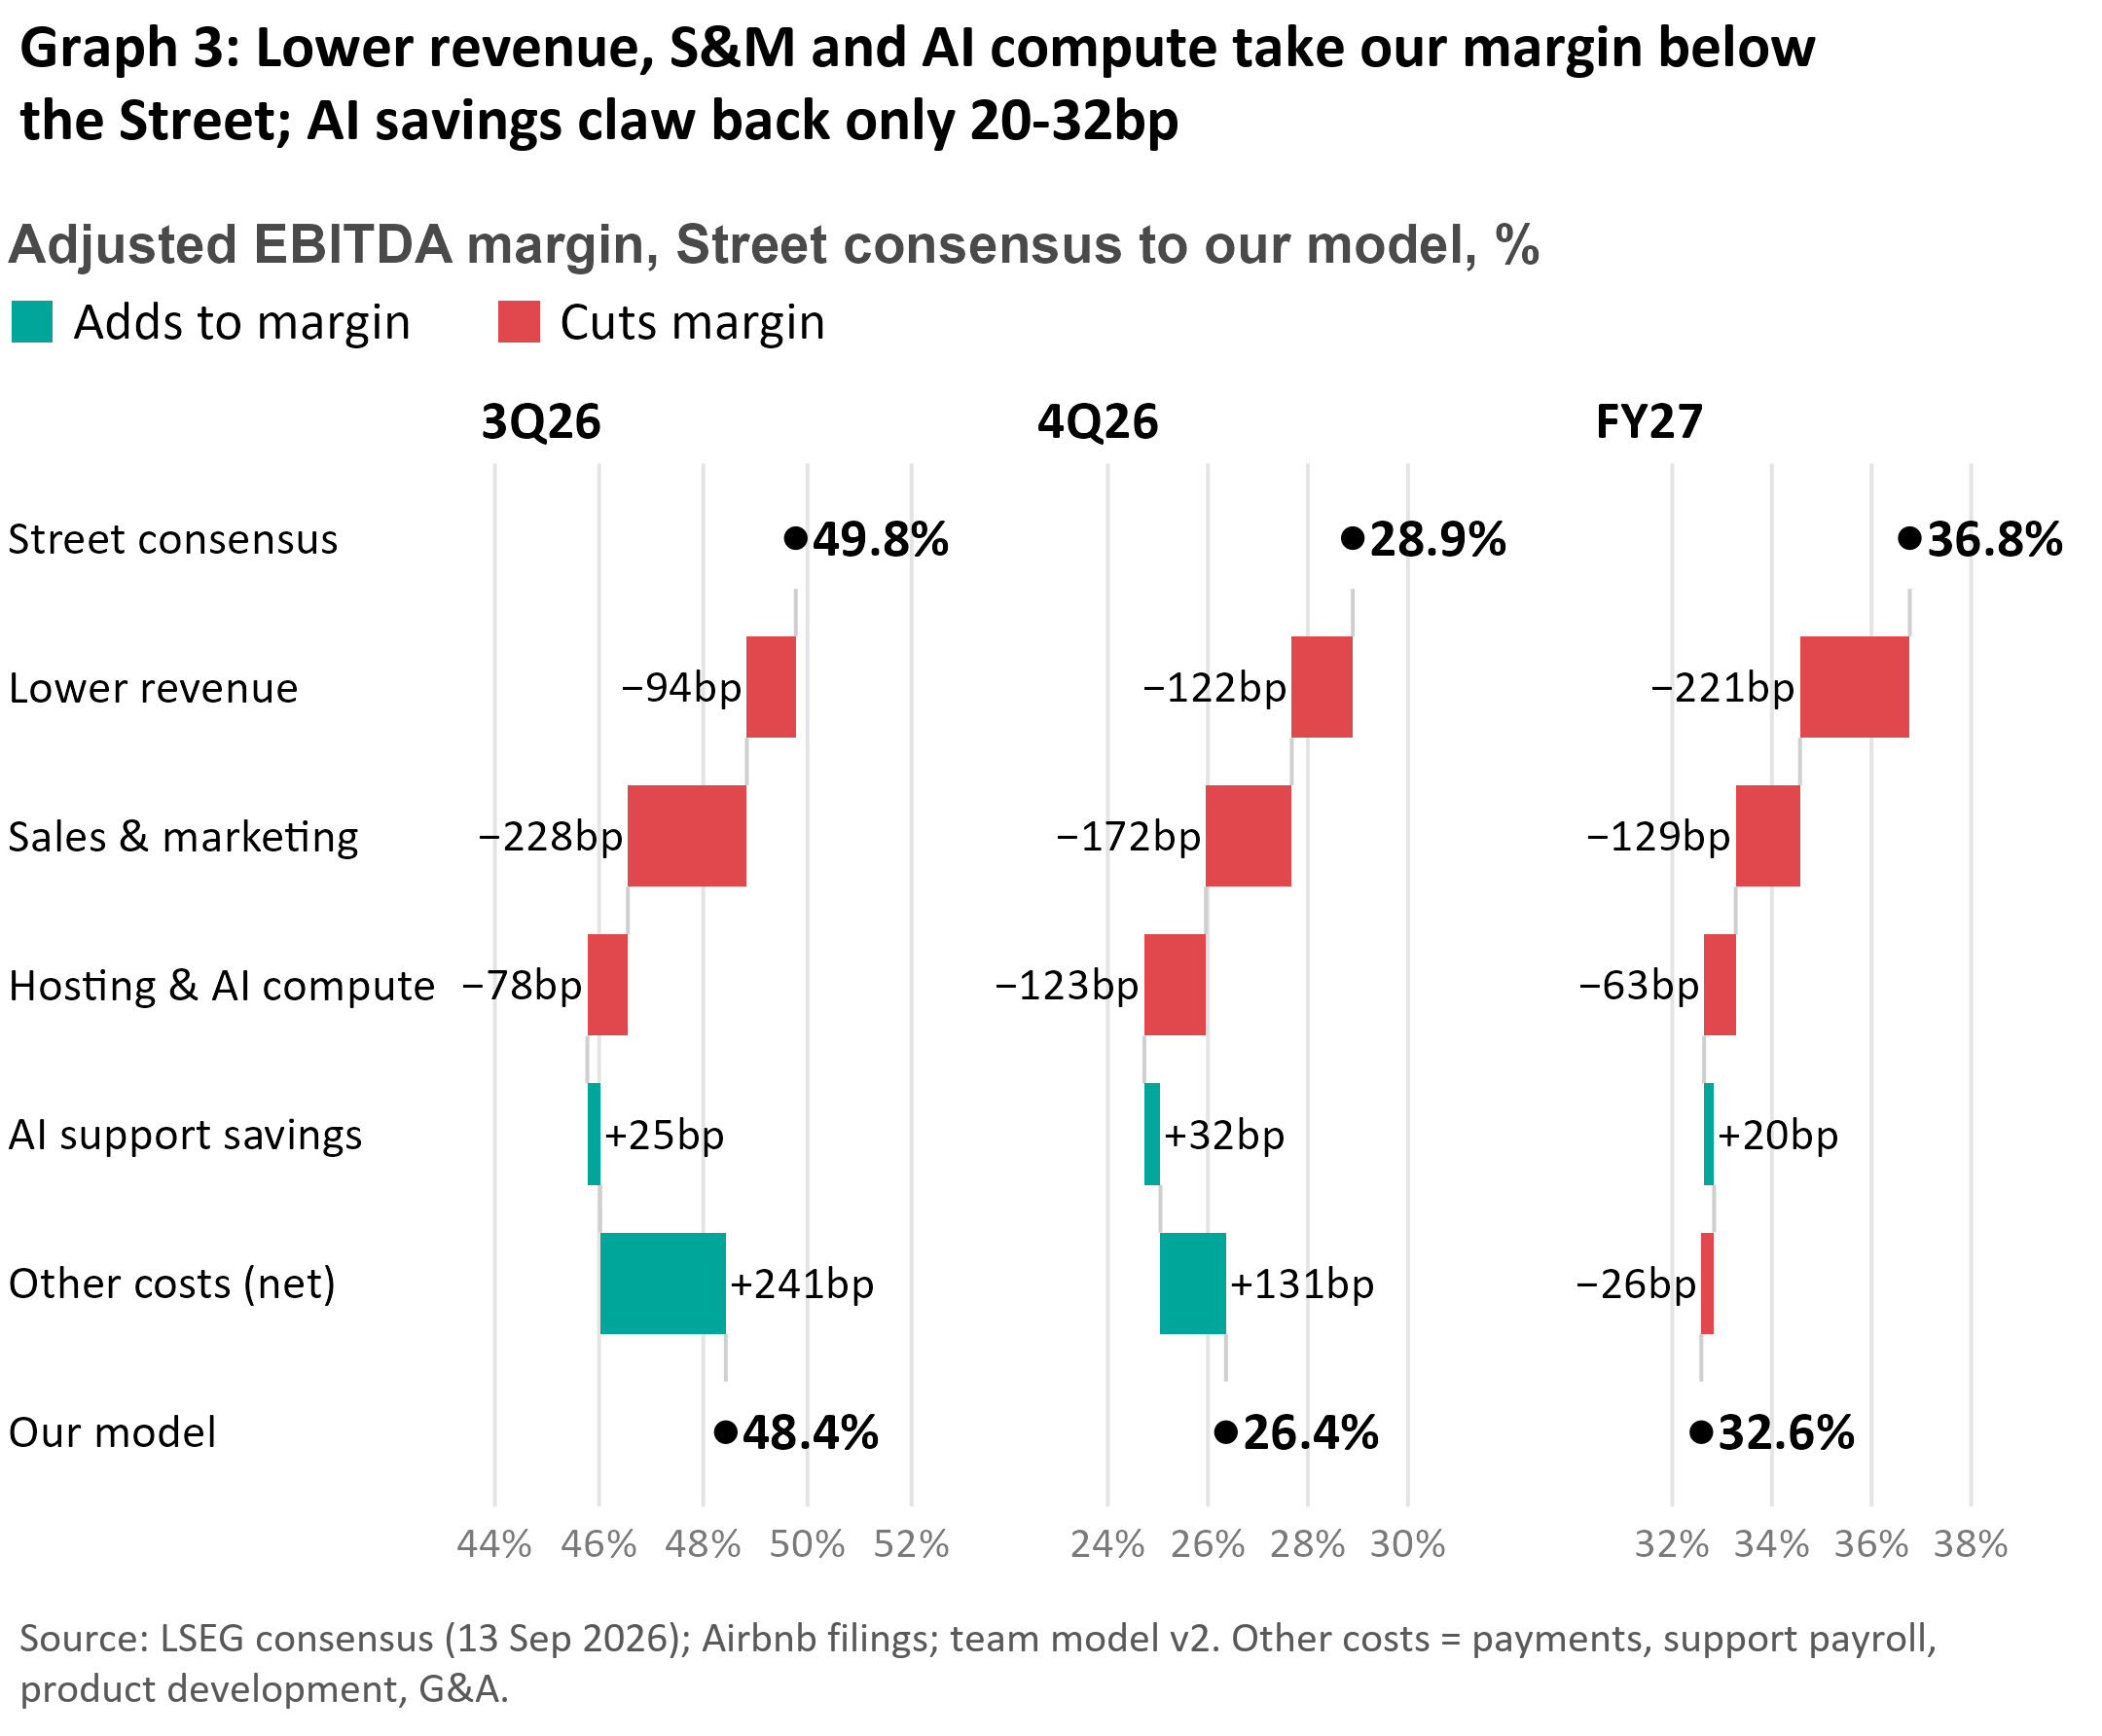
Margins: the Street models leverage Airbnb has not shown. The Street's FY27 margin of 36.8% (from 35.6%) needs cash-cost growth to slow from 15.0% to 9.7%, the slowest since the IPO. Sales and marketing says otherwise: cash S&M rose from 16.5% of revenue in FY23 to 19.4% in FY25, has outgrown revenue for nine straight quarters, and each extra dollar bought $6.6 of revenue in FY23 but $2.7 in 1H26. AI is a cost before it is a saving: the 2Q26 10-Q credits AI with $17M of lower support costs in a quarter when S&M rose $184M; hosting and AI compute rise from $224M (FY25) to $330M (FY27) in our model; and management will "reinvest most of these efficiencies" while guiding "a material increase" in AI spend. Our margins sit below the Street in every period (Graph 3): 48.4% vs 49.8% in 3Q26, 26.4% vs 28.9% in 4Q26 and 32.6% vs 36.8% in FY27. Even on the Street's own cost plan, flexed to our revenue, FY26 is 34.9% and FY27 34.6%, below management's "at least 35.5%" floor.
Catalysts. 5 Nov (3Q26 print): nights +9.2% vs +11.5%; a 4Q26 revenue guide below the Street ($3.08bn ours vs $3.16bn) with nights guided to "high single digits" or lower (Street +9.9%), and the FY26 margin floor at risk. FY27 cuts follow. ~11 Feb 2027 (4Q26 print): the 1Q27 guide laps a +17.9% revenue comparison, and management sets its FY27 margin outlook; FY27 consensus resets. Through 2027: ~6% prints bring the Street to us.
Valuation. On our numbers ABNB trades at 17.0x NTM EBITDA against 14.9x on consensus. Multiples 1.5–10 turns below consensus on our NTM, FY27 and 4Q26 EBITDA (13.4x, 12.2x, 77.2x) give $117–123; our target is $120. On NTM, our EBITDA is 12% below consensus and the multiple falls 10% (14.9x → 13.4x); slower growth earns it.
Risks & Mitigants. (1) Airbnb's AI agent re-ignites growth. Mitigant: an agent is another conversion feature, a one-time level shift like the bundle that reaches reported nights late in our window; Airbnb is outside every AI booking channel so far (ChatGPT, Google AI Mode, Meta) while Booking and Expedia are in, and partnering would mean paying for traffic that is ~90% free today. (2) A $6bn+ buyback reload (~$2.3bn left at 5 Nov). Mitigant: it cushions day 1, not EBITDA or the multiple; ~5% of shares a year is already in consensus, SBC absorbs over a third, and authorization days show no excess return. (3) Loyalty and paid ads. Mitigant: loyalty is still a test and management already guides take rate flat on higher incentives; $250M of ads at a 70% margin is a fifth of our $0.93bn FY27 EBITDA gap. (4) The guide is delivered. We cover if 3Q26 nights print ≥10.3% and the 4Q26 guide meets the Street; the upside marker is the 7 Aug close ($178, +18%).

