(NASDAQ: ABNB) Airbnb: SHORT
Current S/P (9/24/2026): $151.39 | Mkt Cap: $89.3B | Target Price: $120 | Implied Return: −20.7% | Horizon: 12 months | EV/NTM EBITDA: 14.9x Street, 17.0x ours | SI: 3.59%
Investment Thesis: We recommend a SHORT on ABNB with a $120 target, −20.7% over 12 months. The market has missed one fact: Airbnb's growth has slowed every year since 2022, and its 2026 re-acceleration was bought, not earned. A one-time bundle of booking features, plus FX, dressed up underlying nights growth of ~7% that is heading to ~6% by 2H27, and the bundle now laps. The 5 Nov 3Q26 print starts the reveal: we expect nights of +9.2% against the Street's +11.5% and a 4Q26 guide below consensus. The February 4Q26 print, when management frames 2027, completes it. FY27 consensus then converges to our numbers through 2027: revenue +7.5% (Street +11.7%) and adjusted EBITDA of $4.89bn, 16% below the Street's $5.83bn. About half the downside is lower estimates, half the lower multiple that slower growth earns. In a liquid $89B large cap with low short interest, and with the thesis playing out through estimate cuts over several prints rather than one binary event, the position can be sized.
The Setup: a slowing platform bought a re-acceleration. Nights growth fell from +31.0% in 2022 to +13.8%, +9.7% and +8.4% in 2023–25, bottoming at +7.4% in 2Q25. Management answered with a bundle of conversion features: Reserve Now, Pay Later (RNPL: $0 at booking, Aug 2025), 14-day free cancellation and a 15.5% host-only fee (Oct 2025). Nights re-accelerated to +10.3% in 2Q26, FX added 3–4pts to reported revenue growth in 1H26, and the stock rose 17.4% on the August print. Management credited the bundle with "over 200 basis points" of nights in 4Q25 and "approximately three points" in 1Q26, then stopped sizing it. Without the bundle and one-off events, nights grew 7.1% in 1Q26 and 6.8% in 2Q26 (Graph 1).
Why the market is wrong. The Street has taken the re-acceleration as the new trend. After 19 straight beats of Airbnb's own revenue guide, analysts carry management's words forward: all 28 Bloomberg estimates put 3Q26 nights at +10.0% or higher (mean +11.5%), an acceleration from 2Q26, and LSEG has FY27 revenue at +11.7%, treating the bundle's one-time lift as lasting demand. The 23 Sep sell-off (−7.6%, when Expedia announced an integration with Meta's Muse AI agent) cut the multiple, not the estimates: LSEG's FY27 numbers were unchanged when re-pulled that day.
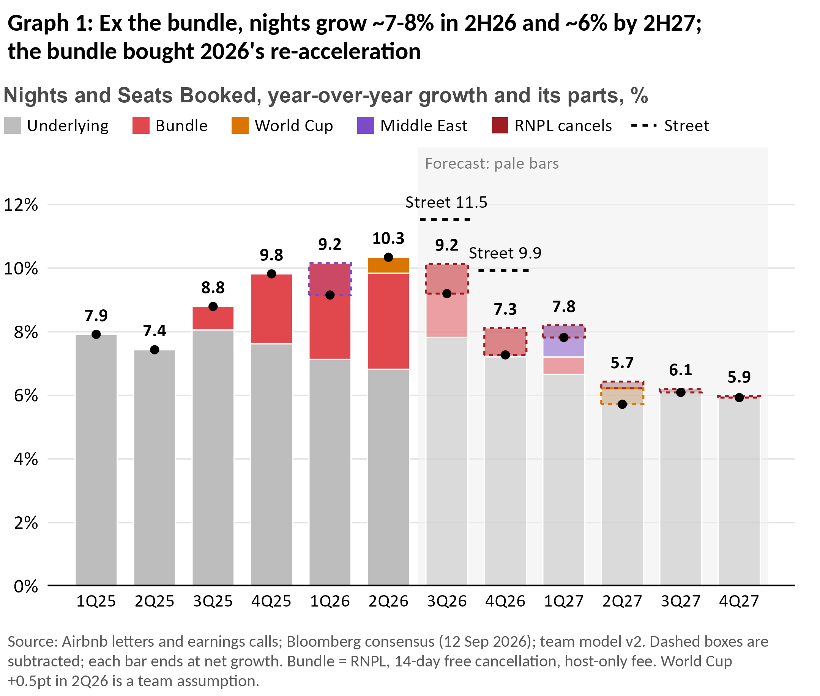 | 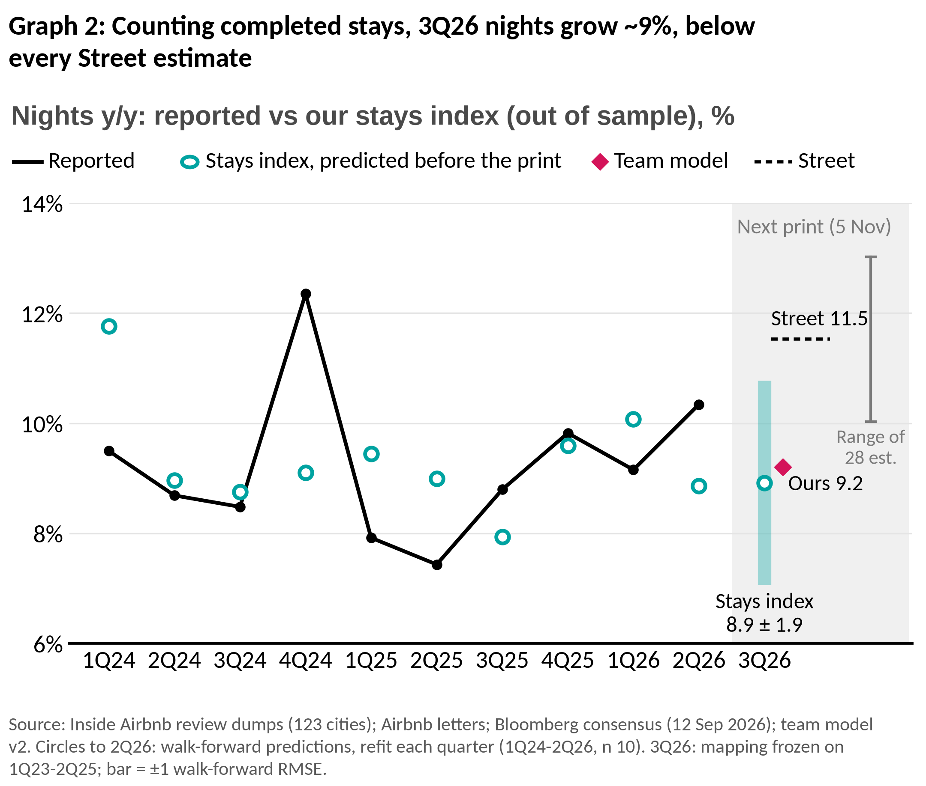

Why the bundle creates the illusion of growth. A conversion feature raises the level of bookings once, so it lifts the growth rate only until it laps: US RNPL in 3Q26, the cancellation and fee legs in 4Q26, RNPL outside the US in 1Q–2Q27. RNPL has also stopped spreading: "roughly 20%" of GBV in 1Q26 with partial global access, only "over 20%" in its first full global quarter. The cost arrives later. RNPL bookings "have experienced higher cancellation rates" (2Q26 10-Q), and the CFO put the platform rate at "maybe 16%… going to 17%", which implies ~22% on RNPL bookings. Guests pay just before check-in, so the booking counts at once while the cancellation often lands a quarter later. Net of cancellations, the bundle adds ~1.4pt in 3Q26 and ~0.1pt in 4Q26. Our model has nights at +9.2% in 3Q26 and +7.3% in 4Q26 (Street +11.5% and +9.9%), and +6.4% for FY27, while FX, a tailwind all of 2026, fades from 4Q26.
Our proof: we count the stays that actually happen. Bookings include reservations that later cancel; completed stays do not. Our stays index is built from 75 million Inside Airbnb guest reviews across 123 cities, reading each review month at the same age in two annual dumps so that the 15–16% of reviews that disappear each year cancel out. Covered cities show 3Q26 stays growth of 5.99% (reviews through August); a two-parameter mapping frozen on pre-RNPL history turns that into +8.9% global nights (±1.9pp). Refit each quarter, the index has predicted reported nights with about 0.7x the error of a naive forecast in both backtest windows (Graph 2). Twelve external series (hotels, flights, national statistics; STR RevPAR faded from +8.2% in July to ~4% by mid-August) read +9.2%. Every route lands below the lowest Street estimate; our model gives under a 10% chance of a print at or above consensus.
Why Airbnb is no longer a growth company. It had to buy growth because the organic engine is running down.
- Growth comes from new homes, not more demand per home. Nights per active listing have held at ~62.6 since 2022 only because new listings keep coming; stays at existing listings are shrinking (−3% to −7% y/y in 2026).
- The core market is saturated. North America fell from 39.8% of nights (1Q22) to ~29%; Latin America and Asia-Pacific, at FY25 ADRs of $95 and $118 against North America's $255, now supply over half of growth.
- Each night costs more to win. Cash S&M rose from 16.5% of revenue (FY23) to 19.4% (FY25); each extra S&M dollar bought $6.6 of revenue in FY23 and $2.7 in 1H26.
- Regulators cap supply where Airbnb is densest (New York's Local Law 18; 65,122 listings removed in Spain; Barcelona in 2028), and new businesses are small: hotels are a single-digit share of nights; ad revenue is zero.
Margins take the hit. The Street's FY27 margin of 36.8% (from 35.6%) needs cash-cost growth to slow from 15.0% to 9.7%, the slowest since the IPO, while S&M has outgrown revenue for nine straight quarters. Even if costs follow the Street's plan and flex down with our revenue at the historical rate, FY27 margin is 34.6% and FY26 34.9%, below management's "at least 35.5%" floor; on our costs FY27 is 32.6%.
Macro no longer helps. The Fed resumed hiking on 16 Sep, CPI airfares were +25.5% y/y in July, and CoStar sees US hotel RevPAR growth halving in 2027 (+2.1%). We do not lean on it: dearer flights also push travellers to drive-to trips, Airbnb's strength.
Catalysts. 5 Nov (3Q26 print): nights +9.2% vs +11.5%; a 4Q26 revenue guide below the Street ($3.08bn ours vs $3.16bn) with nights guided to "high single digits" or lower (Street +9.9%), and the FY26 floor at risk (ours 34.5% on our costs). First FY27 estimate cuts follow. ~11 Feb 2027 (4Q26 print): the 1Q27 guide laps a +17.9% revenue comparison, and management sets its FY27 margin outlook; FY27 consensus resets. Through 2027: prints at ~6% nights growth bring the Street to our numbers.
Valuation. On our numbers ABNB trades at 17.0x NTM EBITDA against 14.9x on consensus. Compressed multiples on our estimates (13.4x NTM, 12.2x FY27, 77.2x 4Q26 EBITDA, each 1.5–10 turns below consensus) give $117–123; our target is $120. On NTM, our EBITDA is 12% below consensus and the multiple falls 10% (14.9x → 13.4x); slower growth (FY27 revenue ~4pts below the Street) is what earns the lower multiple.
Risks & Mitigants.
- Airbnb's AI agent re-ignites growth. Chesky has committed to an agent "next year" on inventory no one else has. Mitigant: an agent is another conversion feature: at best a one-time level shift like the bundle, launching in 2027 and reaching reported nights late in our window. Airbnb is absent from every AI booking channel launched so far (ChatGPT apps, Google AI Mode hotel booking, Meta's Muse) while Booking and Expedia (Vrbo's parent) are in, so Muse is share risk for Airbnb, not upside. Partnering means paying for distribution it now gets free (~90% of traffic is direct or unpaid). We would revisit on a distribution deal with disclosed volume. AI savings are small and being spent: the 2Q26 10-Q credits AI with $17M of lower support costs in a quarter when S&M rose $184M; management will "reinvest most of these efficiencies" and guides "a material increase" in AI spend; our model credits the savings.
- Buyback. ~$2.3bn remains at 5 Nov at ~$1.1bn a quarter, and a $6bn+ reload is likely (every authorization came in a print-day letter). Mitigant: a reload with the 5 Nov guide would cushion day 1, which is why we do not trade day 1; it moves per-share numbers, not EBITDA or the multiple; ~5% of shares a year is already in our model and consensus; SBC ($1.6bn in FY25) absorbs over a third; and authorization days have shown no excess return.
- Loyalty and paid ads. Mitigant: no loyalty program exists yet, only tests (a launch at a print is a headline risk we size for), and management already guides FY26 take rate "relatively flat" on "higher customer incentives related to new businesses", which is what loyalty perks are. Sponsored listings are unlaunched (analysts expect 2027); even $250M of ad revenue at a 70% margin is ~$175M of EBITDA, a fifth of our $0.93bn FY27 gap.
- The guide is delivered: we cover if 3Q26 nights print ≥10.3% and the 4Q26 guide meets the Street ($3.16bn; "low double digits" nights). The 7 Aug post-print close ($178, +18%) marks the upside risk. February prints were up days in 5 of 6 years, so we hold for estimate cuts, not day-1 moves.

