(NASDAQ: ABNB) Airbnb: SHORT – Reserved Now, Paying Later
Current S/P (9/24/2026): $151.39 | Mkt Cap: $89.3B | Target Price: $120 | Target Return: −20.7% | SI: 3.59%
Investment Thesis: We recommend a SHORT on ABNB with a $120 target, −20.7% within 6 months. Airbnb's 2026 re-acceleration is not a turnaround; it was bought. After three straight years of slowing nights growth, management reached for a bundle of booking features led by Reserve Now, Pay Later (RNPL), and the Street mistook a one-time boost for a new growth trend. Strip it out and underlying nights growth is only ~7% and falling, heading to ~6% in 2027. The 5 Nov 3Q26 print is the first crack: we expect nights of +9.2% against a Street at +11.5%, where not one of 28 estimates sits below +10%. The February 4Q26 print, when management sets its 2027 outlook, finishes the job: FY27 consensus falls to our revenue growth of +7.5% (Street +11.7%) and adjusted EBITDA of $4.89B (Street $5.83B), and a stock priced as a growth company re-rates as one that isn't.
Company and Industry Overview: ABNB divides revenue into four geographic segments: North America (42%); Europe, Middle East, and Africa (EMEA) (39%); Latin America (10%); and Asia Pacific (APAC) (9%). ABNB competes primarily with Expedia's Vrbo, Booking.com, and hotels.
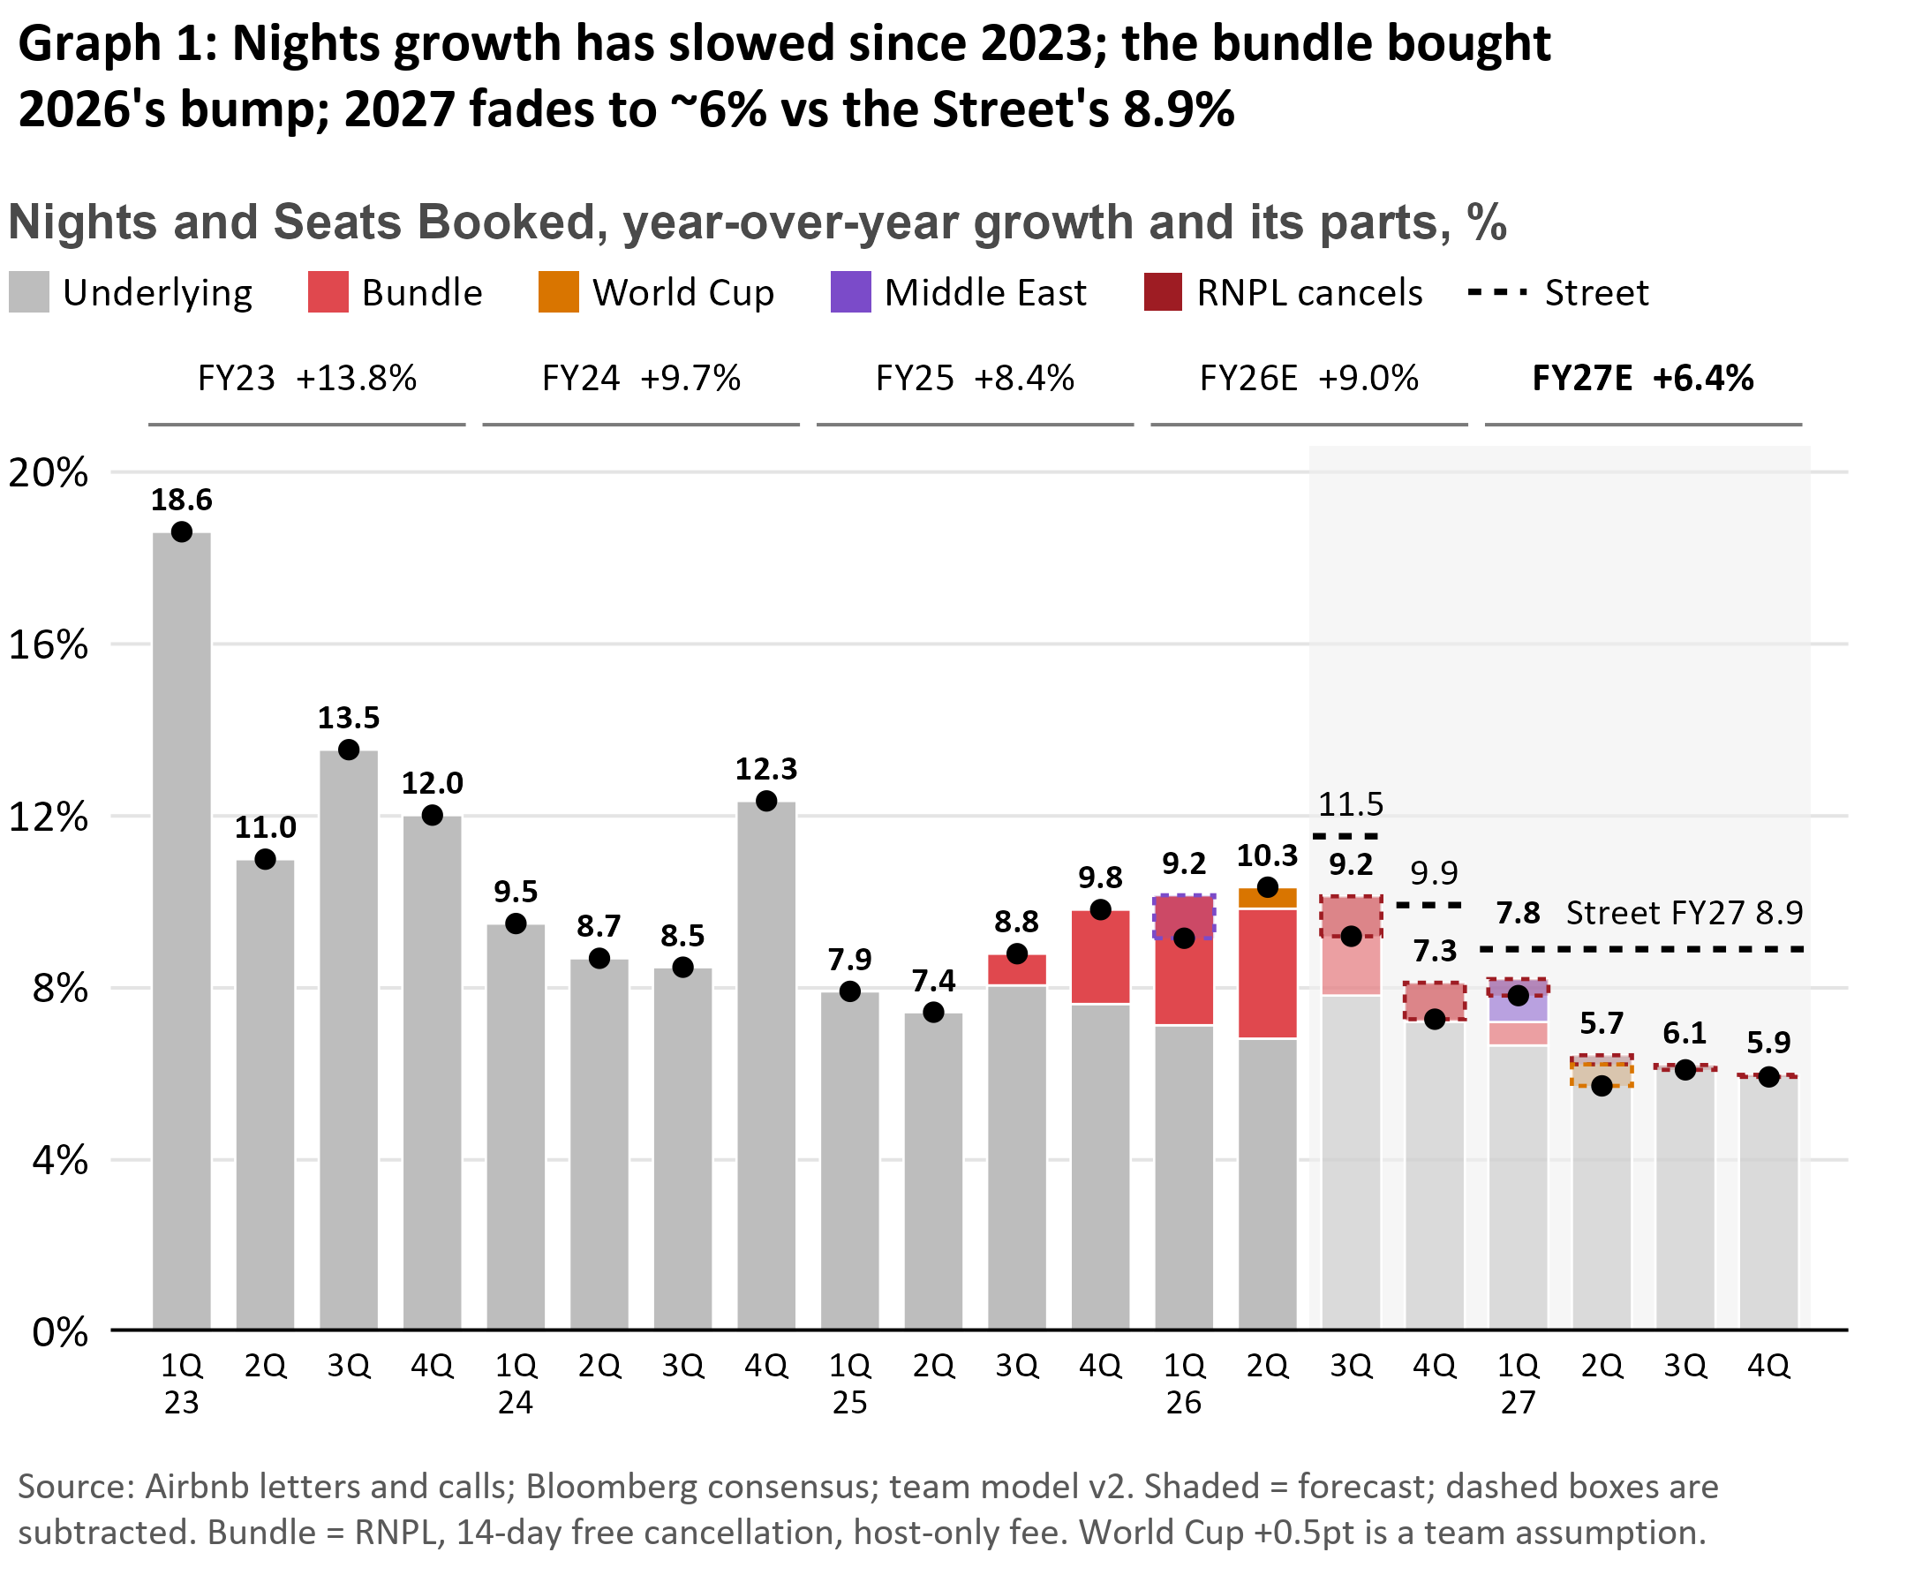
The Street is extrapolating a sugar high: Nights growth slowed three straight years, from +31% in 2022 to +13.8% in 2023 and a low of +7.4% in 2Q25. Management's answer was a bundle of conversion features: RNPL (guests pay $0 at booking), 14-day free cancellation, and a single host-only fee. Nights re-accelerated to +10.3% in 2Q26 and the stock jumped 17% on the print. Management credited the bundle with "over 200bps" of nights in 4Q25 and "approximately 3 points" in 1Q26, then stopped quantifying it. Strip the bundle out and nights grew only ~7% in 1H26, slower than in 2025 (Graph 1). Yet after 19 straight revenue-guide beats, and nights beating guidance every quarter of 2026, analysts treat management's word as a floor: management guided 3Q26 nights to "low double digits" (10–12%), every Street estimate sits at +10% or higher, and FY27 consensus has nights at +8.9% against our +6.4%. Those beats came while the bundle ramped faster than management itself expected. With the bundle lapping, the source of the beats is gone, and we expect the first nights print below management's guide in Airbnb's history.
A one-time boost dressed up as a trend: RNPL turns browsers into bookers, which lifts the level of bookings for good but lifts growth only once. Nights growth compares each quarter with the same quarter a year earlier, so once a feature has been live for 12 months, both periods include it and the boost disappears. Now the laps arrive: US RNPL in 3Q26, the cancellation and fee changes in 4Q26, and international RNPL in 1Q–2Q27. RNPL has stopped spreading (~20% of GBV since 1Q26), and its cost is still arriving: RNPL bookings "have experienced higher cancellation rates" (2Q26 10-Q). With the platform cancellation rate up from 16% to 17%, if non-RNPL bookings still cancel at 16%, RNPL bookings cancel at ~21%. Guests can cancel free until payment is due, so the booking counts first and the cancellation often lands in a later quarter; our cohort model times each one. Net of cancellations, the bundle adds only 1.4pt in 3Q26 and 0.1pt in 4Q26.
Our edge: we count the stays that actually happen: Bookings include reservations that later cancel, but a guest can only review a stay that happened. We built a stays index from 75 million Inside Airbnb reviews across 123 cities. Reviews disappear as listings delist (15–16% a year), so we compare each month at the same age in two annual snapshots, canceling the deletion, then weight cities up to ABNB's four regions by their share of stays that quarter. These mature cities, which grow slower than the platform, show 3Q26 stays growth of ~6% through August. A straight-line fit of reported nights on the index, estimated only on pre-RNPL quarters (1Q23–2Q25), converts that to +8.9% global nights (±1.9pp, its out-of-sample error). Refit quarterly on only the data available at the time, the index has predicted reported nights with ~0.7x the error of carrying last quarter's growth forward, in both backtest windows. Since RNPL launched, prints have run ~0.7pp above the index on average, inside that band; adding it back still gives only +9.6%. Two other routes agree: 12 external series (hotels, flights, tourism statistics) read +9.2%, and a regional build of North America vs the rest reads +9.9%. Every point estimate lands below the lowest Street estimate (+10.0%), and we model +9.2%. The reviews see the quarter before Airbnb reports it.
Price doesn't save the stock: We forecast 3Q26 ADR at $175.66 vs the Street's $177.06 because we model FX differently. Excluding FX, our price growth matches the Street's: a straight currency translation at today's rates gives $177.07, while our blended region-based FX model, which beats it in backtests, makes FX a −0.4pt drag. Ex-FX ADR growth then slows from +4% in 2Q26 to ~1% by 1Q27 as the bundle's ~1pt price lift laps, pricing reverts to its 2023–26 average, and growth shifting to lower-priced LatAm and APAC pulls mix down 1.6pts: price won't offset nights.
Growth now depends on new supply: Nights per active listing have stalled at ~62.6 since 2022, and stays at existing listings are shrinking (−3% to −7% YoY in 2026), so growth relies on adding homes. Even that engine is slowing: new listings added 18.9pts of stays growth in 1Q23 but only 11.4pts in 2Q26. Regulation caps supply where Airbnb is densest (New York; 65k listings removed in Spain), and new businesses are too small to fill the gap: hotels are a single-digit share of nights, and ad revenue is zero. Nor does the macro help: the Fed resumed hiking on 16 Sep, and airfares were +25.5% YoY in July.
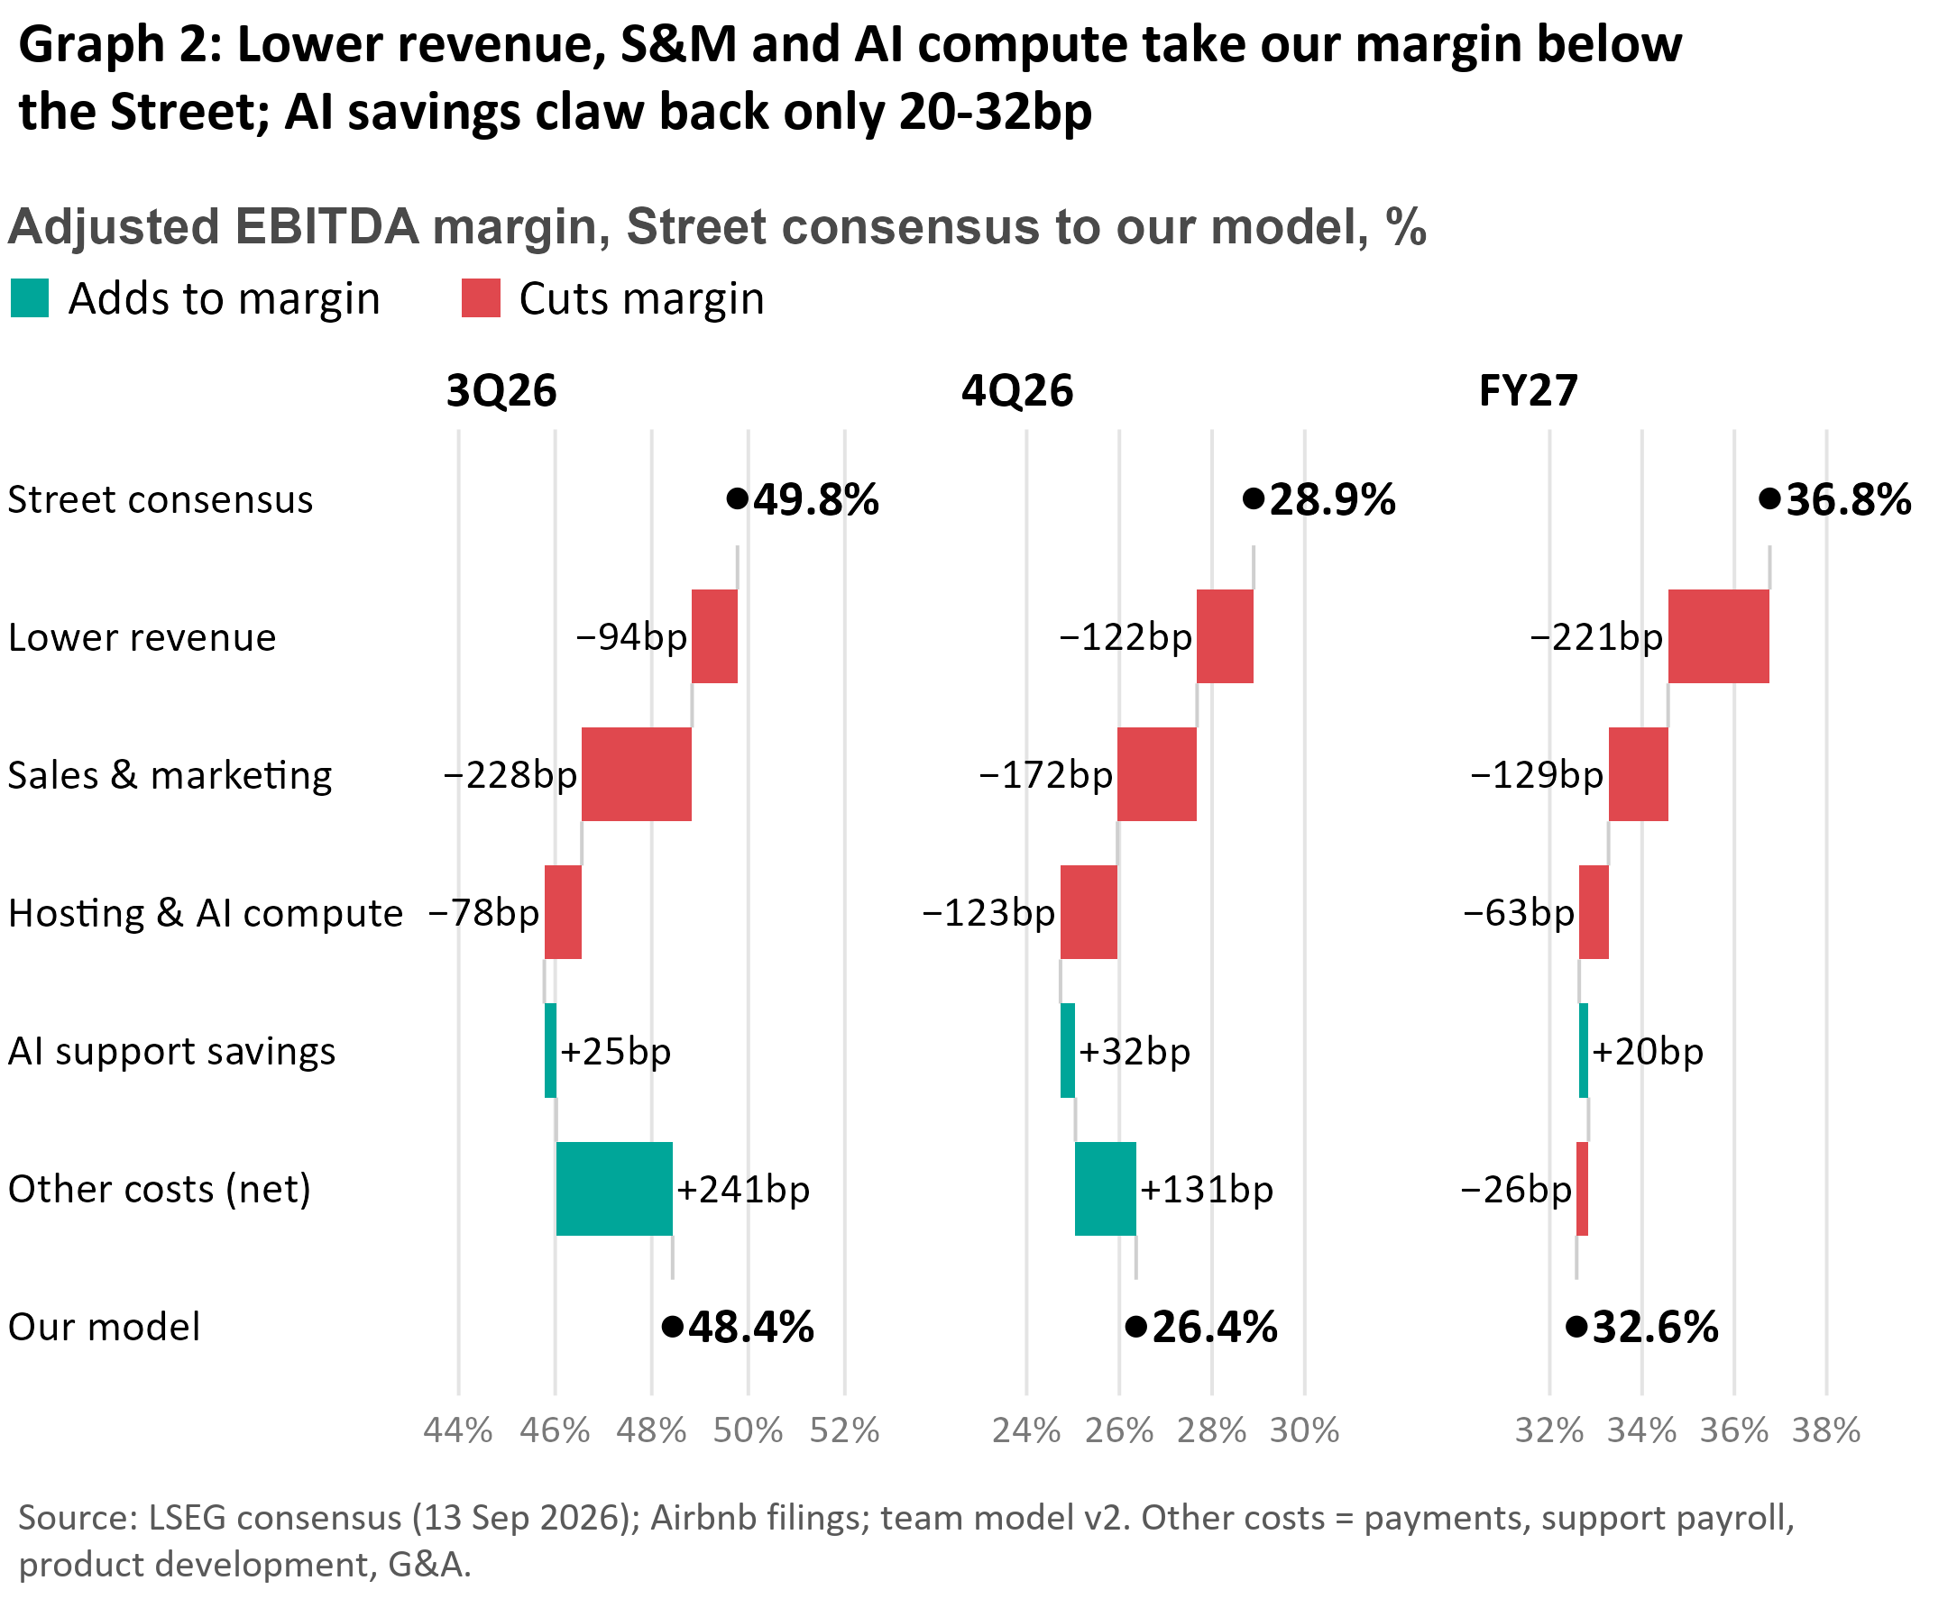
The Street models margin leverage ABNB doesn't have: The Street's FY27 margin of 36.8% (up from 35.6% in FY26) needs cash-cost growth to slow from 15% to ~9.7%, the slowest since the IPO, but sales and marketing won't allow it. Each incremental S&M dollar bought $6.6 of incremental revenue in FY23 but only $2.7 in 1H26, and cash S&M rose from 16.5% of revenue to 19.4% over FY23–25. AI won't close the gap: FY26 AI savings are ~$40M while hosting and AI compute rise ~$90M to ~$313M, heading to ~$450M in FY27 (our estimates), and management itself will "reinvest most of these efficiencies." We forecast margins below the Street in every period (Graph 2), from S&M near term and lower revenue in FY27. Even on the Street's own cost plan with our revenue, FY26 margin is 34.9%, below management's "at least 35.5%" floor.
Catalysts: (1) 5 Nov (3Q26 print): nights +9.2%, below management's "low double digits" and the Street's +11.5%; a 4Q26 revenue guide below the Street ($3.08B ours vs $3.16B) with nights guided to "high single digits" or lower (Street +9.9%); and the FY26 margin floor at risk. (2) Feb 2027 (4Q26 print): management sets its FY27 margin outlook and a 1Q27 guide that laps a +17.9% revenue comparison; FY27 consensus resets to our +6.4% nights, +7.5% revenue.
Valuation: By February, the market prices FY27. On our FY27 adjusted EBITDA of $4.89B, today's consensus FY27 multiple of 13.7x gives $130 (−14%): the estimate reset alone. As growth resets to ~6%, the multiple compresses 1.2 turns to 12.5x, giving $120 (−21%); historically ABNB's multiple has moved ~0.5 turns per point of growth, and our FY27 revenue growth is ~4pts below the Street's. Prices add $9.6B net cash over 590M shares.
Risks & Mitigants: (1) Airbnb's own AI agent re-ignites growth. Mitigant: an agent converts more of the same visitors, a one-time lift like the bundle's (~3pt at peak) arriving late in our window; Airbnb is outside every major agentic booking channel (ChatGPT, Google AI Mode, Meta's Muse) where Booking and Expedia have signed, so partnering means paying for traffic that is ~90% free today. (2) A $6B+ buyback reload. Mitigant: buybacks change neither EBITDA nor the multiple our target rests on, and Airbnb does not defend the stock: after the Aug 2025 drop it bought less ($857M vs $1.0B), not more. (3) Loyalty and paid ads. Mitigant: Airbnb already has what loyalty buys (~90% of traffic direct or unpaid), leisure travelers don't choose on points, and owning no rooms, it must fund every reward in cash; ads are unlaunched, and our $250M bull case adds under a fifth of our $0.93B FY27 EBITDA gap. (4) Main risk: 3Q26 nights land inside management's 10–12% guide, showing the lift lasts; the 7 Aug close ($178, +18%) marks that case.

