

Internet of Things 1
Problem-Based Learning Unit

Presented to Jimmy Plaitis

Submitted by Kaeo Kloss and Antonio Lastoria (sec. 00002) on November 28th 2025

Table of Contents

Executive Summary ...................................................... 2
Technical Documentation ......................................... 2
2.1 Software Architecture
2.2 Data Flow
2.3 Hardware Connections
2.4 Circuit Schematic
2.5Components Justification
Development Process ............................................... 3
3.1 Timeline
3.2 Main Challenges & Solutions
Results ........................................................................ 3
Conclusion ................................................................. 3
Deliverables Submitted ............................................ 3
References ................................................................. 3

1. Executive Summary
Our team successfully designed a functional, low-cost IoT climate monitor for our library. This was done using the ESP32, BME280 sensor, 128×64 OLED display, and an RGB LED. We fulfilled all the core requirements: continuous temperature/humidity/pressure measurement through the integration of sensors, local display, web Interface, and visual alerts to provide continuous monitoring of temperature, humidity and pressure.
Individual Contributions (graded individually)
- Kaeo Kloss:

Wi-Fi connection, implementation of web server, debugging and optimization of codes, management of GitHub repositories, writing and formatting the full report, preparation of presentation, Hardware design and wiring
- Antonio Lastoria:

Worked on the baseline of the code, Writing and formatting the full report, worked on the JSON file for the code. Managing the GitHub page

2. Technical Documentation
2.1 Software Architecture Single Arduino sketch with non-blocking loop.
Key modules:
- I^2C BME280 sensor reading
- Rendering of OLED, Current Value, Trend Graphs
- Built-in HTTP web server (auto-refresh every 5 s) and a graph
- Threshold-based RGB LED alerts
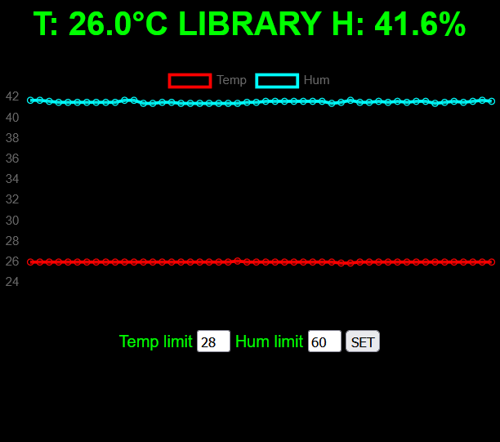
Figure 1 The web UI for the ESP32 temperature monitor sensor showing the temperature and humidity graphs.
2.2 Data Flow BME280>ESP32>real-time processing>LED alert>displayed locally + served over Wi-Fi
2.3 Hardware Connections
Device | Connections | Notes
BME280 SDA | GPIO 32 | Used for I2C data
BME280 SCL | GPIO 33 | Used for I2C clock
OLED MOSI | GPIO 23 | Used for SPI data
OLED SCK | GPIO 18 | Used for SPI clock
OLED DC | GPIO 2 | Data/Command
OLED CS | GPIO 17 | Chip Select
OLED RST | GPIO 4 | Reset
RGB Red | GPIO 14 | PWM capable
RGB Green | GPIO 27 | PWM capable
RGB Blue | GPIO 26 | PWM capable

2.4 Circuit schematic

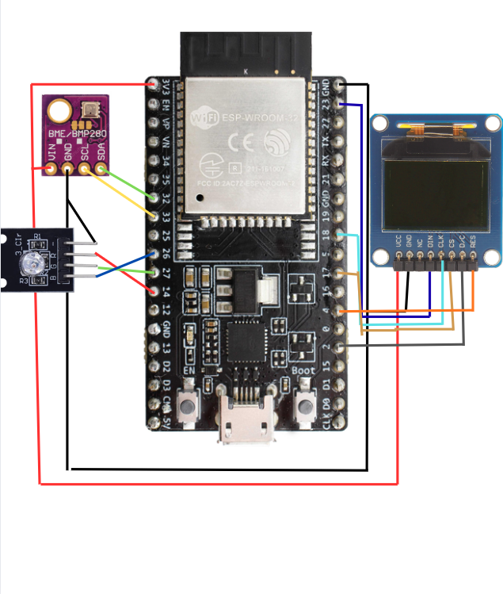
Figure 2 The circuit schematic for the indoor climate monitoring system

2.5 Components Justification
Item | Qty | Unit Price
ESP32-Devkit | 1 | $6
BME280 module | 1 | $1.77
0.96 64x128 SPI OLED SSD1306 | 1 | $3.56
RGB module | 1 | $0.30
Wires | 1 | $0.30

Total cost is less than $15 and all 3.3 V compatible, low power usage, and easy library support. An overall efficient and cheap project.
3. Development Process
3.1 Timeline
Week 1: Component testing & wiring, Sensor + OLED + alerts working + Graphing + Web server + full integration
Week 2: Troubleshooting and debugging our circuit, report
Week 3: Final debugging and demo of the circuit
3.2 Main Challenges & Solutions
• OLED not initializing because of wrong SPI pins; solved by correcting pinout.
• BME280 detection problems. Solved by soldering pins
4. Results
- True to life, real-time readings
- Smooth temperature & humidity trend graphs
- Instant red/green LED alerts
- Responsive web dashboard accessible on local network (

5. Conclusion
This system is a clean, simple, low-cost solution for climate monitoring, fulfilling all the features required and the enhanced ones. This project is a great way to dive deeper into the subject of IOT and data collection while improving our group working skills/collaborative engineering. The IOT circuit meets the core requirements with continuous measurements of temperature, humidity, and pressure.
Deliverables Submitted
- Complete, fully commented source code (GitHub: https://github.com/Kaeokk/Smart-Indoor-Climate-Monitor-with-Local-Display)
- Technical report
- Successful 10-minute live demonstration
References
- Adafruit BME280 & SSD1306 libraries
adafruit/Adafruit_BME280_Library: Arduino Library for BME280 sensors
adafruit/Adafruit_SSD1306: Arduino library for SSD1306 monochrome 128x64 and 128x32 OLEDs

- ESP32 Arduino Core documentation
https://www.espressif.com/en/support/documents/technical-documents

- Project GitHub repository
https://github.com/Kaeokk/Smart-Indoor-Climate-Monitor-with-Local-Display

