Comparison of 2 THD algorithms
Alg. 1: TWM-THDWFFT, based on windowed FFT,
Alg. 2: TWM-MFSF, based on Multi Harmonic Frequency Estimator.

Testing signal properties
Nominal values:
fs.v = 1e5; fs.u = 1e-9; % is it used somewhere?
% record length:
L.v = 1e5;
% signal frequency
f.v = 50.01; f.u = 0.01; % this is uncertainty of estimate. is it used in some alg?
% harmonics
DI.nharm.v = [1 2 3 4 5]; % signal harmonic multiple
DI.A.v = [1 0.01 0.01 0.01 0.01]; % signal amplitudes
DI.ph.v = [0 0 0 0 0]; % signal phase
DI.O.v = [0 0 0 0 0]; % signal offset
DI.noise.v = 1e-5;

Variation: noise
DIvar.noise.v = logspace(-6, 1, 20);
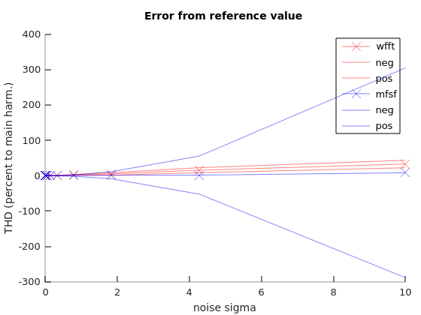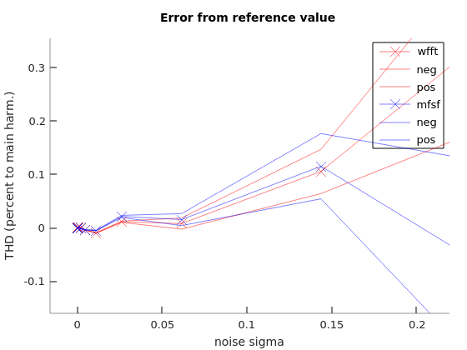

Variation: THD value
DIvar.A.v = logspace(-6, -2, 10)'.*[1 1 1 1];
DIvar.A.v = [ones(size(DIvar.A.v,1), 1) DIvar.A.v];
that results in reference THD values:
ans = 2.0000e-04 5.5651e-04 1.5485e-03 4.3089e-03 1.1990e-02 3.3362e-02 9.2832e-02 2.5831e-01 7.1876e-01 2.0000e+00
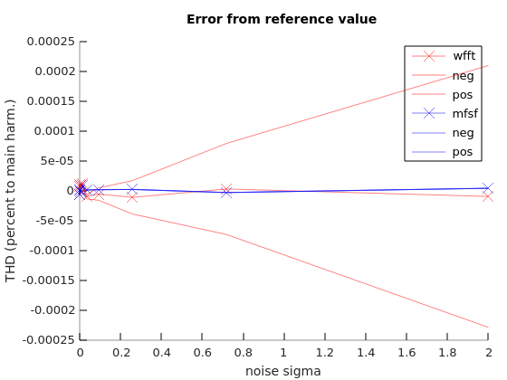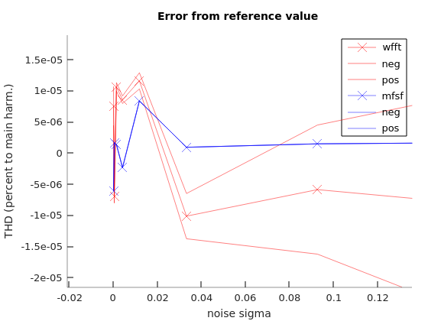

Variation: frequency
DIvar.f.v = 50 + [-0.5:0.0001:0.5];
(guf)
