How to validate an algorithm, example
Algorithm SINAD-ENOB, available in QWTB
Algorithm calculate SINAD from sampled data. It is useful for finding out some impurities. E.g. very pure sine wave is generated by JAWS, and sampled by NI5922. As found by many, the spectrum is spoiled by non-linearity of 5922, and SINAD is lower than one would expect:
Illustration 1: O. F. Kieler, R. Behr, R. Wendisch, S. Bauer, L. Palafox, and J. Kohlmann, ‘Towards a 1 V Josephson Arbitrary Waveform Synthesizer’, IEEE Transactions on Applied Superconductivity, vol. 25, no. 3, pp. 1–5, Jun. 2015.
Validation of SINAD algorithm
One of input parameters of the algorithm SINAD-ENOB is the estimate of the signal frequency. How precisely this estimate must be known? No one knows. Does the algorithm calculate correct result if estimate is 0.1 % off? 10 % off?
So lets run simulation – simulate a selected signal with some distortion, variate estimate of signal frequency, calculate SINAD and take a look at the result (ellipses show uncertainties):
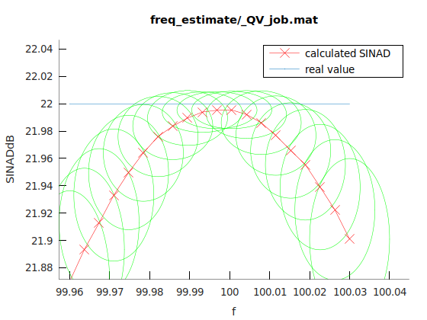
So one can see that the estimate must be in range <99.978, 100.015> to get correct result (for selected sine wave and uncertainties). If the estimate is incorrect, the calculated SINAD with uncertainty do not cover true value of SINAD.
The input parameters have to be varied and the error of the algorithm estimated. This can easily result in many input parameters.

Scripts
QWTB with SINAD-ENOB algorithm, qwtbvar (in last commits of QWTB)
% example how to estimate uncertainties of an algorithm

clear all, close all
%%%%%%%%% SETTINGS %%%%%%%%%
% path to the qwtb:
addpath('../Q-Wave/qwtb/qwtb/')
% calculation settings:
% monte carlo:
CS.unc = 'mcm';
CS.mcm.repeats = 1e3;
CS.mcm.method = 'multicore';
CS.mcm.procno = 6;
% variation settings:
CS.var.dir = 'SINAD-ENOB';
CS.var.dir = 'freq_estimate';
CS.var.cleanfiles = 1;
%%%%%%%%% SETTINGS %%%%%%%%%

% the SINAD-ENOB algorithm will be tested for the quality of frequency estimate
% for a selected sinewave

% generate sine wave %<<<1
% sampling frequency:
DI.fs.v = 1e4;
DI.fs.u = 0;
% record length:
M = 1e3;
% time series:
DI.t.v = [0 : 1./DI.fs.v : M./DI.fs.v];
DI.t.u = ones(size(DI.t.v)).*1e-10;
% signal amplitude
DI.A.v = 1;
% signal frequency
DI.f.v = 1e2;
% signal phase
DI.ph.v = 0;
% signal offset
DI.O.v = 0;
% sampled values:
DI.y.v = DI.A.v.*sin(2.*pi.*DI.f.v.*DI.t.v + DI.ph.v) + DI.O.v;
% add distortion at 5. harmonic and SINAD -22 dB:
harm = 5;
distortion_dB = -22;
DI.y.v = DI.y.v + DI.A.v.*10^(distortion_dB/20).*sin(2.*pi.*harm.*DI.f.v.*DI.t.v + DI.ph.v) + DI.O.v;
% uncertainties of every sample:
DI.y.u = ones(size(DI.y.v)).*1e-5;
% bit resolution
DI.bitres.v = 10;
DI.bitres.u = 0;
% full scale range
DI.FSR.v = 2;
DI.FSR.u = 0;

% uncertainties %<<<1
% suppose all estimates have uncertainty of 0.1 %
DI.A.u = DI.A.v .*1e-4;
DI.f.u = DI.f.v .*1e-4;
DI.ph.u = DI.ph.v.*1e-4;
DI.O.u = DI.O.v .*1e-4;

% varied values %<<<1
% suppose we want to know the dependence of output SINADdB on the frequency
% estimate

% DIvar.f.v = linspace(99.9, 100.1, 20);%[990 : 2 : 1010];
DIvar.f.v = linspace(99.96, 100.03, 20);%[990 : 2 : 1010];

% calculation %<<<1
jobfn = qwtbvar('SINAD-ENOB', DI, DIvar, CS);

% output plotting %<<<1
[H, x, y] = qwtbvar(jobfn, 'f', 'SINADdB');
hold on
plot(xlim, -1.*[distortion_dB distortion_dB], '-')
legend('calculated SINAD','real value')

