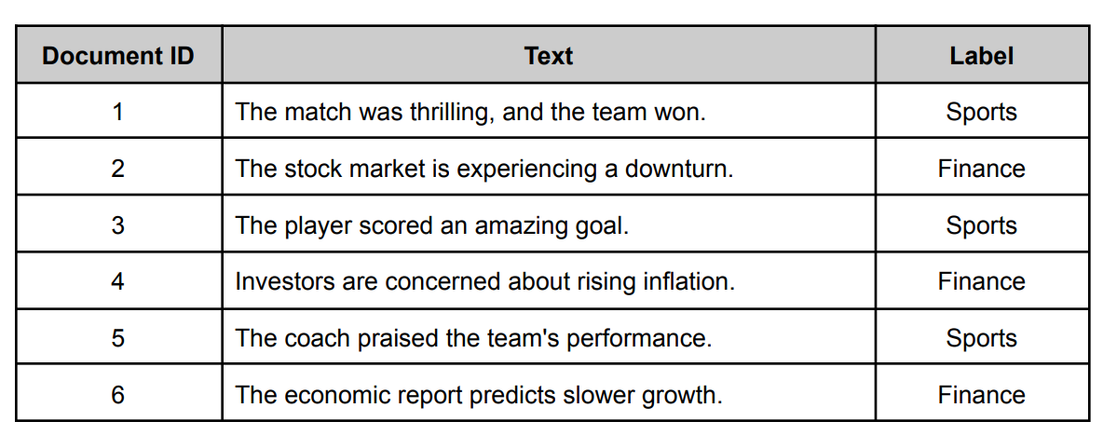
- Consider the following dataset containing labeled text documents.
Test set:
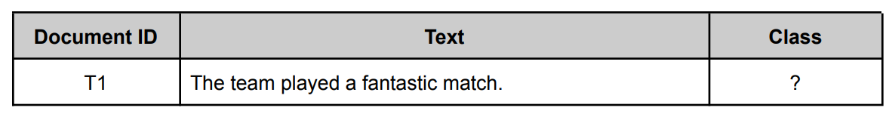
Describe step-by-step how a Naive Bayes classifier calculates the probability of a document belonging to either the Sports or Finance class. Use the document T1 (“The team played a fantastic match.”) to illustrate your explanation.
Ans:
1) Preprocess
Lowercase & remove punctuation : ["the", "team", "played", "a", "fantastic", "match"]
2) Get conditional probabilities $P(w∣C)$and priors $P(C)$
Priors:
$$P(\text{Sports})=0.5, P(\text{Finance})=0.5$$
$P(w∣\text{Sports})$:
- the = 0.1132
- team = 0.0566
- a = 0.0189
- match = 0.0377
$P(w∣\text{Finance})$:
- the = 0.0588
- team = 0.0196
- a = 0.0392
- match = 0.0196
3) Compute the likelihood
- For Sports:
$$\begin{matrix}P(T1∣\text{Sports}) & =0.1132×0.0566×0.0189×0.0189×0.0189×0.0377 \\ & ≈1.6307584×{10}^{-9}\end{matrix}$$
- For Finance:
$$\begin{matrix}P(T1∣\text{Finance}) & =0.0588×0.0196×0.0196×0.0392×0.0196×0.0196 \\ & ≈3.4016347×{10}^{-10}\end{matrix}$$
4) Multiply by prior
- Sports numerator: $0.5×1.6307584×{10}^{-9}≈8.15379×{10}^{-10}$
- Finance numerator: $0.5×3.4016347×{10}^{-10}≈1.70082×{10}^{-10}$
5) Normalize to get $P(C∣T1)$
$$P(C∣T1)=\frac{{\text{numerator}}_{C}}{\sum_{C^{'}}{}{\text{numerator}}_{C^{'}}}$$
- Sum of numerators $≈9.85461×{10}^{-10}$
So
- $P(\text{Sports}∣T1)≈\frac{8.15379×{10}^{-10}}{9.85461×{10}^{-10}}≈0.8274$
- $P\left(\text{Finance} ∣ T1\right)≈1-0.8274≈ 0.1726$
Thus, it can classify T1 as Sports (posterior ≈ 82.7%).

Attachments CPE393_Lab6.1 :
https://docs.google.com/spreadsheets/d/1vu2dcRhgGGNU4E8ImwkJMRac6cfJFk7u6N04gRUGy9A/edit?gid=0#gid=0

