Republic of the Philippines

**TECHNICAL EDUCATION AND SKILLS DEVELOPMENT AUTHORITY**

# NATIONAL CERTIFICATE II

## in

**COMPUTER SYSTEMS SERVICING**

*is hereby awarded to*

# JAMES JOSEPH R. NONO

## for having completed the competency requirements under the Philippine TVET Competency Assessment and Certification System in the following units of competency:

Unit Code Unit Title

### BASIC COMPETENCIES

500311105 Participate in workplace communication 500311106 Work in a team environment

500311107 Practice career professionalism 500311108 Practice occupational health and safety

procedures

Unit Code Unit Title

### COMMON COMPETENCIES

ELC315202 Apply quality standards ELC311203 Perform computer operations

ELC311201 Perform mensuration and calculation ELC311202 Prepare and interpret technical drawing ELC724201 Use hand tools

ELC724202 Terminate and connect electrical wiring and electronic circuits

ELC724205 Test electronic components

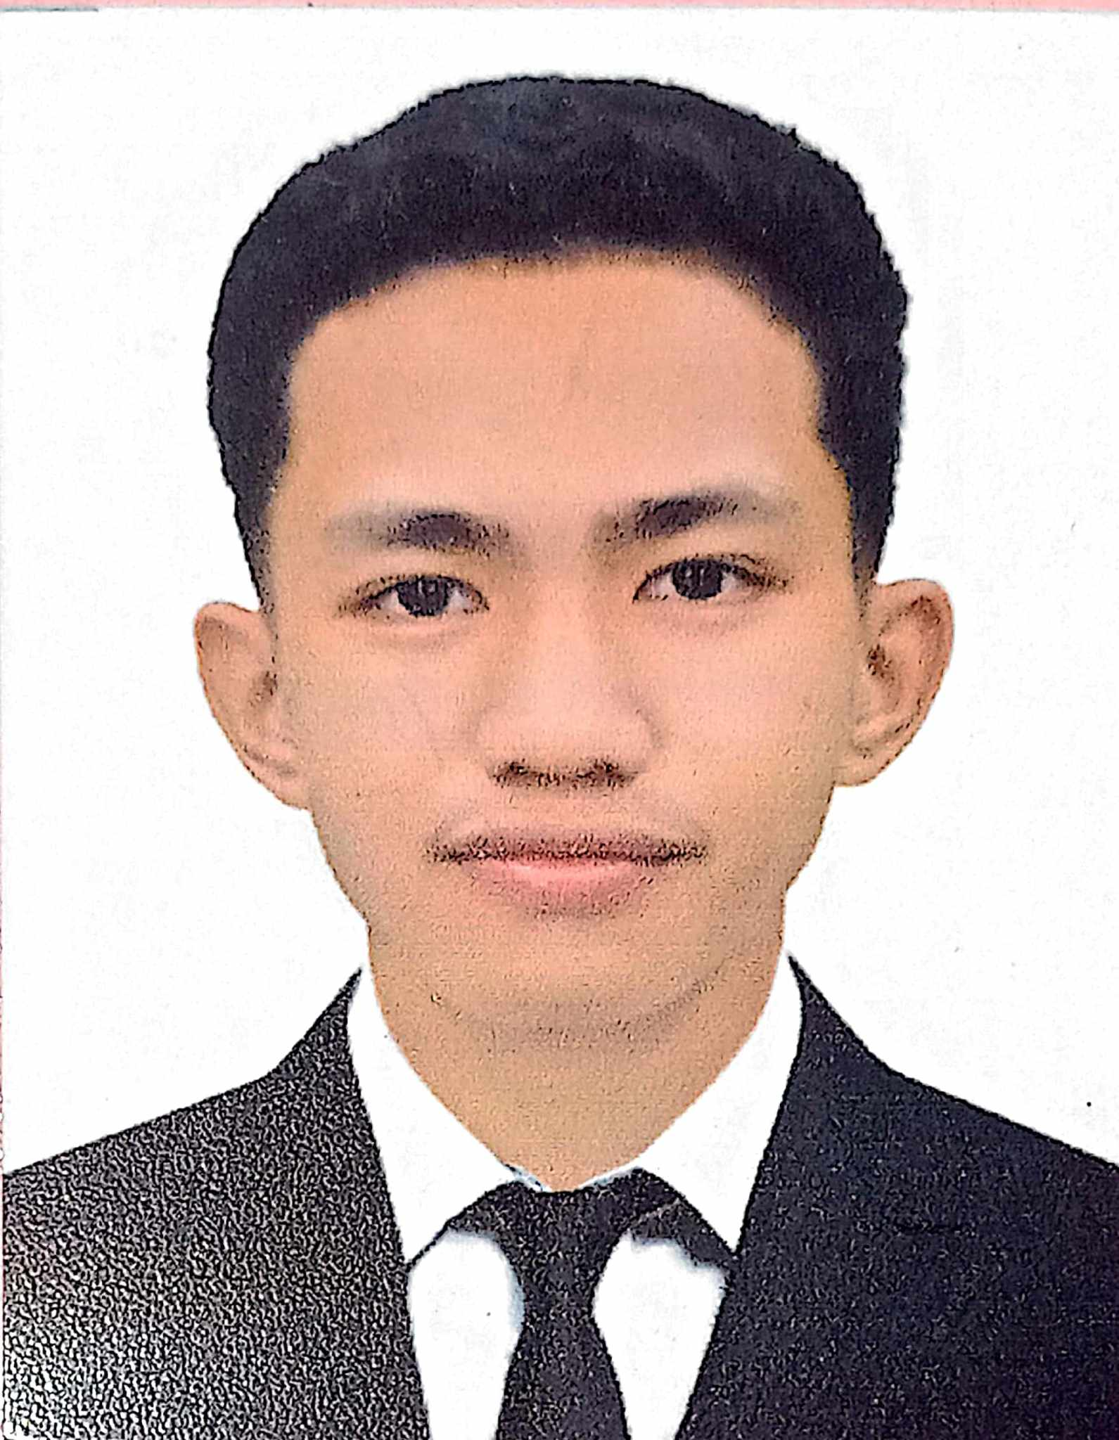Unit Code Unit Title

### CORE COMPETENCIES

ELC724331 Install and configure computer systems ELC724332 Set­up Computer Networks ELC724333 Set­up Computer Servers

ELC724334 Maintain and Repair Computer Systems and Networks

Issued on: **May 03, 2024**

Valid until: **May 02, 2029**

**SEC. SUHARTO T. MANGUDADATU, Ph. D.**

TESDA DIRECTOR GENERAL

Certificate No: **24131602006014 ULI-NJR-06-140-13076-001**



This certificate is system generated through T2MIS