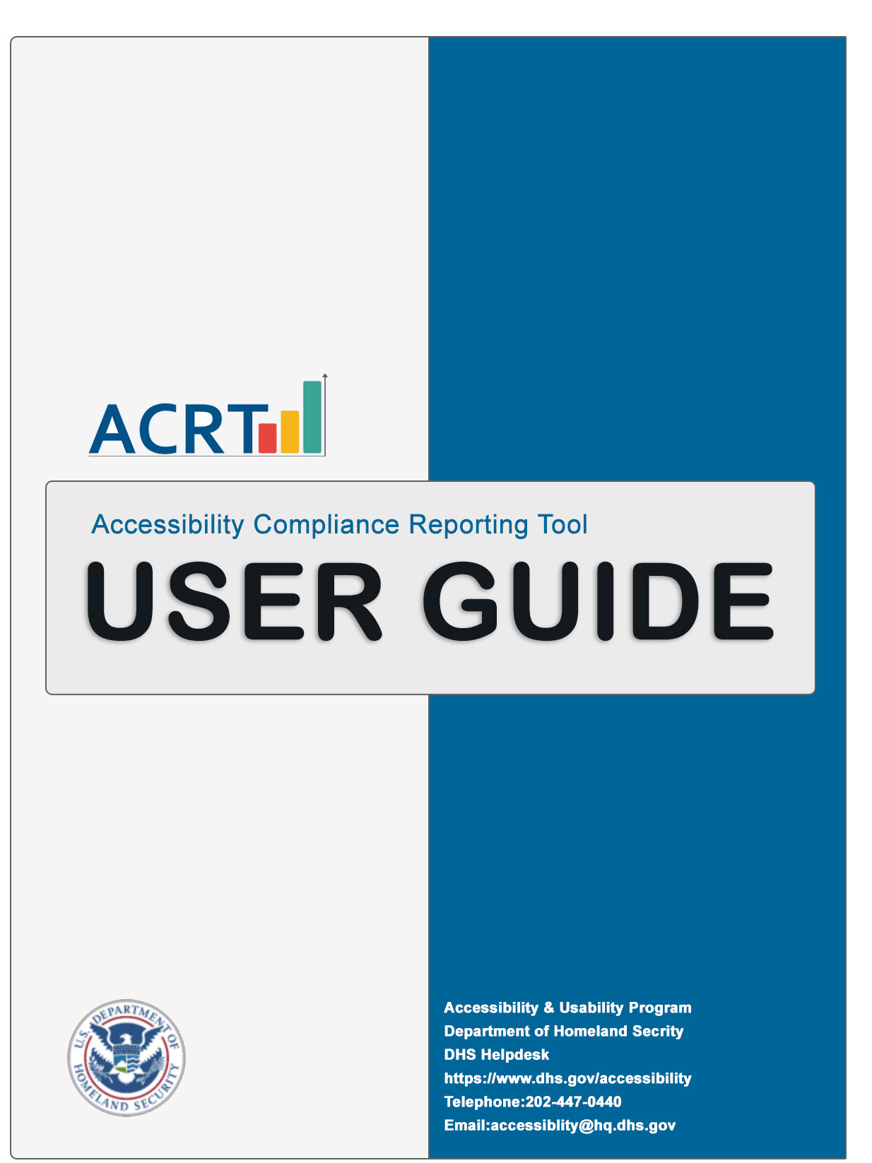

Contents

Section 1: Accessibility Compliance Reporting Tool Overview 2
1.1 Introduction to ACRT 2
1.2 User Guide 2
Section 2: Create Report 3
2.1 Load JSON File 3
2.2 Enter Data 3
2.2.1 Product Information 3
2.2.2 Testing Information 4
2.2.3 Test Environment Information 5
2.3 Enter or Edit Test Results 6
2.4 Add Remediation Details 7
2.5 Additional Results – Add Child Issue 7
2.6 Save 8
2.6.1 Save as Test Results 8
2.6.2 Save as a Template 8
Section 3: View Report 9
3.1 View Accessibility Conformance Report (ACR) 9
Section 4: References 11
4.1 Download 11

4.1.2 ACRT from GitLab 11
4.2 Files in ACRT Source Files 12
4.3 JSON File 12
4.3.1 Introduction to JSON 12
4.3.2 How to Manipulate the JSON File 13
4.3.3 How to Update Test Conditions 13
4.3.4 Updating Dropdown Menu Option 13
4.4 Accessibility Compliance Management System (ACMS) 13
4.5 Help Desk 14

Section 1: AEA Overview

1.1 Introduction to AEA
AEA is a free open source (MIT License) and browser-based application compatible to all common operating systems and does not require installation. The current version of AEA uses Trusted Tester v5.1.1. As a standalone application, it does not directly interact with any resources outside the local working machine. Captured data can be stored on a local machine in JSON file format or HTML file format. All test results can be modified based on different organizational and testing needs. All test data can be shared using storage devices, as email attachments, and/or printed HTML reports, as needed. Access to government sites or databases is not required to use AEA and private email accounts are accepted.

AEA works best with Google Chrome, Microsoft Edge, Safari, and Firefox. It is not compatible with Internet Explorer (IE).

1.2 User Guide
The AEA User Guide provides standardized instructions on using the application to create test results for web and/or software content. Refer to this user guide for instructions on how to create, edit and view the Accessibility Conformance Report. To access it within AEA, go to the instructions page and select the ‘AEA User Guide’ link to open the AEA User Guide in a new tab. It can also be accessed in the Resources folder in both Word and PDF format. The language and user interface details may differ depending on the application version and browser used.

Section 2: Create Report

2.1 Load JSON File

- Open AEA
Navigate to AEA folder and open Index.html.

- Select Create Report in the menu
Keyboard Users have the option to skip to main page content using the hyperlink at the top of the page or Alt+M.
- Select the ‘Choose File’ Button
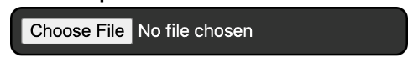
- Locate the JSON file
Navigate to the AEA folder and select the Resources folder to locate the JSON files.
New Report:
Select the SuccessCriteriaTT5.1.1.json file and select Open.

Edit Previous Report:
To edit a previously created report, navigate to the JSON file, and select Open.

- Select ‘Load File’ Button
After selecting Load File, a modal dialog displays instructions on how to save. Select OK to close it. The JSON file is loaded at the bottom of the page and is ready for editing.

After the JSON file is loaded, the ‘Select File’ button is hidden. To load a different file, reload the page from the browser menu.
Optional Step - Select ‘Disable Add/Remove Issue Alerts’ Checkbox
You can disable the alerts for adding and/or removing issues within the test results form here.

2.2 Enter Data

2.2.1 Product Information
Complete required fields as indicated by a red asterisk. *
- Select ‘Show Product Section’ Show/Hide Button
This expands the section to reveal all fields. The same button is also used to collapse and hide the fields.
- Input Product Name *
Complete the required form field, which has a character limit. The name is used to construct the filename of the saved JSON file.

- Input Product Version *
Complete the required form field which has a character limit. The version is used with the name to construct the filename of the saved JSON file.

- Input Product Owner/Vendor
The form field is optional and has a character limit.

- Select Product Type
The form field is optional. Use the dropdown menu and choose one:
- Custom developed web page
- COTS
- Customization of COTS product
- GOTS application
- Software
- Other

- Input Location
The form field is optional and has a character limit.

- Input Product Description *
Complete the required form field which has a character limit.

- Input Notes
The form field is optional and has a character limit. Notes can include items such as summary of defects identified as global issues, questions about the application defects, embedded non-accessible documents, or any notes that would be of value.

2.2.2 Testing Information
Complete required fields as indicated by a red asterisk. *
- Select the ‘Show Testing Information Section’ Show/Hide Button
This expands the section to reveal all fields. The same button is also used to collapse and hide the section.
- Input Company Name *
Complete the required form field which has a character limit.

- Input Tester’s First Name *
Complete the required form field.

- Input Tester’s Last Name *
Complete the required form field.

- Input Trusted Tester ID
This form field is optional but users are encouraged to provide a Trusted Testers certification number.

- Input Tester’s Email *
Complete the required form field. Users have the option to use a government or a private email address.

- Input Testing Scope
This form field is optional but is commonly used as a description or list of what was tested.

- Verify Testing Method and Version
When the JSON file is loaded (refer to 2.1), these form fields are auto-populated and are read-only.

2.2.3 Test Environment Information
This section does not contain any required fields but Trusted Testers are encouraged to complete this section.
- Select the ‘Show Test Environment Section’ Show/Hide Button
This expands the section to reveal all fields. The same button is also used to collapse and hide the section.

- Select the Browser Compatibility View
Use the dropdown menu to select:
- None
- Turned On
- Turned Off

- Choose Browser Type and Version
Select the type of browser used by navigating to the dropdown menu to select the browser type. More than one browser type and version can be selected.

- Choose the Operating System and Version
Select the operating system used by navigating to the dropdown menu to select the version used. More than one operating system and version can be selected. If ‘Other Operating System’ is selected, additional form fields for the Name and Version will become available.

2.3 Enter or Edit Test Results
This step cannot be completed without first uploading a JSON file (refer to 2.1).
- Locate the Test Results Form
Scroll down to find the Enter Test Results form. It is only visible after a valid JSON file is loaded
- Enter the Test Results

Each row in the Test Results Form includes:

- Issue Number

- Test Name

- Test ID

- Test Condition

- Test Result
Use the dropdown to select
  - No Selection
  - Pass
  - Fail
  - Does Not Apply

- Browser
If the browser used for this test result is different it can be noted here. When applicable, select the check box to change the browser. Use the dropdown to select the version of the browser used for the test.

- Tester Comments
The form field has a character limit and is used for any comments about the test.

- Location/Screen
The form field has a character limit and is used to provide details needed to locate the defect on the web page.

- Screenshot
After a test result is added, a ‘Choose File’ button will appear to add images to the corresponding test result. To add a screenshot, select the ‘Choose File’ button, select the image file (PNG, JPEG, or GIF), and select Open.

- Global Issue
Use the dropdown to select
  - None
  - Yes
  - No

- Go to Parent/Add Child Issue
The Child Issue is a separate issue added that is associated to the same Test ID, the parent.
(Refer to 3.3).

Additional Option: Remediation Details. (Refer to 3.2)
These columns are only available if ‘Show Remediation Detail’ is checked.
- Remediation Details
- Remediation Screenshot
- Remediation Date

- Save The file will be saved to the system’s Downloads folder by default. (Refer to 2.6)

2.4 Add Remediation Details
Any accessibility issues that are not addressed before production release should be tracked within the test results generated using AEA to be prioritized in the product backlog. Trusted Testers should coordinate with their IT Project Manager regarding remediation details.
- Load JSON file (Refer to 2.1)
- Select the Checkbox for Show Remediation Detail Columns
Two columns are added to the report next to Global Issues.

- Remediation Details
Include the steps taken to remediate the accessibility issues identified. This field has a character limit.

- Remediation Screenshot
Add in any images needed to document the remediation. To add a screenshot, select the ‘Choose File’ button, select the image file (PNG, JPEG, or GIF) and select Open.
- Remediation Date
Provide the date the accessibility issues were remediated and finalized.
- Enter the Remediation Details
Document the planned or remediated fix. Additional remediation details could include:
- Remediation details for all test results that failed.
- Ticket numbers and expected release number. Commercial off-the-shelf (COTS) products will need the commercial vendor to create issue tickets for remediation purposes.

- Enter the Remediation Date
Provide the estimated planned or fix release date of the remediation.

- Save
The file will be saved to the system’s Downloads folder by default. (Refer to 2.6)

2.5 Additional Results – Add Child Issue
Document any additional issues for a specific Test ID by creating a child issue. A Test Result of “Fail” must be selected before being able to add a child issue.
- Select the ‘Add Child Issue’ Button
After the first fail result is added for a Test ID, the ‘Add Child Issue’ button will appear. Once selected, a dialog box will appear; select OK to close it. A new row for the Test ID is added above the current row.

- Add Child Issue Details
Enter the Test Results for the new Child Issue.

- Save
The file will be saved to the system’s Downloads folder by default. (Refer to 2.6)

2.6 Save
Before saving, all required fields must be entered. Unsaved data will be lost if the page is refreshed or closed without saving it.
- Save JSON file
Scroll to the bottom of the page and select the ‘Save (ALT+S)’ button or use the shortcut key ALT+S to Save. Each time the report is saved, a new JSON file is created.

- Locate File
The JSON file will be saved to the system's Downloads folder by default.

2.6.1 Save as Test Results
Save JSON file with test results so that it can be loaded and edited later. After saving, continue entering testing information. The Report will be marked as Draft after save until results are entered for each test.

2.6.2 Save as a Template
Save a file with entered data as a custom template for later use. For example, by entering standard information such as name, email, operating system, and browser used can be saved as a template and used for future reports.

Section 3: View Report

3.1 View Accessibility Conformance Report (ACR)
Once all test results are entered, generate a draft or final ACR. There must be at least one valid test result in order to view the report. A final report includes each defect detail, along with any Disability Impact and other test results for Hardware Test and Document Test. The View Report page is read-only, so no changes can be made. To make changes, Refer to Section 2.

- Select View Report
In the top menu, select View Report.

Keyboard Users have the option to skip to main page content using the hyperlink on top of page or use shortcut Alt+M.

- Select the ‘Choose File’ Button
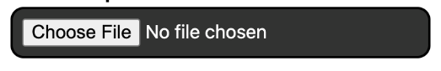
Locate the Test Results File JSON file. By default, JSON files are saved in the Downloads folder (Refer to 2.5). Once found, select Open. The label on the button changes to ‘Load Results’.

- Select ‘Load Results’ Button
A modal dialog box will appear with a tool tip that states, “To save printer friendly HTML file, select the keyboard shortcut (Alt+S) or ‘Save’ button located at the bottom of the page. Select ‘OK’ button to close.”
After a file is loaded, the ‘Select File’ button is hidden. To load a different file, reload the page from the browser menu.
The page will display:
  - ‘Product Section’ Show/Hide Button
  - ‘Testing Information Section’ Show/Hide Button
  - ‘Test Environment Section’ Show/Hide Button
  - ‘Terms Used in the Conformance Level Section’ Show/Hide Button
- Test Method
  - Testing Method Version
  - Review Date
  - Note: ‘This is a Draft report. For final report, please input results for all tests.’
  - WCAG Report
  - Filter Results Option
A dropdown menu to filter the test results by selecting Pass/Fail/Does Not Apply/Not Tested/All.
  - All the test results in a table, by default
  - Disability Impact Summary Link
Downloads the WCAG 2.0 Impact Statements with Section 508 Functional Performance
Criteria.
  - ‘Disability Impact Score’ Show/Hide Button
Displays the Risk Score Breakdown for the test results.
  - ‘Other Test Results’ Show/Hide Button
Shows Hardware and Document test results.
- Review & Verify
Review all Test Information to verify all information is correct. By default, all test results are shown. The ‘Filter by’ dropdown menu can change the results table to only show either Pass/Fail/Does Not Apply/Not Tested/All test results.

- Select the “Save as HTML” Button or ALT+S
Generates a printer-friendly HTML version of the report. By default, the file is saved in the Downloads folder unless otherwise specified. A draft report in HTML format is generated if not all test results have been entered. It is advisable to keep both JSON & HTML files for future use.

- Open a Final Version
Locate the HTML file and select Open. Review and check test results.

Optional Steps:
  - Select the ‘Print this page’ button to print
  - Convert the HTML report to PDF
  - Save the HTML report a PDF file, if available under printer options.

Section 4: References

4.1 Download

4.1.1 AEA From GitHub
The latest version of the AEA repository is provided to the public and does not require a GitHub account.
- Locate the AEA Repository
  - Find the latest version and all support files from the AEA repository located at: https://github.com/Section508Coordinators/AEA
- Select the ‘Code’ Button for the Latest AEA Version.


- Select Download Zip

- Extract the Zip File
  - The application will not properly execute from within the zipped folder.

- Copy/Move Folder
Go to the “Downloads” folder and copy or move the “AEA-master” folder to another location.

- Open AEA
Open the “AEA-master” folder and select Index.html to launch AEA.

For additional information on how to download from GitHub, visit: https://www.wikihow.com/Download-a-GitHub-Folder

4.1.2 AEA from GitLab
This option is available to DHS employees who cannot access GitLab. Sign in with your DHS SSO or PIV card.
- Locate the AEA Repository
  - Find the latest version and all support files from the AEA repository located at: https://maestro.dhs.gov/gitlab-ce/appdev/AEA
- Download the AEA GitLab Files
- Select the Download Button Icon.
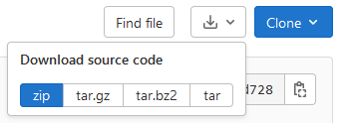

- Select ‘zip’ from Download source code options

- Extract Zip File
  - The application will not properly execute from within the zipped folder.

- Copy/Move Folder
  - Go to the “Downloads” folder and copy or move the folder to another location.

- Open AEA
  - Open the Index.html file to launch AEA.

For more information about gitlab, visit:
https://docs.gitlab.com/ee/user/project/repository/

4.2 Files in AEA Source Files
File Name Type | File Purpose
About.html | Provides AEA overview
AEATrainingManual.docx | Detailed instructions on how to use AEA (Word format)
AEATrainingManual.pdf | Detailed instructions on how to use AEA (PDF format)
AEA_View_webReport.html | Used to view test results
AEA_Web_Input_Form.html | Used to create or edit test results
CSS
Help.html | General instructions on how to use AEA
Index.html | Landing page for AEA
JS
LICENSE.html | AEA license in html format
LICENSE.md | AEA license in text format
README.md | Provides overview on how to use AEA
SuccessCriteriaTT4 | JSON file needed for entering test results (TT4 format).
SuccessCriteriaTT5 | JSON file needed for entering test results (TT5 format).
Trusted_Tester_Test_Process_v5.0.docx | Details of Section 508 test process (Word format)
trusted_tester_test_process_v5_0_aug_16_2019.pdf | Details of Section 508 test process (PDF format)
TT5-ID-FPC_Mapping.xlsx | Disability mapping reference document
WCAG 2.0 Impact Statements.docx | Describes type of disabilities and groups impacted
Acr.pdf | Accessibility Conformance Report details

4.3 JSON File

4.3.1 Introduction to JSON
JavaScript Object Notation (JSON) is a standard text-based format representing structured data based on JavaScript object syntax. AEA uses the JSON file to populate Baseline elements and transmit data in web applications, such as sending data from AEA to display Application Test Results in HTML format. Users can modify the JSON files to create their own personal test results template. Test conditions can be modified in the local JSON file based on different user’s needs.

4.3.2 How to Manipulate the JSON File
- Open a ‘SuccessCriteria.JSON’ file.

- Go to the section of JSON file to be modified.
- Only update the values (“ “) for different properties.
DO NOT modify the property name.
- Copy, modify or delete sections as needed.
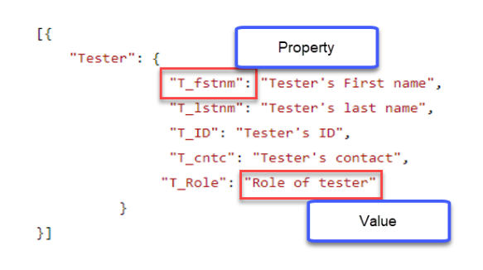
Sample JSON file with property and value attribute highlighted.

4.3.3 How to Update Test Conditions
If following test processes other than Trusted Tester, change test conditions in the ‘SuccessCriteria.json’ file as needed by updating the values for properties. To do so, replace “CrtID”:”2.2.2” test condition value with a different test condition or process using for the Criteria ID property.

4.3.4 Updating Dropdown Menu Option
Different test conditions have different dropdown menu options. Please use this reference to update “OptMenu1” property accordingly:
- Menu1: ‘Does Not Apply’ & ‘Not Tested’
- Menu2: ‘Pass’, ‘Fail’ & ‘Does Not Apply’
- Menu3: ‘Pass’ & ‘Does Not Apply’
- Menu4: ‘Does Not Apply’
- Menu5: ‘Pass’ & ‘Fail’

4.4 Accessibility Compliance Management System (ACMS)
ACMS is only available to Trusted Testers with DHS government email accounts. ACMS is used to provide test results related to information and communication technology (ICT).
- Go to OAST Homepage in ACMS
Create an ICT Review Request in ACMS and attach test results in JSON and HTML file formats. For additional guidance, please refer to ACMS instructions on how to attach test results within ACMS.

- Select “Submit 508 Test Results”
Using the ICT Review Request ticket number, submit test results using the “Submit 508 Test Results” feature within ACMS. The ticket number is provided to the requestor that created the ticket. For additional guidance, please refer to ACMS user instructions.

4.5 Help Desk
DHS Accessibility Help Desk
https://dhs.gov/accessibility
202-447-0440 (Voice)
accessibility@hq.dhs.gov

