$REPORTDATE

$COMPANYNAME

$COMPANYADDRESS

$COMPANYCITY, $COMPANYPROVINCE

$COMPANYPOSTALCODE

**Attn: $CLIENTNAME**

**$CONTACTPOSITION**

**Re: Pre-Abatement Inspection Report - Type 2 Operations**

**SEL Project Number: $PROJECTNUMBER**

**$SPECIFICLOCATION – $BUILDINGNAME**

**$PROJECTLOCATION, $PROJECTCITY, $PROJECTPROVINCE**

1.0 BACKGROUND

On $PREABATEMENTSTARTDATE, Safetech Environmental Limited (SEL) conducted a pre-abatement visual inspection for the asbestos abatement project to be conducted within $SPECIFICLOCATION at $BUILDINGNAME located at $PROJECTADDRESS, $PROJECTCITY, $PROJECTPROVINCE.

These services were conducted on behalf of $CLIENTNAME, $CLIENTPOSITION for $COMPANYNAME, to ensure that all work was conducted in accordance with the requirements set forth in Ontario Regulation 278/05 (O.Reg. 278/05) *Designated Substance – Asbestos on Construction Projects and in Buildings and Repair Operations* as made under the Occupational Health and Safety Act and Humber College’s Asbestos Management Program. The scope of work includes ceiling access work within $SPECIFICLOCATION where asbestos-containing sprayed fireproofing is present. This work is classified as a Type 2 operation under O.Reg. 278/05.

2.0 METHODOLOGY

A visual inspection was conducted prior to the start of asbestos abatement. The objective of our pre-abatement visual inspection was to ensure that the work area was properly constructed and contained, equipment and materials were adequately protected and that adequate engineering controls were in place in accordance with project specifications and O. Reg. 278/05 requirements. SEL also verified that the contractor had the proper equipment, materials and personal protective equipment (PPE) on site. Lastly, an on-site review was conducted with the remediation contractor prior to the start of abatement to confirm the scope of work and expected contractor work practices and procedures.

3.0 RESULTS

SEL personnel were on-site at approximately $ONSITETIME. Figure 1 below shows the general location of the Type 2 enclosure. Refer to attached photographs for typical site conditions observed at the time of our inspection.

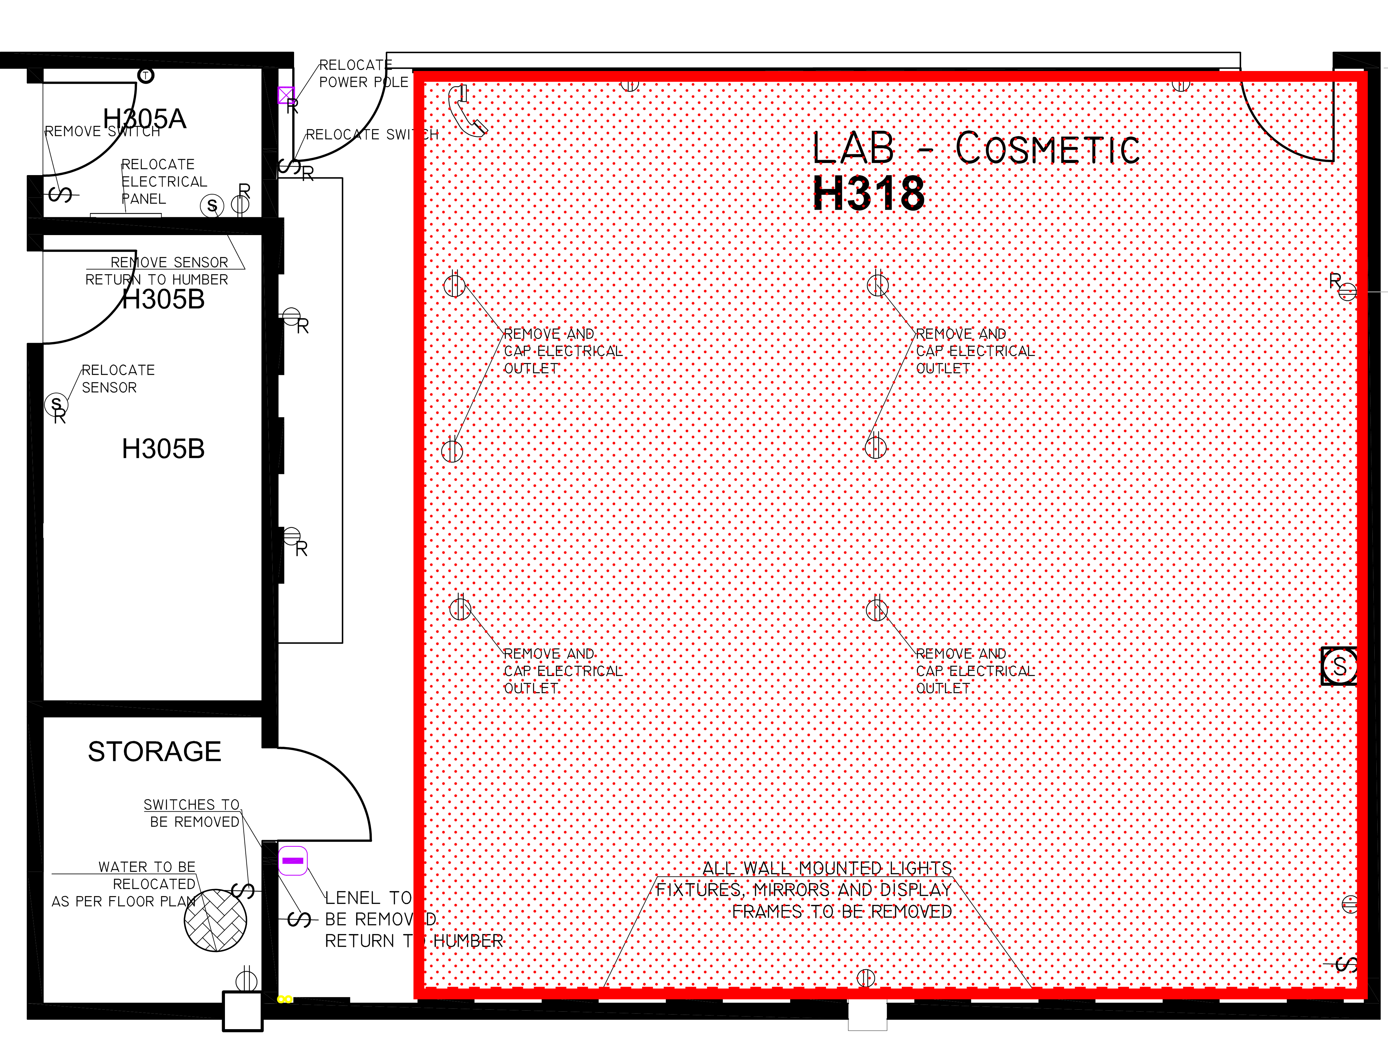

Figure 1

Results of our pre-abatement visual inspection indicated the following:

* Our visual inspection confirmed that an enclosure had been properly constructed with rip-proof polyethylene sheeting (white);
* All seams were sealed with construction grade tape;
* Asbestos cautionary signage was posted at the entrance to the work area;
* A one-stage worker decontamination facility was constructed at the entrance to the work area;
* Weighted curtained doorways were present;
* Floor surfaces within the Type 2 work area were covered with polyethylene sheeting;
* Upper seals were constructed from the top of the false ceiling to the deck;
* The four (4) diffusers were covered with polyethylene sheeting;
* One (1) HEPA-filtered construction air handling unit (CAHU) was in operation (exhausted into Room H318). The CAHU had been DOP-tested on August 7, 2018.
* One (1) HEPA-filtered vacuum was observed on-site;
* All required personal protective equipment (PPE) was observed on-site; and
* All required equipment was observed on-site.

The following deficiencies were observed:

* The HVAC system was in operation; and
* The DOP test record for the HEPA-filtered vacuum on-site is out-of-date (2010).

4.0 CONCLUSIONS AND RECOMMENDATIONS

Results of our pre-abatement inspection on $PREABATEMENTSTARTDATE, verified that a Type 2 enclosure had been constructed within $SPECIFICLOCATION at $BUILDINGNAME. Once deficiencies noted in Section 3.0 have been corrected, permission is granted to commence ceiling access work.

Please note that all workers in the Type 2 enclosure must don full-face air-purifying respirators with P-100 filters, disposable coveralls, and other personal protective equipment as required under the Occupational Health and Safety Act.

5.0 LIMITATIONS

The investigation, assessments and recommendations detailed in this report were carried out in a manner consistent with the level of care and skill normally exercised by reasonable members of the environmental and industrial hygiene consulting profession currently practicing under similar conditions in the area. Furthermore, the investigation, assessments and recommendations in this report have been made based on conditions observed at the time of the assessment and are limited to the areas investigated.

In preparing this report, Safetech Environmental Limited (SEL) relied on information supplied by others, including independent laboratories and testing services. Conclusions made in this report are based on the laboratory analytical results for the air samples analyzed. Except as expressly set-out in this report, SEL has not made any independent verification of such information.

This report has been prepared for the sole use of the person or entity to who it is addressed. No other person or entity is entitled to use or rely upon this report without the express written consent of Safetech Environmental Limited and the person or entity to who it is addressed. Any use that a third party makes of this report, or any reliance based on conclusions and recommendations made, are the responsibility of such third parties. SEL accepts no responsibility for damages suffered by third parties as a result of actions based on this report.

Should you have any questions regarding this project, please contact our office.

Sincerely,

**SAFETECH ENVIRONMENTAL LIMITED**



James R. Green, BA, CRSP, AMRT

Senior Project Manager

*Attachment: Site Photographs*

|  |  |  |
| --- | --- | --- |
|  |  |  |
| **P1**: Typical view of the Type 2 enclosure. |  | **P2**: View of asbestos cautionary signage posted at the entrance to the work area. |
|  |  |  |
| **P3**: View of HEPA-filtered CAHU in operation. |  | **P4**: View of DOP test record for the CAHU. |

|  |  |  |
| --- | --- | --- |
|  |  |  |
| **P5**: Typical view of Type 2 work area. |  | **P6**: View of upper seals constructed within the work area. |
|  |  |  |
| **P7**: Typical view of Type 2 work area. |  | **P8**: View of sealed HVAC supply-air diffusers. |