**U10P32002, School of Computer Science and Technology, NPU, Spring 2019**

**Dikshya Kafle-2018380039**

**Assignment 1**

**March 25th**

**Problem Statement**–Three different classes are to be created for date.h,homework.h and homeworklist.h. The files are created as date.cpp, homework.cpp,homeworklist.cpp.

**Structure Chart** **–** The following is the structural chart of the program:

main

choice

homeworklist

homework

date

**Implementation:**

**date.cpp** – date is the class name .This class includes the header file date.h. In this class day, month and year are the integers. another_date is used for the comparison purpose. It is just the another date as it is written.

**Input:**The initialized value of date , month and year is 0 unless some another value is assigned by a programmer.

**Output:** In function compareTo in the member function allows the program to compare between two dates. Zero is returned if the dates are equal, Positive value will be returned if the invoking value is greater than the date presented in the parameter. Similarly, the negative value will be returned when the invoking value is less than the date value presented in the parameter. Therefore, the Output value is to be in the form of month, year and date just like (mm/dd/yyyy).

Algorithm int date::compareTo (date and another_date)

Similarly,

{ year is compared to year;

month is compared to month;

day is compared to day;}

ostream&operator<<(ostream&stream,date d)

{

stream<<d.month<< ‘/’<< ‘/’<<d.year;

return stream;

}

**homework.cpp**

It includes the file homework.h in the head directory and also includes the string as name. assigned_date and due_date are two fixed dates. another_homework is the homework which is used in comparision purpose of the program.

**homeworklist.cpp**

Input: When we assign name for name, date for assign_date and due_date then the output will be as the following:

**Test Description and Results:**

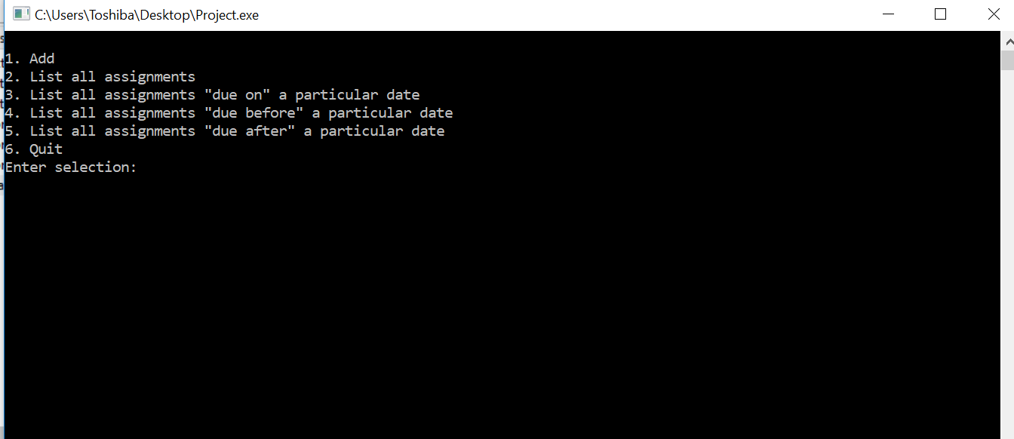

As displayed on the screen we can clearly see what is going on. If I press 1 I get to add the name of the homework, the assigned date and the due date . Therefore, the following result will be obtained after that:

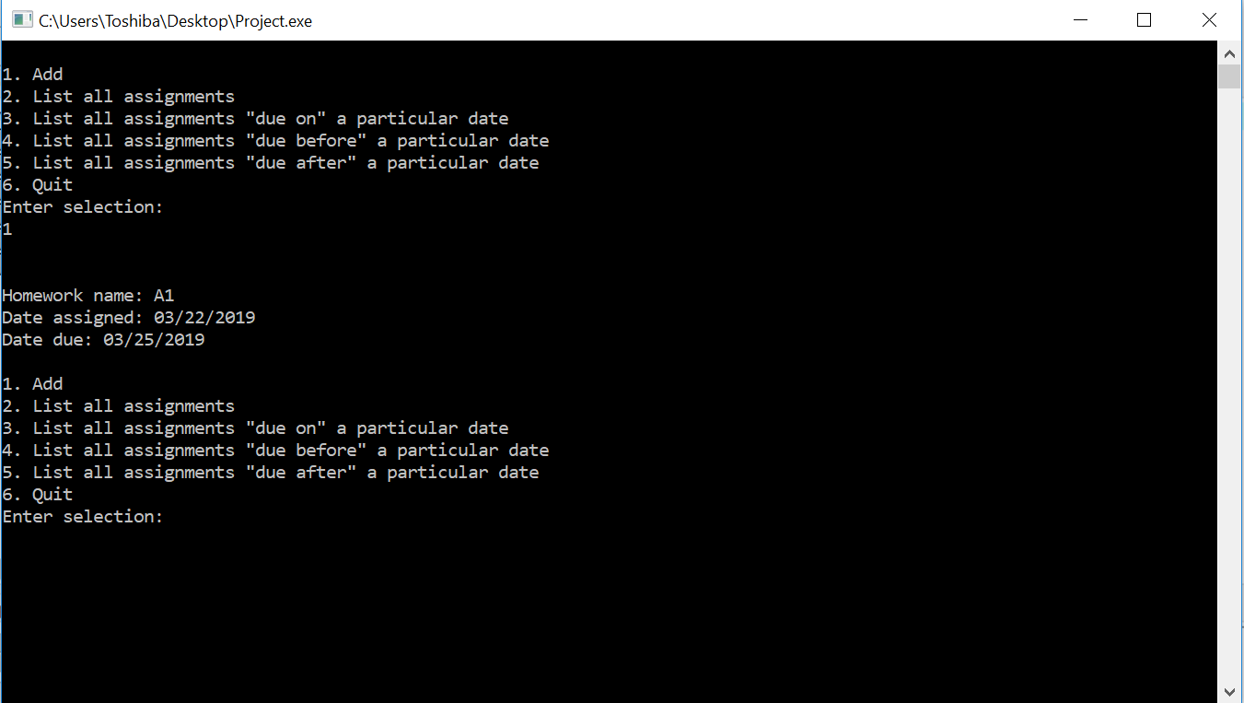

Furthermore, when 2 is entered in the enter selection the particular due date from the assigned date is displayed with its homework name (A1:3/22/2019-3/25/2019). The following the whole result:

The output is displayed as shown in the screenshots. Thus, to exist the program number 6 is being entered as it is displayed in the following screenshot:

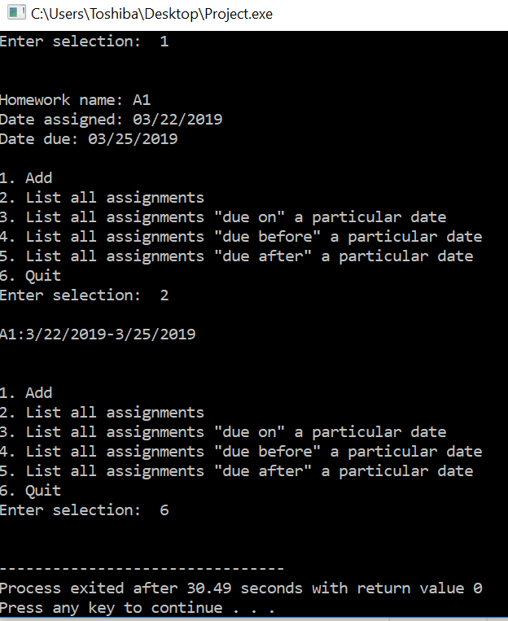

Throughout the procedure I think the program is quiet good enough. However, there will be some problem cause if the user enters the date that doesn’t exist at all. There should be given some conditions or limits for entering the date. By doing this the user will consider the requirements and will not fail to enter the proper date which leads to have no program error.

**Epilogue** – Since I’ve never studied c++ it was a very complicated task for me. I couldn’t figure out what was going on and what I should be doing. I stressed a lot. After sometime I asked help to the TA and Teacher. From the explanation I understood a little bit about how classes work and how the files are combined and run together. I tried to understand how such kind of programs are done and found some solutions to solve the program. After the explanation of the teacher in the class I took the picture of the program and tried to understand how it worked and what their functions are. However, after completing the program it was very annoying because I couldn’t get the results at once. I asked my friends to send the original files and figured out that some changes was made in the original file unknowingly. After compiling the whole project together with the original files finally, I was able to see the results. It was the happiest moment of the whole day. I learned some basic ideas about c++ while doing this program. I am teaching myself more in order to able able to do everything on my own.

Attachments – The attachments are to be attached in the email. The name of the files are:

date.cpp

homework.cpp

homeworklist.cpp

**Acknowledgement** – Teachers’ explanation in the class about the assignment. The explanation gave me little confidence in doing the assignment. Thanks to YouTube for helping me figure out how to create a project and after that compiling all the file and running them together.