**Northwestern Polytechnical University**

**Business administration**



Professor: Yan Xie

**Business Plan Flâneur**

**INNOVATION AND ENTREPRENEURSHIP PRACTICE**

Andrea Salas González – 2019380223

Dikshya Kafle - 2018380039

Chhorn Sreyneath – 2019380128

October 11th, 2021

**Table of Contents**

Executive Summary 3

1. Industry Analysis 4

Industry Statistics & Trends… 4

PESTLE Analysis… 5

1. Company Overview 6

Mission, Vision and Values 6

Products and Services 7

Legal Structure 8

1. Market Analysis 8

Market Segmentation 8

Competitive Analysis 9

SWOT Analysis 10

1. Operating Plan 10

Administrative Functions 11

FLANER Application Functions 11

Service Functions & Payment 11

Customer Relationship 12

Technology 12

1. Marketing & Sales Plan 13

The ‘FLANER’ Brand 12

Promotions Strategy 13

Purchasing Procedures 14

IV. ORGANIZATIONAL STRUCTURE 15

IIV FINANCIAL PLAN 15

Ownership & Equity Distribution 15

Funding Request 15

Cash Flow 16

Balance Sheet 17

Marketing Budget 17

Appendix 18

# EXECUTIVE SUMMARY

#### Business Overview

**Flâner**, is an app where you can buy second handed clothes. An app that connects locals with each other so that still reusable clothes won’t go to waste. Flâner rescues clothes before it gets thrown away with the caveat that if the quality of the clothes are low, they won’t be suitable for sale, having to pass some filters in order to be candidates for a sale. Making brand clothes accessible for everyone and reduce pollution. Using our app you’ll be able to get on trend with clothes from great stores at the best cost.

#### Products and Services

**Flâner** will offer a wide variety of clothes that will still be in trend and in great quality from the most trustworthy retailers (e.g. people that bought a garment from a specific store and only used it once and don’t want it anymore, someone who ordered something online and it’s not of their size and can’t take it back, small second handed shops, etc).

### Our services include:

1. . Matching the app users with their favorite brands.
2. Optimizing the prices for retailers.
3. Original designing clothes and bags accessible for everyone.
4. Giving a second chance retailer’ garments.
5. Making the best fashion garments accessible and at the best price.

**Flâner** will primarily target people who enjoy fashion, good quality clothes, shopping and those who are environmentally and or economical conscious.

### Flâner is uniquely qualified to succeed for the following reasons:

There is currently no app where you can buy second handed clothes in China. In addition, we have surveyed target users of and received extremely positive feedback saying that they explicitly would benefit highly from such services.

The mobile applications business is a proven business and has succeeded throughout the world.

Market trends, such as the growth in smartphone users, mobile app downloads, and in sharing economy proves very favorable to Flâner.

#### Financial Highlights

**Flâner** is seeking a total funding of $100,000 to launch its business. The capital will be used for include further app development, marketing collateral, website development and working capital.

## INDUSTRY ANALYSIS

The sharing economy is a type of market based on a concept that refers to peer-to-peer sharing of access to products and services, which is facilitated through community-based online services. The positive goal is to maximize the use of existing resources while avoiding overproduction, pollution reduction, and equitable distribution.

With advances in Internet technology, mobile payment, logistical infrastructure, and large demographic dividends, China's sharing economy has exploded in recent years, altering China's economic pattern and positioning itself as one of the country's top goals for future development. According to recent statistics, this form of economy is thriving.

## Industry Statistics

The following industry size facts and statistics bode well for **Flâner.[1]**

* + Revenue in the Apps segment is projected to reach US$554.83m in 2021.
  + Revenue is expected to show an annual growth rate (CAGR 2020-2024) of 7.2%, resulting in a projected market volume of US$734m by 2024.[2]
  + User penetration will be 68.0% in 2021 and is expected to hit 83.5% by 2025.
  + The average revenue per user (ARPU) is expected to amount to US$1,562.07.
  + Peer-to-peer lending and crowd funding will grow at a compound annual growth rate of 63% by 2025.
  + Sharing economy businesses will grow by a staggering 2,133% in just 12 years.[3]
  + In 2018, more than 760 million people in China participated in the sharing economy.[4]
  + Chinese netizens generally had higher satisfaction with the use of shared economic products in 2019.

## Industry Trends

* Advanced digital platforms and gadgets are becoming more widely available.
* Efforts to make better use of material resources, as well as economic rationality
* New consumer demands include increased collaboration and a shift in ownership
* Attitudes, as well as more ecologically responsible purchase choices.
* Globalization and urbanization are causing social changes.

Currently, most sharing economy rules are industry-specific and are implemented mostly by local governments and departments. As a result, there are currently no consistent laws governing the sector, with firms operating in different sectors of the sharing economy with differing levels of regulation.

China's sharing economy has a patchwork regulatory environment.

Because the sharing economy is still in its infancy, rules will need to develop to keep up with shifting consumer needs and the business models that new rivals bring to the table.

The Chinese government, as well as big corporations, is enthusiastic about the sharing economy. They see the sharing economy as a way for government, corporations, and consumers to benefit from one other. That is why, in terms of the global sharing economy, China sees itself as a leader, setting the bar in terms of both regulatory procedures and infrastructure transformation. In addition, according to a recent consumer poll, 94% of respondents claimed they were willing to share resources.

China's "Internet Plus" policy attempts to combine online business models with traditional industries, making it easier for new businesses to get started online. Because apps are so important in sharing platforms, penetration is high, with an estimated 601.8 million Chinese citizens using smartphones on a regular basis.

**PESTLE Analysis** Table 1 (Appendix) **Barriers to entry**

For us, the most difficult aspects of entering the market are establishing brand recognition and finding trustworthy partners. The following is our strategy:

We will focus on creating great partner connections rather than competing with potential market competitors.

According to the State Information Center's China Sharing Economy Development Report (2021), the sharing economy in China is predicted to recoup between 10-15% in 2021, with an annual growth rate of 10% for the next five years.[5]

## Financial Projection

The report from the State Information Center, a government think tank, forecast the annual compound growth rate of the China's sharing economy sector in the coming three years will remain between 10 and 15 percent.

## COMPANY OVERVIEW

FLANER aims to reduce the negative social and environmental consequences of clothing production, consumption, and waste by boosting our usage of secondhand clothing.

FLANER is a free app that deals with the problem of rapid fashion by linking locals with one another and with different sellers so that people can reuse garments. It is open to the public and aids in the reduction of pollutants. Making high-end clothing more available to the general public while also reducing pollution is a win-win situation.

**Mission statement:**

The negative social and environmental consequences of clothing production, consumption, and waste are addressed in our app. It aims to increases the use of secondhand clothes by implementing a combination of intelligent systems that are able to make decisions that contribute in reducing pollution in China.

**#1- Reuse Clothes**: People can get quality products. Reused good quality products can be bought in low price. It is a clothes sharing community which gives the people with limited access to worn clothes. Providing people with reuse services to stop wearable clothes being thrown into the waste stream or left unused.

**#2-Funding and supporting:** Funding, supporting and promoting global projects to establish more sustainable production and safer fairer conditions for people working in the supply chains making our clothes.

**#3-Raise Awareness:** Running education programs and campaigns to raise awareness of the socio-environmental impacts of clothes and to persuade and inspire people, businesses and policy makers to take action to keep clothes in use for longer.

Flâner is the **#1** Second Hand Clothes Selling App in China that will initially slow resource loops, then gradually narrow resource loops, and eventually close resource loops.

**Vision:**

**Flâner** aims to increase the use of second handed clothes resources at the source worldwide and play an active role in enabling the transformation to circular business.

**We are Inclusive:** Flâner is for everybody. It’s a mind-set, not a demographic. We value diversity of background, perspective and thought. We empower others to help fulfill our mission. We believe in the power of sharing and collaboration.

**We are Resourceful:** We hate waste of any variety. We spend our money very carefully; and time is our most precious asset so we guard it well. We take the initiative.

**We are Caring:** We’re caring in our actions and words within the Flâner community, towards each other, ourselves, and the planet.

**We are Innovative:**

**Values:**

-Beauty

-Quality

-Simplicity

-Sustainability

## Operational Structure

The divisional structure was chosen as the organizational structure for this corporation. This is due to the fact that this structure is the most basic in terms of grouping employees into different departments in order to meet the organization's needs.

## Products and Services

#### For Consumers:

* + Matching the app users with their similar dress interests
  + Reviews
  + Quality products in affordable prices
  + Volunteer opportunities.

#### For Businesses:

Optimize the prices of products with near expiry clothes. 24/7 Pick-ups of leftovers and unwanted products by trained volunteers.

## Technology Platform

Flâner will be built for iPhone and Android. Its modern, flat design has been optimized for the latest versions. Other features include:

1. Powerful resting API.
2. Security.
3. Full social network capabilities and transparent rating system.
4. Push notifications and Smart availability time estimation.
5. Smart localization / Real-time chat, sharing map location and voice messaging

## Legal structure

Flâner is a Limited Liability Company [LLC]. As a startup business adopting this legal structure was the best choice for the following reasons:

* 1. Avoid double taxation and, if necessary, support several stock classes.
  2. The ability to choose the LLC location that best meets our financial capacities, as well as the ease with which we can convert to a corporation as we grow and expand.
  3. There are no restrictions on foreigners and the registration process is simple.

## Market Analysis

In 2022, China's sharing economy is anticipated to be worth more than 9 trillion yuan (about 1.28 trillion dollars).

## Market Segmentation

Flâner will primarily target smartphone savvy people in two primary age **groups: 18-29 and 30-60.**

The demographics of these customers are as follows:

### User Group #1:

Age Group: 18-29

App Users: 55% Profile: Gen Y/Gen Z

Behavior: Willing to Try New Things, Lazy, Extra Tech-Savvy, Smart Working.

### User Group #2:

Age Group: 29-60

App Users: 35%

Profile: Gen X/Baby Boomers. Behavior: Hard-workers, Economically Conscious

Consumers aged 18 to 29 accounts for the majority of revenue in the mobile app sector. Consumers in this age bracket are the most technologically adept, have the highest smartphone penetration rate, and are most at ease making online purchases.

Consumers aged 30 to 49 are thought to account for 35% of the market. Because this market has much higher wealth than consumers aged 18 to 29, more lifestyle, tools, and productivity apps are being developed to cater to them.

## Competitive Analysis

**Flâner** directly or indirectly competes with all mobile applications. Direct competitors will come from companies who sell second hand clothes in a very satisfactory price related to mobile applications, similar second hand clothing sellers which is global competitor; We Chat where anonymous groups can offer sharing experiences in an intimate customer setting. Indirect competitor will come from companies offering sharing platforms such as, Alibaba, Taobao and clothes selling companies such as SHEIN, Zhuanzhuan.

**Our Competitive advantages**

**Flâner**

• We have modern platform ( size charts which is a kind of survey and it’s convenient for customers to choose the right side)

• Fast delivery ( within 24 hours)

• Does charity stuff that encourage people to buy stuff from our app maybe

• The product price is more reachable

**Them**

• None kind of platform which leads the percentage of stuff return increase and customers satisfied fall down

• Late delivery

• The product price is a little bit higher than us

Figure 1 (Appendix)

## SWOT Analysis

|  |  |  |  |  |
| --- | --- | --- | --- | --- |
| **Variables** | **Strengths** | **Weaknesses** | **Opportunities** | **Threats** |
| **Service Offering** | No investment needed for products | Minimal Variety at the Early Stage. | Innovation, Global Trends | Culture Habits, and Fear of Quality**.** |
| **Brand** | High Relevance & Strong Positioning. | No Presence. | Circular Economy/ Social & Eco.  Significance. | Culture Habits, and Fear of Quality**.** |
| **Staff/HR** | Opportunity to outsource. (Volunteers) | No Legal Team/Audit. | Motivation / Volunteering | Commitment, Creativity, and Quality |
| **Market** | Lack of direct competitors | Low profit at first stages | #1 in the Chinese Market/ Niche App | Copy Cat. |

**Estimated Revenue & Financials**

An average consumer throws away 70 Pounds (31.75 KG) of clothing per year. Globally we produce 13 million of textile waste. Each year 95% of which could be reused or recycled.

## OPERATING PLAN

In order to execute on Flâner’s business model, the Company needs to perform many functions including the following:

## Administrative Functions

1. General & administrative functions including legal, marketing, bookkeeping, etc.
2. Sourcing suppliers of content and managing supplier relations
3. Paying tax on all clothing
4. Recycle the unsold stock
5. Establish Key Partnerships

## Flâner Application Functions

## Developing additional application features

1. Produce cost-efficient articles of clothing in response to fast-shifting consumer demands
2. Accelerating supply chains and drives costs down to meet constantly evolving consumers' demands.
3. Mitigating the sustainability impact of environment bug-fixing

## Service Functions

1. Listen to the needs and wants of the customers.
2. Focus on customer satisfaction by provide the affordable prices and instant gratification

## Flâner Fashion Capabilities

For fast fashion seller, both service and speed are essential in providing a good experience for their customers. FLANER platform for fashion is designed with the following capabilities specifically to help the sellers offer their customers both a convenient shopping experience and real-time personalized offerings.

## Payment

### With recent technological advancements, it is advantageous to accept different types of payment because not every customer has the same preferences. Customers will have a better experience with your fashion business if you provide them with flexibility of payment methods.

### Credit &Debit Cards: It is very common for companies to offer credit and debit card payments as an option. They can be used for both in-person and online transactions.

### Digital Wallets: Mobile wallet payments are a new form of payment that our fashion business may want to accept. Nowadays you cannot go outside without seeing an individual holding a smartphone. People take their smartphones with them everywhere they go. The rise in smartphone use has resulted in an increase in the growth of contactless payments. Some mobile payment options include Apple Pay, Google Wallet, Samsung Pay, and Android Pay. These digital wallets are easy to understand and allow the purchasing process to go fast. Examples of items you can store in your mobile wallet are coupons, credit card numbers, debit card numbers, and loyalty card numbers. This payment method is convenient for customers for both offline and online shopping. Furthermore, digital wallets might give our fashion company access to our customers’ data. We can then learn their spending habits in fashion and send them notifications if new products are arriving or if a sale is occurring soon.

### Flâner Technology

## 

**Overview -** Flâner visualizes innovation as intelligence. In the following section, we present an overview of the intelligent features that we believe give Flâner its value and competitive advantage visualizes innovation as intelligence.

* 1. **Size Charts**: Flâner provides size charts to help consumers find the right size clothing, although not every customer might take the time to measure themselves before ordering online. We use data-driven personalization platforms that can be integrated within the seller online stores to provide size guides for website visitors. Using these platforms, a user can answer a few questions via an online survey, and replies are run through an algorithm that makes size recommendations.
  2. **Keeping The Consumer Informed:** Our app will guide and give solutions that offer detailed info about the specific item you intend to buy, including whether or not it’s worth buying. The guide uses algorithms to process massive consumer decision data and provide helpful, data-driven information that makes it easy for consumers to pick out great items that meet their unique needs. If, for instance, the customers are trying to figure out the best mattress for people with back problems, it would definitely take hours before they find a good fit. With this solution, however, they can get suggestions based on processed data from consumers of similar products.
  3. **Speeding up Communication:** Once the consumer has decided on the product they need, the next step would be to communicate with the seller. With the introduction of automation in business, customers no longer have to call in and wait in line to speak to an agent. Instead, live chats help the sellers communicate with customers as soon as they contact their websites and show an interest in making a purchase. Within a few minutes, a customer can have all their questions answered by an automated bot and make a purchase.
  4. **Providing Self-Serve Options:** Today’s customer wants to interact with a business independently. The technology enables this by allowing the sellers to give their customers different levels of engagement in their shopping experience to suit every need. With automation, businesses can ensure that their sites are as easy to navigate as possible; ensuring that the customers can have easy access to the products and services they need and access automated checkouts. Additionally, offering a FAQ segment on the seller website can be an excellent way of answering customer questions and improving engagement.
  5. **Increased Shopping Convenience:** The purpose of our app is to improve the buyer’s shopping experience. We use technology allows businesses to ensure that every aspect of the consumer journey is smooth, intuitive, and time-saving. This is achieved by incorporating fast and efficient ways of purchasing, such as cashless and one-touch payments. This helps remove obstacles to consumers, which can encourage customers to get through with the buying decision
  6. **See now, Buy now:** We allow the seller to sell their products in our platform and when the customers buy the clothes after finishing the payment, the customers will receive their products in one day. Because one day delivery times are evidence of the moves towards faster service for the consumer. Expectation of openness around supply chains and labor conditions are important to the consumer in order to decide if the clothes fit their personal values. The sellers need to articulate their culture in a way that is honest and enticing to their consumer.

## MARKETING AND SALES PLAN

## The ‘Flâner’ Brand

FLANER will focus on the Company’s unique value proposition

## 

## Market Analysis:

## Fast fashion is a contemporary term used by fashion retailers to express that designs move from catwalk quickly to capture current fashion trends. Fast fashion allows mainstream consumers to purchase trendy clothing at an affordable price. Fast fashion became common because of cheaper clothing, an increase in the appetite for fashionable clothing, and the increase in purchasing power on the part of consumers. Because of all this, fast fashion is challenging new fashion lines that are introduced on a seasonal basis by traditional fashion houses. That’s why our company sees this is the best opportunity if we help the customers to find clothes more conveniently.

## Global Fast Fashion Market: The research report has incorporated the analysis of different factors that augment the market’s growth. It constitutes trends, restraints, and drivers that transform the market in either a positive or negative manner. This section also provides the scope of different segments and applications that can potentially influence the market in the future. The detailed information is based on current trends and historic milestones. This section also provides an analysis of the volume of production about the global market and about each type from 2016 to 2027. This section mentions the volume of production by region from 2016 to 2027. Pricing analysis is included in the report according to each type from the year 2016 to 2027, manufacturer from 2016 to 2021, region from 2016 to 2021, and global price from 2016 to 2027. A thorough evaluation of the restrains included in the report portrays the contrast to drivers and gives room for strategic planning. Factors that overshadow the market growth are pivotal as they can be understood to devise different bends for getting hold of the lucrative opportunities that are present in the ever-growing market. Additionally, insights into market expert’s opinions have been taken to understand the market better.

## Segmentation Analysis: The report has classified the global Fast Fashion industry into segments including product type and application. Every segment is evaluated based on growth rate and share. Besides, the analysts have studied the potential regions that may prove rewarding for the Fast Fashion manufacturers in the coming years. The regional analysis includes reliable predictions on value and volume, thereby helping market players to gain deep insights into the overall Fast Fashion industry.

* Marketing Strategy

We use the 4C theory corresponding to the 4P of traditional marketing. Guided by consumer demand, it redefined the four basic elements of the marketing mix: Customer, Cost, Convenience, and Communication. The theory holds that satisfying customer demand and improving customer satisfaction are the top priorities, followed by reducing customer purchase costs, providing convenience to customers in the purchase process as much as possible, and finally implementing effective marketing communication with consumers as the center.

* **Meet customer needs:** In order to meet the target customers' pursuit of fashion trends, FLANER chooses to sell the design of international brands in clothing design. At the same time, we will learn the preference of consumers according to the feedback information and sales data of customers, and then improve the products. This strategy allows us to quickly choose and sell clothing that meets the needs of consumers to keep up with fashion trends by quickly following the fashion trends of major brands.
* **Reduce Customer cost:** The main target customers of FLANER are young consumers who are keen on fashion but have limited consumption capacity, and their income is not enough to afford luxury brands. They are willing to pay for fashion, but are relatively sensitive to price. In order to meet the needs of these consumers, FLANER adheres to the price strategy of “affordable fashion”.
* **Customer Convenience:** We divide the main categories in our app according to the brands, jacket category, shirt category, skirt category, jeans category and shoes category, etc. Different types of clothing will be placed in different areas, so that customers at a glance when buying. This one-stop shopping platform meets the diverse needs of consumers, solves the confusion of customers in matching clothes, and provides great convenience to customers. We use the network platform to show the latest fashion styles to consumers, and provide professional online consultation, virtual fitting and other services to consumers.
* **Good Communicating:** The sellers are very friendly and have high professional quality. They will not always follow closely behind customers to sell goods. They will only provide customers with some wear guides and professional advice on clothing washing and nursing when they are in need. So the customers will by the product confidently.

Beside that we also use Instagram Stories to drive conversions because Instagram is one of the more visual platforms, utilizing a photo-first user experience with the Instagram feed, and allowing users to post Instagram stories or even run IGTV. Furthermore we use Facebook Video Ads to get our Customer’s Attention. While apparel brand engagement is lower on Facebook, the popular social media platform is still a must-have for fashion companies.

## Promotion: You will receive coupons and discounts according to our sale policy, which we will inbox you right after you complete your profile set up.

## Purchasing Procedures:

* 1. Download the application from the play-store, app-store, or apple-store directed from our website or ads.
  2. Sign-Up through the mobile number or e-mail.
  3. Set up the profile (name, age, address).
  4. Fill the bank information.

## ORGANIZATIONAL STRUCTURE

## Management Team

* Salas Gonzalez Andrea – CEO & R&D Director: Holds a BA in Psychology and Business Engineering with 8+ years working experience in Innovation management and Business Development.
* Dikshya Kafle– Head of Technology: Holds a BA in Computer Science and Technology with 7+ years’ work experience in app development, game development and 4+ years’ work experience in AI.
* Chhorn Sreyneath– Marketing, Sales & Financial Co-Director: Holds a BA in Business Administration and Marketing and PR, with 6+ years’ work in brand management and 5+ year’s work in Financial Management.
  + **Gaps in Management:** Accounting and Legal experts. However, in the startup stage we will be outsourcing such services.

## FINANCIAL PLAN

The following sections will detail Flâner’s projected financials; forecast over the next 5 operational years. This model was built with consideration to the following assumptions.

1. A public launching with an already establish 5,000 users that are active on the app.
2. A new consumer base of 60 business customers in 1 year; spread across Shanghai and Xi’an.

## Ownership & Equity Distribution

Flâner’s Equity is currently distributed as follows:

Andrea Salas González – CEO 40%

Kafle Dikshya – Head of technology, 30%

Chhorn Sreyneath – Marketing Co-Director, CFO, 30%

It has been agreed that equity will be diluted in the future to accommodate partnerships with company investors.

## Funding Request

Flâner is requesting an Angel Capital Fund of $100,000. The majority of the investment will be used to finalize the consumer-inclusive version of the application, implement initial marketing techniques and maintain enough working capital to cover expenses during the first year before the company reaches profitability.

Table 2: Funding Balance Sheet (Appendix)

## Cash Flow

Although the company will operate at a loss in its first year, it is expected that a positive cash balance will always be maintained with an exponential growth. A sufficient working capital in the initial stage will ensure that the Company’s cash balance in sufficient until positive profits are reached in the second year of operation.

Table 3: Cash Flow Statement (Appendix)

## Balance Sheet

Flâner will maintain consistently and accurately updated financial records to ensure a proper balance of assets, liabilities and equity, at all the times. The company’s 5-year balance sheet projections are displayed in the Appendix.

Table 4: Balance Sheet (Appendix)

## Marketing Budget

The company’s initial marketing budget will be equal to $52,290 growing to over $498,000 by the end of Year 5. This budget is based on several fixed costs for specific marketing activities, which will increase as the company grows. Specifically, Flâner will increase its marketing budget by 25% of its annual gross profit. The tables in the Appendix showcases how Flâner’s marketing budget will build each year to further acquire users and key partnerships

Table 5: Marketing Budget (Appendix)

## Exit Strategy

By its fifth year of operation, Flâner plans to be well established with the Chinese consumers and Local and National Businesses in China, and ready to enter other major markets. At this time, the executive board will consider profitable exit. Most likely, this acquisition from a larger company – either one that is already in the digital stack place or one that seeks to enter the space with an already established network.

By its 5th year operational year, it is expected that the company will be valued at around $5.1 million. This valuation is based upon a conservative 4x multiple of earnings. Expected valuations for Flâner over the next 5 years are highlighted in the appendix.

Graph 2: Revenue Growth Projection (Appendix)

**APPENDIX**

### Table 1: PESTLE Analysis

|  |  |  |  |  |  |
| --- | --- | --- | --- | --- | --- |
| **P** | **E** | **S** | **T** | **L** | **E** |
| Increasing | High Inflation | High Interest | Ai Models to | Startup- | Focused to |
| Political | Rate. | Towards New | Better Predict | Friendly | Create A |
| Focus on |  | Technologies | Costumer | Taxation | Positive Impact |
| Healthcare |  |  | Preferences | . | on Environment |
| Increasing | Significant | High | High | Policies | Waste |
| Political | GDP Growth | Influence of | Technological | E.G. | Reduction Can |
| Focus on | Rate. | Trends. | Development | ‘’Clean | Positively |
| Ecological |  |  | in Country | Plate” | Affect |
| Issues |  |  |  |  | Ecological |
|  |  |  |  |  | Situation |
| Governmen | Economically | High Rate of | Ant Financial |  |  |
| tal Stability | Conscious. | Computer | (WeChat Pay, |
|  |  | and | Alipay) |
|  |  | Technology |  |
|  |  | Literacy. |  |

**Figure 1: Competitive Analysis**

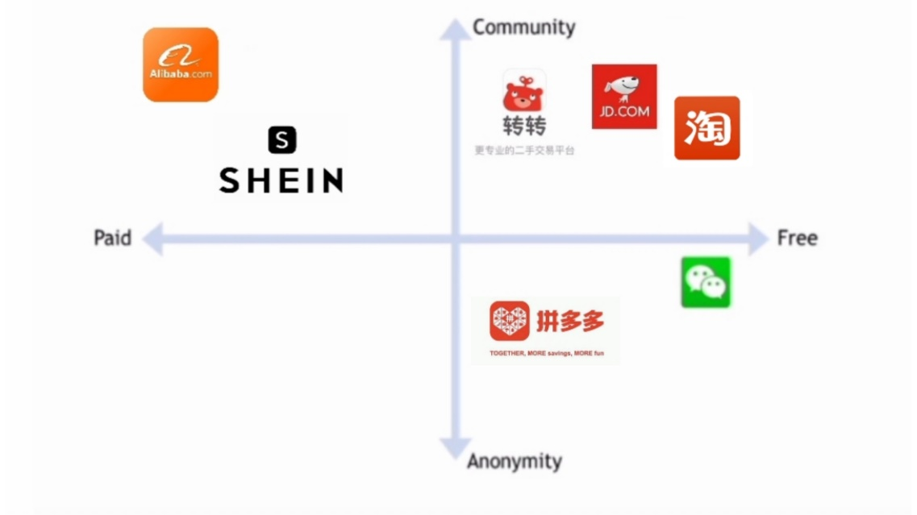

### Prototype Figure 2: User journey

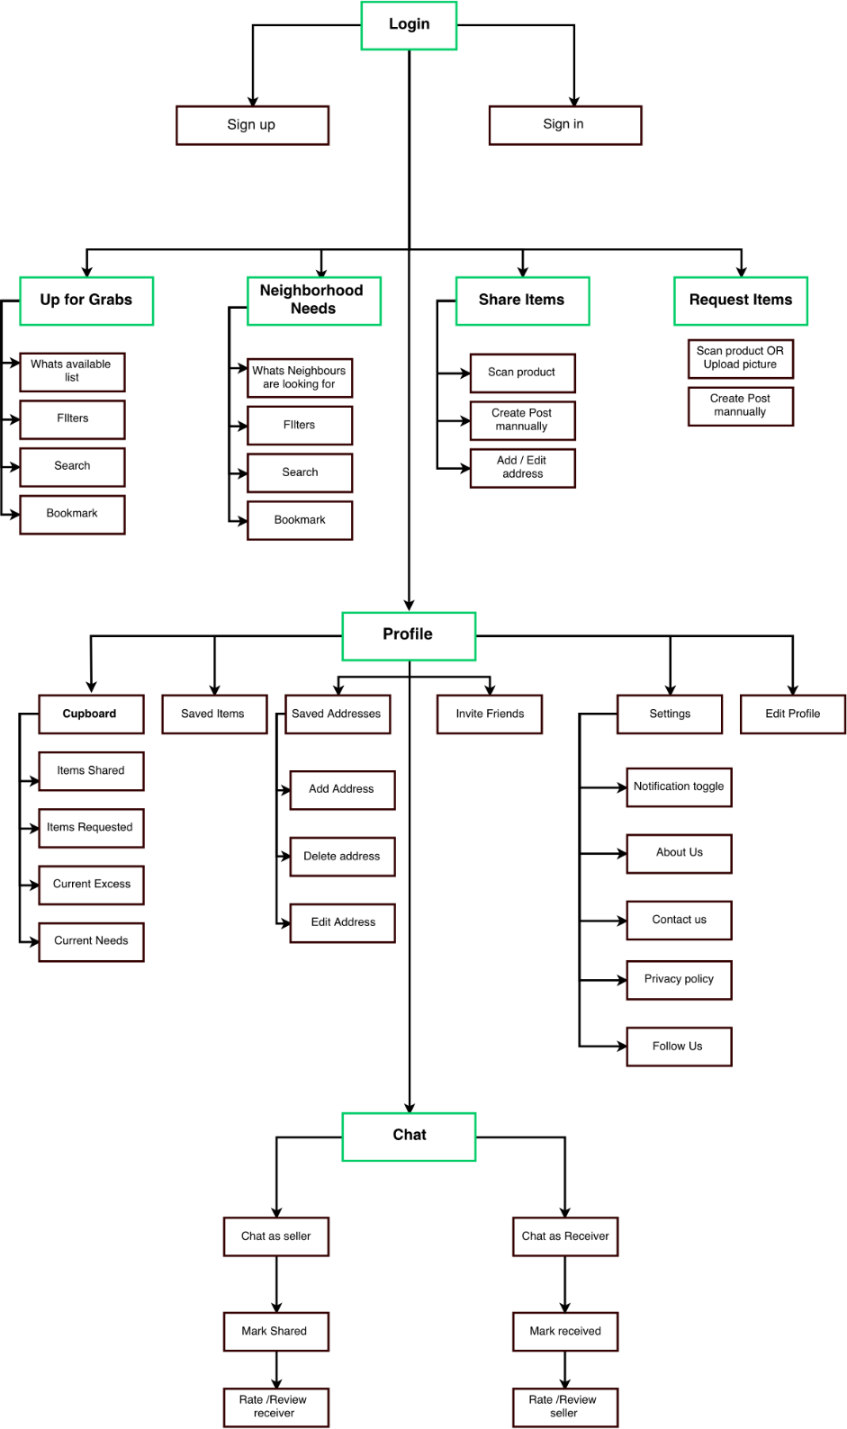

**Figure 3: Theme and Design Execution**

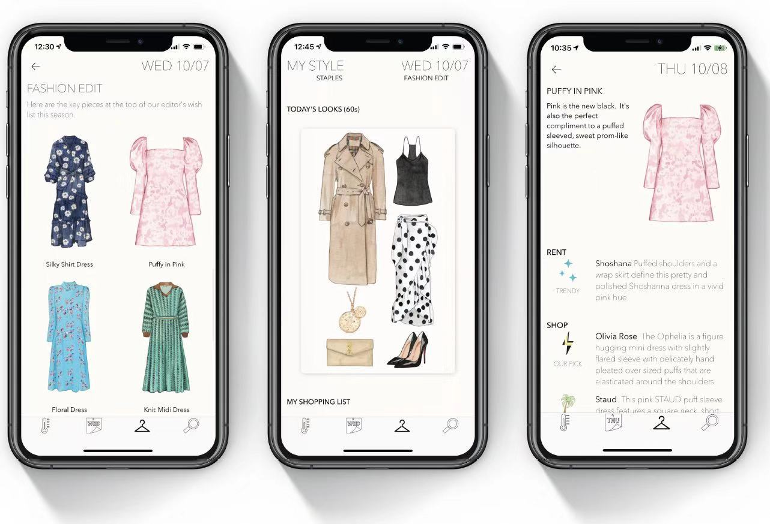

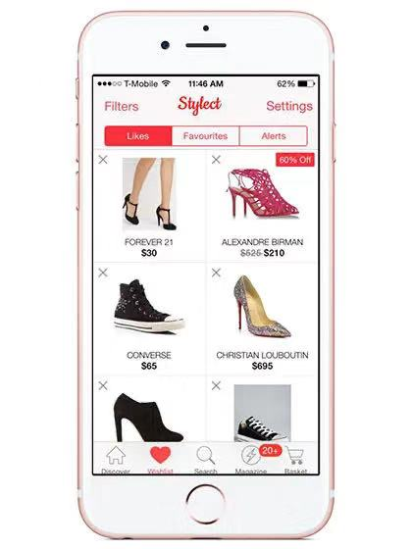

**Figure 4: Customization**

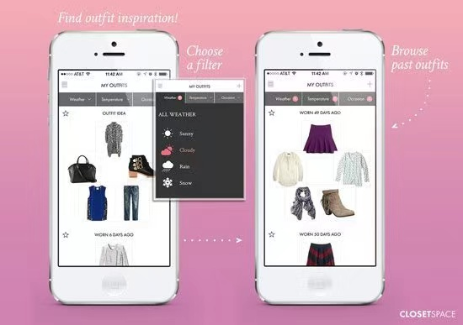

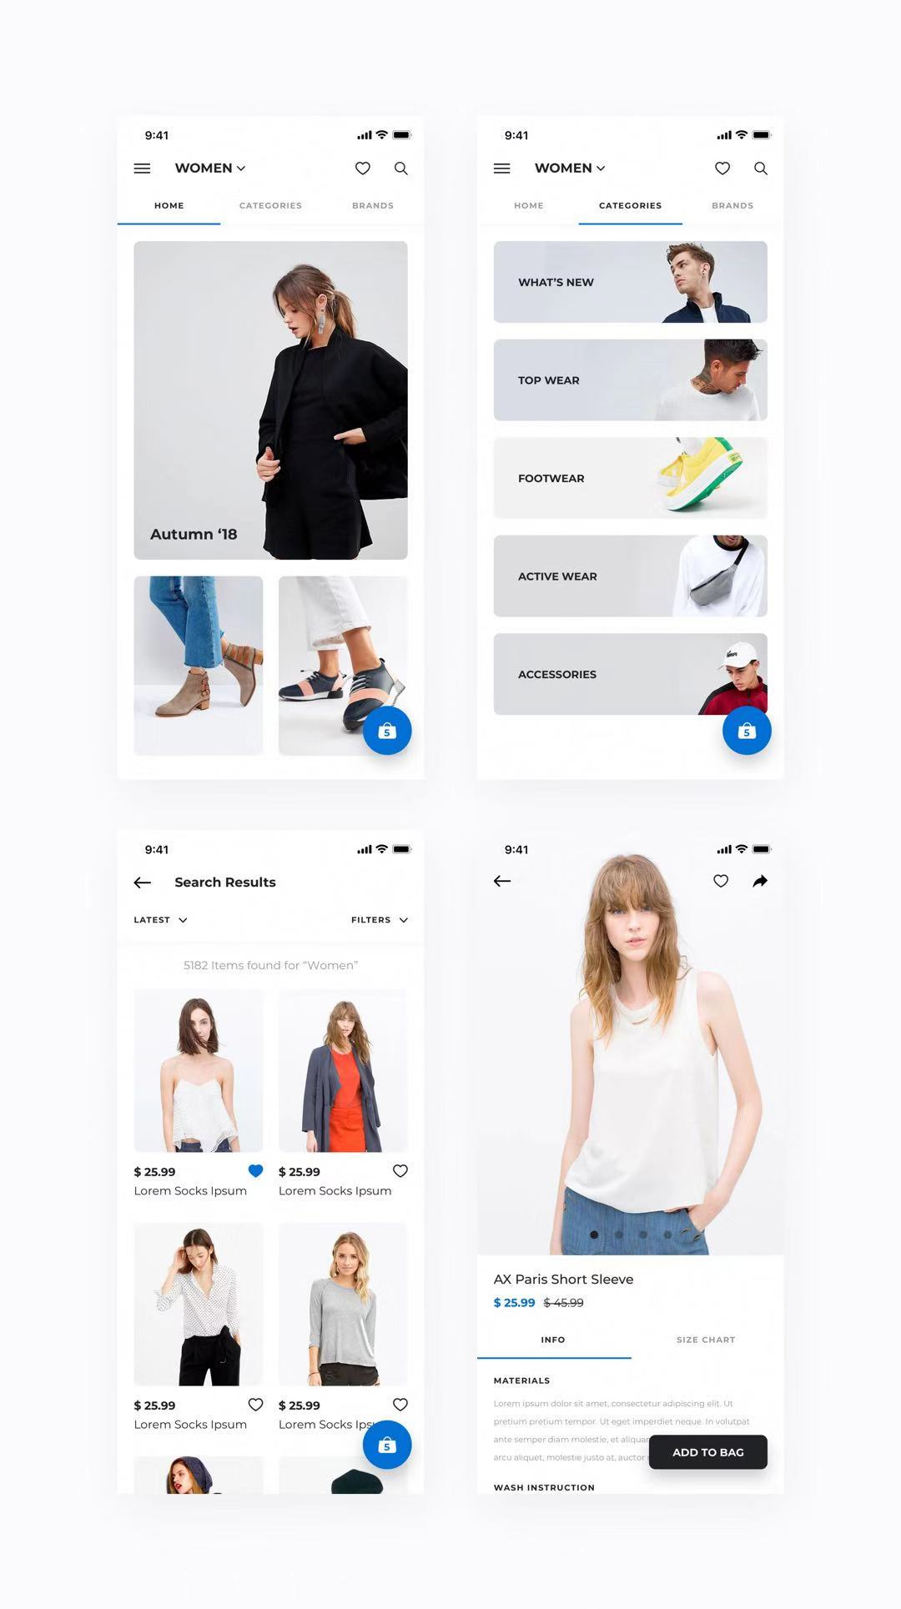

### Figure 5: Delivery Theme

### C:\Users\Toshiba\AppData\Local\Temp\WeChat Files\dd29071932725dc0403718f60d5a8cf.jpg

### Figure 7: Flâner’s Business Model Canvas

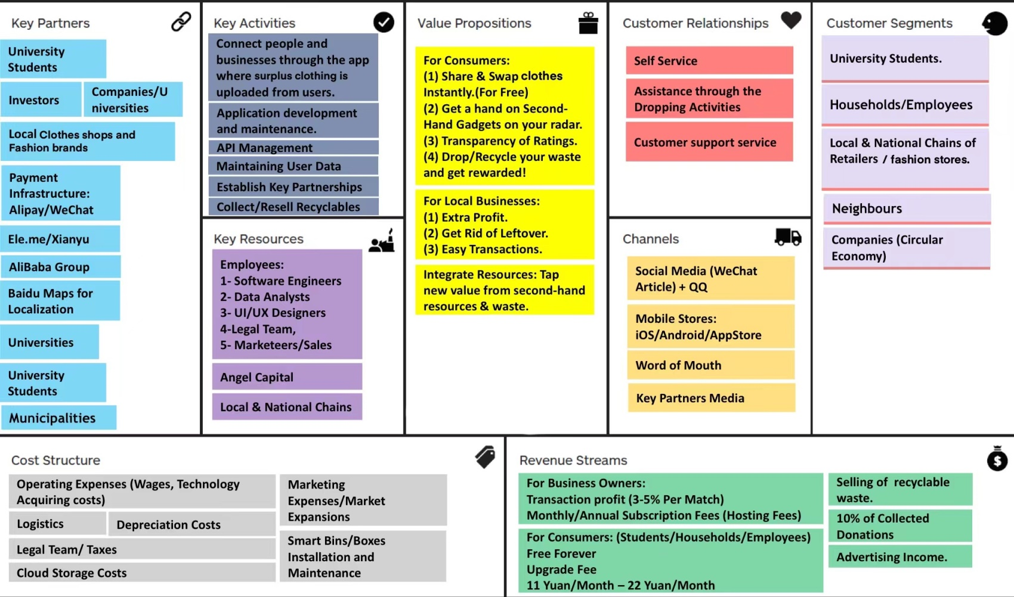

**Figure 8:** **Flâner ’s User Data Monetization Model**

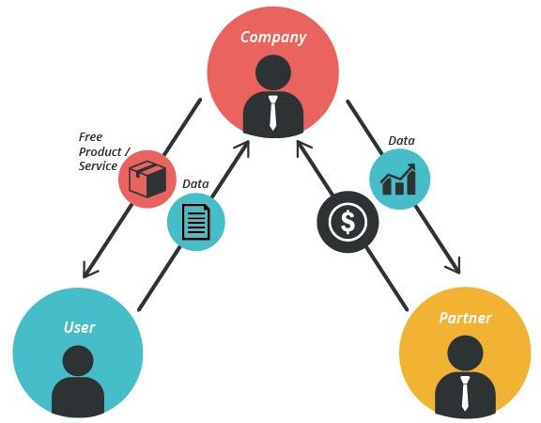

### Figure 9: Organizational Structure

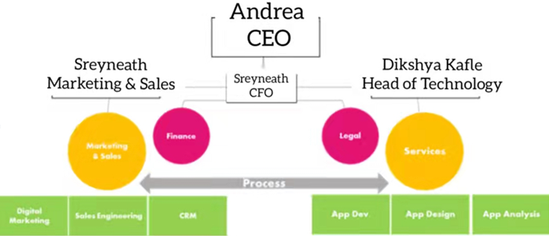

**Table 2: Funding Balance Sheet**

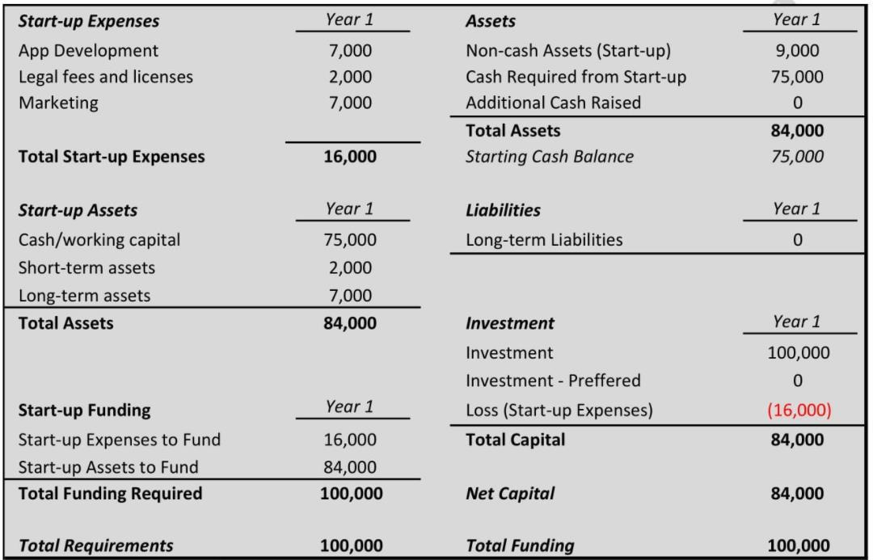

### Table 3: Balance Sheet

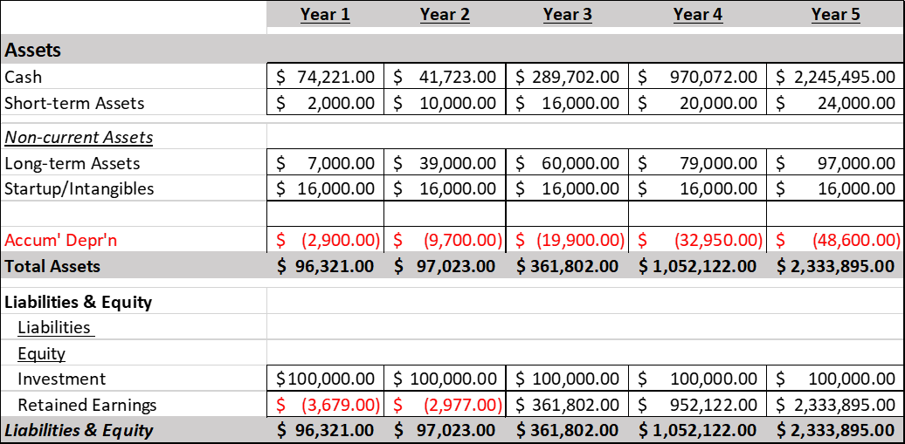

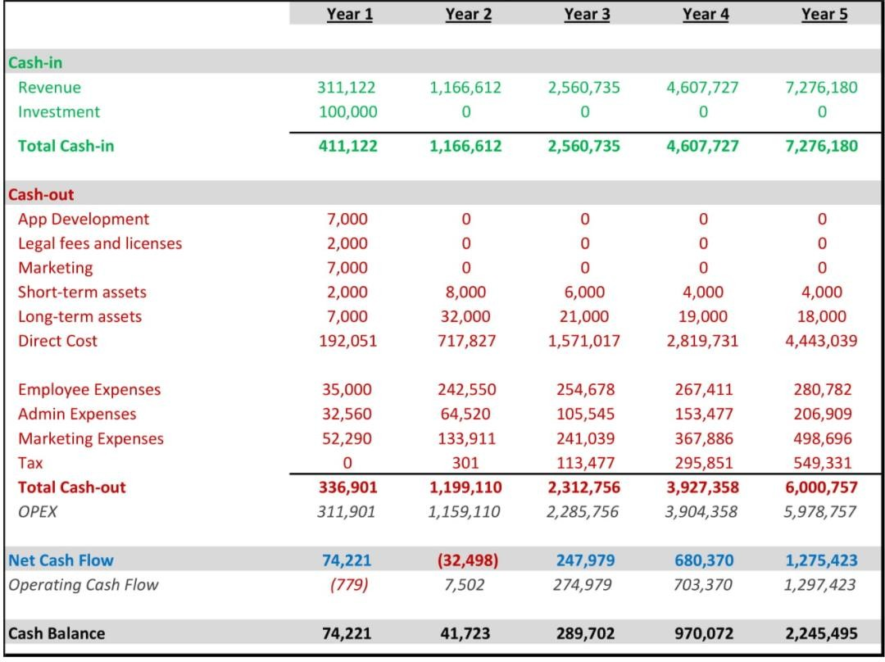**Table 4: Cash Flow**

Table 5: Marketing Budget

|  |  |  |  |  |  |
| --- | --- | --- | --- | --- | --- |
| **Marketing & Advertising** | **Year 1** | **Year 2** | **Year 3** | **Year 4** | **Year 5** |
| Promotions | $ 35,490.00 | $ 116,271.00 | $ 222,517.00 | $ 348,438.00 | $ 478,275.00 |
| Content Marketing | $ 2,400.00 | $ 2,520.00 | $ 2,646.00 | $ 2,788.00 | $ 2,917.00 |
| Social Media | $ 2,400.00 | $ 2,520.00 | $ 2,646.00 | $ 2,788.00 | $ 2,918.00 |
| Live Marketing Events | $ 12,000.00 | $ 12,600.00 | $ 13,230.00 | $ 13,892.00 | $ 14,586.00 |
| Other | $ - | $ - | $ - | $ - | $ - |
| ***Total Marketing Expenses*** | **$52,290.00** | **$133,911.00** | **$241,039.00** | **$367,906.00** | **$498,696.00** |

### Table 6: Human Resources Expenses

|  |  |  |  |  |  |  |
| --- | --- | --- | --- | --- | --- | --- |
| **Number of Employees**  **C Levels** |  | **Year 1** | **Year 2** | **Year 3** | **Year 4** | **Year 5** |
| CEO  CFO CTO | Month 7  Month 13  Month 1 | **1** | **1** | **1** | **1** | **1** |
| **1** | **1** | **1** | **1** | **1** |
| **1** | **1** | **1** | **1** | **1** |
| **Sales & Marketing** | | | | | | |
| Marketing Directors **Operations** Customer Service Back-End-Developer  Others | Month 13  Month 13  Month 13 Month | **2** | **2** | **2** | **2** | **2** |
|  |  |  |  |  |
| **0** | **1** | **2** | **2** | **3** |
| **0** | **1** | **2** | **2** | **3** |
| **0** | **1** | **2** | **2** | **3** |
| ***Total Employees*** |  | **5** | **8** | **11** | **11** | **14** |
| **Cost Per Employee**  **C Levels** |  | **Year 1** | **Year 2** | **Year 3** | **Year 4** | **Year 5** |
| CEO | | $ 4,167.00 | $ 4,375.00 | $ 4,594.00 | $ 4,823.00 | $ 5,065.00 |
| CFO | | $ 2,917.00 | $ 3,063.00 | $ 3,216.00 | $ 3,376.00 | $ 3,545.00 |
| CTO | | $ 2,917.00 | $ 3,063.00 | $ 3,216.00 | $ 3,376.00 | $ 3,545.00 |
| **Sales & Marketing** | | | | | | |
| Marketing Directors | | $ 2,833.00 | $ 2,975.00 | $ 3,124.00 | $ 3,280.00 | $ 3,444.00 |
| **Operations** | | | | | | |
| Customer Service | | $ 2,250.00 | $ 2,363.00 | $ 2,481.00 | $ 2,605.00 | $ 2,735.00 |
| Back-End-Developer | | $ 4,167.00 | $ 4,375.00 | $ 4,594.00 | $ 4,823.00 | $ 5,065.00 |
| Others | | $ - | $ 800.00 | $ 850.00 | $ 900.00 | $ 1,000.00 |
| **Employees Expenses C Levels** | | | | | | |
| CEO |  | $ 5,000.00 | $ 52,500.00 | $ 55,125.00 | $ 57,881.00 | $ 60,775.00 |
| CFO |  | $ 5,000.00 | $ 36,750.00 | $ 38,588.00 | $ 40,517.00 | $ 42,543.00 |
| CTO | Month 1 | $ 10,000.00 | $ 36,750.00 | $ 38,588.00 | $ 40,517.00 | $ 42,543.00 |
| **Sales & Marketing** | | | | | | |
| Marketing Directors | | $ 5,000.00 | $ 35,750.00 | $ 37,485.00 | $ 39,359.00 | $ 41,327.00 |
| **Operations** | | | | | | |
| Customer Service | | $ - | $ 28,350.00 | $ 29,768.00 | $ 31,256.00 | $ 32,819.00 |
| Back-End-Developer | | $ - | $ 52,500.00 | $ 55,125.00 | $ 57,681.00 | $ 60,775.00 |
| Others | |  | $ 9,600.00 | $ 10,200.00 | $ 11,400.00 | $ 12,000.00 |
|  | | | | | | |
| ***Total Personnel Cost*** | | $ 35,000.00 | $ 242,550.00 | $ 254,678.00 | $ 267,411.00 | $ 280,782.00 |

Table 7: App Development Cost Breakdown

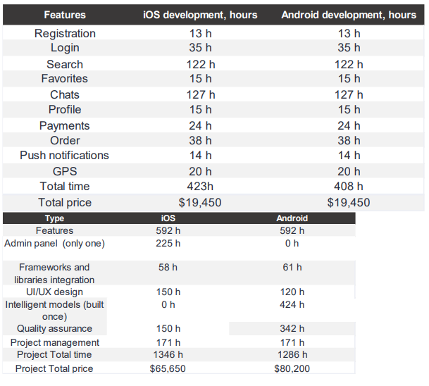

|  |  |
| --- | --- |
| **Intelligent Models** | **Time** |
| Classification model | 87 h |
| Regression model | 13 h |
| Time series analysis | 15 h |
| Prediction model | 105 h |
| Clustering Model | 134 h |
| Summarization model | 70 h |
| Total time | 424 h |
| Total price | $15,700 |

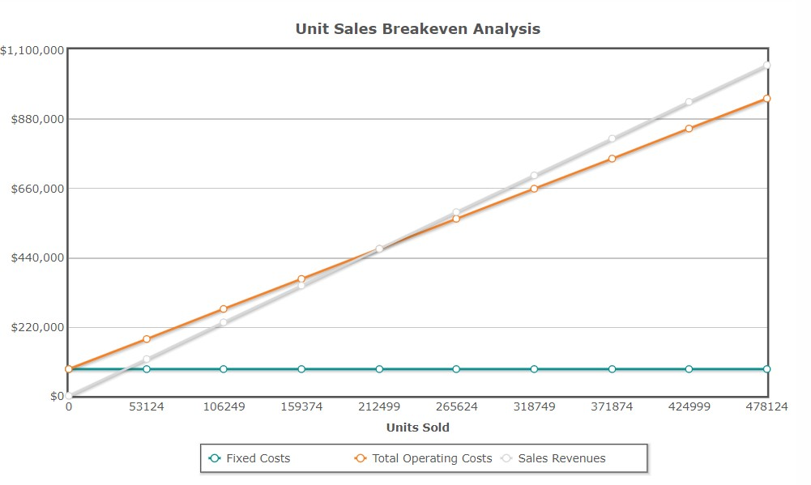Graph 1: Unit Sales Breakeven Analysis

Graph 2: Five Year Revenue Growth Projection



Flâner’s Revenue Growth Projection

2020

2021

2022

2023

Years

2024

2025

1.
2.
3.
4.
5. https://www.globaltimes.cn/page/202102/1216183.shtml