Dikshya Kafle-2018380039 Report –OpenRocket

## 1. The OpenRocket file, the suffix is ‘.ork’

## 2. A report describing your methodology to design the rocket (how you design, why you design like that). The report should also show the trajectory simulation results and a little analysis of the simulation

Rockets are now used for fireworks, weaponry, ejection seats, launch vehicles for artificial satellites, human spaceflight, and space exploration. Chemical rockets are the most common type of high power rocket, typically creating a high speed exhaust by the combustion of **fuel** with an oxidizer.

The basic **principle** of any **rocket** is the most famous of Newton's Law: Every action has an equal and opposite reaction: So, in order to product lift in the upward direction, you need to give a force in the downward direction. Based on the quantum of lift required, an equal amount of downward force is required.

**Rockets** are used to launch satellites and Space Shuttles into space. Their powerful engines allow spacecraft to be blasted into space at incredible speeds, putting them into the correct orbit. Europe's most **important rocket** family is the Ariane.

**OpenRocket** is a free, fully featured model rocket simulator that allows designing and simulating your rockets before you build and flying them.

A **rocket** has four (4) main **parts**: nose cone, fins, **rocket** body, and engine. The nose cone carries the payload or cargo. Common payloads include astro- nauts, satellites, scientific instruments, and even explosives. The nose cone may also contain the guidance system that controls the flight direction of the **rocket**.

**OpenRocket** supports attaching **motors** in either body tubes or inner tubes. To make a component be a **motor** mount, open the configuration dialog for that component, move to the **Motor** tab and tick the box this component is a **motor** mount. After that you can select **motors** for different **motor** configurations on the same tab.

Firstly, we open the OpenRocket application with the java environment. To build the first part of the rocket the new component called Nose cone is being selected and as per the requirement the configuration is made;

Nose cone shape: Ogive

Shape Parameter: 1

Nose Cone Length: 20cm

Base Diameter:9 cm (<10cm)

Wall thickness:0.2cm

The mass component is then being configured:

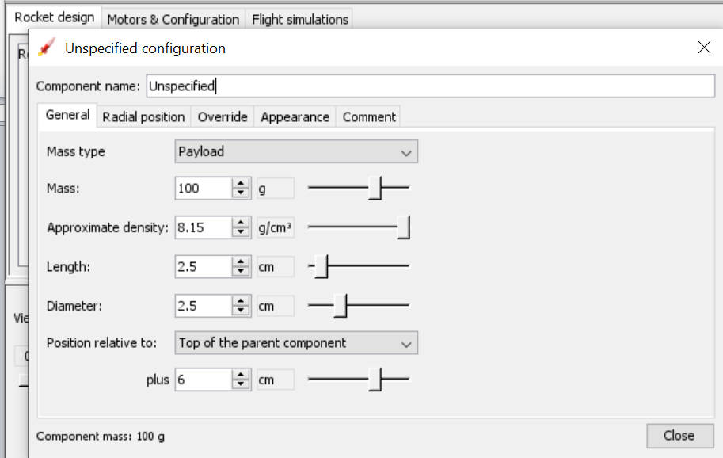

After the completion of the first part Body tube is being selected. In the first body tube we add the component Parachute.and the configuration of parachute is done:

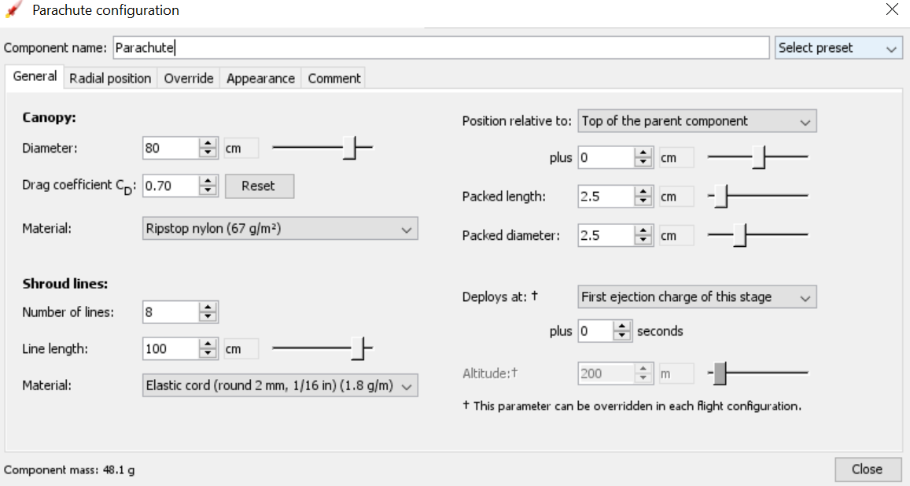

After this mass component i.e unspecified is being selected and the configuration is done;

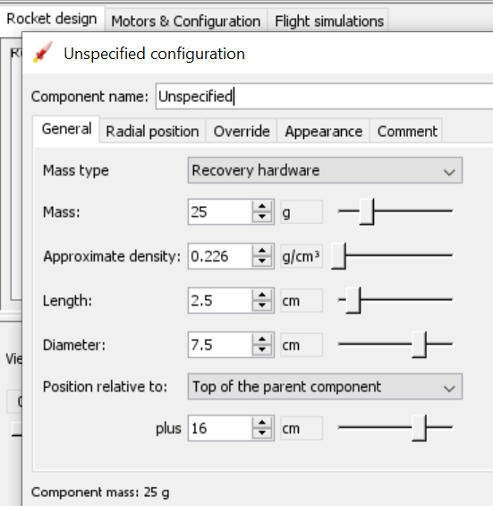

In addition to this, another mass component is selected and the configurationis done;

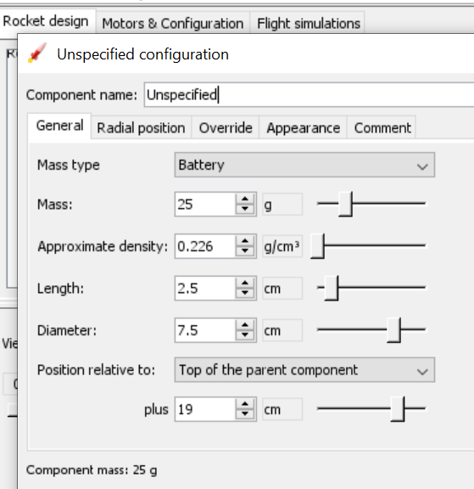

This is the completion of first body part and now heading to the second body tube. Three different component are being added i.e. Trapezoidal fin set, Inner Tube and the Bulk head.

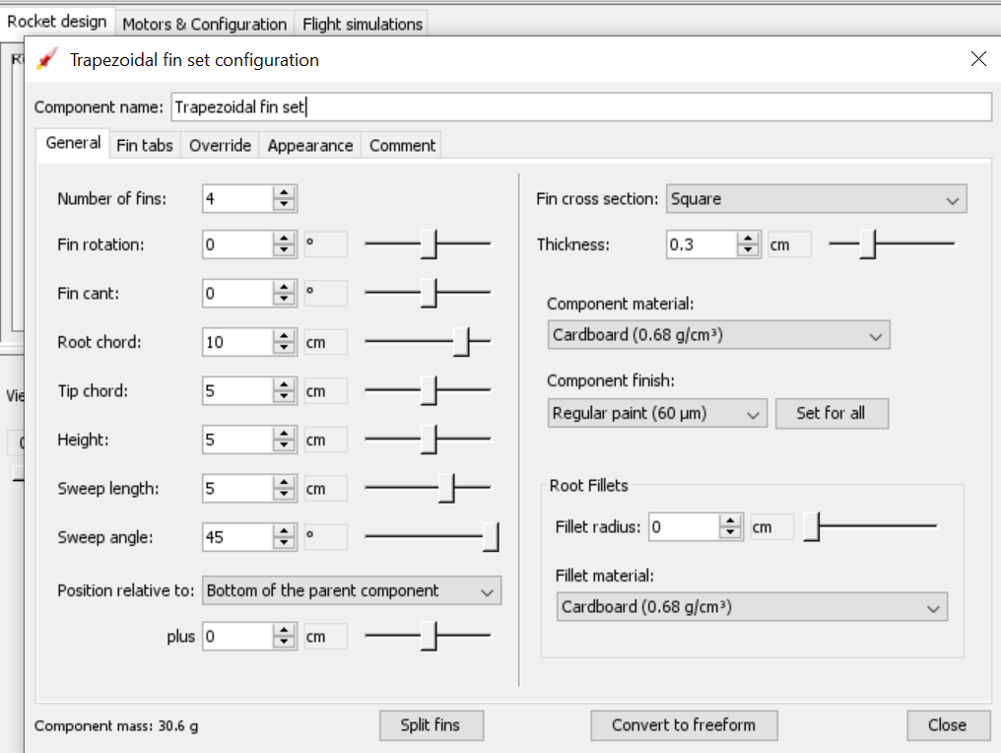

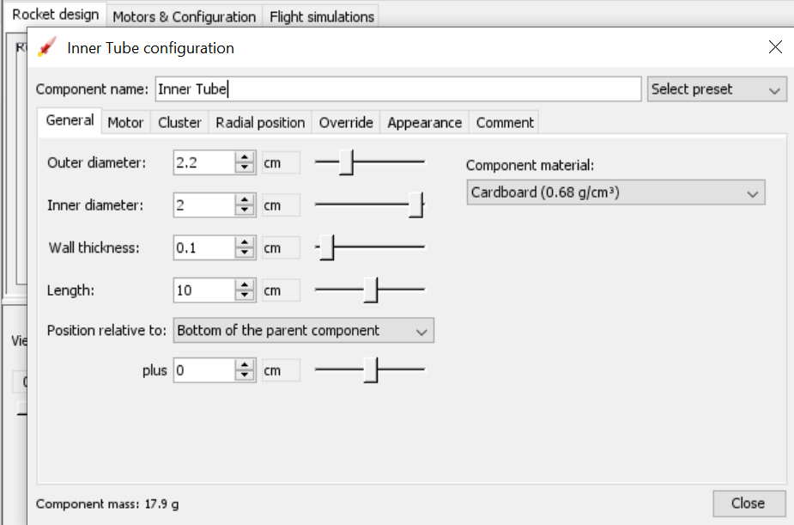

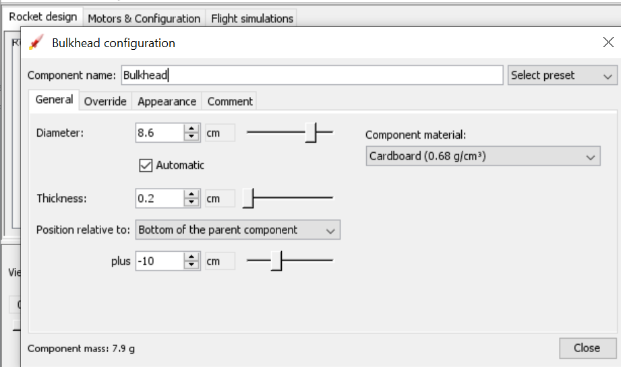

After the completion of the body part the configuration of the motors is done. In the motor configuration the inner tube is being selected and the motor is being selected.

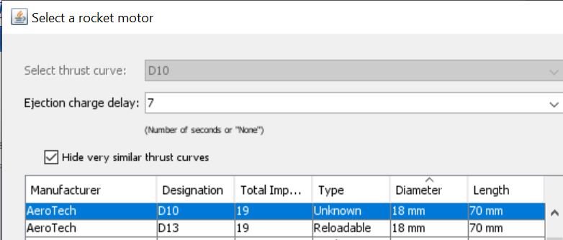

The motor.txt file is created at first:

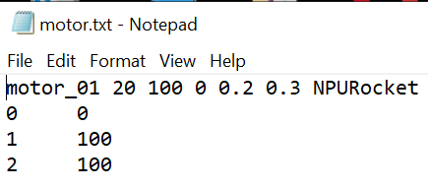

Then it’s change to .eng file as such: 

In the OpenMoter we click the edit and then preference and add the moter.eng file to the program.

After the motor is being added the simulation is carried;

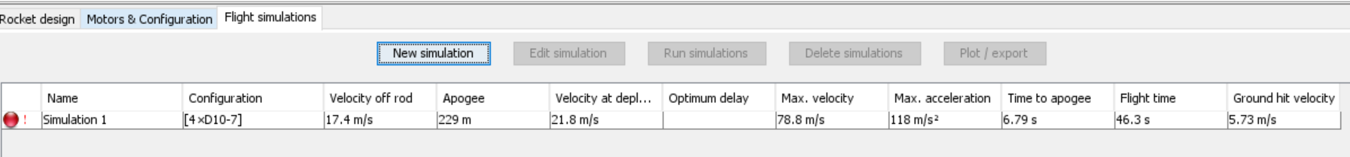

**Result of Simulation:**

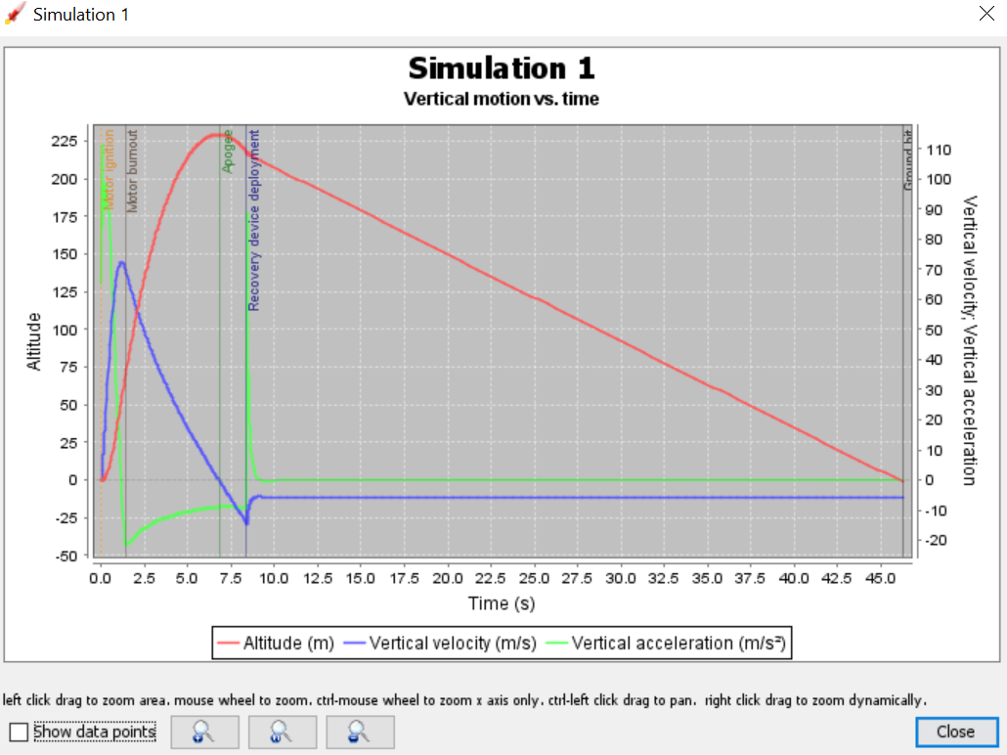

After the simulation the plotting is done as shown in the above picture. The above graph shows the relation of vertical motion and time. The changes in altitude (m), vertical velocity (m/s) and vertical acceleration(m/s^2) corresponding to the time(s) is being plotted.

**Slide View of the Rocket**

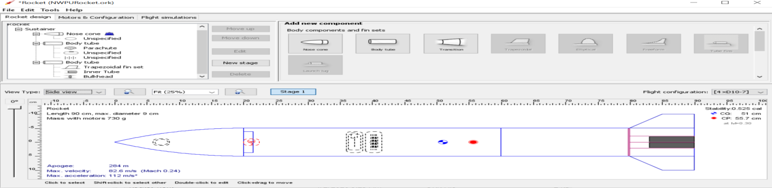

**3D figure of the Rocket:**

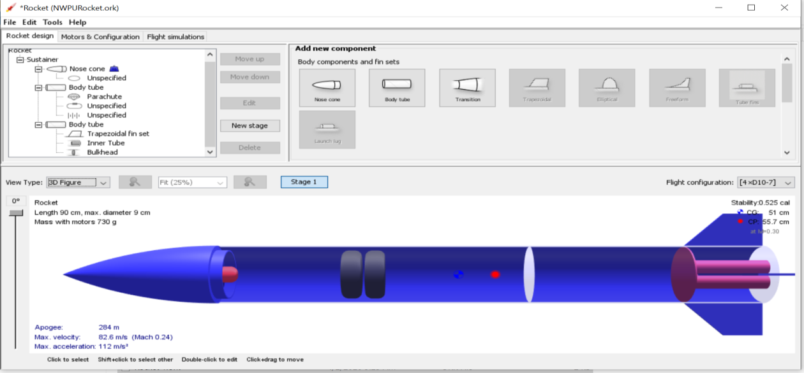

**Conclusion:**

The length of the rocket is 90cm and the diameter is 9cm. The mass of the rocket with the motors is 730g. The **stability** of a **rocket** is its ability to keep flying through the air pointing in the right direction without wobbling or tumbling. Fins are used on smaller **rockets** to provide this **stability** and control direction. It works in the same way as placing feathers at the tail of an arrow. The stability of the rocket is 0.525 cal. Apogee of the rocket is 284cm, Maximum velocity of the rocket is 82.6m/s (Mach 0.24) and Maximum acceleration is 112m/s^2.