Dikshya Kafle-2018380039 Report –OpenRocket

## 1. The OpenRocket file, the suffix is ‘.ork’

## 2. A report describing your methodology to design the rocket (how you design, why you design like that). The report should also show the trajectory simulation results and a little analysis of the simulation

Rockets are now used for fireworks, weaponry, ejection seats, launch vehicles for artificial satellites, human spaceflight, and space exploration. Chemical rockets are the most common type of high power rocket, typically creating a high speed exhaust by the combustion of fuel with an oxidizer.

The basic principle of any rocket is the most famous of Newton's Law: Every action has an equal and opposite reaction: So, in order to product lift in the upward direction, you need to give a force in the downward direction. Based on the quantum of lift required, an equal amount of downward force is required.

Rockets are used to launch satellites and Space Shuttles into space. Their powerful engines allow spacecraft to be blasted into space at incredible speeds, putting them into the correct orbit. Europe's most important rocket family is the Ariane.

OpenRocket is a free, fully featured model rocket simulator that allows designing and simulating your rockets before you build and flying them.

A rocket has four (4) main parts: nose cone, fins, rocket body, and engine. The nose cone carries the payload or cargo. Common payloads include astro- nauts, satellites, scientific instruments, and even explosives. The nose cone may also contain the guidance system that controls the flight direction of the rocket.

OpenRocket supports attaching motors in either body tubes or inner tubes. To make a component be a motor mount, open the configuration dialog for that component, move to the Motor tab and tick the box this component is a motor mount. After that you can select motors for different motor configurations on the same tab.

Firstly, we open the OpenRocket application with the java environment. To build the first part of the rocket the new component called Nose cone is being selected and as per the requirement the configuration is made;

Nose cone shape: Ogive

Shape Parameter: 1

Nose Cone Length: 20cm

Base Diameter:9 cm (<10cm)

Wall thickness:0.2cm

The mass component is then being configured:

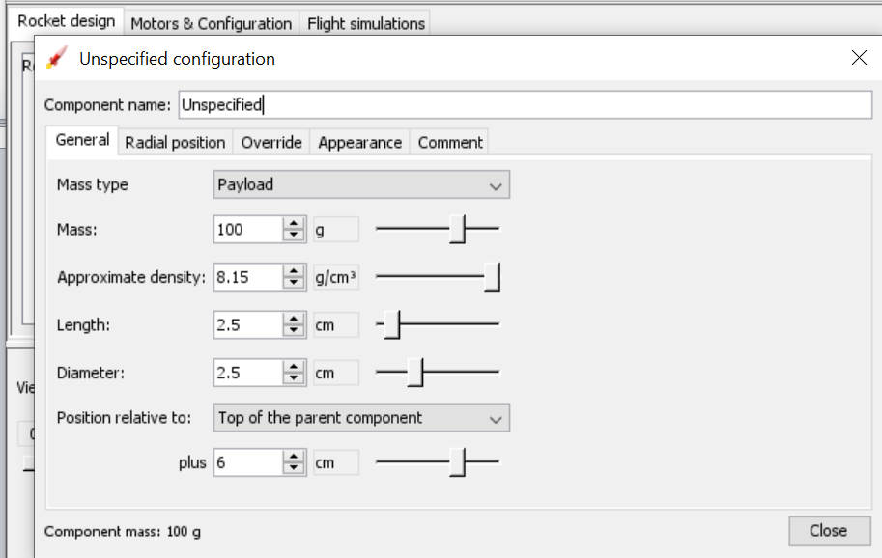

After the completion of the first part Body tube is being selected. In the first body tube we add the component Parachute.and the configuration of parachute is done:

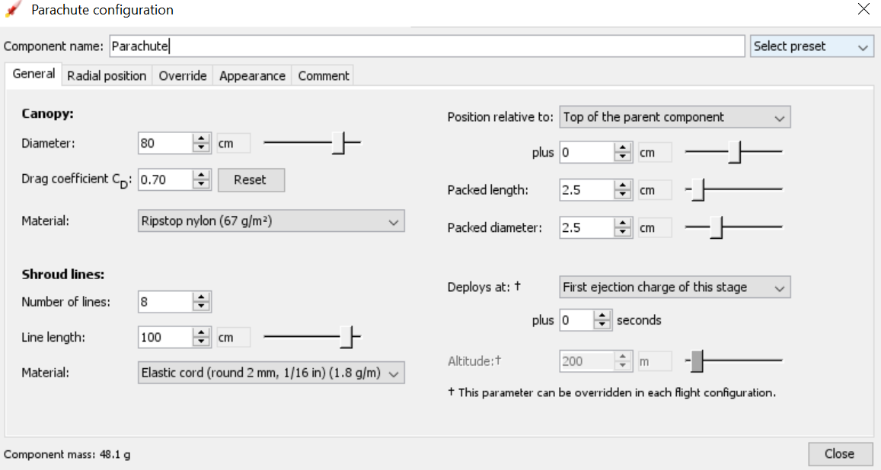

After this mass component i.e unspecified is being selected and the configuration is done;

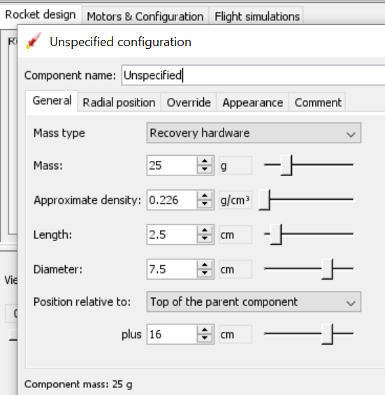

In addition to this, another mass component is selected and the configurationis done;

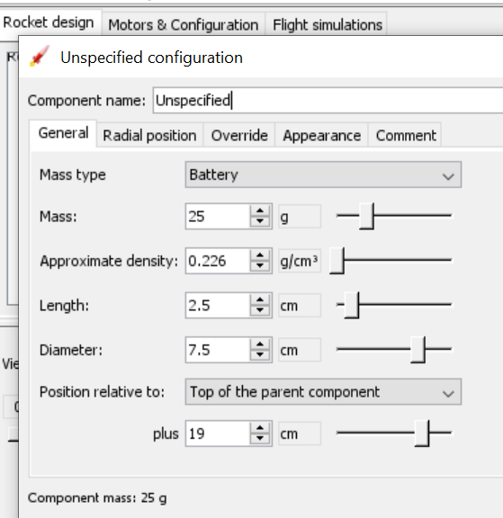

This is the completion of first body part and now heading to the second body tube. Three different component are being added i.e. Trapezoidal fin set, Inner Tube and the Bulk head.

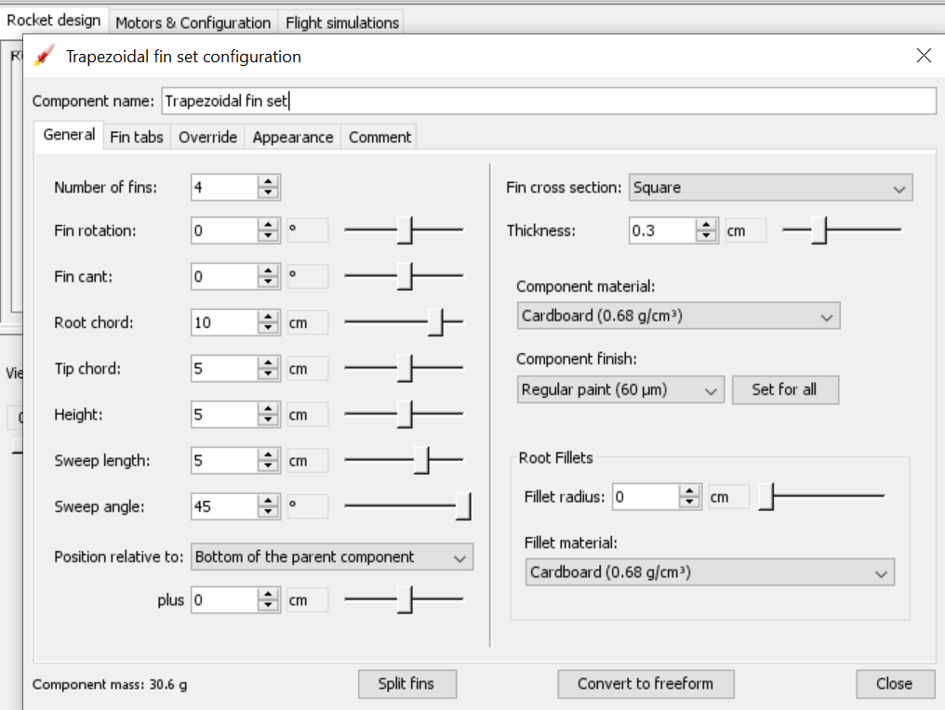

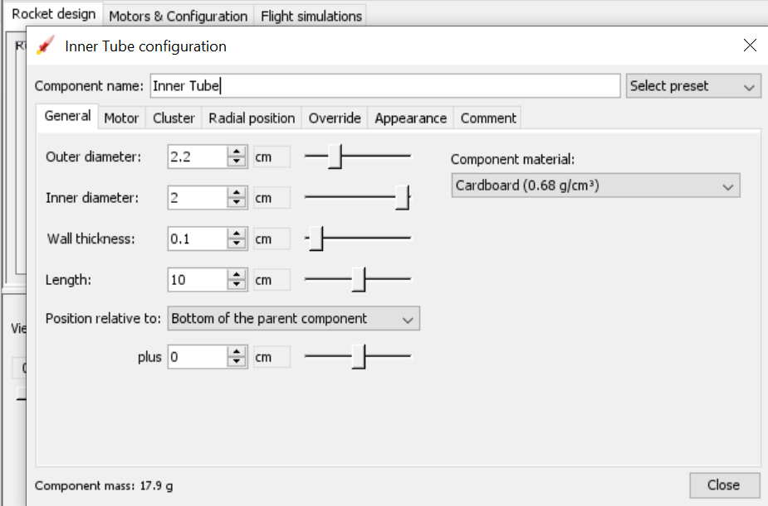

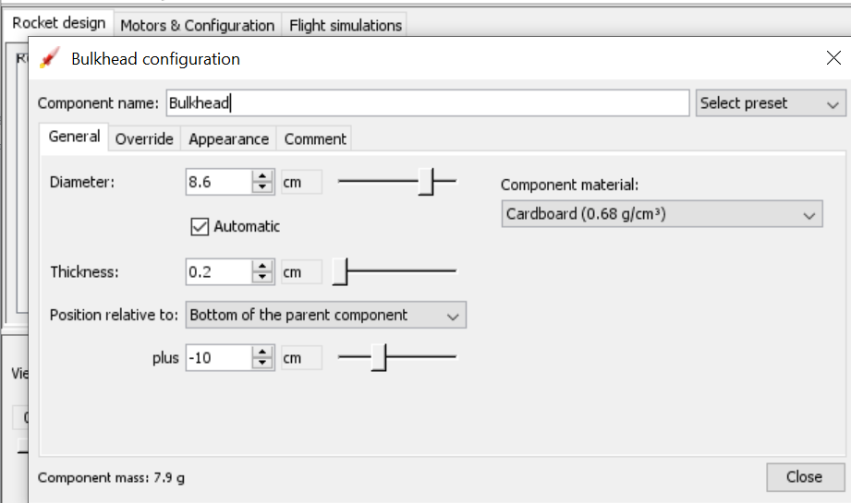

After the completion of the body part the configuration of the motors is done. In the motor configuration the inner tube is being selected and the motor is being selected. The code consists of a letter and two numbers such as D10-19. A D10-19 model rocket motor. The letter is the total impulse, the first number is the average thrust in Newtons, and the second number is the time delay in seconds to the initiation of the recovery system.

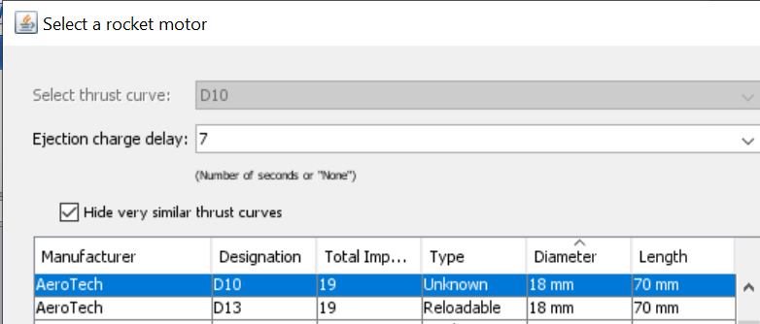

The motor.txt file is created at first:

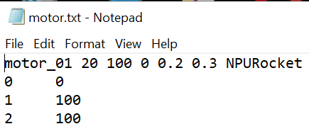

Then it’s change to .eng file as such: 

In the OpenMoter we click the edit and then preference and add the moter.eng file to the program.

After the motor is being added the simulation is carried;

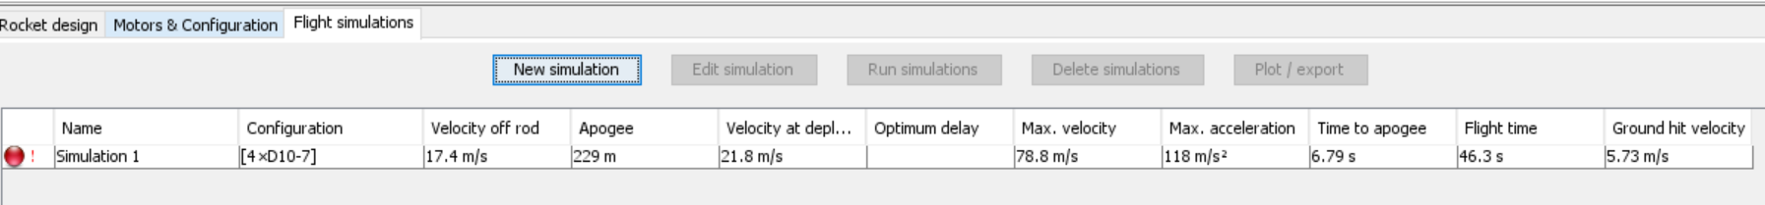

**Result of Simulation:**

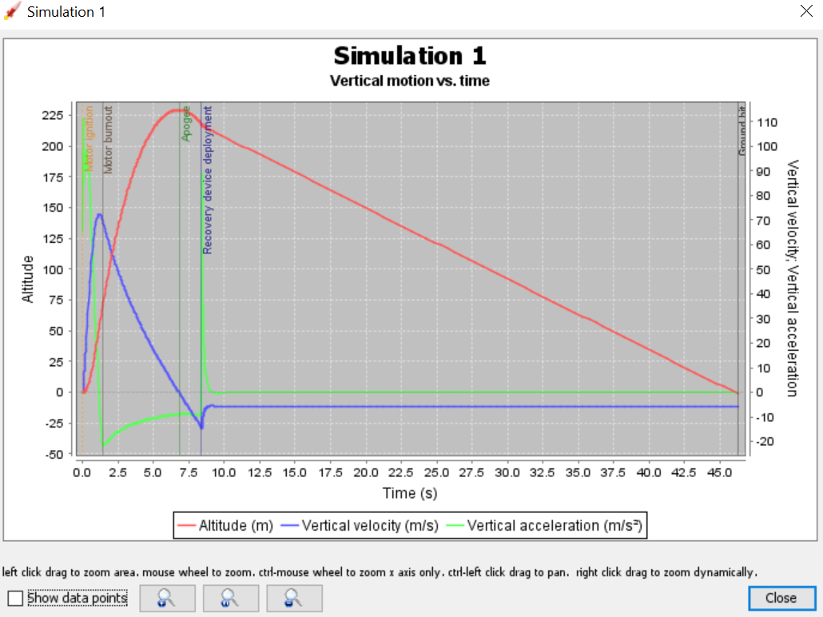

After the simulation the plotting is done as shown in the above picture. The above graph shows the relation of vertical motion and time. The changes in altitude (m), vertical velocity (m/s) and vertical acceleration (m/s^2) corresponding to the time(s) is being plotted.

Newton's third law of motion states that to every action, there is an equal and opposite reaction. The greater the exhaust velocity of the gases, the greater the acceleration. The faster the rocket burns its fuel, the greater its acceleration. The smaller the rocket's mass, the greater the acceleration.

**Slide View of the Rocket**

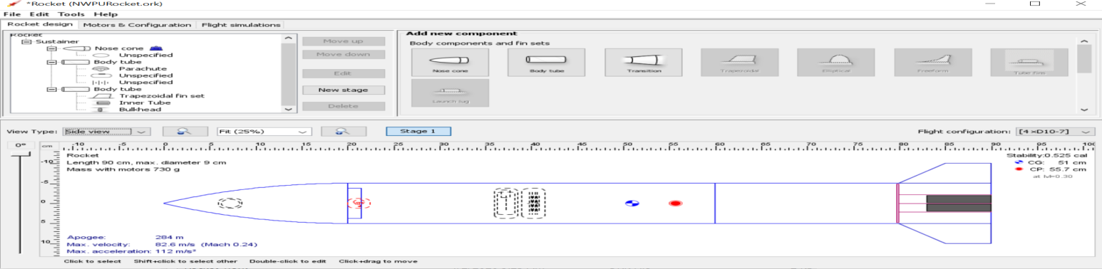

**3D figure of the Rocket:**

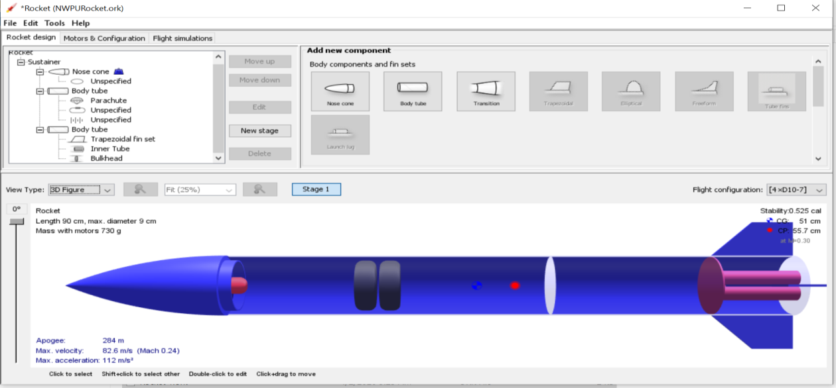

Analysis:

The length of the rocket is 90cm and the diameter is 9cm. The mass of the rocket with the motors is 730g. The stability of a rocket is its ability to keep flying through the air pointing in the right direction without wobbling or tumbling. Fins are used on smaller rockets to provide this stability and control direction. It works in the same way as placing feathers at the tail of an arrow. For a rocket to be stable, the center of pressure must be behind the center of gravity. For a model rocket, you can make adjustments to make your rocket more stable. One way to make your rocket more stable is to increase the size of the fins or to move the fins more to the rear of the rocket. The stability of the rocket designed above is 0.525 cal.

The definition of Apogee is the highest point of something. In the case of rocketry, the Apogee is the peak of flight, its highest point traveled. Several things happen at the Apogee. First off, the Velocity of the rocket is equal to zero. Apogee of the rocket designed in the OpenRocket is 284cm.

A rocket's acceleration depends on three major factors: the exhaust velocity, the rate the exhaust is ejected, and the mass of the rocket. To achieve the high speeds needed to hop continents, obtain orbit, or escape Earth's gravity altogether, the mass of the rocket other than fuel must be as small as possible. Maximum velocity of the rocket is 82.6m/s (Mach 0.24) and Maximum acceleration is 112m/s^2. An object's acceleration increases as the force on the object increases. So to help your rocket go faster and higher: 1) The faster the fluid can be expelled from the rocket, the greater the thrust (force) of the rocket. This is because a greater mass of air inside the bottle escapes with a higher acceleration.