Assessment of Quality and Health of Wheat Varieties under Normal and Late Sown Conditions in Chitwan, Nepal

Kalpana Kafle¹, Avinash Kafle¹, Suman Dhakal^{1,} Santosh Marahatta¹, Rajan Dhakal², Narayan Prasad Pathak³
¹ Agriculture and Forestry University, Rampur, Chitwan, Nepal
² Ministry of Agriculture and Livestock Development (MoALD), Bagmati Province, Nepal
³ Ministry of Agriculture, Land Management and Cooperative, Gandaki Province, Nepal
Corresponding author: Avinash Kafle – E-mail: kafleavinash@gmail.com

Abstract
Wheat seed quality and health play a crucial role in determining productivity, which is strongly affected by sowing dates and varieties. An experiment in strip plot design was conducted with two sowing dates (November 15 and December 25) and ten wheat varieties (Vijay, BL 4341, NL 971, Borlaug 2020, Gautam, Tilottama, Bhrikuti, Zinc Gahun 1, Aditya, and Banganga) to assess the effect on seed quality and seed health at the Research Farm of Agriculture and Forestry University, Chitwan, Nepal, in 2019/2020. Data were recorded and analyzed using R Studio.
Wheat sown on November 15 recorded significantly higher germination percentage, vigour index-I, and vigour index-II during the first three months of storage, with a gradual decline over time. Seed deterioration and infection occurred more in wheat sown on December 25. NL 971 showed a lower root-shoot ratio in early sowing, which increased with prolonged storage. Gautam showed lower infection with Bipolaris sorokiniana, Vijay and Borlaug 2020, with Alternaria triticina. Overall, wheat sowing on November 15 provided more quality and healthy seed, and Borlaug 2020 was found to be most suitable for next-season seed production due to its high and consistent germination and vigour stability in the inner Terai of Nepal.

Keywords: seed health, seed quality, sowing date, vigour index, wheat varieties

1. Introduction
Quality seed refers to genetically and physically pure, viable seed with appropriate moisture content, high germination capacity, strong seed vigour, good yield potential, and free from pests and diseases (Hegde et al., 2025). Seed quality and seed health indicators are their physical, genetic, physiological, and pathological qualities (Bishaw et al., 2012). Quality seed is superior to other kinds in many ways, i.e., it possesses physical, physiological, phytosanitary, and genetic qualities such as viability, vigour, germination, moisture, genetic purity, and seed health, which are desirable for plantation (Nigussu et al., 2019). Quality seed helps to utilize the genetic potential of a crop, which is crucial for seed and food security for the emerging population (Rinukshi, 2015).

Physical quality of seed includes cleanliness of the seed from other crop seed, weed seed, inert matter, insect-damaged and broken seed, and empty seed, as well as appropriate moisture content. Genetic quality refers to the true-to-type nature of the seed, its adaptability to specific agro-climatic conditions, high yield potential, and tolerance to biotic and abiotic stresses. Physiological quality comprises two important attributes, seed germination and vigour. Physiological quality determines the establishment of the seed under a diverse range of growing conditions (Sundareswaran et al., 2023). Seed health emphasizes seeds free from bacteria, viruses, fungi, nematodes, and insect infestation to ensure healthy crop establishment (DADO, 2016; FAO, 2014).

Quality seed ensures the required plant population, as emergence will be uniform and higher (>70%). Its use leads to the vigorous growth of seedlings, increased stress resistance to environmental hazards, reduces weed emergence, and allows the crop to utilize its yield potential, increasing production up to 5 - 25% (Nadew, 2018). IRRI (2013) reported that quality seed produces 5 to 20% more yield and reduces food insecurity. The use of improved varieties was observed to uplift the yield of wheat by 208% between the periods of 1960 and 2000 AD (FAO, 2019).

Wheat (Triticum aestivum L.) provides approximately 20% of the total energy intake in the human diet, which makes it a major cereal crop worldwide (Bayeh, 2010). It is a major food for more than 35% of the global population (Sharma & Sharma, 2025; Alomari et al., 2023). In Nepal, it ranks third in terms of acreage, production, and consumption, right after rice and maize in the mid-hills and high-hills, but in the terai, it ranks second and accounts for approximately 19% of total cereal production in the country (FAO, 2025; Adhikari et al., 2021). Together, wheat contributes about 5.67% to Nepal’s agricultural GDP (MOALD, 2023) (Pokhrel et al., 2025) Therefore, the availability of high-quality wheat seed both nationally and globally is crucial for the achievement of food security.

Although wheat production and productivity in Nepal have increased steadily over the years, from 2.50 t/ha in 2013/14 to 2.99 t/ha in 2023/24, and the crop is currently cultivated on approximately 0.68 million hectares, the country continues to experience a substantial yield gap (MOALD, 2025). Major wheat-producing countries such as China (5.7 t/ha) and India (3.4t/ha) achieve significantly higher productivity levels than Nepal. This indicates Nepal has a higher yield gap and considerable scope for further yield improvement. This productivity gap can be narrowed down through the adoption of quality seed, timely sowing, and effective disease and pest control. (Fischer et al., 2014).

To support seed quality improvement, Nepal has established a formal seed policy framework. The Seed Act of 1988 and the National Seed Vision 2013–2025 provide strategic guidelines for the production, processing, and distribution of high-quality seeds across diverse agro-climatic zones. The National Seed Board (NSB) is the coordinating agency for varietal release and registration. The National Agricultural Research Council (NARC) is responsible for the breeder and foundation seed production. Seed certification and quality assurance are conducted by the Seed Quality Control Centre (SQCC)(FAO, 2025). In Nepal, seed supply is mainly governed by two systems: the formal and informal seed systems. The formal seed sector involves government and private companies, and the informal seed system involves farmers saving seed from their harvest and exchanging seed between neighbors and relatives (Adhikari, 2016; Joshi, 2017). According to Atreya et al. (2022) and Devkota & Shrestha (2020), the formal seed sector meets up to 20% of Nepal’s cereal crop seed requirements, while the informal sector meets around 80% of the seed requirements. This informal system plays a great role in seed availability in Nepal, particularly in remote farming areas. The target farmers' seed replacement rate of 25-30 percent for open-pollinated cereal crops was only partially achieved for wheat (FAO, 2025). The seeds are obtained through informal systems, where seed quality is rarely tested. Using such seeds generation after generation without testing their quality is a major reason for the production of low-quality seeds (Rahel & Noriega, 2018). Consequently, the continued reliance on old and low-quality seed remains one of the major constraints contributing to the low productivity of wheat in Nepal.

Moisture supply, heat stress during seed development, post-maturation, and pre-harvest environment, agro-climatic conditions in the seed production location, etc., play an important role in producing quality seeds (Delouche, 1980). The obstacles in wheat seed production are a lack of quality seed and other inputs, erratic winter rainfall, disease, pests, weeds, and irrigation facilities (Bist et al., 2021). Seasonal precipitation and temperature have a prominent impact on the yield and quality of the crop. A suitable environment increases the yield and quality of products, and the harsh conditions reduce them (Bhandari, 2014). Timely planting enables wheat to escape heat stress during the post-anthesis period, thereby creating more favorable environmental conditions for improved yield and grain quality.

After realizing the importance of quality wheat seed and the factors that affect its quality, this study was conducted at the field of the Agriculture and Forestry University, at Rampur, Chitwan, Nepal, in 2019/2020. The study aimed to evaluate the effects of sowing dates and storage periods on the quality and health of wheat seed varieties and to identify the sowing time and variety for enhancing productivity. It looked at the seed quality and health of different types of wheat varieties by applying the right time and late sown conditions. This study supports sustainable agriculture by enhancing national wheat productivity and can serve as a valuable asset for all stakeholders involved in the seed sector.

2. Materials and methods

2.1 Description of the experimental site

2.1.1 Location
The field experiment was conducted at the Agronomy Farm of Agriculture and Forestry University (AFU), Rampur, from November 2019 to April 2020. The location is situated at 27⁰40’ North latitude and 84⁰23’ East longitude, 228 meters above sea level in central Nepal. This site lies 9 km west of Bharatpur Metropolitan City, Chitwan, Nepal. Similarly, seed health and quality tests were conducted at the Provincial Plant Protection Laboratory and Seed Laboratory, Pokhara, from July 2020 to November 2020. Soil testing was done in the Soil Testing Laboratory, Agricultural Technology Center, Lalitpur, Nepal. For soil testing, the sample of soil was collected from eight different spots from a depth of 0 to 15 cm in the field under experimentation before sowing the crop. The texture of the soil was found to be sandy loam at a depth of (0-15) cm, with acidic reaction (pH = 5.64), medium soil organic matter (3.6%), medium total nitrogen (0.15%), low available phosphorus (22.04 kg/ha), and low available potassium (80.4 kg/ha). The experimental field followed a rice–wheat cropping system over the past two years, with rice grown during the summer seasons, wheat cultivated in winter, and the field remained fallow in spring.

2.1.2 Climatic conditions during the field trial
The research site has a tropical, humid climate with distinct seasons: monsoon (June to September), autumn (September to November), winter (November to February), and spring (February to May). The weather data during the growing period were received from the National Maize Research Program (NMRP), Rampur, Chitwan. The average maximum temperature was recorded as the lowest, i.e., 18.65°C, in the first week of January and the highest, i.e., 35.54°C, in the second week of April during the harvesting of late sown wheat. Similarly, the average minimum temperature ranged from 7.87°C in the last week of December to 22.32°C in the second week of April. The total rainfall was 122.10 mm, which was well distributed throughout all months except in November, fulfilling the moisture requirement of the crop at all the critical stages. The relative humidity recorded during the entire growing period was minimum (47.84%) in the first week of April, and maximum (97.79%) in the second week of December.

2.2 Experimental details
The experiment was conducted in a strip plot design with the combination of twenty treatments consisting of ten varieties recommended for the Terai region of Nepal by the Ministry of Agriculture and Livestock Development in the vertical factor and two different dates of sowing in the horizontal factor (first, timely planting on November 15, and second, late planting on December 25) (MOALD, 2021; Upadhyay et al., 2019). Each treatment was replicated three times. The spacing between the plots was 0.5 m, and between the replications was 1 m. The size of the individual plot was 12 m² (4 m x 3 m), which contained 16 rows with a spacing of 25 cm. The central 12 rows with a 9 m² area (3 m x 3 m) were used as the net plot area. The outermost row from both sides were border row, and two rows from the same side in all the plots were kept for the biometric and phenological observations.

2.2.1 Treatments details

2.2.1.1 Vertical Factor (A): Variety (V)
V1: Vijay, V2: BL 4341, V3: NL971, V4: Borlaug 2020, V5: Gautam, V6: Tilottama, V7: Bhrikut, V8: Zinc Gahun 1, V9: Aditya, V10: Banganga

2.2.1.2 Horizontal Factor (B): Date of Sowing (D)
D1: November 15, D2: December 25
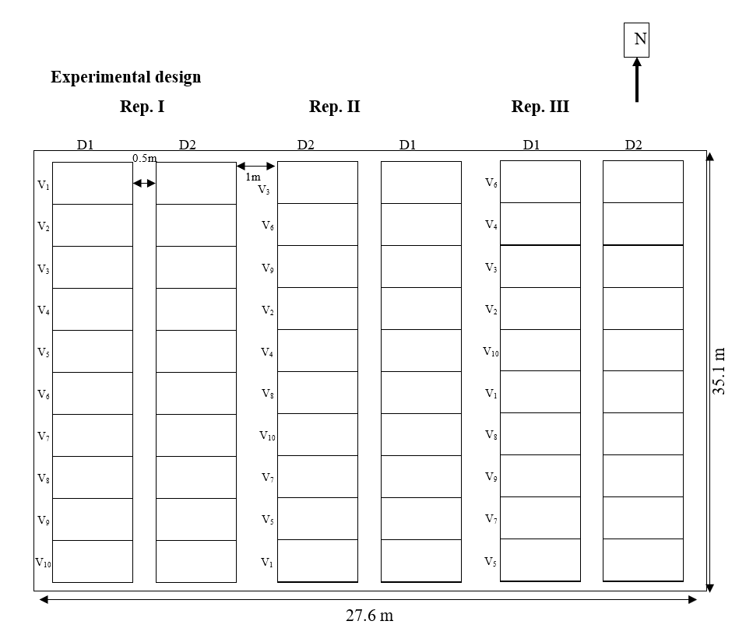

Figure 1. Layout of the experiment (strip-plot design) in the Agronomy Farm

2.3 Details of field operation
The field was cleared, and tillage was performed until fine tilth of soil was obtained before sowing. The recommended dose of fertilizer was applied, i.e., 100-50-50 kg N P₂O₅ K₂O ha⁻¹ through the application of urea, DAP, and muriate of potash, respectively. The full dose of phosphorus and potash and half dose of nitrogen were applied as a basal dose at the time of final land preparation. The remaining half dose of nitrogen was given in two split doses, first at the active tillering stage and second at 60 days after sowing for all treatments. Ten varieties of wheat seed for the experiment were brought from the National Wheat Research Program (NWRP), Bhairahawa. The seed rate used in this experiment was 120 kg ha^{-1,} which was sown manually in 25 cm row-to-row spacing and continuously within the row. The sowing of ten varieties was completed on two different dates (November 15 and December 25).

Hand weeding was done at the active tillering stage before the top dressing of the first split of nitrogen, and the second weeding was done just before the top dressing of the second split of nitrogen. No irrigation was provided as the rainfall received during the field experiment was well distributed. Emamectin benzoate 5% (contact insecticide) was used to control the damage of the Fall Army Worm (FAW), confirmed by its morphology when the infestation was observed on both dates of sowing. Similarly, Propiconazole 25% EC (systemic fungicide) was used to control leaf blight disease. Harvesting of the crop was done manually when the crop reached harvest maturity, indicated by the different maturity indices (brittle awn, distorted awn, drying of flag leaf, yellowing of stem, etc.). 9 m² of net plot area was harvested to estimate the yield and left in the field for sun drying. As there were ten varieties with different maturity days, harvesting was carried out considering the variety and maturity indices. A multi-crop thresher (plot thresher) was used for threshing, and the grain yield obtained was cleaned by winnowing.

2.4 Laboratory observations
A lab experiment was also conducted in a strip plot design on seed harvested from the experimental plot in the field with four replications and twenty treatments. Germination, seed vigour, and seed health were tested.

2.4.1 Seed storage
After threshing and cleaning, the seeds were sun-dried for two consecutive days to maintain a moisture level to 11%. The net yield of the same treatment of each replication was mixed well in a sack, and a 1kg sample for laboratory test was drawn with the help of a hand. Thus, the obtained sample was stored in a cotton bag, which was stored in the PICS (Purdue Improved Crop Storage) bag, sealed, and stored at room temperature for two months in Rampur, Chitwan, conditions, thereafter shifted to the storage chamber with 7-10°C temperature in the Seed Laboratory, Pokhara, Nepal, for further storage.

2.4.2 Seed moisture
Seed moisture was recorded with the help of a hand seed moisture meter.

2.4.3 Germination test
The seed germination test was conducted as per the International Seed Testing Association (ISTA) guidelines. The paper method was used to determine germination % by drawing the 4×100 seeds. The temperature of 20 °C and relative humidity of 90 ± 5% was maintained in the germinator as per the ISTA procedure (ISTA, 2021). On the seventh day of the germination test, the total number of normal seedlings was counted, and their average was expressed as germination percentage for each treatment.
Germination percentage = $\frac{Number of seeds germinated}{Number of seeds put for germination}×100$

Seedling vigour index
The vigour index value was computed using the following formula, suggested by Abdul-Baki & Anderson (1973) and expressed as a whole number. To calculate root length (cm) on the seventh day of germination, ten normal seedlings were selected randomly from each treatment in four replications. Root length was measured from the tip of the primary root to the base of the hypocotyls, and the mean root length was expressed in cm. Shoot length (cm) was calculated using ten normal seedlings chosen for measurement of root length, which were also used for measurement of shoot length and measured on a metric scale from the base of the primary leaf to the base of the hypocotyls, expressed in cm. To determine the dry weight of seedlings (g), the fresh weight of the ten selected seedlings was measured and recorded. A composite sample of 100 g of seedlings was taken in four replications and oven-dried until constant weight. Then, the dry weight of the individual treatment was determined using the unitary method.
Vigour index I = Germination percentage × [Root length (mm) + Shoot length (mm)]
Vigour index II = Germination percentage × Seedling dry weight (g)

2.4.5 Seed health
The blotter paper method was used to test the seed health. For this, 25 seeds were placed in a single petri plate. One replication contained 100 seeds, i.e., four petri-plates. This was replicated four times for all the treatments. All procedures for the seed health test were conducted in aseptic conditions in a laminar flow (LAF) using sterilized instruments. After placing the seed in a sterilized plate with wet filter paper and distilled water, the plates were sealed with parafilm and then incubated at 25 ± 1 °C for five days. After five days, every individual seed from all plates was observed under the binocular microscope to observe the spores of Bipolaris sorokiniana, causing spot blotch disease, and Alternaria triticina, causing leaf blight in wheat. The spores of these fungi were also isolated and observed under the compound microscope for further confirmation. The number of seeds infected by both pathogens was recorded, which was used to calculate the percentage of infection of seeds.

Seed infection percentage = $\frac{Number of infected seeds}{Total number of seeds}×100$

2.5 Statistical analysis
All collected data were entered into Microsoft Excel and subjected to analysis of variance (ANOVA). Data analysis was performed using R-Studio. Mean comparisons were conducted using Duncan’s Multiple Range Test (DMRT) at the 5% level of significance.

3 Result

3.1 Germination Percentage (GP)
Table 1 shows that the mean germination percentage of wheat seeds was maximum at three months of storage (93.28%), decreased slightly at five months of storage (92.68%), and reached even lower at seven months of storage (88.83%). The GP of wheat was found to be significantly different among wheat varieties as well as sowing dates. November 15 planted wheat was found to have the higher GP (95.65% at 3months, 94.68% at 5 months, and 94.25% at 7 months of storage) as compared to December 25 planted wheat (90.90% at 3 months, 90.68% at 5 months, and 83.40% at 7 months of storage). Similarly, among the varieties, the GP was found to be maximum at 3 months of storage, which subsequently decreased in 5 months and then more rapidly in 7 months of storage. In the first 3 months of storage, GP of BL 4341 was found significantly higher (95%), which was at par with Bhrikuti (94.75%), Gautam (94.25%), Banganga (94%), and Borlaug 2020 (93.50%), while GP of Vijay was found to be the minimum (91.50%) among ten varieties. Likewise, in the first 5 months of storage, BL 4341 (94.5%) was known to have the highest GP that was at par with Bhrikuti (94.25%), Gautam (93.63%), Borlaug 2020 (92.88%), Tilottama (92.75%) and Aditya (92.5%) while Zinc Gahun 1 (90.38%) was known to have lowest GP. Furthermore, Borlaug 2020 (92.5%) was recorded to have the highest GP in seven months of storage, while the rest of the nine varieties were found to be at par with one another.

Table 2 shows that the interaction effect of varieties and sowing date was highly significant. At three months of storage, a significantly similar germination percent was observed in varieties BL 4341, Borlaug 2020, Bhrikuti, and Banganga on November 15 and December 25. However, a significantly different and highest GP was observed in Vijay, NL 971, Gautam, Tilottama, Zinc Gahun 1, and Aditya. Gautam was sown on November 15 and was known to have the highest GP. In five months of storage, significantly different GP was recorded in all the tested varieties except BL 4341, Borlaug 2020, and Banganga. GP was highest in Gautam, Bhrikuti, and Aditya, planted on November 15. During this test, Zinc Gahun 1, sown on December 25, was recorded to have the lowest GP. During extended storage up to seven months, significantly different GP was observed between November 15 and December 25 in all tested varieties except Borlaug 2020.

Aditya (96%) sown on November 15 was found to have the highest GP, while Zinc Gahun 1 sown on December 25 was known to have the lowest GP among all the treatments. The mean GP was found to be highly negatively correlated with the period of storage after harvest of the wheat seed. The correlation coefficient was observed to be -0.665. In addition, it was found that 44.1 % (r² = 0.441) of the variation in germination percentage was accounted for by the period of storage (Figure 2).

Table 1. Germination percent of wheat as influenced by varieties and sowing dates under different storage intervals at Rampur, Chitwan, 2019/20

Treatments | Germination % at different storage periods
Treatments | Three months | Five months | Seven months
Varieties
Vijay | 91.50e | 91.25de | 88.38^{b}
BL 4341 | 95.00ª | 94.50ª | 90.13^{b}
NL 971 | 92.75^{cde} | 92.50^{bcd} | 88.75^{b}
Borlaug 2020 | 93.50^{abcd} | 92.88^{abcd} | 92.50ª
Gautam | 94.25^{abc} | 93.63^{abc} | 89.63^{b}
Tilottama | 93.25^{bcd} | 92.75^{abcd} | 88.50^{b}
Bhrikuti | 94.75^{ab} | 94.25^{ab} | 88.38^{b}
Zinc Gahun 1 | 91.50e | 90.38e | 84.38^{c}
Aditya | 92.25de | 92.13^{cde} | 87.88^{b}
Banganga | 94.00^{abc} | 92.50^{bcd} | 89.75^{b}
SEm (±) | 0.4 | 0.4 | 0.65
LSD (=0.05) | 1.51 | 1.76 | 2.36
CV, % | 1.6 | 1.8 | 2.6
Date of sowing
15-Nov | 95.65ª | 94.68ª | 94.25ª
25-Dec | 90.90^{b} | 90.68^{b} | 83.40^{b}
SEm (±) | 2.38 | 2 | 5.43
LSD (=0.05) | 1.09 | 1.45 | 0.59
CV % | 1.6 | 2.2 | 0.9
Grand mean | 93.275 | 92.675 | 88.83
Note: ns: non-significance; treatments means followed by a common letter (s) are not significantly different from each other based on DMRT at a 5% level of significance, SEM: Standard Error of the Mean, LSD: Least Significant Difference, CV: Coefficient of Variation

Table 2. Seed germination percent of wheat as influenced by the interaction between varieties and sowing dates under different periods of storage at Rampur, Chitwan, 2019/20

Treatments | Germination percent under different storage periods
Treatments | Three months |  | Five months |  | Seven months
Treatments | 15 Nov | 25 Dec | 15 Nov | 25 Dec | 15 Nov | 25 Dec
Varieties
Vijay | 94.25^{abcd} | 88.75^{ef} | 92.50^{cde} | 95^{ab} | 92.75^{ab} | 84.00^{cd}
BL 4341 | 95.25^{abc} | 94.75^{abc} | 95.00^{ab} | 94^{abcd} | 93.25^{ab} | 87.00^{c}
NL 971 | 96.25^{ab} | 89.25^{ef} | 95.50^{ab} | 89.00^{gh} | 95.25^{ab} | 82.25de
Borlaug 2020 | 94.75_{abc} | 92.25^{cd} | 93.50^{bcde} | 92.25^{cdef} | 93.25^{ab} | 91.75^{b}
Gautam | 97.25ª | 91.25de | 96.00ª | 91.25^{efg} | 95.50^{ab} | 83.75^{cd}
Tilottama | 95.00^{abc} | 91.50de | 94.25^{abc} | 91.25^{efg} | 94.25^{ab} | 82.75de
Bhrikuti | 96.25^{ab} | 93.25^{bcd} | 96.00ª | 92.50^{cde} | 95.00^{ab} | 81.75de
Zinc Gahun 1 | 96.25^{ab} | 86.75^{f} | 94.50^{abc} | 86.25^{i} | 94.50^{ab} | 74.25^{f}
Aditya | 96.50ª | 88.00^{f} | 96.25ª | 88.00^{hi} | 96.00ª | 79.75e
Banganga | 94.75^{abc} | 93.25^{bcd} | 93.25^{bcde} | 91.75^{defg} | 92.75^{ab} | 86.75^{c}
SEm (±) | 0.69 |  | 0.61 |  | 1.45
LSD (=0.05) | 3.44 |  | 4.59 |  | 1.86
CV % | 2.0 |  | 1.8 |  | 2.6
Note: ns: non-significance; treatments means followed by a common letter (s) are not significantly different from each other based on DMRT at a 5% level of significance, Nov: November, Dec: December

Figure 2. Correlation between storage period and germination percent of wheat seed at Rampur, Chitwan, 2019/20

3.2 Vigour index-I
The average vigour index-I decreased from 16795.72 at three months of storage to 15656.31 at five months of storage and then to 14221.02 at seven months of storage (Table 3). The vigour index-I was significantly different among sowing dates and among different varieties under different storage periods. In the first three months of storage, the vigour index-I of Borlaug 2020 (18422.90) and BL 4341 (18291.72) was found significantly higher compared to other varieties. These two varieties constantly performed as the leading character in five months and seven months of storage time (Table 3). Variety Tilottama also performed well in five and seven months of storage. Likewise, variety Vijay was found to have significantly lower vigour index-I in the first three months and five months of storage, while in Zinc Gahun, vigour index-I was statistically significantly lower in the first seven months of storage.

There was a highly significant interaction effect of varieties and sowing dates for vigour index-I under all storage periods in the experiment (Table 4). After three months of storage, a significantly different vigour index-I was observed in all tested varieties except BL 4341 and Bhrikuti. Borlaug 2020, planted on November 15, was found to have the highest vigour index-I, while Vijay, planted on December 25, was found to have the lowest vigour index-I. After five months of storage, all the tested varieties showed significantly different vigour index-I on November 15 and December 25, except Bhrikuti. Tilottama sown on November 15 was recorded to have the highest vigour index-I, while the lowest vigour index-I was observed in Aditya, Vijay, and Zinc Gahun 1 sown on December 25 among the tested varieties.

Furthermore, all the varieties were found to have significantly different vigour index-I on November 15 and December 25, except Borlaug 2020 and Banganga. Tilottama was recorded with the highest vigour index-I, while Zinc Gahun 1 was recorded to have the lowest. Vigour index-I was found to be highly negatively correlated with the period of storage. The correlation coefficient was observed to be -0.733. Similarly, it was recorded that 53.8% (R² = 0.538) variation in vigour index- I was accounted for by the period of storage after harvest of wheat seed (Figure 3).

Table 3. Vigour index I of wheat as influenced by varieties and sowing dates under different storage periods at Rampur, Chitwan, 2019/20

Treatments | Vigour index I under different periods of storage
Treatments | Three months | Five months | Seven months
Varieties
Vijay | 15093.24^{f} | 14296.64^{c} | 13847.09de
BL 4341 | 18291.72ª | 16803.45ª | 15506.29^{ab}
NL 971 | 16144.50de | 15604.33^{b} | 14553.66^{bcd}
Borlaug 2020 | 18422.90ª | 16939.97ª | 15917.80ª
Gautam | 16852.64^{bcd} | 14862.72^{bc} | 13250.13^{ef}
Tilottama | 17489.09^{b} | 16694.59ª | 15336.90^{abc}
Bhrikuti | 17032.28^{bc} | 15768.66^{b} | 14295.48^{cde}
Zinc Gahun 1 | 16021.15e | 14978.58^{bc} | 12389.64^{f}
Aditya | 16379.84^{cde} | 15421.05^{b} | 13532.54de
Banganga | 16229.81de | 15193.09^{b} | 13580.64de
SEm (±) | 330.68 | 284.11 | 352.96
LSD (=0.05) | 680.13 | 816.33 | 1008.29
CV % | 3.9 | 5.1 | 6.9
Date of sowing
15-Nov | 18060.31ª | 16861.82ª | 15744.97ª
25-Dec | 15531.13^{b} | 14450.80^{b} | 12697.06^{b}
SEm (±) | 1264.59 | 1205.51 | 1523.95
LSD (= 0.05) | 623.21 | 357.79 | 757.39
CV % | 5.2 | 3.2 | 7.5
Grand mean | 16795.72 | 15656.31 | 14221.02
Note: ns, non-significance; treatments means followed by a common letter (s) are not significantly different from each other based on DMRT at a 5% level of significance

Table 4. Vigour index-I of wheat as influenced by the interaction between varieties and sowing dates under different periods of storage at Rampur, Chitwan, 2019/20
Treatments | Vigour index-I
Treatments | Three months |  | Five months |  | Seven months
Treatments | 15 Nov | 25 Dec | 15 Nov | 25 Dec | 15 DAS | 25 DAS
Varieties
Vijay | 16954.22^{defg} | 13232.25^{k} | 15248.62^{efg} | 13344.65^{h} | 15568.03^{cde} | 12126.15^{ijkl}
BL 4341 | 18464.47^{abc} | 18118.97^{abcd} | 17838.10^{ab} | 15768.80^{def} | 17290.05^{ab} | 13722.52^{fghi}
NL 971 | 17366.75^{cdef} | 14922.26^{ij} | 16932.90^{bcd} | 14275.75^{gh} | 16103.57^{abc} | 13003.75^{hijk}
Borlaug 2020 | 19538.80ª | 17307.00^{cdef} | 18100.38^{ab} | 15779.58^{def} | 16499.80^{abc} | 15335.80^{cdef}
Gautam | 17761.00^{bcde} | 15944.27^{fghi} | 16058.63^{def} | 13666.80^{h} | 14829.90^{cdefg} | 11670.36^{jkl}
Tilottama | 19163.88^{ab} | 15814.30^{ghi} | 18347.65ª | 15041.52^{fg} | 17516.72ª | 13157.08^{ghij}
Bhrikuti | 17660.20^{cde} | 16404.35^{efgh} | 16337.76^{cde} | 15199.56^{efg} | 15813.83^{bcd} | 12777.12^{hijk}
Zinc Gahun 1 | 18429.08^{abcd} | 13613.23^{jk} | 16607.25^{cd} | 13349.90^{h} | 14148.50^{defgh} | 10630.78^{l}
Aditya | 18155.85^{abcd} | 14603.83^{ij} | 17307.60^{abc} | 13534.50^{h} | 15697.90^{bcd} | 11367.17^{kl}
Banganga | 17108.83^{cdefg} | 15350.80^{hi} | 15839.27^{def} | 14546.90^{gh} | 13981.42^{efgh} | 13179.85^{ghij}
SEm (±) | 396.18 |  | 351.45 |  | 444.81
LSD (=0.05) | 1970.77 |  | 1131.41 |  | 2395
CV % | 5.3 |  | 4.8 |  | 7.4
Note: ns, non-significance; treatments means followed by a common letter (s) are not significantly different from each other based on DMRT at a 5% level of significant

Figure 3. Correlation between storage period and vigour index I of wheat seed at Rampur, Chitwan, 2019/20

3.3 Vigour index-II
The average vigour index-II of wheat varieties sown under early and late planting was found to be decreasing from three months of storage (354.91) to seven months of storage (299.98). Wheat planted on November 15 showed a statistically significantly higher vigour index-II compared to that on December 25, in all periods of storage (Table 5). Furthermore, during the first three months of storage, the variety Banganga (382.03) exhibited a significantly higher vigour index-II, which was statistically similar to that of Vijay, Borlaug 2020, Gautam, Bhrikuti, NL 971, Zinc Gahun 1, and Aditya. Tilottama was found to have the significantly lowest vigour index-II in all storage periods. After five months of storage, Borlaug 2020 was found to have statistically significantly higher vigour index-II, which was statistically similar to Banganga, Aditya, Zinc Gahun 1, Gautam, and NL 971. Moreover, Borlaug 2020 was recorded to have a significantly higher vigour index-II at seven months of storage.

The interaction effect between varieties and sowing dates was found to be significant for vigour index-II (Table 6). The varieties, viz. BL 4341, NL 971, Borlaug 2020, Gautam, Zinc Gahun 1 were found to be significantly different in vigour index-II on November 15 and December 25, while the varieties viz. Vijay, Tilottama, Bhrikuti, Aditya, and Banganga were found to be significantly similar in vigour index-II. Borlaug 2020 was recorded to have the highest vigour index-II, while the lowest vigour index-II was observed in NL 971, Tilottama, and Borlaug 2020 sown on Dec 25. At five months of storage, significantly different vigour index-II on November 15 and December 25 was observed only in the varieties, viz. NL 971, Borlaug 2020, Tilottama, and Zinc Gahun 1, while no significant difference was recorded in the others. Borlaug 2020, planted on November 15, was again found to have the highest vigour index-II, while during the same period, Tilottama was recorded to have the lowest vigour index-II.

Furthermore, under the seven months of storage, significantly different vigour index-II was observed in varieties BL 4341, Zinc Gahun 1, and Aditya, while the other varieties were similar on November 15 and December 25. Zinc Gahun 1 sown on November 15 was found to have the highest vigour index-II, while the same variety sown on December 25 was recorded to have the lowest vigour index-II. The vigour index-II was found to be highly negatively correlated with the storage period with a correlation coefficient of -0.718. The 51.6% (r² = 0.516) variation in vigour index-II was found to be accounted for by the period of storage after harvest (Figure 4).

Table 5. Vigour index II of wheat as influenced by varieties and sowing dates under different storage periods at Rampur, Chitwan, 2019/20

Treatments | Vigour Index-II
Treatments | Three months | Five months | Seven months
Varieties
Vijay | 363.84^{ab} | 344.67^{b} | 296.65^{bc}
BL 4341 | 342.15^{bc} | 342.82^{b} | 306.40^{b}
NL 971 | 345.93^{abc} | 357.35^{ab} | 277.15^{cd}
Borlaug 2020 | 364.74^{ab} | 375.47ª | 350.89ª
Gautam | 364.94^{ab} | 349.26^{ab} | 311.83^{b}
Tilottama | 322.87^{c} | 313.93^{c} | 259.47^{d}
Bhrikuti | 361.38^{ab} | 341.19^{b} | 277.16^{cd}
Zinc Gahun 1 | 348.35abc | 358.86^{ab} | 302.67^{b}
Aditya | 352.91^{abc} | 360.34^{ab} | 305.44^{b}
Banganga | 382.03ª | 362.45^{ab} | 312.19^{b}
SEm (±) | 5.13 | 5.27 | 7.93
LSD (=0.05) | 32.37 | 24.02 | 20.46
CV, % | 8.9 | 6.7 | 6.6
Date of sowing
15-Nov | 378.23ª | 364.92ª | 308.37ª
25-Dec | 331.59^{b} | 336.35^{b} | 291.59^{b}
SEm (±) | 23.32 | 14.29 | 8.39
LSD (=0.05) | 15.41 | 8.87 | 5.7
CV % | 6.1 | 3.6 | 2.7
Grand mean | 354.91 | 350.63 | 299.98
Note: ns, non-significance; treatments means followed by a common letter (s) are not significantly different from each other based on DMRT at a 5% level of significance

Table 6. Vigour index-II of wheat as influenced by the interaction between varieties and sowing dates under the different periods of storage at Rampur, Chitwan, 2019/20

Treatments | Vigour index-II
Treatments | Three months |  | Five months |  | Seven months
Treatments | 15 Nov | 25 Dec | 15 Nov | 25 Dec | 15 DAS | 25 DAS
Varieties
Vijay | 371.67^{bcd} | 356.01^{bcde} | 356.15^{cd} | 333.18de | 313.45^{cdef} | 279.83^{fghi}
BL 4341 | 368.51^{bcd} | 315.78^{ef} | 328.60de | 357.05^{cd} | 285.70^{efghi} | 327.08^{bcd}
NL 971 | 391.22^{abc} | 300.63^{f} | 381.58^{bc} | 333.11de | 274.13^{ghij} | 280.16^{fghi}
Borlaug 2020 | 423.38ª | 306.08^{f} | 423.02ª | 327.92de | 357.57^{ab} | 344.21^{abc}
Gautam | 399.51^{ab} | 330.36^{def} | 346.16^{cde} | 352.36^{cde} | 313.01^{cdef} | 310.64^{cdef}
Tilottama | 343.84^{cdef} | 301.87^{f} | 338.13de | 289.72^{f} | 251.47^{ij} | 267.46^{hij}
Bhrikuti | 345.49^{cdef} | 377.25^{bcd} | 344.05^{cde} | 338.32de | 293.65^{defgh} | 260.65^{hij}
Zinc Gahun 1 | 380.27^{abc} | 316.41^{ef} | 403.23^{ab} | 314.48^{ef} | 364.44ª | 240.90^{j}
Aditya | 361.02^{bcde} | 344.79^{cdef} | 362.40^{cd} | 358.27^{cd} | 326.65^{bcd} | 284.22^{fghi}
Banganga | 397.35^{ab} | 366.70^{bcd} | 365.86^{cd} | 359.02^{cd} | 303.64^{defg} | 320.74^{cde}
SEm (±) | 7.89 |  | 6.59 |  | 7.64
LSD (=0.05) | 48.73 |  | 28.03 |  | 18.03
CV % | 7.9 |  | 6.4 |  | 7.2
Note: ns, non-significance; treatments means followed by a common letter (s) are not significantly different from each other based on DMRT at a 5% level of significance

Figure 4. Correlation between storage period and vigour index-II of wheat seed at Rampur, Chitwan, 2019/20

3.4 Root-shoot ratio
The mean root-shoot ratio of wheat varieties sown under November 15 and December 25 was found to increase from three months of storage (1.66) to (1.68) in five months and then (1.73) in seven months. Seeds from both sowing dates showed no significant difference in their root-shoot ratio in seven months of storage. The root–shoot ratio was significantly higher in wheat planted on December 25 than on November 15 after three and five months of storage. The root-shoot ratio in variety Zinc Gahun 1 was considerably higher under all the storage periods, whereas NL 971 consistently showed a significantly lower root-shoot ratio throughout the storage period. In three months of the storage period, the root-shoot ratio of varieties such as Vijay, Gautam, and Aditya were found to be the same as that of Zinc Gahun 1. Similarly, under five months of storage, Aditya and Tilottama were found to be statistically similar to Zinc Gahun 1, whereas, in seven months of storage, Vijay, Borlaug 2020, Gautam, Tilottama, Bhrikuti, and Aditya were found to be at par with Zinc Gahun 1(Table 7).

The interaction effect of varieties and sowing dates was significant for the root-shoot ratio at 3, 5, and 7 months (Table 8). At three months of storage, the root-shoot ratio of all tested varieties was statistically similar at both sowing dates except for BL 4341. Sowing of wheat on December 25 resulted in a significantly higher root-shoot ratio. After five months, all the tested varieties showed a statistically similar root-shoot ratio except Vijay, which had a statistically significantly higher root-shoot ratio on wheat sown on December 25. Further storage of wheat seeds up to seven months showed a significantly similar root-shoot ratio in all the varieties except Vijay and Aditya.

Table 7. Root-shoot ratio of wheat as influenced by varieties and sowing dates under different storage periods at Rampur, Chitwan, 2019/20
Treatments | Root-shoot ratio under different periods of storage
Treatments | Three months | Five months | Seven months
Varieties
Vijay | 1.74^{ab} | 1.65^{b} | 1.66^{abc}
BL 4341 | 1.69^{bc} | 1.68^{b} | 1.62^{bc}
NL 971 | 1.44^{d} | 1.49^{c} | 1.53^{c}
Borlaug 2020 | 1.56^{d} | 1.71^{b} | 1.75^{abc}
Gautam | 1.80^{ab} | 1.65^{b} | 1.74^{abc}
Tilottama | 1.71^{b} | 1.74^{ab} | 1.86ª
Bhrikuti | 1.57^{cd} | 1.65^{b} | 1.79^{ab}
Zinc Gahun 1 | 1.86ª | 1.86ª | 1.88ª
Aditya | 1.74^{ab} | 1.74^{ab} | 1.83a^{b}
Banganga | 1.54^{d} | 1.61^{bc} | 1.62^{bc}
SEm (±) | 0.04 | 0.03 | 0.04
LSD (=0.05) | 0.13 | 0.13 | 0.2
CV, % | 7.4 | 7.3 | 11.5
Date of sowing
15-Nov | 1.61^{b} | 1.64^{b} | 1.67
25-Dec | 1.71ª | 1.71ª | 1.78
SEm (±) | 0.05 | 0.04 | 0.05
LSD (=0.05) | 0.04 | 0.05 | ns
CV % | 3.7 | 4.3 | 12.7
Grand mean | 1.66 | 1.68 | 1.73
Note: ns, non-significance; treatments means followed by common letter (s) are not significantly different from each other based on DMRT at 5% level of significance

Table 8. Root-shoot ratio of wheat as influenced by the interaction between varieties and sowing dates under different periods of storage at Rampur, Chitwan, 2019/20
Treatments | Root-shoot ratio
Treatments | Three months |  | Five months |  | Seven months
Treatments | 15 Nov | 25 Dec | 15 Nov | 25 Dec | 15 DAS | 25 DAS
Varieties
Vijay | 1.71^{abcdef} | 1.53^{efg} | 1.52^{cd} | 1.78^{ab} | 1.52^{ef} | 1.80^{abcde}
BL 4341 | 1.53^{efg} | 1.85^{ab} | 1.63^{bc} | 1.73^{abc} | 1.59^{def} | 1.64^{cdef}
NL 971 | 1.32^{g} | 1.55^{defg} | 1.37^{d} | 1.60^{bcd} | 1.46^{f} | 1.59^{def}
Borlaug 2020 | 1.52^{efg} | 1.59^{cdef} | 1.73^{abc} | 1.68^{abc} | 1.74^{bcdef} | 1.75^{bcde}
Gautam | 1.74^{abcde} | 1.84^{abc} | 1.65^{abc} | 1.64^{abc} | 1.87^{abcd} | 1.61^{def}
Tilottama | 1.68^{bcdef} | 1.73^{abcde} | 1.78^{abc} | 1.70^{abc} | 1.73^{bcdef} | 1.98^{ab}
Bhrikuti | 1.55^{defg} | 1.58^{def} | 1.60^{bcd} | 1.68^{abc} | 1.65^{cdef} | 1.92^{abc}
Zinc Gahun 1 | 1.76^{abcde} | 1.95ª | 1.82^{ab} | 1.89ª | 1.96^{ab} | 1.80^{abcde}
Aditya | 1.68^{bcdef} | 1.80^{abcd} | 1.67^{abc} | 1.79^{ab} | 1.59^{def} | 2.06ª
Banganga | 1.59^{cdef} | 1.47^{fg} | 1.61^{bcd} | 1.60^{bcd} | 1.60^{def} | 1.64^{cdef}
SEm (±) | 0.03 |  | 0.02 |  | 9.8
LSD (=0.05) | 0.14 |  | 0.16 |  | 0.49
CV % | 9.0 |  | 8.9 |  | 9.8
Note: ns, non-significance; treatments means followed by a common letter (s) are not significantly different from each other based on DMRT at a 5% level of significance

3.5 Seed health
Among ten varieties and two dates of sowing, the mean percentage of seed infection by Alternaria triticina and Bipolaris sorokiniana was recorded as 7.76% and 3.68%, respectively. The infection percentage of seed by A. triticina and B. sorokiniana was found to be significantly affected by sowing dates as well as varieties. Wheat sown on December 25 was recorded to have a higher infection percentage, 13.13% and 5.35% respectively for A. triticina and B. sorokiniana, as compared to November 15 planted wheat, whose infection percentage was found to be 2.40% and 2.00% respectively for A. triticina and B. sorokiniana. Similarly, variety Borlaug 2020 was found to be more infected by A. triticina (9.63%), which was similar to Zinc Gahun 1 (9.38%). Gautam (6.00%) was recorded to have a significantly lower infection percentage, similar to BL 4341 and Bhrikuti. Furthermore, variety Tilottama (5.5%) was recorded to have a significantly higher infection percentage by B. sorokiniana, which was similar to Banganga (5.00%). Likewise, Zinc Gahun 1 (1.88%) was found to be significantly the least infected among the varieties used (Table 9).

Table 10 shows the interaction effect of date of sowing and variety on the infection of A. tricicina and B. sorokiniana on the wheat seed. The seed infection percentage of wheat by B. sorokiniana and A. triticina was found statistically different for the sowing dates, except Borlaug 2020, which had no significant difference in infection percent by A. triticina under both sowing dates. In all varieties, on December 25, sown wheat, the infection percentage by both fungi was found to be higher.

Results revealed that the infection on December 25 planting conditions was significantly higher compared to the November 15 planting conditions. Varieties such as BL 4341, Bhrikuti, Zinc Gahun 1, Aditya, NL 971, and Vijay, planted on November 15, had significantly lower seed infection percentage by A. triticina. Whereas Banganga and Aditya, planted on December 25, had significantly higher seed infection by A. triticina. Similarly, Zinc Gahun 1, planted on December 25, had a significantly higher infection percentage by B. sorokiniana. While Aditya planted on November 15 had a lower seed infection.

Table 9. Seed infection percentage by Bipolaris sorokinaiana and Alternaria triticina of wheat as influenced by varieties and sowing dates at Rampur, Chitwan, 2019/20

Treatments | Seed infection percent by
Treatments | Bipolaris sorokiniana | Alternaria triticina
Varieties
Vijay | 6.75de | 2.88^{d}
BL 4341 | 6.50^{ef} | 3.38^{cd}
NL 971 | 8.38^{c} | 3.88^{bc}
Borlaug 2020 | 9.63ª | 2.88^{d}
Gautam | 6.00^{f} | 4.25^{b}
Tilottama | 8.63^{c} | 5.50ª
Bhrikuti | 6.13^{ef} | 3.00^{d}
Zinc Gahun 1 | 9.38^{ab} | 1.88e
Aditya | 7.38^{d} | 4.13^{b}
Banganga | 8.88^{bc} | 5.00ª
SEm (±) | 0.43 | 0.35
LSD (=0.05) | 0.68 | 0.51
CV, % | 8.5 | 13.7
Date of sowing
15 Nov | 2.40^{b} | 2.00^{b}
25 Dec | 13.13ª | 5.35ª
SEm (±) | 5.36 | 1.68
LSD (=0.05) | 0.33 | 0.4
CV % | 5.9 | 15.3
Grand mean | 7.76 | 3.68
Note: ns, non-significance; treatments means followed by a common letter (s) are not significantly different from each other based on DMRT at a 5% level of significance

Table 10. Seed infection percent by Alternaria triticina and Bipolaris sorokinaiana of wheat as influenced by the interaction between varieties and sowing dates at Rampur, Chitwan, 2019/20

Treatments | Seed infection % by A. triticina |  | Seed infection % by B. sorokiniana
Treatments | Date of sowing |  | Date of sowing
Treatments | 15Nov | 25 Dec | 15 Nov | 25 Dec
Varieties
Vijay | 1.50^{h} | 4.25de | 1.00^{ij} | 12.50^{d}
BL 4341 | 1.00^{h} | 5.75^{bc} | 3.00^{gh} | 10.00e
NL 971 | 1.25^{h} | 6.50^{ab} | 3.25^{g} | 13.50^{cd}
Borlaug 2020 | 2.50^{g} | 3.25^{fg} | 4.75^{f} | 14.50^{bc}
Gautam | 3.50^{ef} | 5.00^{cd} | 1.75^{ij} | 10.25e
Tilottama | 4.50^{d} | 6.50^{ab} | 3.50^{g} | 13.75^{bc}
Bhrikuti | 1.00^{h} | 5.00^{cd} | 2.00^{hi} | 10.25e
Zinc Gahun 1 | 1.00^{h} | 2.75^{fg} | 1.00^{ij} | 17.75ª
Aditya | 1.00^{h} | 7.25ª | 0.75^{j} | 14.00^{bc}
Banganga | 2.75^{fg} | 7.25ª | 3.00^{gh} | 14.75^{b}
SEm (±) | 0.49 |  | 1.3
LSD (=0.05) | 1.26 |  | 0.04
CV, % | 14.1 |  | 9.6
Note: ns, non-significance; treatments means followed by a common letter (s) are not significantly different from each other based on DMRT at a 5% level of significance

4. Discussion:
The germination percentage (GP) of the wheat was found to be significantly different among the varieties as well as sowing dates, and it was found to decrease as the storage time progressed (Table 1). The GP of early-sown wheat was found significantly higher than that of late-sown wheat during all the periods of storage. The GP of November 15 sown wheat reduced very slowly with the progress of time, while the GP of late sown wheat showed a sharp decline as the storage period progressed. The lower GP observed in late-sown wheat was mainly attributed to temperature stress during the grain-filling period and rainfall at harvest. In addition, wheat planted on December 25 exhibited a lower thousand-grain weight (TGW), which is directly linked to reduced food reserves in the seed, ultimately resulting in lower GP. The stressful environment during the grain filling period of late sown wheat led to rapid seed deterioration, affecting the seed longevity, and hence, the rate of GP was reduced in late sown wheat. Similarly, the variation in germination percentage and keeping quality of wheat seed during storage among the tested varieties was due to the genetic makeup of the varieties themselves. Among the tested varieties, Borlaug 2020 showed the highest and most stable germination with both November and December sowing conditions, indicating long storability relevant to next-season use. The result of this study was similar to the findings of Joshi et al. (2016), who found significantly lower GP in late-sown wheat because of the deterioration of the food reserve and enzymes associated with seed germination. A similar result was found by Ali et al. (2018) and Rahman et al. (2013), who observed the significantly lower seed germination in late-sown wheat. While the findings of Babiker et al. (2017) and Shaheb et al. (2016) contradicted the observed result, as they found no significant difference in germination percent among the sowing dates. Likewise, the declining seed GP under the longer period of storage was supported by Garoma et al. (2017), who found higher GP in the early storage period, which started to decline as time progressed. They reported that the decline in GP with longer storage duration was due to seed deterioration associated with the natural aging process.

The vigour index I and II were found to be significantly different among the sowing dates as well as the varieties. In addition, a declining trend in vigour index I and II was observed with increasing storage duration (Table 3 and Table 5). The vigour index I and II of November 15 sown wheat was found significantly higher compared to the late sown wheat, and Borlaug 2020 exhibited higher stability and vigour retention even with late sowing and prolonged storage. The finding was in line with Ali et al. (2018), who stated that the lower vigour index I and II in late-sown conditions were due to the heat and drought stress prevailing during the seed formation and maturation period. A similar finding was illustrated by Joshi et al. (2016), who found the variation in the vigour index was due to heat stress, leading to asynchronous maturity of the seed and deterioration of reserve food and enzymes associated with germination. The result obtained was also in line with the findings of Delouche (1980) and Rahman et al. (2013). The reduction in seed vigour during storage for a longer period was due to the deterioration of the food reserve, which is in line with Rahman et al. (2013), who found a significantly low vigour index in soybeans with time.

Similarly, the root-shoot ratio was found to be significantly different among sowing dates and varieties, and it was observed to increase with the progress in the storage period (Table 7). The late-sown wheat showed a higher root-shoot ratio compared to early-sown wheat. It was because of faster shoot growth in early-sown wheat compared to late-sown wheat. The increase in the root-shoot ratio with the storage period reflects reduced seedling vigour. Among the tested varieties, NL 971 maintained the lowest and most stable ratio, indicating the highest seeding growth performance. Mašková and Herben (2018) stated that early growth of larger seed size enhances the above-ground dry matter, including shoot length, and vice versa, because of the higher nutrition-supplying capacity of the seed to the growing seedling. They also found that a large-seeded crop was advantageous over a small-seeded one, even in a stressful environment. The shoot length of early-sown wheat was higher. With the passing of time in storage, the depletion of the food reserve causes a shorter shoot length and a higher root-shoot ratio.
Wheat seed health was assessed by observing the seed infection percentage by the most predominant fungal pathogen of wheat in Nepal: Bipolaris sorokiniana and Alternaria triticina. The infection percentage of the seed by both fungi was found to be significantly different among the tested varieties as well as across different sowing dates (Table 9). The seed infection rate of both fungi was statistically higher in wheat sown on December 25. It was because of the stressful environment towards the maturity of the wheat crop, i.e., rainfall during the harvesting time, higher temperature, and humidity during the grain filling period, which favored the invasion of the pathogen to cause infection to the plant, the infection ultimately reached the seed and germinated when the favorable environment was provided in the incubator. Similarly, the variation in the infection percentage among the varieties was attributed to the genetic character of the varieties, which showed different levels of resistance to the pathogen. Gautam showed the highest tolerance to Bipolaris sorokiniana, and Vijay and Borlaug 2020 showed the highest resistance to Alternaria triticina infection. Based on seed health performance, Vijay, Gautam, and Borlaug 2020 can be considered a better choice. A more favorable environment for seed infection by these fungal diseases prevailed under the late-sown condition, as also stated by Li et al. (2019) and Lorenz (1986). Deterioration in seed health affects the overall performance of seed used for successive production, like seed germination, seedling emergence, and establishment, as well as the performance of the crop after establishment (Toklu et al., 2008).
Assessment of seed quality and seed health is crucial for improving yield and quality, as well as for reducing the inoculum of the disease for subsequent cultivation (Adhikari et al., 2016). Late sowing is an important factor that adversely affects the yield and quality of the wheat seed, as the crop does not get the optimum period for photosynthetic accumulation (Akmal et al., 2011). Likewise, late sown wheat shows more yield loss due to the foliar blight disease, while the earlier-sown wheat escapes the adverse impact of the disease (R. C. Sharma & Duveiller, 2004). The incident of delayed wheat sowing is caused by the increased cultivation of fine rice long-duration varieties, which leads to a much longer turnaround period before wheat planting. This results in poor plant population, growth, and poor seed yield and quality. The harvesting of late-sown wheat coincides with rainfall, which results in poor seed quality due to fungus infection (Adhikari et al., 1999). Delayed planting could cause moisture stress in the rainfed wheat-growing areas, and the germination under moisture stress is lowered, resulting in a poor plant population (Akmal et al., 2011). So, this research demonstrates that some of the reasons for low wheat yield in Nepal are the late sowing due to rice-wheat cropping system, which forces the late planting of wheat; lack of availability of quality seeds to the farmers in time; and the favorable environment for the wheat pathogens, mainly foliar blight and leaf rust, in accordance with (Morris et al., 1992;Kafle & Joshi, 2024)

The research covered only the timely and late planting conditions that prevail in farmers' conditions. Future research should assess the same varieties under multiple sowing dates to better understand their performance and response. This research covered the findings of one growing season, and further research using the harvested and tested seed from the experiment could give more realistic information to the beneficiaries. This study focused on the two most prevalent fungal pathogens, which could be further expanded to multiple seed-borne pathogens affecting the quality parameters of the seed.

5. Conclusion
The results showed that all seed quality and health parameters differed significantly among sowing dates, varieties, and storage periods. Wheat sown on November 15 had higher germination percentages and vigour and lower fungus infection in all storage durations, compared to December 25 sown wheat, and the quality decreased progressively with increasing storage duration in all varieties.

Borlaug 2020 maintained comparatively higher vigour across all storage periods, and NL 971 had an initial low root-shoot ratio, which increased with time. Gautam showed lower infection by Bipolaris sorokiniana, and Vijay and Borlaug 2020 showed lower infection by Alternaria triticina. November 15 is recommended as the sowing date to maintain superior seed quality and seed health, which supports higher production. Borlaug 2020 wheat variety is recommended for next season seed production due to its high and consistent germination and vigour stability in the central inner Terai of Nepal.

Acknowledgements
This research was carried out under the academic research support of the Department of Agronomy, Agriculture and Forestry University (AFU), Rampur, Research grant support of the Ministry of Agriculture and Livestock Development (MoALD), Bagmati Province, and the Lab support of Provincial Seed Laboratory and Provincial Plant Protection Laboratory, Pokhara, Gandaki Province, Nepal

Reference
Abdul-Baki, A. A., & Anderson, J. D. (1973). Vigor determination in soybean seed by multiple criteria. Crop Science, 13(6), 630–633. https://doi.org/10.2135/cropsci1973.0011183X001300060013x
Adhikari, C., Adhikary, B., Rajbhandari, N. P., Hooper, M., Upreti, H. K., Gyawali, B. K., Rajbhandari, N. K., & Hobbs, P. R. (1999). Wheat and rice in the mid-hills of Nepal: A Benchmark Report, CIMMYT on Farm Resources and Production Practices in Kavre District.
Adhikari, Ghimire, Y. N., Timsina, K. P., Subedi, S., & Kharel, M. (2021). Technical efficiency of wheat-growing farmers of Nepal. Journal of Agriculture and Natural Resources, 4(2), 246–254. https://doi.org/10.3126/janr.v4i2.33857
Adhikari, K. (2016). History, growth and implications of the formal seed system in Nepal. 1, 1–8.
Adhikari, Khatri-chhetri, G. B., Shrestha, S. M., & Marahatta, S. (2016). Turkish Journal of Agriculture - Food Science and Technology Study on Prevalence of Mycoflora in Wheat Seeds. 4(1), 31–35.
Akmal, M., Shah, S. M., Asim, M., & Arif, M. (2011). Causes of yield reduction by delayed planting of hexaploid wheat in Pakistan. pakistan journal of botany, 43(5), 2561–2568.
Ali, N., Dayal, A., Thomas, N., Lal, G. M., & Gupta, J. (2018). Effect of different sowing times on seed vigour parameters of wheat (Triticum aestivum L.) Varieties. International Journal of Pure & Applied Bioscience, 6(2), 1532–1538. https://doi.org/10.18782/2320-7051.6627
Alomari, D. Z., Alqudah, A. M., Alqahtani, M. D., Wagner, S., Rolletschek, H., Borisjuk, L., & Röder, M. S. (2023). Wheat Grains as a Sustainable Source of Protein for Health.
Atreya, K., Gartaula, H., Parajuli, M., & Kattel, K. (2022). Gender analysis of household seed security : A case of maize and wheat seed systems in Nepal.
Babiker, W., Abdelmula, A., Eldessougi, H., & Gasim, E. (2017). The effect of location, sowing date, and genotype on seed quality traits in bread wheat (Triticum aestevium). Asian Journal of Plant Science and Research, 7(3), 24–28.
Bayeh, B. (2010). Assessment of bread wheat production, marketing, and selection of n-efficient bread wheat (Tritium aestivum l.) varieties for higher grain yield and quality in northwestern Ethiopia. Bahir Dar University.
Bhandari, G. (2014). Effect of rainfall on the yield of major cereals in Darchula District of Nepal. International Journal of Environment, 3(1), 205–213. https://doi.org/10.3126/ije.v3i1.9954
Bishaw, Z., Struik, P. C., & Gastel, A. J. G. Van. (2012). Farmers ’ seed sources and seed quality : 1 . Physical and physiological quality farmers ’ seed sources and seed quality : Journal of Crop Improvement, 37–41. https://doi.org/10.1080/15427528.2012.670695
Bist, P., Bhatt, P., Bist, N. S., & Kafle, R. (2021). Factors affecting wheat seed production and associated constraints in Kailali District, Nepal. International Journal of Social Sciences and Management, 8(1), 299–305. https://doi.org/10.3126/ijssm.v8i1.34224
DADO. (2016). Wheat Seed Production Techniques Manual. 49.
Delouche, J. C. (1980). Environmental Effects on Seed Development and Seed Quality.
Devkota, K., & Shrestha, R. B. (2020). Strengthening community-based seed systems for improving food and nutrition security in Nepal. In Strengthening Seed Systems (pp. 140–155). http://www.sac.org.bd/archives/publications/Strengthening Seed Systems.pdf%0A
FAO. (2014). Seed and Seed Quality : Technical Information for FAO Emergency Staff.
FAO. (2019). Crop variety improvements. In Sustainable Food and Agriculture (pp. 205–207). Elsevier Inc. https://doi.org/10.1016/b978-0-12-812134-4.00018-2
FAO. (2025). Special Report: 2024 FAO Crop and Food Supply Assessment Mission to the Federal Democratic Republic of Nepal - 18 March 2025 (Issue March).
Fischer, T., Byerlee, D., & Edmeades, G. (2014). Crop yields and global food security. Australian Centre for International Agricultural Research (ACIAR).
Garoma, B., Chibsa, T., Keno, T., & Denbi, Y. (2017). Effect of storage period on seed germination of different maize parental lines. 8–14.
Hegde, R. B., Kudva, V., Nayak, S., Sampathila, N., & Thalengala, A. (2025). Advanced techniques for seed quality assessment and germination monitoring.
IRRI. (2013). Rice Seed Quality Reference Manual. October 1–19.
ISTA. (2021). Introduction Rules For Seeds Testing.
Joshi, K. D. (2017). Farmers ’ Seed Systems in Nepal: Review of National Legislation.
Joshi, M., Faridullah, S., & Kumar, A. (2016). Effect of heat stress on crop phenology, yield, and seed quality attributes of wheat (Triticum aestivum L.). Journal of Agrometeorology, 18(2), 206–215.
Kafle, K., & Joshi, P. P. (2024). An assessment of factors affecting productivity and production limitations of wheat farming in Kanchanpur District of Nepal. 1–8. https://doi.org/10.3897/ia.2024.124216
Li, Q. Y., Xu, Q. Q., Jiang, Y. M., Niu, J. S., Xu, K. G., & He, R. S. (2019). The correlation between wheat black point and agronomic traits in the North China Plain. Crop Protection, 119(63), 17–23. https://doi.org/10.1016/j.cropro.2019.01.004
Lorenz, K. (1986). Effects of blackpoint on grain composition and baking quality of New Zealand wheat. New Zealand Journal of Agricultural Research, 29, 711–718. https://doi.org/10.1080/00288233.1986.10430468
Mašková, T., & Herben, T. (2018). Root: shoot ratio in developing seedlings: How seedlings change their allocation in response to seed mass and ambient nutrient supply. Ecology and Evolution, 8(14), 7143–7150. https://doi.org/10.1002/ece3.4238
MOALD. (2021). Krishi Diary. Ministry of Agriculture and Livestock Development, 356.
MOALD. (2023). Statistical Information on Nepalese Agriculture.
MOALD. (2025). Statistical Information on Nepalese Agriculture 2080/81 (2023/24) (Vol. 81). https://giwmscdnone.gov.np/media/pdf_upload/Statistical Information on Nepalese Agriculture%2C 2080_81_a7s8aj4.pdf%0A
Morris, M. L., Dubin, H. J., & Pokhrel, T. (1992). Returns to wheat research in Nepal. 92–04, 46.
Nadew, B. (2018). Effects of climatic and agronomic factors on yield and quality of bread wheat (Triticum aestivum L.) seed: A review on selected factors. Advances in Crop Science and Technology, 06(02). https://doi.org/10.4172/2329-8863.1000356
Nigussu, B., Bulti, T., & Asnake, F. (2019). Assessment of seed quality parameters in different seed sources of chickpea (Cicer arietinum (L.). African Journal of Agricultural Research, 14(33), 1649–1658. https://doi.org/10.5897/ajar2019.14292
Pokhrel, N., Neupane, B., Dhungana, P., Subedi, D., & Puri, K. (2025). Assessment of yield and yield attributes of wheat varieties under different dates of sowing in Madhesh Province of Nepal. 16(1), 153–162.
Rahman, M., Rahman, M., & Hossain, M. (2013). Effect of sowing date on germination and vigour of soybean (Glycine max (l.) merr) seeds. The Agriculturists, 11(1), 67–75. https://doi.org/10.3329/agric.v11i1.15245
Rinukshi, W. (2015). Crop production and global environmental issues. In Crop Production and Global Environmental Issues. https://doi.org/10.1007/978-3-319-23162-4
Shaheb, M. R., Islam, M. N., Rahman, M. S., & Nessa, A. (2016). Effect of sowing time and variety on seed germination and vigour index of wheat. Bangladesh Journal of Agricultural Research, 41(1), 127–136. https://doi.org/10.3329/bjar.v41i1.27678
Sharma, K., & Sharma, P. K. (2025). Wheat as a nutritional powerhouse: shaping global food security. IntechOpen. https://doi.org/10.5772/intechopen.1009499
Sharma, R. C., & Duveiller, E. (2004). Effect of Helminthosporium leaf blight on performance of timely and late-seeded wheat under optimal and stressed levels of soil fertility and moisture. Field Crops Research, 89(2–3), 205–218. https://doi.org/10.1016/j.fcr.2004.02.002
Sundareswaran, S., Ray Choudhury, P., Vanitha, C., & Yadava, D. K. (2023). Seed quality: variety development to planting—an overview bt - Seed Science and Technology: biology, production, quality. In M. Dadlani & D. K. Yadava (Eds.), Seed Science and Technology (pp. 1–16). Springer Nature Singapore. https://doi.org/10.1007/978-981-19-5888-5_1
Toklu, F., Akgül, D. S., Biçici, M., & Karaköy, T. (2008). The relationship between black point and fungi species and effects of black point on seed germination properties in bread the relationship between black point and fungi species and effects of black point on seed germination properties in bread wheat. 32(4).
Upadhyay, S. R., Pandey, D., Pant, K. R., Gautam, N. R., & Nidhi, D. (2019). Wheat varietal improvement for timely sown irrigated conditions of the terai, tar, and lower valley of Nepal. 123–139.
W. Rahel; Noriega, I. L. G. D. . G. D. (2018). Farmers’ access to quality and diverse seed in Nepal: Implications for seed sector development. Biodiversity International.

Appendix:

Glimpse of research activities
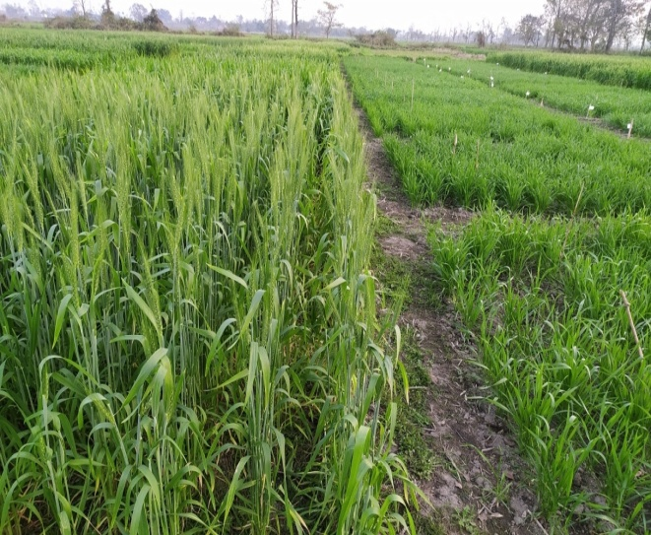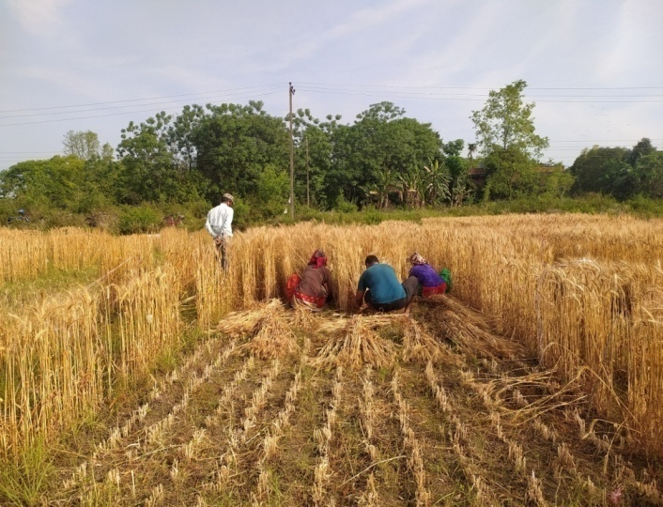
Field performance of wheat Harvesting net plot area
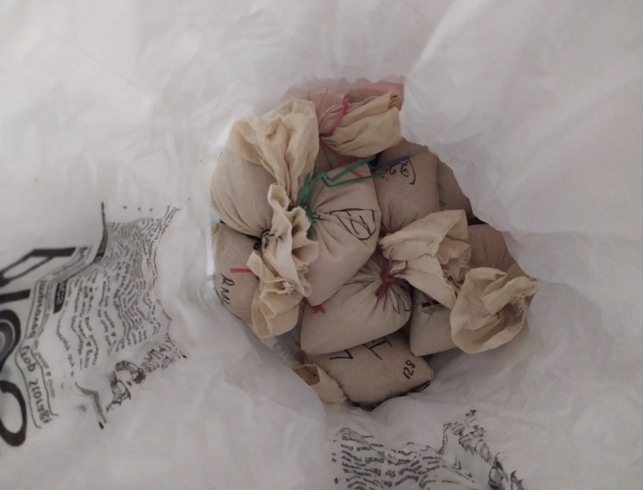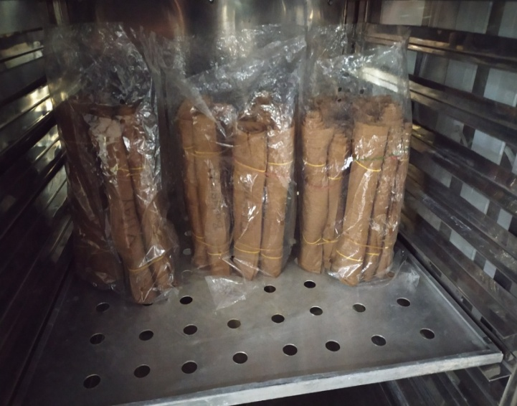
Preparation for the storage of seeds in a PICS bag Sample in the seed germinator for germination

