Analysis of Tomato Yield Estimations using Sentinel-2 and UAV-Based NDVI with Guided Sampling: A Case Study in Northern Italy.
Avinash Kafle¹ᵃ, Andrea Caporrella², Federica Carmagnola², Fabio Dell’Acqua¹, Giuseppe Caporrella²,

¹ Department of Earth and Environmental Science, Università di Pavia, Via Ferrata 5, 27100 Pavia, Italy.
² Innova-tech srl, Operational Office: Strada Provinciale 180, No. 2, 15065 Frugarolo (AL), Italy.
ᵃ Permanent address: Sainamaina-5, Rupandehi, Nepal.
Corresponding author: Avinash Kafle – E-mail: kafleavinash@gmail.com

Abstract
This study presents a guided sampling approach to investigate the relationship between NDVI and tomato yield and quantify the accuracy and error patterns of Sentinel-2 and UAV platforms for yield prediction. Sentinel-2 and UAV-derived NDVI were extracted in three different tomato fields in Northern Italy. Yield samples were collected from 2 × 2 m² grids covering all NDVI categories and spatial zones of each field, with three samples per NDVI class (low, medium, high) in the first two fields and two per class in the third field. NDVI from specific dates with the highest adjusted R² was used to create a linear regression model, which was later evaluated in validation plots and in total field yield. In Field 1, the strongest Sentinel-2 NDVI-yield relationship occurred 30 days before harvest. Due to rainfall-induced yield losses occurring after image acquisition, the field experienced large overestimation in validation (RRMSE=9.39%) and at the field scale (16.07%). For similar reasons, UAV-derived NDVI-based yield was also overestimated in validation plots (8.04%) and at the field scale (13%). In Fields 2 and 3, optimal relations were observed 22 and 15 days before harvest, respectively. In these fields, Sentinel-2 predictions overestimated yield at both validation (6.06 and 9.73% respectively) and field scales (9.36% and 10.13% respectively), whereas UAV-derived NDVI showed no significant yield relationship in Field 2 but significantly underestimated yield in Field 3 validation (6.77%) and field scales (7.85%). Across all fields, errors increased from validation to field scale, reflecting additional variability at increased spatial scale. Overall, the RRMSE range of 7.85–16.07% in the field scale incorporates multiple sources of variability, including late rainfall damage and staggered transplanting. This indicates that the approach is robust under contrasting field conditions. So, NDVI acquisition approximately 15–30 days before harvest is recommended for the most reliable yield estimation. UAV-based NDVI was more suitable for yield estimation in heterogeneous fields using guided sampling, whereas Sentinel-2-based NDVI was comparable under more homogeneous conditions. Generally, Sentinel-2-based NDVI showed stronger systematic overestimates across fields, while UAV-based observations provided more stable and reliable yield estimates at both validation and field scales.

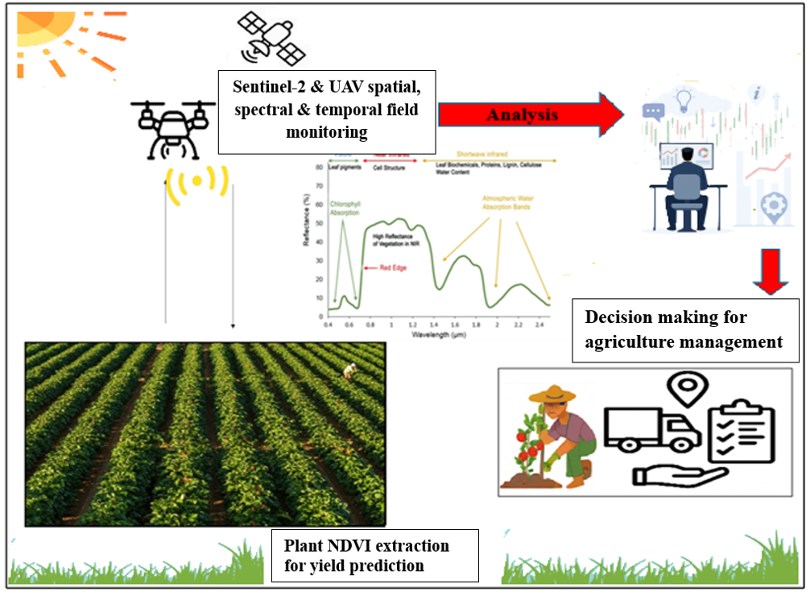
Graphical abstract
Keywords
Remote sensing in agriculture; Sentinel-2; UAV; NDVI; Yield estimation

Highlights
- The guided sampling technique showed a reliable yield estimation
- NDVI-yield relation was evaluated across training, validation, and field scales
- Sentinel-2-derived NDVI-based yield estimation tends to overestimate
- UAV-derived NDVI-based yield estimation was more consistent across scales
- Remote sensing supports data-driven sustainable agricultural decisions

1. Introduction
Tomato (Solanum lycopersicum L.) is a widely cultivated commercial fruit of the Solanaceae family (Martins et al., 2023). According to the World Processing Tomato Council (2024), global processing tomato production in 2023 was 44.56 million megagrams. Between September 2023 and August 2024, the demand for tomato paste increased by 9% in the top 20 importing nations compared to the average of the three years prior (Branthôme, 2024). This figure provides evidence of the growing demand for processing tomatoes and the need for more accurate yield estimation. Accurate yield estimation at the national, regional, and farmer field scale requires precise and timely information on crop distribution, phenology, and biophysical conditions. Such information supports effective monitoring and management of agricultural systems, including optimized input use, logistics, and land-use planning. Accurate yield forecasting can thus indirectly reduce greenhouse gas (GHG) emissions by enhancing resource-use efficiency (Inglada et al., 2016).

Advanced technologies in agriculture, including remote sensing, leverage site-specific spatial information supporting field monitoring, thereby contributing to improving a reliable global food supply and food security (Bégué et al., 2018). It enables farmers to make optimal decisions with the available resources, increasing productivity, improving yield forecasts, and developing marketing strategies (Aslan et al., 2024; H. Zhang et al., 2023). Among remote sensing systems, Sentinel-2 offers frequent revisits and multispectral data at a moderate spatial resolution (10–20 m), making it important for regional to field-scale application for precision agriculture, including crop health assessment and yield estimation. Similarly, unmanned aerial vehicle (UAV) technology like DJI Mavic 3M equipped with a global navigation satellite system (GNSS) and real-time kinematic (RTK) operates effectively even under cloud cover conditions, delivering higher quality images up to centimeter-level detail (Manfreda et al., 2018) (Szypuła, 2024; Harm-Altstädter et al., 2023). However, UAVs may not be affordable and accessible in all regions, while Sentinel-2, even with comparatively coarser resolution, can offer superior spatial coverage and temporal consistency, supporting agriculture monitoring and food security assessment (Desloires et al., 2023).

In Italy, processed tomatoes are produced on a contractual basis between producers and processors, harvested mechanically on scale, and rapidly delivered to factories. A formally recognized institutional body, the Interbranch Organization (IBO), supports value chain management of agricultural products. Processing Tomato Producers Organizations (PTPOs) work as the core body of this IBO. This producer’s association supports its members by facilitating access to subsidies and co-financing programmes that help meet production demand and stability in production costs. The producer’s association, stakeholder processing industries, and retailers are involved in price negotiations and subsidies recommendations, which are mostly based on the previous year's report (Samoggia et al., 2022). Most economic support payments provided by governmental or non-governmental organizations to farmers are currently based on farm production reports (Lankoski et al., 2025). Historical production data sources are often insufficient for early production estimation, hindering early logistics and market insight, and leading to uncertainty and speculation in the market. Indeed, such reports are largely subjective and difficult to cross-validate, due to accuracy issues and data limitations (Vaglio Laurin et al., 2018).

At the regional scale, a machine-learning-based estimation model prepared by experts using multiple predictor features generally works better (Darra et al., 2023). However, in a context where farmers are required to understand their field conditions, minimize GHG emissions from both pre- and post-production, a comprehensive approach that can operate with limited data is beneficial. The average field size for processing tomato production in Northern Italy is 20 hectares per farmer (OI Pomodoro da Industria Nord Italia, n.d.). The models that demand high training data and resolution definitely increased generalizability and accuracy. However, collecting a huge field training sample from a small field is highly labor-intensive and impractical. Using sample-guided estimation, this study demonstrates the simplest possible methodology, considering the model's applicability at the farm scale. Vegetation indices such as enhanced vegetation index (EVI), leaf area index (LAI), vegetation condition index (VCI), percent of average seasonal greenness (PASG), vegetation supply water index (VSWI) normalized difference red edge (NDRE), and normalized difference vegetation index (NDVI) have been widely used to assess crop phenology, vegetation cover, crop health, and to estimate grain yield based on vegetation greenness levels (Xue & Su, 2017). Several studies have reported the suitability of the NDVI for yield estimation. Belmahi et al. (2023) have suggested that a simple linear regression model using NDVI as the sole predictor can provide reliable yield estimates. The Index database (https://www.indexdatabase.de/db/ias.php) also recognizes NDVI as an effective indicator for yield monitoring (Henrich et al. 2012). While NDVI is widely used due to its simplicity and strong sensitivity to green vegetation, it is limited by saturation at high canopy densities (Son et al., 2014; Wu et al., 2023). When leaf area index (LAI) is large, NDVI becomes less sensitive to biomass variation, reducing its predictive ability. However, NDVI performs best under moderate canopy conditions, and reliable yield estimation is generally achieved when NDVI values remain below saturation levels (NDVI < 0.9) (Naser et al., 2020).

Normalized difference vegetation index helps to estimate yield by calculating the photosynthesis rate (Roman & Ursu, 2016). Researchers have consistently reported that the net primary productivity of any crop is highly correlated with its NDVI (X. Zhang & Zhang, 2016; Rafique et al., 2016). Schauberger et al. (2020), Petersen (2018), and Shammi & Meng (2021) have emphasized that the NDVI is a good estimator of crop yield. Meng et al. (2013) found that plant productivity monitoring is improved when using time-series NDVI data. Radočaj et al. (2023) reported that NDVI indices over time showed significant variation for modeling plant growth kinetics. Trentin et al. (2025) reported that using NDVI as an independent variable in a linear regression model explained 63% of the variation in processing tomato yield. Chávez-Martínez et al. (2024) reported that NDVI was sensitive to detect crop changes in the tomato crop under optimal greenhouse conditions. Candiago et al. (2015) reported that NDVI maps are crucial tools for examining tomato crop conditions; they support the visualization of the spatial distribution of vegetation, fundamental for evaluating yield. Martins et al. (2023) found that NDVI is fundamental to examining the spatial and temporal variability of industrial tomato yield. However, Gutiérrez-Castorena et al. (2025) reported that NDVI-based models were unreliable for predicting the yield of indeterminate tomatoes in protected agriculture systems. Psiroukis et al. (2022) reported a high correlation between NDVI and processing tomato yield, with a coefficient of determination of up to 0.89. Therefore, this study aimed to analyze Sentinel-2-derived NDVI time series field data to see the significance of NDVI for yield estimation, identify the optimum crop physiological stage and time window that best represents sample yields, and compare the information with limited UAV-based NDVI data using a guided sampling approach, in cloud-free summer Mediterranean conditions of Northern Italy. The methods support farmers in decision-making and can also be transferred to other regions and cultivation systems, contributing to a better understanding of remote sensing data for estimating crop production.

2. Materials and methods

2.1 Site description and field operations
The study was conducted in three different tomato fields in Northern Italy: Field 1 (29.15 hectares; coordinates: 45°01′49.3″N, 9°29′38.4″E) in the province of Piacenza, Field 2 (4.47 hectares), and Field 3 (2.67 hectares); coordinates: 44°50′21.6″N, 8°37′01.4″E in the province of Alessandria ( Figure 1). Soil texture was estimated in the field using the ribbon method (Turk & Young, 2022) and soil pH was measured on-site using a Schindengen handheld pH meter. In Field 1, the soil was silty clay with a slightly acidic pH of 6.2, while in Fields 2 and 3, it was medium-textured loamy with a slightly acidic pH of 6.6.

All three fields were prepared through deep plowing and leveling and transplanted using an Agri-transplanter. Plants spacing was maintained at 25-30 cm within rows and 140-150 cm between the rows. A drip irrigation system was used for the irrigation and fertigation process across the fields. Agronomic inputs and treatment were kept constant across the field. A basal fertilizer dose of NPK at the rate 50:80:120 Mg/h was applied before transplantation. Weed control was performed with herbicides STOMP, Challenge 600 SC, and Anthem. Fungal disease and insect were managed by applying Cymoxanil at 7 to 10-day intervals, while Altacor insecticide and Nealta acaricides were applied twice during the growing season. In Field 1, medium-early/early-maturity processing tomato hybrid ‘H1301’, characterized by good adaptability across transplanting periods and tolerance to Alternaria solani (Furia Seed, 2015), was transplanted on 4 June 2024 and harvested on 28 September 2024 (114 days after transplantation (D.A.T)). In Field 2, 'N507', BASF F1 hybrid tomato recommended for early April to late May and characterized by high resistance to Fusarium oxysporum (BASF, n.d.) was transplanted on 10 and 20 May 2024, and harvested on September 6, 2024, i.e., 110 D.A.T. Similarly, in Field 3, the same 'N507' variety was transplanted on 19 April 2024 and harvested on 29 August 2024, i.e., 130 D.A.T.

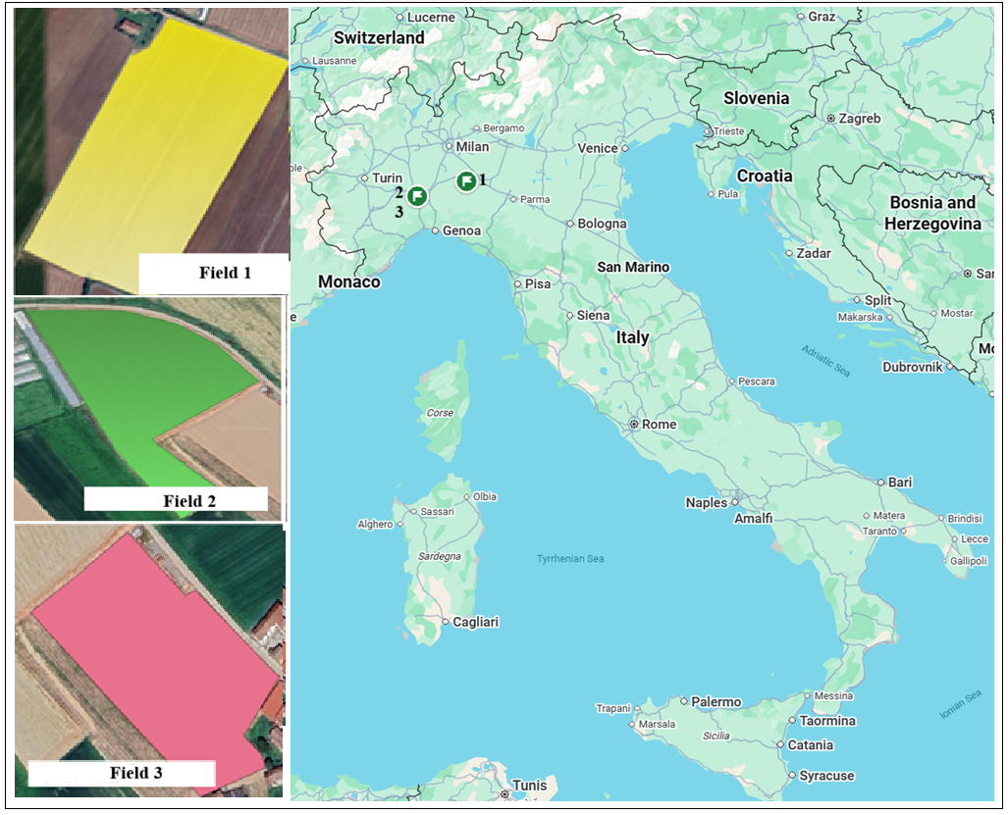
Figure 1. Study field locations

2.2 Image acquisition, processing
Cloud-free Sentinel-2A and Sentinel-2B images of the study area were obtained from the Copernicus Data Space Ecosystem (https://dataspace.copernicus.eu/browser/) under the EPSG:3857-WGS 84 coordinate reference system. Images were acquired at a 5-day interval between 4 July and 28 September 2024, which is also the acquisition interval of Sentinel-2 (European Union, Copernicus Programme, 2024). This Copernicus data space ecosystem browser provides an option to view and filter images based on cloud cover percentage. After the cloud cover threshold was set below 20%, and the field-level cloud cover condition was checked, only images after June were found suitable for analysis. The imagery was subsequently reprojected to EPSG:32632 (WGS 84 / UTM Zone 32N) using QGIS software to ensure spatial accuracy for field-scale analysis (QGIS Development Team, 2024). The European Space Agency (ESA) Sentinel Application Platform (SNAP) desktop tool was used to generate orthorectified and atmospherically corrected NDVI raster images (European Space Agency, 2024). The original Sentinel-2 NDVI raster, with a spatial resolution of 10 × 10 m², was resampled to 2 × 2 m² using the Warp (Reproject) function in QGIS. The target output resolution was set to 2 m in both X and Y directions, the resampling method was set to nearest neighbor, and the “target aligned pixels” option was enabled. This procedure subdivided each 10 × 10 m² pixel into 25 identical 2 × 2 m² pixels while preserving the original NDVI value. This resampling was performed solely to match the physical size of the 2 × 2 m² yield sampling plots, as harvesting yield over 10 × 10 m² areas was not feasible under the experimental conditions. Ten (4 July 2024; 9, 14, 19, and 24 July; 3, 13, and 23 August; 27 September) Sentinel-2 cloud-free raster images were acquired for Field 1 and nine (4, 14, 24, and 29 July; 3, 13, 23, and 28 August; 27 September 2024) for Fields 2 and 3 excluding cloud cover imagery (Supplementary Table 2).

In addition to satellite imagery, UAV data were collected in each experimental field using a DJI Mavic 3M (SZ DJI Technology Co., Ltd., Shenzhen, China)(Reinprecht & Kieffer, 2025). UAV image acquisition was conducted during two key phenological stages: the anticipated full flowering stage (Biologische Bundesanstalt, Bundessortenamt und Chemische Industrie 65 (BBCH 65 )) and the fruit fully ripe stage (BBCH 89, extended to 107) (Cardoso et al., 2021). In Field 1, on 6 August and 3 September, 2024, UAV flights were carried out; in Field 2 on 30 July and 5 September, 2024; and in Field 3 on 30 July and 13 August, 2024. Only Field 3 had image acquisitions on the same date in the maturity stage of tomato, with the same data from both Sentinel-2 and UAV platforms. This ensured that the NDVI represented the same phenological stage; those NDVI values were compared using a histogram; any differences observed were due to the sensing platforms rather than plant development. All UAV imagery was georeferenced in the EPSG:3857 WGS 84 coordinate system. Flights were conducted at an altitude of 50 m with a ground speed of 1.5 m/s, ensuring 70% side overlap and 80% front overlap to achieve high-quality photogrammetric reconstruction. The UAV is equipped with a built-in 1/2.8-inch CMOS multispectral sensor (5 MP) capturing four spectral bands: Green (560 ± 16 nm), Red (650 ± 16 nm), Red Edge (730 ± 16 nm), and Near-Infrared (860 ± 26 nm). A shutter speed of 1/2000 was used to minimize motion blur, and images were acquired at 3-second intervals. Multispectral data processing and vegetation index generation were performed using DJI Terra software (DJI, n.d.), following the procedures described in the DJI Terra User Manual (DJI, 2024), which directly computes radiometrically corrected NDVI from the red and near-infrared bands. The resulting NDVI products were exported as georeferenced GeoTIFF raster files and subsequently resampled to a spatial resolution of 2 × 2 m² in QGIS before being reprojected to EPSG:32632 WGS 84 / UTM Zone 32N.

 | NDVI = $\frac{NIR-RED}{NIR+RED}$ | Equation 1
Where;
NDVI represents the normalized difference vegetation index, NIR denotes the light reflectance in the near-infrared region (720 -1300 nm), and RED denotes reflectance in the red wavelength region (600 - 720 nm) (Petersen, 2018).

Field boundaries for the tomato field were delineated using the create polygon option in QGIS 3.36.1. SNAP and UAV-derived NDVI raster images were clipped to the field boundaries, and field masking was applied to extract NDVI values for the study area. ‘Zonal statistics’ categorized the field NDVI into low, medium, and high zones. Yield samples were collected from all NDVI categories and across the entire field. For linear model training, nine 2 × 2 m² grids were selected in Fields 1 and 2 (three each from low-, medium-, and high-NDVI zones), while in Field 3, considering its smaller size, six different 2 × 2 m² grids (two each from low-, medium-, and high-NDVI field zones) were selected. In total, twenty-four training yield samples were collected across the three fields. For validation, four independent yield samples of the same grid size were collected in each field and excluded from the training. Additionally, the total production was also compared with the total estimated yield in each field to assess the field-level estimation performance.

2.3 Statistical analysis
Statistical analysis was conducted using the MS Excel data analysis tool (Microsoft Corporation, 2024), incorporating NDVI data from all available acquisition dates from both remote sensing platforms. A linear regression (LR) model was developed using NDVI as the independent variable (X) and measured sample tomato yield as the dependent variable (Y). The optimal regression model (Equation 2) was selected based on the correlation coefficient (r), adjusted R², RMSE, and P-value.
 | Y =$\sum_{1}^{n}{βx+ε}$ | Equation 2

Where;
Y is the dependent variable, indicating tomato yield, and X is the independent variable, indicating NDVI. β represents the slope, and ε represents the error.

Field-level NDVI values were extracted using the ‘basic statistics tool’ in QGIS, and the best-fit regression equation was applied to the grid-level NDVI using the ‘field calculator’ to estimate yield. Both the estimated yield and grid coordinates were extracted, and then MS Excel was used to sum the total estimated yield across all grids. Estimated yield maps were generated using R version 4.3.3 (R Core Team, 2024). The field area was calculated to determine crop productivity. Model performance was evaluated using root mean square error (RMSE) (Equation 3) and the relative root mean square error (RRMSE) (Equation 4).RMSE provides an absolute measure of prediction error in the same units as the yield (Hodson, 2022). RRMSE, normalized RMSE using mean observed yield, allowing comparison of estimation errors across fields with different production levels. This approach follows Richter et al. (2011), who recommend normalized error metrics such as RRMSE because they indicate the relative prediction error without being influenced by data magnitude. Since the objective of this study was to assess model accuracy across fields with varying yield magnitudes, rather than to compare mean values, comparison tests such as Tukey or Student–Newman–Keuls (SNK) were not applied. The overall data acquisition, processing, and analysis workflow is summarized in Figure 2.

 | $$RMSE= \sqrt{ \left(\frac{1}{n}\right) Σᵢ^{n} {\left(yᵢ - ŷᵢ\right)}^{2} }$$ | Equation 3

 | $$RRMSE= 100*\frac{1}{\overline{Y } }\sqrt{ \left(\frac{1}{n}\right) Σᵢ^{n} {\left(yᵢ - ŷᵢ\right)}^{2} }$$ | Equation 4
Where;
n = total number of observations, ̂y = predicted value, y = actual value, and $\overline{Y }$ = average of actual values

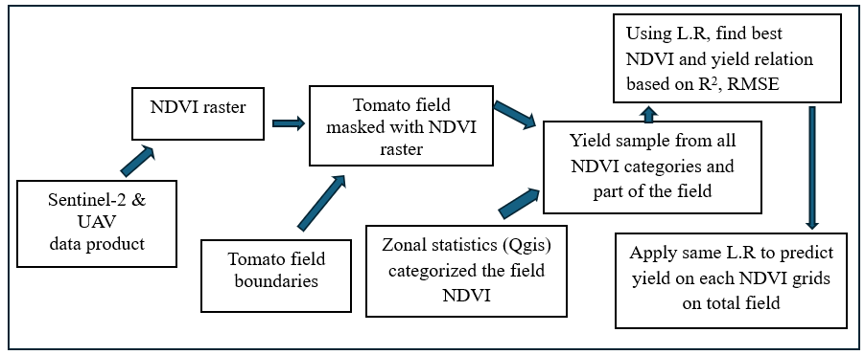
Figure 2. Schematic flow chart for data acquisition, processing, and analysis

3. Results

3.1 Sentinel-2 vs UAV-derived NDVI distribution
The histogram presents the NDVI values derived from Sentinel-2 and UAV imagery, both aggregated using 2 x 2 m² grids (methodology mentioned in 2.2) to illustrate the field-level variation (Figure 3). In the Sentinel-2-derived histogram, most grids (approximately 3,000) were concentrated around an NDVI value of 0.65, with relatively few grids falling between 0.45 and 0.75. In contrast, in the UAV-derived histogram, grids show significant variations with NDVI values spanning from 0.2 to 0.85.

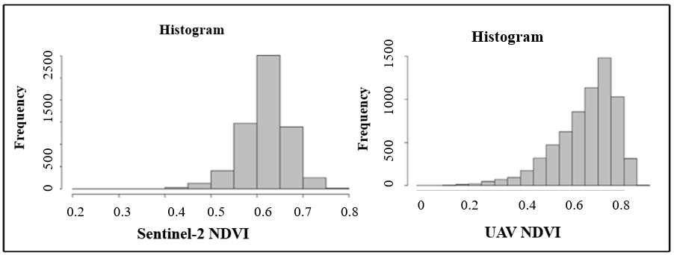
Figure 3. Histogram of Sentinel-2 and UAV-derived NDVI values in Field 3, aggregated to 2 × 2 m² grids. UAV data show greater NDVI variability compared to Sentinel-2

3.2. Temporal performance of NDVI for yield estimation
In Field 1, the correlation between NDVI and yield showed consistent improving trends from the first available Sentinel-2 image taken one month after transplantation, until 30 days before harvest (Table 1). Similarly, a significant P-value (<0.05) was observed starting 45 days after transplantation (D.A.T). From 60 to 85 D.A.T., the significance level improved to P < 0.001, then decreased to < 0.01 by 90 D.A.T. On 28 August 2024, the field had the highest correlation coefficient of 0.95 and an adjusted R² of 0.90. The RMSE value shows an average deviation of 4.55 Mg/ha between the predicted and actual yield. For UAV-acquired NDVI, the 90 D.A.T. had a significant relationship to yield prediction, with a correlation coefficient of 0.90 and an adjusted R² of 0.79. In Field 2, on the first available Sentinel-2 image (i.e., 45 D.A.T.), a correlation coefficient of 0.71 was observed. This value decreased to 0.60 on 55 D.A.T., then improved up to 22 days before harvest. A significant P-value (<0.05) was recorded on 45 D.A.T. and from 60 to 95 D.A.T. On 13 August 2024, Field 2 showed the highest evaluation metrics: correlation of 0.76, an adjusted R² of 0.51, and RMSE of 7.93 Mg/ha. In this field, in the period between 45 and 85 D.A.T., the predictive power of the Sentinel-2-derived NDVI was significant and satisfactory. After 13 August, 2024, the P-value and other statistics became insignificant. Likewise, in Field 2, UAV-derived acquisitions didn’t yield sufficiently reliable results. In Field 3, the correlation between NDVI and yield improved steadily from the first available imagery at 70 D.A.T. to 15 days before harvest, except for the 85 to 90 D.A.T. The P-value (<0.05) indicated a significant relationship from 70 D.A.T. to 110 D.A.T. The highest statistical agreement for Sentinel-2-derived NDVI and yield was observed on 13 August 2024. It showed a correlation of 0.86, an adjusted R² of 0.67, and an RMSE of 5.88 Mg/ha, while the unmanned aerial vehicle (UAV) showed a correlation of 0.92, an adjusted R² of 0.81, and RMSE of 5.88 Mg/ha. However, after 13 August 2024, the P-value and other relations were found to be statistically insignificant.

Table 1. Temporal variation in the statistical relationship between Sentinel-2 and UAV-derived NDVI across crop growth stages with tomato yield.
S. N  Field 1 | D.A.T.  Sentinel-2 | Date | Linear regression (LR) | Correlation (r) | Adjusted R²  (adj. R²) | RMSE  Mg/ha | P -Value
1 | 30 | 04-07 |  | 0.28 | 0.04 | 14.80 | 0.45
2 | 35 | 09-07 |  | - | 0.13 | - | 0.81
3 | 40 | 14-07 |  | 0.57 | 0.23 | - | 0.103
4 | 45 | 19-07 |  | 0.71 | 0.44 | 10.60 | 0.02
5 | 50 | 24-07 |  | 0.78 | 0.62 | 8.65 | 0.007
6 | 60 | 03-08 |  | 0.86 | 0.71 | 7.80 | <0.001
7 | 70 | 13-08 |  | 0.92 | 0.80 | 5.50 | <0.001
8 | 80 | 23-08 |  | 0.95 | 0.89 | 4.65 | <0.001
9 | 85 | 28-08 | Y = 155.30 × NDVI - 13.03 | 0.95 | 0.90 | 4.55 | <0.001
10 | 115 | 27-09 |  | 0.0018 | 0.14 | 15.55 | 0.96
S. N | D.A.T. UAV | Date | LR | r | adj. R² | RMSE | P-value
1 | 63 | 06-08 | Y = 125.10 × NDVI - 9.65 | 0.90 | 0.79 | 6.55 | <0.001
2 | 90 | 03-09 |  | 0.77 | 0.53 | 9.95 | <0.01
S. N  Field 2 | D.A.T. Sentinel | Date | LR | r | adj. R² | RMSE | P-Value
1 | 45 | 04-07 |  | 0.71 | 0.44 | 8.45 | 0.030
2 | 55 | 14-07 |  | 0.60 | 0.26 | 9.7 | 0.089
3 | 60 | 19-07 |  | 0.66 | 0.36 | 9 | <0.05
4 | 65 | 24-07 |  | 0.62 | 0.29 | 9.48 | <0.07
5 | 70 | 29-07 |  | 0.71 | 0.45 | 8.4 | <0.02
6 | 75 | 03-08 |  | 0.70 | 0.43 | 8.53 | <0.03
7 | 85 | 13-08 | Y = 202.75 × NDVI -13.71 | 0.76 | 0.51 | 7.93 | <0.018
8 | 95 | 23-08 |  | 0.13 | -0.12 | 12 | 0.18
9 | 100 | 28-08 |  | 0.13 | - | - | -
S. N | D.A.T. UAV | Date | LR | r | adj. R2 | RMSE | P-Value
1 | 71 | 30-07 | - | 0.54 | 0.29 | 10 | <0.12
2 | 107 | 05-09 | - | 0.18 | - | - | 0.45
S. N  Field 3 | D.A.T.  Sentinel-2 | Date | LR | r | adj. R² | RMSE | P-Value
1 | 70 | 04-07 |  | 0.79 | 0.54 | 7.75 | 0.05
2 | 80 | 14-07 |  | 0.83 | 0.61 | 7 | 0.05
3 | 85 | 19-07 |  | 0.77 | 0.49 | 8.18 | 0.07
4 | 90 | 24-07 |  | 0.69 | 0.35 | 9.25 | 0.12
5 | 95 | 29-07 |  | 0.84 | 0.64 | 6.90 | 0.05
6 | 100 | 03-08 |  | 0.845 | 0.64 | 6.88 | 0.05
7 | 110 | 13-08 | Y = 150.44 × NDVI - 27.67 | 0.861 | 0.67 | 5.88 | <0.01
8 | 125 | 28-08 |  | 0.25 | 0.06 | 12 | 0.62
S. N | D.A.T. UAV | Date | LR | r | adj. R² | RMSE | P-value
1 | 95 | 30-07 |  | 0.90 | 0.78 | 3.68 | <0.01
2 | 110 | 13-08 | Y = 224.95 × NDVI - 88.34 | 0.92 | 0.81 | 3.38 | <0.001

3.3 NDVI–yield regression analysis
In Field 1, on 28 August 2024 Sentinel-2 derived NDVI had strong relation with yield (adjusted R² of 0.90, P-value<0.001), with sample NDVI ranging from 0.4 to 0.7, while with UAV, the significant relation was on 6 August 2024 (adjusted R² of 0.79, P-value<0.001), and the corresponding yield was 50 to 95 Mg/ha (Figure 4). In Field 2, the relationship was significant only with Sentinel-2 but was weaker (adjusted R² = 0.51, P-value = 0.018) with sample NDVI ranging from 0.68 to 0.81, and corresponding yield 120 to 160 Mg/ha. In Field 3, yield shows a strongly significant association with both Sentinel-2 (adjusted R² = 0.81, P<0.001) and UAV (adjusted R² = 0.81, P<0.001)-derived NDVI. Sentinel-2 had NDVI values ranging from 0.55 to 0.70 and the corresponding sample yield between 57.5 and 82.5 Mg/ha, while UAV had NDVI values ranging from 0.66 to 0.77.
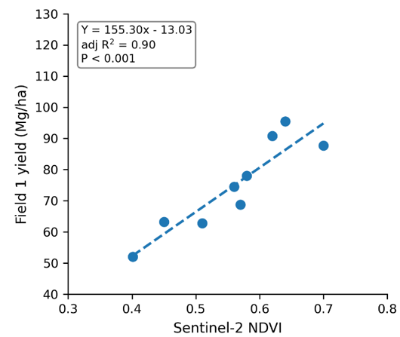 | 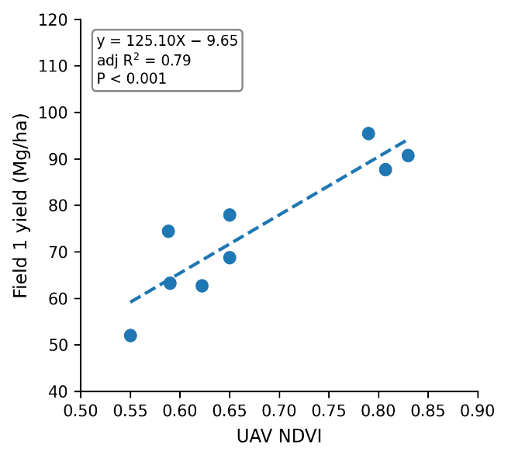

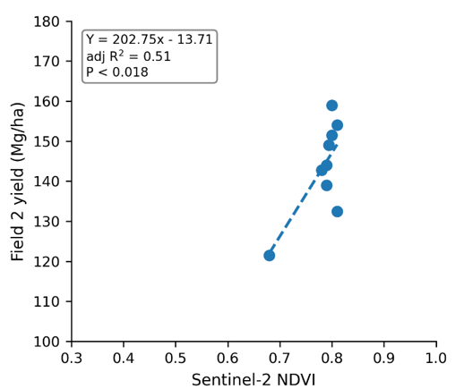

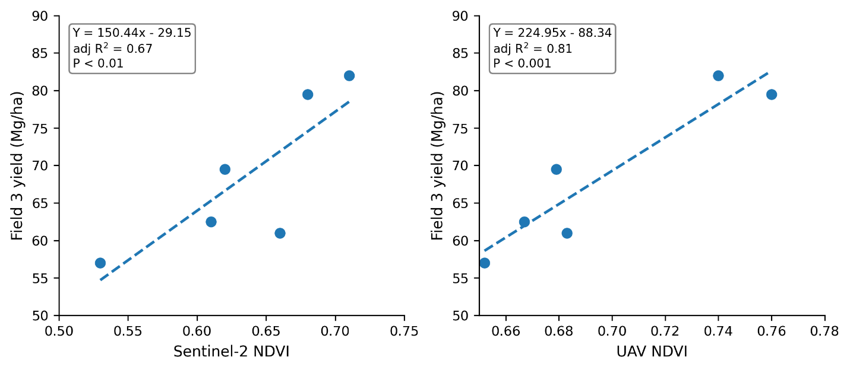

Figure 4. Linear relationship between NDVI and the yield of training samples across fields. The Sentinel-2-derived NDVI yield relationship is shown for Fields 1, 2, and 3, while the UAV-derived is shown only for Fields 1 (Right-top) and 3 (Right-bottom). Points represent sample observations, while dashed lines denote linear regression fits, with corresponding regression statistics.

3.4 Accuracy evaluation and overall error comparison
The RMSE and RRMSE values for training (Tr), validation (Val), and total (Tot) fields assess the relative estimation accuracy of the NDVI-based yield models (Figure 5). For Field 1, Sentinel-2-based RMSE ranged from 4.25 Mg/ha (Tr), 7.40 Mg/ha (Val), to 10.45 t/ha (Tot). The corresponding Field 1 UAV-based model showed RMSE values of 5.85 Mg/ha (Tr), 6.34 Mg/ha (Val), and 8.45 Mg/ha (Tot). Similarly, Sentinel-2-based estimation had RRMSE values ranging from 5.68% (Tr) to 9.39% (Val) and 16.07% (Tot), and UAV-based estimation had RRMSE values of 7.82% (Tr), 8.04% (Val), and 13% (Tot). In Field 2, Sentinel-2-based RMSE increased to 7.03 Mg/ha (Tr), 8.55 Mg/ha (Val), and 12.26 Mg/ha (Tot), where corresponding RRMSE values were 4.89% (Tr), 6.06% (Val), and 10.13% (Tot). For Field 3, Sentinel-2-based RMSEs were 8.23 Mg/ha, 6.40 Mg/ha, and 6.00 Mg/ha, and RRMSEs were 12.00%, 9.73%, and 9.36%, for Tr, Val, and Tot, respectively. The corresponding UAV-based NDVI-yield model demonstrated the lowest RMSE values, with 4.15 Mg/ha, 4.45 Mg/ha, and 5.03 Mg/ha for Tr, Val, and Tot, respectively, and achieved the lowest RRMSE values, ranging from 6.05% (Tr) to 6.77% (Val) and 7.85% (Tot). Overall, the RMSE and RRMSE values varied across fields, sensor platforms, and evaluation subsets.
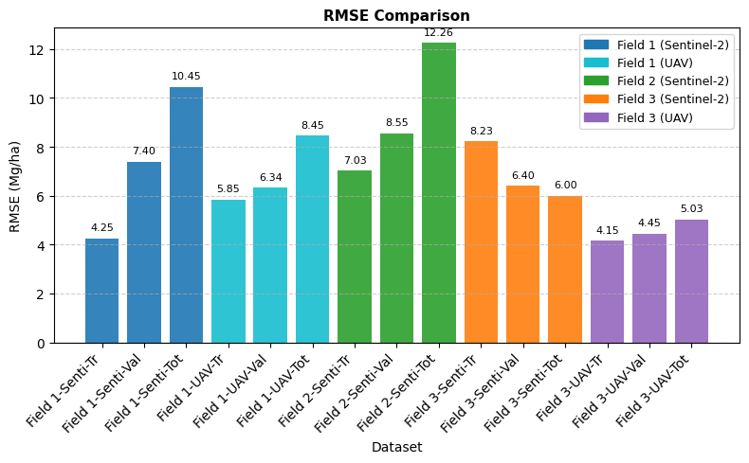

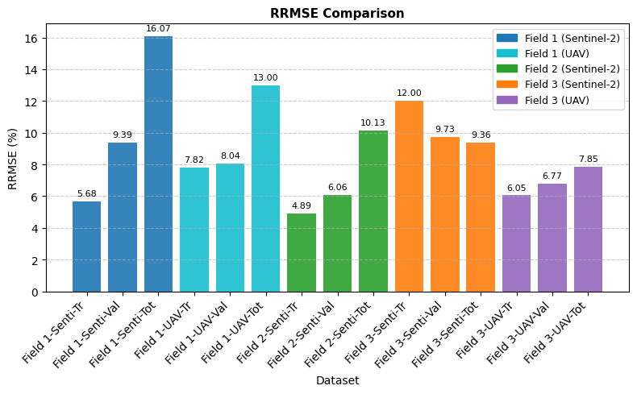
Figure 5. Overall RMSE and RRMSE comparison across fields and sensors
In Field 1, estimation errors in each training sample for both Sentinel-2 (-5.22 to +6.83 Mg/ha) and UAV (-6.32 to +7.15 Mg/ha) included positive and negative values. Similarly, in Field 2, Sentinel-2 also showed both error types (-10.30 to +17.20 Mg/ha). For Field 3, Sentinel-2 estimations showed both error types, with larger negative errors (-16.17 to +8.78 Mg/ha), whereas UAV estimation showed smaller, more balanced negative errors (-5.45 to +4.48 Mg/ha) (Supplementary Table 3). For Field 1, across each validation sample, Sentinel-2 showed strong overestimation (+5.50 to +9.50 Mg/ha), while UAV reduced the degree of overestimation (+3.43 to +7.60 Mg/ha). For Field 2, Sentinel-2 consistently overestimated yields with uniformly positive errors (+4.00 to +10.25 Mg/ha). For Field 3, Sentinel-2 estimations were mostly overestimated with one underestimation (-7.75 to +7.25 Mg/ha). In contrast, UAV-based estimates were mainly underestimated, with a few overestimations (-5.25 to +3.00 Mg/ha) (Supplementary Table 4). At the field-total scale in Field 1, Sentinel-2 substantially overestimated yield (+10.45 Mg/ha), whereas UAV showed a smaller overestimation (+8.45 Mg/) with lower RMSE and RRMSE. In Field 2, Sentinel-2 consistently overestimated yield by 12.26 Mg/ha. In Field 3, Sentinel-2 overestimated yield by 6.00 Mg/ha, while UAV underestimated yield by 5.03 Mg/ha, yet UAV achieved lower RMSE and RRMSE (Supplementary Table 5).

3.5 Yield estimation map
The NDVI-based productivity map derived from Sentinel-2 and UAV imagery showed spatial variability in yield across the three experimental fields, with green indicating high-yield zones and orange to red indicating lower-yielding areas (Figure 6). In Field 1, Sentinel-2 (28 August 2024) derived yield estimates ranged between approximately 25 and 100 Mg/ha, while the UAV-derived yield map (6 August, 2024) showed yield values ranging from 0 to 100 Mg/ha with finer spatial detail. In Field 2, Sentinel-2 imagery (13 August 2024) indicated yield ranged 75 to 125 Mg/ha, with spatial variation across the field. For Field 3 (13 August, 2024), the Sentinel-2-derived yield map produced smoother yield patterns (25-75 Mg/ha), consistent with its coarser spatial resolution, whereas the UAV-derived yield map (bottom right) offers fine-scale variability (0–100 Mg/ha), enhanced resolution, effectively capturing intra-field heterogeneity. Overall, the maps illustrate within-field and between-field variability in productivity as represented by NDVI-based yield estimates.

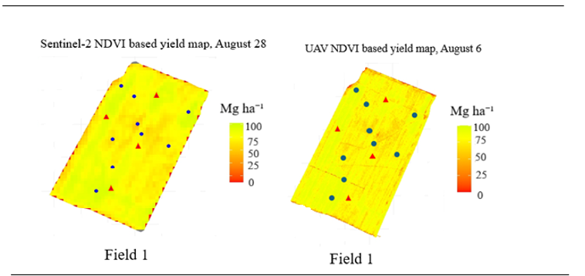

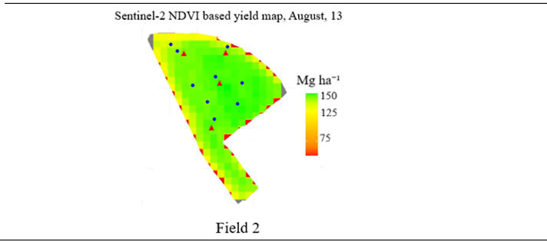

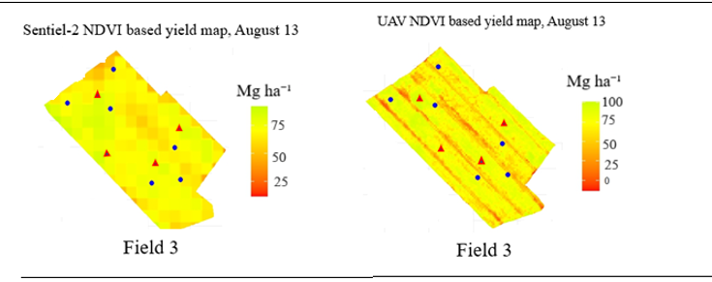
Figure 6. NDVI-based yield estimation maps derived from Sentinel-2 and UAV imagery for Fields 1, 2, and 3. Yield is reported in Mg/ha. Blue points denote training samples and red points denote validation samples.

4. Discussions
Sentinel-2 is an open-access Earth observation satellite system operated under the Copernicus Programme. It has 13 spectral bands, ranging from visible and near-infrared to short-wave infrared (490 to 2180 nm). Depending on the spectral band, it has a spatial resolution of 10 m to 60 m, with a 290 km field of view. This feature significantly broadens the opportunities for agricultural monitoring at both field and farm scales (Drusch et al., 2012). The red and NIR bands used in NDVI have a resolution of 10 m. Similarly, the DJI Mavic 3M UAV with RTK is prepared for centimeter-level positioning (resampled here to 2 m). The comparison of NDVI-based imagery from Sentinel-2 and UAV demonstrates the strong influence of spatial resolution on NDVI variability and field-scale yield estimation (Figure 6). UAV-derived NDVI captured greater within-field heterogeneity, enabling improved representation of localized vegetation patterns and yield gradients. In contrast, Sentinel-2-derived NDVI exhibited a narrower range due to spatial smoothing associated with its coarser resolution, limiting its ability to resolve fine-scale variability, as also noted by Matese et al. (2015). Despite this limitation, Sentinel-2-derived NDVI showed strong agreement with UAV-derived NDVI under cloud-free and less heterogeneous Field 3 conditions, indicating that satellite-based NDVI can still provide reliable crop condition information (Figure 3). Previous study reporting strong correlations between Sentinel-2 and UAV-derived NDVI values ( considering both points and polygons, r = 0.835–0.983) also supports its applicability for yield prediction in relatively uniform fields (Bollas et al., 2021). From a practical perspective, when UAV-related costs, including image-processing software, pilot licensing, and acquisition time, are prohibitive (Bendig et al., 2014), Sentinel-2 serves as a viable alternative for broader monitoring applications. Conversely, when coarse spatial resolution is inadequate, UAVs serve as an alternative. The complementary strengths of both platforms suggest that their integrated use can enhance the robustness and generalizability of yield estimation, consistent with Aslan et al. (2024).

Darra et al. (2023) reported that NDVI-yield relationships are weak during the first two months after transplantation due to limited canopy development in growing tomato. In this study, cloud-free Sentinel-2 imagery was available mainly after one to two months, which proved suitable for monitoring crop development and yield. Sentinel-2-derived NDVI across all three fields showed significant and non-significant sample-level yield estimation in varying D.A.T (Table 1), mainly driven by field-specific image acquisition timing, transplantation schedules, and crop phenological stages. In particular, late image availability in Field 3 and staggered transplantation in Field 2 introduced phenological variability, explaining the observed variation in NDVI predictive performance across D.A.T. and among fields. These findings are consistent with Psiroukis et al. (2022), who observed a low yield-NDVI relation at the first measurement of the season, followed by increasing and subsequently decreasing trends at a later stage. Across the three fields, the NDVI at the sample location, considering representative of the whole field, ranged from 0.40 to 0.81, below the NDVI saturation threshold reported by Naser et al. (2020). Strong relationship between NDVI and yield in Field 1(Figure 4) (adj. R² = 0.90), indicating NDVI’s ability to capture high-yield variability. In contrast, Field 2 suggested that NDVI has a lower ability to describe yield variability (adj R² = 0.51). Field 2 underwent transplantation in two phases separated by a 10-day gap, which likely introduced variability in crop development, making it difficult to identify a suitable date for correlating NDVI values with final yield. Similarly, Field 3 showed a strong statistical relation for yield estimation (Sentinel-2-based: adj. R² = 0.67, UAV-based: adj. R² = 0.81). These findings are again consistent with Psiroukis et al. (2022), who reported varying correlation and R² values of NDVI, with the best observed correlation of 0.892 and R² of 0.789 for yield.

A significant statistic in NDVI-based yield estimation and NDVI’s intra-field variability monitoring capability (Figure 6) are consistent with previous findings reported by Sellers (1985) and more recent studies by Hunt et al. (2019), Son et al. (2022), and Amankulova et al. (2023). Similar to Madugundu et al. (2024), it explored a significant time window for prediction from the BBCH 51 (first inflorescence visible, visible closed flower bud stage) to BBCH 89 (fruit fully ripe for consumption stage) (Table 1). While the development stages remain constant, the number of days required to reach each stage may vary based on the variety and local environmental conditions. Considering 0.29-0.3 NDVI as a senescence threshold (Shammi & Meng, 2021) and the time to harvest, and based on correlation, adjusted R², RMSE, and P-value as evaluation metrics, this study recommends that NDVI acquisition be done between 15 and 30 days before harvest for accurate early prediction, which is consistent with Johansen et al., (2020) who reported that imagery captured two weeks before harvest achieved the highest explained yield mass per plant. When comparing the results from the sample training plot, validation plots, and field-level Sentinel-2-based data in Fields 1 and 2, a clear and noticeable increase in both RMSE and RRMSE error metrics is observed (Figure 5). This suggests that the model’s error increased in unseen validation plots and the total-field dataset, highlighting that unseen plots and larger spatial upscaling introduce additional variability, likely due to heterogeneity in field and localized management practices. Consequently, estimation accuracy decreased from training to validation, and then to the total field. At the field scale, both Field 1 and Field 2 (Sentinel-2) showed overestimation; the rate was higher in Field 1 compared to Field 2 due to significant tomato damage caused by heavy late-season rainfall in Field 1. This aligns with Matese et al. (2015) and Gómez et al. (2019), who reported that satellite images often fail to capture high field variability, and rain-induced yield loss results in overestimation. Comparatively, Field 3 (Sentinel-2) showed a more balanced performance, with lower errors across training, validation, and the total field, which could be due to less heterogeneous field conditions and management (no staggering transplantation and no rainfall damage).

UAV-derived estimates showed low RMSE and RRMSE in both Field 1 and 3 comparisons to Sentinel-2, highlighting the ability of UAV-based NDVI data to capture subtle yield variations with greater precision, supporting its effectiveness for field-level yield estimation. The UAV-derived NDVI-based yield estimation was not only closer to the observed values but also consistently more accurate across all sample plots, reflecting their reliability in capturing high spatial variability in yield that coarser satellite imagery may overlook. This finding aligns with the understanding that UAV platforms capture high-resolution data, enabling more accurate mapping of crop conditions (Primicerio et al. 2012). While Sentinel-2 imagery remains valuable for monitoring, UAV imagery provides better detail of the field, making it a superior tool for precision agriculture and yield estimation. UAV-based underestimation of yield at the validation and field-scale in field 3 (RMSE=5.03 Mg/ha, RRMSE=7.85%) aligns with the report of Prudnikova et al. (2019), which stated that in sparsely vegetated fields, UAV-acquired NDVI values may be lower than the actual due to bright soil reflectance, ‘soil noise’. This reflectance decreases the difference between the red and near infra-red bands, lowering the NDVI. To overcome this ‘soil noise’, Son et al. (2014) suggested using the soil-adjusted vegetative index (SAVI) in sparse field conditions, while NDVI was used in this study because observations were acquired during periods of high canopy cover, when soil influence is reduced, and because the study aimed to isolate the platform and its resolution effects rather than compare vegetation indices. Meanwhile, Sentinel-2 with comparatively coarser resolution assigned NDVI values even to the barren parts of the field, overestimating yield (RMSE=6 Mg/ha, RRMSE=9.36%) at the field scale. Unlike to Field 3, in Field 1, the UAV overestimated the yield both in validation and field scale (RMSE= 8.45 Mg/ha, RRMSE of 13%), which could be because the NDVI for the prediction model was derived much earlier at the full canopy stage, where, later at the harvest stage, the field had rainfall, which damaged the tomato production. Overall, findings from both Field 1 and 3 indicate that the UAV-based predictions were more consistent from training to validation to the field level, while Sentinel-2-based estimation, although sometimes more accurate at the sample level, tended to show less consistency at the field scale. This aligns with the findings of Bukowiecki et al. (2021), who reported that UAV-based spectral data accounts for a larger share of field yield variability, producing lower yield estimation error than Sentinel-2.

Fields 2 and 3, which were not affected by late rain, had considerably better estimation even with using Sentinel-2, suggesting that stable field conditions improve the reliability of satellite-based NDVI. In contrast, in Field 1, affected by late rainfall, which likely introduced yield variability and affected the estimation accuracy. However, the estimation in Field 1 was comparable to the result reported by Fortes et al. (2015), who achieved RRMSE values of 14%–17% for NDVI-based yield prediction, which is good for processing tomato farms in Spain. Their collected NDVI was derived from the Crop Circle ACS-470 reflectance sensor, with a logging interval of approximately 10 seconds and a transect spacing of about 8 meters, and spatially interpolated using regression kriging, indicating that the level of uncertainty observed in Field 1 is within the range reported in previous field-scale studies. Overall, the derived RRMSE range of 8–16 % across the studied fields was a good prediction, a range considered reliable for NDVI-based yield estimation. This range already incorporates diverse sources of variability, including late rainfall damage and staggered transplanting, indicating that the approach is robust under contrasting management and environmental conditions. At the same time, it showed that the more homogeneous the field conditions, the stronger the predictive performance. Taken together, the findings confirm that while NDVI-based predictions are not entirely uniform across all sites, they remain coherent within acceptable error margins and can be transposed to other crops and regions. It also demonstrated good predictive ability and a pattern of error between the UAV and Sentinel-2 remote sensing platform, under given local environmental conditions. Finally, linear regression using NDVI as an independent variable proved suitable for describing crop yield patterns derived from estimation maps, consistent with Trentin et al. (2025) and Fortes et al. (2015). This methodology is comprehensive and practical, supporting effective decision-making at the field scale, while resampling of Sentinel-2 data from 10 m to 2 m resolution was necessary to align with high-resolution drone and field data, which may have led to pseudo-precision; future studies could address this by incorporating methods such as cluster-robust standard errors clustered by the parent Sentinel-2 pixel. Future research should extend this methodology by incorporating additional vegetation indices such as the enhanced vegetation index (EVI), leaf area index (LAI), and Soil-Adjusted Vegetation Index (SAVI), extend the study over multiple years of growing season to assess inter-annual variability, use more and timely UAV acquisition campaigns, and statistical approaches that account for resolution-induced uncertainty and explore the strong relationship.

5. Conclusion
This study provides evidence that a simple, sample-guided NDVI-based yield modeling approach can provide reliable yield for processing tomatoes under diverse field conditions in Northern Italy.
NDVI explained a significant proportion of yield variation from the first visible inflorescence stage through fruit ripening, with the most reliable estimation on approximately 15–30 days before harvest. This method is straightforward and feasible at the farm scale, offering a cost-effective approach for yield estimation. UAV-derived NDVI consistently outperforms Sentinel-2, offering better capability and consistency in yield estimation with fine-scale spatial information, whereas Sentinel-2 performed comparably under homogeneous field conditions. Under a less heterogeneous field, UAV showed a tendency toward field-scale underestimation, whereas Sentinel-2 showed overestimation. Differences in performance between the fields were due to site-specific and field-specific characteristics, including weather and management variability. Overall, the observed error range demonstrates that NDVI-based yield estimation using a minimal-data linear framework is robust and transferable.

Recommendation
For Northern Italian tomato growers and other producers in similar contexts, this approach is both highly relevant and beneficial. It enables site-specific field monitoring and yield estimation, supporting better resource allocation and environmental and economic gain.

Acknowledgements
This research was carried out under a Laurea Magistrale Plus (LM+) agreement between the University of Pavia, Italy, and INNOVA-TECH Agro-company, Via Valparaiso, 1, Milan (MI)-CAP-20144, and was also funded by the European Union - NextGenerationEU, Mission 4 Component 1.5 - ECS00000036 - CUP F17G22000190007. The authors used an AI-based language tool (OpenAI) to improve the clarity and fluency of the writing.

Authors’ Contributions
Avinash Kafle, Andrea Caporrella, and Federica Carmagnola generated the ideas, designed the methodology, and collected data. Giuseppe Caporrella assisted with data collection. Avinash Kafle led the writing of the manuscripts, and Fabio Dell’Acqua revised and edited them for intellectual content. All authors contributed critically to the drafts and gave final approval for publication.

Conflict of interest
The authors declare that Innova-tech srl provided financial and technical research support under the LM-plus thesis agreement, which may be considered a conflict of interest. The author also affirms that this support didn’t influence the design and interpretation of the research.
6. Bibliography

Amankulova, K., Farmonov, N., & Mucsi, L., 2023. Time-series analysis of Sentinel-2 satellite images for sunflower yield estimation. Smart Agricultural Technology, 3. https://doi.org/10.1016/j.atech.2022.100098
Aslan, M. F., Sabanci, K., & Aslan, B., 2024. Artificial intelligence techniques in crop yield estimation based on Sentinel-2 data: A comprehensive survey. Sustainability (Switzerland), 16(18). https://doi.org/10.3390/su16188277
BASF. (n.d.). Nunhems – BASF vegetable seeds. https://www.nunhems.com
Bégué, A., Arvor, D., Bellon, B., Betbeder, J., de Abelleyra, D., Ferraz, R. P. D., Lebourgeois, V., Lelong, C., Simões, M., & Verón, S. R., 2018. Remote sensing and cropping practices: A review. Remote Sensing, 10(1), 1–32. https://doi.org/10.3390/rs10010099
Belmahi, M., Hanchane, M., Krakauer, N. Y., Kessabi, R., Bouayad, H., Mahjoub, A., & Zouhri, D., 2023. Analysis of relationship between grain yield and ndvi from MODIS in the Fez-Meknes region, Morocco. Remote Sensing, 15(11), 1–12. https://doi.org/10.3390/rs15112707
Bendig, J., Bolten, A., Bennertz, S., Broscheit, J., Eichfuss, S., & Bareth, G., 2014. Estimating biomass of barley using crop surface models (CSMs) derived from UAV-based RGB imaging. 10395–10412. https://doi.org/10.3390/rs61110395
Bollas, N., Kokinou, E., & Polychronos, V., 2021. Comparison of Sentinel-2 and uav multispectral data for use in precision agriculture: An application from northern Greece. Drones, 5(2), 1–22. https://doi.org/10.3390/drones5020035
Bolton, D. K., & Friedl, M. A., 2013. Forecasting crop yield using remotely sensed vegetation indices and crop phenology metrics. Agricultural and Forest Meteorology, 173, 74–84. https://doi.org/10.1016/j.agrformet.2013.01.007
Bukowiecki, J., Rose, T., & Kage, H., 2021. Sentinel-2 data for precision agriculture?—a UAV-based assessment. Sensors, 21(8). https://doi.org/10.3390/s21082861
Candiago, S., Remondino, F., Giglio, M. De, Dubbini, M., & Gattelli, M., 2015. Evaluating multispectral images and vegetation indices for precision farming applications from UAV images. Vi, 4026–4047. https://doi.org/10.3390/rs70404026
Cardoso, E. F., Lopes, A. R., Dotto, M., Pirola, K., & Giarola, C. M., 2021. Phenological growth stages of Gaúcho tomato based on the BBCH scale. Comunicata Scientiae, 12(October). https://doi.org/10.14295/CS.v12.3490
Chávez-martínez, O., Monjardin-Armenta, S. A., & Rangel-Peraza, J. G., Sanhouse-García, AJ, Mora-Felix, ZD, Plata-Rocha, W., 2024. Use of different vegetation indices for the evaluation of the kinetics of the cherry tomato (Solanum lycopersicum var. cerasiforme) growth based on multispectral images by UAV. Open Agriculture 9:20220357. https://doi.org/10.1515/opag-2022-0357
European Union, Copernicus Programme, 2024. Copernicus Data Space Ecosystem Browser. Available from: https://dataspace.copernicus.eu/browser/
Darra, N., Espejo-Garcia, B., Kasimati, A., Kriezi, O., Psomiadis, E., & Fountas, S., 2023. Can satellites predict yield? Ensemble machine learning and statistical analysis of Sentinel-2 imagery for processing tomato yield prediction. Sensors, 23(5). https://doi.org/10.3390/s23052586
Desloires, J., Ienco, D., & Botrel, A., 2023. Out-of-year corn yield prediction at the field scale using Sentinel-2 satellite imagery and machine learning methods. Computers and Electronics in Agriculture, 209(April), 107807. https://doi.org/10.1016/j.compag.2023.107807
Drusch, M., Del Bello, U., Carlier, S., Colin, O., Fernandez, V., Gascon, F., Hoersch, B., Isola, C., Laberinti, P., Martimort, P., Meygret, A., Spoto, F., Sy, O., Marchese, F., & Bargellini, P., 2012. Sentinel-2: ESA’s optical high-resolution mission for GMES operational services. Remote Sensing of Environment, 120, 25–36. https://doi.org/10.1016/j.rse.2011.11.026
European Space Agency, 2024. Sentinel application platform (SNAP), version 10.0. Available from: https://step.esa.int/main/toolboxes/snap/
Fortes, R., Prieto, M. H., García-Martín, A., Córdoba, A., Martínez, L., & Campillo, C., 2015. Using NDVI and guided sampling to develop yield prediction maps of processing tomato crop. Spanish Journal of Agricultural Research, 13(1), 1–9. https://doi.org/10.5424/sjar/2015131-6532
François-Xavier Branthôme, 2024. Global imports of tomato products. Tomato News. https://www.tomatonews.com/
Furia Seed, 2015. Pomodoro da industria 2015 i nostri ibridi. Seed catalogue. Furia Seed Srl, Italy.
Gómez, D., Salvador, P., Sanz, J., & Casanova, J. L., 2019. Potato yield prediction using machine learning techniques and Sentinel-2 data. Remote Sensing 11:1745. https://doi.org/10.3390/rs11151745
Gutiérrez-Castorena, E. V., Silva-núñez, J. A., Gaytán-martínez, F. D., Encinia-uribe, V. V., Ramírez-gómez, G. A., & Olivares-sáenz, E., 2025. Evaluation of statistical models of NDVI and agronomic variables in a protected agriculture system. Horticulturae 2025, 11, 131. https://doi.org/10.3390/ horticulturae11020131
Harm-Altstädter, B., Bärfuss, K., Bretschneider, L., Schön, M., Bange, J., Käthner, R., Krejci, R., Mazzola, M., Park, K., Pätzold, F., Peuker, A., Traversi, R., Wehner, B., & Lampert, A., 2023. Spatial distribution and variability of boundary layer aerosol particles observed in Ny-Ålesund during late spring in 2018. Aerosol Research, 1(1), 39–64. https://doi.org/10.5194/ar-1-39-2023
Hodson, T. O., 2022. Root-mean-square error (RMSE) or mean absolute error (MAE): When to use them or not. Geoscientific Model Development, 15(14), 5481–5487. https://doi.org/10.5194/gmd-15-5481-2022
Hunt, M. L., Blackburn, G. A., Carrasco, L., Redhead, J. W., & Rowland, C. S., 2019. High-resolution wheat yield mapping using Sentinel-2. Remote Sensing of Environment, 233(August), 111410. https://doi.org/10.1016/j.rse.2019.111410
Inglada, J., Vincent, A., Arias, M., & Marais-Sicre, C., 2016. Improved early crop type identification by joint use of high temporal resolution SAR and optical image time series. Remote Sensing, 8(5). https://doi.org/10.3390/rs8050362
Johansen, K., Morton, M. J. L., Malbeteau, Y., Aragon, B., Al-Mashharawi, S., Ziliani, M. G., Angel, Y., Fiene, G., Negrão, S., Mousa, M. A. A., Tester, M. A., & McCabe, M. F., 2020. Predicting biomass and yield in a tomato phenotyping experiment using uav imagery and random forest. Frontiers in Artificial Intelligence, 3(May), 28. https://doi.org/10.3389/frai.2020.00028
Lankoski, J., Nales, E., & Valin, H. (2025). Assessing the impacts of agricultural support policies on the environment. OECD Publishing, Paris, France. Available from: https://www.oecd.org/en/publications/assessing-the-impacts-of-agricultural-support-policies-on-the-environment_808f110c-en.html
Madugundu, R., Al-Gaadi, K. A., Tola, E. K., Edrris, M. K., Edrees, H. F., & Alameen, A. A., 2024. Optimal timing of carrot crop monitoring and yield assessment using Sentinel-2 images: A Machine-learning approach. Applied Sciences (Switzerland), 14(9). https://doi.org/10.3390/app14093636
Manfreda, S., McCabe, M. F., Miller, P. E., Lucas, R., Madrigal, V. P., Mallinis, G., Dor, E. Ben, Helman, D., Estes, L., Ciraolo, G., Müllerová, J., Tauro, F., de Lima, M. I., de Lima, J. L. M. P., Maltese, A., Frances, F., Caylor, K., Kohv, M., Perks, M., … Toth, B., 2018. On the use of unmanned aerial systems for environmental monitoring. Remote Sensing, 10(4). https://doi.org/10.3390/rs10040641
Martins, M. P. de O., dos Reis, E. F., & de L. Lopes, L., 2023. Spatial and temporal variability of vegetation indices with industrial tomato yield. Journal of Sustainable Development, 16(6), 42. https://doi.org/10.5539/jsd.v16n6p42
Matese, A., Toscano, P., Di Gennaro, S. F., Genesio, L., Vaccari, F. P., Primicerio, J., Belli, C., Zaldei, A., Bianconi, R., & Gioli, B., 2015. Intercomparison of UAV, aircraft and satellite remote sensing platforms for precision viticulture. Remote Sensing, 7(3), 2971–2990. https://doi.org/10.3390/rs70302971
Meng, Q., Cooke, W. H., & Rodgers, J., 2013. Derivation of 16-day time-series NDVI data for environmental studies using a data assimilation approach. GIScience and Remote Sensing, 50(5), 500–514. https://doi.org/10.1080/15481603.2013.823733
Microsoft Corporation, 2024. Microsoft Excel, version 2108 (Build 14334.20136. https://www.microsoft.com/en-us/microsoft-365/excel
Naser, M. A., Khosla, R., Longchamps, L., & Dahal, S., 2020. Using NDVI to differentiate wheat genotypes productivity under dryland and irrigated conditions. Remote Sensing, 12(5). https://doi.org/10.3390/rs12050824
Petersen, L. K., 2018. Real-time prediction of crop yields from MODIS relative vegetation health: A continent-wide analysis of Africa. Remote Sensing, 10(11), 1–31. https://doi.org/10.3390/rs10111726
Primicerio, J., Di Gennaro, S. F., Fiorillo, E., Genesio, L., Lugato, E., Matese, A., & Vaccari, F. P., 2012. A flexible unmanned aerial vehicle for precision agriculture. Precision Agriculture, 13(4), 517–523. https://doi.org/10.1007/s11119-012-9257-6
Prudnikova, E., Savin, I., Vindeker, G., Grubina, P., Shishkonakova, E., & Sharychev, D., 2019. Influence of soil background on spectral reflectance of winter wheat crop canopy. Remote Sensing, 11(16). https://doi.org/10.3390/rs11161932
Psiroukis, V., Darra, N., Kasimati, A., Trojacek, P., Hasanli, G., & Fountas, S., 2022. Development of a multi-scale tomato yield prediction model in Azerbaijan using spectral indices from Sentinel-2 imagery. Remote Sensing, 14(17). https://doi.org/10.3390/rs14174202
QGIS Development Team, 2024. QGIS geographic information system, version 3.36.1. https://www.qgis.org/
R Core Team, 2024. R: A language and environment for statistical computing (4.3.3). R foundation for statistical computing. https://www.r-project.org/
Radočaj, D., Šiljeg, A., Marinović, R., & Jurišić, M., 2023. State of major vegetation indices in precision agriculture studies indexed in Web of Science : A review. Agriculture, 13(7). https://doi.org/10.3390/agriculture13030707
Rafique, R., Zhao, F., De Jong, R., Zeng, N., & Asrar, G. R., 2016. Global and regional variability and change in terrestrial ecosystems net primary production and NDVI: A model-data comparison. Remote Sensing, 8(3), 1–16. https://doi.org/10.3390/rs8030177
Reinprecht, V., & Kieffer, D. S., 2025. Application of UAV photogrammetry and multispectral image analysis for identifying land use and vegetation cover succession in former mining areas. Remote Sensing 17:405. https://doi.org/10.3390/rs17030405
Richter, K., Hank, T. B., Atzberger, C., & Mauser, W., 2011. Goodness-of-fit measures: what do they tell about vegetation variable retrieval performance from Earth observation data. Remote Sensing for Agriculture, Ecosystems, and Hydrology XIII, 8174(0), 81740R. https://doi.org/10.1117/12.897980
Roman, A., & Ursu, T., 2016. Multispectral satellite imagery and airborne laser scanning techniques for the detection of archaeological vegetation marks perform-increasing research capacity and institutional performance of incdsb view project. April. https://www.researchgate.net/publication/315797574
Samoggia, A., Monticone, F., & Esposito, G., 2022. Governance in the Italian processed tomato value chain: The case for an interbranch organisation. Sustainability (Switzerland), 14(5), 1–18. https://doi.org/10.3390/su14052749
Schauberger, B., Jägermeyr, J., & Gornott, C., 2020. A systematic review of local to regional yield forecasting approaches and frequently used data resources. European Journal of Agronomy, 120(April), 126153. https://doi.org/10.1016/j.eja.2020.126153
Sellers, P. J., 1985. Canopy reflectance, photosynthesis and transpiration. International Journal of Remote Sensing, 6(8), 1335–1372. https://doi.org/10.1080/01431168508948283
Shammi, S. A., & Meng, Q., 2021. Use time series NDVI and EVI to develop dynamic crop growth metrics for yield modeling. Ecological Indicators, 121(October 2020), 107124. https://doi.org/10.1016/j.ecolind.2020.107124
Son, N. T., Chen, C. F., Chen, C. R., Minh, V. Q., & Trung, N. H., 2014. A comparative analysis of multitemporal MODIS EVI and NDVI data for large-scale rice yield estimation. Agricultural and Forest Meteorology, 197, 52–64. https://doi.org/10.1016/j.agrformet.2014.06.007
Son, N. T., Chen, C. F., Cheng, Y. S., Toscano, P., Chen, C. R., Chen, S. L., Tseng, K. H., Syu, C. H., Guo, H. Y., & Zhang, Y. T., 2022. Field-scale rice yield prediction from Sentinel-2 monthly image composites using machine learning algorithms. Ecological Informatics, 69(March), 101618. https://doi.org/10.1016/j.ecoinf.2022.101618
Szypuła, B., 2024. Accuracy of UAV-based DEMs without ground control points. GeoInformatica, 28(1), 1–28. https://doi.org/10.1007/s10707-023-00498-1
Terra, D. J. I., 2024. DJI Terra. 0–64.
Trentin, C., Ampatzidis, Y., Tasioulas, S., & Tsouvaltzis, P., 2025. Smart agricultural technology optimizing tomato yield prediction using phenologically timed UAV-based spectral data and machine learning. Smart Agricultural Technology, 12(July), 101158. https://doi.org/10.1016/j.atech.2025.101158
Turk, J. K., & Young, R. A., 2022. A novel approach for teaching soil texture estimation : Replacing standard protocols with directed self-calibration. Journal of Geoscience Education, 70(1), 40–55. https://doi.org/10.1080/10899995.2021.1891402
Vaglio Laurin, G., Belli, C., Bianconi, R., Laranci, P., & Papale, D., 2018. Early mapping of industrial tomato in Central and Southern Italy with Sentinel 2, aerial and RapidEye additional data. Journal of Agricultural Science, 156(3), 396–407. https://doi.org/10.1017/S0021859618000400
World processing tomato council., 2024. 2024 WPTC Congress. https://www.wptc.to/
Wu B, Zhang M, Zeng H, Tian F, Potgieter AB, Qin X, Yan N, Chang S, Zhao Y, Dong Q, Boken V, Plotnikov D, Guo H, Wu F, Zhao H, Deronde B, Tits L, Loupian E., 2023. Challenges and opportunities in remote sensing-based crop monitoring: a review. National Science Review 10: nwac290. https://doi.org/10.1093/nsr/nwac290
Xue, J., & Su, B., 2017. Significant remote sensing vegetation indices : A review of developments and applications. 2017. https://doi.org/10.1155/2017/1353691
Zhang, H., Zhang, Y., Liu, K., Lan, S., Gao, T., & Li, M., 2023. Winter wheat yield prediction using integrated Landsat 8 and Sentinel-2 vegetation index time-series data and machine learning algorithms. Computers and Electronics in Agriculture, 213(May), 108250. https://doi.org/10.1016/j.compag.2023.108250
Zhang, X., & Zhang, Q., 2016. Monitoring interannual variation in global crop yield using long-term AVHRR and MODIS observations. ISPRS Journal of Photogrammetry and Remote Sensing, 114, 191–205. https://doi.org/10.1016/j.isprsjprs.2016.02.010

Appendix:

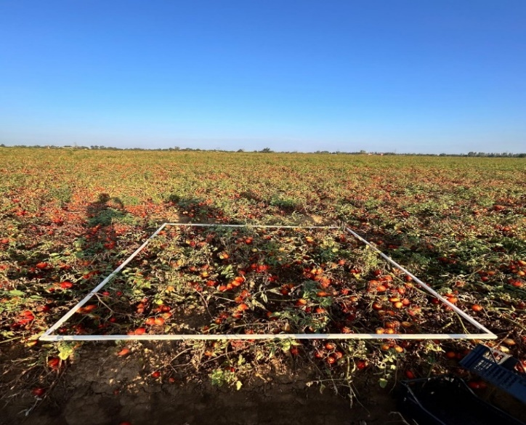 | 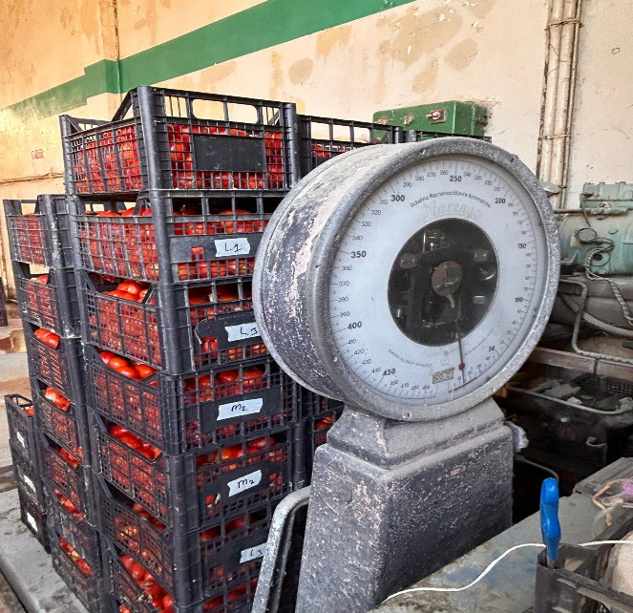
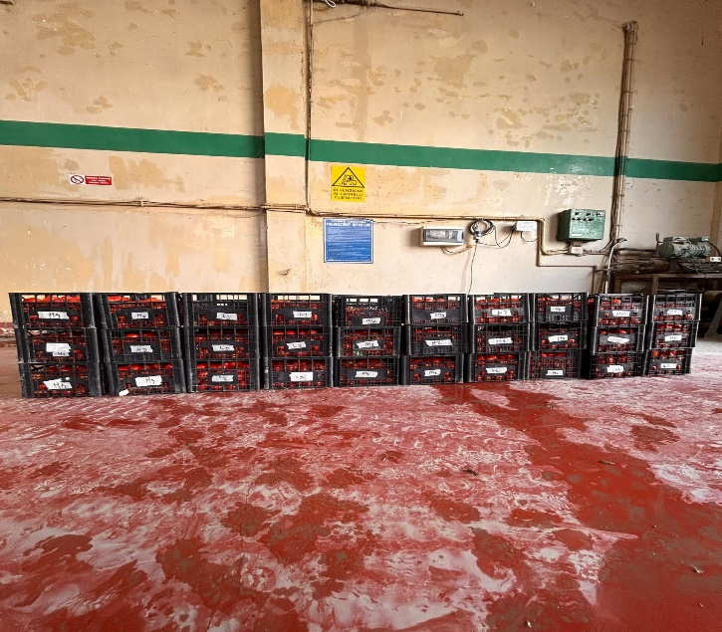 | 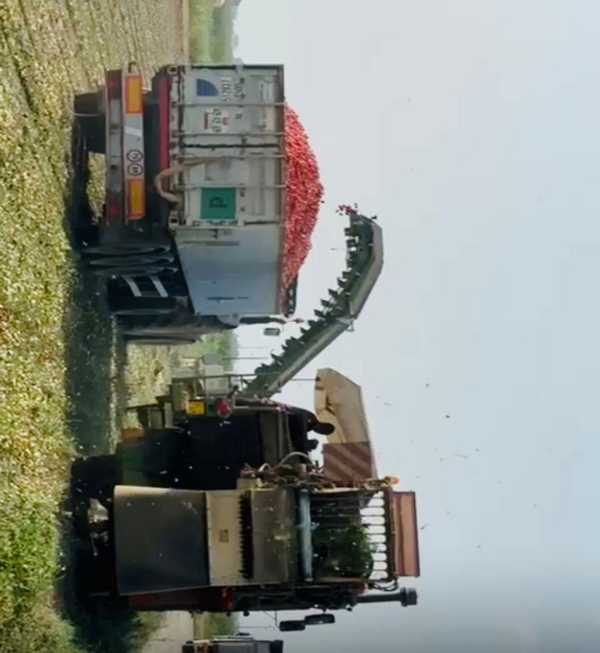
Figure 7. Sample and field tomato collection and weighting

Supplementary:

Table 2. Sentinel-2 Cloud-Free Raster Used in the Field
Date |  | Raster used in Field 1
2024-07-04 |  | S2B_MSIL2A_20240704T101559_N0510_R065_T32TNQ_20240704T130125.SAFE
2024-07-09 |  | S2A_MSIL2A_20240709T102031_N0510_R065_T32TNQ_20240709T142949.SAFE
2024-07-14 |  | S2B_MSIL2A_20240714T101559_N0510_R065_T32TNQ_20240714T125806.SAFE
2024-07-19 |  | S2A_MSIL2A_20240719T102021_N0510_R065_T32TNQ_20240719T141151.SAFE
2024-07-24 |  | S2B_MSIL2A_20240724T101559_N0511_R065_T32TNQ_20240724T144342.SAFE
2024-08-03 |  | S2B_MSIL2A_20240803T101559_N0511_R065_T32TNQ_20240803T130328.SAFE
2024-08-13 |  | S2B_MSIL2A_20240813T101559_N0511_R065_T32TNQ_20240813T133715.SAFE
2024-08-23 |  | S2B_MSIL2A_20240823T101559_N0511_R065_T32TNQ_20240823T145151.SAFE
2024-08-28 |  | S2A_MSIL2A_20240828T102021_N0511_R065_T32TNQ_20240828T150452.SAFE
2024-09-27 |  | S2A_MSIL2A_20240927T101811_N0511_R065_T32TNQ_20240927T163600.SAFE
 | Date |  | Raster used in Fields 2 and 3
 | 2024-07-04 |  | S2B_MSIL2A_20240704T101559_N0510_R065_T32TMQ_20240704T130125.SAFE
 | 2024-07-14 |  | S2B_MSIL2A_20240714T101559_N0510_R065_T32TMQ_20240714T125806.SAFE
 | 2024-07-24 |  | S2B_MSIL2A_20240724T101559_N0511_R065_T32TMQ_20240724T144342.SAFE
 | 2024-07-29 |  | S2A_MSIL2A_20240729T102021_N0511_R065_T32TMQ_20240729T194952.SAFE
 | 2024-08-03 |  | S2B_MSIL2A_20240803T101559_N0511_R065_T32TMQ_20240803T130328.SAFE
 | 2024-08-13 |  | S2B_MSIL2A_20240813T101559_N0511_R065_T32TMQ_20240813T133715.SAFE
 | 2024-08-23 |  | S2B_MSIL2A_20240823T101559_N0511_R065_T32TMQ_20240823T145151.SAFE
 | 2024-08-28 |  | S2A_MSIL2A_20240828T102021_N0511_R065_T32TMQ_20240828T150452.SAFE
 | 2024-09-27 |  | S2A_MSIL2A_20240927T101811_N0511_R065_T32TMQ_20240927T163600.SAFE

Table 3. Estimation accuracy in the training plot
Field 1  Training | Observed Yield Mg/ha | Predicted (Sentinel-2) | Predicted (UAV) | RMSE Sentinel-2 | RRMSE Sentinel-2 (%) | RMSE UAV | RRMSE UAV (%)
1 | 90.75 | 85.53 | 94.18 | 4.25 | 5.68 | 5.85 | 7.82
2 | 78.00 | 75.58 | 71.68
3 | 95.50 | 90.95 | 89.18
4 | 52.00 | 49.80 | 59.15
5 | 68.75 | 73.58 | 71.68
6 | 62.75 | 67.75 | 68.18
7 | 63.25 | 64.15 | 64.15
8 | 74.50 | 71.58 | 63.90
9 | 87.75 | 94.58 | 91.35

Field 2  Training | Observed (Mg/ha)  Sentinel-2 | Predicted | RMSE | RRMSE (%)
1 | 139 | 142.20 | 7.03 | 4.89
2 | 142.75 | 141
3 | 121.50 | 123.55
4 | 154 | 152.13
5 | 151.50 | 149.10
6 | 149 | 145.05
7 | 144 | 143.83
8 | 132.50 | 149.70
9 | 159. | 148.70

Field 3  Training | Observed Yield (Mg/ha) | Predicted (Sentinel-2) | Predicted (UAV) | RMSE Sentinel-2 | RRMSE Sentinel-2 (%) | RMSE UAV | RRMSE UAV (%)
1 | 82 | 65.83 | 77.75 | 8.23 | 12 | 4.15 | 6.05
2 | 57 | 53.98 | 61.48
3 | 79.50 | 73.88 | 83.78
4 | 62.50 | 64.35 | 65.45
5 | 61 | 69.78 | 58.08
6 | 69.50 | 64.68 | 64.05

Table 4. Estimation accuracy in validation plots
Field 1  Validation | Observed Yield (Mg/h) | Predicted (Sentinel-2) | Predicted (UAV) | RMSE Sentinel-2 | RRMSE Sentinel-2 (%) | RMSE UAV | RRMSE UAV (%)
1 | 65.75 | 75.25 | 71.75 | 7.40 | 9.39 | 6.34 | 8.04
2 | 88.00 | 95.75 | 95
3 | 78.75 | 84.25 | 86.35
4 | 83.00 | 89.25 | 86.43

Field 2  Validation | Observed (Mg/ha) | Predicted | RMSE | RRMSE (%)
1 | 135.50 | 145.75 | 8.55 | 6.06
2 | 143.25 | 151.75
3 | 138.50 | 148.50
4 | 146.75 | 150.75

Field 3  Validation | Observed Yield (Mg/ha) | Predicted (Sentinel-2) | Predicted (UAV) | RMSE Sentinel-2 | RRMSE Sentinel-2 (%) | RMSE UAV | RRMSE UAV (%)
1 | 69.50 | 75.25 | 65.25 | 6.40 | 9.73 | 4.45 | 6.77
2 | 59.75 | 67.00 | 62.75
3 | 73.50 | 65.75 | 68.25
4 | 60.25 | 64.50 | 55.25

Table 5. Estimation accuracy in the total field scale
Field 1  Total | Observed Yield (Mg/ha) | Predicted (Sentinel-2) | Predicted (UAV) | RMSE Senti-2 | RRMSE Senti-2 (%) | RMSE UAV | RRMSE  UAV (%)
 | 65.0 | 75.45 | 73.45 | 10.45 | 16.07 | 8.45 | 13

Field 2  Total | Observed  (Mg/ha) | Predicted | RMSE | RRMSE  (%)
 | 121.0 | 133.26 | 12.26 | 10.13

Field 3  Total | Obser. Yield (Mg/) | Predi. (Senti-2) | Predi. (UAV) | RMSE Senti-2 | RRMSE Senti-2 (%) | RMSE  UAV | RRMSE UAV (%)
 | 64.0 | 70.00 | 58.97 | 6.00 | 9.36 | 5.03 | 7.85

