Seed Quality and Seed Health-Based Wheat Variety and Sowing Time Selection in Chitwan, Nepal

Kalpana Kafle¹, Avinash Kafle¹, Suman Dhakal^{1,} Santosh Marahatta¹, Rajan Dhakal², Narayan Prasad Pathak³
¹ Agriculture and Forestry University, Rampur, Chitwan, Nepal
² Ministry of Agriculture and Livestock Development (MoALD), Bagmati Province, Nepal
³ Ministry of Agriculture, Land Management and Cooperative, Gandaki Province, Nepal
Corresponding author: Avinash Kafle – E-mail: kafleavinash@gmail.com

ABSTRACT

Wheat seed quality and health play a crucial role in determining its productivity, which is strongly affected by sowing dates and varieties. Nepal continues to experience low wheat productivity. This study aims to quantify the impact of sowing data and storage on seed quality and seed health on different wheat varieties recommended for the inner Terai of Nepal, and recommend the suitable time and variety. An experiment in strip plot design was conducted in two sowing dates (November 15 and December 25) and ten wheat varieties (Vijay, BL 4341, NL 971, Borlaug 2020, Gautam, Tilottama, Bhrikuti, Zinc Gahun 1, Aditya, and Banganga) at the Research Farm of Agriculture and Forestry University, Chitwan, Nepal, in 2020. Data on seed germination percentage, vigor index-I and vigor index-II, root-shoot ratio, and seed health (percentage of infected seed by Alternaria triticina and Bipolaris sorokiniana) were recorded at three storage durations and analyzed in RStudio.
Wheat sown on November 15 recorded significantly higher germination percentage, vigour index-I, and vigour index-II during the first three months of storage, with a gradual decline over time. Seed deterioration and infection occurred more in wheat sown on December 25. NL 971 showed a lower root-shoot ratio in early sowing, which increased with prolonged storage. Gautam showed lower infection with Bipolaris sorokiniana, Vijay and Borlaug 2020, with Alternaria triticina. Overall, wheat sown on November 15 produced higher-quality, healthier seed, and Borlaug 2020 was found to be most suitable for next-season seed production due to its high, consistent germination and vigour stability.

Keywords: Seed health and quality, Sowing date, Vigour index, Wheat varieties

1. INTRODUCTION
Quality seed refers to genetically and physically pure, viable seed with appropriate moisture content, high germination capacity, strong seed vigour, good yield potential, and free from pests and diseases, which possesses all physical, physiological, phytosanitary, and genetic qualities (Hegde et al., 2025; Nigussu et al., 2019). Seed quality and seed health indicators are their physical, genetic, physiological, and pathological qualities (Bishaw et al., 2012). The use of quality seed enables a crop to express its full genetic potential, which is crucial for food security for the emerging population (Rinukshi, 2015). Physical quality of seed includes cleanliness of seed from other crop seed, weed seed, inert matter, insect-damaged and broken seed, and empty seed, as well as appropriate moisture content. Genetic quality refers to the true-to-type nature of the seed, its adaptability to specific agro-climatic conditions, high yield potential, and tolerance to biotic and abiotic stresses. Physiological quality comprises two important attributes, seed germination and vigour. Physiological seed quality determines how well seeds establish across a diverse range of growing conditions (Sundareswaran et al., 2023). Seed health emphasizes seeds free from bacteria, viruses, fungi, nematodes, and insect infestation to ensure healthy crop establishment (DADO, 2016; FAO, 2014). Quality seed ensures the required plant population, as emergence will be uniform and higher (>70%). Its use leads to vigorous seedling growth, increased stress resistance to environmental hazards, suppresses weed emergence, and allows the crop to express its yield potential, increasing production by 5 to 25% (Nadew, 2018). Quality seed produces 5 to 20% more yield and reduces food insecurity (IRRI, 2013). The use of improved wheat varieties was observed to increase production by 208% between 1960 and 2000 AD (FAO, 2019).

Wheat (Triticum aestivum L.) provides approximately 20% of the total energy intake in the human diet, which makes it a major cereal crop worldwide (Bayeh, 2010). It is a major food for more than 35% of the global population (Sharma & Sharma, 2025; Alomari et al., 2023). In Nepal, it ranks third in terms of acreage, production, and consumption, right after rice and maize in the mid-hills and high-hills, but in the terai, it ranks second and accounts for approximately 19% of total cereal production in the country (FAO, 2025; Adhikari et al., 2021). Together, wheat contributes about 5.67% to Nepal’s agricultural GDP (MOALD, 2023; Pokhrel et al., 2025). Therefore, ensuring the availability of high-quality wheat seed at both national and global levels is crucial for achieving food security. Although wheat production and productivity in Nepal have increased steadily over the years, from 2.50 t/ha in 2013/14 to 2.99 t/ha in 2023/24, and the crop is currently cultivated on approximately 0.68 million hectares, the country continues to experience a substantial yield gap (MOALD, 2025). Major wheat-producing countries such as China (5.7 t/ha) and India (3.4t/ha) achieve significantly higher productivity than Nepal. This indicates Nepal has a higher yield gap and considerable scope for further yield improvement. This productivity gap can be narrowed down through the adoption of quality seed, timely sowing, and effective disease and pest control. (Fischer et al., 2014).

To support seed quality improvement, Nepal has established a formal seed policy framework. The Seed Act of 1988 and the National Seed Vision 2013–2025 provide strategic guidelines for the production, processing, and distribution of high-quality seeds across diverse agro-climatic zones. The National Seed Board (NSB) is the coordinating agency for varietal release and registration. The National Agricultural Research Council (NARC) is responsible for the breeder and foundation seed production. Seed certification and quality assurance are conducted by the Seed Quality Control Centre (SQCC)(FAO, 2025). In Nepal, seed supply is mainly governed by two systems: the formal and informal seed systems. The formal seed sector involves government and private companies; the informal seed system involves farmers saving seed from their harvest and exchanging seed between neighbors and relatives (Adhikari, 2016; Joshi, 2017). According to Atreya et al. (2022) and Devkota & Shrestha (2020), formal seed sector meets up to 20% of Nepal’s cereal crop seed requirements, while the informal sector meets around 80% of the seed requirements. This informal system plays a great role in seed availability in Nepal, particularly in remote farming areas. The target farmers' seed replacement rate of 25-30 percent for open-pollinated cereal crops was only partially achieved for wheat (FAO, 2025). The seeds are obtained through informal systems, where seed quality is rarely tested. Using such seeds generation after generation, without testing their quality, is a major reason for the production of low-quality seeds (Rahel & Noriega, 2018). Consequently, the continued reliance on old, low-quality seed remains one of the major constraints to wheat productivity in Nepal.

Moisture supply, heat stress during seed development, post-maturation, and pre-harvest environment, agro-climatic conditions in the seed production location, etc., play an important role in producing quality seeds (Delouche, 1980). The obstacles in wheat seed production are a lack of quality seed and other inputs, erratic winter rainfall, disease, pests, weeds, and irrigation facilities (Bist et al., 2021). Seasonal precipitation and temperature have a major impact on determining crop yield and quality. A suitable environment increases the yield and quality of products, and the harsh conditions reduce them (Bhandari, 2014). Timely planting enables wheat to escape heat stress during the post-anthesis period, thereby creating more favorable environmental conditions for improved yield and grain quality. Therefore, this study was conducted at the field of the Agriculture and Forestry University, at Rampur, Chitwan, Nepal, in 2020. The study aimed to evaluate the effects of sowing dates and storage periods on the quality and health of wheat seed varieties and to identify the sowing time and variety to enhance productivity. The study evaluated seed quality and seed health of different wheat varieties under timely and late sowing conditions. It supports sustainable agriculture by enhancing national wheat productivity and can serve as a valuable asset for all stakeholders involved in the seed sector.

2. MATERIALS AND METHODS
2.1 Description of the Experimental Site
The field experiment was conducted at the Agronomy Farm of Agriculture and Forestry University (AFU), Rampur, from November 2019 to April 2020. The location is situated at 27⁰40’ North latitude and 84⁰23’ East longitude, 228 meters above sea level in central Nepal. The research site has a tropical, humid climate with distinct seasons: monsoon (June to September), autumn (September to November), winter (November to February), and spring (February to May). The weather data during the growing period were received from the National Maize Research Program (NMRP), Rampur, Chitwan. The average maximum temperature was recorded as the lowest, i.e., 18.65°C, in the first week of January and the highest, i.e., 35.54°C, in the second week of April during the harvesting of late-sown wheat. Similarly, the average minimum temperature ranged from 7.87°C in the last week of December to 22.32°C in the second week of April. The total rainfall was 122.10 mm and was well distributed throughout all months, except in November, which helped meet the crop’s moisture requirement at critical growth stages. The relative humidity recorded during the growing period ranged from 47.84% in the first week of April to 97.79% in the second week of December.
Seed health and quality tests were conducted at the Provincial Plant Protection Laboratory and Seed Laboratory, Pokhara, from July 2020 to November 2020. Soil testing was done in the Soil Testing Laboratory, Agricultural Technology Center, Lalitpur, Nepal. For soil testing, soil samples were collected from eight spots at a depth of 0 to 15 cm in the field under experimentation before sowing the crop. The texture of the soil was found to be sandy loam at a depth of (0-15) cm, with acidic reaction (pH = 5.64), medium soil organic matter (3.6%), medium total nitrogen (0.15%), low available phosphorus (22.04 kg/ha), and low available potassium (80.4 kg/ha). The experimental field followed a rice–wheat cropping system over the past two years, with rice grown during the summer seasons, wheat cultivated in winter, and the field remained fallow in spring.

2.2 Experimental Details
The experiment was conducted in a strip plot design with the combination of twenty treatments consisting of ten varieties recommended for the Terai region of Nepal by the Ministry of Agriculture and Livestock Development in the vertical factor and two different dates of sowing in the horizontal factor (first, timely planting on November 15, and second, late planting on December 25) (MOALD, 2021; Upadhyay et al., 2019). Each treatment was replicated three times. The spacing between the plots was 0.5 m, and between the replications was 1 m. Each plot measured 12 m² (4 m × 3 m) and contained 16 rows spaced 25 cm apart. The central 12 rows with a 9 m² area (3 m x 3 m) were used as the net plot area. The outermost row on both sides served as a border row. The experiment consisted of two treatment factors arranged in a factorial design. The vertical factor (Factor A) was wheat variety, with ten levels: Vijay, BL 4341, NL971, Borlaug 2020, Gautam, Tilottama, Bhrikut, Zinc Gahun 1, Aditya, and Banganga. The horizontal factor (Factor B) was sowing date, with two levels: 15 November and 25 December.
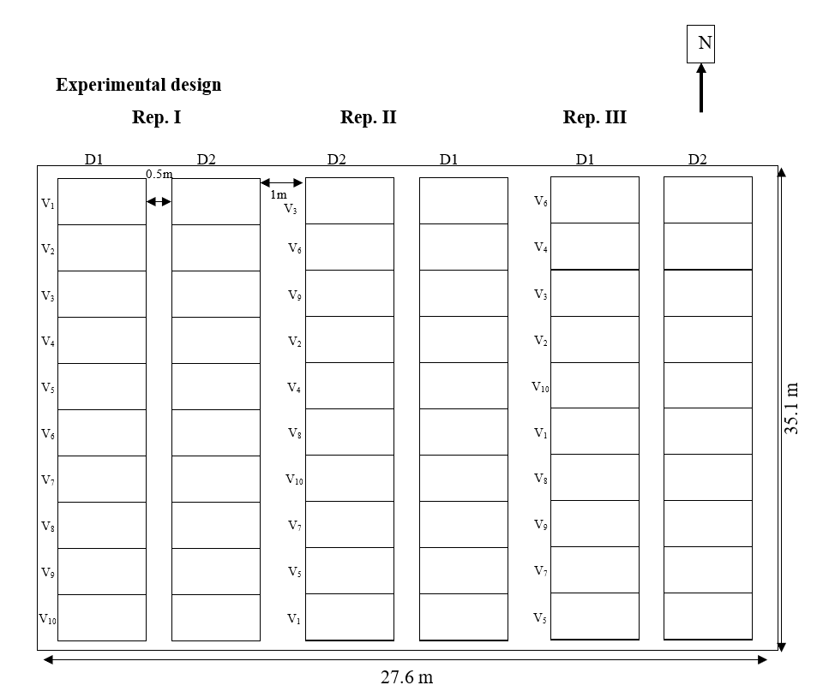
Figure 1. Layout of the experiment (strip-plot design) in the Agronomy Farm

2.3 Details of Field Operation
The field was cleared, and tillage was carried out to obtain a fine soil before sowing. The recommended dose of fertilizer was applied, i.e., 100-50-50 kg N P₂O₅ K₂O per ha through urea, DAP, and muriate of potash, respectively. The full dose of phosphorus and potash, and a half dose of nitrogen, were applied as a basal dose at the time of final land preparation. The remaining half-dose of nitrogen was applied in two split doses, first at the active tillering stage and second at 60 days after sowing for all treatments. Seeds of ten wheat varieties of quality wheat seed were obtained from the National Wheat Research Program (NWRP), Bhairahawa. The seed rate was 120 kg per ha, and the seeds were sown manually in 25 cm row-to-row spacing and continuously within the row. The ten varieties were sown completely on two different dates (November 15 and December 25). No irrigation was applied because rainfall during the experiment was well distributed. Emamectin benzoate 5% (contact insecticide) was used to control damage from the Fall Army Worm (FAW), confirmed by its morphology when infestation was observed on both sowing dates. Similarly, Propiconazole 25% EC (systemic fungicide) was used to control leaf blight. Harvesting was done manually at physiological maturity identified using maturity indices such as brittle awn, distorted awn, drying of flag leaf, yellowing of stem, etc. A net plot area of 9 m² was harvested and left in the field for sun-drying. Since the ten wheat varieties had different maturity durations, harvesting was done variety-wise, using maturity indices to decide the harvest time for each variety. A multi-crop thresher (plot thresher) was used for threshing, and the grain yield obtained was cleaned by winnowing.

2.4 Laboratory Observations
A lab experiment on Germination, seed vigour, and seed health was also conducted in a strip-plot design on harvested seed from the experimental plot. After threshing and cleaning, the seeds were sun-dried for two consecutive days to maintain a moisture level to 11%. The net yield of the same treatment of each replication was mixed well in a sack, then 1kg sample for laboratory test was drawn and stored in a cotton bag, which was stored in the PICS (Purdue Improved Crop Storage) bag, sealed, and stored at room temperature for two months in Rampur, Chitwan, conditions, thereafter shifted to the storage chamber with 7-10 °C temperature in the Seed Laboratory, Pokhara, Nepal, for further storage. A hand seed moisture meter was used to record seed moisture. The seed germination test was conducted as per the International Seed Testing Association (ISTA) guidelines. The paper method was used to determine germination percentage by drawing 4 × 100 seeds. The temperature of 20 °C and relative humidity of 90 ± 5% was maintained in the germinator as per the ISTA procedure (ISTA, 2021). On the seventh day of the germination test, the total number of normal seedlings was counted, and their average was expressed as germination percentage for each treatment.
Germination percentage = $\frac{Number of seeds germinated}{Number of seeds put for germination}×100$
The vigour index value was computed using the following formula, suggested by Abdul-Baki & Anderson (1973) and expressed as a whole number. On the 7th day of germination, root length (cm) was measured by randomly selecting ten normal seedlings from each treatment in each of the four replications. Root length was measured from the tip of the primary root to the base of the hypocotyls, and the mean root length was expressed in cm. Shoot length (cm) was measured using the same ten normal seedlings used for root length measurement. Shoot length measured using a metric scale from the base of the primary leaf to the base of the hypocotyls, expressed in cm.
To determine the dry weight of seedlings (g), the fresh weight of the ten selected seedlings was measured and recorded. A composite sample of 100 g of seedlings was taken in four replications and oven-dried until constant weight. Then, the dry weight of the individual treatment was determined using the unitary method.
Vigour index I = Germination percentage × [Root length (mm) + Shoot length (mm)]
Vigour index II = Germination percentage × Seedling dry weight (g)
The blotter paper method was used to test the seed health. For this, 25 seeds were placed in a single petri plate. Each replication contained 100 seeds, four petri-plates. This was replicated four times for all the treatments. All procedures for the seed health test were conducted under aseptic conditions in a laminar airflow (LAF) cabinet using sterilized instruments. After placing the seed on a sterilized plate with wet filter paper and distilled water, the plates were sealed with parafilm and then incubated at 25 ± 1 °C for five days. After five days, each seed from all plates was examined under a binocular microscope to observe spores of Bipolaris sorokiniana, which causes spot blotch disease, and Alternaria triticina, which causes leaf blight in wheat. The spores of these fungi were also isolated and observed under the compound microscope for further confirmation. The number of seeds infected by both pathogens was recorded, and the percentage of infection of seeds was calculated

Seed infection percentage = $\frac{Number of infected seeds}{Total number of seeds}×100$

2.5 Statistical Analysis
All collected data were entered into Microsoft Excel and subjected to analysis of variance (ANOVA). Data analysis was performed using R-Studio. Mean comparisons were conducted using Duncan’s Multiple Range Test (DMRT) at the 5% significance level.

3. RESULTS
3.1 Germination Percentage (GP)
Table 1 shows that the mean wheat seed germination was highest at three months of storage (93.28%), decreased slightly at five months of storage (92.68%), and dropped further at seven months of storage (88.83%). The GP of wheat was found to be significantly different among wheat varieties and sowing dates. November 15 planted wheat was found to have the higher GP (95.65% at three months, 94.68% at five months, and 94.25% at seven months of storage) as compared to December 25 planted wheat (90.90% at three months, 90.68% at five months, and 83.40% at seven months of storage). Similarly, across the varieties, the GP was highest at three months of storage, decreased by five months, and then declined more sharply by seven months of storage. In the first three months of storage, GP of BL 4341 was found significantly higher (95%), which was at par with Bhrikuti (94.75%), Gautam (94.25%), Banganga (94%), and Borlaug 2020 (93.50%), while GP of Vijay was found to be the minimum (91.50%) among ten varieties. Likewise, in the first five months of storage, BL 4341 (94.5%) was known to have the highest GP that was at par with Bhrikuti (94.25%), Gautam (93.63%), Borlaug 2020 (92.88%), Tilottama (92.75%) and Aditya (92.5%) while Zinc Gahun 1 (90.38%) was known to have lowest GP. Furthermore, Borlaug 2020 (92.5%) recorded the highest GP at seven months of storage, and the remaining nine varieties were found to be at par with one another.

Table 2 shows that the interaction effect of varieties and sowing date was highly significant. At three months of storage, a significantly similar germination percent was observed in varieties BL 4341, Borlaug 2020, Bhrikuti, and Banganga on November 15 and December 25. However, a significantly higher GP was observed in Vijay, NL 971, Gautam, Tilottama, Zinc Gahun 1, and Aditya. Gautam was sown on November 15 and was known to have the highest GP. At five months of storage, significantly different GP was found in all tested varieties except BL 4341, Borlaug 2020, and Banganga. GP was highest in Gautam, Bhrikuti, and Aditya, planted on November 15. During this test, Zinc Gahun 1, sown on December 25, had the lowest GP. During extended storage up to seven months, significantly different GP was observed between November 15 and December 25 in all tested varieties except Borlaug 2020. Aditya (96%) sown on November 15 had the highest GP, while Zinc Gahun 1 sown on December 25 had the lowest GP among all the treatments. The mean GP was found to be highly negatively correlated with the storage period after harvest of the wheat seed. The correlation coefficient of -0.665 was observed. In addition, 44.1% (r² = 0.441) of the variation in germination percentage was accounted for by the storage period (Figure 2).

Table 1. Germination percentage of wheat varieties across sowing dates and storage intervals at Rampur, Chitwan (2020)
Treatments | Germination % at different storage periods
Treatments | Three months | Five months | Seven months
Varieties
Vijay | 91.50e | 91.25de | 88.38^{b}
BL 4341 | 95.00ª | 94.50ª | 90.13^{b}
NL 971 | 92.75^{cde} | 92.50^{bcd} | 88.75^{b}
Borlaug 2020 | 93.50^{abcd} | 92.88^{abcd} | 92.50ª
Gautam | 94.25^{abc} | 93.63^{abc} | 89.63^{b}
Tilottama | 93.25^{bcd} | 92.75^{abcd} | 88.50^{b}
Bhrikuti | 94.75^{ab} | 94.25^{ab} | 88.38^{b}
Zinc Gahun 1 | 91.50e | 90.38e | 84.38^{c}
Aditya | 92.25de | 92.13^{cde} | 87.88^{b}
Banganga | 94.00^{abc} | 92.50^{bcd} | 89.75^{b}
SEm (±) | 0.4 | 0.4 | 0.65
LSD (=0.05) | 1.51 | 1.76 | 2.36
CV, % | 1.6 | 1.8 | 2.6
Date of sowing
15-Nov | 95.65ª | 94.68ª | 94.25ª
25-Dec | 90.90^{b} | 90.68^{b} | 83.40^{b}
SEm (±) | 2.38 | 2 | 5.43
LSD (=0.05) | 1.09 | 1.45 | 0.59
CV% | 1.6 | 2.2 | 0.9
Grand mean | 93.275 | 92.675 | 88.83
Note: ns: non-significance; treatments means followed by a common letter (s) are not significantly different from each other based on DMRT at a 5% level of significance, SEM: Standard Error of the Mean, LSD: Least Significant Difference, CV: Coefficient of Variation

Table 2. Interaction effect of wheat varieties and sowing dates on seed germination percentage under different storage periods at Rampur, Chitwan (2020)
Treatments | Germination percent under different storage periods
Treatments | Three months |  | Five months |  | Seven months
Treatments | 15 Nov | 25 Dec | 15 Nov | 25 Dec | 15 Nov | 25 Dec
Varieties
Vijay | 94.25^{abcd} | 88.75^{ef} | 92.50^{cde} | 95^{ab} | 92.75^{ab} | 84.00^{cd}
BL 4341 | 95.25^{abc} | 94.75^{abc} | 95.00^{ab} | 94^{abcd} | 93.25^{ab} | 87.00^{c}
NL 971 | 96.25^{ab} | 89.25^{ef} | 95.50^{ab} | 89.00^{gh} | 95.25^{ab} | 82.25de
Borlaug 2020 | 94.75_{abc} | 92.25^{cd} | 93.50^{bcde} | 92.25^{cdef} | 93.25^{ab} | 91.75^{b}
Gautam | 97.25ª | 91.25de | 96.00ª | 91.25^{efg} | 95.50^{ab} | 83.75^{cd}
Tilottama | 95.00^{abc} | 91.50de | 94.25^{abc} | 91.25^{efg} | 94.25^{ab} | 82.75de
Bhrikuti | 96.25^{ab} | 93.25^{bcd} | 96.00ª | 92.50^{cde} | 95.00^{ab} | 81.75de
Zinc Gahun 1 | 96.25^{ab} | 86.75^{f} | 94.50^{abc} | 86.25^{i} | 94.50^{ab} | 74.25^{f}
Aditya | 96.50ª | 88.00^{f} | 96.25ª | 88.00^{hi} | 96.00ª | 79.75e
Banganga | 94.75^{abc} | 93.25^{bcd} | 93.25^{bcde} | 91.75^{defg} | 92.75^{ab} | 86.75^{c}
SEm (±) | 0.69 |  | 0.61 |  | 1.45
LSD (=0.05) | 3.44 |  | 4.59 |  | 1.86
CV% | 2.0 |  | 1.8 |  | 2.6
Note: ns: non-significance; treatments means followed by a common letter (s) are not significantly different from each other based on DMRT at a 5% level of significance, Nov: November, Dec: December

Figure 2. Correlation between storage period and germination percent of wheat seed at Rampur, Chitwan, 2020

3.2 Vigour Index-I
The average vigour index-I decreased from 16795.72 at three months of storage to 15656.31 at five months of storage and then to 14221.02 at seven months of storage (Table 3). The vigour index-I was significantly different among sowing dates and among different varieties under different storage periods. In the first three months of storage, the vigour index-I of Borlaug 2020 (18422.90) and BL 4341 (18291.72) was significantly higher than that of other varieties. These two varieties constantly performed as the leading character in five months and seven months of storage time (Table 3). Variety Tilottama also performed well in five and seven months of storage. Likewise, variety Vijay had significantly lower vigour index-I in the first three months and five months of storage, and vigour index-I in Zinc Gahun was statistically significantly lower in the first seven months of storage.

There was a highly significant interaction effect of varieties and sowing dates for vigour index-I under all storage periods in the experiment (Table 4). After three months of storage, a significantly different vigour index-I was observed in all tested varieties except BL 4341 and Bhrikuti. Borlaug 2020, planted on November 15, had the highest vigour index-I, while Vijay, planted on December 25, had the lowest vigour index-I. After five months of storage, all the tested varieties showed significantly different vigour index-I on November 15 and December 25, except Bhrikuti. Tilottama sown on November 15 had the highest vigour index-I, while the lowest vigour index-I was observed in Aditya, Vijay, and Zinc Gahun 1 sown on December 25 among the tested varieties. Furthermore, all the varieties had significantly different vigour index-I on November 15 and December 25, except Borlaug 2020 and Banganga. Tilottama had recorded with the highest vigour index-I, while Zinc Gahun had the lowest. Vigour index-I was found to be highly negatively correlated with storage period. The correlation coefficient -0.733 was observed. Similarly, it was recorded that 53.8% (R² = 0.538) variation in vigour index-I was accounted for by the period of storage after harvest of wheat seed (Figure 3).

Table 3. Vigour index-I of wheat varieties across sowing dates and storage periods at Rampur, Chitwan (2020)
Treatments | Vigour index I under different periods of storage
Treatments | Three months | Five months | Seven months
Varieties
Vijay | 15093.24^{f} | 14296.64^{c} | 13847.09de
BL 4341 | 18291.72ª | 16803.45ª | 15506.29^{ab}
NL 971 | 16144.50de | 15604.33^{b} | 14553.66^{bcd}
Borlaug 2020 | 18422.90ª | 16939.97ª | 15917.80ª
Gautam | 16852.64^{bcd} | 14862.72^{bc} | 13250.13^{ef}
Tilottama | 17489.09^{b} | 16694.59ª | 15336.90^{abc}
Bhrikuti | 17032.28^{bc} | 15768.66^{b} | 14295.48^{cde}
Zinc Gahun 1 | 16021.15e | 14978.58^{bc} | 12389.64^{f}
Aditya | 16379.84^{cde} | 15421.05^{b} | 13532.54de
Banganga | 16229.81de | 15193.09^{b} | 13580.64de
SEm (±) | 330.68 | 284.11 | 352.96
LSD (=0.05) | 680.13 | 816.33 | 1008.29
CV % | 3.9 | 5.1 | 6.9
Date of sowing
15-Nov | 18060.31ª | 16861.82ª | 15744.97ª
25-Dec | 15531.13^{b} | 14450.80^{b} | 12697.06^{b}
SEm (±) | 1264.59 | 1205.51 | 1523.95
LSD (= 0.05) | 623.21 | 357.79 | 757.39
CV% | 5.2 | 3.2 | 7.5
Grand mean | 16795.72 | 15656.31 | 14221.02
Note: ns, non-significance; treatments means followed by a common letter (s) are not significantly different from each other based on DMRT at a 5% level of significance

Table 4. Interaction effect of wheat varieties and sowing dates on vigour index-I under different storage periods at Rampur, Chitwan (2020)
Treatments | Vigour index-I
Treatments | Three months |  | Five months |  | Seven months
Treatments | 15 Nov | 25 Dec | 15 Nov | 25 Dec | 15 DAS | 25 DAS
Varieties
Vijay | 16954.22^{defg} | 13232.25^{k} | 15248.62^{efg} | 13344.65^{h} | 15568.03^{cde} | 12126.15^{ijkl}
BL 4341 | 18464.47^{abc} | 18118.97^{abcd} | 17838.10^{ab} | 15768.80^{def} | 17290.05^{ab} | 13722.52^{fghi}
NL 971 | 17366.75^{cdef} | 14922.26^{ij} | 16932.90^{bcd} | 14275.75^{gh} | 16103.57^{abc} | 13003.75^{hijk}
Borlaug 2020 | 19538.80ª | 17307.00^{cdef} | 18100.38^{ab} | 15779.58^{def} | 16499.80^{abc} | 15335.80^{cdef}
Gautam | 17761.00^{bcde} | 15944.27^{fghi} | 16058.63^{def} | 13666.80^{h} | 14829.90^{cdefg} | 11670.36^{jkl}
Tilottama | 19163.88^{ab} | 15814.30^{ghi} | 18347.65ª | 15041.52^{fg} | 17516.72ª | 13157.08^{ghij}
Bhrikuti | 17660.20^{cde} | 16404.35^{efgh} | 16337.76^{cde} | 15199.56^{efg} | 15813.83^{bcd} | 12777.12^{hijk}
Zinc Gahun 1 | 18429.08^{abcd} | 13613.23^{jk} | 16607.25^{cd} | 13349.90^{h} | 14148.50^{defgh} | 10630.78^{l}
Aditya | 18155.85^{abcd} | 14603.83^{ij} | 17307.60^{abc} | 13534.50^{h} | 15697.90^{bcd} | 11367.17^{kl}
Banganga | 17108.83^{cdefg} | 15350.80^{hi} | 15839.27^{def} | 14546.90^{gh} | 13981.42^{efgh} | 13179.85^{ghij}
SEm (±) | 396.18 |  | 351.45 |  | 444.81
LSD (=0.05) | 1970.77 |  | 1131.41 |  | 2395
CV% | 5.3 |  | 4.8 |  | 7.4
Note: ns, non-significance; treatments means followed by a common letter (s) are not significantly different from each other based on DMRT at a 5% level of significant

Figure 3. Correlation between storage period and vigour index I of wheat seed at Rampur, Chitwan, 2020

3.3 Vigour Index-II
The average vigour index-II of wheat varieties sown under early and late planting was decreased from three months of storage (354.91) to seven months of storage (299.98). Wheat planted on November 15 showed a statistically significantly higher vigour index-II compared to that on December 25, in all periods of storage (Table 5). Furthermore, during the first three months of storage, the variety Banganga (382.03) exhibited a significantly higher vigour index-II, which was statistically similar to that of Vijay, Borlaug 2020, Gautam, Bhrikuti, NL 971, Zinc Gahun 1, and Aditya. Tilottama had the significantly lowest vigour index-II in all storage periods. After five months of storage, Borlaug 2020 was found to have statistically significantly higher vigour index-II, which was statistically similar to Banganga, Aditya, Zinc Gahun 1, Gautam, and NL 971. Moreover, Borlaug 2020 had recorded a significantly higher vigour index-II at seven months of storage.

The interaction effect between varieties and sowing dates was significant for vigour index-II (Table 6). Varieties, viz. BL 4341, NL 971, Borlaug 2020, Gautam, Zinc Gahun 1 were found to be significantly different in vigour index-II on November 15 and December 25, while the varieties viz. Vijay, Tilottama, Bhrikuti, Aditya, and Banganga were found to be significantly similar in vigour index-II. Borlaug 2020 was recorded to have the highest vigour index-II, while the lowest vigour index-II was observed in NL 971, Tilottama, and Borlaug 2020 sown on December 25. At five months of storage, significantly different vigour index-II on November 15 and December 25 was observed only in the varieties, viz. NL 971, Borlaug 2020, Tilottama, and Zinc Gahun 1, while no significant difference in the others. Borlaug 2020, planted on November 15, was again found to have the highest vigour index-II, while during the same period, Tilottama was recorded to have the lowest vigour index-II. Furthermore, in the seven months of storage, significantly different vigour index-II was observed in varieties BL 4341, Zinc Gahun 1, and Aditya, while the other varieties were similar on November 15 and December 25. Zinc Gahun 1 sown on November 15 had the highest vigour index-II, while the same variety sown on December 25 had the lowest vigour index-II. The vigour index-II was found to be highly negatively correlated with the storage period with a correlation coefficient of -0.718. The 51.6% (r² = 0.516) variation in vigour index-II was accounted for by the storage period after harvest (Figure 4).

Table 5. Vigour index-II of wheat varieties across sowing dates and storage periods at Rampur, Chitwan (2020)
Treatments | Vigour Index-II
Treatments | Three months | Five months | Seven months
Varieties
Vijay | 363.84^{ab} | 344.67^{b} | 296.65^{bc}
BL 4341 | 342.15^{bc} | 342.82^{b} | 306.40^{b}
NL 971 | 345.93^{abc} | 357.35^{ab} | 277.15^{cd}
Borlaug 2020 | 364.74^{ab} | 375.47ª | 350.89ª
Gautam | 364.94^{ab} | 349.26^{ab} | 311.83^{b}
Tilottama | 322.87^{c} | 313.93^{c} | 259.47^{d}
Bhrikuti | 361.38^{ab} | 341.19^{b} | 277.16^{cd}
Zinc Gahun 1 | 348.35abc | 358.86^{ab} | 302.67^{b}
Aditya | 352.91^{abc} | 360.34^{ab} | 305.44^{b}
Banganga | 382.03ª | 362.45^{ab} | 312.19^{b}
SEm (±) | 5.13 | 5.27 | 7.93
LSD (=0.05) | 32.37 | 24.02 | 20.46
CV, % | 8.9 | 6.7 | 6.6
Date of sowing
15-Nov | 378.23ª | 364.92ª | 308.37ª
25-Dec | 331.59^{b} | 336.35^{b} | 291.59^{b}
SEm (±) | 23.32 | 14.29 | 8.39
LSD (=0.05) | 15.41 | 8.87 | 5.7
CV% | 6.1 | 3.6 | 2.7
Grand mean | 354.91 | 350.63 | 299.98
Note: ns, non-significance; treatments means followed by a common letter (s) are not significantly different from each other based on DMRT at a 5% level of significance

Table 6. Interaction effect of wheat varieties and sowing dates on vigour index-II under different storage periods at Rampur, Chitwan (2020)
Treatments | Vigour index-II
Treatments | Three months |  | Five months |  | Seven months
Treatments | 15 Nov | 25 Dec | 15 Nov | 25 Dec | 15 DAS | 25 DAS
Varieties
Vijay | 371.67^{bcd} | 356.01^{bcde} | 356.15^{cd} | 333.18de | 313.45^{cdef} | 279.83^{fghi}
BL 4341 | 368.51^{bcd} | 315.78^{ef} | 328.60de | 357.05^{cd} | 285.70^{efghi} | 327.08^{bcd}
NL 971 | 391.22^{abc} | 300.63^{f} | 381.58^{bc} | 333.11de | 274.13^{ghij} | 280.16^{fghi}
Borlaug 2020 | 423.38ª | 306.08^{f} | 423.02ª | 327.92de | 357.57^{ab} | 344.21^{abc}
Gautam | 399.51^{ab} | 330.36^{def} | 346.16^{cde} | 352.36^{cde} | 313.01^{cdef} | 310.64^{cdef}
Tilottama | 343.84^{cdef} | 301.87^{f} | 338.13de | 289.72^{f} | 251.47^{ij} | 267.46^{hij}
Bhrikuti | 345.49^{cdef} | 377.25^{bcd} | 344.05^{cde} | 338.32de | 293.65^{defgh} | 260.65^{hij}
Zinc Gahun 1 | 380.27^{abc} | 316.41^{ef} | 403.23^{ab} | 314.48^{ef} | 364.44ª | 240.90^{j}
Aditya | 361.02^{bcde} | 344.79^{cdef} | 362.40^{cd} | 358.27^{cd} | 326.65^{bcd} | 284.22^{fghi}
Banganga | 397.35^{ab} | 366.70^{bcd} | 365.86^{cd} | 359.02^{cd} | 303.64^{defg} | 320.74^{cde}
SEm (±) | 7.89 |  | 6.59 |  | 7.64
LSD (=0.05) | 48.73 |  | 28.03 |  | 18.03
CV% | 7.9 |  | 6.4 |  | 7.2
Note: ns, non-significance; treatments means followed by a common letter (s) are not significantly different from each other based on DMRT at a 5% level of significance

Figure 4. Correlation between storage period and vigour index-II of wheat seed at Rampur, Chitwan, 2020

3.4 Root–Shoot Ratio
The mean root–shoot ratio of wheat varieties sown under November 15 and December 25 was found to increase from three months of storage (1.66) to (1.68) in five months and then (1.73) in seven months. Seeds from both sowing dates showed no significant difference in root–shoot ratio at seven months of storage.

The root–shoot ratio was significantly higher in wheat planted on December 25 than on November 15 after three and five months of storage. The root–shoot ratio in variety Zinc Gahun 1 was considerably higher under all the storage periods, whereas NL 971 consistently showed a significantly lower root–shoot ratio throughout the storage period. At three months of storage, the root–shoot ratio of varieties such as Vijay, Gautam, and Aditya were found to be the same as that of Zinc Gahun 1. Similarly, under five months of storage, Aditya and Tilottama were found to be statistically similar to Zinc Gahun 1, whereas, in seven months of storage, Vijay, Borlaug 2020, Gautam, Tilottama, Bhrikuti, and Aditya were found to be at par with Zinc Gahun 1(Table 7).

The interaction effect of varieties and sowing dates was significant for the root-shoot ratio at three, five, and seven months (Table 8). At three months of storage, the root-shoot ratio of all tested varieties was statistically similar at both sowing dates except for BL 4341. Sowing of wheat on December 25 resulted in a significantly higher root–shoot ratio. After five months, all the tested varieties showed a statistically similar root–shoot ratio except Vijay, which had a statistically significantly higher root–shoot ratio on wheat sown on December 25. Further storage of wheat seeds for up to seven months resulted in a similar root–shoot ratio across all the varieties, except Vijay and Aditya.

Table 7. Root–shoot ratio of wheat varieties across sowing dates and storage periods at Rampur, Chitwan (2020)
Treatments | Root-shoot ratio under different periods of storage
Treatments | Three months | Five months | Seven months
Varieties
Vijay | 1.74^{ab} | 1.65^{b} | 1.66^{abc}
BL 4341 | 1.69^{bc} | 1.68^{b} | 1.62^{bc}
NL 971 | 1.44^{d} | 1.49^{c} | 1.53^{c}
Borlaug 2020 | 1.56^{d} | 1.71^{b} | 1.75^{abc}
Gautam | 1.80^{ab} | 1.65^{b} | 1.74^{abc}
Tilottama | 1.71^{b} | 1.74^{ab} | 1.86ª
Bhrikuti | 1.57^{cd} | 1.65^{b} | 1.79^{ab}
Zinc Gahun 1 | 1.86ª | 1.86ª | 1.88ª
Aditya | 1.74^{ab} | 1.74^{ab} | 1.83a^{b}
Banganga | 1.54^{d} | 1.61^{bc} | 1.62^{bc}
SEm (±) | 0.04 | 0.03 | 0.04
LSD (=0.05) | 0.13 | 0.13 | 0.2
CV% | 7.4 | 7.3 | 11.5
Date of sowing
15-Nov | 1.61^{b} | 1.64^{b} | 1.67
25-Dec | 1.71ª | 1.71ª | 1.78
SEm (±) | 0.05 | 0.04 | 0.05
LSD (=0.05) | 0.04 | 0.05 | ns
CV% | 3.7 | 4.3 | 12.7
Grand mean | 1.66 | 1.68 | 1.73
Note: ns, non-significance; treatments means followed by common letter (s) are not significantly different from each other based on DMRT at 5% level of significance

Table 8. Interaction effect of wheat varieties and sowing dates on root–shoot ratio under different storage periods at Rampur, Chitwan (2020)
Treatments | Root-shoot ratio
Treatments | Three months |  | Five months |  | Seven months
Treatments | 15 Nov | 25 Dec | 15 Nov | 25 Dec | 15 DAS | 25 DAS
Varieties
Vijay | 1.71^{abcdef} | 1.53^{efg} | 1.52^{cd} | 1.78^{ab} | 1.52^{ef} | 1.80^{abcde}
BL 4341 | 1.53^{efg} | 1.85^{ab} | 1.63^{bc} | 1.73^{abc} | 1.59^{def} | 1.64^{cdef}
NL 971 | 1.32^{g} | 1.55^{defg} | 1.37^{d} | 1.60^{bcd} | 1.46^{f} | 1.59^{def}
Borlaug 2020 | 1.52^{efg} | 1.59^{cdef} | 1.73^{abc} | 1.68^{abc} | 1.74^{bcdef} | 1.75^{bcde}
Gautam | 1.74^{abcde} | 1.84^{abc} | 1.65^{abc} | 1.64^{abc} | 1.87^{abcd} | 1.61^{def}
Tilottama | 1.68^{bcdef} | 1.73^{abcde} | 1.78^{abc} | 1.70^{abc} | 1.73^{bcdef} | 1.98^{ab}
Bhrikuti | 1.55^{defg} | 1.58^{def} | 1.60^{bcd} | 1.68^{abc} | 1.65^{cdef} | 1.92^{abc}
Zinc Gahun 1 | 1.76^{abcde} | 1.95ª | 1.82^{ab} | 1.89ª | 1.96^{ab} | 1.80^{abcde}
Aditya | 1.68^{bcdef} | 1.80^{abcd} | 1.67^{abc} | 1.79^{ab} | 1.59^{def} | 2.06ª
Banganga | 1.59^{cdef} | 1.47^{fg} | 1.61^{bcd} | 1.60^{bcd} | 1.60^{def} | 1.64^{cdef}
SEm (±) | 0.03 |  | 0.02 |  | 9.8
LSD (=0.05) | 0.14 |  | 0.16 |  | 0.49
CV% | 9.0 |  | 8.9 |  | 9.8
Note: ns, non-significance; treatments means followed by a common letter (s) are not significantly different from each other based on DMRT at a 5% level of significance

3.5 Seed Health
Among ten varieties and two sowing dates, the mean seed infection percentages by Alternaria triticina and Bipolaris sorokiniana were recorded as 7.76% and 3.68%, respectively. The seed infection percentage by A. triticina and B. sorokiniana was significantly affected by sowing dates and varieties. Wheat sown on December 25 was recorded to have a higher infection percentage, 13.13% and 5.35% respectively for A. triticina and B. sorokiniana, as compared to November 15 planted wheat, whose infection percentage was found to be 2.40% and 2.00% respectively for A. triticina and B. sorokiniana. Similarly, variety Borlaug 2020 was found to be more infected by A. triticina (9.63%), which was similar to Zinc Gahun 1 (9.38%). Gautam (6.00%) had a significantly lower infection percentage, similar to BL 4341 and Bhrikuti. Furthermore, variety Tilottama (5.5%) had a significantly higher infection percentage by B. sorokiniana, which was similar to Banganga (5.00%). Likewise, Zinc Gahun 1 (1.88%) was found to be significantly the least infected among the varieties used (Table 9).

Table 10 shows the interaction effect of date of wheat sowing and variety on the infection of A. tricicina and B. sorokiniana on the wheat seed. The seed infection percentages of wheat by B. sorokiniana and A. triticina differed significantly between sowing dates, except Borlaug 2020, which had no significant difference in infection percent by A. triticina under both sowing dates. In all varieties, wheat sown on December 25 showed higher infection percentages by both fungi.

Results revealed that the infection on December 25 planting conditions was significantly higher compared to November 15 planting conditions. Varieties such as BL 4341, Bhrikuti, Zinc Gahun 1, Aditya, NL 971, and Vijay, planted on November 15, had significantly lower seed infection percentage by A. triticina. Whereas Banganga and Aditya, planted on December 25, had significantly higher seed infection by A. triticina. Similarly, Zinc Gahun 1, planted on December 25, had a significantly higher infection percentage by B. sorokiniana. While Aditya planted on November 15 showed lower seed infection.

Table 9. Seed infection percentage of wheat varieties across sowing dates infected by Bipolaris sorokiniana and Alternaria triticina at Rampur, Chitwan (2020)
Treatments | Seed infection percent by
Treatments | Bipolaris sorokiniana | Alternaria triticina
Varieties
Vijay | 6.75de | 2.88^{d}
BL 4341 | 6.50^{ef} | 3.38^{cd}
NL 971 | 8.38^{c} | 3.88^{bc}
Borlaug 2020 | 9.63ª | 2.88^{d}
Gautam | 6.00^{f} | 4.25^{b}
Tilottama | 8.63^{c} | 5.50ª
Bhrikuti | 6.13^{ef} | 3.00^{d}
Zinc Gahun 1 | 9.38^{ab} | 1.88e
Aditya | 7.38^{d} | 4.13^{b}
Banganga | 8.88^{bc} | 5.00ª
SEm (±) | 0.43 | 0.35
LSD (=0.05) | 0.68 | 0.51
CV% | 8.5 | 13.7
Date of sowing
15 Nov | 2.40^{b} | 2.00^{b}
25 Dec | 13.13ª | 5.35ª
SEm (±) | 5.36 | 1.68
LSD (=0.05) | 0.33 | 0.4
CV% | 5.9 | 15.3
Grand mean | 7.76 | 3.68
Note: ns, non-significance; treatments means followed by a common letter (s) are not significantly different from each other based on DMRT at a 5% level of significance

Table 10. Interaction effect of wheat varieties and sowing dates on seed infection percentage by Alternaria triticina and Bipolaris sorokiniana at Rampur, Chitwan (2020)
Treatments | Seed infection% by A. triticina |  | Seed infection% by B. sorokiniana
Treatments | Date of sowing |  | Date of sowing
Treatments | 15Nov | 25 Dec | 15 Nov | 25 Dec
Varieties
Vijay | 1.50^{h} | 4.25de | 1.00^{ij} | 12.50^{d}
BL 4341 | 1.00^{h} | 5.75^{bc} | 3.00^{gh} | 10.00e
NL 971 | 1.25^{h} | 6.50^{ab} | 3.25^{g} | 13.50^{cd}
Borlaug 2020 | 2.50^{g} | 3.25^{fg} | 4.75^{f} | 14.50^{bc}
Gautam | 3.50^{ef} | 5.00^{cd} | 1.75^{ij} | 10.25e
Tilottama | 4.50^{d} | 6.50^{ab} | 3.50^{g} | 13.75^{bc}
Bhrikuti | 1.00^{h} | 5.00^{cd} | 2.00^{hi} | 10.25e
Zinc Gahun 1 | 1.00^{h} | 2.75^{fg} | 1.00^{ij} | 17.75ª
Aditya | 1.00^{h} | 7.25ª | 0.75^{j} | 14.00^{bc}
Banganga | 2.75^{fg} | 7.25ª | 3.00^{gh} | 14.75^{b}
SEm (±) | 0.49 |  | 1.3
LSD (=0.05) | 1.26 |  | 0.04
CV% | 14.1 |  | 9.6
Note: ns, non-significance; treatments means followed by a common letter (s) are not significantly different from each other based on DMRT at a 5% level of significance

4. DISCUSSIONS
The germination percentage (GP) of wheat differed significantly among the considered varieties and sowing dates, which decreased as storage time progressed (Table 1). This decline reflects that seed storability is genetically driven, and late sowing likely produced weaker seeds under less favorable maturation conditions. GP consistently declined with storage time due to progressive seed aging and loss of viability, as shown by GP of early-sown wheat, which was significantly higher than that of late-sown wheat at all storage periods. The GP of wheat sown on November 15 gradually declined over time, while that of late-sown wheat decreased sharply as the storage period progressed. The lower GP observed in late-sown wheat was mainly attributed to temperature stress during grain-filling and rainfall at harvest. The stressful environment during the grain-filling period led to rapid seed deterioration, reduced seed longevity, and, consequently, a reduced rate of GP. Similarly, the variation in germination percentage and keeping quality of wheat seed during storage among the tested varieties was due to genetic makeup of the varieties themselves. Among the tested varieties, Borlaug 2020 showed the highest and most stable germination with both November and December sowing conditions, indicating long storability relevant to next-season use. The result of this study was similar to the findings of Joshi et al. (2016), who reported significantly lower GP in late-sown wheat due to deterioration of the food reserve and enzymes associated with seed germination. A similar result was found by Ali et al. (2018) and Rahman et al. (2013), who observed significantly lower seed germination in late-sown wheat. However, the findings of Babiker et al. (2017) and Shaheb et al. (2016) contradicted the observed result, as they found no significant difference in germination percent among sowing dates. Likewise, the declining seed GP under a longer storage period was supported by Garoma et al. (2017), who found higher GP in the early storage period, which declined as time progressed. They reported that the decline in GP with longer storage duration was due to seed deterioration associated with natural aging process.

Vigour index I and II patterns suggest that seed vigour was shaped by both genetic potential (variety) and the seed development environment (sowing date), with a clear penalty under late sowing and a steady loss as storage progressed (Table 3 and Table 5). Seeds produced from the 15 November sowing likely matured under more favorable temperature–moisture conditions, helping preserve embryo integrity and reserve accumulation, which later translated into higher vigour compared with the late-sown crop. This supports earlier reports that heat and drought stress during the seed formation/maturation stage reduces seed vigour by disrupting normal filling and physiological maturity Ali et al. (2018), and can cause asynchronous maturity and faster deterioration of reserve food and germination-related enzymes Joshi et al. (2016). Among the varieties, Borlaug 2020 showed comparatively better vigour retention, even under late sowing and extended storage, indicating stronger inherent storability and stress tolerance, traits that are especially important when seeds are produced under suboptimal conditions. The consistent decline in vigour with longer storage further aligns with the general seed-aging mechanism described by Delouche (1980) and Rahman et al. (2013), where membrane and metabolic damage accumulate over time and reserve materials become less available for early seedling growth, ultimately depressing vigour indices.

Similarly, the root–shoot ratio differences across sowing dates and varieties suggest that early seedling biomass allocation was strongly influenced by both seed production environment and genetic background (Table 7). The higher ratio in late-sown wheat likely reflects comparatively constrained shoot development under less favorable seed maturation conditions, whereas early-sown wheat produced seedlings with more vigorous shoot growth, which naturally lowers the ratio. The gradual increase in root–shoot ratio with longer storage is due to declining reserve quality and metabolic efficiency, which limit shoot elongation, signaling reduced overall vigour. Variety-wise, NL 971 maintains a lower with a more stable ratio, indicating better early growth performance and resilience during storage. This observation aligns with Mašková and Herben (2018), who highlighted that enhanced above-ground growth gives seedlings an advantage under stress; as storage progresses and reserves deteriorate, shoot length tends to decline, contributing to the observed rise in root–shoot ratio.
Fungal infection in stored wheat seed indicates that seed health gets affected by both the crop environment during seed development and the genetic resistance of varieties (Table 9). The significantly higher infection by Bipolaris sorokiniana and Alternaria triticina in the 25 December sowing suggests that late sowing likely exposed the crop to a more disease-conducive microclimate during grain filling and maturity, particularly higher temperature and humidity and rainfall near harvest, which can favor pathogen buildup on spikes and facilitate movement of infection into the developing seed. Under incubation, these latent infections get expressed, explaining the higher observed seed infection percentages. This aligns with earlier reports that late-sown conditions often create a more favorable window for infection by wheat fungal pathogens (Li et al. 2019; Lorenz 1986). Varietal differences further reinforce the role of host genetics, as resistance levels vary across cultivars: Gautam showed better tolerance against Bipolaris sorokiniana, Vijay and Borlaug 2020 were more resistant to Alternaria triticina. From a practical standpoint, this poor seed health issue directly translates into weaker germination, reduced emergence, and establishment, which compromises crop performance and production in the next season (Toklu et al., 2008). Therefore, considering both infection pressure under late sowing and varietal resistance, Vijay, Gautam, and Borlaug 2020 appear comparatively safer choices for seed use, especially when production conditions are likely to be stressful or when seeds must be stored before planting.
Therefore, seed quality and seed health assessment are crucial not only to improve yield and grain quality, but also to reduce disease inoculum for the following season (Adhikari et al., 2016). Late sowing is found to be a major constraint, as the wheat crop does not get the optimum window for photosynthetic accumulation, which ultimately affects seed yield and quality (Akmal et al., 2011). In addition, late sown wheat generally experiences more yield losses from foliar blight, whereas early sowing helps the crop to escape the adverse impact of the disease (R. C. Sharma & Duveiller, 2004). The delay in wheat sowing is often linked to the increased cultivation of fine and long-duration rice varieties, which extend the turnaround time and ultimately push wheat planting to a later window. This results in poor wheat plant population, growth, and poor seed yield and quality. Moreover, the harvest of late-sown wheat coincides with rainfall, which results in poor seed quality due to fungus infection (Adhikari et al., 1999). Delayed planting could cause moisture stress in the rainfed wheat-growing areas, and the germination under moisture stress is lowered, resulting in a poor plant population (Akmal et al., 2011). To improve wheat productivity in Nepal, promotion of timely sowing of wheat within the rice-wheat system is recommended, which helps the timely availability of quality seed for the next season, which decreases the occurrence of diseases against major pathogens like foliar blight and leaf rust (Morris et al., 1992;Kafle & Joshi, 2024). Among the considered varieties, Borlaug 2020 is recommended across sowing time and storage duration. However, this study covered only the timely and late planting conditions that prevail in farmers' conditions. Future research should assess the same varieties under multiple sowing dates to better understand their performance and response. This study considered only the two most prevalent fungal pathogens, which could be expanded to multiple seed-borne pathogens affecting seed quality parameters.

5. CONCLUSION
The results showed that all seed quality and health parameters differed significantly among sowing dates, varieties, and storage periods. Wheat sown on November 15 had higher germination percentages and vigour with lower pathogen infection at all storage durations, compared to December 25 sown wheat, and the quality decreased progressively with increasing storage duration in all varieties. Borlaug 2020 maintained comparatively higher vigour across all storage periods, and NL 971 had an initial low root-shoot ratio, which increased with time. Gautam showed lower infection by Bipolaris sorokiniana, and Vijay and Borlaug 2020 showed lower infection by Alternaria triticina. November 15 is recommended as the sowing date to maintain superior seed quality and seed health, which supports higher production. Borlaug 2020 wheat variety is recommended for next season seed production due to its high and consistent germination and vigour stability in the central inner Terai of Nepal.

ACKNOWLEDGEMENTS
This research was carried out under the academic research support of the Department of Agronomy, Agriculture and Forestry University (AFU), Rampur, Research grant support of the Ministry of Agriculture and Livestock Development (MoALD), Bagmati Province, and the Lab support of Provincial Seed Laboratory and Provincial Plant Protection Laboratory, Pokhara, Gandaki Province, Nepal

REFERENCE
Abdul-Baki, A. A., & Anderson, J. D. (1973). Vigor determination in soybean seed by multiple criteria. Crop Science, 13(6), 630–633. https://doi.org/10.2135/cropsci1973.0011183X001300060013x
Adhikari, C., Adhikary, B., Rajbhandari, N. P., Hooper, M., Upreti, H. K., Gyawali, B. K., Rajbhandari, N. K., & Hobbs, P. R. (1999). Wheat and rice in the mid-hills of Nepal: A Benchmark Report, CIMMYT on Farm Resources and Production Practices in Kavre District.
Adhikari, Ghimire, Y. N., Timsina, K. P., Subedi, S., & Kharel, M. (2021). Technical efficiency of wheat-growing farmers of Nepal. Journal of Agriculture and Natural Resources, 4(2), 246–254. https://doi.org/10.3126/janr.v4i2.33857
Adhikari, K. (2016). History, growth and implications of the formal seed system in Nepal. 1, 1–8.
Adhikari, Khatri-chhetri, G. B., Shrestha, S. M., & Marahatta, S. (2016). Turkish Journal of Agriculture - Food Science and Technology Study on Prevalence of Mycoflora in Wheat Seeds. 4(1), 31–35.
Akmal, M., Shah, S. M., Asim, M., & Arif, M. (2011). Causes of yield reduction by delayed planting of hexaploid wheat in Pakistan. pakistan journal of botany, 43(5), 2561–2568.
Ali, N., Dayal, A., Thomas, N., Lal, G. M., & Gupta, J. (2018). Effect of different sowing times on seed vigour parameters of wheat (Triticum aestivum L.) Varieties. International Journal of Pure & Applied Bioscience, 6(2), 1532–1538. https://doi.org/10.18782/2320-7051.6627
Alomari, D. Z., Alqudah, A. M., Alqahtani, M. D., Wagner, S., Rolletschek, H., Borisjuk, L., & Röder, M. S. (2023). Wheat Grains as a Sustainable Source of Protein for Health.
Atreya, K., Gartaula, H., Parajuli, M., & Kattel, K. (2022). Gender analysis of household seed security : A case of maize and wheat seed systems in Nepal.
Babiker, W., Abdelmula, A., Eldessougi, H., & Gasim, E. (2017). The effect of location, sowing date, and genotype on seed quality traits in bread wheat (Triticum aestevium). Asian Journal of Plant Science and Research, 7(3), 24–28.
Bayeh, B. (2010). Assessment of bread wheat production, marketing, and selection of n-efficient bread wheat (Tritium aestivum l.) varieties for higher grain yield and quality in northwestern Ethiopia. Bahir Dar University.
Bhandari, G. (2014). Effect of rainfall on the yield of major cereals in Darchula District of Nepal. International Journal of Environment, 3(1), 205–213. https://doi.org/10.3126/ije.v3i1.9954
Bishaw, Z., Struik, P. C., & Gastel, A. J. G. Van. (2012). Farmers ’ seed sources and seed quality : 1 . Physical and physiological quality farmers ’ seed sources and seed quality : Journal of Crop Improvement, 37–41. https://doi.org/10.1080/15427528.2012.670695
Bist, P., Bhatt, P., Bist, N. S., & Kafle, R. (2021). Factors affecting wheat seed production and associated constraints in Kailali District, Nepal. International Journal of Social Sciences and Management, 8(1), 299–305. https://doi.org/10.3126/ijssm.v8i1.34224
DADO. (2016). Wheat Seed Production Techniques Manual. 49.
Delouche, J. C. (1980). Environmental Effects on Seed Development and Seed Quality.
Devkota, K., & Shrestha, R. B. (2020). Strengthening community-based seed systems for improving food and nutrition security in Nepal. In Strengthening Seed Systems (pp. 140–155). http://www.sac.org.bd/archives/publications/Strengthening Seed Systems.pdf%0A
FAO. (2014). Seed and Seed Quality : Technical Information for FAO Emergency Staff.
FAO. (2019). Crop variety improvements. In Sustainable Food and Agriculture (pp. 205–207). Elsevier Inc. https://doi.org/10.1016/b978-0-12-812134-4.00018-2
FAO. (2025). Special Report: 2024 FAO Crop and Food Supply Assessment Mission to the Federal Democratic Republic of Nepal - 18 March 2025 (Issue March).
Fischer, T., Byerlee, D., & Edmeades, G. (2014). Crop yields and global food security. Australian Centre for International Agricultural Research (ACIAR).
Garoma, B., Chibsa, T., Keno, T., & Denbi, Y. (2017). Effect of storage period on seed germination of different maize parental lines. 8–14.
Hegde, R. B., Kudva, V., Nayak, S., Sampathila, N., & Thalengala, A. (2025). Advanced techniques for seed quality assessment and germination monitoring.
IRRI. (2013). Rice Seed Quality Reference Manual. October 1–19.
ISTA. (2021). Introduction Rules For Seeds Testing.
Joshi, K. D. (2017). Farmers ’ Seed Systems in Nepal: Review of National Legislation.
Joshi, M., Faridullah, S., & Kumar, A. (2016). Effect of heat stress on crop phenology, yield, and seed quality attributes of wheat (Triticum aestivum L.). Journal of Agrometeorology, 18(2), 206–215.
Kafle, K., & Joshi, P. P. (2024). An assessment of factors affecting productivity and production limitations of wheat farming in Kanchanpur District of Nepal. 1–8. https://doi.org/10.3897/ia.2024.124216
Li, Q. Y., Xu, Q. Q., Jiang, Y. M., Niu, J. S., Xu, K. G., & He, R. S. (2019). The correlation between wheat black point and agronomic traits in the North China Plain. Crop Protection, 119(63), 17–23. https://doi.org/10.1016/j.cropro.2019.01.004
Lorenz, K. (1986). Effects of blackpoint on grain composition and baking quality of New Zealand wheat. New Zealand Journal of Agricultural Research, 29, 711–718. https://doi.org/10.1080/00288233.1986.10430468
Mašková, T., & Herben, T. (2018). Root: shoot ratio in developing seedlings: How seedlings change their allocation in response to seed mass and ambient nutrient supply. Ecology and Evolution, 8(14), 7143–7150. https://doi.org/10.1002/ece3.4238
MOALD. (2021). Krishi Diary. Ministry of Agriculture and Livestock Development, 356.
MOALD. (2023). Statistical Information on Nepalese Agriculture.
MOALD. (2025). Statistical Information on Nepalese Agriculture 2080/81 (2023/24) (Vol. 81). https://giwmscdnone.gov.np/media/pdf_upload/Statistical Information on Nepalese Agriculture%2C 2080_81_a7s8aj4.pdf%0A
Morris, M. L., Dubin, H. J., & Pokhrel, T. (1992). Returns to wheat research in Nepal. 92–04, 46.
Nadew, B. (2018). Effects of climatic and agronomic factors on yield and quality of bread wheat (Triticum aestivum L.) seed: A review on selected factors. Advances in Crop Science and Technology, 06(02). https://doi.org/10.4172/2329-8863.1000356
Nigussu, B., Bulti, T., & Asnake, F. (2019). Assessment of seed quality parameters in different seed sources of chickpea (Cicer arietinum (L.). African Journal of Agricultural Research, 14(33), 1649–1658. https://doi.org/10.5897/ajar2019.14292
Pokhrel, N., Neupane, B., Dhungana, P., Subedi, D., & Puri, K. (2025). Assessment of yield and yield attributes of wheat varieties under different dates of sowing in Madhesh Province of Nepal. 16(1), 153–162.
Rahman, M., Rahman, M., & Hossain, M. (2013). Effect of sowing date on germination and vigour of soybean (Glycine max (l.) merr) seeds. The Agriculturists, 11(1), 67–75. https://doi.org/10.3329/agric.v11i1.15245
Rinukshi, W. (2015). Crop production and global environmental issues. In Crop Production and Global Environmental Issues. https://doi.org/10.1007/978-3-319-23162-4
Shaheb, M. R., Islam, M. N., Rahman, M. S., & Nessa, A. (2016). Effect of sowing time and variety on seed germination and vigour index of wheat. Bangladesh Journal of Agricultural Research, 41(1), 127–136. https://doi.org/10.3329/bjar.v41i1.27678
Sharma, K., & Sharma, P. K. (2025). Wheat as a nutritional powerhouse: shaping global food security. IntechOpen. https://doi.org/10.5772/intechopen.1009499
Sharma, R. C., & Duveiller, E. (2004). Effect of Helminthosporium leaf blight on performance of timely and late-seeded wheat under optimal and stressed levels of soil fertility and moisture. Field Crops Research, 89(2–3), 205–218. https://doi.org/10.1016/j.fcr.2004.02.002
Sundareswaran, S., Ray Choudhury, P., Vanitha, C., & Yadava, D. K. (2023). Seed quality: variety development to planting—an overview bt - Seed Science and Technology: biology, production, quality. In M. Dadlani & D. K. Yadava (Eds.), Seed Science and Technology (pp. 1–16). Springer Nature Singapore. https://doi.org/10.1007/978-981-19-5888-5_1
Toklu, F., Akgül, D. S., Biçici, M., & Karaköy, T. (2008). The relationship between black point and fungi species and effects of black point on seed germination properties in bread the relationship between black point and fungi species and effects of black point on seed germination properties in bread wheat. 32(4).
Upadhyay, S. R., Pandey, D., Pant, K. R., Gautam, N. R., & Nidhi, D. (2019). Wheat varietal improvement for timely sown irrigated conditions of the terai, tar, and lower valley of Nepal. 123–139.
W. Rahel; Noriega, I. L. G. D. . G. D. (2018). Farmers’ access to quality and diverse seed in Nepal: Implications for seed sector development. Biodiversity International.

APPENDIX:

Glimpse of research activities
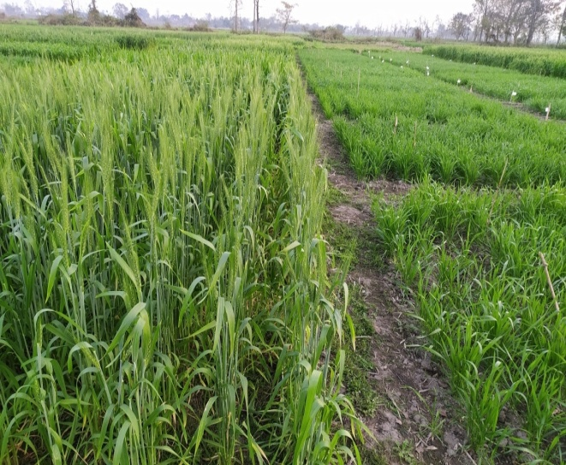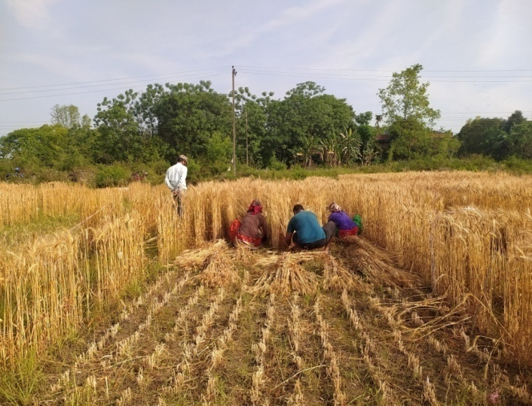
Field performance of wheat Harvesting net plot area
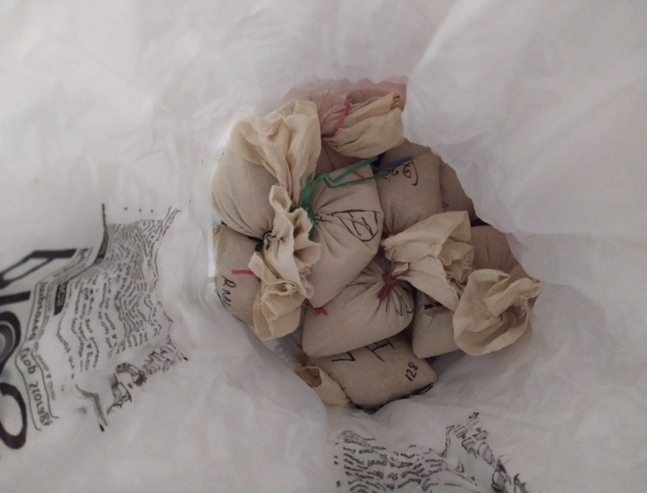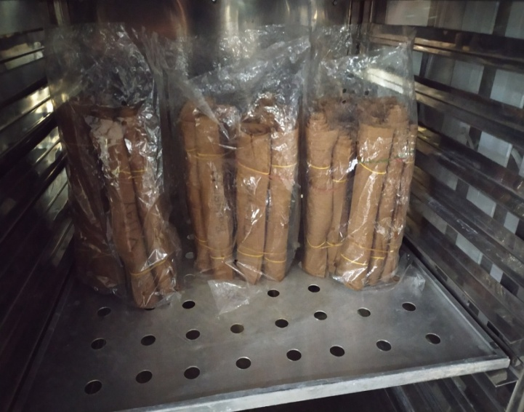
Preparation for the storage of seeds in a PICS bag Sample in the seed germinator for germination

|l-------l||l-------l|.

