Stacked Ensemble Machine Learning Models of Multiple Open-Source Data Predict Soil Organic Matter Content in Minnesota
Avinash Kafle¹², Yuxin Miao¹, Muhammad Abdul Munnaf ³
¹Precision agriculture center, Department of Soil, Water, and Climate, University of Minnesota, St. Paul, MN 55108, USA.
²Department of Earth and Environmental Science, Università di Pavia, Via Ferrata 5, 27100, Pavia, Italy.
³Agricultural Biosystems Engineering, Wageningen University & Research, Droevendaalsesteeg 1, 6700 Aa Wageningen, the Netherlands.
kafleaviansh@gmail.com, ymiao@umn.edu, Abdul.munnaf@wur.nl

Abstract:
Field-scale spatial estimation of Soil Organic Matter (SOM) is crucial for precision agriculture. Traditional laboratory methods are highly accurate but limited by high costs and time requirements. This study integrates predictor variables for machine learning from the USA-based National soil gNATSGO and POLARIS databases together with terrain attributes, and soil Sentinel-2 derived soil brightness index for predicting and mapping field-scale SOM across agricultural fields in Minnesota. Measured SOM data from sixteen fields were used for training machine learning models, and data from two independent fields were used for model testing and validation. Twelve machine-learning models were evaluated, including tree-based, kernel-based, boosting, and ensemble approaches. A stacked ensemble model combining Random Forest, AdaBoost, Gradient Boosting, Extra Trees, and Light Gradient Boosting as base learners with CatBoost as a meta-learner achieved the best generalization performance, with a coefficient of determination = 0.58, root means squared error = 0.98%, and ratio of inter-quartile range = 2.27 on testing. Recursive feature elimination and SHapley Additive exPlanations (SHAP) identified standard height, soil brightness index, gNATSGO-derived soil organic carbon, and clay content as dominant predictors of SOM alongside multiresolution valley bottom flatness and topographic wetness index. Predicted SOM maps were not always representative at field-scale. Overall, integrating terrain attributes with soil databases and remote sensing data can improve SOM prediction to a limited extent; however, cannot fully replace the requirement of on-field measurements.

Keywords: soil organic matter; terrain attributes; soil brightness index; machine learning; feature engineering; precision agriculture

1. Introduction:
Soil is the fundamental backbone of the terrestrial ecosystem [1]. Soil Organic Matter (SOM) is a collective set of carbon-based organic substances present in the soil [2]and is widely recognized as an indicator of fertility due to its effect on soil microbial activity and role in enhancing the nutrient supply for plant growth. SOM contributes not only to higher agricultural productivity and food security but also to sustainable agriculture practices. Precise estimation and mapping of the spatial distribution of field-scale is, therefore, an urgent demand for many purposes, such as precision agriculture, land quality evaluation, assessing soil carbon pool, and mitigating greenhouse gas emissions from farming, and so on [3,4,5]. Despite multi-dimensional importances, measuring and mapping the SOM accurately at the agricultural field scale remains a challenge [6].
Within-field SOM heterogeneity arises from the complex interactions of biological and physical processes regulated by soil properties, field attributes, land use and management, and climate history [7, 8]. Understanding the processes and factors affecting within-field SOM variation is important for its quantification and modeling [9]. Traditionally, SOM mapping has relied on natural environmental covariates such as topographic factors, temperature, precipitation, and soil physical properties [10]. Farmers often depend on soil texture and color for assessing soil fertility; however, it lacks precision[11]. Laboratory analysis provides accurate measurements, but at a high cost of energy and time, which makes it infeasible [12].
Good to mention that the national level datasets are available for the USA, such as the National Soil Geographic Database (gNATSGO), and the probabilistic remapping of SURRGO (POLARIS).The gNATSGO represents soil properties using expert-defined the lowest, representative, and the highest values derived from traditional soil surveys [13]. The gNATSGO gets updated annually and is used in many soil models. It is static (a snapshot of the soil survey) and may not reflect recent field management changes, which cause a great impact on the upper layer of soil. Moreover, gNATSGO is provided at 10 m resolution; the underlying soil map units typically span areas on the order of hectares (tens to hundreds of meters), so rasterization subdivides existing polygons rather than introducing new spatial detail. Likewise, another database, POLARIS, which statistically disaggregates SSURGO survey data into spatially continuous, is reported to have 5%–95% uncertainty confidence intervals, which is unrealistically wide. This is why these two databases have not been used much; instead, most farmers collect a 1 ha grid sample for SOM mapping, which is too coarse and does not sufficiently capture the within-field heterogeneity required for precision agriculture. Moreover, these datasets include data on soil organic carbon, which is often considered a proxy or determinant of SOM; however, there is no evidence whether such organic carbon information is realistic enough to translate into SOM estimation.
One approach to empower the SOM mapping with this kind of datasets is to use secondary exhaustive attributes. For example, Li et al. [14] included terrain attributes (i.e., aspect, slope, topographic wetness index, plane curvature, profile curvature, elevation, valley depth), soil type, and soil texture to predict spatial SOM in the black soil region of the Southern Northeast plain in China. Guo et al. [15] included terrain attributes like standardized height, local slope, terrain ruggedness index, convergence index, mid-slope position, multiresolution index of valley bottom flatness (MRVBF), and multiresolution index of ridge top flatness (MRRTF). Zayani et al. [16] and Nozari et al. [17] suggested a combination of remotely sensed spectral indices with non-spectral covariates, such as digital elevation models, soil and land use maps, meteorological and environmental data, to improve the accuracy of the SOC predictive model. Bouslihim et al. [18] studied the integration of multi-temporal Sentinel-2 data with ground-based soil samples to enhance SOM prediction and mapping at the field scale. To the best of our knowledge, no attempts have been given to integrate the gNATSGO database and Polaris database with terrain attributes and remote sensing data for estimating SOM across Minnesota state. Therefore, this study integrates predictor variables for machine learning from POLARIS soil database and gNATSGO soil properties together with terrain attributes, and Sentinel-2 derived soil brightness index for estimating and mapping field-scale SOM content across agricultural fields in Minnesota. By doing so, we answer how can these two datasets be deployed to estimate SOM at field scale. Novelty of this study primarily lies in the developing a ML framework for enhancing the power of POLARIS and gNATSGO datasets for spatial mapping of SOM across Minnesota state. The results aim to reduce reliance on the existing 1-ha coarser-grid SOM sampling technique used for SOM map generation by improving spatial resolution and minimizing the need for field-based sample collection when such sampling is not feasible, thereby supporting improved decision-making in precision agriculture.

2. Method and methodology:
The working methodology used in this study is presented in Figure 1. The location of the study stays in Minnesota, USA, from where field soil samples were taken. SOM, as a dependent feature, soil brightness, terrain attributes, POLARIS soil data, and gNATSGO were collected and processed as independent variables. Recursive Feature Elimination (RFE) was used for selecting the most contributory variables, and twelve different ML models were used evaluated. Afterward, it depicts a model stacking approach with original feature concatenation.
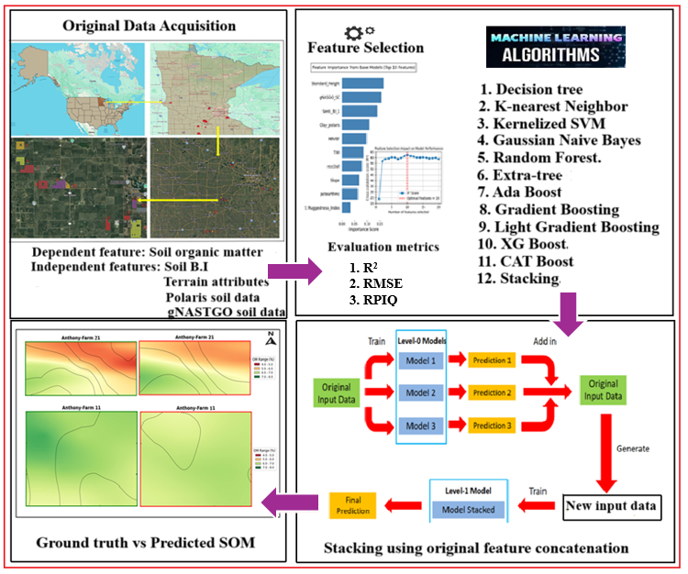
Figure 1. Methodological workflow for developing staked ensemble machine learning model for predicting and mapping soil organic carbon

2.1. Data collection

2.1.1 Soil organic matter
The SOM test reports collected between 2019 and 2023 from eighteen different fields in southern Minnesota were aggregated. A total of 675 samples were collected at a sampling interval of 100 m. Samples were taken from a depth of 0 to 15 cm with a tube auger. Then, the samples were mixed properly to form a composite sample, and half a kg of soil was taken and dried at room temperature. The air-dried soil was passed through a mesh sieve, and SOM was determined using the Walkley–Black method. The sampling date, field number, field coordinate, and graphical field location are presented in Table 1, while spatial location of the study area from the continental to the field scale is shown in Figure 2.
Table 1. Basic information of sample fields and field coordinates

Date of sample | Field number | Field Name | Latitude(N) | Longitude(E)
2023-07-02 | 1 | Kirk_Neil | 45.662533 | -96.301458
2019-6-30 | 2 | Brennan_Big | 45.286693 | -93.936850
2020-5-15 | 3 | Collins | 44.677083 | -92.851492
2024-05-05 | 4 | Monitor_Brother | 44.667953 | -92.764925
2022-10-17 | 5 | Anthony Farm 11 | 44.453044 | -94.246117
2022-08-15 | 6 | Anthony Farm18 | 44.439418 | -94.245280
2022-10-17 | 7 | Anthony Farm19 | 44.431300 | -94.237720
2022-06-08 | 8 | SoilsampleUTM1 | 44.417447 | -94.220569
2022-06-08 | 9 | Anthony Farm 21 | 44.416492 | -94.199668
2022-06-08 | 10 | Anthony Farm21B | 44.377381 | -94.116577
2022-08-15 | 11 | Anthony Farm10 | 44.393385 | -94.109040
2022-10-12 | 12 | Anthony Farm13 | 44.386694 | -94.126371
2022-10-12 | 13 | Anthony Farm5 | 44.399769 | -94.118452
2022-06-08 | 14 | Anthony Farm1 | 44.374675 | -94.117747
2022-10-14 | 15 | Anthony Farm15 | 43.379649 | -94.148259
2020-06-23 | 16 | A2 Soil_Sampling | 43.090401 | -94.602726
2023-07-02 | 17 | Historic_sampling | 43.580867 | -94.528504
2020-07-14 | 18 | 1H Soil_Sampling | 43.583961 | -94.600639

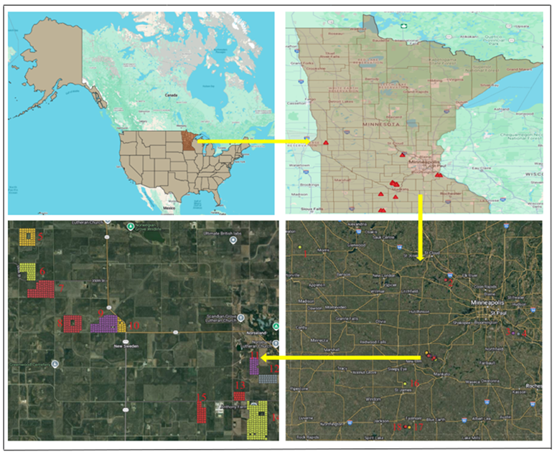
Figure 2. Studied field’s location. Insets show Minnesota within North America (left-top), statewide sampling distribution (right-top), field-level sampling plots (right-bottom), and an enlarged view of densely clustered plots for improved clarity (left-bottom). The labeled sampling number locations shown on this field location map correspond to the field numbers listed in Table 1.

2.1.2 Gridded National Soil Survey Geographic Database (gNATSGO)
The gNATSGO is a United States Department of Agriculture – Natural Resources Conservation Service – Soil and Plant Science Division (USDA-NRCS-SPSD) composite database created by combining Soil Survey Geographic (SSURGO), State Soil Geographic Version 2 (STATSGO2), and Raster Soil Survey (RSS) into a single ESRI file geodatabase to provide complete U.S. soil coverage for all areas of the United States and Island Territories. In the state and island territory databases, the soil map units are delivered only as a 10-meter raster version, and in the CONUS database, the raster is 30-meter [21, 22].
SSURGO contains information about soil as collected by the National Cooperative Soil Survey over the course of a century. This information was gathered by field observation, aerial interpretation, and map unit delineation. Many soil samples were analyzed in laboratories [21]. STATSGO2 is a broad-based inventory of soils and non-soil areas that is cartographically shown at the scale of 1:250,000 in the continental U.S., island territories, and 1:1,000,000 in Alaska. The level of mapping is designed for broad planning covering state, regional, and multi-state areas [22]. Raster Soil Surveys, products of soil survey work derived using digital soil mapping methodologies, are available as part of the Gridded National Soil Survey Geographic Database (gNATSGO) [23]. STATSGO2 fills regional gaps where SSURGO is unavailable, and RSS uses predictive digital soil mapping where detailed data are lacking. The gNATSGO database is primarily of SSURGO data, but STATSGO2 data was used to fill in the gaps. The RSSs are newer products. These RSSs were merged into the gNATSGO after combining the SSURGO and STATSGO2 data [20]. gNATSGO is not fully model-predicted, but largely based on actual field survey data — so it inherits the detail and quality of SSURGO (which is based on real observations).
From this gNATSGO database, Soil organic carbon (gNASGO_SC), available water storage at 5 to 20 cm depth expressed in millimeters (aws_5_20), the National Commodity Crop Productivity Index percent earthy map unit (pctearthmc), and the National Commodity Crop Productivity index based on corn, soybean, small grains, and cotton productivity (ncci3all) were selected. These variables capture field-scale variability for SOM variability mapping, and they directly influence SOM at the field scale. The database was accessed via the Microsoft Planetary Computer, which provides cloud access to the original gNATSGO raster products [24].

2.1.3 Probabilistic Remapping of SSURGO (POLARIS)
The Probabilistic Remapping of SSURGO (Polaris) provides soil information at 30-m resolution over the contiguous United States (CONUS) [25]. POLARIS applies machine-learning–based probabilistic remapping and digital soil mapping techniques to statistically disaggregate SSURGO survey data into spatially continuous, grid-based surfaces, reducing discontinuities inherent in polygon-based soil maps. The dataset provides depth-resolved soil properties at six standardized depth intervals (0–5, 5–15, 15–30, 30–60, 60–100, and 100–200 cm). Table 2 presents the selected independent features from it for use in this study. The datasets were accessed and processed using the R code.
Table 2. Selected features from the POLARIS database
S. N | Variable name | Descriptive name
1 | BD_Polaris | bulk density
2 | Polaris_SC | organic matter
3 | PH_Polaris | soil pH in H₂0
4 | Sand_Polaris | sand %
5 | Silt_Polaris | silt %
6 | Clay_polaris | clay %
7 | Lambda_Polaris | pore size distribution index (Brooks-Cole)
8 | Alpha_Polaris | scale parameter inversely proportional to mean pore diameter (van Genuchten)
9 | Ksat_Polaris | saturated hydraulic conductivity
10 | n_Polaris | measure of the pore size distribution (van Genuchten)
11 | Theta_r_Polaris | residual soil water content
12 | HB_Polaris | bubbling pressure (Brooks Corey)

2.1.4 Terrain attributes
Standard height (Standard_Height), multiresolution valley bottom flatness (MRVBF), multiresolution index of the ridge top flatness (MRRTF), Topographic Wetness Index (TWI), slope, mid-slope position, slope height, aspect, profile curvature (Profile_curva), tangential curvature (Tang_curva), terrain ruggedness Index (T. Ruggedness_index), convergence index, and convexity were the eleven major topographic attributes used in this study. These attributes were obtained at 1$×$1 m² resolution from the web-based application MnTOPO [26]. The Topographic Wetness Index (TWI) is calculated as TWI = ln(α/tanβ), where α is the upslope contributing area (m²) flowing downward through a pixel (in units of length squared, m²) and tanβ is the tangent of slope β (^{c}) in radians. It quantifies the topographic variation in the surface wetness. An array of GIS and SAGA GIS algorithm techniques is used for its extraction [27].
The standard height terrain attribute is calculated as the product of normalized height (normalh) and absolute height. Equation 1 and Equation 2 present the formulas used to derive standard height and normalized height.

 | $Standard height = normalh × \left[\left(Z_{s}- Z_{min}\right)- Z_{min}\right]$ | 1

 | $$normalh = 0.5 × \left(1 +\frac{slph-vall_{depth}}{slph+vall_{depth}}\right)$$ | 2

2.1.5 Soil Brightness Index
The soil Brightness Index (B.I.) was computed using red (R) and green (G) bands derived from Sentinel-2 imagery from mid-May of the soil sampled years 2019 to 2024, except 2021, with the formula provided in Equation 3.
 |  | B.I = $\sqrt{\frac{R^{2}+G^{2 }}{2}}$ | 3.
Source:[28]

2.2 Data pre-processing
Data pre-processing was started with removing missing values, followed by feature scaling and z-score standardization. By standardizing the values, the data were transformed into a format with a mean of 0 and a variance of 1. This is achieved by subtracting the mean from each value and then dividing the result by the standard deviation using the following Equation 4.
 | $$z = \frac{v - μA}{σA}$$ | 4
where,
σA and μA are the standard deviation and mean of feature A. The original and the normalized feature values are given by v and z, respectively.

2.3 Description of the models used
Both individual and ensemble model algorithms were implemented to explore the best predictive results, counting total of 12 number of ML regression methods. Decision trees (DT) are easy to interpret and explain; however, they struggle with high-dimensional data, and errors can propagate through trees. Random Forest (RF) is an ensemble method that trains several decision trees and returns the class predicted by the majority of trees. However, as the number of trees increases, their performance becomes slow for real-time prediction. Extra-Tree (ET) is another ensemble methods that splits nodes by choosing cut-points fully at random and use the whole learning sample (rather than a bootstrap replica) to grow the trees [29]. Support vector machine (SVM) is based on maximizing the minimum distance from the hyperplane to the nearest sample point. SVM with an appropriate kernel, model’s data that is not linearly separable in the original feature space. K-means-based SVM regression with a radial basis function (RBF) requires fewer hyperplanes than linear and can handle non-linear attributes. However, its training speed is slower, and performance depends on the choice of parameters. K-Nearest Neighbor (KNN) assigns a label to an unlabeled sample point based on the majority class of its nearest neighbors, where the user selects the number of neighbors, and performance depends on this value [30]. Bayesian Ridge Regression (BayR) adheres to Bayesian inference principles in linear regression, enabling stable and reliable predictions compared to traditional linear regression methods [31]. Similarly, Gradient Boosting (GB) is the stage-wise addition algorithm, where multiple weak learning algorithms are trained, and their outputs are combined to form a strong predictive model. XGBoost (XG) is a regularized form of the existing gradient-boosting algorithm. AdaBoost, unlike GB and XGBoost procedures, calculates the alpha parameter to emphasize the difficult-to-predict samples. Categorical boosting (CatBoost) operates by symmetric growth of decision trees, which makes it better and different from others. Light Gradient Boosting Machine (LGBM) grows a decision tree leaf-wise, meaning that at a single time, only one leaf from the whole tree is grown [32]. The stacked model offers flexible combinations in the selection and design of base and meta-learners. By combining different models and feature indicators, it effectively improves the generalization and adaptability of the model prediction. In this framework, the base learner takes input variables from the original feature set, while the meta-learner takes the outputs of the base learner as inputs. An optional “pass through true” mechanism allows concatenation of the original feature with the base learner output. The result of the meta-learner is the final prediction result of the model. Importantly, the training set of the stacking meta-learner is not composed entirely of base learners' training data. Instead, the k-fold cross-validation option is used. During training, each base learner retains a portion of the data as a validation set. All validation sets from the k-fold are aggregated to form a new dataset, which is the training set for the meta-learner. This approach addresses the challenges of poor generalization ability, small sample size, low tolerance to noise, and limited robustness in ensemble learning [5] [33] [34]. This feature-augmented stacking method further enables the system to learn and incorporate additional instance information [35].

2.4 Modeling and feature selection
Randomly, the samples from sixteen fields were pooled together. Using feature selection and the 10-fold cross-validation technique, Decision Tree, Random Forest, Extra Trees (Extremely Randomized Trees), Kernel Support Vector Machine, k-Nearest Neighbors, Bayesian Ridge Regression, Gradient Boosting, Extreme Gradient Boosting (XGBoost), AdaBoost, CatBoost, Light Gradient Boosting Machine, and stacked machine learning models were trained. The remaining two fields (Anthony Farm 11 and Anthony Farm 21) were used as a test set to evaluate the predictive performance of the developed model. The RFE process was used to identify and remove redundant features [36]. The number of top features was selected based on their impact on performance and model improvement using averaging permutation-based feature importance scores. Model performance was evaluated and validated using the coefficient of determination (R²), ratio of performance to interquartile distance (RPIQ), and statistical errors were derived using root mean square error (RMSE), along with their stability. The coefficient of determination (R²) represents the proportion of variance in the dependent variable that is predictable from the independent variables. RPIQ is the interquartile range of the observed values divided by the root mean square error or prediction (RMSEP). The RPIQ considers both the prediction error and the variation of observed values, providing a metric of model validity [37] [38]. RMSE provides the prediction error in the same unit as the dependent variable. The formulas for the performance evaluation parameters are as follows:
 | Coefficient of determination (R²)$= 1 -\left(\sum_{i=1}^{m}{\frac{{\left(X_{i}- Y_{i}\right)}^{2}}{{\left(\overline{Y}- Y_{i}\right)}^{2}}}\right)$ | 5.

 | Root-mean square error ($RMSE) = \sqrt{ \left(\frac{1}{n}\right) Σᵢ^{n} {\left(yᵢ - ŷᵢ\right)}^{2} }$ | 6.

 | $$Ratio of Performance to Interquartile distance(RPIQ)=\frac{IQ}{RMSE}$$ | 7
Where; $X_{i}$ : Predicted values, $Y_{i}$: Actual (observed) values, $\overline{Y}$ : Mean of the observed values, m: Number of observations,$\left| X_{i}- Y_{i}\right|$ = absolute error for each prediction, $D_{ie}$ ​: Experimental or observed value, $D_{im}$​: Model or predicted value, N: Total number of observations, IQ: difference between the third quartile Q3 ( 75% of the samples ) and the first quartile Q1 ( 25% of samples).

2.4.1 Hyperparameter on individual model
GridSearchCV with 3-fold cross-validation was used to select the best hyperparameter on each model at a random state of 42, and the selected best hyperparameters are listed below in Table 3.

Table 3. Model with selected hyperparameters.
Model | Hyperparameter options | Best selected hyperparameter
DT | max_depth (5, 10, 15, None), min_samples_split (2, 5, 10), and min_samples_leaf (1, 2, 4). | max_depth=5, min_samples_split=2, min_samples_leaf=4
RF | n_estimators (100, 200), max_depth (10, 20, None), min_samples_split (2, 5), min_samples_leaf (1, 2), max_features (sqrt, log2), and bootstrap (True, False). | n_estimators=200, max_depth=None, min_samples_split=2, min_samples_leaf=2, max_features='sqrt', bootstrap=True
ET | n_estimators (100, 200), max_depth (10, 20, None), min_samples_split (2, 5), min_samples_leaf (1, 2), and max_features (sqrt, log2). | n_estimators=100, max_depth=20, min_samples_split=2, min_samples_leaf=1, max_features='sqrt'
KSVM | (rbf, poly, linear), C (0.1, 1, 10), epsilon (0.01, 0.1, 1), gamma (scale, auto), and degree (2, 3, 4) for polynomial kernels. | C=10, degree=2, epsilon=1, gamma='auto', kernel='rbf'
KNN | n_neighbors (3, 4, 5), weights ('uniform', 'distance'), and distance metrics (euclidean, manhattan, minkowski). | n_neighbors=5, weights='distance', metric='manhattan'
BayR |  | alpha_1=1e−06, alpha_2=0.0001, lambda_1=0.0001, lambda_2=1e−06
GB | n_estimators (100, 200), learning_rate (0.01, 0.05, 0.1), max_depth (3, 5, 10), min_samples_split (2, 5), min_samples_leaf (1, 2), and subsample (0.8, 1.0). | n_estimators=200, learning_rate=0.05, max_depth=5, min_samples_split=2, min_samples_leaf=1, subsample=1.0
XG | n_estimators (100, 200), learning_rate (0.01, 0.05, 0.1), max_depth (3, 5, 10), min_child_weight (1, 3, 5), subsample (0.8, 1.0), and colsample_bytree (0.8, 1.0). | n_estimators=100, learning_rate=0.1, max_depth=6, subsample=1, colsample_bytree=1.0
Ada | n_estimators (50, 100, 200), learning_rate (0.01, 0.05, 0.1, 0.2), and estimator__max_depth (3, 5, 10). | n_estimators=100, learning_rate=0.1, estimator__max_depth=10
Cat | iterations (100, 200), learning_rate (0.01, 0.1), depth (4, 6, 8), and L2_leaf_reg (1, 3, 5). | iterations=100, learning_rate=0.1, depth=6, L2_leaf_reg=1
LGBM | n_estimators (100, 200), learning_rate (0.01, 0.1), max_depth (4, 6, 8), num_leaves (15, 31, 63), and reg_alpha (0, 0.1, 1.0). | n_estimators=200, learning_rate=0.1, max_depth=4, num_leaves=15, reg_alpha=0.1
Note: DT = Decision Tree; RF = Random Forest; ET = Extra Trees (Extremely Randomized Trees); KSVM = Kernel Support Vector Machine; KNN = k-Nearest Neighbors; BayR = Bayesian Ridge Regression; GB = Gradient Boosting; XG = Extreme Gradient Boosting (XGBoost); Ada = AdaBoost; Cat = CatBoost; LGBM = Light Gradient Boosting Machine; n_estimators = number of trees; max_depth = maximum tree depth; min_samples_split = minimum samples required to split a node; min_samples_leaf = minimum samples at a leaf node; max_features = number of features considered per split; bootstrap = use of bootstrap sampling; learning_rate = shrinkage rate controlling learner contribution; subsample = fraction of samples used per learner; min_child_weight = minimum instance weight in a child node; colsample_bytree = fraction of features sampled per tree; num_leaves = maximum number of leaves per tree; reg_alpha = L1 regularization coefficient; L2_leaf_reg = L2 regularization on leaf weights; C = regularization parameter; epsilon = epsilon-insensitive loss width; gamma = kernel coefficient; kernel = kernel function type; degree = polynomial kernel degree; n_neighbors = number of nearest neighbors; weights = neighbor weighting scheme; metric = distance metric; alpha_1, alpha_2, lambda_1, lambda_2 = Gamma prior hyperparameters in Bayesian regression; iterations = number of boosting iterations; depth = tree depth; estimator__max_depth = maximum depth of AdaBoost base estimator.

2.4.2 Hyperparameter in stacked model
After an extensive experiment with ML regression algorithms for use as base and meta learners, RF, ADA, GBR, ET, and LGBM were selected as base learners, while CatBoost was used as a meta-learner. Similarly, both with and without a pass-through were evaluated. The pass-through true process added the original input features to the set of predictions to make the final decision [39]. In this study, the ensemble model with the “pass-through true” option significantly improves the estimation accuracy and generalizability of SOM compared to individual models and the “pass-through false” option. Among the configurations, the CatBoost meta-models achieved the highest accuracy. The optimum hyperparameters used during the stacking of the base learner and the meta learner are presented in Table 4.
Table 4. Base learner and meta-learner with their tuned hyperparameters
Model | Configuration
RF | n_estimators=100, max_depth=8
ADA | n_estimators=50, learning_rate=0.05, max_depth =10
GBR | n_estimators=100, learning_rate=0.05, max_depth=4
ET | n_estimators=100, max_depth=8,
LGBM | n_estimators=100, learning_rate=0.05, max_depth=4
CatBoost (Meta Learner) | iterations=100, learning_rate=0.05, depth=4
Note: RF = Random Forest; Ada = AdaBoost; GBR = Gradient Boosting Regressor; ET = Extra Trees; LGBM = Light Gradient Boosting Machine; n_estimators= number of trees; max_depth/depth = maximum tree depth; learning_rate = shrinkage factor; iterations = number of boosting iterations.

2.5 Feature importance and Shapley Additive exPlanations (SHAP) in stacked model
The top 10 most influential features were defined by averaging permutation-based feature importance scores from the base model. For this, a feature selection curve was created to evaluate and select the number of features based on model performance. The curve revealed that model performance was at its peak with the top 10 features, measured by the cross-validated R² value. This analysis defined the features to be used in the staking model. The CatBoost meta-learner was trained using output from the individual base learners, along with other top 10 most important features as additional input, derived from the average of all base learners. This framework depicted feature-level and model-level predictive and insightful information. The SHAP values further improved the interpretability of SOM modeling. The SHAP Beeswarm plot was used to get a more intuitive understanding of the feature-target relationship and the hidden nature of the model. The SHAP values indicated both the magnitude and direction of each influential feature, revealing how they affected the prediction in the study. SHAP values were assigned to each feature based on the collaborative results of all features and their impact on the prediction result [35].
2.6 Model comparisons
Paired t-tests were applied for comparing performances of models, except for DT model. For the DT model, paired differences were predominantly unidirectional with many ties; the result from the pair-t test was undefined; therefore, the sign test was used instead. The stacked ensemble model was treated as the reference and compared individually with other models. Besides, the performance of the best performing models were also compared against conversion function of soil organic carbon to SOM [40]. This comparison justifies the use of POLARIS_SC and gNATSGO_SC as independent variables in training ML models.

2.9 SOM visualization using Kriging
Spatial interpolation was performed using Ordinary Kriging (OK), implemented using the PyKrige library in Python. The system of OK interpolation is known as the best linear unbiased predictor. OK predicts unknown values of unsampled points by considering the distance as well as the autocorrelations between neighboring observations and points of unsampled locations [41]. A linear variogram model was selected to describe the spatial dependence of SOM. A regular interpolation grid was generated over the study area's spatial extent, with a resolution of 100 × 100 m cells. The resulting interpolated map was visualized using a color gradient to highlight the ranges of SOM concentration, and contour lines were overlaid to emphasize the spatial gradients. Kriging maps of measured SOM and predicted SOM were compared for qualitative similarity. Pham et al. [42] has given the simple description of OK as the following formula:

 | $$Z'(x₀) = \sum_{i=1}^{n}{ λᵢ Z(xᵢ)}$$ | 8

Where,
Z_(x₀) is the predicted value at the unmeasured position x₀, Z(xi) is the measured value at position x_{i}, λ_{i} is the weighting coefficient from the measured position to x₀, the sum of weights is equal to 1, and n is the number of positions within the neighborhood searching.

3. Results

3.1 Descriptive statistics of SOM
Both the training and testing datasets share the similar data distributions, with a comparable range (train; test = 0.5–12; 2.99–11.67), mean (5.56%; 6.11%), standard deviation (2.4%; 1.51%), skewness (0.25, 0.30) and kurtosis (-0.11; 0.40) (Figure 3). This similarity between data splits satisfies the requirement for building ML regression models.

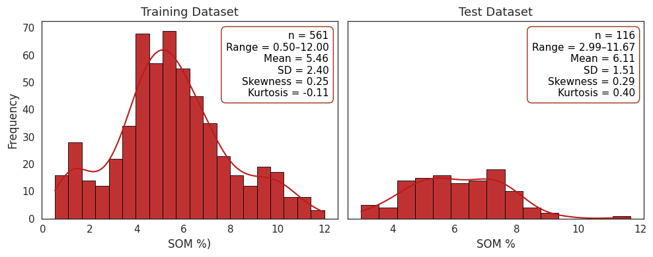
Figure 3. Distribution of SOM on the training and test fields
The Pearson correlation analysis revealed that SOM exhibited moderate correlation with Polaris_SC, gNASGO_SC, Clay_polaris, Sand_Polaris, Silt_Polaris, BD_Polaris, pH_Polaris, Ksat_Polaris, Lamda_Polaris, n_Polaris, Theta_s_Polaris, Theta_r_Polaris (i.e., |r| > 0.45 < 0.57) (Figure 4). Besides, SOM was found correlated with MRVBF, pctearthmc, ncci3all, aws_5_20s, Alpha_Polaris, HB_Polaris, convexity, Senti_BI_1 corelated with |r| > 0.20 < 0.40). Importantly, the correlations with Polaris_SC and gNASGO_SC are presumed as the SOM and organic carbon can be a determinant of one another. However, in this study, correlation was not sufficiently high but moderate, and organic carbon cannot be considered as a direct proxy for SOM. The overall correlation also confirms that all independent variables are correlated with SOM to some extents, but none has strong correlations that could be considered as inflation factor.

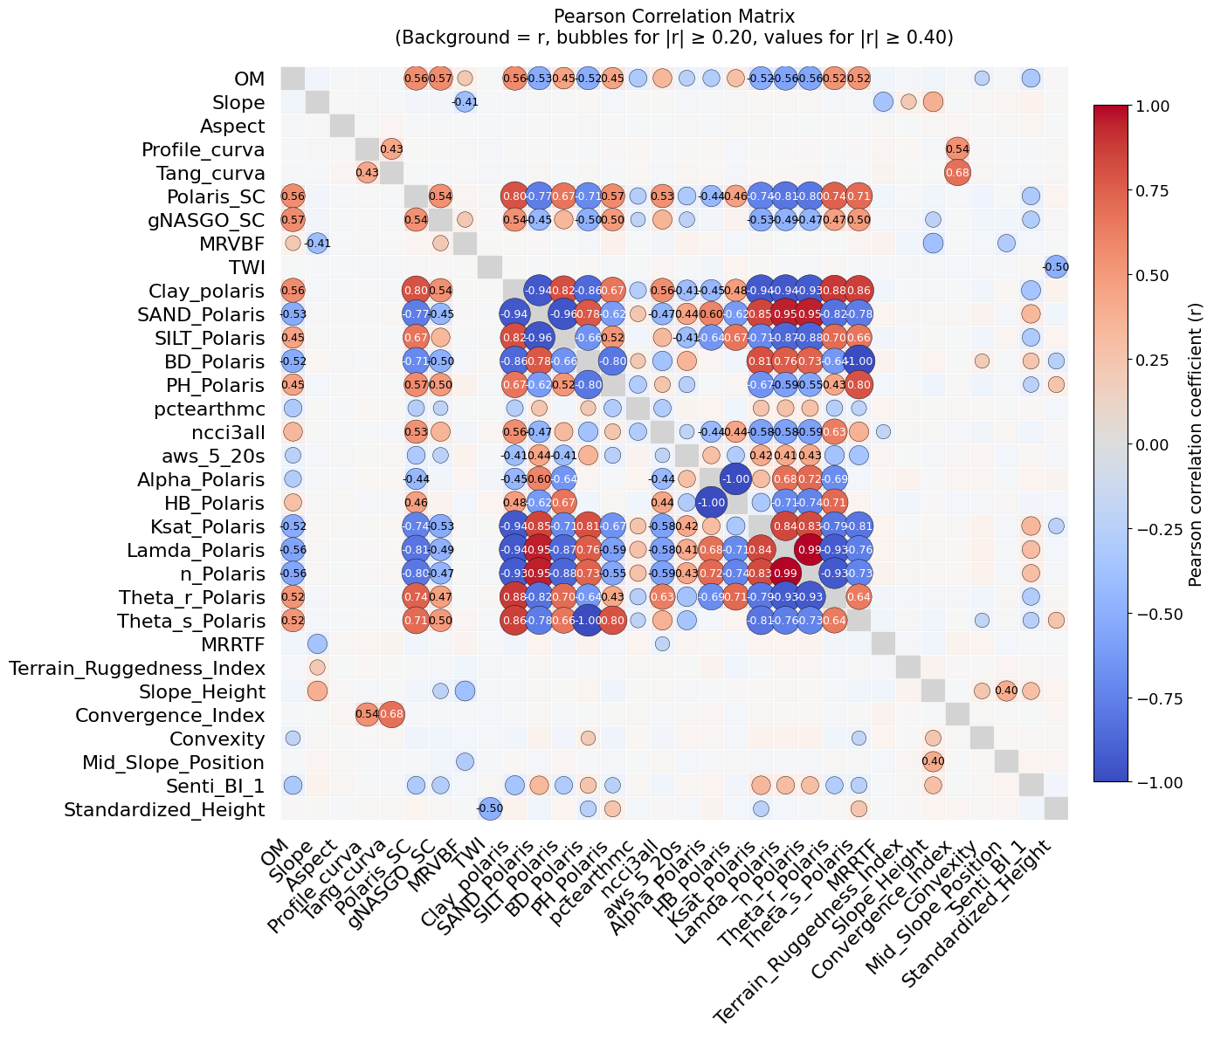

Figure 4. Pair-wise correlations of all the variables considered in this study.

3.2 Feature importance analysis
Feature selection by RFE method revealed a consistent set of top-performing variables for most of the ML models, such as gNASGO_SC, Senti_BI_1, Standard_Height, and Clay_polaris (Figure 5). Ensemble models such as XGBoost, AdaBoost, and CatBoost relied heavily on Standard_Height. DT relied on Clay_polaris. RF, ET, KNN, LGBM, BayR, and KSVM models distributed feature importance more broadly to additional features of Lamda_Polaris, MRVBF, pH_Polaris, Theta_r_Polaris, Theta_s_Polaris, Ksat_Polaris, and TWI. CatBoost and LGBM included topographic and morphometric variables such as TWI, Slope_Height, and Profile_curva as significant contributors. Unlikely, Polaris_SC was rarely ranked high across models. Overall, Standard_Height, gNASGO_SC, and Senti_BI_1 were the most consistently important features across all models, followed by other key contributors, such as clay_polaris, MRVBF, pH_Polaris, and TWI, which confirmed their role in SOM prediction.

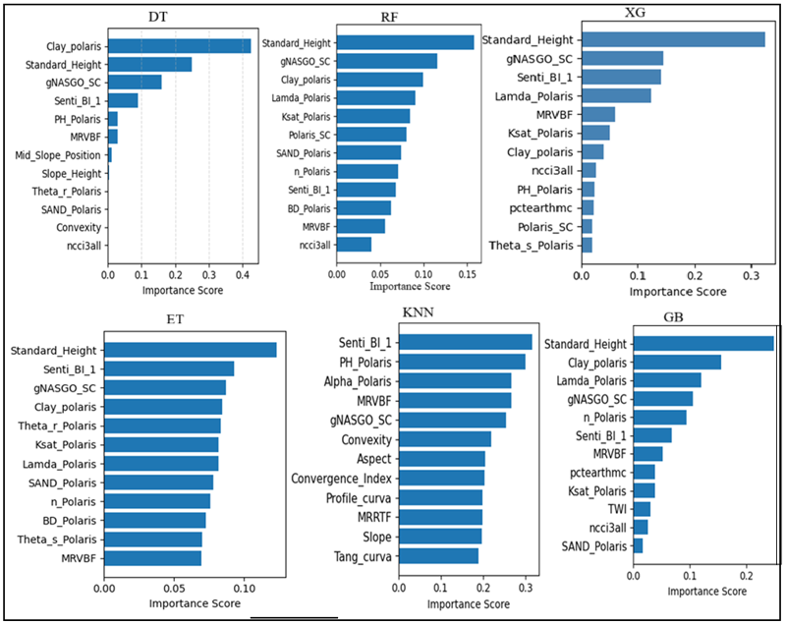
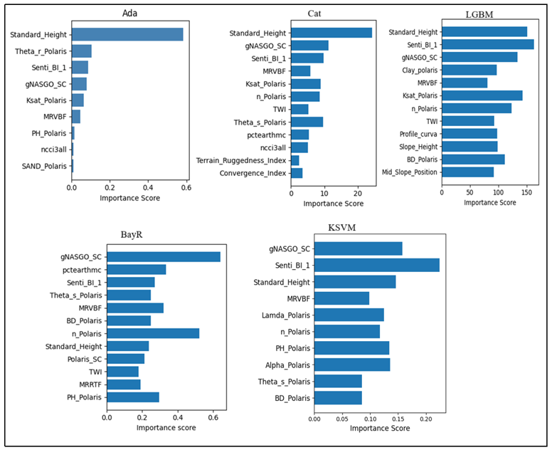
Figure 5. Feature importance for different machine learning models developed.

3.3 Performance of ML models on the training field
The ensemble stacked model (Figure 6) demonstrated strong constituency and predictive capacity with R² of around 0.61, RMSE of 1.4%, and RPIQ of 1.87. XGBoost, CatBoost, LightGBM, and GB demonstrated slightly higher performance than the stacked model, achieving R² value of 0.61 and up to 0.64, with RMSE value of 1.3%, and RPIQ of 2. However, these models were not as stable as the stacked model, indicating limited opportunity for using these models in real-world applications. Likewise, KNN and BayR were the poorest performing models, with an R² of 0.39 and 0.44, respectively. All other models performed similarly to the stacked model, with the key difference shown by the error bars.
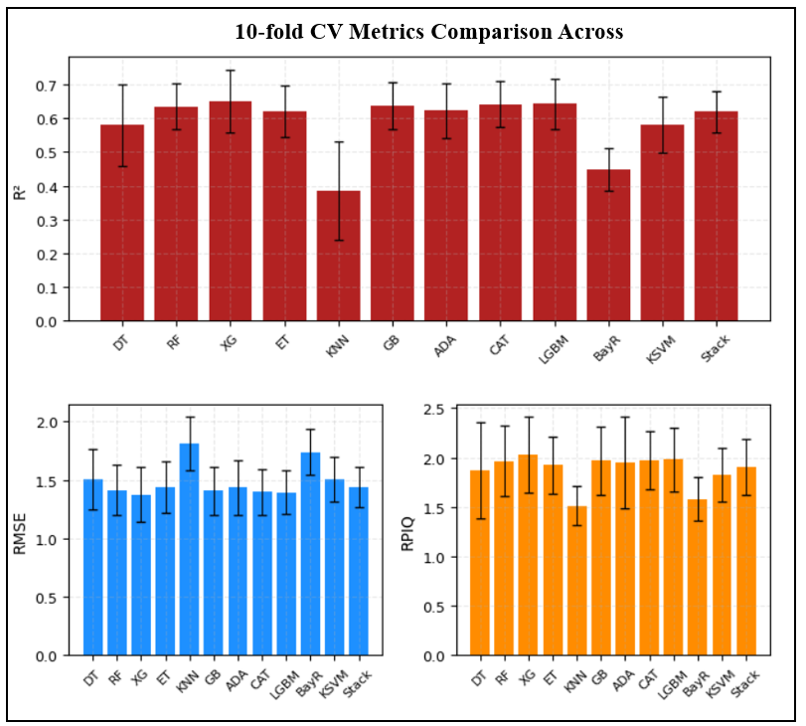

Figure 6. Performance of machine learning models on the training fields.

3.4 Performance of ML models on the test field
The stacked model with the top original feature concatenation outperformed all other models tested in this study (Figure 7). It recorded a stable predictive R² score of 0.58, which was 15% higher than models without original feature concatenation. This indicates that the concatenation of the top original features highly improved the model’s generalization ability. Likewise, the lowest RMSE of 0.98% and the highest RPIQ of 2.3 were recorded, which were comparatively better than other models. Among all the considered models, random forest and CatBoost had R² of around 0.5, while in others, it was considerably lower. Similarly, these, as well as Extra-tree, had a high RPIQ compared to other models (around 2), just below the stacked model, and had RMSE just above 1%.

An individual CatBoost model demonstrated a comparatively high predictive R² score of 0.52 in the test set with RMSE of 1.1 and RPIQ of 2.2. In comparison, almost all other models had R² scores below 0.50, with significantly high RMSE (1.14 -1.4) and low RPIQ (2.1-1.5) scores.

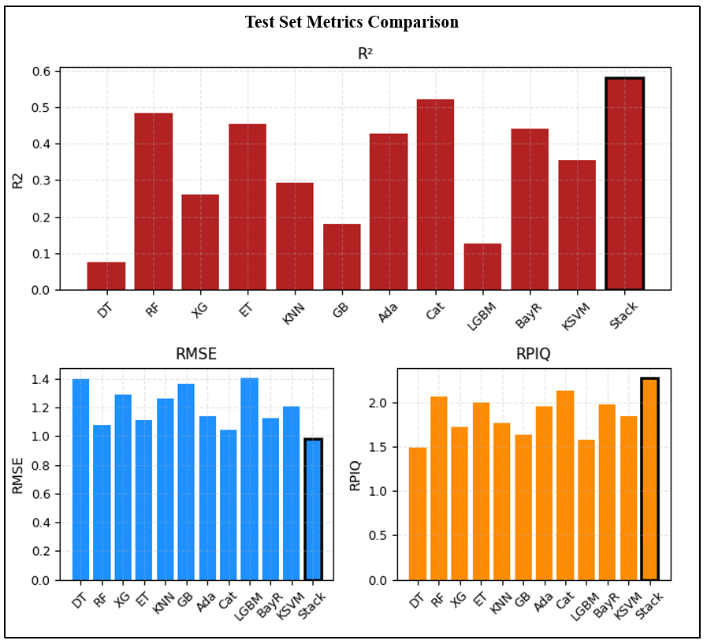
Figure 7. Models on the Test field
3.5 Quality of stacked models on train and test fields
The stacked model was found to have a better predictive score compared to all models across train and test fields (Figure 8). The training model demonstrated a low error margin (±5% error margin) for a measured SOM value that is below the reported maximum range (8%) [43]. The evaluation metrics, calculated from the global out-of-fold 10-fold cross-validation were R² of 0.64, RMSE of 1.45%, and RPIQ of 1.89. Similarly, in the test dataset, the model demonstrated close performance to the training set, with an R² of 0.58, RMSE of 0.98%, and RPIQ of 2.27.
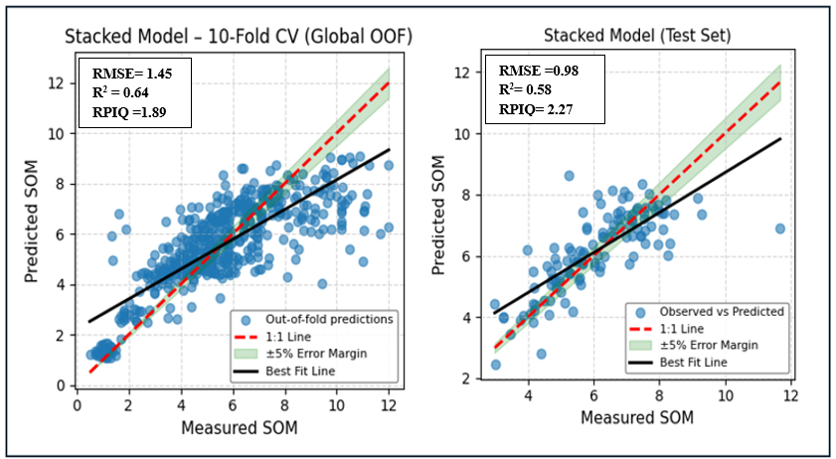
Figure 8. Scatter plots of measured and predicted soil organic matter obtained from training (a) and testing (b) datasets used in stacked model.
3.6 Feature importance and Shapley Additive exPlanations (SHAP) on stacked model
Stack models ranked the Standard_Height, gNASGO_SC, Senti_BI_1, Clay_polaris, MRVBF, TWI, together with ncci3all, slope, and Terrain ruggedness index as the best predictors for SOM (Figure 9 a). Besides, the SHAP beeswarm plot of the input features to the meta-learner provided a deeper understanding of individual features in the prediction (Figure 9 b). SHAP revealed positive scores for gNASGO_SC, Clay_polaris, MRVBF, ncci3all, and TWI, suggesting a direct relation with SOM. On the other side, Standard_Height, Senti_BI_1, T. Ruggedness_index, and Slope had a negative SHAP score for features with higher values, indicating their indirect relation with SOM. Surprisingly, pctearthmc had a negative SHAP score for its higher value, despite representing the percent of earthy map unit that support crop growth. Similarly, base learner models, RF, ET, LGBM, and GB, had a positive SHAP score for their higher value, except for Adaboost, which had a non-linear score.

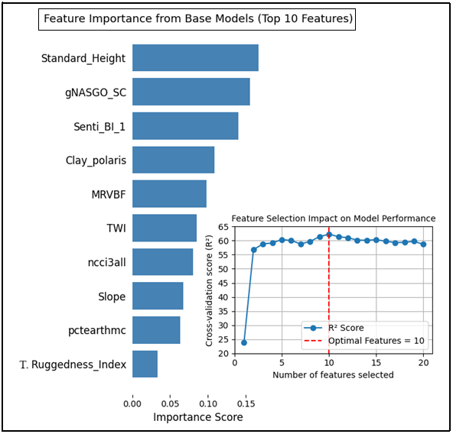 | 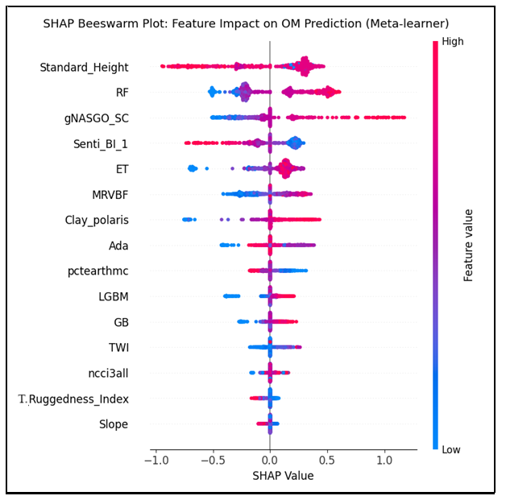
Figure 9. Feature importance(left) of Meta-learner and SHAP Beeswarm plot (Right) of staked models

3.7 Quality of staked model over other models
Paired t-test indicated that the stacked model significantly outperformed all other models with p-values less than 0.05 (Table 5). Stacked against the decision tree model consistently produced low errors; therefore, a sign test was applied, which confirmed the stacked model achieved significantly superior performance (p-value<0.001).
Table 5. Statistical pair-t test results for models’ comparison.
Comparison | Mean_Error_STACK | Mean_Error_Model | Test | p_value
STACK vs RF | 0.6941 | 0.8162 | Pair-T test | 0.0083
STACK vs ET | 0.6941 | 0.8136 | Pair-T test | 0.0263
STACK vs DT | 0.6941 | 1.2446 | Sign test | 0.001
STACK vs KNN | 0.6941 | 0.9429 | Pair-T test | 0.001
STACK vs GB | 0.6941 | 1.0342 | Pair-T test | 2.6e-07
STACK vs XGB | 0.6941 | 1.0108 | Pair-T test | 3.1e-08
STACK vs LGBM | 0.6941 | 1.0609 | Pair-T test | 6.1e-08
STACK vs ADA | 0.6941 | 0.7961 | Pair-T test | 0.0487
STACK vs CAT | 0.6941 | 0.7917 | Pair-T test | 0.0283
STACK vs KSVM | 0.6941 | 0.8384 | Pair-T test | 0.0247
STACK vs BAYES | 0.6941 | 0.881 | Pair-T test | 0.0009

Moreover, the stacked model achieved the best performance, with the highest R² (0.58) and lowest RMSE (0.98%) compared to the organic carbon to SOM conversion functions (Table 6). The combined Polaris_SC and gNATSGO_SC use for SOM conversion model improved prediction accuracy (R² = 0.38, RMSE = 1.15%) compared to their individual predictions, i.e., Polaris_SC achieved R² = 0.27 and RMSE = 1.25%, and gNATSGO_SC achieved R² = 0.21 and RMSE = 1.30%. Neither individual conversion models nor their combined use outperforms the stacked ML model, justifying the need for advance ML modeling over traditional conversion or pedo-transfer functions.
Table 6. Performance of the stake model compared with the soil organic carbon to soil organic matter conversion functions.
Comparison | TEST
Model vs Individual Vs Combine | R² | RMSE%
Stacked Model | 0.58 | 0.98
Polaris_SC (OM) | 0.27 | 1.25
gNATSGO _OM | 0.21 | 1.30
Polaris_SC and gNATSGO_OM | 0.38 | 1.15

3.7 Spatial distribution of predicted SOM
Anthony Farm 21 had higher SOM concentrations in the southeast region, while the lower values were in the northwest region (Figure 10). The stacked model, with only 0.58 predictive capacity, clearly represented the field's spatial heterogeneity, similar to the measured distribution at field scale. In Anthony Farm 11, the measured SOM distribution differs across the field, while the stacked model represented it as with homogeneous SOM distribution. This suggested that the field-level applicability of the current models is not highly successful in this field.

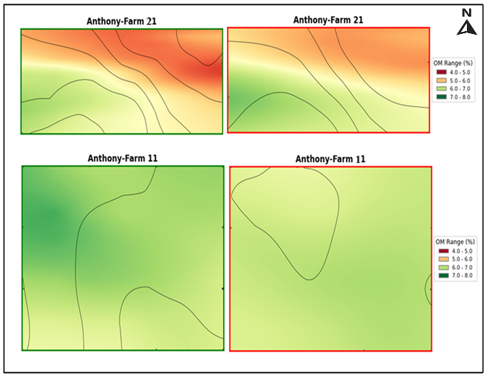
Figure 10.Field-scale measured SOM (green border) and predicted SOM (red border)

4. Discussions
This study combines multi-source data from US-based soil databases, field terrain attributes, and remote sensing products to evaluate their prediction potential for the field-scale SOM in Minnesota region. It estimated and drawn a spatial distribution of SOM at the field scale, to facilitate optimal fertilizer input and selection of the best field for agricultural purposes. This study deployed several ML models, compared their performances, and analyzed feature contributions.
The SOM sample distribution of this study was a wider range than the reported range of 2-8% in the studied site, confirming the dataset's suitability [43]. Similar data distributions between training and test sets was effective to reduce the likelihood of distributional shift, and enhanced confidence of the ML models (Figure 3). Most of the predictors had a moderate to low correlation with the SOM, while a few of them had a high correlation with each other (Figure 4). This study includes all of them as a predictor variable. In statistical modeling, the presence of strongly correlated variables may cause redundancy and unnecessary complexity in the model. Kutner et al. [44] and Ahmad et al. [45] argued that these correlated variables do not typically affect inferences about mean responses in the data. This suggests that even if variables share a strong correlation, each can still provide unique and valuable insights about the average responses in the dataset, thereby making them essential components of the model. Besides, this tendency can also weigh regression coefficient towards predicting central values, while doing over- and under-prediction of end values of the dataset, which is also noticeable in study, though no strong correlations were observed.

From the gNATSGO dataset, this study included only 4 variables: gNASGO_SC, aws_5_20, pctearthmc, and ncci3all. This was because of that these were the only variables varied in spatial data within the study area and could affect the SOM prediction at the field scale. gNATSGO_SC is important because it represent gNASTGO raster-based soil organic carbon content. Available water storage (aws_5_20) is enhanced by hydrophilic nature of SOM [46]. Variability in pctearthmc reflects differences in the proportion of mineral soil within map units, which can affect organic matter accumulation [19]. Higher ncci3all values indicate greater soil productivity, which is commonly associated with higher soil organic matter [47]. In addition, gNATSGO_SC, pctearthmc, and ncci3all variables were the top predictors in the base model (Figure 9). Although gNATSGO is provided at 10 m resolution at the state level, the underlying soil map units typically span areas on the order of hectares (tens to hundreds of meters), so rasterization subdivides existing polygons rather than introducing new spatial detail. This could be the reason why it does not capture within-field heterogeneity alone, which is reflected in moderate correlation between gNATSGO_SC and SOM (Figure 4).

The current results confirmed that the stacked model leveraged the complementary strengths of the individual models together with other original features. This finding is consistent with previous studies [46] [47] [5]. Similarly [48], it highlighted the improvement capability and generalizability of ensemble learning. Gholizadeh et al. [49] and Chang et al. [50], mentioned that model with R² values between 0.5 and 0.8 for SOC estimation are categorized as having reliable prediction accuracy. CatBoost, as an individual model, achieves R² score above 50% in the test set (Figure 7), reinforcing its utility in soil modeling. Similarly, based on Nawar and Mouazen [51] and Zayani et. al. [16], RF, ET, and CatBoost (test score) models were found to have a very-good performance; unfortunately, no excellent model were obtained.

Just like mentioned by Guo et al. [15], standard height in this study is seen as a top predictor in most of the ML models (Figure 9). The influence of elevation (Standard_Height) on SOM in similar nature of field and cropping history is mainly realized through soil erosion effect, which is highly significant for concentration and distribution of SOM. Soil with high SOM generally looks darker and reflects less sunlight which has been capture in this study, as reflected by the Sentinel-2-derived soil Brightness index, which emerged as the major predictive score in most of the models. The MRVBF represents a valley bottom, commonly low and flat, where material rich in organic matters accumulates over time and can be detected across a wide range of scales [52]. Among 105 auxiliary data as predictors, MRVBF ranks fourth, explaining 8.7% of SOC spatial variability [53]. This study also identified it as among the top features and showed a high SHAP value for high MRVBF. Soil clay shows a positive correlation with SOM, particularly within the top 30 cm depth [54]. This research found a comparable relationship, confirming the importance of clay in SOM accumulation. Fine particles plays role in stabilizing organic carbon and nitrogen through organo–mineral associations, for long-term SOM preservation [55]
The ncci3all represents a weighted average of major earthy components across corn, soybeans, small grains, and cotton. Similarly, pctearthmc is the percent earthy map unit summing earthy components that support crop growth [56]. In this study, the relationship between ncci3all and SOM was consistent with the expectation. In contrast, the relationship between pctearthmc and the SOM didn’t align with the scientific assumption. This may be because of that pctearthmc supports crop growth, but does not necessarily correspond to high SOM levels. Swetnam et al. [27], Liu et al. [57], and Zádorová et al. [58] reported that high TWI values were associated with high soil water content and a slow rate of decomposition and mineralization, which in turn increases SOM. In contrast, Hu et al. [2] found that TWI had a small negative correlation with SOM. It suggests that the TWI relation with SOM is site-specific. This study found a high SHAP value for high TWI. In contrast to the previous research of Ågren & Andersson [59], this study showed a slightly negative SHAP value for a high degree of slope. Slope and aspect influence microclimate variation in soil properties and nutrients by affecting the spatial distribution of incoming solar radiation, temperature, precipitation, and nutrient concentration.
This work classified Ksat as a top predictor in seven different models and bulk density (BD_Polaris) in five different models, though neither was dominant in the final stacked model (Figure 5, Figure 9). Depending on texture and bulk density, organic matter can either increase or decrease Ksat [60]. Prior studies, Sakin [61], Périé and Ouimet [62], and Nath [63] reported a strong relation of bulk density to SOM. The porosity between 0.2–720 μm diameter was positively correlated with SOC in arable topsoil, indicating its role in the plant-available water content, unsaturated hydraulic conductivity, and SOC, whereas larger pore (1200-3120 μm) diameter classes and bio-porosity were not related to SOC content [64]. This study highlighted pore size distribution (n_Polaris) and saturated soil water content (Theta_s_Polaris) as important features in seven and five different ML models, respectively.

Previous research by Tu et al. [65] reported that soil pH plays a key role in shaping the spatial pattern of soil organic carbon levels in farming cropland soil. In this research, soil pH was also identified as one of the top features in a few models (Figure 5). Soil pH is the primarily control soil enzyme activity and some soil enzymes were correlated with soil organic matter [66].Consistent with previous studies of Mao et al. [67], the silt-clay fractions contain more organic carbon than the sand fraction. Sand_Polaris was ranked as a top predictor in four models with a relatively low predictive score of around 5% of the total predicted score. Slope height and convergence index are other geomorphological parameters that were studied as predictors for SOM [68] [69]. Likewise, Singh and Benbi [70] reported that mid-slope had the lowest stocks of SOC, while Chen et al[71], reported middle-slope position had relatively fertile soil. In this study, slope height, convergence index, and mid-slope position were among the top 10 feature variables in two models, demonstrating their weak importance in field-scale SOM variability. Polaris_SC was the top predictor in only three of the models. This may be due to high spatial resolution, which worsened the capacity to represent the field-scale SOM, as mentioned by Adhikari et al. [72], and may exhibit variability in soil properties, which can vary significantly due to factors such as management practices, human intervention, climate fluctuations, and biological processes over time [73].
Consistent with previous assumptions and research, the stacked model identified Standard_Height, the Soil Brightness Index, gNASGO-derived soil organic carbon, and Polaris-derived clay as the most influential features, together with slope, TWI, and Terrain Ruggedness Index, as secondary features. Similarly, mid-slope position, slope height, aspect, profile curvature (Profile_curva), tangential curvature (Tang_curva), convergence index, and convexity didn’t show significant influence, which is also explained by the plain topographic characteristic of the study area. These results suggest that soil brightness index, terrain attributes, soil texture, and soil information derived from gNASGO-POLARIS datasets can significantly capture spatial SOM variability. RFE identified important variables as part of the optimal subset that maximized cross-validation R² and removed the redundant variables.
The ground-truth heterogeneous SOM map of Anthony Farm 21 further illustrated the need for localized predictive modeling in farm-scale soil. Digital Soil Organic Matter Map (DSOMM) generated from the prepared model in this study provided spatially continuous information in one field (Anthony Farm 21), which could support precision agriculture practices; in another (Anthony Farm 11), it didn’t. It means that this process cannot substitute for soil measuring. Instead, this procedure can be viewed as an important aid for understanding SOM trends and targeting management interventions, rather than a replacement for field-based observation. These findings suggest the need for additional features that account for field management, address spatial heterogeneity, and reduce sample measurement error, such as sampling depth error, depth mismatch (sample depth Vs covariates layers), and lab variability. This shows that while field-scale SOM mapping is crucial, it remains a highly challenging task. To address the challenges, discarding SOM samples from training that exceed the reported range, avoiding this methodology in the field with SOM above 9%, fixing standardized sampling depth to address depth mismatch, and field monitoring to analyze uncertainty due to human intervention are recommended. A major limitation is the current POLARIS and gNATSGO dataset, which is limited to states within the USA. This work is limited to the region where this dataset is available; however, the proposed methodology is reproducible globally, depending on the local dataset availability. It identifies the important predictor features from those datasets, but even with terrain attributes and remote sensing data, it could not outsmart the existing highly accurate models. Moreover, this work struggles to predict the spatial variability of SOM precisely in one of the fields, where the ranges are above the normal reported range of 9%. This explains a need for developing future research on domain adapted ML modeling technique.

5. Conclusion
This study demonstrated the potential of the stacked ensemble model for scalable SOM prediction and mapping, essential for site-specific field management and decision-making. The model demonstrates moderate predictive performance in both training and testing fields, categorizing models as very good (RPIQ = 2.27). It confirms the importance of integrating base learner predictions in improving generalization and robustness. Standard_Height, the Soil Brightness Index, gNATSGO-derived soil organic carbon, and Polaris-derived clay are the most influential drivers of SOM variability in this region. The use of specific variables from the gNATSGO-POLARIS database, terrain attributes, and soil brightness index is found effective for digital soil mapping and can support precision agriculture and crop productivity. However, the proposed models and thus datasets are not universally accurate across all fields. Therefore, while this approach is highly supportive, we cannot rely on it solely; it needs further refinement to handle varying field conditions and improve its overall accuracy.

Acknowledgments
The author sincerely thanks the Precision Center, Department of Soil, Water, and Climate, University of Minnesota, for the technical support. The author uses Grammarly to enhance readability, language polishing, and correct grammatical errors.
Funding
European Union Erasmus+ traineeship fund, and EDISU Pavia, Italy, additional contributions through an integrated mobility grant.
Data Availability
https://github.com/Kafleavinash/SOM-prediction_rawdata, https://github.com/Kafleavinash/Polaris_R_mycompute, https://github.com/microsoft/PlanetaryComputerExamples/blob/main/datasets/gnatsgo/gnatsgo-example.ipynb
Conflicts of Interest
The authors declare that they have no conflicts of interest.

Reference
1. Jackson, R.B.; Lajtha, K.; Crow, S.E.; Hugelius, G.; Kramer, M.G.; Piñeiro, G. The Ecology of Soil Carbon: Pools, Vulnerabilities, and Biotic and Abiotic Controls. Annu. Rev. Ecol. Evol. Syst. 2017, 48, 419–445, doi:10.1146/annurev-ecolsys-112414-054234.
2. Hu, W.; Shen, Q.; Zhai, X.; Du, S.; Zhang, X. Impact of Environmental Factors on the Spatiotemporal Variability of Soil Organic Matter: A Case Study in a Typical Small Mollisol Watershed of Northeast China. J. Soils Sediments 2021, 21, 736–747, doi:10.1007/s11368-020-02863-1.
3. Lehmann, J.; Kleber, M. The Contentious Nature of Soil Organic Matter. Nature 2015, 528, 60–68, doi:10.1038/nature16069.
4. Liu, W.; Yang, Z.; Ye, Q.; Peng, Z.; Zhu, S.; Chen, H.; Liu, D.; Li, Y.; Deng, L.; Shu, X.; et al. Positive Effects of Organic Amendments on Soil Microbes and Their Functionality in Agro-Ecosystems. Plants 2023, 12, 3790, doi:10.3390/plants12223790.
5. Wu, M.; Dou, S.; Lin, N.; Jiang, R.; Zhu, B. Estimation and Mapping of Soil Organic Matter Content Using a Stacking Ensemble Learning Model Based on Hyperspectral Images. Remote Sens. 2023, 15, doi:10.3390/rs15194713.
6. Wieder, W.R.; Pierson, D.; Earl, S.; Lajtha, K.; Baer, S.G.; Ballantyne, F.; Asefaw Berhe, A.; Billings, S.A.; Brigham, L.M.; Chacon, S.S.; et al. SoDaH: The SOils DAta Harmonization Database, an Open-Source Synthesis of Soil Data from Research Networks, Version 1.0. Earth Syst. Sci. Data 2021, 13, 1843–1854, doi:10.5194/essd-13-1843-2021.
7. Schrumpf, M.; Schulze, E.D.; Kaiser, K.; Schumacher, J. How Accurately Can Soil Organic Carbon Stocks and Stock Changes Be Quantified by Soil Inventories? Biogeosciences 2011, 8, 1193–1212, doi:10.5194/bg-8-1193-2011.
8. Todd-Brown, K.E.O.; Randerson, J.T.; Post, W.M.; Hoffman, F.M.; Tarnocai, C.; Schuur, E.A.G.; Allison, S.D. Causes of Variation in Soil Carbon Simulations from CMIP5 Earth System Models and Comparison with Observations. Biogeosciences 2013, 10, 1717–1736, doi:10.5194/bg-10-1717-2013.
9. Huggins, D.R.; Uberuaga, D.P. Field Heterogeneity of Soil Organic Carbon and Relationships to Soil Properties and Terrain Attributes. 2010.
10. Dong, Y.; Wang, X.; Wang, S.; Li, B.; Liu, J.; Huang, J.; Li, X.; Zeng, Y.; Su, W. Enhancing Soil Organic Carbon Prediction by Unraveling the Role of Crop Residue Coverage Using Interpretable Machine Learning. Geoderma 2025, 455, doi:10.1016/j.geoderma.2025.117225.
11. Yageta, Y.; Osbahr, H.; Morimoto, Y.; Clark, J. Comparing Farmers’ Qualitative Evaluation of Soil Fertility with Quantitative Soil Fertility Indicators in Kitui County, Kenya. Geoderma 2019, 344, 153–163, doi:10.1016/j.geoderma.2019.01.019.
12. Sandhya, K.; Gayathri, B.; Papireddy, M.; Praveenkumar, R.; Vishwanath; Swathi, B.; Naveen, D.V. Assessing the Nutrient Status and Soil Fertility Using Nutrient Indexed of Farmer’s Fields in Chikkaballapura District, Karnataka. Int. J. Plant Soil Sci. 2023, 35, 639–649, doi:10.9734/ijpss/2023/v35i234283.
13. Rossiter, D.G.; Poggio, L.; Beaudette, D.; Libohova, Z. How Well Does Digital Soil Mapping Represent Soil Geography? An Investigation from the USA. SOIL 2022, 8, 559–586, doi:10.5194/soil-8-559-2022.
14. Li, Y.; Yao, G.; Li, S.; Dong, X. Predicting and Mapping of Soil Organic Matter with Machine Learning in the Black Soil Region of the Southern Northeast Plain of China. Agronomy 2025, 15, 533, doi:10.3390/agronomy15030533.
15. Guo, Z.; Adhikari, K.; Chellasamy, M.; Greve, M.B.; Owens, P.R.; Greve, M.H. Selection of Terrain Attributes and Its Scale Dependency on Soil Organic Carbon Prediction. Geoderma 2019, 340, 303–312, doi:10.1016/j.geoderma.2019.01.023.
16. Zayani, H.; Fouad, Y.; Michot, D.; Kassouk, Z.; Baghdadi, N.; Vaudour, E.; Lili-Chabaane, Z.; Walter, C. Using Machine-Learning Algorithms to Predict Soil Organic Carbon Content from Combined Remote Sensing Imagery and Laboratory Vis-NIR Spectral Datasets. Remote Sens. 2023, 15, 4264, doi:10.3390/rs15174264.
17. Nozari, S.; Pahlavan-Rad, M.R.; Brungard, C.; Heung, B.; Borůvka, L. Digital Soil Mapping Using Machine Learning-Based Methods to Predict Soil Organic Carbon in Two Different Districts in the Czech Republic. Soil Water Res. 2024, 19, 32–49, doi:10.17221/119/2023-SWR.
18. Bouslihim, Y.; Aboutayeb, R.; Benabdelouahab, T. High-Resolution Field-Scale Mapping of Soil Organic Matter Using Multi-Temporal Sentinel Data and Machine Learning Approach. Geomatica 2025, 77, 100076, doi:10.1016/j.geomat.2025.100076.
19. United States Department of Agriculture, Natural Resources Conservation Service gNATSGO (Gridded National Soil Survey Geographic Database) - Awesome-Gee-Community-Catalog 2024.
20. Gridded National Soil Survey Geographic Database (gNATSGO).
21. Soil Survey Staff, Natural Resources Conservation Service, United States Department of Agriculture Soil Survey Geographic (SSURGO) Database.
22. Natural Resources Conservation Service Description of STATSGO2 Database.
23. U.S. Department of Agriculture, Natural Resources Conservation Service Raster Soil Surveys (RSS).
24. Microsoft Planetary Computer for Sustainable Future.
25. Chaney, N.W.; Minasny, B.; Herman, J.D.; Nauman, T.W.; Brungard, C.W.; Morgan, C.L.S.; McBratney, A.B.; Wood, E.F.; Yimam, Y. POLARIS Soil Properties: 30‐m Probabilistic Maps of Soil Properties Over the Contiguous United States. Water Resour. Res. 2019, 55, 2916–2938, doi:10.1029/2018WR022797.
26. Minnesota Department of Natural Resources MnTOPO: Minnesota Elevation Mapping Portal.
27. Swetnam, T.L.; Brooks, P.D.; Barnard, H.R.; Harpold, A.A.; Gallo, E.L. Topographically Driven Differences in Energy and Water Constrain Climatic Control on Forest Carbon Sequestration. Ecosphere 2017, 8, e01797, doi:10.1002/ecs2.1797.
28. AbdelRahman, M.A.E.; Farg, E.; Saleh, A.M.; Sayed, M.; Abutaleb, K.; Arafat, S.M.; Elsharkawy, M.M. Mapping of Soils and Land-Related Environmental Attributes in Modern Agriculture Systems Using Geomatics. Sustain. Water Resour. Manag. 2022, 8, 116, doi:10.1007/s40899-022-00704-2.
29. Geurts, P.; Ernst, D.; Wehenkel, L. Extremely Randomized Trees. Mach. Learn. 2006, 63, 3–42, doi:10.1007/s10994-006-6226-1.
30. Singh, A.; Thakur, N.; Sharma, A. A Review of Supervised Machine Learning Algorithms. Proc. 10th INDIACom 2016 3rd Int. Conf. Comput. Sustain. Glob. Dev. INDIACom 2016 2016, 1310–1315.
31. Imane, M.; Aoula, E.S.; Achouyab, E.H. Using Bayesian Ridge Regression to Predict the Overall Equipment Effectiveness Performance. 2022 2nd Int. Conf. Innov. Res. Appl. Sci. Eng. Technol. IRASET 2022 2022, 1–4, doi:10.1109/IRASET52964.2022.9738316.
32. GeeksforGeeks GradientBoosting vs AdaBoost vs XGBoost vs CatBoost vs LightGBM Available online: https://www.geeksforgeeks.org/machine-learning/gradientboosting-vs-adaboost-vs-xgboost-vs-catboost-vs-lightgbm/ (accessed on 17 August 2025).
33. Brownlee, J. Configure StackingClassifier “Passthrough” Parameter Available online: https://sklearner.com/sklearn-stackingclassifier-passthrough-parameter/ (accessed on 17 August 2025).
34. Brownlee, J. How to Use Out-of-Fold Predictions in Machine Learning. MachineLearningMastery.com 2021.
35. Rajani, N.F.; Mooney, R.J. Stacking with Auxiliary Features. IJCAI Int. Jt. Conf. Artif. Intell. 2017, 0, 2634–2640, doi:10.24963/ijcai.2017/367.
36. Ben Abdallah, E.; Grati, R.; Boukadi, K. A Machine Learning-Based Approach for Smart Agriculture via Stacking-Based Ensemble Learning and Feature Selection Methods. 2022 18th Int. Conf. Intell. Environ. IE 2022 - Proc. 2022, 1–8, doi:10.1109/IE54923.2022.9826767.
37. Bellon-Maurel, V.; Fernandez-Ahumada, E.; Palagos, B.; Roger, J.-M.; McBratney, A. Critical Review of Chemometric Indicators Commonly Used for Assessing the Quality of the Prediction of Soil Attributes by NIR Spectroscopy. TrAC Trends Anal. Chem. 2010, 29, 1073–1081, doi:10.1016/j.trac.2010.05.006.
38. Mruthyunjaya, P.; Shetty, A.; Umesh, P.; Gomez, C. Impact of Atmospheric Correction Methods Parametrization on Soil Organic Carbon Estimation Based on Hyperion Hyperspectral Data. Remote Sens. 2022, 14, 5117, doi:10.3390/rs14205117.
39. Esteban Martínez, D.; Guijarro-Berdiñas, B.; Alonso Betanzos, A.; Hernández-Pereira, E.; Esteban Martínez, A. AI-Based Algorithm for Intrusion Detection on a Real Dataset. 2024, 215–220, doi:10.14428/esann/2024.es2024-204.
40. Shamrikova, E.V.; Kondratenok, B.M.; Tumanova, E.A.; Vanchikova, E.V.; Lapteva, E.M.; Zonova, T.V.; Lu-Lyan-Min, E.I.; Davydova, A.P.; Libohova, Z.; Suvannang, N. Transferability between Soil Organic Matter Measurement Methods for Database Harmonization. Geoderma 2022, 412, 115547, doi:10.1016/j.geoderma.2021.115547.
41. PyKrige Documentation.
42. Gia Pham, T.; Kappas, M.; Van Huynh, C.; Hoang Khanh Nguyen, L. Application of Ordinary Kriging and Regression Kriging Method for Soil Properties Mapping in Hilly Region of Central Vietnam. ISPRS Int. J. Geo-Inf. 2019, 8, 147, doi:10.3390/ijgi8030147.
43. Minnesota Pollution Control Agency Soil Chemical Properties and Processes: Organic Matter (Carbon) Available online: https://stormwater.pca.state.mn.us/index.php?title=Soil_chemical_properties_and_processes#Organic_matter_.28carbon.29 (accessed on 24 August 2025).
44. Kutner, M.H.; Nachtsheim, C.J.; Neter, J.; Li, W. Applied Linear Statistical Models; 5th ed.; McGraw-Hill: Boston, MA;
45. Ahmad, M.; Al Zubi, M.; Almujibah, H.; Sabri Sabri, M.M.; Mustafvi, J.B.; Haq, S.; Ouahbi, T.; Alzlfawi, A. Improved Prediction of Soil Shear Strength Using Machine Learning Algorithms: Interpretability Analysis Using SHapley Additive exPlanations. Front. Earth Sci. 2025, 13, 1542291, doi:10.3389/feart.2025.1542291.
46. Cao, Z.; Luo, X.; Wang, X.; Li, D. Spatial Prediction of Soil Organic Carbon Based on a Multivariate Feature Set and Stacking Ensemble Algorithm: A Case Study of Wei-Ku Oasis in China. Sustain. Switz. 2025, 17, 1–25, doi:10.3390/su17136168.
47. Taghizadeh-Mehrjardi, R.; Schmidt, K.; Amirian-Chakan, A.; Rentschler, T.; Zeraatpisheh, M.; Sarmadian, F.; Valavi, R.; Davatgar, N.; Behrens, T.; Scholten, T. Improving the Spatial Prediction of Soil Organic Carbon Content in Two Contrasting Climatic Regions by Stacking Machine Learning Models and Rescanning Covariate Space. Remote Sens. 2020, 12, 1095, doi:10.3390/rs12071095.
48. Tahmouresi, M.S.; Niksokhan, M.H.; Ehsani, A.H. Enhancing Spatial Resolution of Satellite Soil Moisture Data through Stacking Ensemble Learning Techniques. Sci. Rep. 2024, 14, 1–25, doi:10.1038/s41598-024-77050-0.
49. Gholizadeh, A.; Neumann, C.; Chabrillat, S.; Van Wesemael, B.; Castaldi, F.; Borůvka, L.; Sanderman, J.; Klement, A.; Hohmann, C. Soil Organic Carbon Estimation Using VNIR–SWIR Spectroscopy: The Effect of Multiple Sensors and Scanning Conditions. Soil Tillage Res. 2021, 211, 105017, doi:10.1016/j.still.2021.105017.
50. Chang, C.-W.; Laird, D.A.; Mausbach, M.J.; Hurburgh, C.R. Near‐Infrared Reflectance Spectroscopy–Principal Components Regression Analyses of Soil Properties. Soil Sci. Soc. Am. J. 2001, 65, 480–490, doi:10.2136/sssaj2001.652480x.
51. Nawar, S.; Mouazen, A.M. Predictive Performance of Mobile Vis-near Infrared Spectroscopy for Key Soil Properties at Different Geographical Scales by Using Spiking and Data Mining Techniques. CATENA 2017, 151, 118–129, doi:10.1016/j.catena.2016.12.014.
52. Gallant, J.C.; Dowling, T.I. A Multiresolution Index of Valley Bottom Flatness for Mapping Depositional Areas. Water Resour. Res. 2003, 39, doi:10.1029/2002WR001426.
53. Emadi, M.; Taghizadeh-Mehrjardi, R.; Cherati, A.; Danesh, M.; Mosavi, A.; Scholten, T. Predicting and Mapping of Soil Organic Carbon Using Machine Learning Algorithms in Northern Iran. Remote Sens. 2020, 12, 2234, doi:10.3390/rs12142234.
54. Hartati, W.; Sudarmadji, T. Relationship between Soil Texture and Soil Organic Matter Content on Mined-out Lands in Berau, East Kalimantan, Indonesia. Nusant. Biosci. 1970, 8, doi:10.13057/nusbiosci/n080115.
55. Hassink, J. The Capacity of Soils to Preserve Organic C and N by Their Association with Clay and Silt Particles.
56. Microsoft Planetary Computer Available online: https://planetarycomputer.microsoft.com/dataset/gnatsgo-rasters (accessed on 25 August 2025).
57. Liu, H.; Zhou, J.; Feng, Q.; Li, Y.; Li, Y.; Wu, J. Effects of Land Use and Topography on Spatial Variety of Soil Organic Carbon Density in a Hilly, Subtropical Catchment of China. Soil Res. 2016, 55, 134–144, doi:10.1071/SR15038.
58. Zádorová, T.; Žížala, D.; Penížek, V.; Čejková, Š. Relating Extent of Colluvial Soils to Topographic Derivatives and Soil Variables in a Luvisol Sub-Catchment, Central Bohemia, Czech Republic. Soil Water Res. 2014, 9, 47–57, doi:10.17221/57/2013-SWR.
59. Ågren, G.I.; Andersson, F.O. Terrestrial Ecosystem Ecology: Principles and Applications; Cambridge University Press, 2011; ISBN 978-1-107-37866-7.
60. Nemes, A.; Rawls, W.J.; Pachepsky, Y.A. Influence of Organic Matter on the Estimation of Saturated Hydraulic Conductivity. Soil Sci. Soc. Am. J. 2005, 69, 1330–1337, doi:10.2136/sssaj2004.0055.
61. Sakin, E. Organic Carbon Organic Matter and Bulk Density Relationships in Arid-Semi Arid Soils in Southeast Anatolia Region. Afr. J. Biotechnol. 2012, 11, 1373–1377, doi:10.5897/AJB11.2297.
62. Périé, C.; Ouimet, R. Organic Carbon, Organic Matter and Bulk Density Relationships in Boreal Forest Soils. Can. J. Soil Sci. 2008, 88, 315–325, doi:10.4141/CJSS06008.
63. Nath, T. N. Soil Bulk Density and Its Impact on Soil Texture, Organic Matter Content and Available Macronutrients of Tea Cultivated Soil in Dibrugarh District of Assam, India. Int. J. Dev. Res. 2014, 4, 343–346.
64. Fukumasu, J.; Jarvis, N.; Koestel, J.; Kätterer, T.; Larsbo, M. Relations between Soil Organic Carbon Content and the Pore Size Distribution for an Arable Topsoil with Large Variations in Soil Properties. Eur. J. Soil Sci. 2022, 73, e13212, doi:10.1111/ejss.13212.
65. Tu, C.; He, T.; Lu, X.; Luo, Y.; Smith, P. Extent to Which pH and Topographic Factors Control Soil Organic Carbon Level in Dry Farming Cropland Soils of the Mountainous Region of Southwest China. CATENA 2018, 163, 204–209, doi:10.1016/j.catena.2017.12.028.
66. Yao, H.; Bowman, D.; Rufty, T.; Shi, W. Interactions between N Fertilization, Grass Clipping Addition and pH in Turf Ecosystems: Implications for Soil Enzyme Activities and Organic Matter Decomposition. Soil Biol. Biochem. 2009, 41, 1425–1432, doi:10.1016/j.soilbio.2009.03.020.
67. Mao, J.; Li, Y.; Zhang, J.; Zhang, K.; Ma, X.; Wang, G.; Fan, L. Organic Carbon and Silt Determining Subcritical Water Repellency and Field Capacity of Soils in Arid and Semi-Arid Region. Front. Environ. Sci. 2022, 10, doi:10.3389/fenvs.2022.1031237.
68. Olaya, V.; Conrad, O. Chapter 12 Geomorphometry in SAGA. In Developments in Soil Science; Elsevier, 2009; Vol. 33, pp. 293–308 ISBN 978-0-12-374345-9.
69. Manteghi, S.; Moravej, K.; Mousavi, S.R.; Delavar, M.A.; Mastinu, A. Digital Soil Mapping for Soil Types Using Machine Learning Approaches at the Landscape Scale in the Arid Regions of Iran. Adv. Space Res. 2024, 74, 1–16, doi:10.1016/j.asr.2024.04.042.
70. Singh, P.; Benbi, D.K. Soil Organic Carbon Pool Changes in Relation to Slope Position and Land-Use in Indian Lower Himalayas. CATENA 2018, 166, 171–180, doi:10.1016/j.catena.2018.04.006.
71. Chen, K.; Pan, Y.; Li, Y.; Cheng, J.; Lin, H.; Zhuo, W.; He, Y.; Fang, Y.; Jiang, Y. Slope Position- Mediated Soil Environmental Filtering Drives Plant Community Assembly Processes in Hilly Shrublands of Guilin, China. Front. Plant Sci. 2023, 13, doi:10.3389/fpls.2022.1074191.
72. Adhikari, K.; Mishra, U.; Owens, P.R.; Libohova, Z.; Wills, S.A.; Riley, W.J.; Hoffman, F.M.; Smith, D.R. Importance and Strength of Environmental Controllers of Soil Organic Carbon Changes with Scale. Geoderma 2020, 375, 114472, doi:10.1016/j.geoderma.2020.114472.
73. Noa-Yarasca, E.; Osorio Leyton, J.M.; White, M.J.; Gao, J.; Arnold, J.G. Assessing the Use of Alternative Soil Data in Hydrological and Water Quality Modeling with SWAT+: SSURGO and POLARIS at Sub-Basin and Field Scales. Water 2025, 17, 670, doi:10.3390/w17050670.

