Assignment Week 7

Shisir Kafle
Westcliff University
MTH 306: Applied Calculus
Prof. Lekhnath Timalsena
June 21, 2026

Assignment Week 7
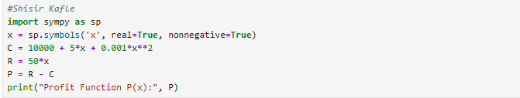
The import Sympy library to import the mathematical formulas. The second of the line creates a variable x using the symbols where real=True means that x is a real number and nonnegative=True means that x cannot be negative. C = 10000 + 5*x + 0.001*x**2 defines the cost function C. R=50*x means that the revenue function R. P=R-C calculates the profit function P which came by subtracting P from the revenue. Finally, last line print(“Profit Function P(x):”,P) displays the profit function as the output.
The given output of the code is the profit function which is calculated by subtracting the Revenue – Cost function.
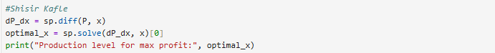
dP_dx = sp.diff(P, x) calculates the derivatives of the profit function P with respect to x which shows the profit changes as the production changes. Second line of the code optimal_x = sp.solve(dP_dx,x) [0] solves the derivative equation and finds the value of x where the derivative is zero, which gives the production level for maximum profit. Finally, the print(“Production level for max profit:”, optimal_x) shows the output which maximizes the profit.
The given output shows the production level for max profit 22500.0000000000.

First line of the code, max_profit = P.subs(x,optimal_x) replaces the optimal production level (optimal_x) into the profit function P to calculate the maximum profit. Print(f”Maximum Profit: ${max_profit:, .2f}) displays the maximum profit as the output, where :,.2f formats the number with commas and shows the exactly two decimal places.
The output of the function is $496.250.00
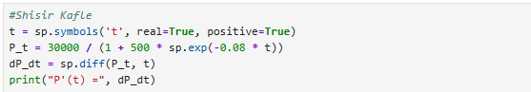
The code creates a t symbol variable using symbols where real = True means that t is a real number and positive = True indicates that t is a real number and positive = True means that t must be greater than zero. P_t = 30000 / (1 + 500 * sp.exp(-0.08 * t)) defines the population.
The output of the code is P'(t) = 1200000.0*exp(-0.08*t)/(1 + 500*exp(-0.08*t))**2
The following code shows on how fast bacteria are growing after 30 hours. Variable named dP_dt represents the rate at which the bacteria population is changing over the time. Subs(t, 30) puts the 30 in the place of t. So, the code calculates the growth rate specially at 30 hours. The evalf() function is used to converts the growth rate into a decimal number so its easier to read. After that the print() function is used print the output in bacteria/hour.
The output of the code is Rate of increase at 30 hours is 50.6532 bacteria/hour.
The following code finds the exact times when the bacteria are growing at the speed of 200. First of all, valid_times solves the equation to find out when the growth rate is equals to 200. This valid_times gives the possible times. It removes the negative valid times between 0 and 200 hours. The result gives the output in screen when the bacteria growth rate is 200.
The time when the growth rate is 200 is in 49.0272 and 106.3380 hours
The given code helps to find when the bacteria growth is the fastest. First of all, d2P_dt2 = sp.diff(dP_dt, t) helps to calculate the second derivatives of the population function. This line tells how the growth rate itself is changing over the time. It means that it helps to find where the growth switches from increasing to decreasing. Another line sp.solve(d2P_dt2, t)[0].evalf() solves the equation where the second derivatives is equal to zero. This means that the time when the growth is at maximum.[0] takes the first solution from the list of answers and evalf() converts it into a decimal number.
The output is the fastest growth is 77.6826 hours
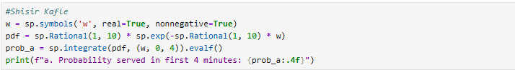
The following code calculates the probability of a waiting time for first 4 minutes. First of all, w is defined as a variable which represents time which is assumed to be a real and non-negative value as time can’t be negative. Next line of a code PDF is defined as the probability density function (PDF) which describes how waiting times are distributed and where shorter waiting times are more likely than longer one. The code sp.integrate(pdf, (w,0,4)) calculates the area under curve of the PDF from 0 to 4 minutes. This area represents the probability that the waiting time is between 0 and 4 minutes. And then print displays the probability function with rounded four decimal place.
The output of the code is 0.3297
The code calculates the probability waiting time for more than 12 minutes. First of all, prob_b = sp.integrate(pdf, (w,12,sp.oo) helps to calculate the area under the probability curve from 12 minutes to infinity. This area represents the chance of waiting time is longer than 12 minutes.
The probability waiting for more than 12 minutes is 0.3012.
The given code is used to calculate the probability waiting time between 8 and 12 minutes. First of all, prob_c = sp.integrate(pdf, (w,8,12)) calculates the area under the probability curve from 8 to 12 minutes. This area represents how likely the waiting time falls within the range.
The output is probability waiting time between 8 and 12 minutes is 0.1481.
The following code finds the median waiting time. First of all the code m = sp.symbols('m', real=True, positive=True) creates a variable m which represents the unknown median time. The unknown median time is assumed to be a real positive number since time cannot be negative. median_eq = sp.integrate(pdf, (w, 0, m)) - 0.5 makes the equation. Integrtion from limit 0 to m gives the probability in which the waiting time is less than or equal to m. Subtracting 0.5 means to find the value of m where exactly 50% of people are served which defines the median.
The output is median waiting time is 6.9315 minutes

