Week 6 Assignments

Shisir Kafle
Westcliff University
BSIT 326: Applied Numerical Analysis
Prof. Lekhnath Timalsena
July 26, 2026

Week 6 Assignments
Figure 1
Analytical solution of Question A
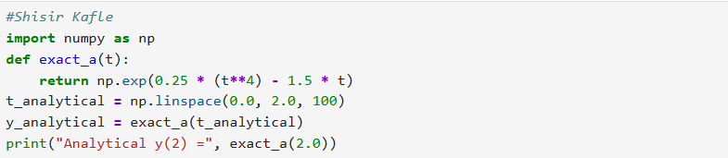
The following code uses the Numpy to calculate the analytical function. First of all, NumPy is imported as np and then defines function exact_a(t) which returns the exponential value. After that np.linespace creates 100 evenly spaced values of t between 0 and 2 and exact_a calculates the functions values for all those points. Finally, the result is printed at t=2 and displays the analytical value of y(2).
Figure 2
Output of analytical solution of Question A
The output is 2.718281828459045

Figure 3
Euler at h = 0.25 of Question A
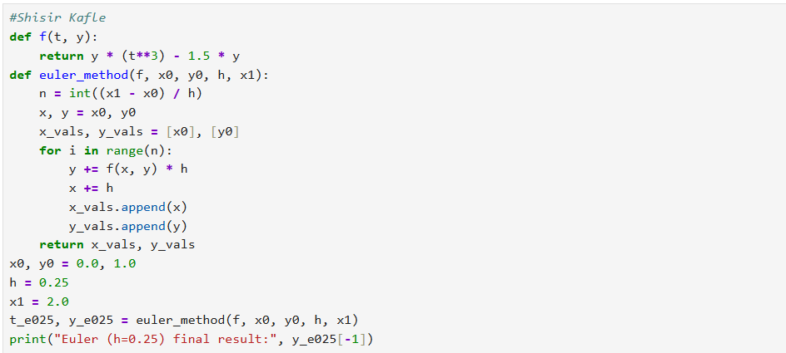
The python code uses the Euler method to solve the equations. The function f(t,y) defines the differential equation of variable t and y. Euler method euler_method(f,x0,y0,h,x1) applies the Euler’s method starting from x0=0, y0=1 using a step size of h = 0.25 till x1= 2. Each loop increases y using the function y = y + f(x,y) * h and then increases x by the step size and calculates x and y values in the lists. So, the code is run and prints the numerical value of y at x = 2 using Euler method.
Figure 4
Output of Euler Method 0.25 of Question A
The output of Euler method is 0.529694828397087

Figure 5
Euler method at h=0.5 of Question A
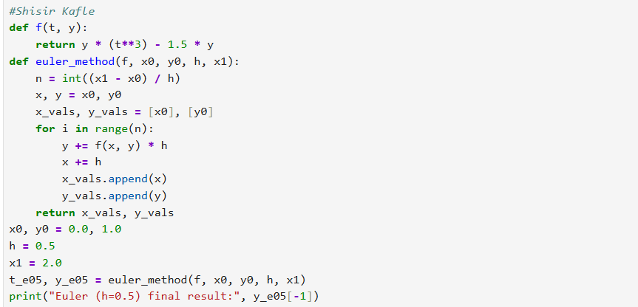
The python code uses the Euler method to solve the equations. The function f(t,y) defines the differential equation of variable t and y. Euler method euler_method(f,x0,y0,h,x1) applies the Euler’s method starting from x0=0, y0=1 using a step size of h = 0.5 till x1= 2. Each loop increases y using the function y = y + f(x,y) * h and then increases x by the step size and calculates x and y values in the lists. So, the code is run and prints the numerical value of y at x = 2 using Euler method at h = 0.5.
Figure 6
Output of Euler at h = 0.5
The output is 0.113525390625

Figure 7
Runge Kutta Fourth Order of Question A
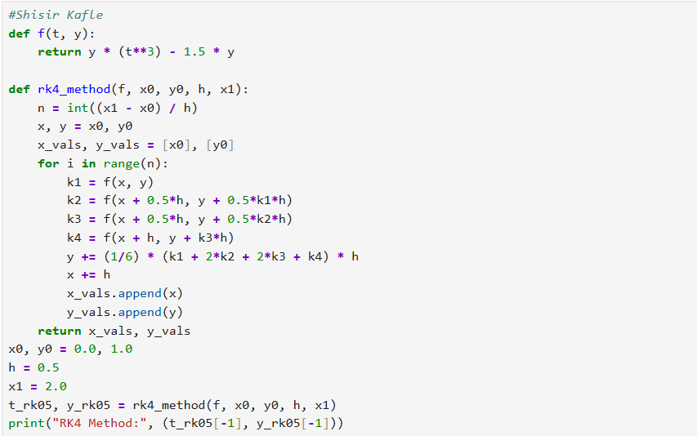
The following code uses the python program to solve the differential equation from x0=0 and y0=1. The function is defined and it divides the interval from x = 0 and 2 using h =0.5. It calculates the four slopes k1, k2, k3 and k4. Then the step is converted into the formula to obtain the approximation value of y than the euler method. Then the output is printed.
Figure 8
Output of RK4 Method
The output is RK4 Method: (2.0, 2.5130724732170266)

Figure 9
Graph Code of Euler and Rk4 Methods
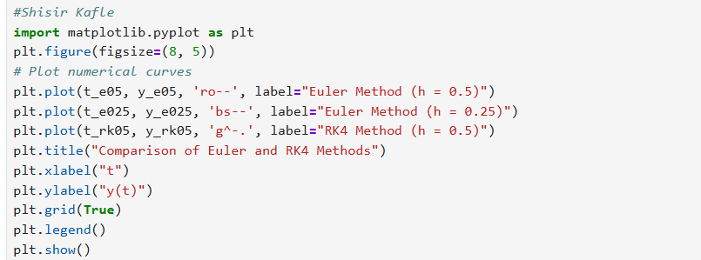
The following code uses the Matplotlib to draw a graph and compare the Euler and Rk4 methods. It plots the three results using different colors and symbols. Plt.title gives the graph of a title, xlabel and ylabel labels the x and y axes and grid adds girds and legends and plt.show displays the graphs.
Figure 10
Graph of Euler and RK4
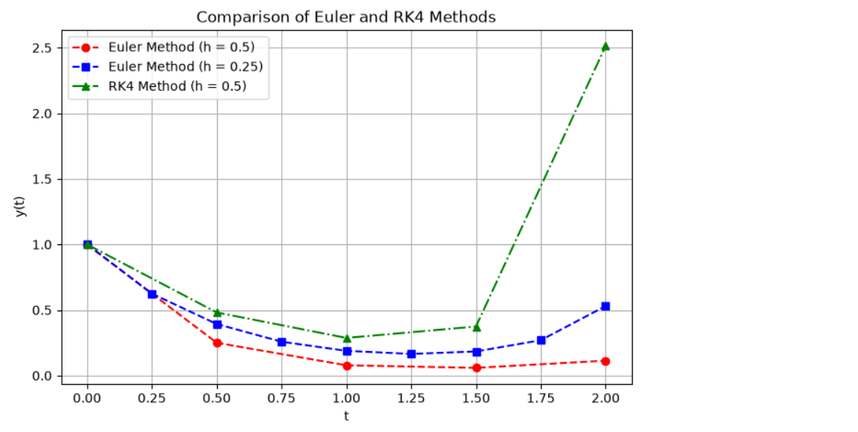
The graphs compares the Euler and Rk4 methods for solving a differential eqution. Red line shows euler at h = 0.5, blue line shows euler at h = 0.25 and the green line shows rk4 at h = 0.5. All methods starts at y = 1 and then decrease the value at first. The red line gives the lowest values while the blue line gives the slightly higher value. The green line gives higher value about 2.5 at t = 2.
Figure 11
Analytical solution of Question B
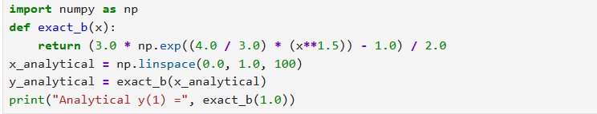
The following code uses the Numpy to calculate the analytical function. First of all, NumPy is imported as np and then defines function exact_b(x) which returns the exponential value. After that np.linespace creates 100 evenly spaced values of y between 0 and 1 and exact_a calculates the functions values for all those points. Finally, the result is printed at t=1 and displays the analytical value of y(1).
Figure 12
Output of Analytical value of y1
The output is 5.190501842024766

Figure 13
Euler at h = 0.25 of Question B
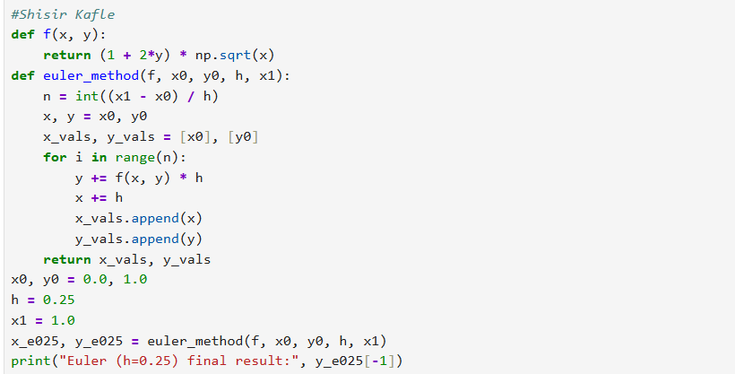
The python code uses the Euler method to solve the equations. The function f(t,y) defines the differential equation of variable t and y. Euler method euler_method(f,x0,y0,h,x1) applies the Euler’s method starting from x0=0, y0=1 using a step size of h = 0.25 till x1= 2. Each loop increases y using the function y = y + f(x,y) * h and then increases x by the step size and calculates x and y values in the lists. Then the code prints the output.
Figure 14
Output of Euler Method Question B
The output is 3.1368610026427035

Figure 15
RK method at 0.25
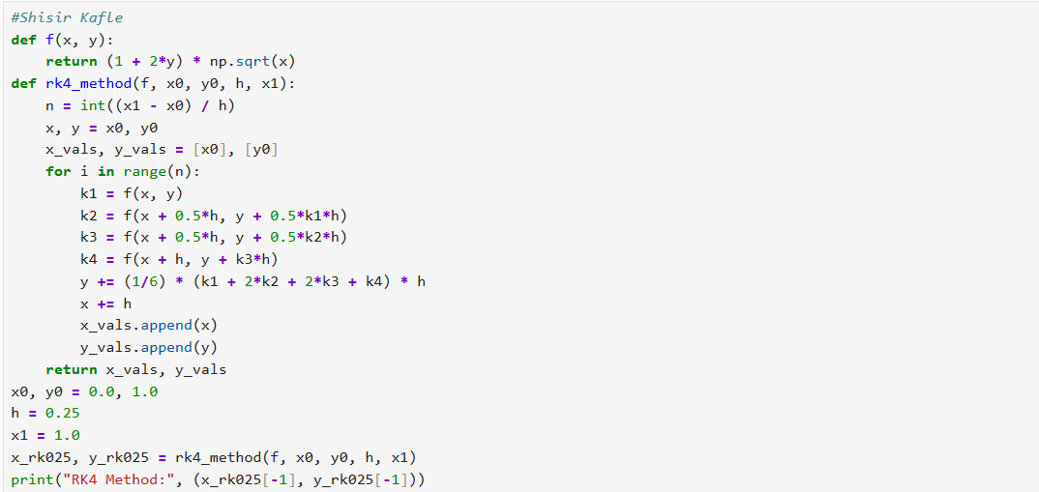
The following code uses the python program to solve the differential equation from x0=0 and y0=1. The function is defined and it divides the interval from x = 0 and 1 using h = 0.25. It calculates the four slopes k1, k2, k3 and k4. Then the step is converted into the formula to obtain the approximation value of y than the euler method. Then the output is printed.
Figure 16
Output
The output is RK4 Method: (1.0, np.float64(5.147546634590661))

Figure 17
Graph code of Euler method and RK4 method
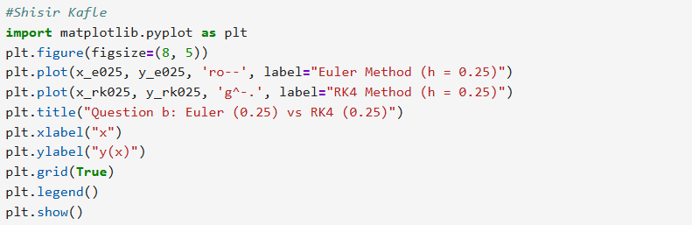
The following code uses the Matplotlib to draw a graph and compare the Euler and Rk4 methods. It plots the three results using different colors and symbols. Plt.title gives the graph of a title, xlabel and ylabel labels the x and y axes and grid adds girds and legends and plt.show displays the graphs.

Figure 18
Graph code of Euler method and RK4 method
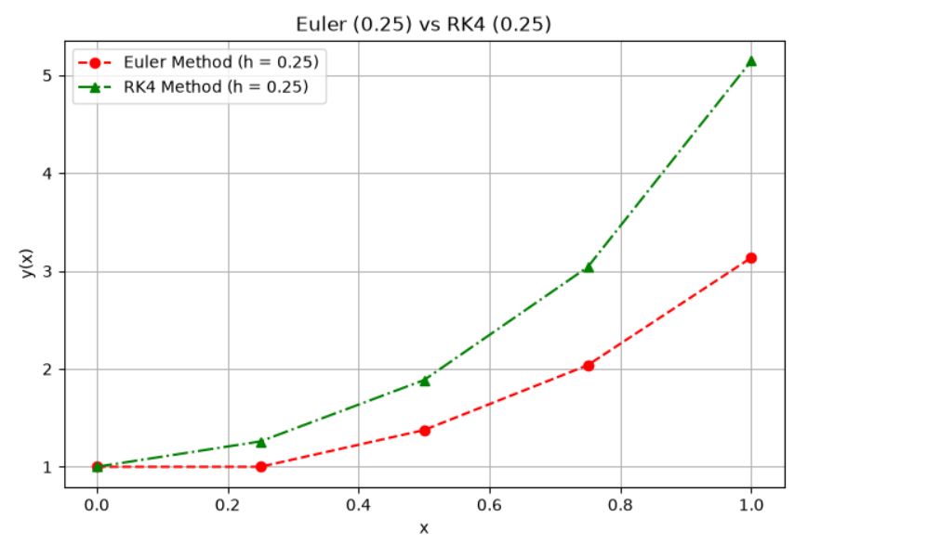
The figure compares Euler and RK4 methods using both h = 0.25. Both starts at y = 1. RK4 increases faster than Euler. At x = 1, Rk4 reaches about 5.2 while Euler reaches about 3.1. This shows that two methods give different results while RK4 produces the higher values.

