Temperature Estimation using Interpolation Methods

Shisir Kafle
Westcliff University
BSIT 326: Applied Numerical Analysis
Prof. Lekhnath Timalsena
July 26, 2026

Temperature Estimation using Interpolation Methods
Dataset
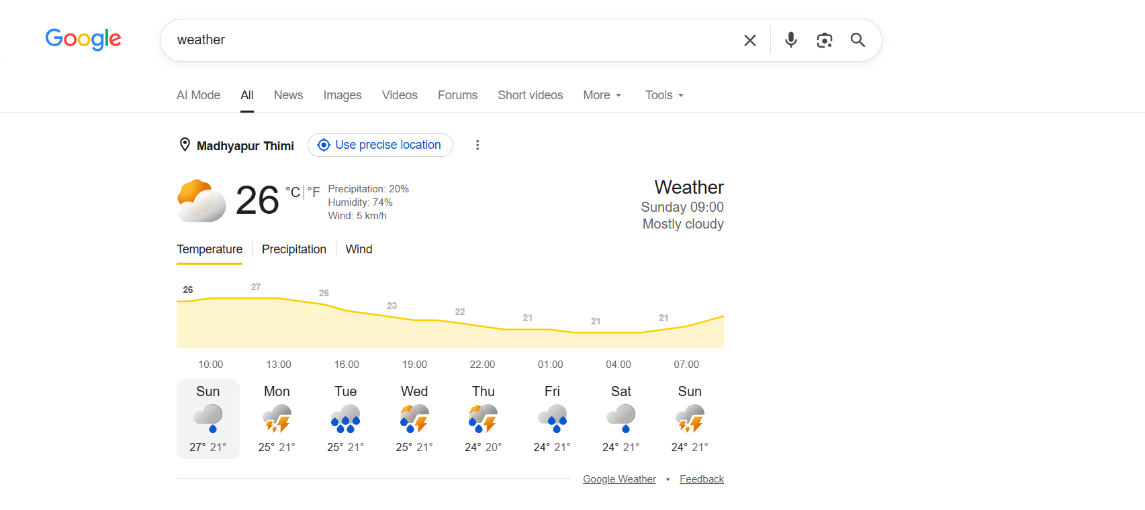
Location: Madhyapur Thimi, Nepal
Source: Google Weather App
Day: Sunday
Interpolation Point:
The prediction time is at 5 PM using Lagrange Interpolation and Newton Divided Difference Interpolation
Python Implementation of Lagrange Interpolation
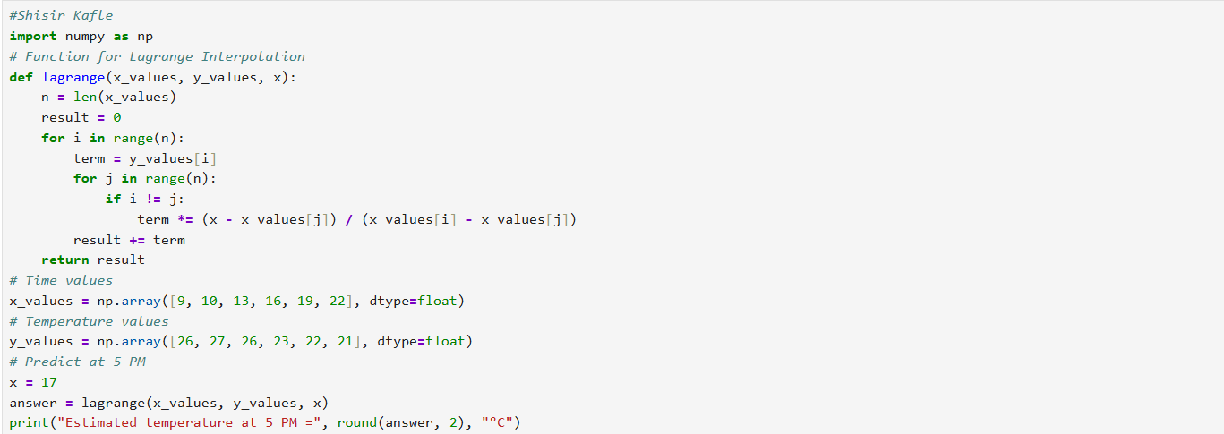
The following program uses the Lagrange Interpolation to find the temperature at 5 PM using six temperature readings. At first, the program imports the NumPy library to perform array implementation and to work with it. Then it creates a function lagrange() which performs the interpolation calculation. The recorded time and their corresponding temperatures are stored in two arrays. The program uses these values to calculate an estimated temperature for the required time.
The estimated temperature at 5 PM is 22.37 °C.
Python Implementation of Newton Divided Difference Interpolation
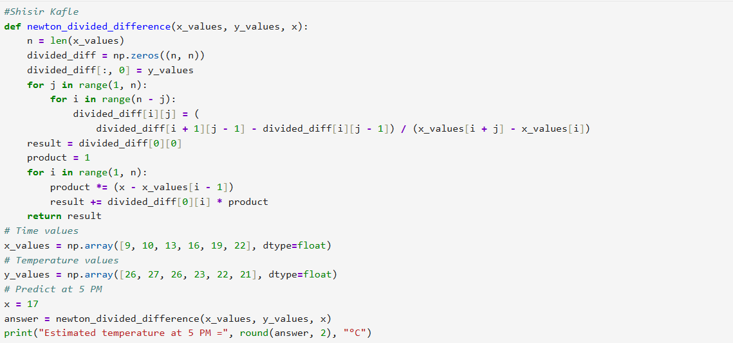
The following program uses the Newton Divided Difference to find the temperature at 5 PM using six temperature readings. Function newton_divided_difference() is created to calculate the interpolated temperature. The program then builds a divided difference table using the recorded time and temperature values. Then it is used to form the interpolation equation. The recorded times and temperatures are stored in two arrays and the value 17 is used to represent the time in 24 hour format. At last, the program calculates the estimated temperature at 5 PM using the Newton Interpolation method.
The estimated temperature is 22.37 °C.
Result and Analysis
Estimated Temperature
After calculating both methods using python program, the estimated temperature at 5 PM is approximately as shown in the table below:
Interpolation Method | Estimated Temperature
Lagrange Interpolation | 22.37 °C
Newton Divided Difference Interpolation | 22.37 °C
Comparison of the Two Methods
Both the Lagrange and Newton Interpolation methods produced the same estimated temperature because they are based on the same interpolation polynomial using the same set of data points. The difference between the methods lies in the way the polynomial is formed rather than the final result.
Lagrange interpolation directly finds the interpolation polynomial using the basis polynomials. This method is straight to implement which work well for the small datasets. However, if a new temperature reading is added then the entire polynomial must be recalculated.
Newton Divided Difference interpolation constructs the interpolation polynomial using a divide difference table. Although it requires an additional pre requisite step. After the step it is more efficient because new data points can be found without recalculating the entire polynomial.
Accuracy Evaluation
The interpolation point at 5 PM lies between the recorded temperature at 4 PM on 23 °C and 7 PM at 22.37 °C. It shows the estimated value of approximately 22.37 °C is reasonable and follows the decreasing temperature which tends to be observed throughout the evening.
Since both the interpolation methods use the same dataset, they provide nearly identical predictions. If the actual temperatures at 5 PM were available from the weather application then the interpolation error could be calculated the predicted value with the observed value.
Computational Efficiency
Feature | Lagrange | Newton
Implementation | Simple | Moderate
Suitable for small datasets | Yes | Yes
Efficient when adding new data | No | Yes
Requires divided difference table | No | Yes
Computational efficiency | Lower | Higher
Practical Applications
Lagrange Interpolation
- It is used for weather and climate data estimation
- It is used for Laboratory experiments
- It is used in Engineering measurements
- It is used in Educational demonstrations of interpolations
Newton Divided Difference Interpolation
- It is used in Numerical Analysis
- It is used in scientific computing
- It is used in sensor data processing
- It is used in weather forecasting
- It is used in applications where new observations are frequently added
Conclusion
The results collected after reading six temperatures collected from the Google weather application for Sunday is estimated at 5 PM using Lagrange and Newton Divided Difference interpolation methods. Both of the methods produced an estimated temperatures of approximately 22.37 °C. This shows that both of the methods generate the interpolation polynomial for a given dataset. Lagrange interpolation is easier to understand and implement. Newton Interpolation is more accurate when the additional data points needs to be added (Werner, 1984). So, Lagrange interpolation is best suitable for small static datasets (Quadling, 1966). Newton interpolation is recommended for larger or frequently updated datasets.

References
Quadling, D. A. (1966). Lagrange’s Interpolation Formula. The Mathematical Gazette, 50(374), 372–375. https://doi.org/10.2307/3613934
Werner, W. (1984). Polynomial Interpolation: Lagrange versus Newton. Mathematics of Computation, 43(167), 205–217. https://doi.org/10.2307/2007406

