Assignment I

Shisir Kafle
Westcliff University
BSIT 326: Applied Numerical Analysis
Prof. Lekhnath Timalsena
July 12, 2026

Assignment 1
Newton Raphson Method
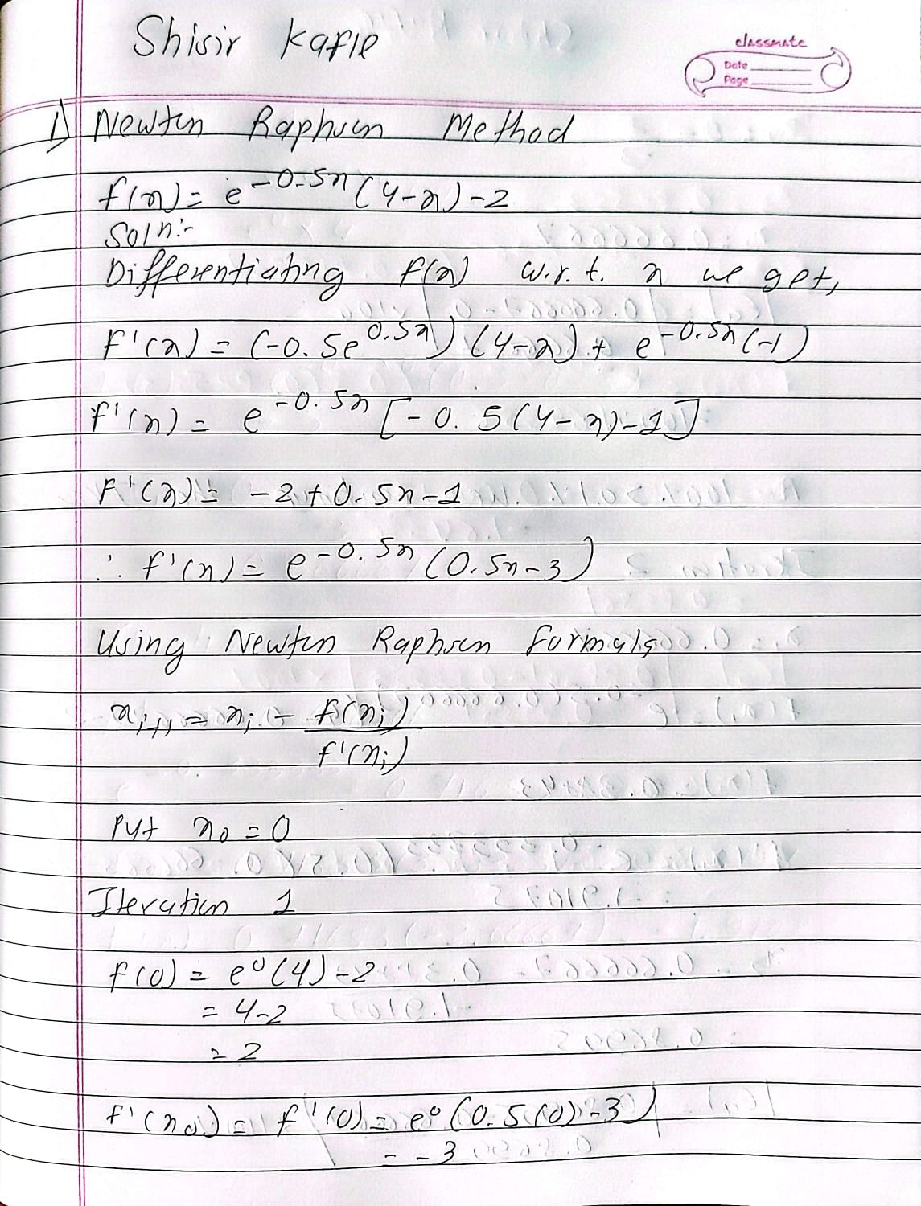
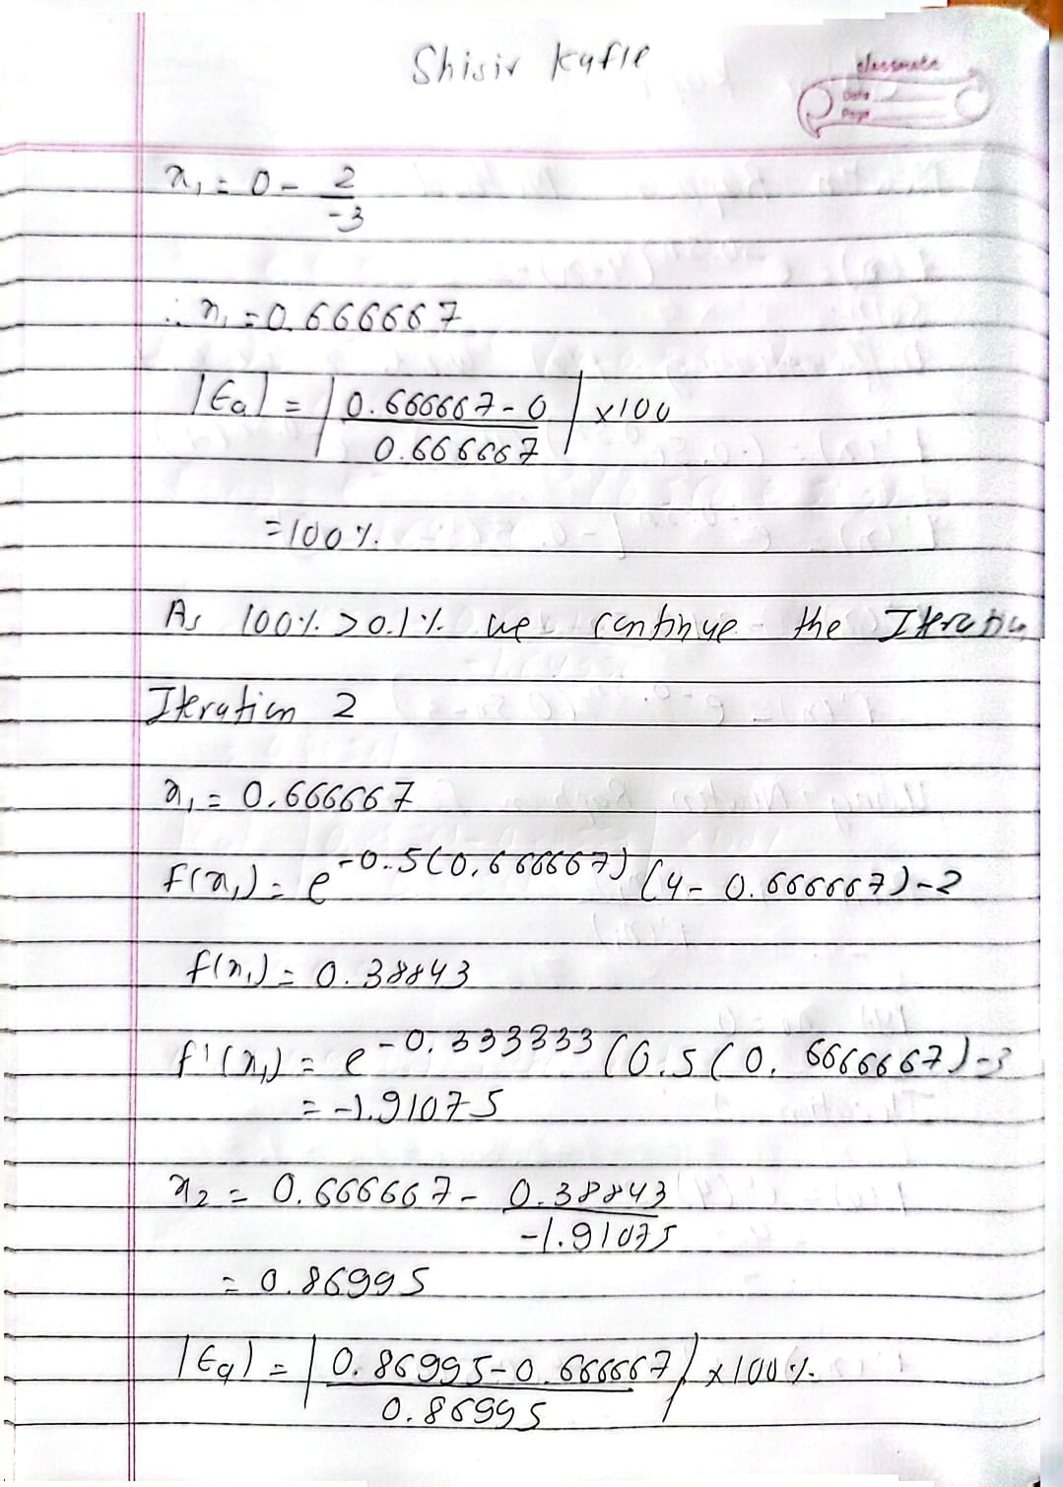

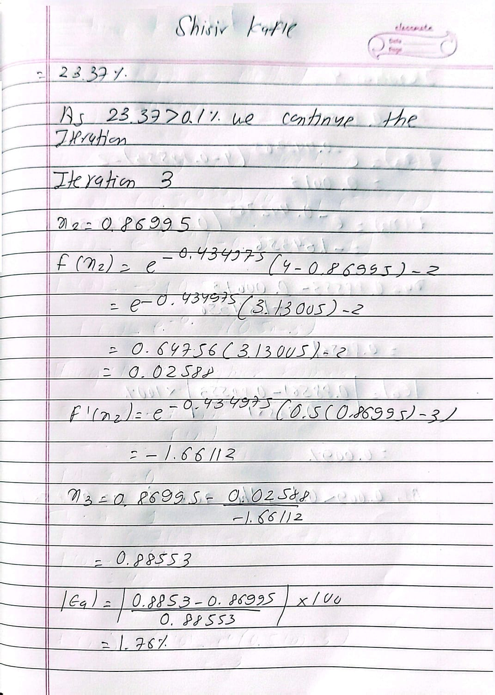
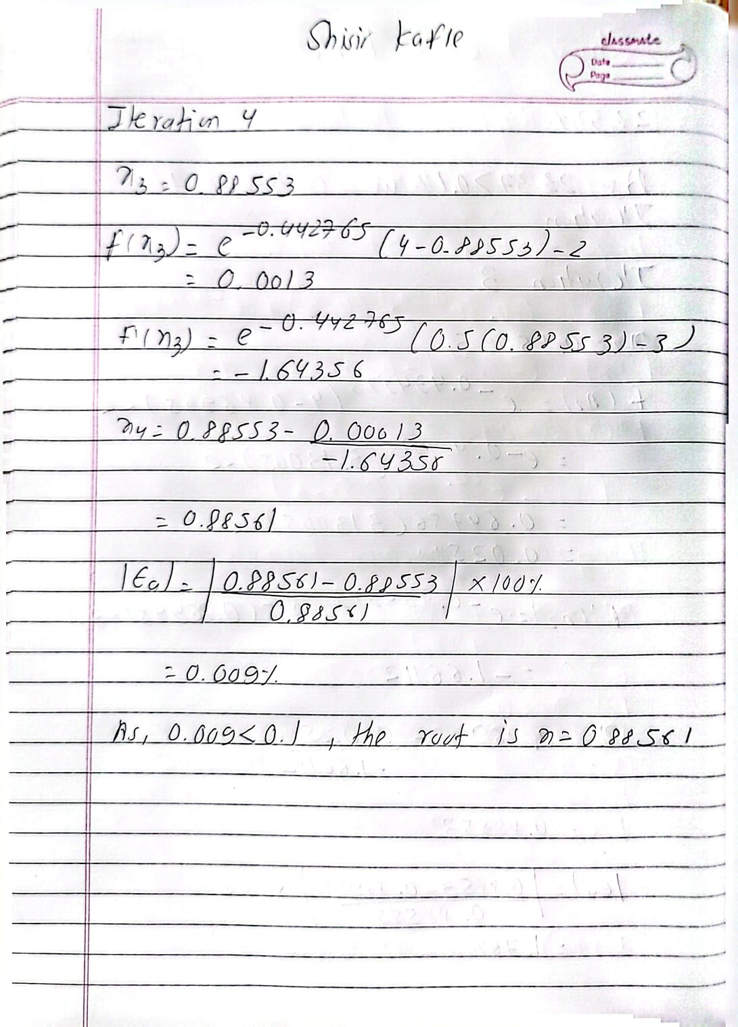
Code Implementation of Newton Raphson Method
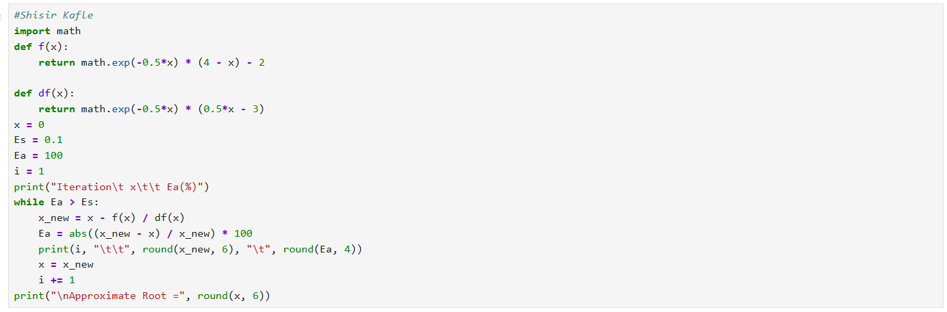
The following program helps to find the root of the equation using Newton Raphson Method. First of all, f(x) and its df(x) is defined as def().The x=0 is the first initial guess to solve the simplification of the program. While loop calculates a new approximation (x_new) using the Newton Raphson method. Then, The approximate error (Ea) is found. The loop is run until the error is 0.1% and then it prints the root of the equation.

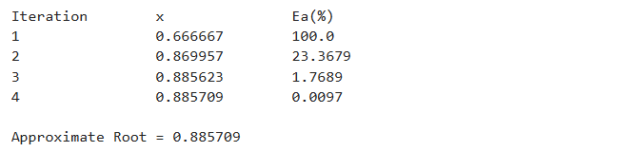
The output of the program is approximate root is 0.885709

Secant Method
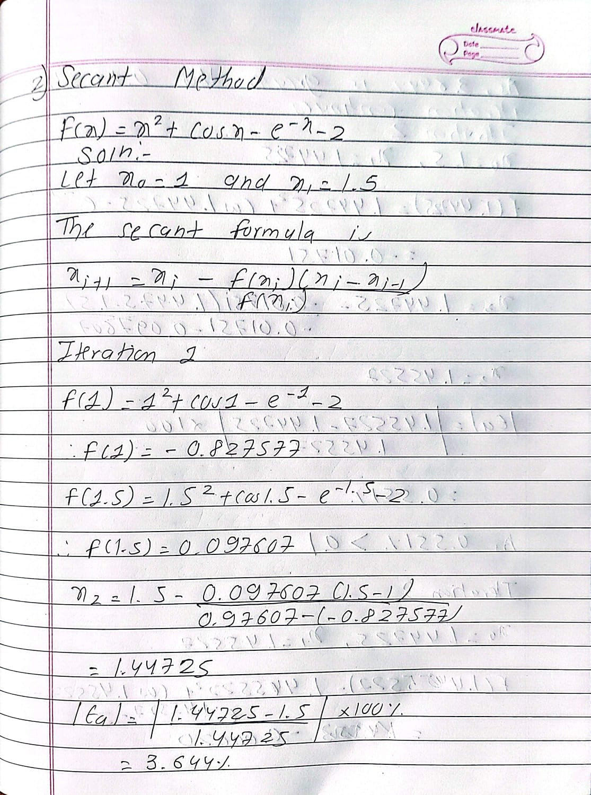

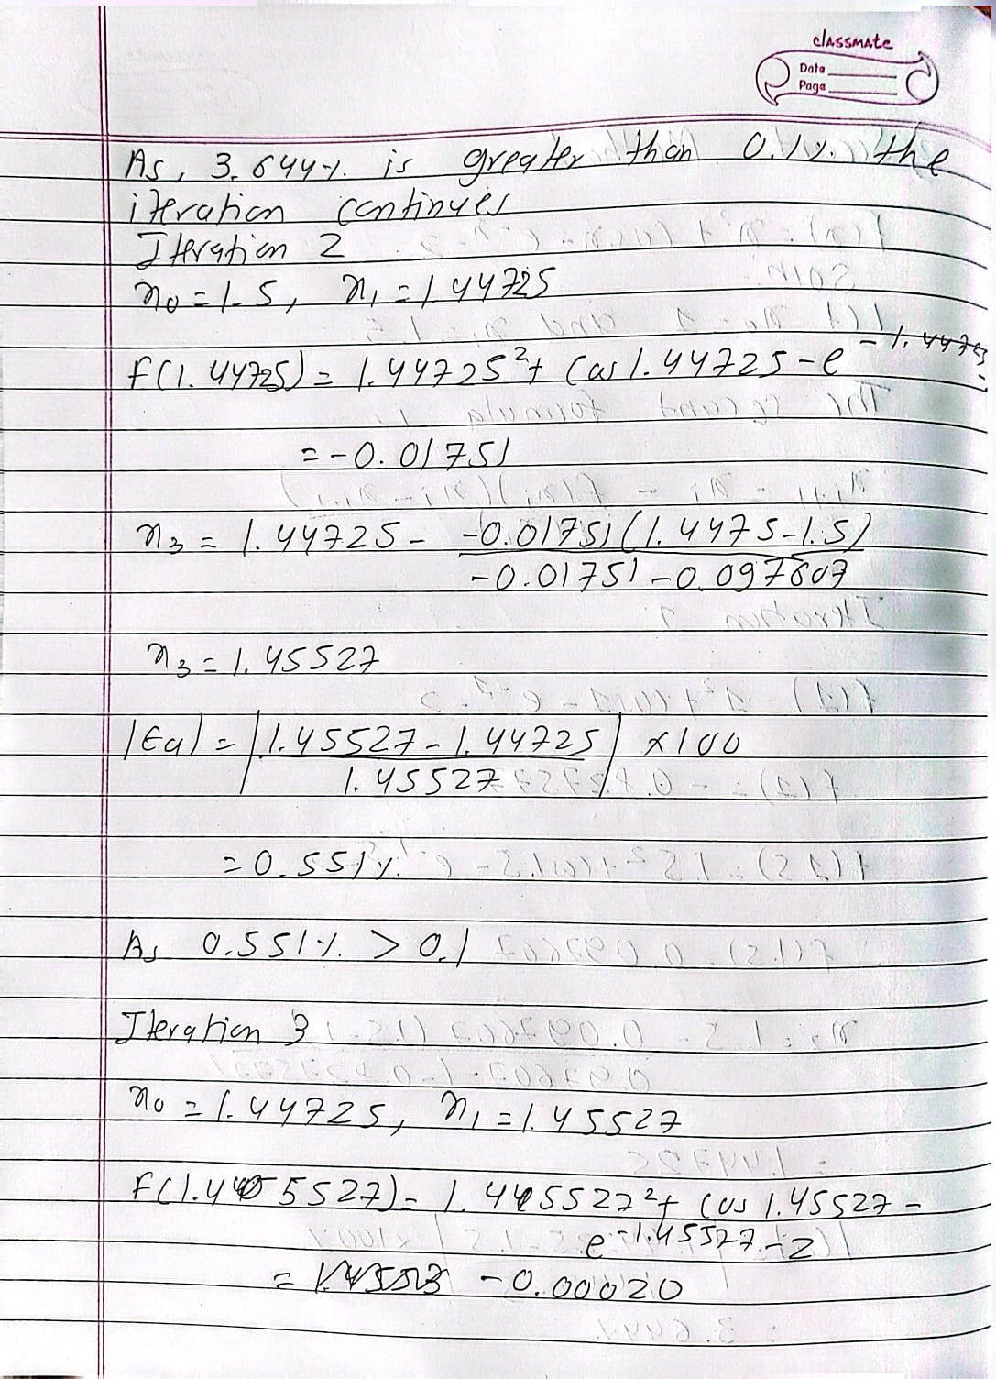
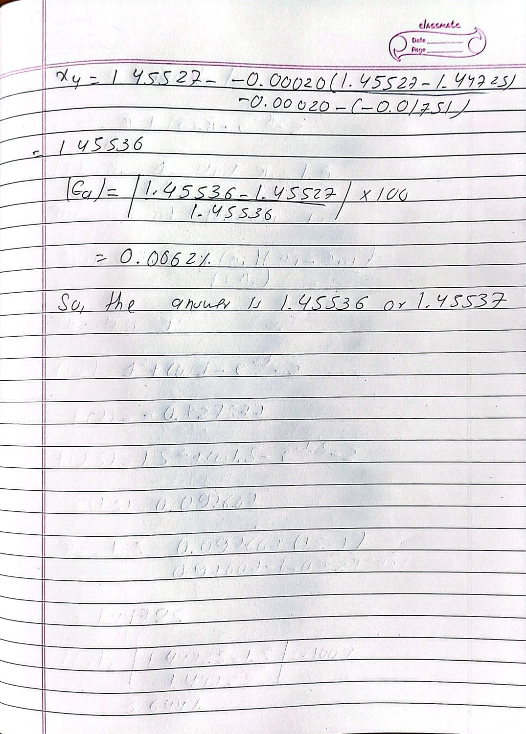
Python Implementation for Secant Method
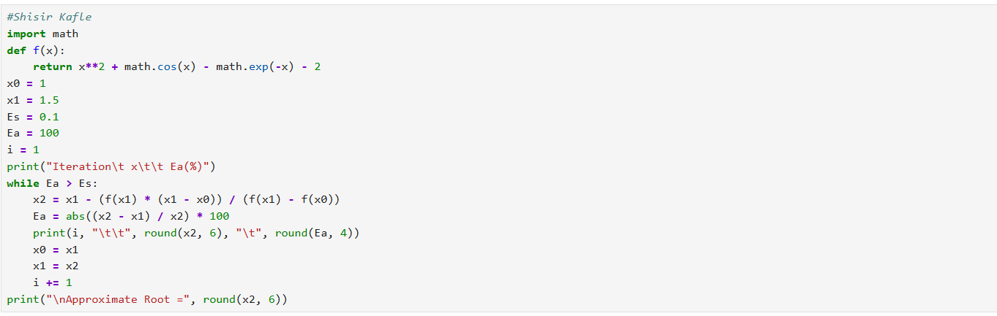
The following program is the secant method implementation in python for finding the roots of the equation. At first, function f(x) is defined using def. After that, it starts with the two values x0=1 and x1=1.5 using variables.. While loop calculates a new approximation x2 using the Secant Method formula. Then it calculates the approximate error Ea. The loop continues until the error becomes less than 0.1%. And then it prints the output.
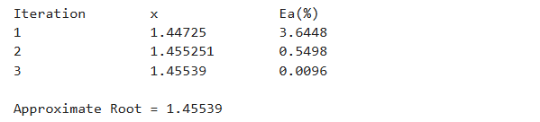
The output of the code is 1.45539

