Assignment II

Shisir Kafle
Westcliff University
BSIT 326: Applied Numerical Analysis
Prof. Lekhnath Timalsena
July 19, 2026

Assignment II
Gauss Elimination Method
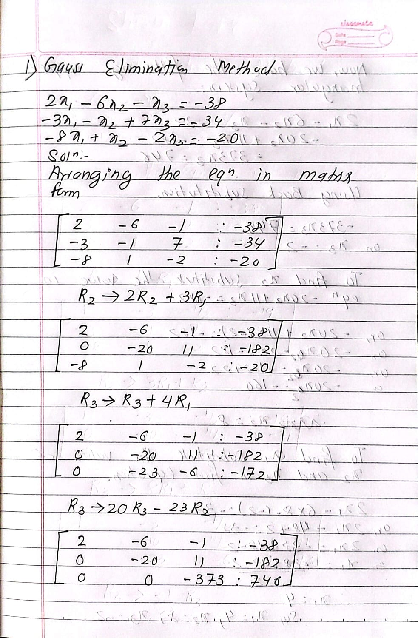

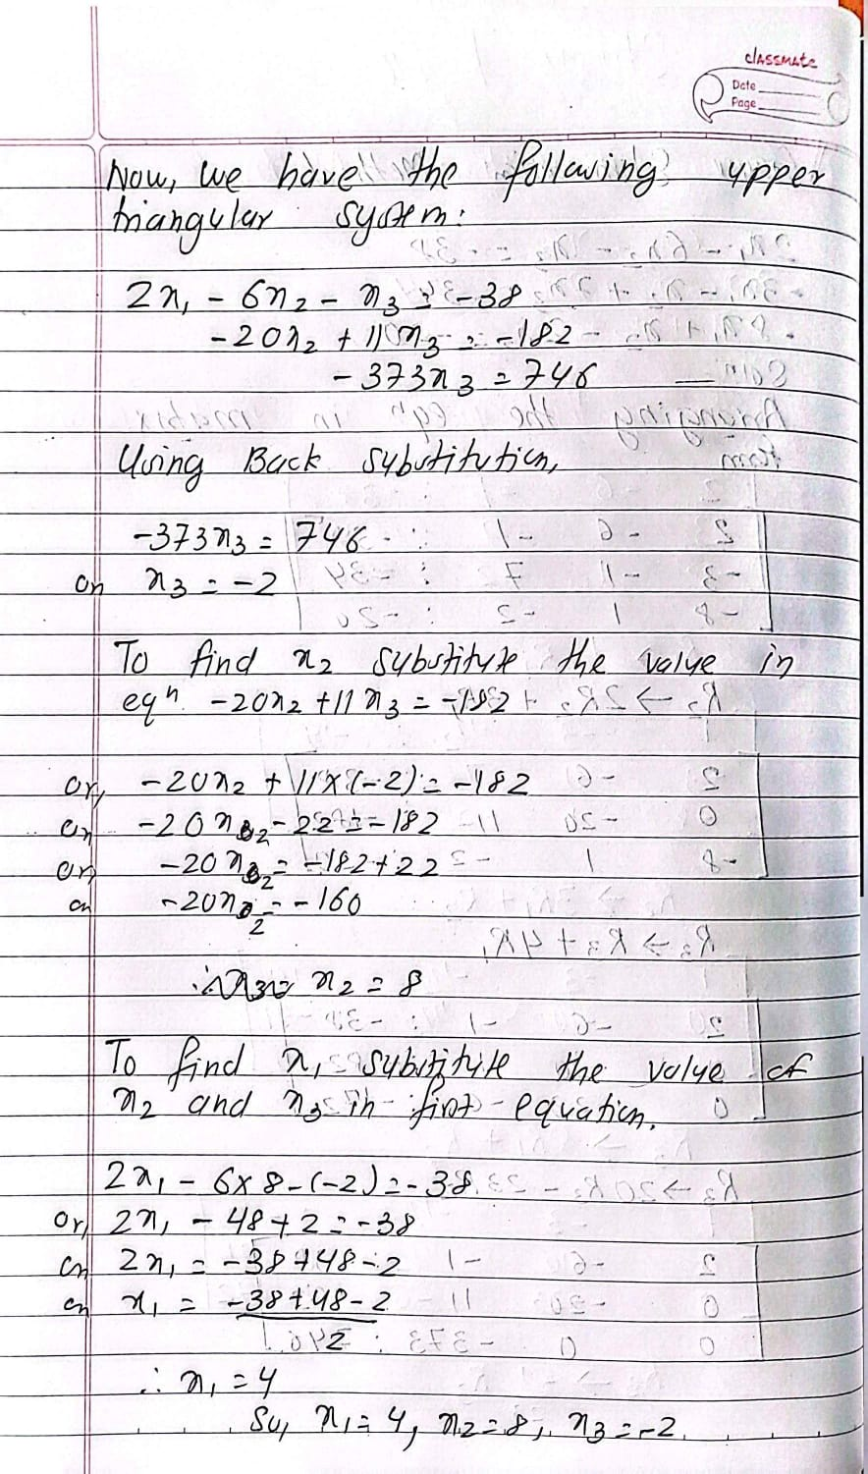
Code Implementation for Gauss Elimination Method
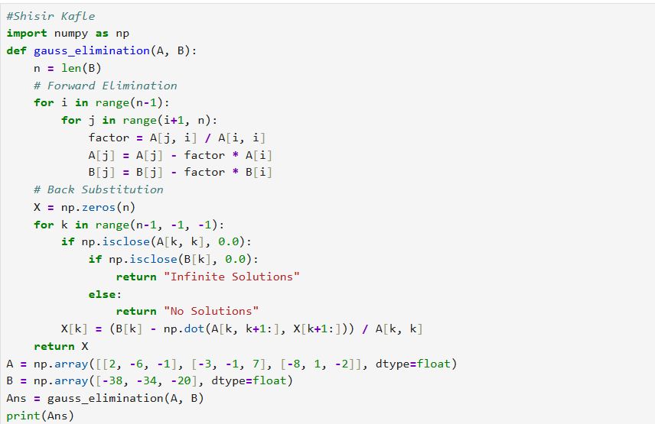
The following programs solves a linear equations using the Gauss Elimination method. It Imports the NumPy to solve the matrix calculations. The function is gauss_elimination(A,B) and has the coefficient matrix A and the vector B. It starts the forward elimination. In forward elimination, it removes the values below the main diagonal to convert into the coefficient matrix into an upper triangular matrix. Then the program performs the back substitution when the last equation value is found. Then the program checks if the equation has infinite solutions or no solutions. If there is a unique solution then it returns the values.
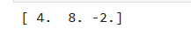
The output of the solution is x1 =4 , x2 = 8 and x3 = -2.

Gauss Jordan Method
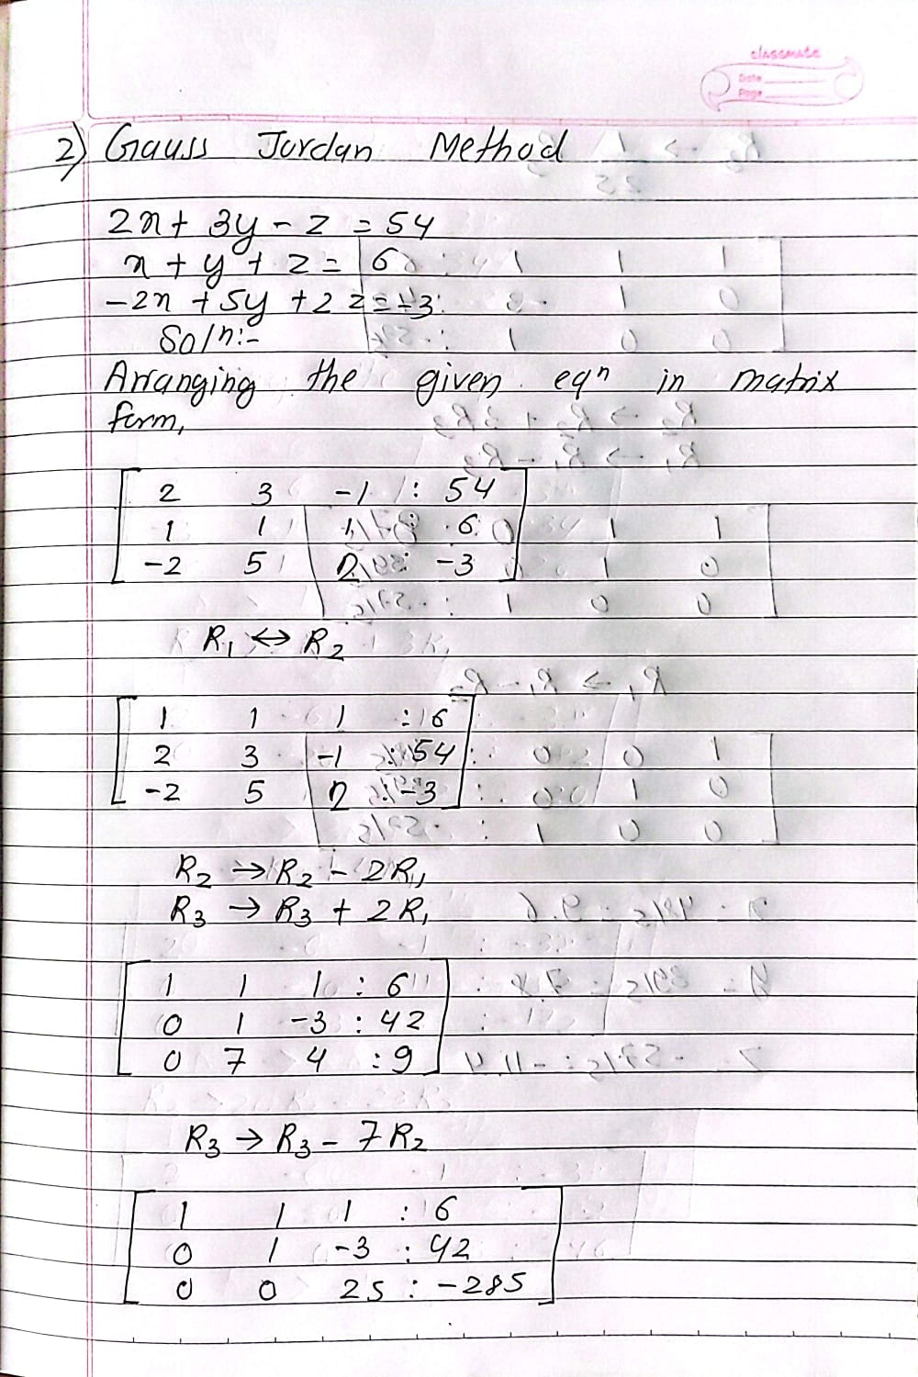

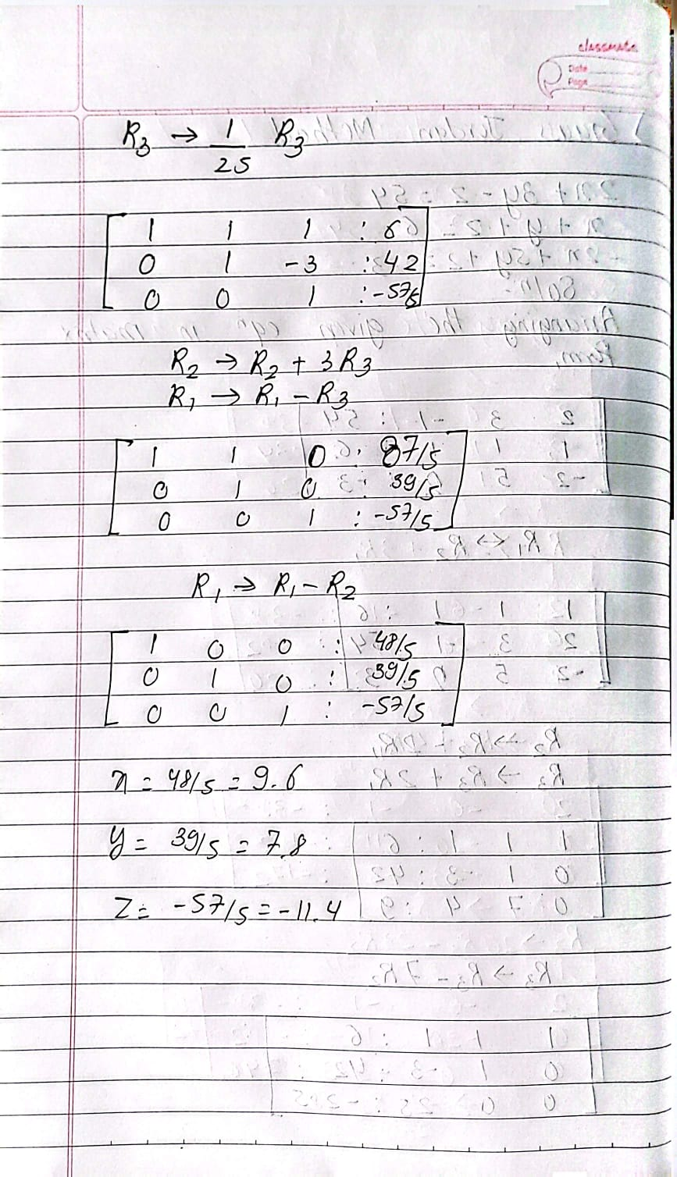
Code Implementation for Gauss Jordan Method
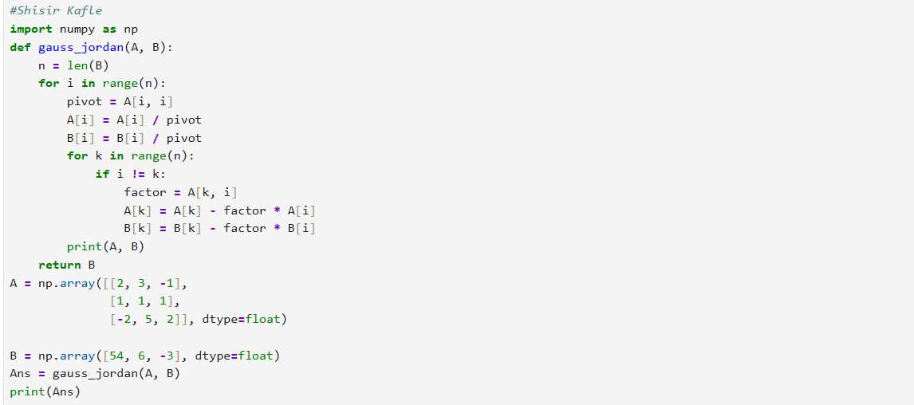
The code solves the linear equations using the Gauss Jordan Method. First of all, it NumPy library is imported to work with the matrices. Then, the function takes the two value A and B which are coefficient matrix and constant value as the input. The program then goes through the each rows. The program uses the diagonal value to make the pivot equal to 1. It makes the pivot 1 when dividing by the whole row. The program removes the other numbers in the same column by subtracting from other pivot row. This process is repeated when the matrix becomes an identity matrix of 0 and 1. The program then displays the updated matrix. The Values in B are the answer to the equations and it is returned and printed.
The output of the program is x = 9.6, y = 7.8 and z = -11.4.

Gauss Seidel Method
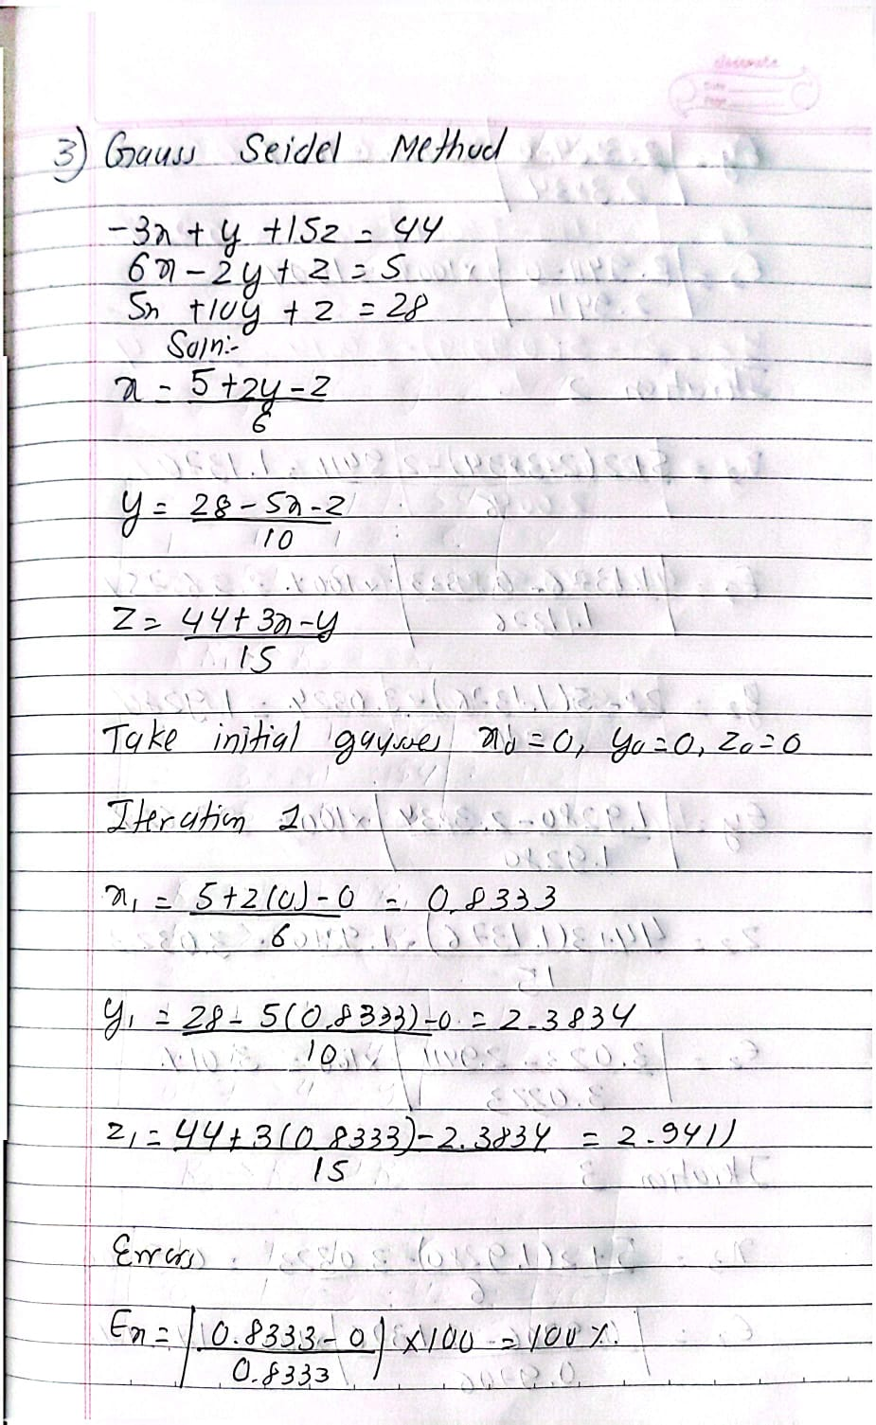

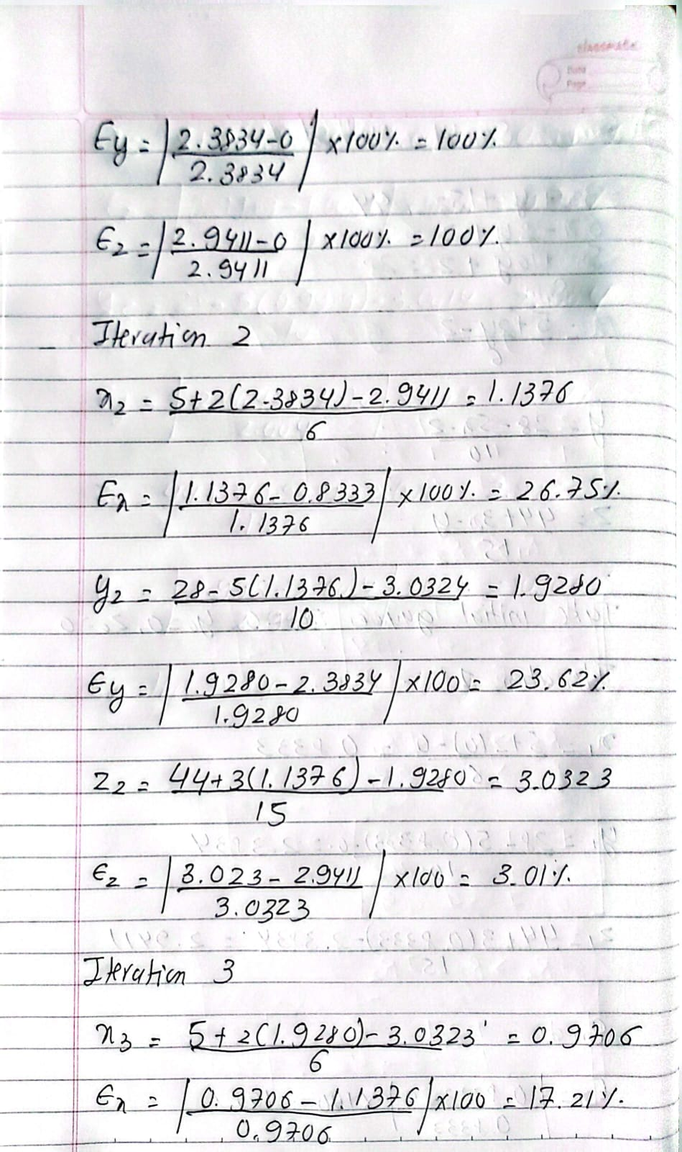
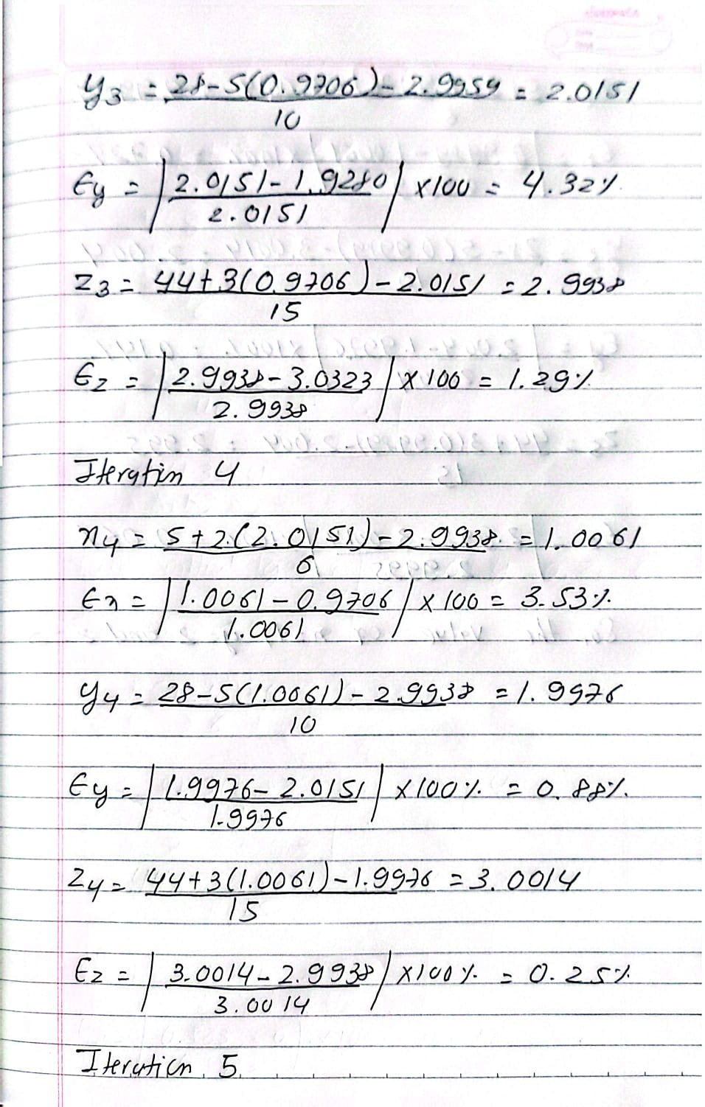
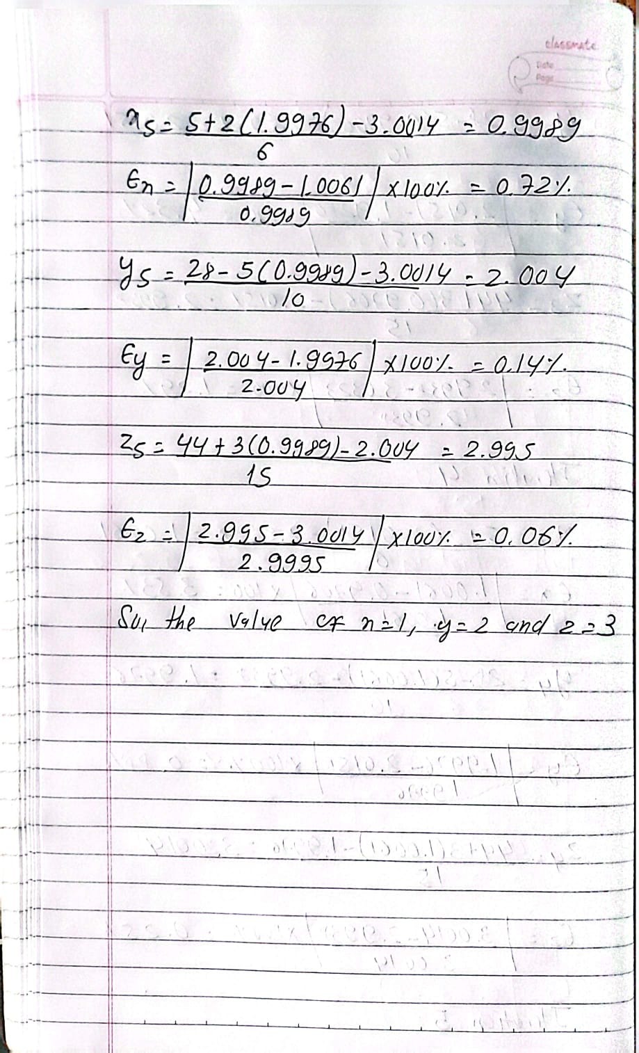
Program Implementation for Gauss Seidel Method
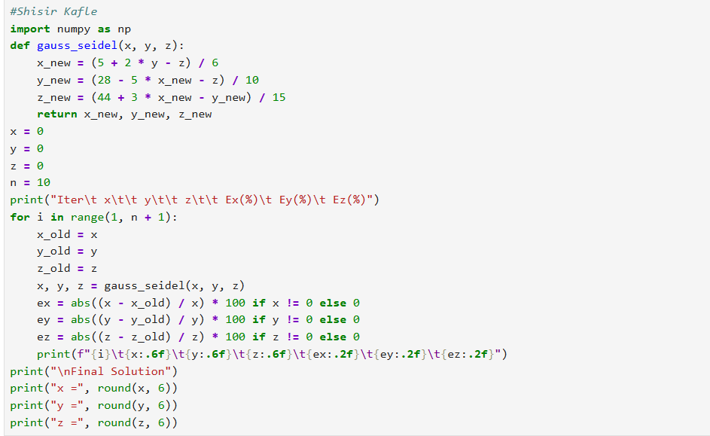
The program is the Gauss Seidel Method to solve the linear equations. Numpy library is imported and then it defines a function to calculate the new values of x, y and z using the equations. The program then begins with the initial guesses of 0 for all the three variables. The program goes upto 10 iterations. In each iterations, the newly calculated value is used to find the next variable. The program also calculates the error percentage for x,y and z by comparing the new value with the previous ones. It then prints the values and errors of each variables. After completing all iterations it finds the approximate solutions to each values.
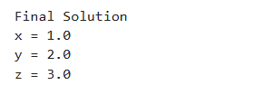
The output is x = 1.0, y = 2.0 and z = 3.0

