Assignment Week 7

Shisir Kafle
Westcliff University
MTH 306: Applied Calculus
Prof. Lekhnath Timalsena
June 21, 2026

Assignment Week 7
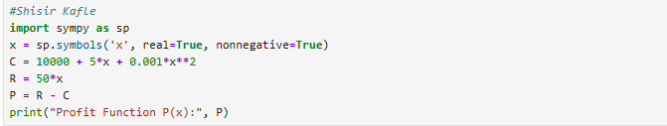
The import Sympy library to import the mathematical formulas. The second of the line creates a variable x using the symbols where real=True means that x is a real number and nonnegative=True means that x cannot be negative. C = 10000 + 5*x + 0.001*x**2 defines the cost function C. R=50*x means that the revenue function R. P=R-C calculates the profit function P which came by subtracting P from the revenue. Finally, last line print(“Profit Function P(x):”,P) displays the profit function as the output.
The given output of the code is the profit function which is calculated by subtracting the Revenue – Cost function.
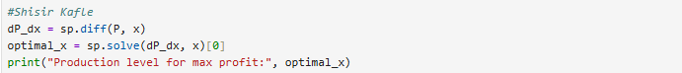
dP_dx = sp.diff(P, x) calculates the derivatives of the profit function P with respect to x which shows the profit changes as the production changes. Second line of the code optimal_x = sp.solve(dP_dx,x) [0] solves the derivative equation and finds the value of x where the derivative is zero, which gives the production level for maximum profit. Finally, the print(“Production level for max profit:”, optimal_x) shows the output which maximizes the profit.
The given output shows the production level for max profit 22500.0000000000.

First line of the code, max_profit = P.subs(x,optimal_x) replaces the optimal production level (optimal_x) into the profit function P to calculate the maximum profit. Print(f”Maximum Profit: ${max_profit:, .2f}) displays the maximum profit as the output, where :,.2f formats the number with commas and shows the exactly two decimal places.
The output of the function is $496.250.00
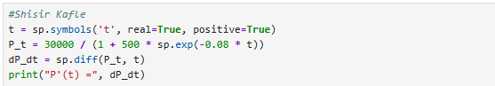
The code creates a t symbol variable using symbols where real = True means that t is a real number and positive = True indicates that t is a real number and positive = True means that t must be greater than zero. P_t = 30000 / (1 + 500 * sp.exp(-0.08 * t)) defines the population.
The output of the code is P'(t) = 1200000.0*exp(-0.08*t)/(1 + 500*exp(-0.08*t))**2
The following code shows on how fast bacteria are growing after 30 hours. Variable named dP_dt represents the rate at which the bacteria population is changing over the time. Subs(t, 30) puts the 30 in the place of t. So, the code calculates the growth rate specially at 30 hours. The evalf() function is used to converts the growth rate into a decimal number so its easier to read. After that the print() function is used print the output in bacteria/hour.
The output of the code is Rate of increase at 30 hours is 50.6532 bacteria/hour.
The following code finds the exact times when the bacteria are growing at the speed of 200. First of all, valid_times solves the equation to find out when the growth rate is equals to 200. This valid_times gives the possible times. It removes the negative valid times between 0 and 200 hours. The result gives the output in screen when the bacteria growth rate is 200.
The time when the growth rate is 200 is in 49.0272 and 106.3380 hours

