**Lab worksheet 1 Answer**

Q1.

Code:

|  |
| --- |
| package Q_01; import javax.swing.JFrame;  public class Q_01 {  public Q_01() {   }   public static void main(String[] args) {  JFrame myWindow = new JFrame();  myWindow.setSize(800, 600);  myWindow.setTitle("Welcome to Java");  myWindow.setVisible(true);  } } |

Output:

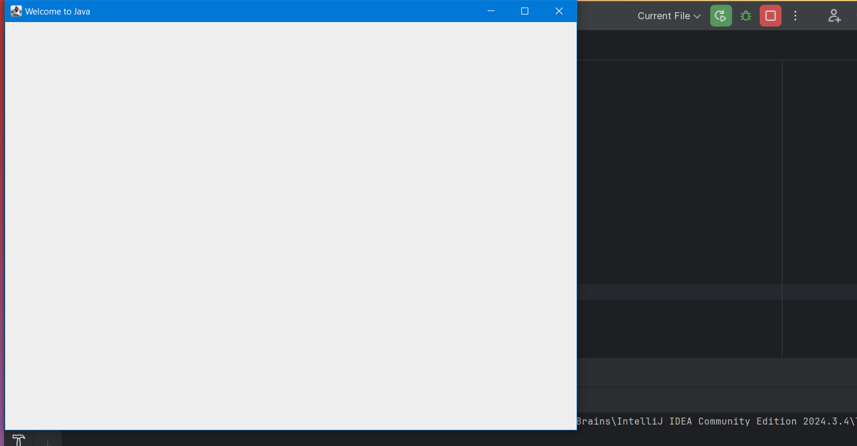

Q2.

Code:

|  |
| --- |
| package Q_02; import java.awt.*; import java.util.Scanner; import javax.swing.JFrame;  public class Q_02 {  public Q_02(){   }  public static void main(String[] args){  Scanner scanner=new Scanner(System.*in*);  System.*out*.println("Enter First Name: ");  String fName=scanner.next();  System.*out*.println("Enter your Last Name: ");  String lName=scanner.next();  JFrame window=new JFrame();  window.setSize(800,600);  window.setTitle(fName + " "+lName);  window.setVisible(true);  window.setDefaultCloseOperation(3); }  } |

Output:

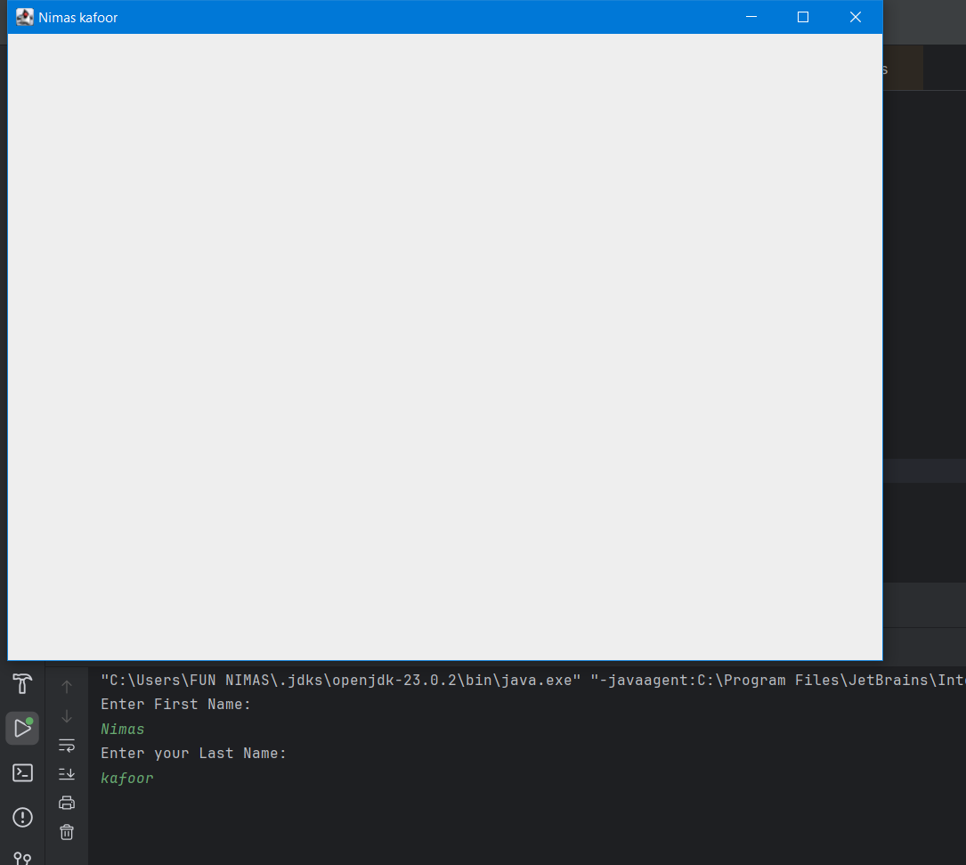

Q3.

Code:

|  |
| --- |
| package Q_03; import java.util.Scanner;  public class Q_03 {  public Q_03(){   }  public static void main(String[] args){  Scanner scanner=new Scanner(System.*in*);  System.*out*.println("Enter your first Name: " );  String fName=scanner.next();  System.*out*.println("Enter Your Middle Name: ");  String mName=scanner.next();  System.*out*.println("Enter Your Last Name : ");  String lName=scanner.next();  String middleInitial=mName.substring(0,1);  System.*out*.println(fName+" "+middleInitial+"."+lName);  } } |

Output:

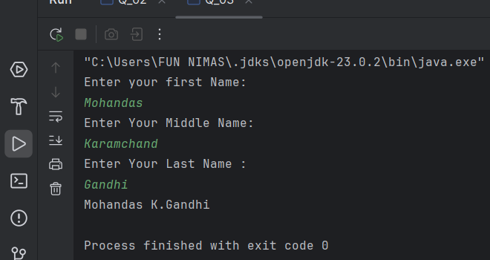

Q4.

Code:

|  |
| --- |
| package Q_04; import java.text.SimpleDateFormat; import java.util.Date;  public class Q_04 {  public Q_04(){   }  public static void main(String[] args){  Date today=new Date();  SimpleDateFormat sdf=new SimpleDateFormat("dd MMM yyyy");  System.*out*.println("Date : "+sdf.format(today));  } } |

Output:

Q5.

Code:

|  |
| --- |
| package Q_05; import java.text.SimpleDateFormat; import java.util.Date;  public class Q_05 {  public Q_05(){   }  public static void main(String[] args){  Date today=new Date();  SimpleDateFormat sdf=new SimpleDateFormat("EEEE,MMM,dd,yyyy ");  System.*out*.println("Date : "+sdf.format(today));  } } |

Output:

Q6.

Code:

|  |
| --- |
| package Q_06; import java.util.Scanner; import javax.swing.JFrame;  public class Q_06 {  public Q_06(){   }  public static void main(String[] args){  Scanner scanner=new Scanner(System.*in*);  System.*out*.println("Enter Width: ");  int width=scanner.nextInt();  System.*out*.println("Enter Heigh: ");  int height=scanner.nextInt();  System.*out*.println("Enter the frame title: ");  String frameTitle=scanner.next();  frameTitle=frameTitle+scanner.nextLine();  scanner.close();  JFrame frame=new JFrame();  frame.setSize(width,height);  frame.setTitle(frameTitle);  frame.setVisible(true);  frame.setDefaultCloseOperation(3);  } } |

Output:

Q7.

Code:

|  |
| --- |
| package Q_07; import javax.swing.*; import java.text.SimpleDateFormat; import java.util.Date;  public class Q_07 {  public Q_07(){   }  public static void main(String[] args){  JFrame frame=new JFrame();  Date today=new Date();  SimpleDateFormat sdf=new SimpleDateFormat("hh:mm:ss a");  String fTitle=sdf.format(today);  frame.setSize(500,250);  frame.setTitle(fTitle);  frame.setVisible(true);    }  } |

Output:

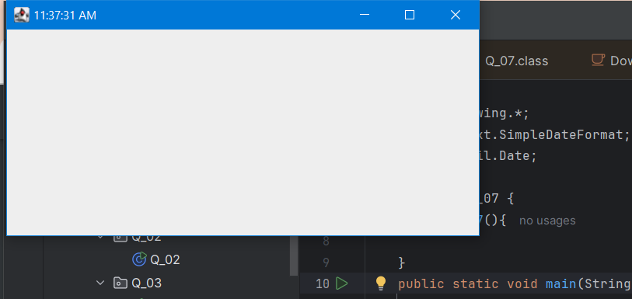

Q8.

Code:

|  |
| --- |
| package Q_08; import java.util.Scanner;   public class Q_08 {  public Q_08(){   }   public static void main(String[] args) {  Scanner scanner=new Scanner(System.*in*);  System.*out*.println("Enter the sentence with ! symbol: ");  String word=scanner.nextLine();  int exlaminationMark=word.indexOf(33);  String firststring=word.substring(0,exlaminationMark).trim();  String secondString=word.substring(exlaminationMark+1).trim();  System.*out*.println("Before ! : "+firststring);  System.*out*.println("After ! : "+secondString);  } } |

Output:

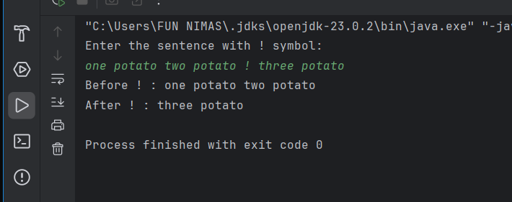

Q9.

Code:

|  |
| --- |
| package Q_09; import java.util.Scanner;   public class Q_09 {  public Q_09(){   }   public static void main(String[] args) {  Scanner scanner=new Scanner(System.*in*);  System.*out*.println("Enter The sentence: ");  String sentence=scanner.nextLine();  int count=sentence.length();  String firstLetter=sentence.substring(0,1);  String lastLetter=sentence.substring(count-1,count);  System.*out*.println("Number of Characters: "+count);  System.*out*.println("First Letter: "+firstLetter);  System.*out*.println("Last Letter: "+lastLetter);  } } |

Output:

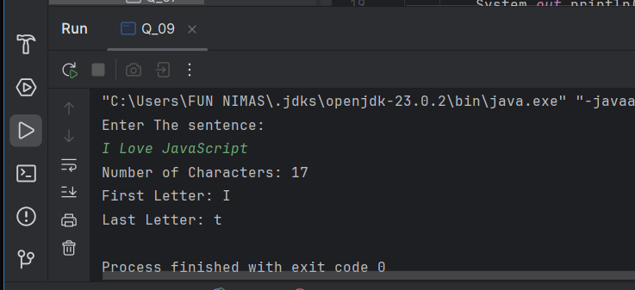

Q10.

Code:

|  |
| --- |
| package Q_10;  import java.util.Scanner;  public class Q_10 {  public Q_10() {  }   public static void main(String[] args) {  Scanner scanner = new Scanner(System.*in*);  System.*out*.println("Enter an odd-length word: ");  String sentence = scanner.nextLine();  int numofChar = sentence.length();  int indexOfMiddle = numofChar / 2;  String middleChar = sentence.substring(indexOfMiddle, indexOfMiddle + 1);  System.*out*.println("Middle Letter: "+middleChar);  } } |

Output:

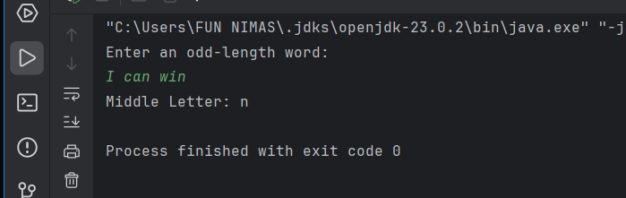

Q11.

Code:

|  |
| --- |
| package Q_11;  import java.util.Scanner;  public class Q_11 {  public Q_11() {  }   public static void main(String[] args) {  Scanner scanner = new Scanner(System.*in*);  System.*out*.println("Enter your full name: ");  String firstName = scanner.next();  String middleName = scanner.next();  String lastName = scanner.next();  String middleLetter = middleName.substring(0, 1);  System.*out*.println(lastName + ", " + firstName + " " + middleLetter+".");  } } |

Output:

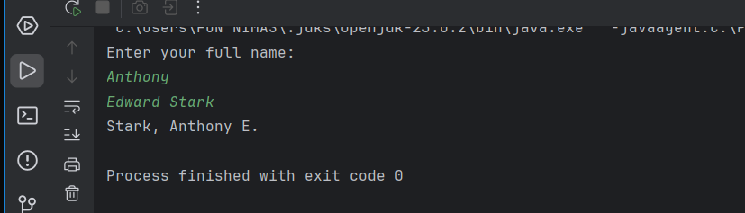

Q12.

Code:

|  |
| --- |
| package Q_12;  import javax.swing.JFrame;  public class Q_12 {  public Q_12() {  }   public static void main(String[] args) {  JFrame frame = new JFrame();  frame.setSize(300, 200);  frame.setTitle("My First Frame");  frame.setVisible(true);  frame.setLocation(100, 50);  frame.setDefaultCloseOperation(3);  } } |

Output:

