**Lab worksheet 2 Answer.**

**CT/2021/004 – K.Nimas**

Q1.

Code:

|  |
| --- |
| package Q_01;  public class Q_01 {  public static void main(String[] args) {  int A=1,B=2,C=3,X=4,Y=5;  System.*out*.println("A=1,B=2,C=3,X=4,Y=5");   double a=Math.*sqrt*((Math.*pow*(B,2)+(4*A*C)));  System.*out*.println(("a="+a));   double b = Math.*sqrt*((X+4*Math.*pow*(Y,3)));  System.*out*.println("b= "+b);   double c = Math.*cbrt*(X*Y);  System.*out*.println("c= "+c);   final double PI = 3.14;  int radius = B;  double area = PI*radius*radius;  System.*out*.println("The area of a circle which radius is 2: "+area);   } } |

Output:

Q2.

Code:

|  |
| --- |
| package Q_02; import java.text.DecimalFormat; import java.util.Scanner;  public class Q_02 {  public static void main(String[] args) {  double cm,totalInches,in;  int ft;  Scanner Input = new Scanner(System.*in*);  System.*out*.print("Enter the value in centimeters : ");  cm = Input.nextDouble();   totalInches = cm / 2.54;  ft = (int) totalInches / 12;  in = totalInches - (ft * 12);   DecimalFormat df = new DecimalFormat("0.00");  System.*out*.println(cm + " Centimeters = " + ft + " feets and " + df.format(in) + " inches");   } } |

Output:

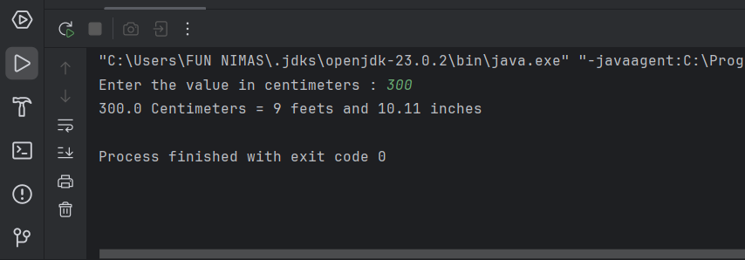

Q3.

Code:

|  |
| --- |
| package Q_03;  import java.util.Scanner;  public class Q_03 {  public static void main(String[] args) {  Scanner input=new Scanner(System.*in*);  System.*out*.println("Enter the temperature in celsius:");  double celsius=input.nextDouble();   double fahrenheit= (1.8*celsius)+32;  System.*out*.println("Temperature in fahrenheit:"+fahrenheit);   } } |

Output:

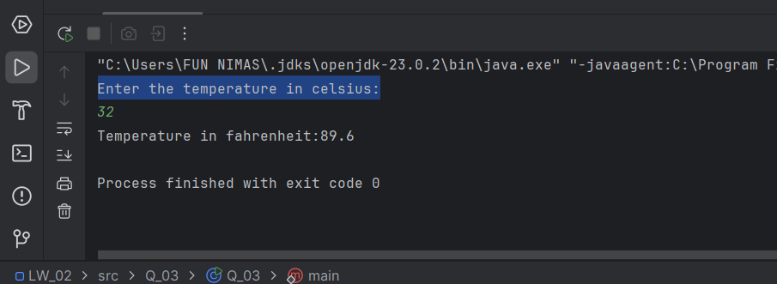

Q4.

Code:

|  |
| --- |
| package Q_04;  import java.util.Scanner;  public class Q_04 {  public static void main(String[] args) {  Scanner scanner = new Scanner(System.*in*);  System.*out*.println("Enter body weight in pounds: ");  double bodyWeight = scanner.nextDouble();  double calories = bodyWeight * 19;  System.*out*.println("You need "+calories+" calories in one day");  } } |

Output:

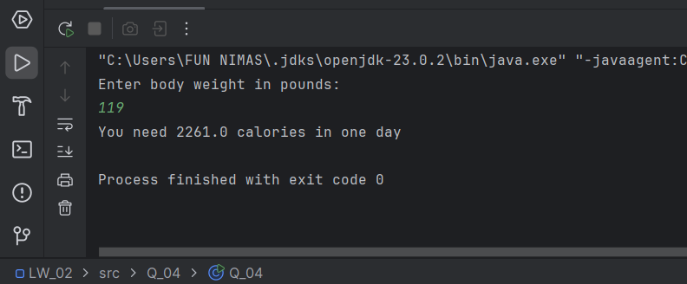

Q5.

Code:

|  |
| --- |
| package Q_05;  import java.util.Scanner;  public class Q_05 {  public static void main(String[] args) {  double Celsius,Fahrenheit;  Scanner Input = new Scanner(System.*in*);  System.*out*.print("Enter the temperature in Fahrenheit : ");  Fahrenheit = Input.nextDouble();   Celsius = (5.0/9) * (Fahrenheit - 32);   System.*out*.println("Celsius Value is : " + Celsius);  } } |

Output:

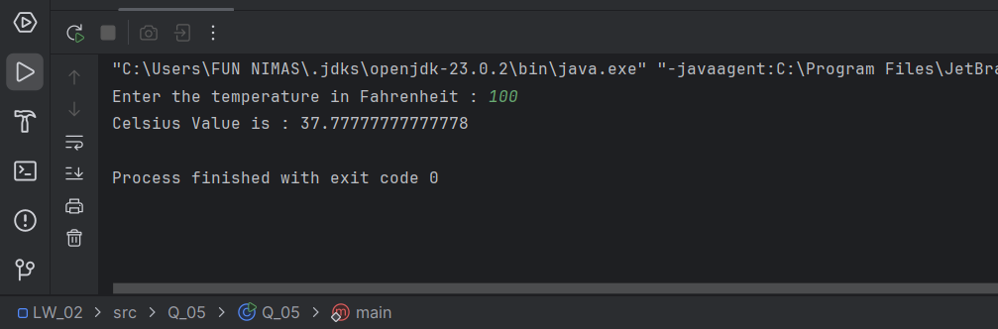

Q6.

Code:

|  |
| --- |
| package Q_06;  import java.util.*;  public class Q_06 {  public static void main(String[] args) {  Scanner input=new Scanner(System.*in*);  System.*out*.println("Enter your birth year:");  int birthYear=input.nextInt();   GregorianCalendar cal=new GregorianCalendar();  int currentYear=cal.get(GregorianCalendar.*YEAR*);  int age=currentYear-birthYear;   System.*out*.println("You were born on "+birthYear+" and will be "+age+" this year.");    } } |

Output:

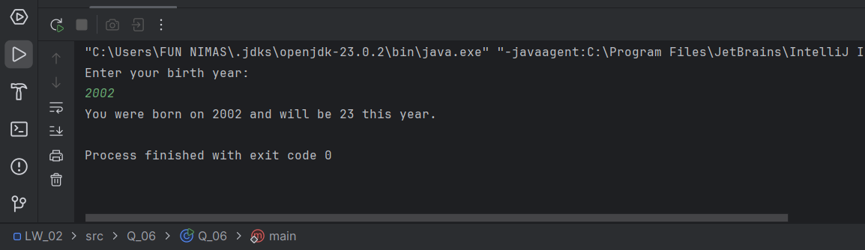

Q7.

Code:

|  |
| --- |
| package Q_07;  import java.text.DecimalFormat; import java.util.Scanner;  public class Q_07 {  public static void main(String[] args) {  Scanner scanner = new Scanner(System.*in*);  System.*out*.println("Enter your weight in Kg: ");  int weight = scanner.nextInt();  System.*out*.println("Enter your height in cm: ");  int height = scanner.nextInt();   double BMI = weight / Math.*pow*((height /100.0),2);  DecimalFormat df = new DecimalFormat("0.00");  System.*out*.println("BMI: "+df.format(BMI));  } } |

Output:

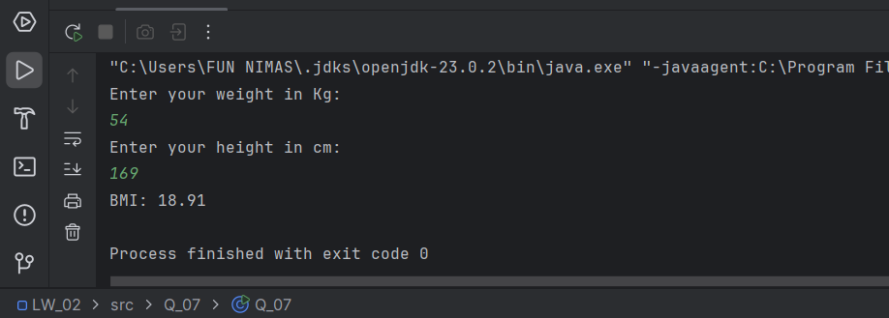

Q8.

Code:

|  |
| --- |
| package Q_08;  import java.text.DecimalFormat; import java.util.Scanner;  public class Q_08 {  public static void main(String[] args) {  double R,V; // R - Radius V - Volume  final double PI = 3.14;   Scanner Input = new Scanner(System.*in*);  System.*out*.print("Enter the Radius : ");  R = Input.nextDouble();   V = (4/3.0) * (PI * Math.*pow*(R,3));  DecimalFormat df = new DecimalFormat("0.00");  System.*out*.println("Volume of a sphere is : " + df.format(V));   } } |

Output:

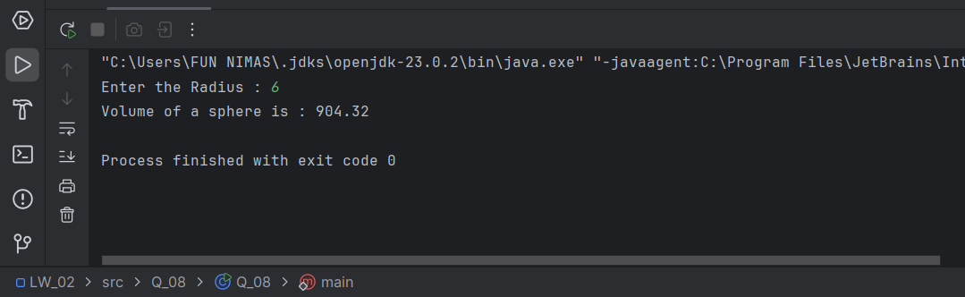

Q9.

Code:

|  |
| --- |
| package Q_09;  import java.util.Scanner;  public class Q_09 {  public static void main(String[] args) {  Scanner input = new Scanner(System.*in*);   System.*out*.println("Enter the amount you invest in dollars:");  double P = input.nextDouble();   System.*out*.println("Enter the annual interest rate:");  double R= input.nextDouble();   System.*out*.println("Enter the number of years for investment:");  int N = input.nextInt();   double totalAmount=P*Math.*pow*(1+(R/100),N);  System.*out*.println("Total amount of money earned after "+N+" years is "+totalAmount);  } } |

Output:

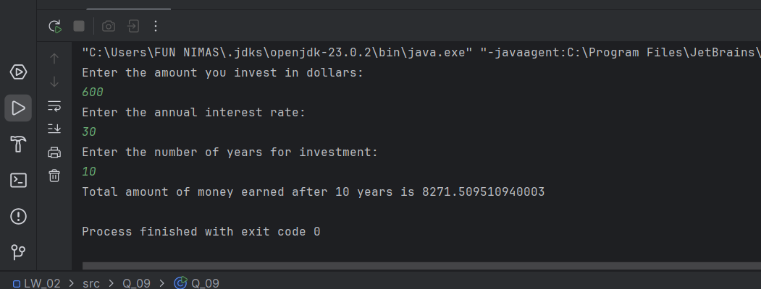

Q10.

Code:

|  |
| --- |
| package Q_10;  import java.text.DecimalFormat; import java.util.Scanner;  public class Q_10 {  public static void main(String[] args) {  Scanner scanner = new Scanner(System.*in*);  final int MONTHS_IN_YEAR = 12;   System.*out*.println("Enter the loan amount: ");  double loanAmount = scanner.nextDouble();   System.*out*.println("Enter the annual interest rate: ");  double annualInterestRate = scanner.nextDouble();   System.*out*.println("Enter the loan period in years: ");  double loanPeriod = scanner.nextDouble();   double monthlyInterestRate = annualInterestRate / 100.0 / MONTHS_IN_YEAR;  double numberOfPayments = loanPeriod * MONTHS_IN_YEAR;  double monthlyPayment = (loanAmount * monthlyInterestRate) / (1 - Math.*pow*(  1 /(1 + monthlyInterestRate), numberOfPayments) );  double totalPayment = monthlyPayment * numberOfPayments;   DecimalFormat df = new DecimalFormat("0.00");  System.*out*.println("Monthly payment amount: "+df.format(monthlyPayment));  System.*out*.println("Total payment amount: "+df.format(totalPayment));  } } |

Output:

