task1, 1)

links

https://ait.ac.th/

https://en.wikipedia.org/wiki/Asian_Institute_of_Technology

https://www.topuniversities.com/universities/asian-institute-technology-thailand

https://www.timeshighereducation.com/world-university-rankings/asian-institute-technology-ait#:~:text=The%20Asian%20Institute%20of%20Technology,management%2C%20research%20and%20capacity%20building.

https://dreamstudy.cc/universities/asian-institute-of-technology/

task2, 1)

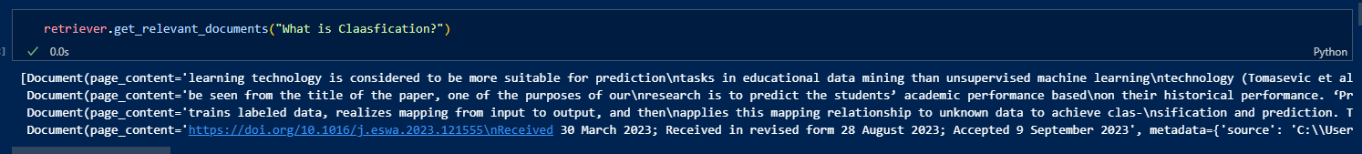

As far as looking at result, first output (first line) looks result of retrieving “What is Classifier”. And second output, it looks retrieving the output of first line. And continue this way. So I guess that the output structure would be like

1st: Answering question  
2nd: Explanation of 1st  
3rd: Explanation of 2nd  
4th: Explanation of 3rd   
  
something like this.

Task2, 2)

- Use a lot of data source(this time I am using reduced ver in order to reduce pc load)  
- Better prompt template  
-> get rid of “I am covering everything in official web page. So if you felt lazy to search in web page by yourself, no hesitate to asking me.”. This potentially causes answering unrelated topics since it is not about AIT. But I think it is rare to slides to other topics.