**Exercise 1:**



const employee = { name: "John Doe", age: 30, department: "IT"};

function Employee() {

    return(

        <div className="employee">

            <h1>Full name: {employee.name}</h1>

            <p>Age : {employee.age}

            -  Department : {employee.department}

            </p>

        </div>

    );

}

export default Employee

**Exercise 2:**

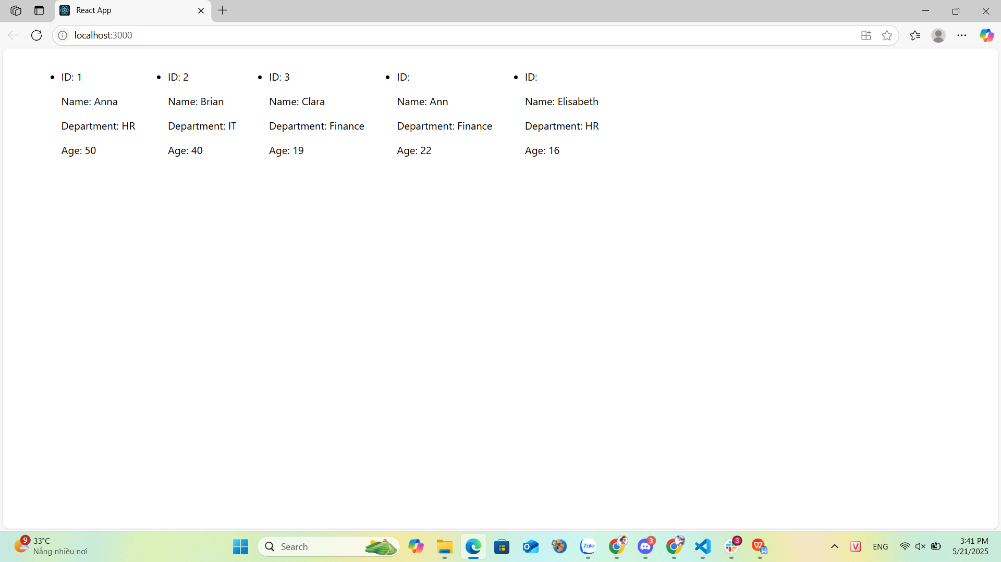

const employees = [

    { id: 1, name: "Anna", department: "HR", age: 50 },

    { id: 2, name: "Brian", department: "IT", age: 40 },

    { id: 3, name: "Clara", department: "Finance", age: 19 },

    { name: "Ann", department: "Finance", age: 22 },

    { name: "Elisabeth", department: "HR", age: 16 }

];

function ListEmployee() {

    return(

        <div className="listEmployee">

            <ul>

                {employees.map((employee) =>

                <li>

                        <p key={employee.id}>ID: {employee.id}</p>

                        <p key={employee.id}>Name: {employee.name}</p>

                        <p key={employee.id}>Department: {employee.department}</p>

                        <p key={employee.id}>Age: {employee.age}</p>

                </li>

                )}

            </ul>

        </div>

    );

}

export default ListEmployee;

**Exercise 3:**

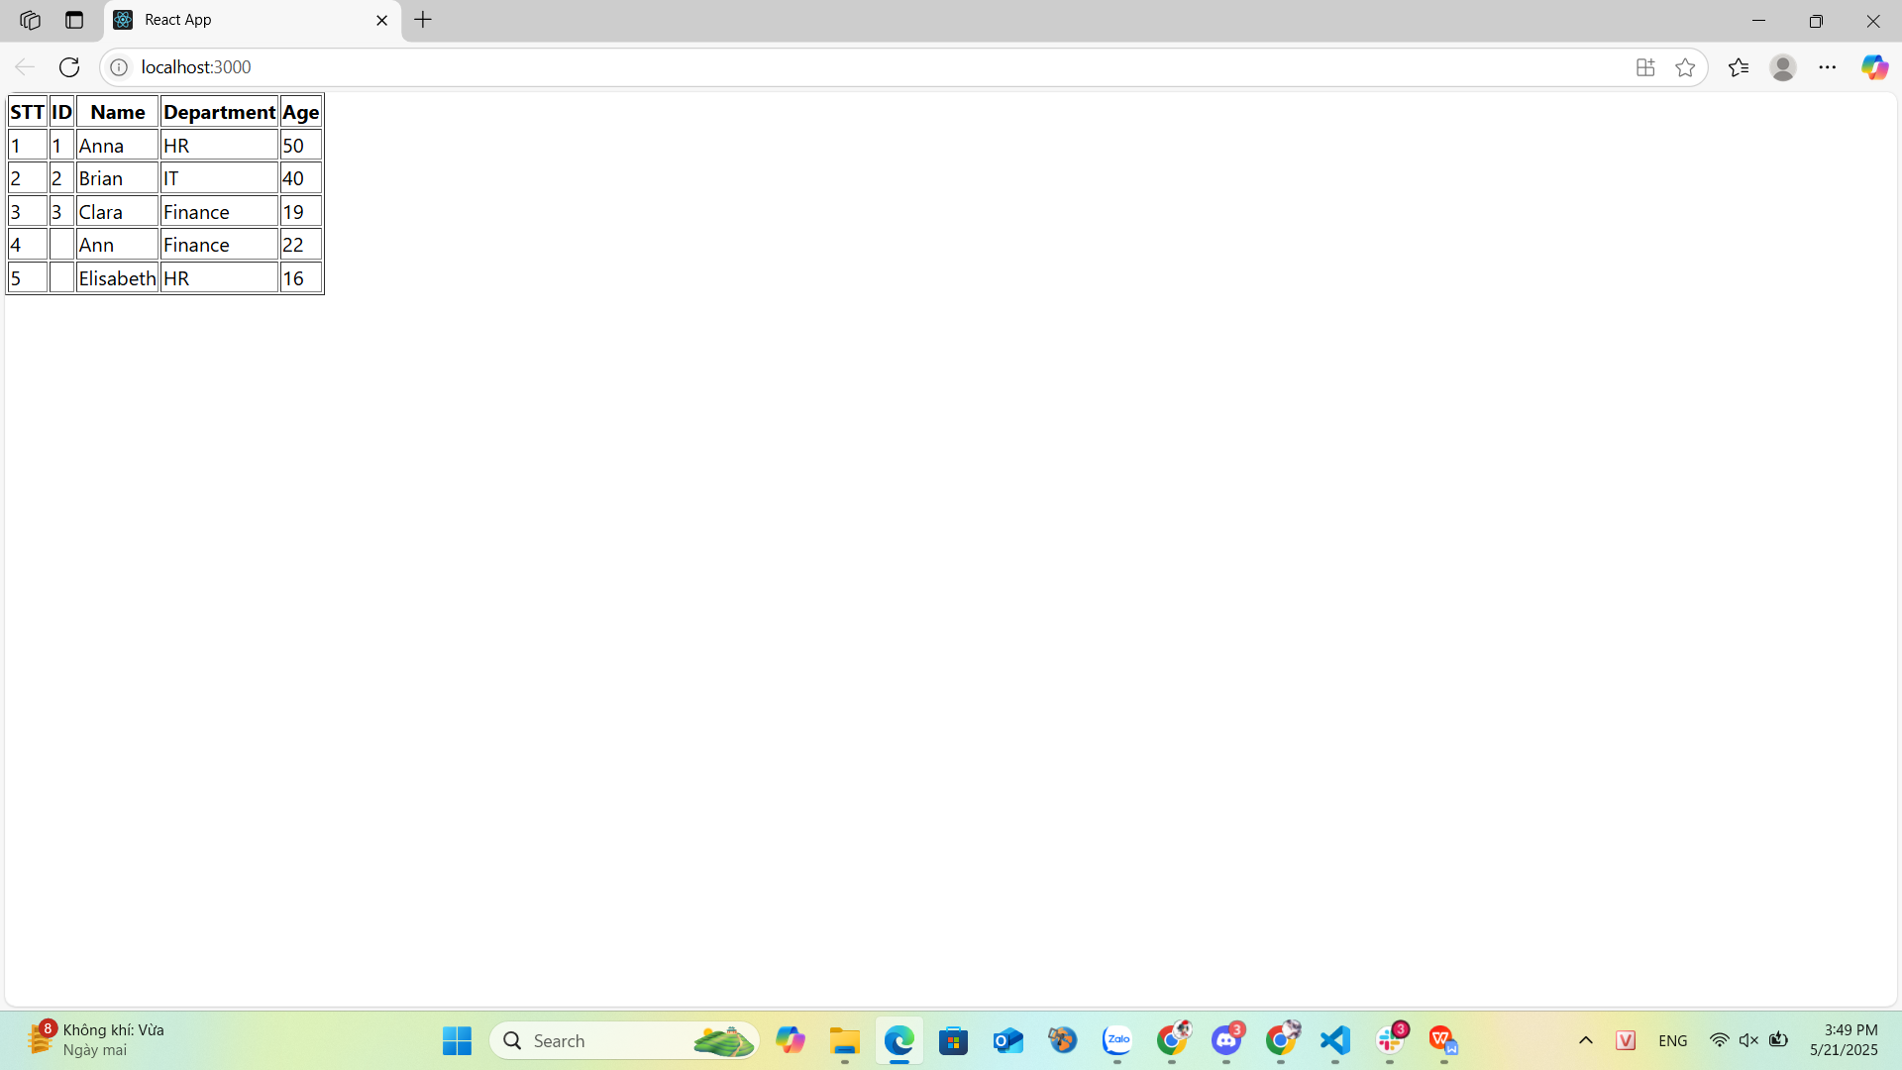

const employees = [

    { id: 1, name: "Anna", department: "HR", age: 50 },

    { id: 2, name: "Brian", department: "IT", age: 40 },

    { id: 3, name: "Clara", department: "Finance", age: 19 },

    { name: "Ann", department: "Finance", age: 22 },

    { name: "Elisabeth", department: "HR", age: 16 }

];

function TableEmployee() {

    return(

        <table border={"1"}>

            <tr>

                <th>STT</th>

                <th>ID</th>

                <th>Name</th>

                <th>Department</th>

                <th>Age</th>

            </tr>

            {employees.map((employees,i) =>

            <tr>

                <td>{i + 1}</td>

                <td>{employees.id}</td>

                <td>{employees.name}</td>

                <td>{employees.department}</td>

                <td>{employees.age}</td>

            </tr>

            )}

        </table>

    );

}

export default TableEmployee;

**Exercise 4:**



const employees = [

    { id: 1, name: "Anna", department: "HR", age: 50 },

    { id: 2, name: "Brian", department: "IT", age: 40 },

    { id: 3, name: "Clara", department: "Finance", age: 19 },

    { name: "Ann", department: "Finance", age: 22 },

    { name: "Elisabeth", department: "HR", age: 16 }

];

function averrageAge() {

    let a =0;

    let b =0;

    employees.forEach(employee => {

        if(employee.age !== undefined){

            a += employee.age;

            b++;

        }

    })

    if(b === 0) return 0;

    if(b !== 0) return a/b;

}

function DisplayAvg () {

    const results = averrageAge();

    return(

        <div className="avg">

            <p>Tuổi trung bình là {results}</p>

        </div>

    );

}

export default DisplayAvg;

**Exercise 5:**



const employees = [

    { id: 1, name: "Anna", department: "HR", age: 50 },

    { id: 2, name: "Brian", department: "IT", age: 40 },

    { id: 3, name: "Clara", department: "Finance", age: 19 },

    { name: "Ann", department: "Finance", age: 22 },

    { name: "Elisabeth", department: "HR", age: 16 }

];

function Menu () {

    return(

        <div className="menu">

            <select>

                {employees.map((employee) =>

                <option>{employee.name}</option>

                )}

            </select>

        </div>

    );

}

export default Menu;

**Exercise 6:**



const employees = [

    { id: 1, name: "Anna", department: "HR", age: 50 },

    { id: 2, name: "Brian", department: "IT", age: 40 },

    { id: 3, name: "Clara", department: "Finance", age: 19 },

    { name: "Ann", department: "Finance", age: 22 },

    { name: "Elisabeth", department: "HR", age: 16 }

];

function FilterEmployee() {

    const filterEmployee = employees.filter(employee => employee.department === "IT");

    return(

         <ul>

            Danh sách Employee "IT"

            {filterEmployee.map((emp) =>

                <li>Name: {emp.name} - Tuổi: {emp.age}</li>

            )}

        </ul>

    );

}

export default FilterEmployee

**Exercise 7:**



const employees = [

    { id: 1, name: "Anna", department: "HR", age: 50 },

    { id: 2, name: "Brian", department: "IT", age: 40 },

    { id: 3, name: "Clara", department: "Finance", age: 19 },

    { name: "Ann", department: "Finance", age: 22 },

    { name: "Elisabeth", department: "HR", age: 16 }

];

function SortEmployee () {

    employees.sort((a,b) => {

        if(a.department < b.department) return -1;

        if(a.department > b.department) return 1;

        if(a.name < b.name) return -1;

        if(a.name > b.name) return 1;

        return 0;

    }

    );

    return(

        <ul>

            {employees.map((emp, i) =>

            <li key={i}>{emp.name} - {emp.department} - {emp.age}</li>

            )}

        </ul>

    );

}

export default SortEmployee;

**Exercise 8:**

**Exercise 9:**

**Exercise 10:**