Exercise 5

5.3

Code:

import React from "react";

const Ex3 = () => {

  return (

    <>

      <div className="container my-4 mx-4">

        {/\* Header block \*/}

        <div className="p-3 mb-3" style={{backgroundColor: "#D3D3D3"}}>

          <h4 className="fw-bold mb-0">Let's test the grid!</h4>

        </div>

        {/\* Nav links \*/}

        <nav className="mb-3">

          <a href="#" className="link-primary me-3 text-decoration-none">Active</a>

          <a href="#" className="link-primary me-3 text-decoration-none">Link</a>

          <a href="#" className="link-primary me-3 text-decoration-none">Link</a>

          <span className="text-muted">Disabled</span>

        </nav>

        {/\* Grid rows \*/}

        <div className="row g-1 bg-secondary text-light py-1">

          <div className="col-4 border border-light">First col</div>

          <div className="col-8 border border-light">Second col</div>

        </div>

        <div className="row g-1 bg-secondary text-light py-1 mt-2">

          <div className="col-4 border border-light">col</div>

          <div className="col-4 border border-light">col</div>

          <div className="col-4 border border-light">col</div>

        </div>

        <div className="row g-1 bg-secondary text-light py-1 mt-2">

          <div className="col-3 border border-light">col</div>

          <div className="col-3 border border-light">col</div>

          <div className="col-3 border border-light">col</div>

          <div className="col-3 border border-light">col</div>

        </div>

      </div>

      {/\* Footer \*/}

      <footer className="bg-secondary bg-opacity-25 text-center py-3 mt-4">

        <h5 className="fw-bold mb-0">Created by ABC!</h5>

      </footer>

    </>

  );

};

export default Ex3;

Hình:

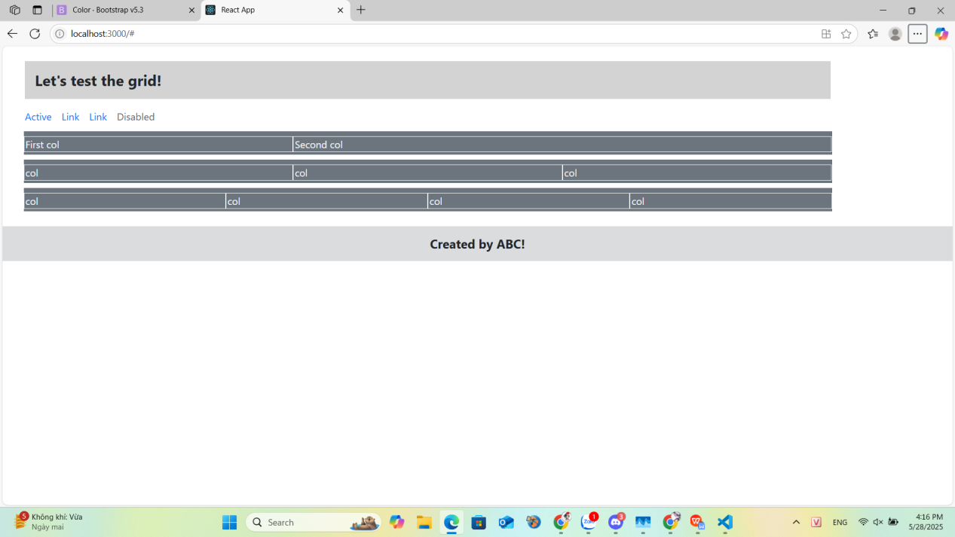

5.4

Code:

import React from "react";

const Ex4 = () => {

  return (

    <>

      {/\* Header with logo and navbar \*/}

      <header className="bg-warning p-3 text-center">

        <img

          src="https://ibrand.vn/wp-content/uploads/2024/07/logo-fpt.jpg"

          alt="FPT University Logo"

          style={{ maxWidth: "300px", height: "auto" }}

          className="mb-2"

        />

        <h2 className="text-white">FPT UNIVERSITY</h2>

        <nav>

          <ul className="nav justify-content-center">

            <li className="nav-item">

              <a className="nav-link text-white" href="#home">

                Home

              </a>

            </li>

            <li className="nav-item">

              <a className="nav-link text-white" href="#about">

                About

              </a>

            </li>

            <li className="nav-item">

              <a className="nav-link text-white" href="#contact">

                Contact

              </a>

            </li>

          </ul>

        </nav>

      </header>

      {/\* Main content \*/}

      <main className="container my-5 text-center">

        <section id="about" className="mb-5">

          <h3>About</h3>

          <p>This is the about section of the website.</p>

        </section>

        <section id="contact">

          <h3>Contact</h3>

          <p>For any inquiries, please contact us at example@example.com.</p>

        </section>

      </main>

      {/\* Footer \*/}

      <footer className="bg-warning bg-opacity-75 text-center py-3 mt-5">

        <small className="text-white">© 2023 Website. All rights reserved.</small>

      </footer>

    </>

  );

};

export default Ex4;

Hình:

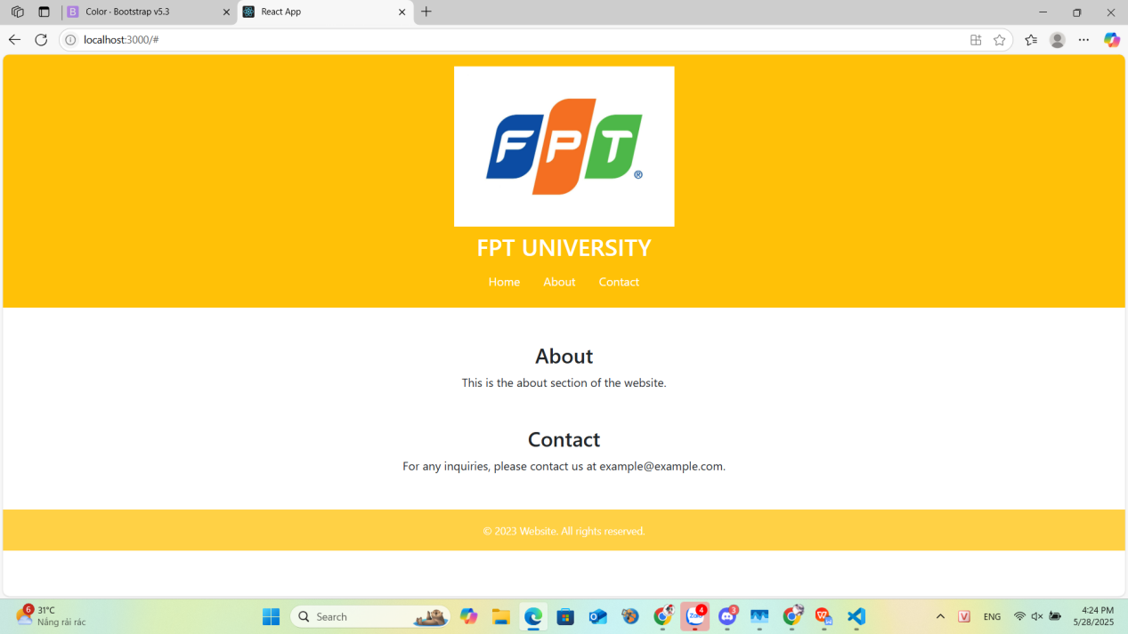

5.5

Code:

import React from "react";

const students = [

  {

    id: "DE180527",

    name: "Nguyễn Văn Nam",

    city: "QuangNam",

    image: "src/Screenshot 2025-05-28 164421.png",

  },

  {

    id: "DE180549",

    name: "Nguyễn Song Gia Huy",

    city: "QuangNam",

    image: "src/image/Screenshot 2025-05-28 164523.png",

  },

  {

    id: "DE180591",

    name: "Lê Phước Phú Lân",

    city: "Hue",

    image: "src/Screenshot 2025-05-28 164549.png",

  },

  {

    id: "DE180597",

    name: "Nguyễn Văn Hoàng Long",

    city: "DaNang",

    image: "src/Screenshot 2025-05-28 164556.png",

  },

];

const StudentCard = ({ student }) => {

  const [attendance, setAttendance] = React.useState("Absent");

  return (

    <div className="card mb-4" style={{ width: "18rem" }}>

      <img

        src={student.image}

        className="card-img-top"

        alt={student.name}

        style={{ height: "250px", objectFit: "cover" }}

      />

      <div className="card-body text-center">

        <h6 className="card-title">{student.name}</h6>

        <p className="card-text">{student.id}</p>

        <div className="mb-2">

          <label className="me-3">

            <input

              type="radio"

              name={`attendance-${student.id}`}

              value="Absent"

              checked={attendance === "Absent"}

              onChange={() => setAttendance("Absent")}

            />{" "}

            Absent

          </label>

          <label>

            <input

              type="radio"

              name={`attendance-${student.id}`}

              value="Present"

              checked={attendance === "Present"}

              onChange={() => setAttendance("Present")}

            />{" "}

            Present

          </label>

        </div>

        <p>{student.city}</p>

        <button className="btn btn-warning btn-sm">Submit</button>

      </div>

    </div>

  );

};

const Ex5 = () => {

  return (

    <div>

      {/\* Header image and nav can be separate components \*/}

      <div className="bg-warning p-3 text-center">

        <h3>Students Detail</h3>

      </div>

      <div className="container my-4">

        <div className="row justify-content-center">

          {students.map((student) => (

            <div key={student.id} className="col-md-3">

              <StudentCard student={student} />

            </div>

          ))}

        </div>

      </div>

      {/\* Footer \*/}

      <footer className="bg-warning text-center py-3">

        <p className="mb-0">&copy; Copyright 2023</p>

      </footer>

    </div>

  );

};

export default Ex5;

Hình:

