Exercise 9

Ex1:

- Code:

import React from 'react';

import { Card } from 'react-bootstrap';

function MyProfile() {

  return (

    <Card style={{ width: '20rem'}}>

      <Card.Body>

        <Card.Title>Full Name: Nguyễn Văn Nam</Card.Title>

        <Card.Subtitle>MSSV: DE180527</Card.Subtitle>

        <Card.Subtitle>Study at FPT University</Card.Subtitle>

        <Card.Text>

          Hello! I'm a software developer learning and creating projects with React-Bootstrap.

        </Card.Text>

      </Card.Body>

    </Card>

  );

}

export default MyProfile;

- Hình:

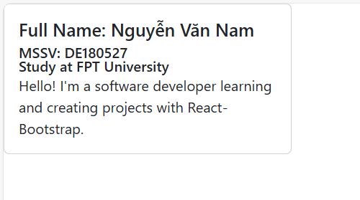

Ex4:

- Code:

import React from 'react';

import { Card, Row, Col, Container } from 'react-bootstrap';

import 'bootstrap/dist/css/bootstrap.min.css';

// Title component

function Title({ text }) {

  return <h5 style={{ marginBottom: '10px', fontWeight: 'bold' }}>{text}</h5>;

}

// Description component

function Description({ text }) {

  return <h6 style={{paddingRight: '170px'}}>{text}</h6>;

}

// Image component

function Image({ imageUrl }) {

  return (

    <img

      src={imageUrl}

      alt="Card"

      style={{ width: '100%', height: 'auto', objectFit: 'cover' }}

    />

  );

}

// SimpleCard component

function SimpleCard({ item }) {

  return (

    <Card style={{ width: '100%', borderRadius: '8px', boxShadow: '0 4px 8px rgba(0, 0, 0, 0.1)' }}>

      <Image imageUrl={item.imageUrl} />

      <Card.Body>

        <Title text={item.title} />

        <Description text={item.description} />

      </Card.Body>

    </Card>

  );

}

function Ex4() {

  const item = {

    title: 'Nguyễn Văn Nam - FPT UNIVERSITY ĐÀ NẴNG',

    description: 'Hí lô anh em',

    imageUrl:

      'https://upload.wikimedia.org/wikipedia/vi/thumb/2/2d/Logo_Tr%C6%B0%E1%BB%9Dng_%C4%90%E1%BA%A1i_h%E1%BB%8Dc_FPT.svg/2560px-Logo_Tr%C6%B0%E1%BB%9Dng_%C4%90%E1%BA%A1i_h%E1%BB%8Dc_FPT.svg.png',

  };

  return (

    <Container className="mt-5">

      <Card className="shadow-sm" style={{ borderRadius: '10px' }}>

        <Card.Body>

          <Row className="align-items-center">

            {/* Logo bên trái */}

            <Col md={6}>

              <Image imageUrl={item.imageUrl} />

            </Col>

            {/* Thông tin bên phải */}

            <Col md={6} className="text-end">

              <Title text={item.title} />

              <Description text={item.description} />

            </Col>

          </Row>

        </Card.Body>

      </Card>

    </Container>

  );

}

export default Ex4;

- Hình:

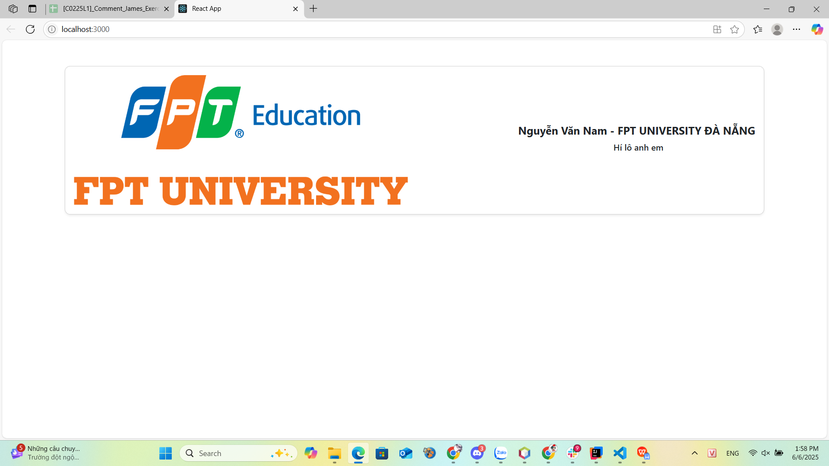

Ex5:

- Code:

import React from 'react';

import { Container, Navbar, Nav, Row, Col } from 'react-bootstrap';

import 'bootstrap/dist/css/bootstrap.min.css';

function Ex5() {

  return (

    <div style={{ display: 'flex', flexDirection: 'column', minHeight: '100vh' }}>

      {/* Header */}

      <div className="text-center py-4" style={{ backgroundColor: '#f28c28' }}>

        <img

          src="https://upload.wikimedia.org/wikipedia/vi/thumb/2/2d/Logo_Tr%C6%B0%E1%BB%9Dng_%C4%90%E1%BA%A1i_h%E1%BB%8Dc_FPT.svg/2560px-Logo_Tr%C6%B0%E1%BB%9Dng_%C4%90%E1%BA%A1i_h%E1%BB%8Dc_FPT.svg.png"

          alt="FPT University"

          style={{

            maxWidth: '300px',

            padding: '10px',  // Thêm khoảng cách xung quanh logo

            backgroundColor: 'white',  // Màu nền trắng

            borderRadius: '10px',  // Bo góc cho khung

            border: '3px solid #f28c28'  // Đường viền màu cam

          }}

        />

      </div>

      {/* Navigation */}

      <Navbar variant="light" className="justify-content-center" style={{backgroundColor: '#f28c28'}}>

        <Nav>

          <Nav.Link href="#">Home</Nav.Link>

          <Nav.Link href="#about">About</Nav.Link>

          <Nav.Link href="#contact">Contact</Nav.Link>

        </Nav>

      </Navbar>

      {/* Main Content */}

      <Container className="my-5 text-center" style={{ flex: 1 }}>

        <Row>

          <Col>

            <h4 id="about">About</h4>

            <p>This is the about section of the website.</p>

            <h4 id="contact">Contact</h4>

            <p>For any inquiries, please contact us at example@example.com.</p>

          </Col>

        </Row>

      </Container>

      {/* Footer */}

      <footer className="text-center py-3" style={{ backgroundColor: '#fbd88b' }}>

        <small>© 2023 Website. All rights reserved.</small>

      </footer>

    </div>

  );

}

export default Ex5;

- Hình:

