Routes

Ví dụ 1:

Code:

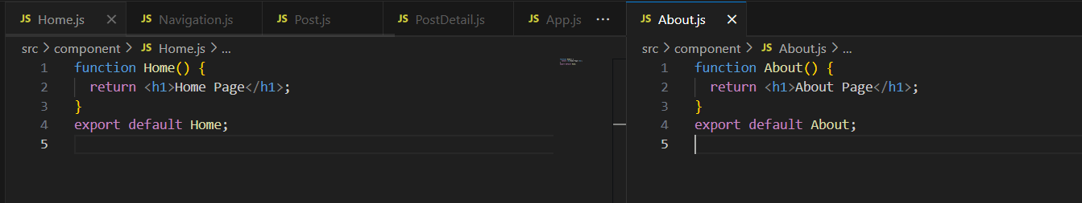

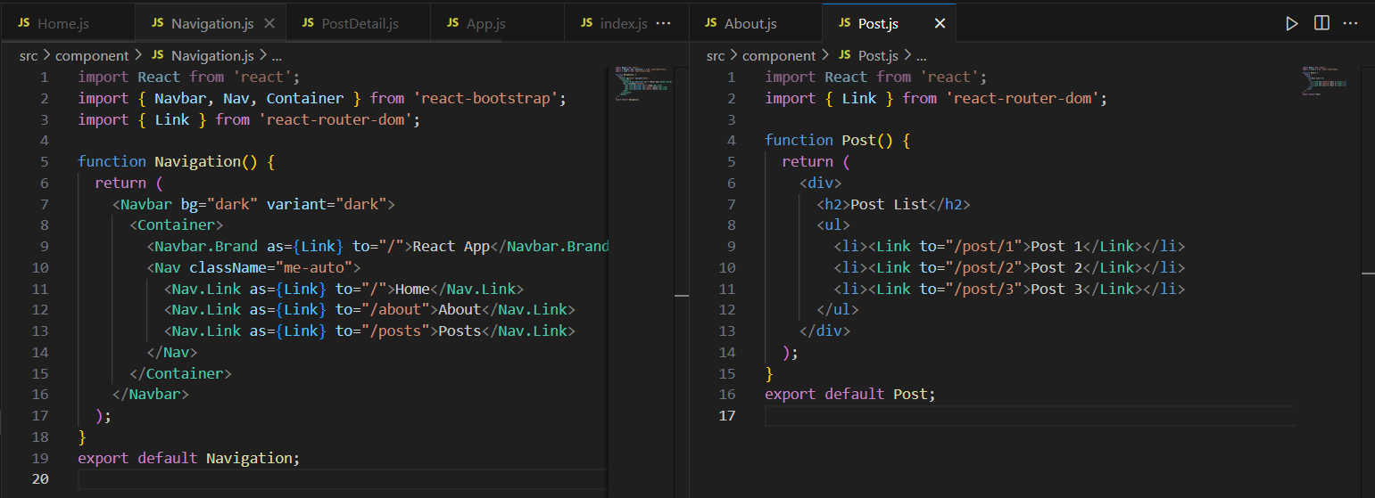

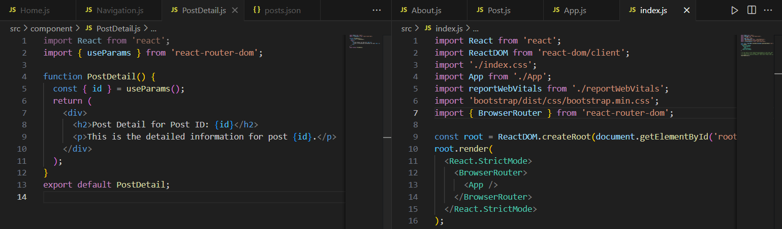

import React from 'react';

import { Routes, Route } from 'react-router-dom';

import { Container } from 'react-bootstrap';

import Navigation from './component/Navigation';

import Home from './component/Home';

import About from './component/About';

import Post from './component/Post';

import PostDetail from './component/PostDetail';

// import Login from './components/Login';

function App() {

  return (

    <div>

      <h1>React Router Example 1</h1>

      <Navigation />

      <Container>

        <Routes>

          <Route path="/" element={<Home />} />

          <Route path="/about" element={<About />} />

          <Route path="/posts" element={<Post />} />

          <Route path="/post/:id" element={<PostDetail />} />

          {/\* <Route path="/login" element={<Login />} /> \*/}

        </Routes>

      </Container>

    </div>

  );

}

export default App;

Kết quả:

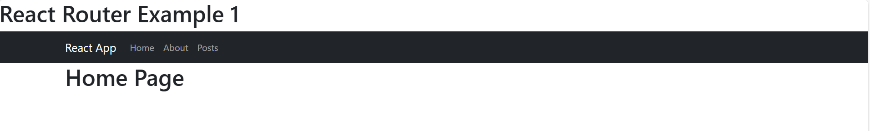

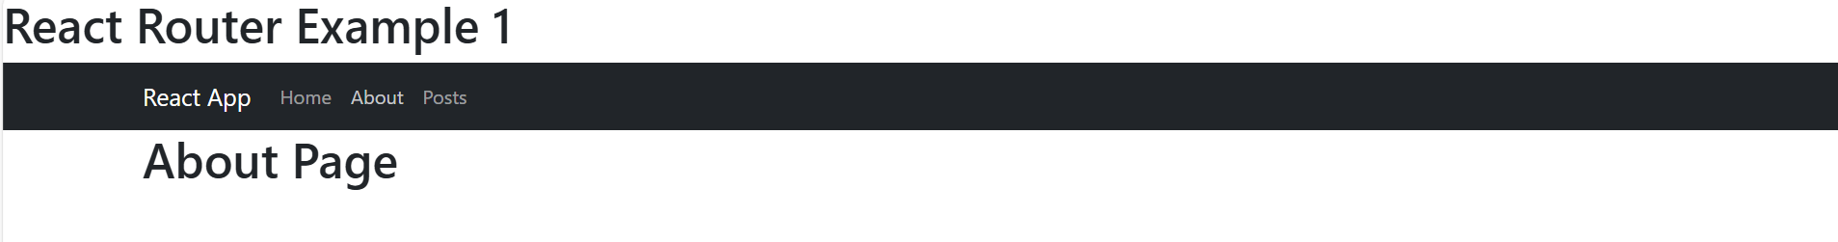

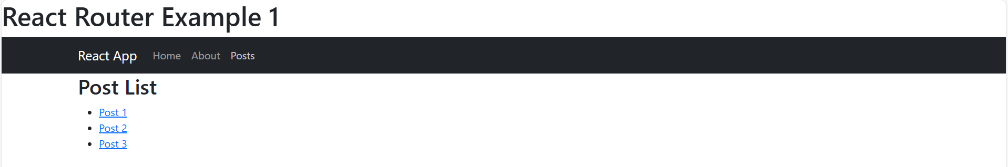

Ví dụ 2:

Code:

import React, { useState, useEffect } from 'react';

import { Link } from 'react-router-dom';

function Post() {

  const [posts, setPosts] = useState([]);

  useEffect(() => {

    fetch('/posts.json')

      .then((res) => res.json())

      .then((data) => setPosts(data))

      .catch((err) => console.error('Error loading posts:', err));

  }, []);

  return (

    <div>

      <h2>Post List</h2>

      <ul>

        {posts.map(post => (

          <li key={post.id}>

            <Link to={`/post/${post.id}`}>{post.title}</Link>

          </li>

        ))}

      </ul>

    </div>

  );

}

export default Post;

import React, { useEffect, useState } from 'react';

import { useParams } from 'react-router-dom';

function PostDetail() {

  const { id } = useParams();

  const [post, setPost] = useState(null);

  useEffect(() => {

    fetch('/posts.json')

      .then(res => res.json())

      .then(data => {

        const found = data.find(p => p.id === id);

        setPost(found);

      });

  }, [id]);

  if (!post) return <h2>Post not found</h2>;

  return (

    <div>

      <h2>{post.title}</h2>

      <p>{post.content}</p>

    </div>

  );

}

export default PostDetail;

Kết quả:

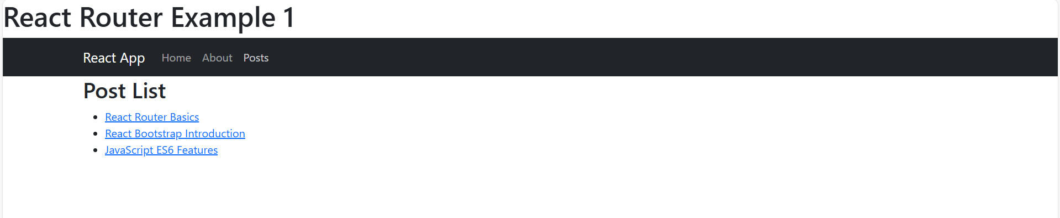

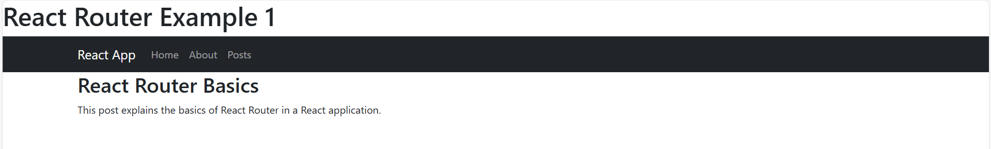

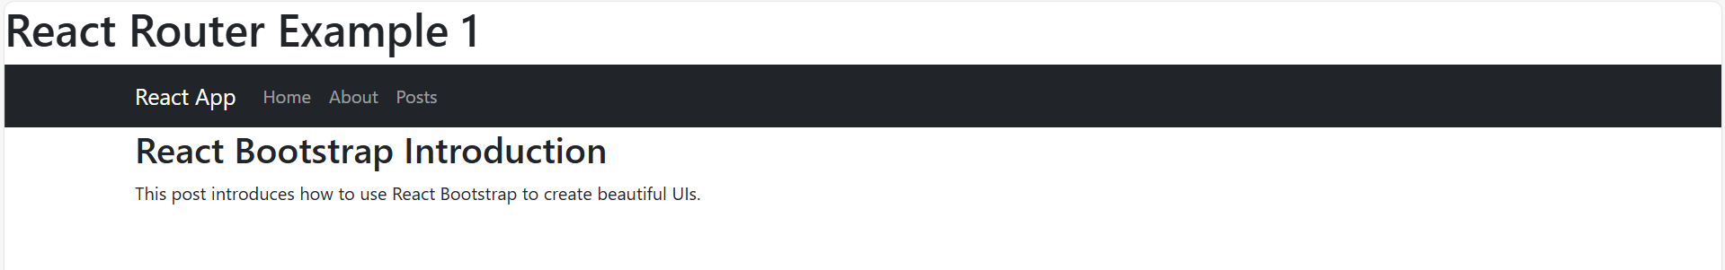

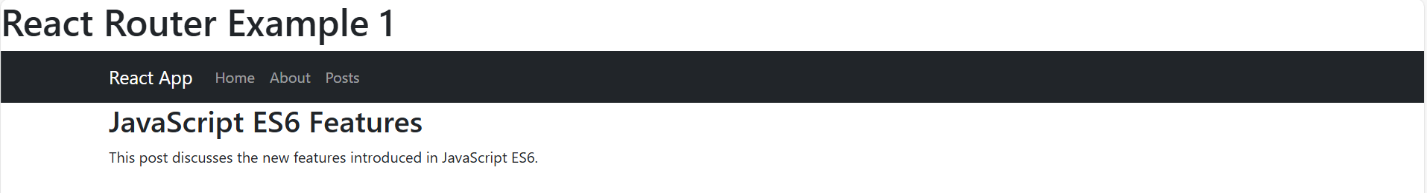

Ví dụ 3:

Code:

import React, { useState } from 'react';

import { useNavigate } from 'react-router-dom';

function Login() {

  const [username, setUsername] = useState('');

  const [password, setPassword] = useState('');

  const navigate = useNavigate();

  const handleLogin = (e) => {

    e.preventDefault();

    if (username === 'admin' && password === '123') {

      navigate('/posts');

    } else {

      alert('Invalid credentials');

    }

  };

  return (

    <form onSubmit={handleLogin}>

      <h2>Login</h2>

      <input type="text" placeholder="Username" value={username}

             onChange={(e) => setUsername(e.target.value)} required />

      <br />

      <input type="password" placeholder="Password" value={password}

             onChange={(e) => setPassword(e.target.value)} required />

      <br />

      <button type="submit">Login</button>

    </form>

  );

}

export default Login;

Kết Quả:

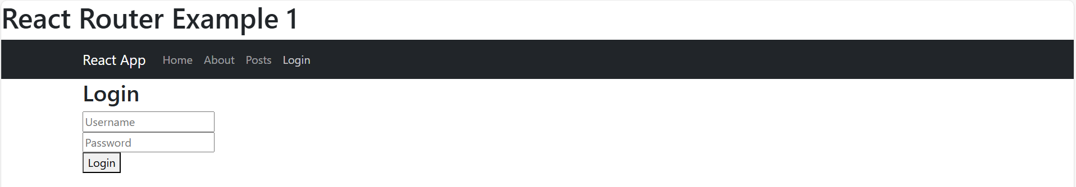

Ví dụ 4:

Code:

Kết quả:

