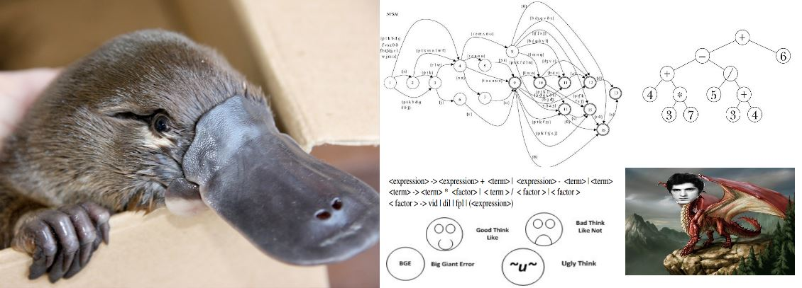

Mark Kaganovsky 040-789-903

|  |  |
| --- | --- |
| **Email 1 (preferred - Algonquin email issues)** | mark.kaganovsky@gmail.com |
| **Email 2** | kaga0004@algonquinlive.com |

|  |  |
| --- | --- |
| **Course:** | CST 8152 – Compilers, **Lab Section:** 012 |
| **Assignment:** | 4 |
| **Professor:** | Sv. Ranev |
| **Due Date:** | April 22 2016 |
| **Date:** | April 20 2016 |
| **Contents:** | RDPP Grammar  parser.h  parser.c  Testing Script  Test Output Files  Marking Sheet |
|  |  |