NAME: Mark Kaganovsky

S#: 100963794

EMAIL: markkaganovsky@cmail.carleton.com

COURSE: COMP3007 - Programming Paridigms

SEMESTER: Fall 2018

PROFESSOR: Dr. Robert Collier

Assignment 1 - Question 2

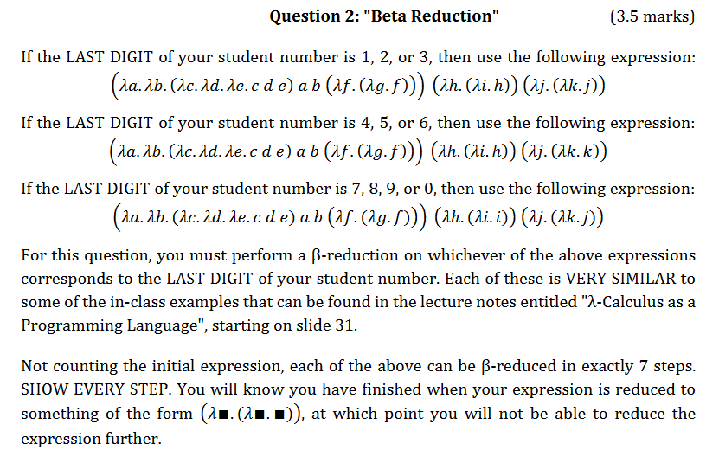



Assignment 1 - Question 3

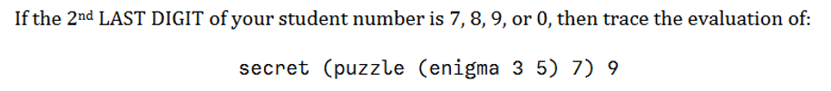

$$secret \left(puzzle \left(enigma 3 5 \right) 7 \right) 9$$

$$secret \left(puzzle \left(3-5 \right) 7 \right) 9$$

$$secret \left(\left(3-5 \right)* 7 \right) 9$$

$$9-\left(\left(3-5\right)* 7\right)$$

$$9-\left(-2*7\right)$$

$$9-\left(-14\right)$$

$$23$$