Mountain Lion Detecting System

**Ian Hock, Lucas Coglianese, Mikah Martinez**

September 27, 2024

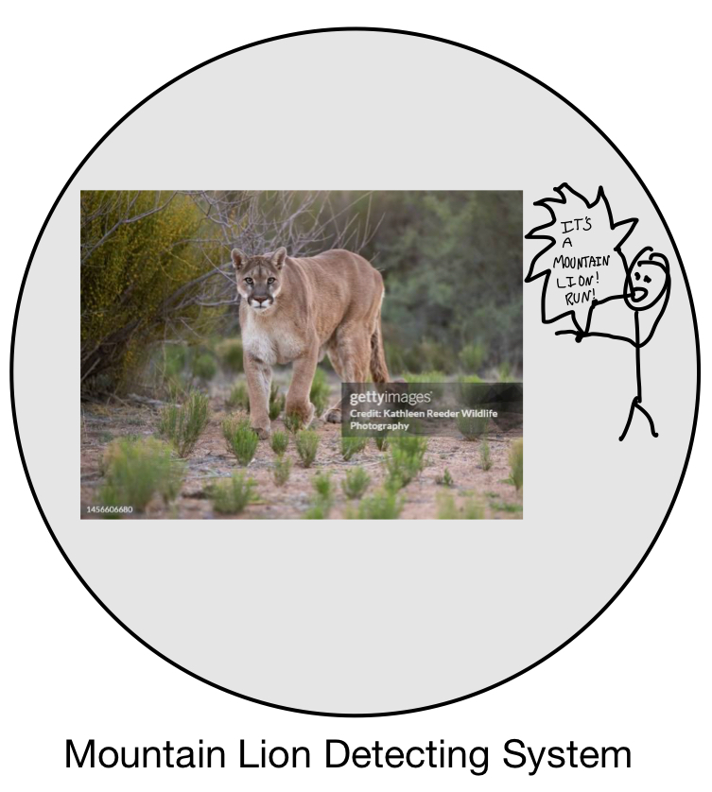

(Logo WIP)

Table of Contents

**1. Introduction** 4

1.1 Purpose 4

1.2 Scope 4

**2. Overall Description** 4

2.1 Product Environment 4

2.2 Product Features 5

2.3 User Characteristics 5

2.4 Operating Environment 5

2.6 Non-Technical Requirements 6

2.6.1 User Interactions and Functions 6

2.6.2 Hardware Context 6

2.6.3 UI (User Interface) Requirements 7

2.6.4 Software and Development Constraints 7

2.6.5 Constraints and Limitations 7

**3. Specific Requirements** 8

3.1 Functional Requirements 8

3.1.1 Noise Detection 8

3.1.2 Classification 8

3.1.3 Alert Notification 8

3.1.4 User Login 8

3.1.5 Reports 8

3.2 Non-Functional Requirements 9

3.2.1 Usability 9

3.2.2 Performance 9

3.2.3 Reliability 9

3.2.4 Security 9

3.2.6 Language 9

4. System Models 4.1 Use Case Diagram 9

4.1.1 Normal Flow – Noise Detected 9

4.1.2 Normal Flow – Park Ranger 10

4.1.3 Exceptional Flow – Unauthorized User 11

**5. Appendices** 12

5.1 Glossary of Terms 12

5.2 Major Risks 13

5.3 System Testing Plan 14

# **1. Introduction**

## **1.1 Purpose**

**The purpose of this document is to provide a precise and comprehensive specification for the Mountain Lion Detecting System. The system will help park rangers with detecting, classifying, and reporting mountain lion activity based on noise detection technology. The system will be implemented on all park ranger stations in the San Diego Area and will help increase both efficiency and safety within the parks.**

**This document details the functional and non-functional requirements, user interactions, and system design constraints. It is going to help the development and implementation processes to make sure the final system meets the requirements of the stakeholders.**

## **1.2 Scope**

The Mountain Lion Detecting System is designed to monitor and alert park rangers of potential mountain lions nearby stations using noise detectors around the parks. Noise detectors will be placed 5 miles apart from one another and will analyze noise detected. They will not only locate generally where the noise is coming from, but also categorize it (mountain lion, suspected mountain lion, or false detection), and notify the park rangers.

Key functionalities include:

* Noise detection and analysis
* Classification of the detected noise
* Alerts actively sent to the park ranger stations
* Reports generated based on mountain lion activity

This system will be a necessary tool to enhance the safety of San Diego’s parks.

# **2. Overall Description**

## 2.1 Product Environment

The Mountain Lion Detection System is apart of a broader initiative by the San Diego Parks and Recreation Department to increase safety around San Diego’s parks. The system will be installed on a controlling computer in each of the park ranger stations around the San Diego region and they will each be connected to an array of noise detection sensors each spaced 5 miles apart. The system will utilize Wi-Fi to relay information between the sensors and the computer as well as send information to other park ranger stations.

This system will integrate into their current infrastructure of wildlife monitoring systems and enhance it by giving real-time alerts to nearby mountain lion threats. It will provide evolved safety measures utilizing noise measurement and classification.

## 2.2 Product Features

Key Features of the System include:

* Noise Detection and Analysis: Detect sounds in the environment and identify the level of severity.
* Classification: Determining the actual threat level.
* Alert System: Send alerts to ranger stations near the threat
* Real-time Monitoring: Constant monitoring of the environment, providing real-time data on the activity nearby
* **Report Generation**
  + Date and time of the detection
  + Classification of the detection
  + Location of the detection
  + A graphical map showing the mountain lion activity

## 2.3 User Characteristics

* **Primary Users**: Park rangers stationed at ranger stations
  + **Technical Proficiency**: Park rangers will vary in technical skills so the system must be intuitive and simple to use with minimal training
  + **Roles and Privileges**: Rangers will have administrative access allowing them to receive alerts and generate the detailed reports. Those who are not rangers and more generally those that are unauthorized will be restricted from accessing the system.

## 2.4 Operating Environment

The Mountain Lion Detecting System will operate on computers at each ranger station in the San Diego area. It will have access to Wi-Fi for communication as well as for updates. Additionally, the system must function well even with a varying Wi-Fi signal due to weather conditions.

If Wi-Fi communication fails, the system will still monitor sounds, but the alerts will be delayed until the connection is restored. If the Wi-Fi fails it should also try to notify the rangers that alerts will be down for the meantime.

## 2.6 Non-Technical Requirements

This subsection outlines the non-technical requirements to provide a clear understanding of the system’s functions, how users will interact with it, and any constraints.

### 2.6.1 User Interactions and Functions

The system will be straightforward when it comes to interacting with it. The following list shows how the user can interact with the system:

* **Login and Access Control**
  + Park rangers will log in to the system using an admin account, and non-rangers will be denied access with an “Access Not Granted” message.
* **Alert Notifications**
  + When a mountain lion is detected, the system will send an alert to the controlling computer at the nearby ranger station. It will include information about where it is located as well as the classification of the detection (definite, suspected, or false).
* **Report Generation** 
  + Rangers will be able to generate reports of all activity in a radius around a specified location, a graphical report showing detection on a map with a 5-mile radius around a park, and a map with the San Diego area and where mountain lions have been detected. These will all include the date and time of each detection as well as the classification.

### 2.6.2 Hardware Context

The system will operate on a standard computer and should not require heavy processing power. The system is described by the following:

* **Controlling Computer**
  + Each ranger station will be equipped with one controlling computer that handles the noise processing, alerts, and report generation
* **Noise Detection Sensors**
  + These sensors will be provided by the department, but the controlling computer will get the noise data and must process it. It will be sent as a .WAV file.
* **Wi-Fi Infrastructure**
  + A reliable Wi-Fi connection will be required to allow transmission of sound data and alerts. If Wi-Fi fails, data will be only stored locally and processed once the connection is restored.

### 2.6.3 UI (User Interface) Requirements

The user interface (UI) must be simple, intuitive, and user-friendly to accommodate the range of technical skills among the rangers. The system will feature:

* **Clear, Easy-to-Read Alerts**
  + The UI will present clear notifications on the mountain lion detections. They must be easily distinguishable with the location and classification displayed clearly.
* **Map-Based Visualization**
  + The UI will also include maps showing the nearby area with points where mountain lions are detected. These must be easy to read and have plenty of coverage.
* **Report Display**
  + Reports must be easily generated through the interface and easy to view and analyze. They will be printed and displayed digitally

### 2.6.4 Software and Development Constraints

The following constraints guide the development of and implementation of the system:

* **Programming Language**
  + The system should be developed using languages compatible with the existing infrastructure at the ranger stations. Python and Java are recommended for the back-end due to their data processing powers, while HTML/CSS/JavaScript can be used for front-end UI.
* **Operating System**
  + The system must be compatible with Windows as that is what is compatible with the current infrastructure
* **Performance Constraints**
  + The system must respond to the detected noises within 2-3 seconds as any delay would compromise the safety of the nearby area.
* **Scalability**
  + The system should also be able to accommodate any new ranger stations or if there is an increased number of detectors in the future.

### 2.6.5 Constraints and Limitations

There are a few constraints and limitations that must be accounted for:

* **Dependency on Wi-Fi**
  + The system heavily relies on a Wi-Fi connection for the real-time alerts. The system will have limited functionality while Wi-Fi is down, but as soon as the connection is restored the alerts must be quick to return as well.
* **Noise Differentiation**
  + While the system is designed for mountain lions, it may get confused will other large animals and this must be adapted as more data is processed. This means the system should also be able to determine other animals in the future as well.

# **3. Specific Requirements**

## 3.1 Functional Requirements

### 3.1.1 Noise Detection

The system will have noise detection sensors distributed around the parks 5 miles apart. It will then use the signatures of the animals to identify the type of animal (specifically focusing on mountain lions).

### 3.1.2 Classification

The noises that are detected will be labeled with either definite, suspected, or false. This will allow the rangers to be wary of nearby threats. This will eventually include the ability to identify other animals other than mountain lions.

### 3.1.3 Alert Notification

Alerts will be generated as quickly as possible while being no longer than 3 seconds. It must state clearly the location as well as the classification it falls under. They will only be displayed on the closest controlling computer, but it can be sent to other computers if needed.

### 3.1.4 User Login

As stated previously, park rangers will have administrative logins that will allow them to make reports and use the functions of the computer. Those who are not authorized (non-rangers) will not be allowed to access the system.

### 3.1.5 Reports

The system will have a few different types of reports: recent alerts of a specified area, graphical map with recent detections around the controlling computer, and a general map of the San Diego area that has all alerts in some time frame. These reports will be printed as requested by the ranger

## 3.2 Non-Functional Requirements

### 3.2.1 Usability

The system will have a large focus on being clean, clear, intuitive, and easy to use. Park rangers should not require much training, and the UI will be easily read by the public.

### 3.2.2 Performance

The system should classify the noise no longer than 3 seconds after detection. The actual alert must show up on the respective controlling computer within 5 seconds after classification.

### 3.2.3 Reliability

The system must be operational 24/7, with minimal downtime only during updates. The classification and noise detection system should be accurate at least 90% of the time to minimize false negatives and positive.

### 3.2.4 Security

Only authorized rangers should have access to the system. This means that the system should be password protected requiring a login.

### 3.2.6 Language

The system will be available in English only for now. Other languages may be added in the future.

## 4. System Models 4.1 Use Case Diagram

### 4.1.1 Normal Flow – Noise Detected

The first use case diagram represents when a noise is detected:

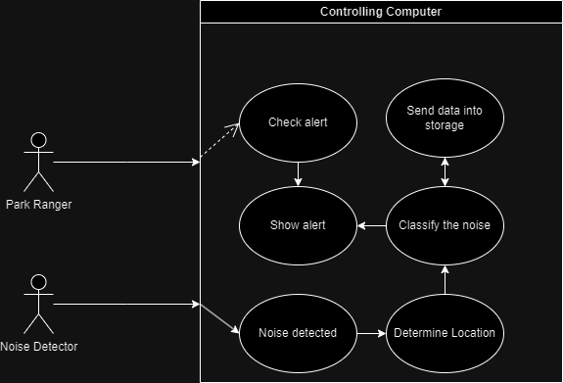

The noise detectors are practically an actor in this situation as they provide the main input. The controlling computer than realizes a noise is detected and begins to process the noise. It first determines its approximate location due to the strength of the noise and the location of the noise sensor that heard it. It then classifies the noise into the three categories and sends the data to the storage as well as the alert. This flow also can take input for the park ranger as they can check the alert and this will show the data of the noise.

### 4.1.2 Normal Flow – Park Ranger

The next diagram shows the other situation in which the park ranger accesses the system:

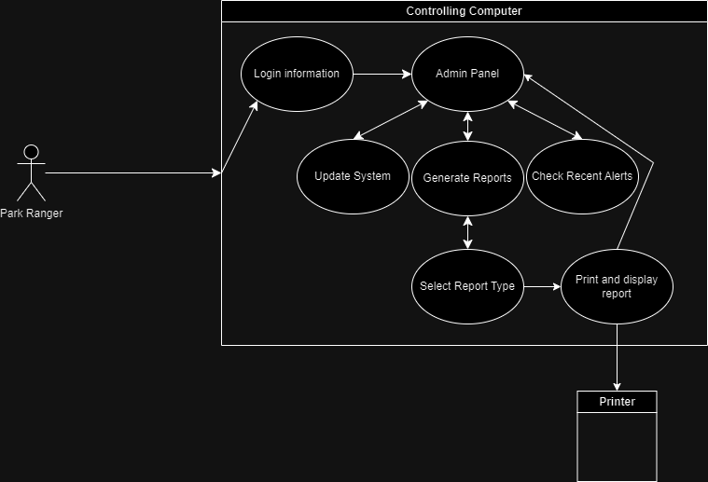

This diagram starts with the ranger using their credentials to login to the system. This then brings up the administrative panel UI which allows the ranger to access the whole system. This will allow them to either update the system, generate a report, or check the recent alerts, all being able to go back to the admin panel (home page). If the user decides to generate a report, they will get prompted to select the type of report desired. They will have the 3 options stated above and after selected it will print the report and go back to the home page.

### 4.1.3 Exceptional Flow – Unauthorized User

There will be a few exceptions, but the most common one will be an unauthorized user. The following diagram describes that situation:

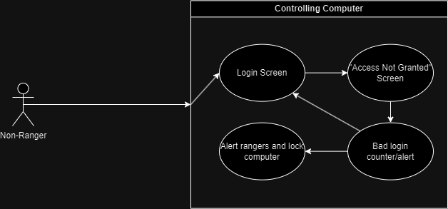The general exception of an unauthorized user will be handled quickly as valid credentials will be required to login to the system. As seen by the diagram the non-ranger will attempt to login, but their credentials will not be recognized as valid. This will send them into the “Access Not Granted” Screen as well as increment the number of bad logins. After 5 bad logins in 5 minutes, it will lock the controlling computer and alert other park rangers.

# **5. System Architecture Overview**

## 5.1 System Architecture Diagram

# **6. Appendices**

## 6.1 Glossary of Terms

* **Detection Radius**
  + 5-mile radius around noise detection sensors
* **Admin Panel**
  + The home screen of the controlling computer after a valid login that allows the user to see alerts and generate reports
* **Controlling Computer**
  + The central computer located at each park ranger station that processes the noise data and sends alerts
* **Lockout**
  + A security measure triggered after multiple failed login attempts, which blocks further access to the system temporarily while alerting authorized users.

## 6.2 Major Risks

The main risks associated with the Mountain Lion Detection System are primarily related to its dependency on Wi-Fi for real-time communication and data transmission. The system is designed to run reliably, but several factors can impact performance:

1. **Wi-Fi Reliability**

* **Risk**
  + The system relies on a stable Wi-Fi connection to transmit data and send alerts. Environmental conditions could reduce Wi-Fi reliability causing delayed alerts or failed data transmission
* **Mitigation**
  + If the Wi-Fi signal ever weakens or fails, the system will attempt to operate but in a degraded state. However, alerts may be delayed, but it will make sure to notify park rangers of the unreliable connection.

1. **Reduced Data Accuracy**

* **Risk**
  + Spotty Wi-Fi could lead to a decrease in reliable data transmission and accuracy
* **Mitigation**
  + To counteract this risk, the system will include protocols to identify if any incomplete data was received. Alerts will be adapted to make sure rangers know to be wary until the full data is received.

1. **Sensor Malfunction**

* **Risk**
  + Environmental conditions may cause damage to the noise sensors
* **Mitigation**
  + Routine diagnostics will be built into the system to check the health of the sensors and test them consistently. If there is a malfunctioning sensor the nearby ranger station will be alerted.

1. **False Positives/Negatives**

* **Risk**
  + The system may generate false positives (alerting on a non-mountain lion noise) or false negative (failing to detect an actual mountain lion). This can be due to noise interference or calibration issues.
* **Mitigation**
  + The system will implement machine learning and regular updates to increase its data of animal noises and fine-tune its noise detection and classification algorithms. Rangers will also be made aware of the possibility of false positive and negatives.

## 6.3 System Testing Plan

A system testing plan will be developed to ensure the quality of the system is of the highest level. It will validate the functionality, performance, security, and user experience of the system. Ever aspect of the system, such as the noise detection and classification system, will be tested thoroughly to establish reliability.