CS7DS4 / CSU44065 Data Visualization 2019-20 Assignment 1.2

Student Name : Abhishek Sarangi

Student No: 19301428

Declaration: "I have read and I understand the plagiarism provisions in the General Regulations of the University Calendar for the current year, found at http://www.tcd.ie/calendar.

I have also completed the Online Tutorial on avoiding plagiarism ‘Ready Steady Write’, located at <http://tcd-ie.libguides.com/plagiarism/ready-steady-write>."

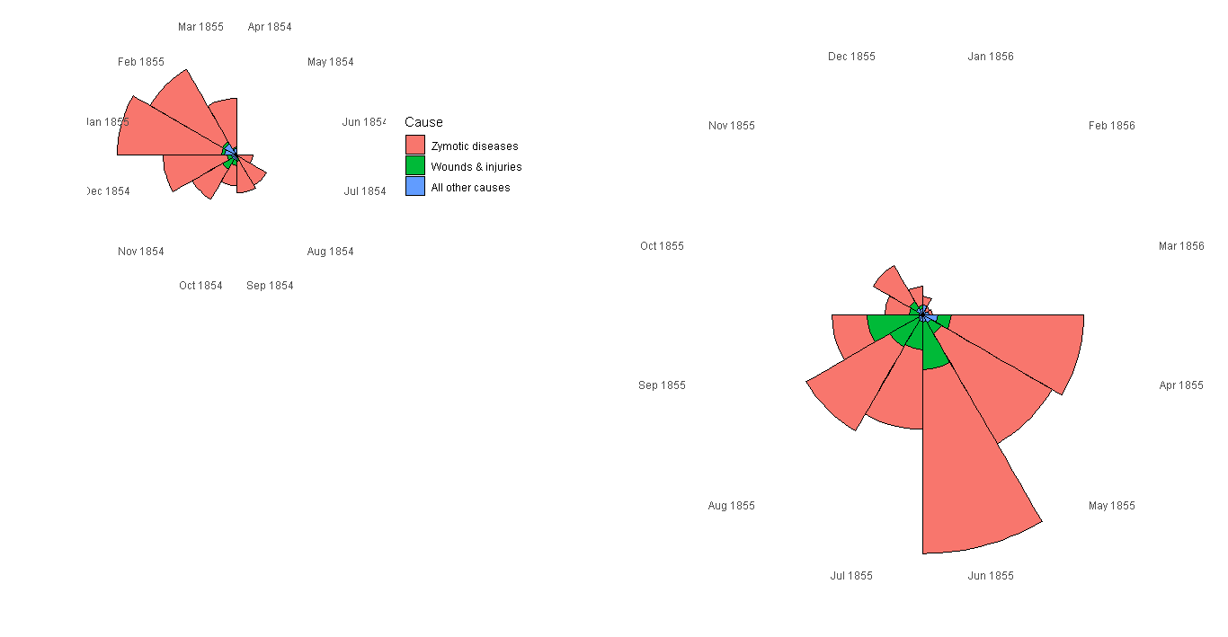

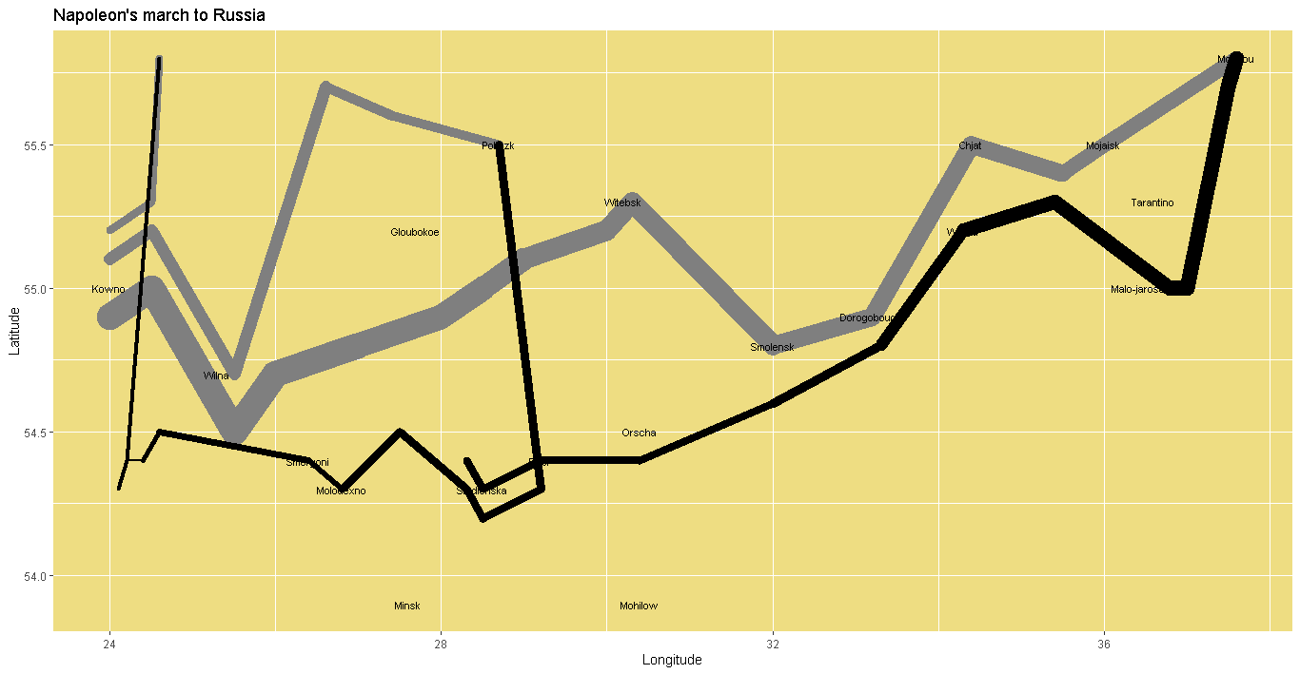

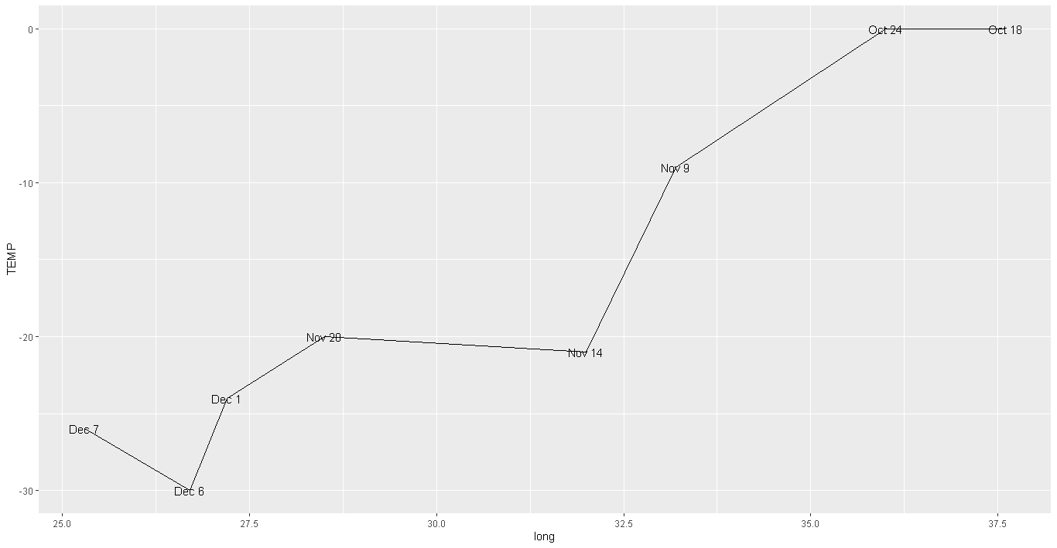

The tool used was R studio. The code is in R. The following libraries were used:

1. readxl
2. dplyr
3. data.table
4. ggplot2
5. gridExtra
6. scales

ggplot2 is powerful library which makes it possible to do good visualizations.

Nightingale visualization

Nightingale dataset is a dataset which concerns with the number of deaths of the soldiers in the army due to Zymotic disease, Wounds & injuries and all other causes. As the death count has been given according to month and also annual rates of mortality per 1000 the visualization was done by using ggplot’s geom_bar first to get an idea of the number of deaths in all the months. Once it was clear from the histogram how the deaths were distributed among three categories coord_polar was used to convert the histogram into a polar chart. The visualization is a polar chart which shows legends for the three causes of death. There are two visualizations with 12 months in each of them. Each slice of the visualization shows a month and the year and shows the shares of different causes of deaths in different colours as shown in the legend. The left visualization was turned by some angle in the code and the right one was zoomed. Thus, it shows a clear picture of all the months and the share of each cause in the death of the soldiers in the army.

Minard visualization

Minard dataset is a dataset which concerns with Napoleon march to Russia. His path and the size of army have been given. Temperature with longitude has also been given. From the visualization it can be seen that there were three expeditions by the army. One of the expeditions lasted only for a small distance and they returned back. There was another attempt to move which is in the middle of the visualization but that too did not last long. The longest one is in the lowest one which has a huge army and reaches Moscow. As it returned back it saw a fall in the army. The return line which is black becomes thinner showing that people died in the war and also during return. Below all this there is a graph of temperature which shows longitude and the corresponding temperature. The visualization also shows the temperature and the corresponding date on the graph. Combined, it shows Napoleon’s march to Russia and return and also the temperature in each month.