**Login Page:**

The Login page allows a user to login using the credentials within the database. There is no create account feature so random users cannot create an account and view private appointments. In order to create an account someone would have to add a user to the database and then provide that user with their credentials. That user could then login to the application and proceed to the next page.

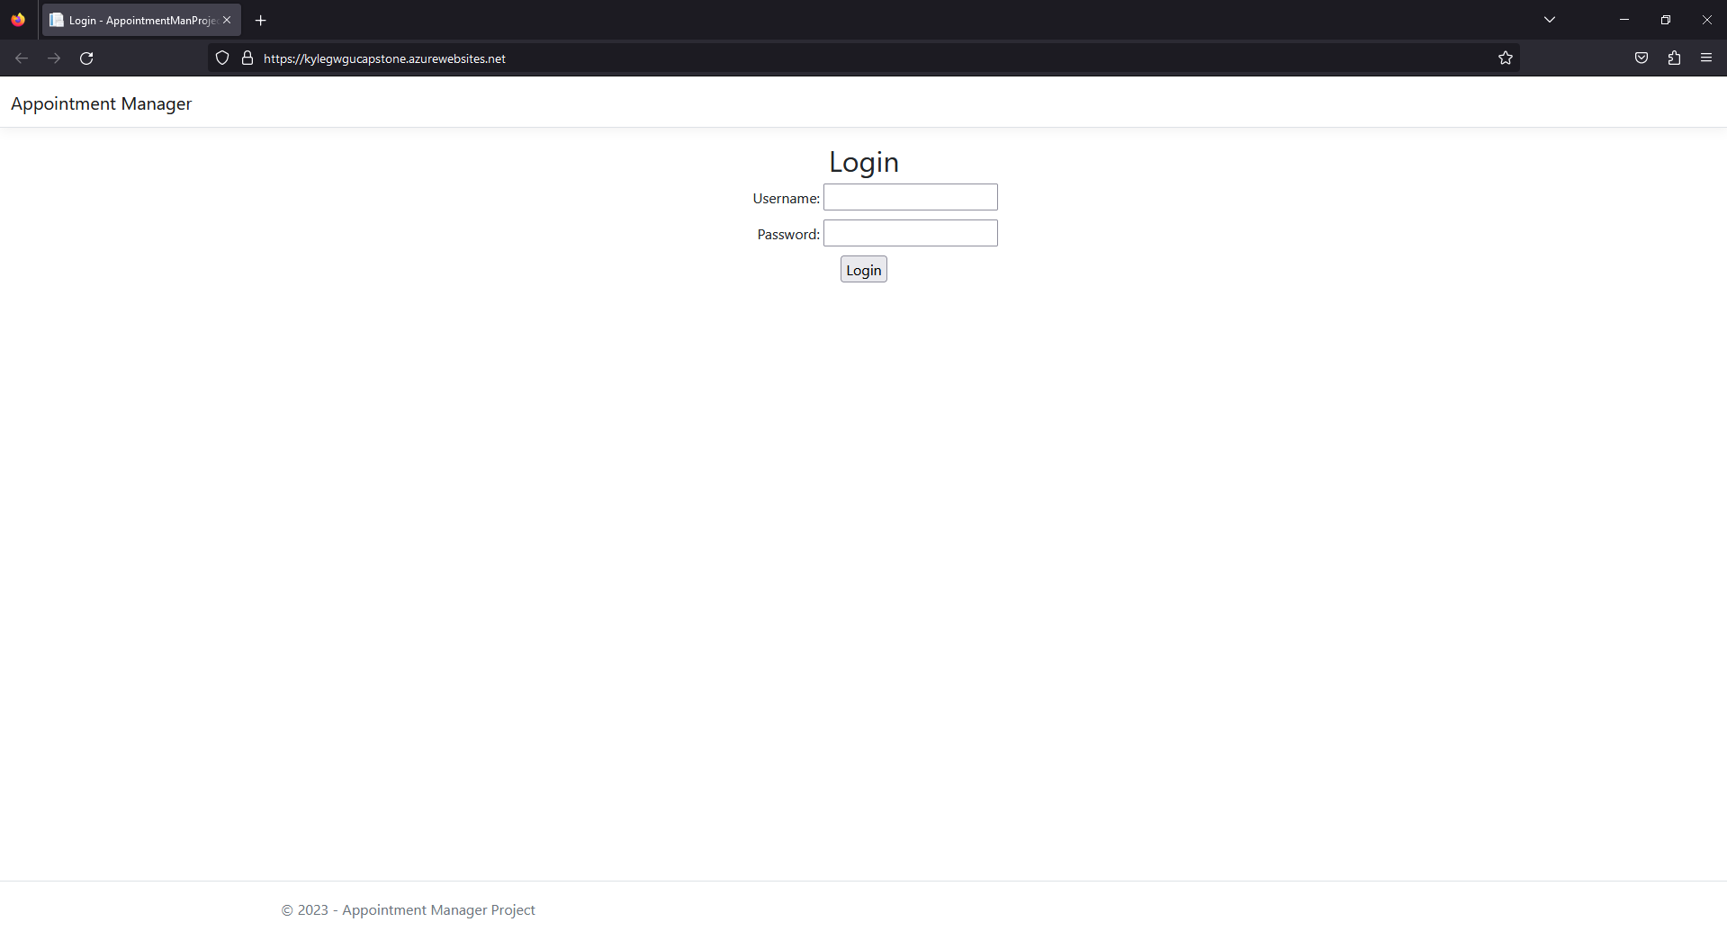

**Home Page:**

This Page allows the user to Create New Appointment, Edit, Delete, Generate Monthly/Yearly Report, and Logout. The Logout feature will return you to the login screen the other features will be explained below.

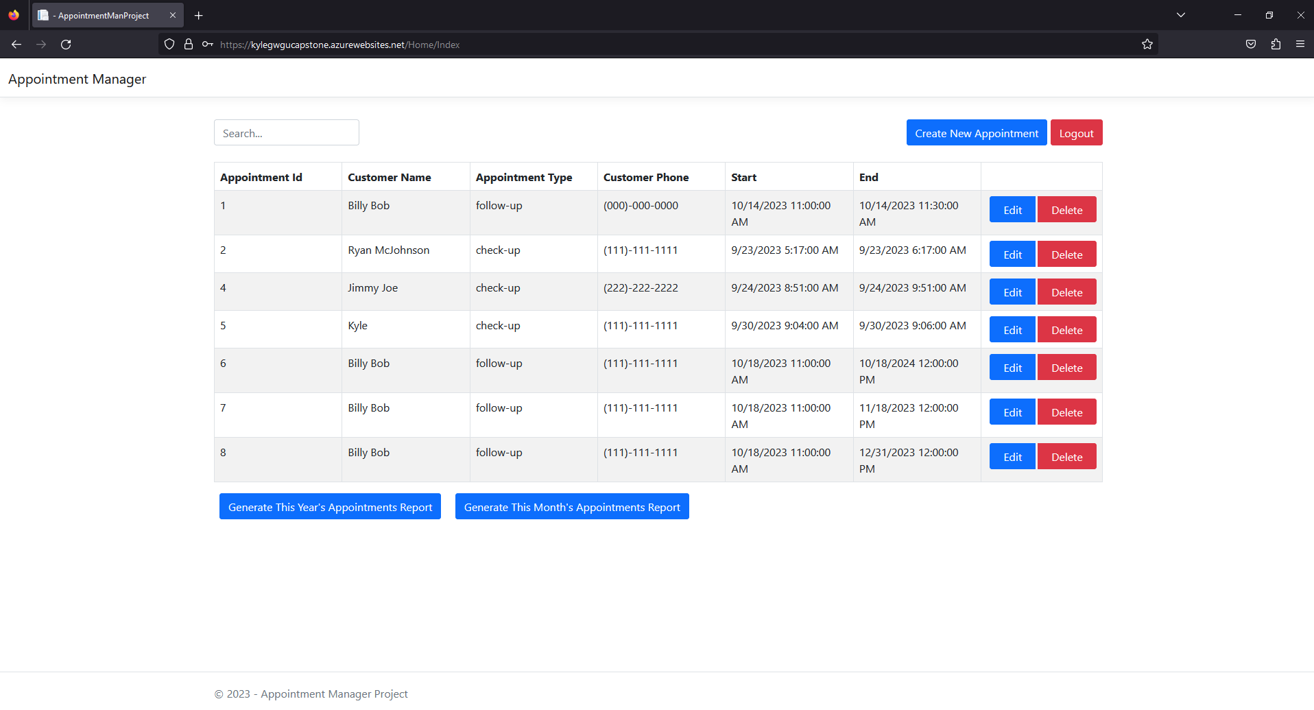

**Create New Appointment:**

When Clicking the create new appointment button in the top right. You will see the following screen.

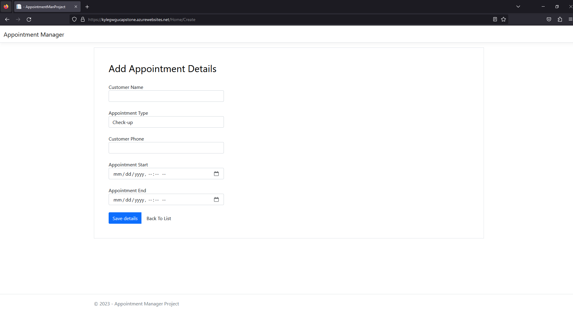

On this screen you have two options:

One you can click “Back To List” to return to the previous page.

Two you can fill out the data and save the new appointment.

Note: Option two includes a few validation controls confirming that data has been filled out correctly. Customer Name cannot include numbers, Customer Phone must be a ten digit number, Appointment End must be after Appointment Start, New appointments can not overlap with other appointments, Appointments can not be scheduled in the past, and etc If you have filled out data incorrectly and click the save button you will be informed on what is incorrect.

Some Examples:

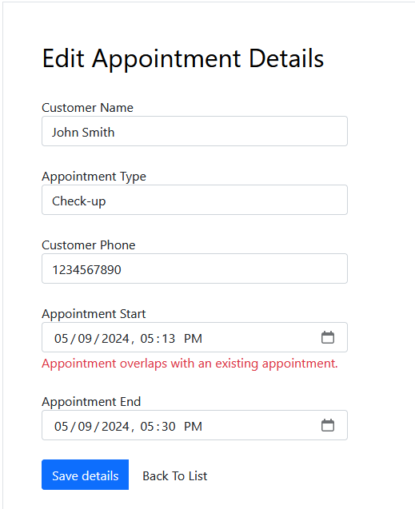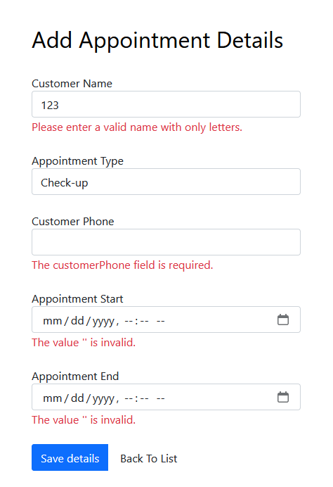

**Edit Appointment:**

When clicking the Edit appointment button next to the appointment you wish to edit it will return a page that includes all of the details of the appointment you selected. On this page you can update the necessary details and click save to update the entry. This page includes all the same validation checks as the Add appointment feature with some modifications to adjust for changes. For example when saving the appointment it will exclude the current appointment being edited for overlapping appointment validation.

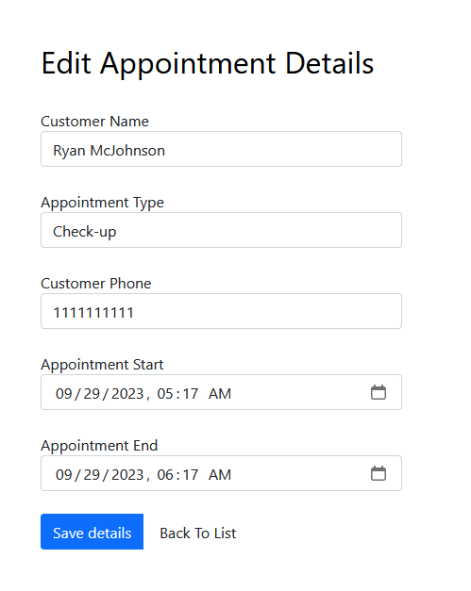

**Delete Appointment:**

Clicking the Delete appointment button next to the appointment you wish to delete will take you to a screen displaying all the details of the appointment you choose to delete. You can then confirm that you want to delete the appointment by clicking “Delete” or you can cancel by clicking “Back To List”.

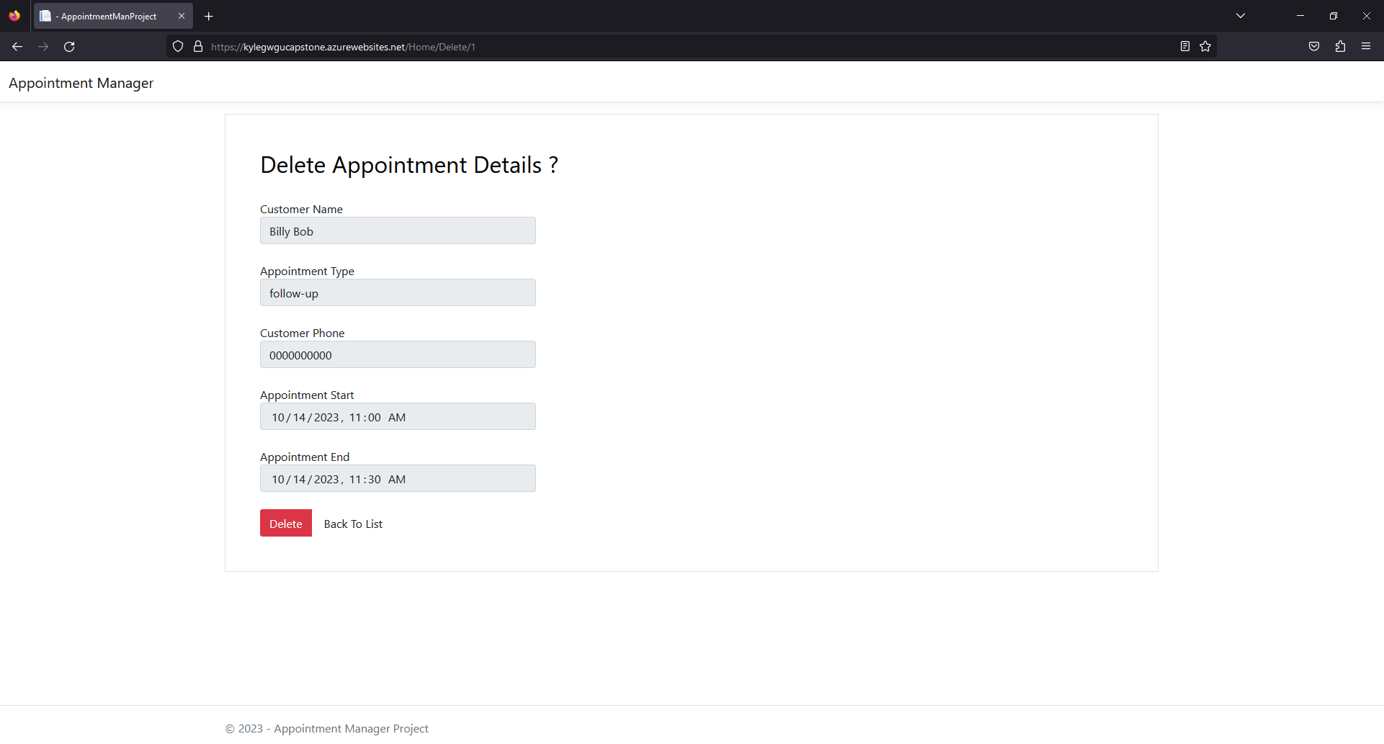

**Yearly Report:**

Clicking the Generate “This Year’s Appointments Report” button on the bottom left of the screen will generate a report showing you all appointments scheduled for the current year. On this page you can choose to print the report by clicking “Print Report” in the bottom left or you can return to the main screen by clicking “Back To List”.

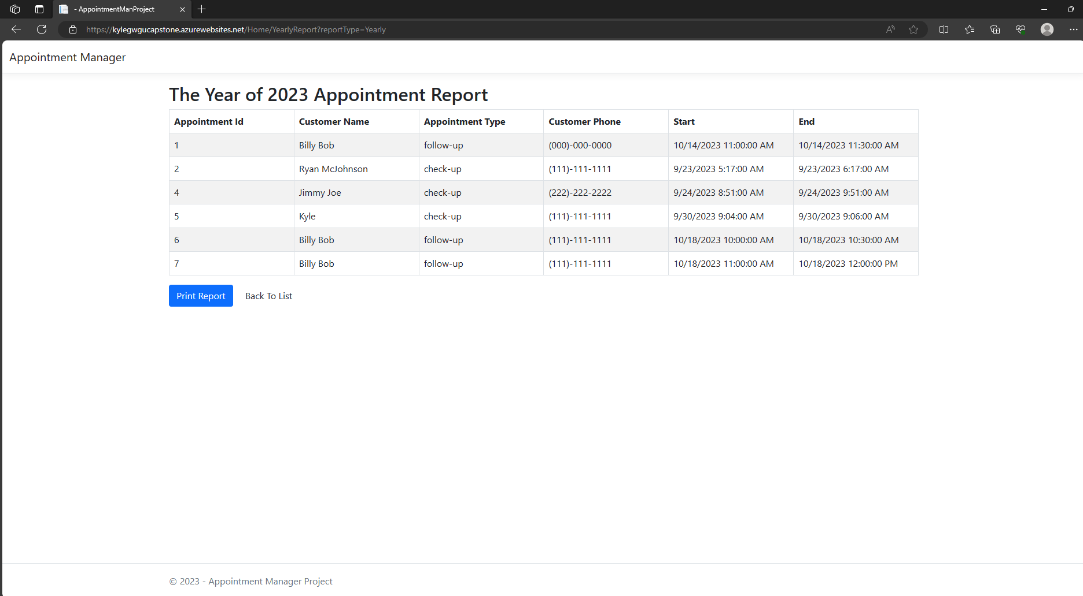

**Monthly Report:**

Clicking the Generate “This Month’s Appointments Report” button on the bottom left of the screen will generate a report showing you all appointments scheduled for the current month. On this page you can choose to print the report by clicking “Print Report” in the bottom left or you can return to the main screen by clicking “Back To List”.

