**Local Setup Guide**

**Software Instructions**:

Software Required: Visual Studio 2022 and MySQL workbench

How to install and configure each of the required software.

**Visual Studio:**

Visit the Following Link and click the download button for visual studio 2022 community edition.

<https://visualstudio.microsoft.com/downloads/>

It should look like this: 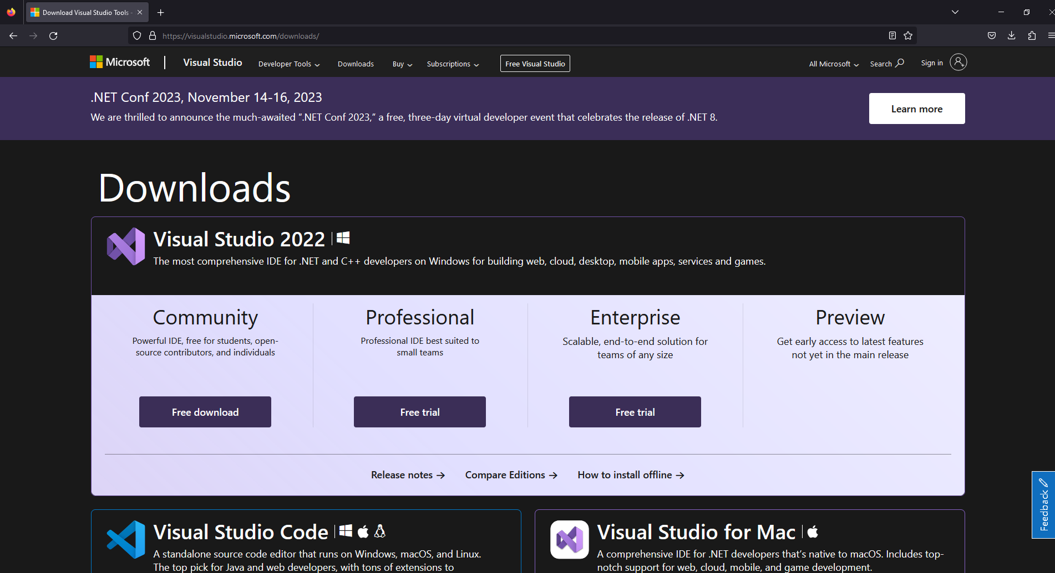

Follow the Installation instructions until you can choose workloads.

In the Workload section under Web & cloud select and install “ASP.NET and web development” and “Azure development”. Install these then continue to the next step.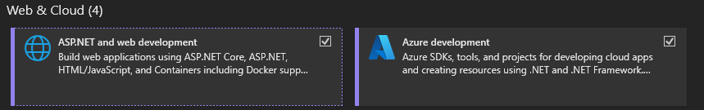

**MySQL Setup:**

Download MySQL Installer: <https://dev.mysql.com/downloads/windows/installer/8.0.html>

Go through the following steps:

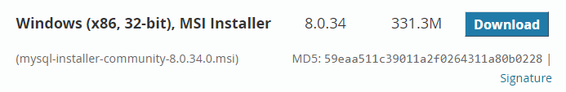



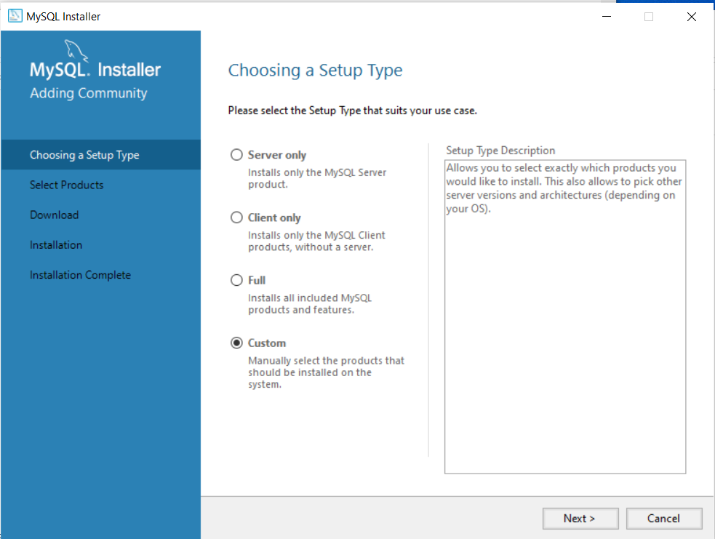

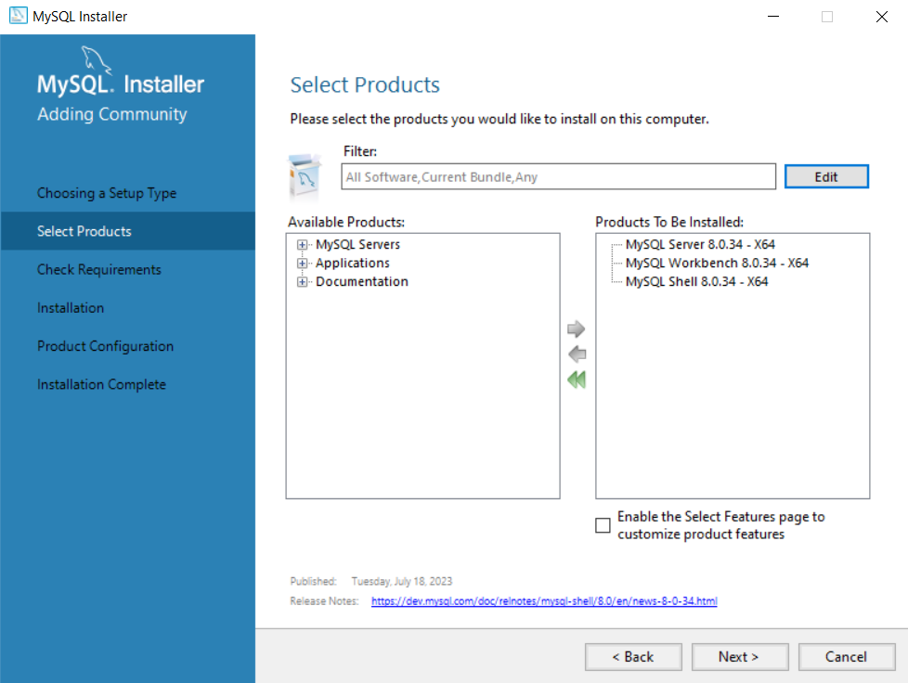

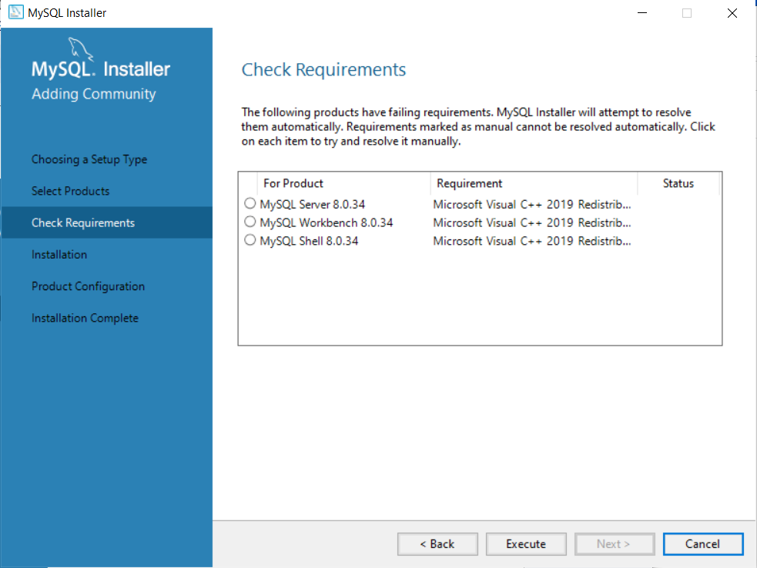

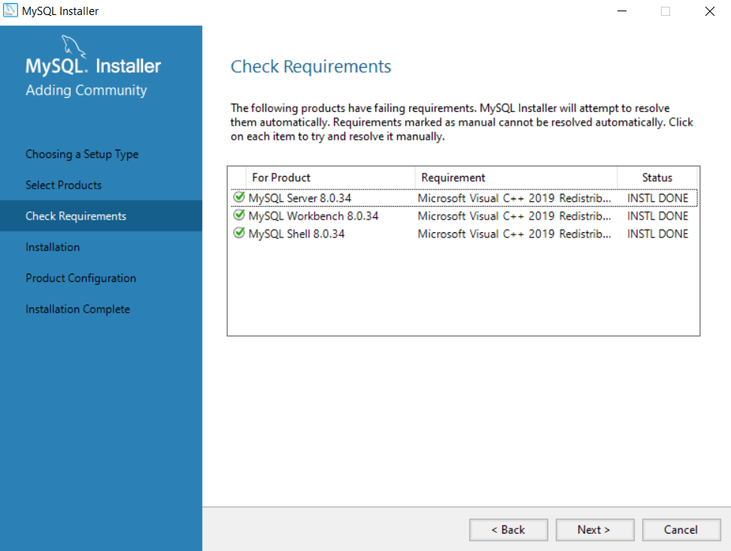

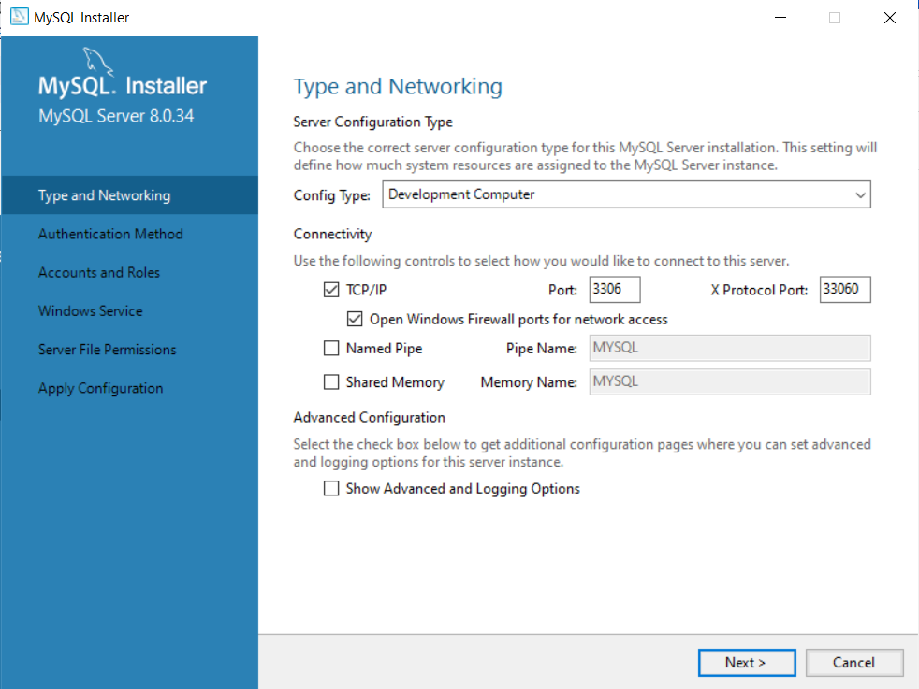

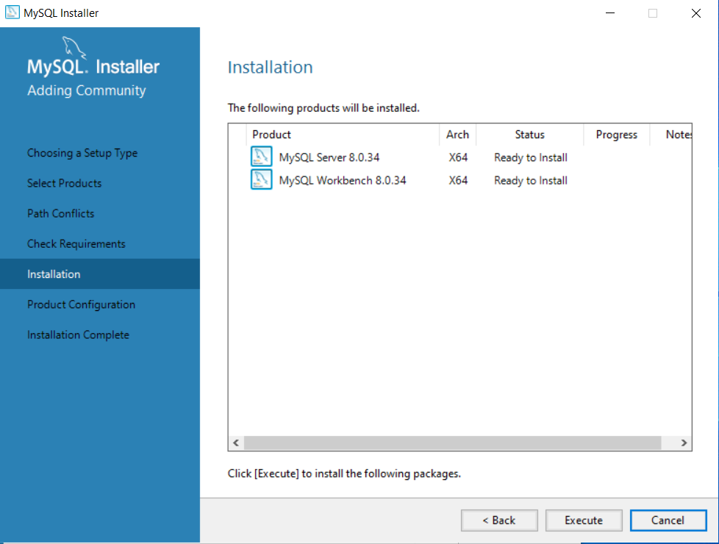

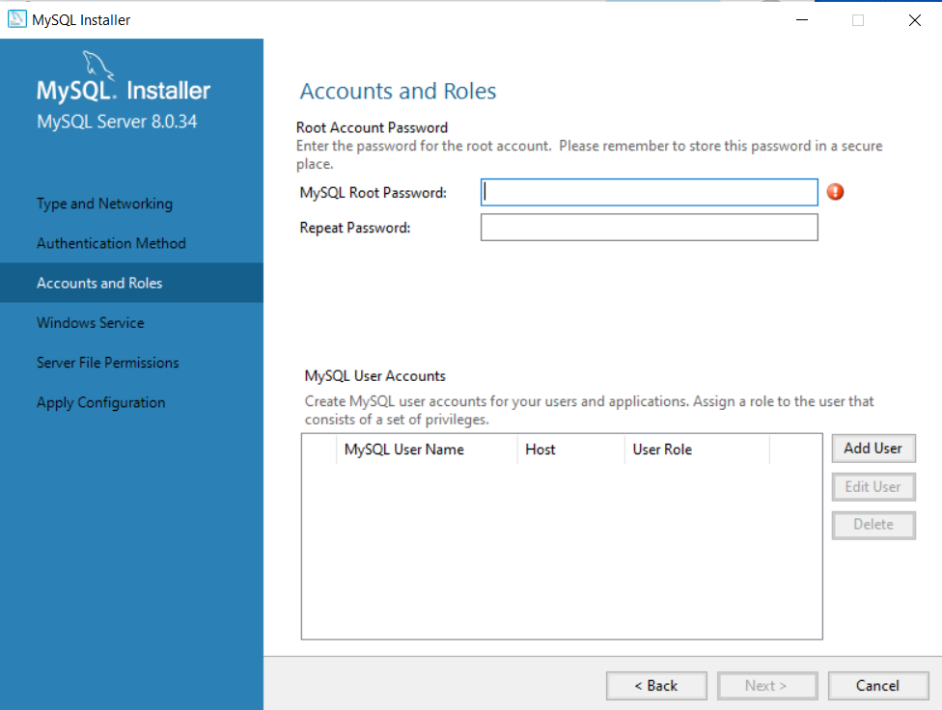

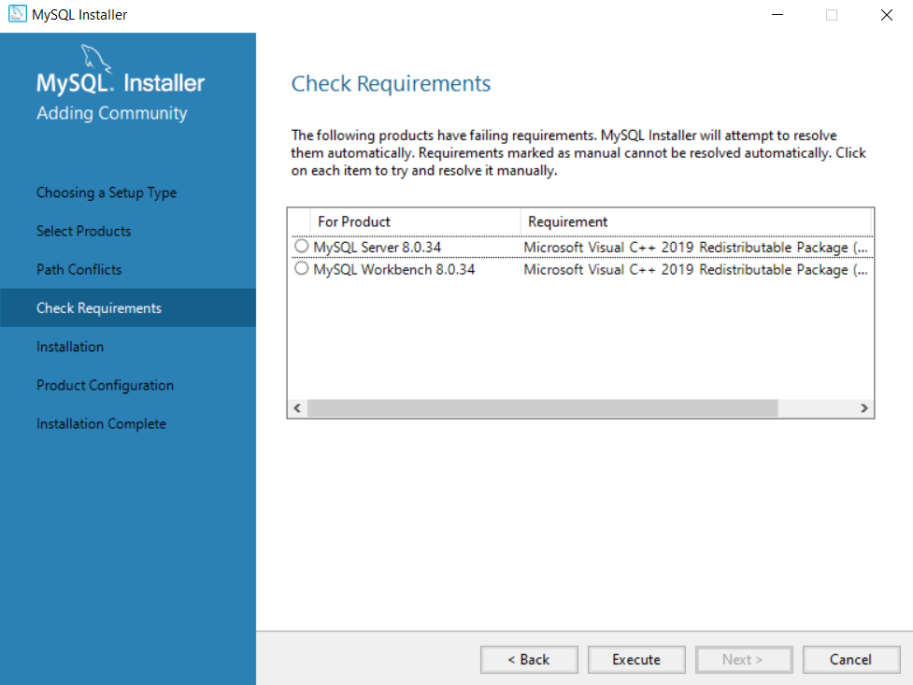

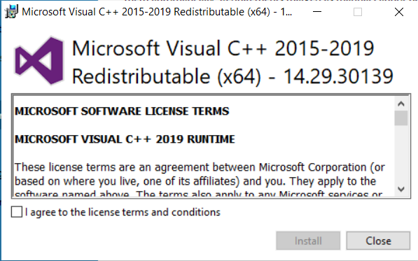

https://downloads.mysql.com/archives/visualstudio/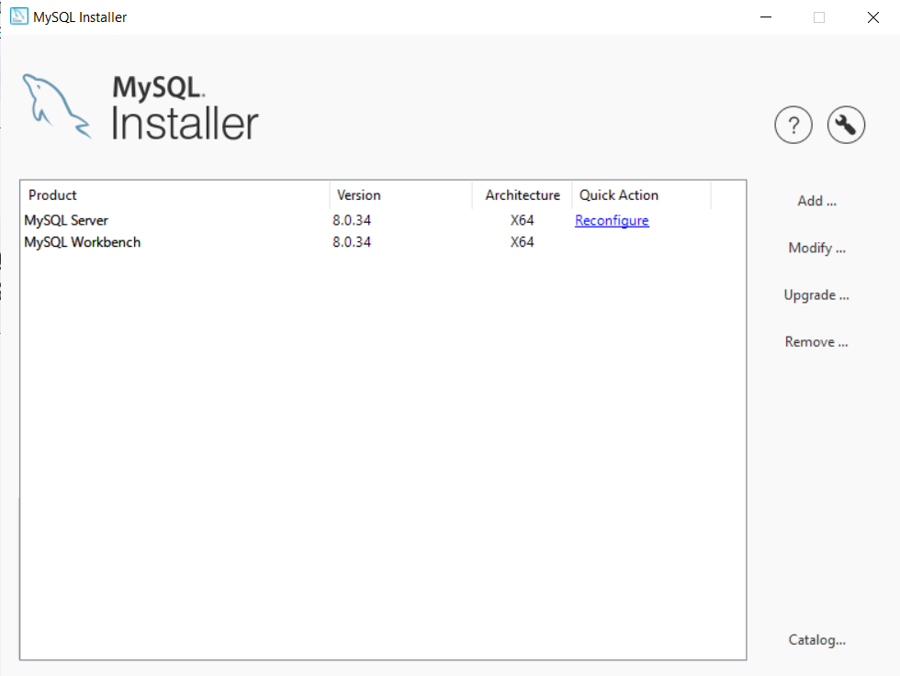

When everything is installed Open MySQL Workbench. Click the + next to MySQL Connections.



Fill out the following form.

Create a connection name.

Hostname should be localhost.

Leave username as root.

Your password will be the password you created for your root account before.

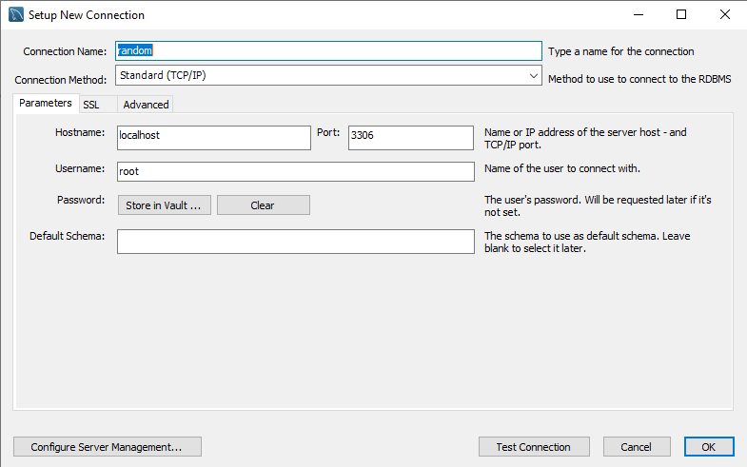

You can now open your database by clicking it on the homepage.



**Setting Up the Database:**

Once inside the database click the new schema at the top.

You should see this tab name the schema then click apply twice and finish.

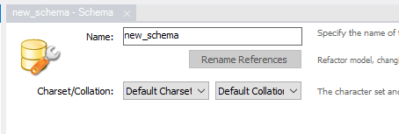

In the schema tab double click the schema you just created twice so it is highlighted

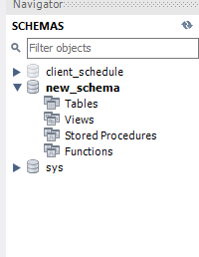

Above the schemas tab click the Create a new SQL tab for executing queries button.

Inside that tab paste the following code and click execute.

Paste the following code inside the tab.

-- Create user Table

CREATE TABLE user (

userId INT AUTO_INCREMENT PRIMARY KEY,

userName VARCHAR(255),

userPassword VARCHAR(255)

);

-- Fill user Table With test account

INSERT INTO user (userName, userPassword)

VALUES

('test', 'test');

-- Create appointment Table

CREATE TABLE appointment (

appointmentId INT auto_increment PRIMARY KEY,

userId INT,

customerName VARCHAR(255),

appointmentType VARCHAR(255),

customerPhone VARCHAR(255),

appointmentStart DATETIME,

appointmentEnd DATETIME,

createdBy VARCHAR(255),

FOREIGN KEY (userId) REFERENCES user(userId)

);

-- Fill appointment Table with test data

INSERT INTO appointment (userId, customerName, appointmentType, customerPhone, appointmentStart, appointmentEnd, createdBy)

VALUES

(

1,

'John Doe',

'check-up',

CONCAT('(', ROUND(RAND()*1000), ')-', ROUND(RAND()*1000), '-', ROUND(RAND()*10000)),

DATE_ADD(NOW(), INTERVAL 30 DAY),

DATE_ADD(DATE_ADD(NOW(), INTERVAL 30 DAY), INTERVAL 1 HOUR),

'test'

),

(

1,

'Jane Smith',

'other',

CONCAT('(', ROUND(RAND()*1000), ')-', ROUND(RAND()*1000), '-', ROUND(RAND()*10000)),

DATE_ADD(NOW(), INTERVAL 37 DAY),

DATE_ADD(DATE_ADD(NOW(), INTERVAL 37 DAY), INTERVAL 1 HOUR),

'test'),

(

1,

'Micheal Johnson',

'check-up',

CONCAT('(', ROUND(RAND()*1000), ')-', ROUND(RAND()*1000), '-', ROUND(RAND()*10000)),

DATE_ADD(NOW(), INTERVAL 17 DAY),

DATE_ADD(DATE_ADD(NOW(), INTERVAL 17 DAY), INTERVAL 1 HOUR),

'test'),

(

1,

'Sarah Brown',

'check-up',

CONCAT('(', ROUND(RAND()*1000), ')-', ROUND(RAND()*1000), '-', ROUND(RAND()*10000)),

DATE_ADD(NOW(), INTERVAL 19 DAY),

DATE_ADD(DATE_ADD(NOW(), INTERVAL 19 DAY), INTERVAL 1 HOUR),

'test'),

(

1,

'David Williams',

'check-up',

CONCAT('(', ROUND(RAND()*1000), ')-', ROUND(RAND()*1000), '-', ROUND(RAND()*10000)),

DATE_ADD(NOW(), INTERVAL 15 DAY),

DATE_ADD(DATE_ADD(NOW(), INTERVAL 15 DAY), INTERVAL 1 HOUR),

'test');

Right click and refresh your schema after executing and if everything was done correctly it should look like this.

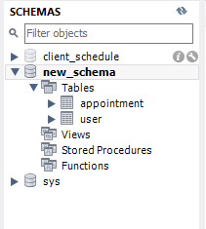

**Download Project & Install Packages:**

Download the project and open the AppointmentManProject.sln inside of visual studio. Once the project is open proceed to tools, NuGet Package Manager, Manage NuGet Packages For Solution. If the following packages are not Installed download the following packages manually.

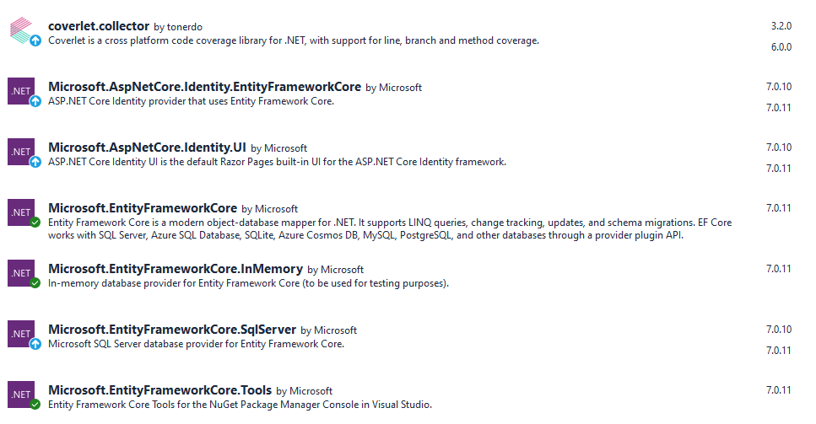

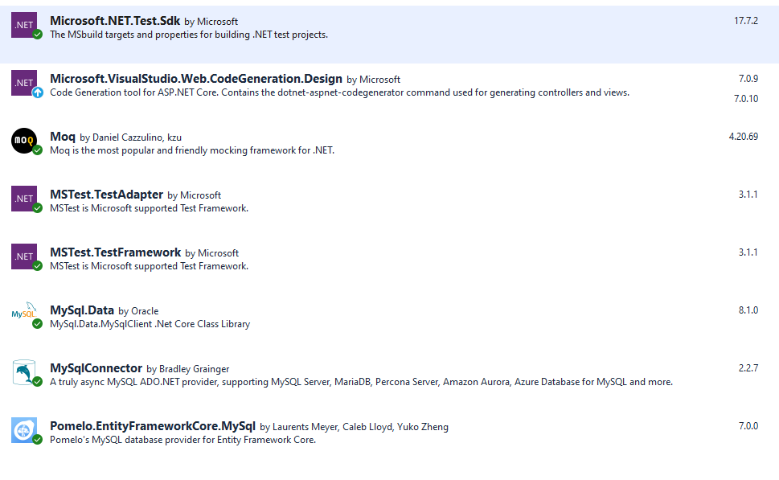

Once all packages are installed proceed to the appsettings.json and update the DefaultConnection line to include the details for the local database you just created.

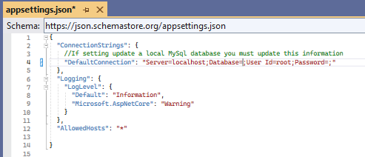

The Database name will be the name of the Schema you created and the password will be the password you created.

If everything was done correctly you can launch the program and login using the test account you added to the database. Username: test Password: test

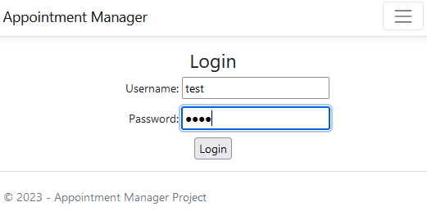

When you login you should see this screen.

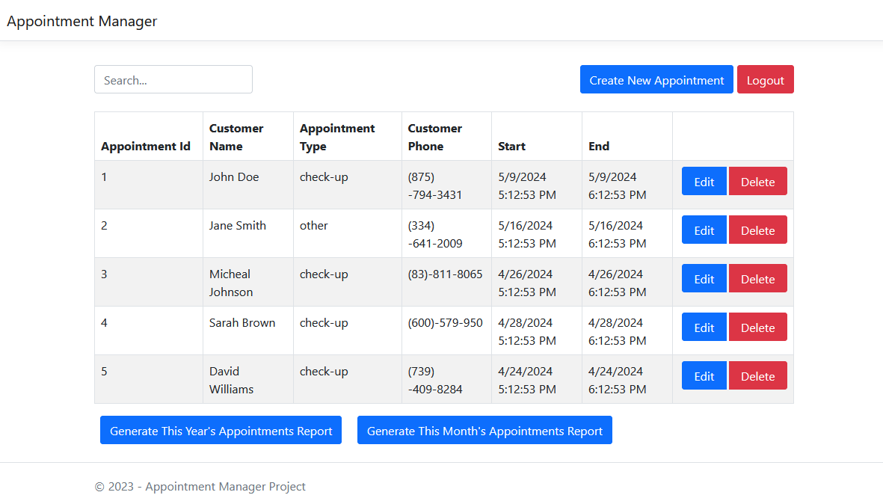

If that is the case you have finished setting up the application locally and can now use it for testing and development purposes.