Sprint 1 Plan:

Sprint Begin: 11/11/2019
Sprint End: 11/23/2019

Hours needed to complete the work this sprint: 33 hrs. (5.5 days, 6hrs per day).

Availability:
Errick Aliifua:
Not available Sundays
Elijah Blake:
Available Anytime
Connor Osborne:
Not Available Sundays
Benji Stewart:
Available Anytime

Metrics:
Cards completed

SCRUM Master: Elijah Blake

Resolutions:
Errick Aliifua:

Elijah Blake:
Get more code committed before the weekend comes. Last time all I had done was on the weekend which didn’t allow for as much collaboration with other teammates durring the week.
Connor Osborne:
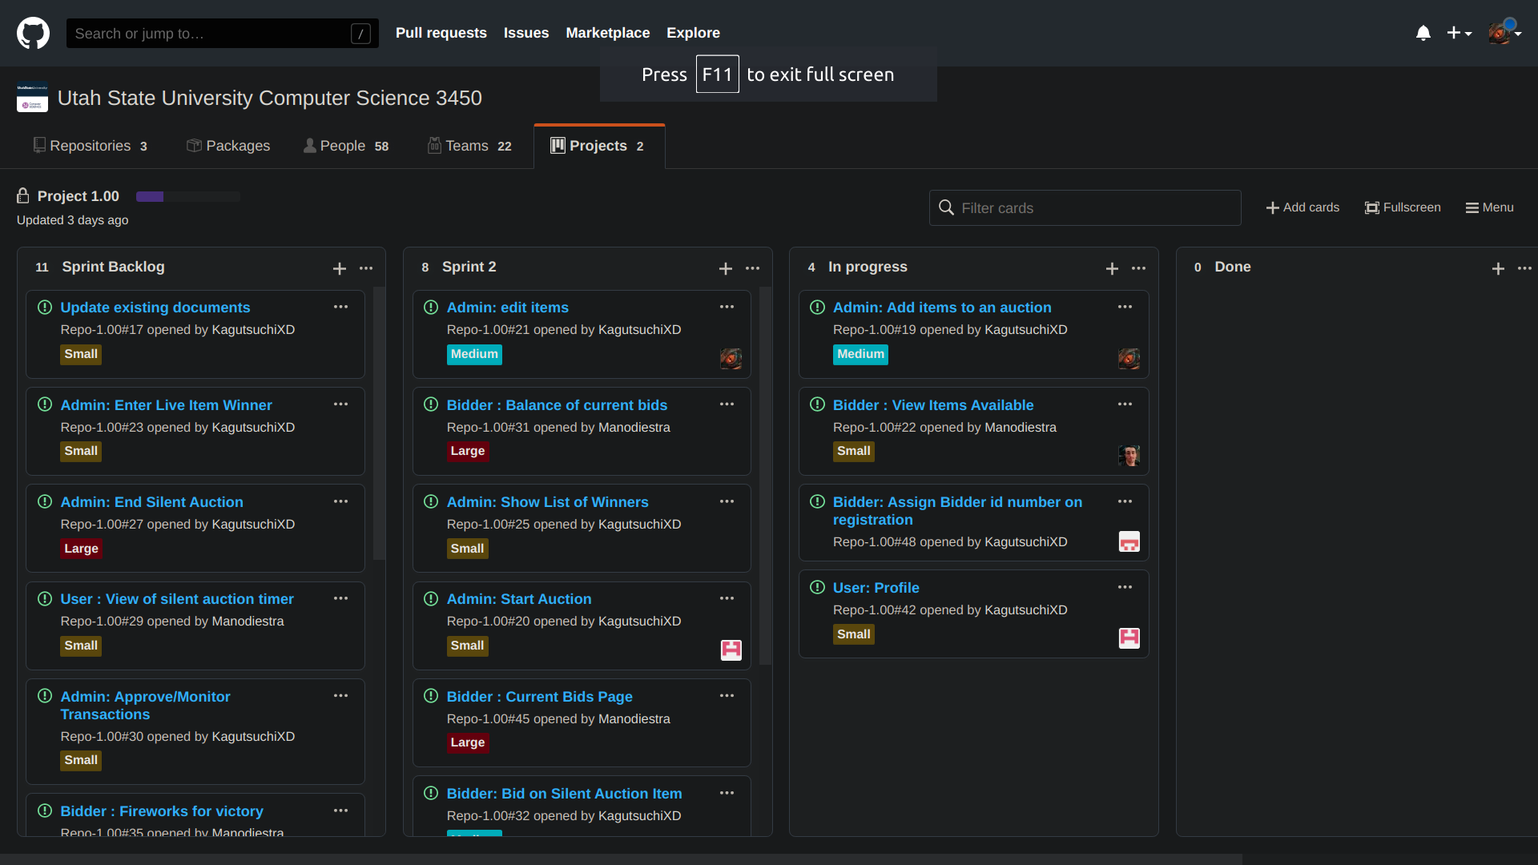
Finish four cards instead of three this time
Benji Stewart:
Put more time into working on the project

