Daily Scrum or Standup Meeting
Team name: Marianas Trench
Scrum Master: Benji Stewart
Date: 10/18/19

Team Member | What did you do since the last scrum? | What do you plan to do before the next scrum? | What obstacles do you have?
Errick Aliifua | Sprint planning | Start auction | Remembering Django
Elijiah Blake | Sprint planning | Add items to auction  edit items | Hubris
Connor Osborne | Sprint planning | Account creation | Homework for other classes  “and I’m lazy”-Connor2019
Benji Stewart | Sprint planning | View items available page | I’m not good at Javascript  Homework for other classes

Burndown

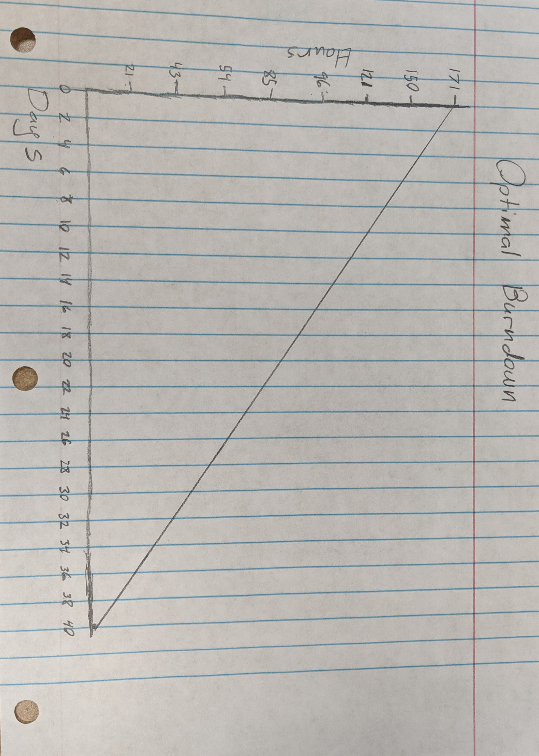

Screenshot of your project board

