Daily Scrum or Standup Meeting
Team name: Marianas Trench
Scrum Master: Benji Stewart
Date: 10/16/19

Team Member | What did you do since the last scrum? | What do you plan to do before the next scrum? | What obstacles do you have?
Errick Aliifua | Nothing | Do the start auction and user profile | Familiarity with Django and homework from other classes
Elijiah Blake | Finished the Sprint Planning updates | Get a functional upload to the database for the Items information | Managin communications with other team members who are updating the database
Connor Osborne | Fixed the URL paths and connections for logins | Make the password recovery page | Homework for other classes  “and I’m lazy”-Connor2019
Benji Stewart | Nothing | Finish the front end interface for the Item view page | Homework from other classes  Debugging won’t be able to be done for the front end to back end functionality until Elijah is done with his part

Burndown
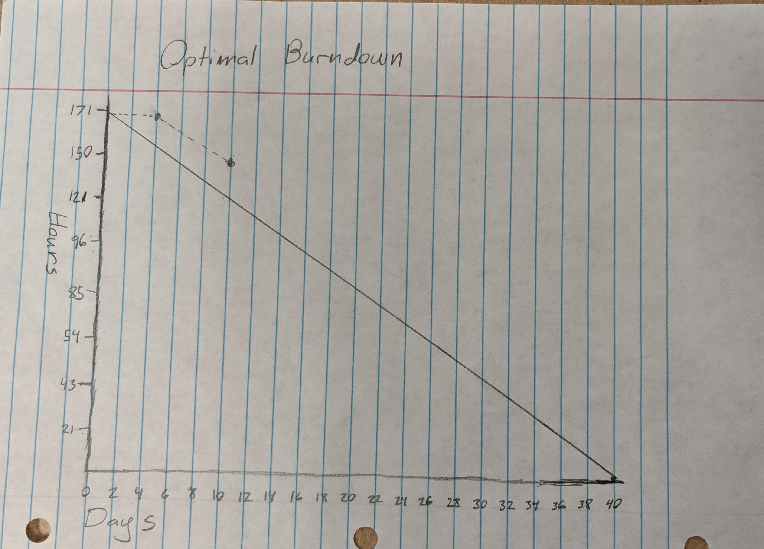

Screenshot of your project board

