Daily Scrum or Standup Meeting
Team name: Marianas Trench
Scrum Master: Benji Stewart
Date: 10/18/19

Team Member | What did you do since the last scrum? | What do you plan to do before the next scrum? | What obstacles do you have?
Errick Aliifua | Got django working | User profile page | Homework from other classes
Elijiah Blake | Nothing | Finish the add items page | Homework from other classes  work schedule because of a deadline coming up
Connor Osborne | Password recovery  Part of the account activation | All account creating stuff done | Using the Outlook server
Benji Stewart | Finished up the navigation bar for the page and some of the layout schematics  Half of the notification dropdown | Work on favorite items page or current bids page | Need database test info  General javascript knowledge

Burndown

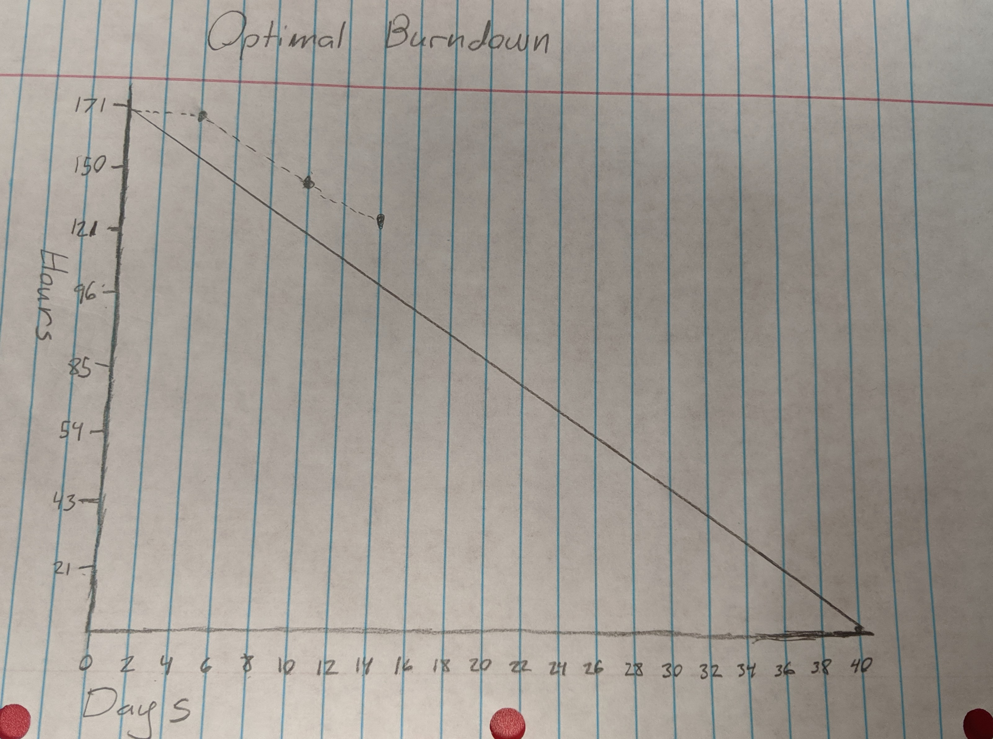

Screenshot of your project board

